Restriction Enzyme Cloning
Restriction enzyme (endonuclease) based molecular cloning is the "classic" cloning method, and for many reasons, remains one of the most popular today. Restriction enzymes, which are naturally produced by certain bacteria and archaea, cleave double stranded DNA (dsDNA) at specific sequence sites in the DNA. In restriction cloning, scientists utilize specific restriction enzymes to cut dsDNA of interest into fragments containing precise 5' or 3' single-strand overhangs (sticky ends), or no overhang (blunt ends). Two pieces of DNA that have complementary overhangs, or which are both blunt-ended, can then be fused together during a ligation reaction with T4 DNA ligase.
Restriction enzyme cloning benefits from the hundreds of available enzymes, many of which are relatively cheap. They also cut specific target sequences, that range from 4 to 13 base pairs, and produce predictable resulting ends in the DNA fragments. Given its prevalence, the vast majority of plasmids used for DNA cloning and expression contain several popular restriction enzyme sites. You can easily move (subclone) any piece of DNA that already has restriction sites on either side of it into any plasmid that has the same sites in the same orientation within its multiple cloning site. Due to their short length, it is also easy to add restriction sites to any piece of DNA during PCR amplification, allowing for it to then be digested and ligated into your desired plasmid. It is important to note that restriction enzyme target sites can be repeated throughout a specific DNA sequence, which can make it difficult at times to identify compatible restriction enzymes, that cut your insert or backbone at only the desired location for your cloning project. Restriction enzyme cloning also leaves behind a short scar in the DNA sequence and can be time consuming compared to other cloning methods.
You can find a protocol for restriction cloning and an in-depth breakdown of restriction digests on our website.
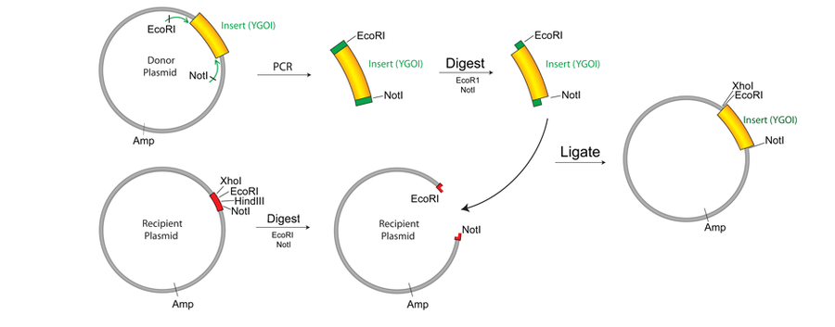Restriction cloning of your gene of interest (YGOI) into a recipient plasmid. (Image from Plasmid 101: Restriction cloning)

https://www.addgene.org/mol-bio-reference/cloning/

