Table of Contents
November 2020 4
Figure 1. Overview of third rotation project. 4
Sequencing primer design for pKR76: 4
Primer dilution: 5
PCR test for pPriM_lacZ: 5
Gel electrophoresis on test PCR: 6
Figure 2. Gel of pPriM-lacz PCR. Lane 1 ladder, lane 2 pPriM-lacz, lane 3 positive control LVS gDNA, lane 4 negative control (no DNA). 6
100uL PCR of pPriM_lacZ: 6
PCR Cleanup of pPriM_lacZ 7
DNA Digest of PKR14 backbone and pPriM_lacZ insert individually: 7
Gel electrophoresis of individually digested backbone (PKR14) and insert (pPriM_lacZ): 8
Figure 3. Gel of digests. Lane 1 ladder, lane 2 negative control, lane 3 BamH1 control, lane 4 empty, lane 5 backbone pKR14, lane 6 empty, lane 7 PCR insert. Spaces added for easier band extraction. 9
Table1. Weight of extracted bands 9
Gel extraction and cleanup: 9
Ligation of insert pPriM_lacZ with plasmid pKR14 to make PKR76: 9
Transformation of E.coli with PKR76 (PKR14+pPriM_lacZ): 10
Grew E.coli at 30 degrees Celsius 10
Table2: Number of colonies from PKR76 (PKR14+pPriM_lacZ) E.coli transformation 11
Overnight cultures of PKR76 (PKR14+pPriM_lacZ) transformed cells: 11
Grew overnight cultures at 30 degrees Celsius, shaking 250rpm 11
Miniprep of PKR76 (pKR14+pPriM_lacZ) plasmids: 11
Diagnostic digest on PKR76 (pKR14+pPriM_lacZ) plasmids from transformation: 11
Streaking cells: 12
Streaked cells ΔpmrA from strain vial 12
Gel electrophoresis of MiniPrepped Plasmids (in theory PKR76->PKR14+pPriM_lacZ): 12
Figure 4. Diagnostic Digest Gel of Plasmids for pPriM_lacz. Lane 1 ladder. Lane 2 positive control from transformation (pKR16). Lane 3-9 plasmids pKR14 labeled “1-6”. Second band indicates insert of pPrIM_lacz. 12
Sequencing reactions: 12
Table 3. Plasmid concentrations and quality. 13
Prepare electrocompetent (EC) cells: 13
ΔpmrA was sticky when picking up 14
Electroporate PKR76 plasmid into EC cells: 14
ΔpmrA cells had clump in cuvette—sticky cells 15
Making Selection Plates, Nat, Kan, xgal: 15
Arbitrary PCR 15
Have extra .13uL in rxn (3.26uL template vs 3.13uL) 16
Prepare electrocompetent (EC) cells: 18
Electroporate with transposon: 18
Freezing cells: 19
Figure 5. Arbitrary PCR. Lane 1 ladder, lane 2 E31, lane 3 E32, lane 4 E35, lane 5 negative control 19
Bands at bottom of gel appear to be primer dimers 19
Figure 6. Xgal nat plate with three strains day1: LVS bottom right, Δ pmrA ΔpriM bottom left, Δ pmrA top 20
Figure 7. Xgal nat plate with three strains day2: LVS bottom right, Δ pmrA ΔpriM bottom left, Δ pmrA top 21
Figure 8. 2nd Arbitrary PCR step with 2 minute extension. Lane 1 ladder, lane 2 e3-1, lane 3 e3-2, lane 4 e3-5, lane 5 LVS gDNA, lane 6 negative control 22
Primer dimers seen again, no sample products seen 22
Running 1st Arbitrary PCR with 3 primers: KROL87, KROL89, and KROL90 22
Arbitrary PCR New Samples: 23
Figure 9. Xgal nat plate with three strains day3: LVS bottom right, Δ pmrA ΔpriM bottom left, Δ pmrA top 23
Figure 10. 2nd Arbitrary PCR step with 2 minute extension from PCR from 1st step with 3 primers. Lane 1 ladder, lane 2 e3-1, lane 3 e3-2, lane 4 e3-5, lane 5 LVS gDNA, lane 6 negative control. Band noted for sample E3-2 24
Questions arising from transfection experiment: 25
Figure 11. 2nd Arbitrary PCR step with 2 minute extension with new samples, 3 primers 1st step, 2 minute extension 2nd step. Lane 1 ladder, lane 2 Tn3, Lane 3 Tn6, Lane 4 LVS, Lane 5 negative control 26
Gradient for Arbitrary PCR Troubleshooting 26
Make CHA-Kan plates (instapot protocol) 27
Question 1. Can cells not producing lots of beta-galactosidase survive next to cells producing beta-galactosidase on plates with X-gal? 28
Question 2. How efficient is the transformation with pSD26? 28
Question 3: What’s up with the LVS pF-PpriM-lacZ pSD26 colony with a tiny bit of blue? 28
Figure 12. Picture of plate made from LVS with blue dot in colony. Light blue in areas 29
Question 1. Can cells not producing lots of beta-galactosidase survive next to cells producing beta-galactosidase on plates with X-gal? 29
Figure 13. Cells with less lacz can survive next to those with lots. LVS and dpmrA mix on CHA (left) and CHA nat xgal (right) 30
Question 2. How efficient is the transformation with pSD26? 30
Bibliography 30

November 2020

Monday, November 2, 2020
To Do:
- Make lab notebook
- Get access key
- Design sequencing primer
Results and Data:
Today I learned about the project, where things are in the lab, and how to set up the notebook. I also designed and ordered a sequencing Primer with Hannah.

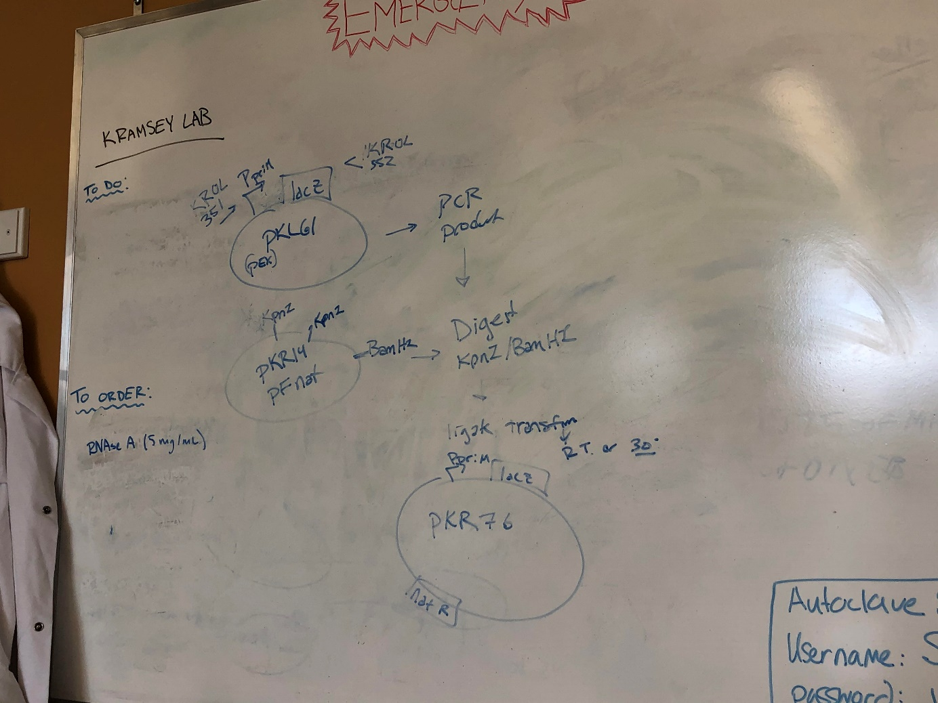

Figure 1. Overview of third rotation project.

Sequencing primer design for pKR76:
Primer name: KROL353 pKR76_seq
Primer sequence: CTTTACACTTTATGCTTCCGGCTCG
Tuesday, November 3, 2020
To Do:
- Get access key Wednesday
- Get primers and dilute primers
- Set up and run PCR

Primer dilution:
Spin tube of primer max speed 3 min. Add 0.1x elution buffer (EB) to tubes for concentration of 100uM (# of uL =10x the # nmoles). Incubate 42 degrees Celsius for 5 minutes. Vortex and spin. Dilute to 10uM for PCR (20uL stock +180uL EB) , 2.5uM for sequencing (5uL stock + 195uL EB).

PCR test for pPriM_lacZ:
Followed “PCR protocol new” protocol and “PCR_worksheet_PrimeStar”
Samples to PCR
Reaction Number | Plasmid/Region | Source DNA | Primers | Length (bps)
1 | pPriM +lacz | PkL61 | KROL351 and KROL352 | 3,324
2 | + control | LVS gDNA | KROL15, KROL16 | 441
3 | - control | - | KROL15, KROL16 | -

PCR math
Total reaction volume | 20
Total number of reactions | 3
 |  |  |  | Factor
Component | Stock concentration | Final concentration | 1 rxn volume | 4
ddiH2O |  |  | 12.4 | 49.6
PrimeSTAR GXL Buffer | 5x | 1x | 4 | 16
dNTPs | 2.5 mM | 0.2 mM | 1.6 | 6.4
oligo F | 10 uM | 0.3 uM | 0.6 | 2.4
oligo R | 10 uM | 0.3 uM | 0.6 | 2.4
template | 100 ng/ul | 2 ng/ul | 0.4 | 1.6
PrimeSTAR GXL DNA Polymerase | 1.25 U/ul | 0.025 U/ul | 0.4 | 1.6
 |  | Total volume | 20 | 80

**Don’t add highlighted wells to master mix, add individually*** --add 18uL MM to wells
PCR protocol name STN1: --edited, 68 degrees step 3:30 minutes (b/c insert is ~3.5kb)

Wednesday, November 4, 2020
To Do:
- Get access key Wednesday
- Run gel of PCR from yesterday
- Make new PCR 100uL
- Gel clean-up and digest

Gel electrophoresis on test PCR:
1%agarose gel (6uL sybr safe): 20uL of samples 4uL loading dye (total/5), 10uL ladder, ~115 volts 30 minutes
Results and Data:
Ladder
Negative control
LVS gDNA
pPriM_lacZ

Figure 2. Gel of pPriM-lacz PCR. Lane 1 ladder, lane 2 pPriM-lacz, lane 3 positive control LVS gDNA, lane 4 negative control (no DNA).

100uL PCR of pPriM_lacZ:
“PCR protocol new” protocol and “PCR_worksheet_PrimeStar”
Samples to PCR
Reaction Number | Plasmid/Region | Source DNA | Primers | Length (bps)
1 | pPriM +lacz | PkL61 | KROL351 and KROL352 | 3,324
2 | - control | - | KROL15, KROL16 | -

PCR math
Total reaction volume | 100
Total number of reactions | 2
 |  |  |  | Factor
Component | Stock concentration | Final concentration | 1 rxn volume | 2.5
ddiH2O |  |  | 62 | 155
PrimeSTAR GXL Buffer | 5x | 1x | 20 | 50
dNTPs | 2.5 mM | 0.2 mM | 8 | 20
oligo F | 10 uM | 0.3 uM | 3 | 7.5
oligo R | 10 uM | 0.3 uM | 3 | 7.5
template | 100 ng/ul | 2 ng/ul | 2 | 5
PrimeSTAR GXL DNA Polymerase | 1.25 U/ul | 0.025 U/ul | 2 | 5
 |  | Total volume | 100 | 250

**Don’t add highlighted wells to master mix, add individually*** --add 98uL MM to wells +2ul either template or water
PCR protocol name STN1: --edited, 68 degrees step 3:30 minutes (b/c insert is ~3.5kb)

PCR Cleanup of pPriM_lacZ
Followed Qiagen kit protocol

DNA Digest of PKR14 backbone and pPriM_lacZ insert individually:
“DNA Digests” protocol under shared files
Digest samples:
Tube | DNA | Enzyme(s) | DNA Volume (uL) | H₂O Volume (uL)
1 | Purified PCR (pPriM_lacZ) | kpn1,bamh1 | 15 | -
2 | Pkr14 | kpn1,bamh1 | 5 | 10
3 | Pkr14 | Bamh1 only | 5 | 10

Components | Volumes in 1 reaction (uL) | Volumes in Master Mix 4x (uL)
H₂O | 10.8 | 43.2
10x Buffer* | 3.0 | 12.0
DNA | (15.0) | -
Enzyme 1 | 0.6 | 2.4
Enzyme 2 | 0.6 | 2.4
Total | 30.0 (15.0 actual b/c of DNA)
Add 15uL of master mix to tubes
Incubate overnight 37 degrees Celsius

Thursday, November 5, 2020
To Do:
- Run gel of digests
- Cut bands out of gel
- Gel cleanup
- Ligation
- Pour LB plates

Gel electrophoresis of individually digested backbone (PKR14) and insert (pPriM_lacZ):
1%agarose gel (6uL sybr safe): 30uL of samples 6uL loading dye (total/5), 10uL ladder, ~115 volts 30 minutes. Added cip enzyme to pKR14 backbone (0.5uL)
Results and Data:
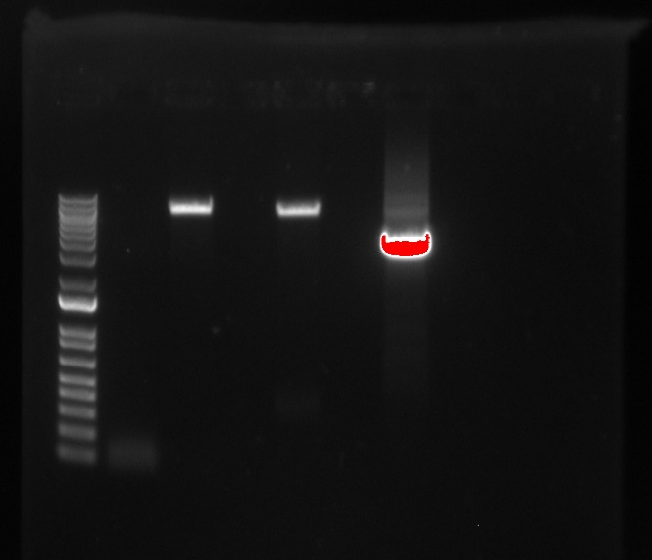
pPriM_lacZ
PKR14 BamH1 kpn1
PKR14 BamH1
Negative control
Ladder

Figure 3. Gel of digests. Lane 1 ladder, lane 2 negative control, lane 3 BamH1 control, lane 4 empty, lane 5 backbone pKR14, lane 6 empty, lane 7 PCR insert. Spaces added for easier band extraction.

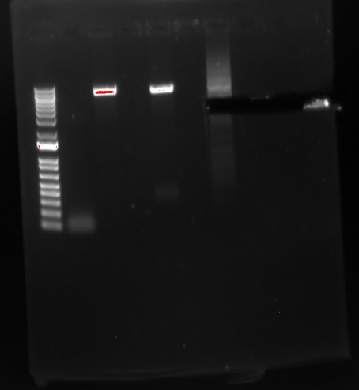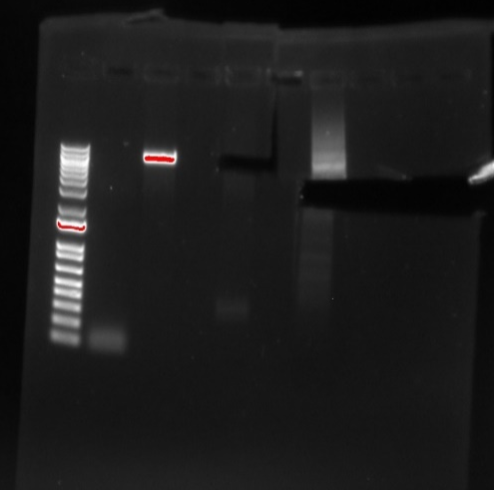
Same gels as figure 3, but showing where the bands were cut out

Table1. Weight of extracted bands
Sample | Weight | Corresponding sample volume
pKR14 backbone | 0.15g | 150uL
PCR insert (pPriM_lacZ) | 0.24g | 240uL

Gel extraction and cleanup:
Image gel with UV light (use blue screen and yellow goggles) and cut bands with razor blade, then followed “Qiagen gel extraction kit protocol”

Ligation of insert pPriM_lacZ with plasmid pKR14 to make PKR76:
Followed “Ligations” protocol under shared files
Samples:
Tube | Insert | Backbone
1 | BamHI, KpnI digested, purified PCR, pPriM_lacz | BamHI, KpnI digested, purified pKR14
2 | - | BamHI, KpnI digested, purified pKR14
Master mix math:
Component | Reaction 1 (uL) | Reaction 2 (uL) | Master Mix (3x)
H₂O | 11.5 | 11.5 | 34.5
10x ligase buffer | 2.0 | 2.0 | 6
Insert | 4.0 | - | -
Backbone | 2.0 | 2.0 | 6
Ligase | 0.5 | 0.5 | 1.5
TOTAL | 20.0 | 20.0 | 48
Incubated overnight 16 degrees in thermocycler

Friday, November 6, 2020
To Do:
- Transformation

Transformation of E.coli with PKR76 (PKR14+pPriM_lacZ):
“E.coli Chemical Transformation” protocol under shared files
Tube number | Purpose | DNA | Volume of DNA | Final volume to plate | Number of nourseothricin (nat) -containing plates
1 | (+) control | pKR16 | 1 uL | 20 ul, 100 ul | 2
2 | (-) control | None | 0 | 20 ul, 100 ul | 2
3 | Ligation 2 (Backbone Ligation) | pkR14 (digested) | 8 uL | 100 uL, remaining | 2
4 | Ligation 1 | PKR76 (pKR14+insert pPriM_lacz) | 8 uL | 100 uL, remaining | 2
Total number of plates |  |  |  |  | 8

Grew E.coli at 30 degrees Celsius

Monday, November 9, 2020
To Do:
- Check transformed plates
- Make overnight cultures
Results and Data:

Table2: Number of colonies from PKR76 (PKR14+pPriM_lacZ) E.coli transformation
Sample | # of colonies
- Control (untransformed E.coli) 20uL | 0
- Control (untransformed E.coli) 100uL | 0
+ Control PKR16 20uL | 2
+ Control PKR16 100uL | 23
Ligation 1 (PKR14+pPriM_lacz) 20uL | 0
Ligation1 (PKR14+pPriM_lacz) 100uL | 1
Ligation 1 (PKR14+pPriM_lacz) Remaining | 6
Ligation 2 (PKR14) 20uL | 0
Ligation 2 (PKR14) 100uL | 0
Ligation 2 (PKR14) Remaining | 0

Overnight cultures of PKR76 (PKR14+pPriM_lacZ) transformed cells:
Picked colonies with wooden sticks, added to 5mL of LB broth with antibiotic at 50ug/mL final concentration
Math for antibiotic (Nat): (100mg/mL)(X)=(0.05mg/mL)(45mL) -> X=22.5uL

Grew overnight cultures at 30 degrees Celsius, shaking 250rpm

Tuesday, November 10, 2020
To Do:
- Mini-prep -Qiagen
- Diagnostic digest
- Streak cells to make electrocompetent cells

Miniprep of PKR76 (pKR14+pPriM_lacZ) plasmids:
Followed protocol for Qiagen miniprep kit

Diagnostic digest on PKR76 (pKR14+pPriM_lacZ) plasmids from transformation:
Digest of miniprepped plasmids using following master mix:
Components | Volumes in 1 reaction (uL) | Volumes in Master Mix 9x (uL)
H₂O | 15 | 135
10x Buffer* | 2.0 | 18
DNA | (2.0) | --
Enzyme 1 Bamh1 | 0.5 | 4.5
Enzyme 2 kpn1 | 0.5 | 4.5
Total | 20.0 (18uL of mix, 2uL DNA) | 180
*Cutsmart Buffer is used for all the “HF” enzymes.

Streaking cells:
Streaked LVS (50uL stock), ΔpmrA, and ΔpmrA ΔpriM (50uL stock) cells on plates

Streaked cells ΔpmrA from strain vial

Wednesday, November 11, 2020
To Do:
- Run gel of digests
- Sequencing

Gel electrophoresis of MiniPrepped Plasmids (in theory PKR76->PKR14+pPriM_lacZ):
1% agarose gel (6ul sybr safe): all 20uL of digests + 4uL loading dye, 10uL ladder, ~115volts 30 minutes

Results and Data:
MiniPrep plasmids:
PKR14+ PpriM_lacZ
PKR16
Ladder

Figure 4. Diagnostic Digest Gel of Plasmids for pPriM_lacz. Lane 1 ladder. Lane 2 positive control from transformation (pKR16). Lane 3-9 plasmids pKR14 labeled “1-6”. Second band indicates insert of pPrIM_lacz.

Sequencing reactions:
Nanodrop concentrations:

Table 3. Plasmid concentrations and quality.

Set up sequencing as indicated in following table:

Thursday, November 12, 2020
To Do:
- Make electrocompetent cells

Prepare electrocompetent (EC) cells:
-Scrape up entire plate of cells into 500 uL of sterile 10% sucrose and resuspend
-Add 1 mL of 10% sucrose to a final volume of 1.5 mL
-Spin for 3 minutes at 10,000 rpm
-remove supernatant, throw out, and resuspend in fresh 1 mL 10% sucrose
-Repeat 4x in 10% sucrose
-After final spin, remove all supernatant.
-Resuspend cells in 10% sucrose at high density (corresponding to ~1x10¹¹ cells /mL –equal amount cells and sucrose); Aliquot into sterile tubes with 110 uL
-For any extra EC cells, aliquot ~110 μL / sterile tube (enough for 2 electroporations) and freeze at -80°C

ΔpmrA was sticky when picking up

Friday, November 13, 2020
To Do:
- Check sequencing results
- Electroporate

Results and Data:
Sequencing results: The sequencing results came back and were overall good. The sequence for the first miniprep (samples MG1-5) was good, but since the concentration was low, only 5 primers were used and the end of the sequence for lacz could not be read. The data showed that the sequence was good until 890 amino acids. The other 3 sequences showed good sequence coverage throughout the whole lacz gene.

Electroporate PKR76 plasmid into EC cells:
**Combine the three good sequencing reactions to have a good amount of DNA.
-For each electroporation, aliquot 4 mL MHB into glass test tubes for recovery, warm in shaker at 37°C
-For each electroporation, in a 2 mm sterile electroporation cuvette, combine:
5 μL of DNA (mini-prep concentration, at least 100 ng/μL)
50 μL electrocompetent cells
-Have recovery media ready
-Electroporate using the following settings: 2.5 kV, 25 μF, and 600 Ω
-Immediately after individual electroporations, use 1 mL warm recovery media from test tube to wash cells out of cuvette and transfer cells to recovery test tube
-Recover cells for 4-8 hours, shaking at 37°C
-Plate on CHAH-Nat plates, 20uL, 100uL, remaining
-Incubate plates at 37°C for 3 days (or until single colonies appear)

*Always include a control electroporation with no plasmid. Eventually single break-through colonies may start appearing; at that point, single colonies on the experimental plates are also likely to just be break-through growth.

ΔpmrA cells had clump in cuvette—sticky cells

Monday, November 16, 2020
To Do:
- Streak cells
Tuesday, November 17, 2020
To Do:
- Make/Pour plates
- Check cells
- Arbitrary PCR
- Make electrocompetent cells
- Electroporate

Making Selection Plates, Nat, Kan, xgal:
-Add 30.6g of CHA media to 300mL water
-Heat and stir 60°C for 10 min
-Autoclave liquid 30min cycle
-Meanwhile warm hemoglobin to 56°C in waterbath
-When media is done in autoclave, cool to 56°C and then add hemoglobin
-Add antibiotics and xgal and stir
-Nat 30uL, Kan 60uL, xgal (light sensitive! use foil)
-Measure 24mL/plate
-Store plates away from light

Results and Data:
Streak plates: The plates do not show a great deal of growth. We will wait until tomorrow to make the electrocompetent cells and electroporate

Arbitrary PCR
1) Find samples: gDNA with transposon insertions
2) Table indicating which samples are being tested (Always include LVS genomic DNA (no transposon insertion) and no template control):
Sample number | DNA
1 | LVS rpsU1-LacZ pSD26 Tn insertion into KRLVS28.1  E3-1, strain 33.1
2 | LVS rpsU1-LacZ pSD26 Tn insertion into KRLVS28.1  E3-2, strain 33.2
3 | LVS rpsU1-LacZ pSD26 Tn insertion into KRLVS28.1  E3-5, strain 33.3
4 | LVS gDNA
5 | -DNA

3) Set up reaction 1, using 500 ng of gDNA in a total reaction volume of 25 uL.
Concentrations of DNA:
Sample | Concentration | Amount to 500ng needed for RXN | uL Water to level RXNs
E3-1 33.1 | 372.02ng/ulL | 1.34uL | 1.92
E3-2 33.2 | 224.92ng/uL | 2.22uL | 1.04
E3-5 33.3 | 153.14mg/uL | 3.26uL

Have extra .13uL in rxn (3.26uL template vs 3.13uL)

4) Dilute reaction 1 PCR samples 1:10 (2 uL into 18 uL). Keep this dilution for future PCRs!
5) Set up reaction 2
6) Run PCR on gel and confirm that there are products. If so, proceed to next step. If not, optimize primers and annealing temperatures further.
7) Re-do PCR 2 using a total reaction volume of 50 uL.
8) PCR-purify samples from larger reaction 2 and elute in 0.1x EB.
9) Submit to the GSC for sequencing using KROL92 Tn_Mar3 (or transposon-specfic primer used in reaction 2).
10) Identify where each transposon insertion is located and design strain-specific primers to confirm specific insertions.

Wednesday, November 18, 2020
To Do:
- Gel of arbitrary PCR
- Make electrocompetent cells
- Electroporate
- Freeze cells

Prepare electrocompetent (EC) cells:
-Scrape up 3 patches into 500 uL of sterile 10% sucrose and resuspend
-Save 4th patch for glycerol stock
-Add 1 mL of 10% sucrose to a final volume of 1.5 mL
-Spin for 3 minutes at 10,000 rpm
-remove supernatant, throw out, and resuspend in fresh 1 mL 10% sucrose
-Repeat 4x in 10% sucrose
-After final spin, remove all supernatant.
-Resuspend cells in 10% sucrose at high density (corresponding to ~1x10¹¹ cells /mL –equal amount cells and sucrose); Aliquot into sterile tubes for electroporation with 55 uL
-For any extra EC cells, aliquot ~110 μL / sterile tube (enough for 2 electroporations) and freeze at -80°C

Electroporate with transposon:
4 Samples: Control -no transposon (use LVS pkR76), +transposon: ΔpmrA pkr76, ΔpmrA ΔpriM pkr76
-For each electroporation, aliquot 4 mL MHB into glass test tubes for recovery, warm in shaker at 37°C
-For each electroporation, in a 2 mm sterile electroporation cuvette, combine:
5 μL of DNA (mini-prep concentration, at least 100 ng/μL)
50 μL electrocompetent cells
-Have recovery media ready
-Electroporate using the following settings: 2.5 kV, 25 μF, and 600 Ω
-Immediately after individual electroporations, use 1 mL warm recovery media from test tube to wash cells out of cuvette and transfer cells to recovery test tube
-Recover cells for 4-8 hours, shaking at 37°C
-Plate on CHAH-Nat-Kan plates (10plates total)
-20uL,100uL, Remaining for 3 samples
-Remaining only for control
-Incubate plates at 37°C for 3 days (or until single colonies appear)

Freezing cells:
400uL of MHB into cryovial
Scrape plate and add to cryovial
Add 400uL more of MHB
Add 200uL of 75% glycerol (for 15% final conc)
Vortex
Freeze in -80
Results and Data:
Negative Control
LVS gDNA
E3-5, strain 33.3
E3-2, strain 33.2
E3-1, strain 33.1
Ladder

Figure 5. Arbitrary PCR. Lane 1 ladder, lane 2 E31, lane 3 E32, lane 4 E35, lane 5 negative control

Bands at bottom of gel appear to be primer dimers

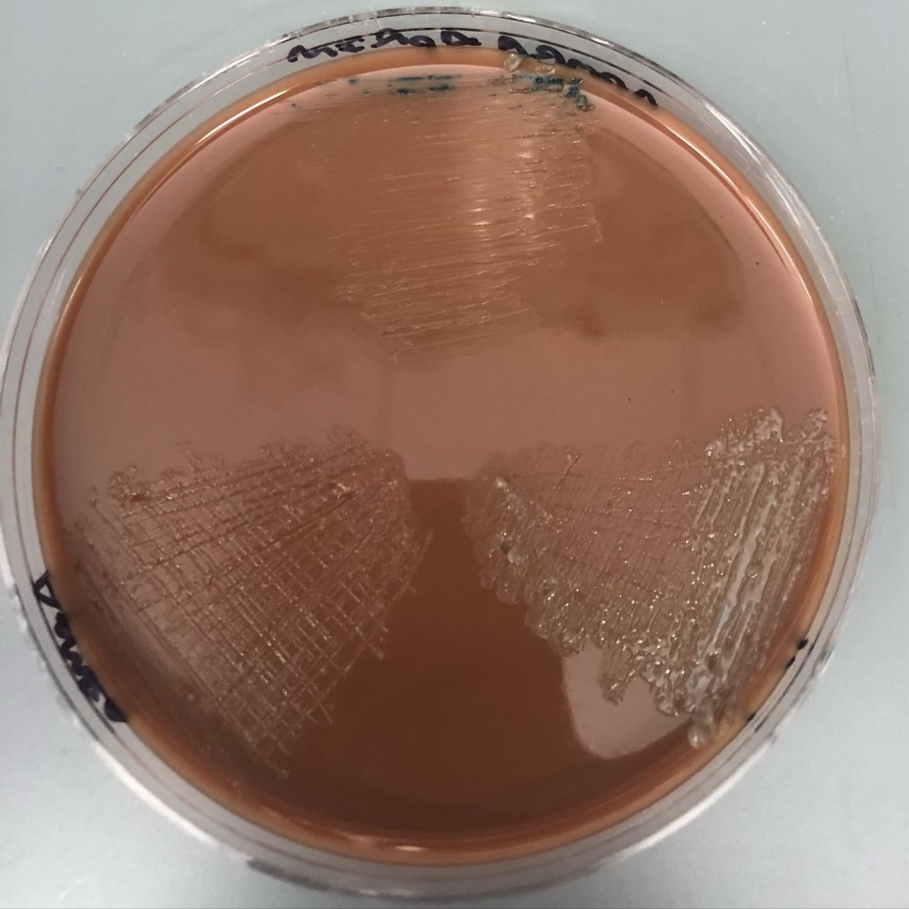
LVS
ΔPmrA ΔPriM
ΔPmrA

Figure 6. Xgal nat plate with three strains day1: LVS bottom right, Δ pmrA ΔpriM bottom left, Δ pmrA top

Thursday, November 19, 2020
To Do:
- Check plate with nat, kan, xgal to see growth of the three strains
- Troubleshoot arbitrary PCR -change protocol: extension in 2nd PCR to 2 minutes, same samples and tables from Tuesday November 17
- Run 1st arbitrary PCR with 3 primers same samples and protocol from Tuesday November 17
Results and Data:

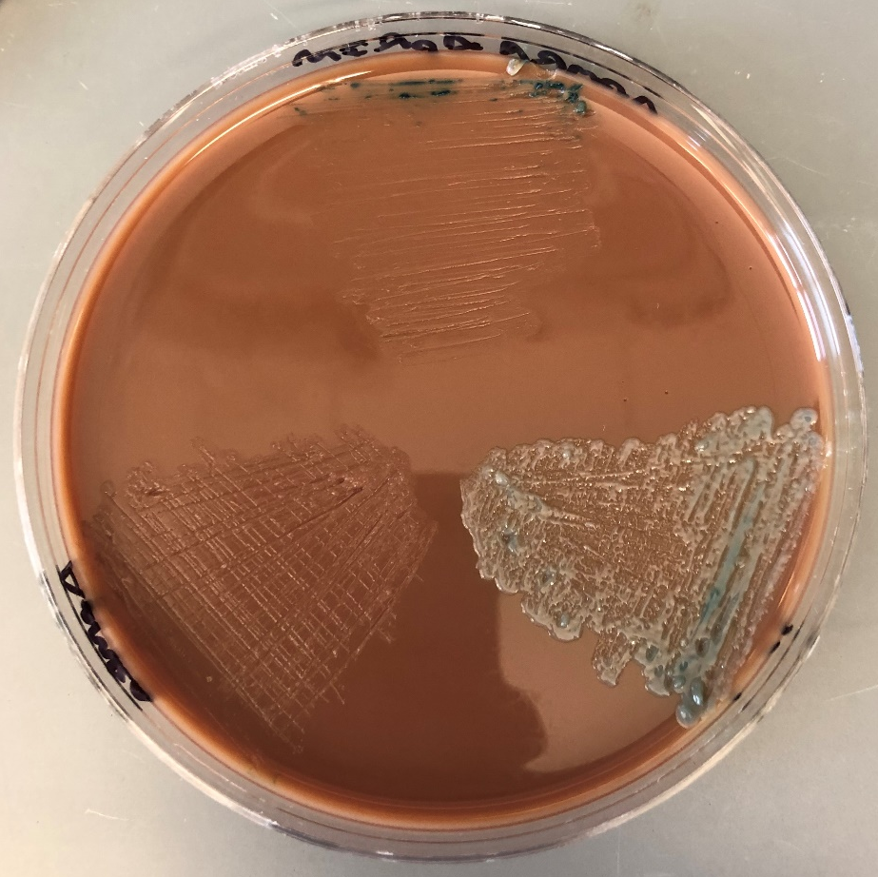
LVS
ΔPmrA ΔPriM
ΔPmrA

Figure 7. Xgal nat plate with three strains day2: LVS bottom right, Δ pmrA ΔpriM bottom left, Δ pmrA top

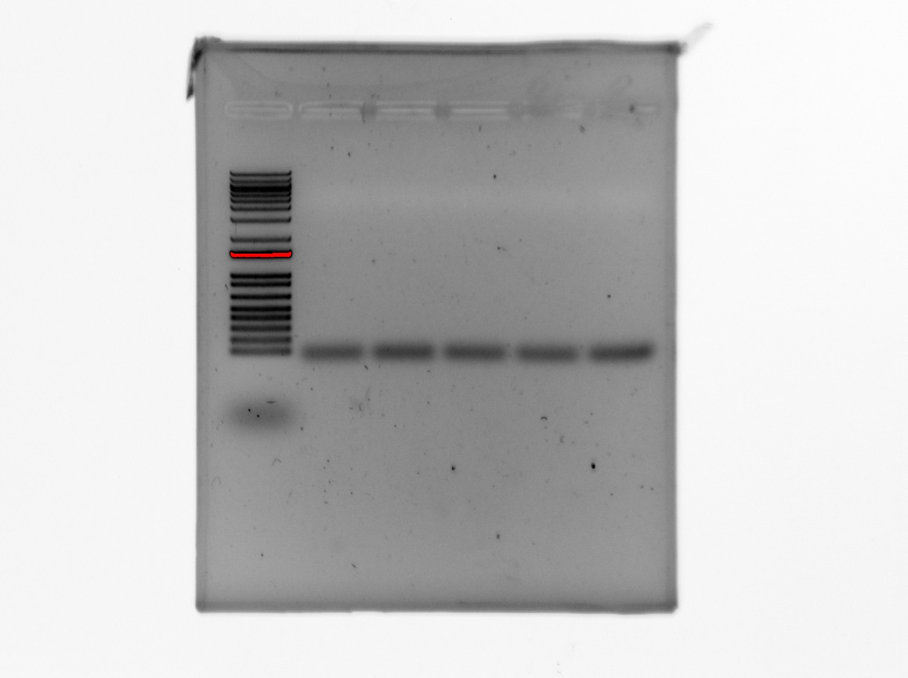
E3-5, strain 33.3
E3-2, strain 33.2
E3-1, strain 33.1
LVS gDNA
Negative Control
Ladder

Figure 8. 2nd Arbitrary PCR step with 2 minute extension. Lane 1 ladder, lane 2 e3-1, lane 3 e3-2, lane 4 e3-5, lane 5 LVS gDNA, lane 6 negative control

Primer dimers seen again, no sample products seen

Running 1st Arbitrary PCR with 3 primers: KROL87, KROL89, and KROL90
Same protocol as from Tuesday November 17th, new master mix math

Friday, November 20, 2020
To Do:
- Check plate with nat, kan, xgal to see growth of the three strains
- Run 2nd arbitrary PCR with the samples made yesterday -use changed protocol: extension in 2nd PCR to 2 minutes, same samples and tables from Tuesday November 17
- Check growth of PKR76 strains electroporated with PSD26
- Run new 1st step arbitrary PCR with new DNA samples

Arbitrary PCR New Samples:
New LVS
Tn 3
Tn 6
Results and Data:
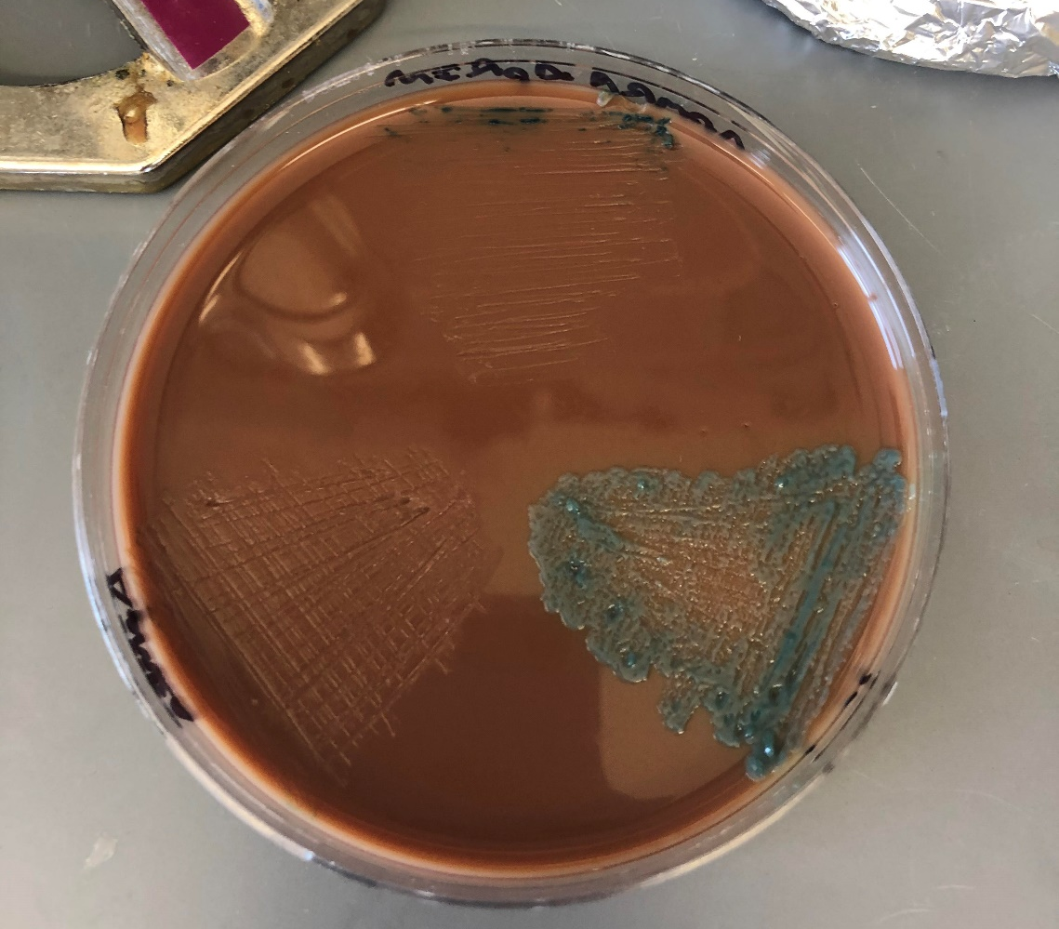

Figure 9. Xgal nat plate with three strains day3: LVS bottom right, Δ pmrA ΔpriM bottom left, Δ pmrA top

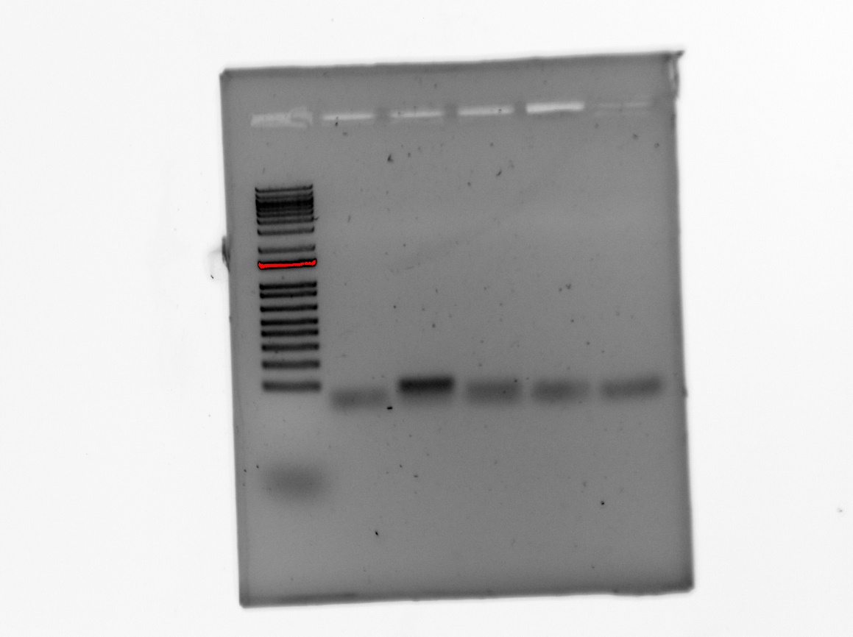
LVS gDNA
Negative Control
E3-2, strain 33.2
E3-1, strain 33.1
E3-5, strain 33.3
Ladder

Figure 10. 2nd Arbitrary PCR step with 2 minute extension from PCR from 1st step with 3 primers. Lane 1 ladder, lane 2 e3-1, lane 3 e3-2, lane 4 e3-5, lane 5 LVS gDNA, lane 6 negative control. Band noted for sample E3-2

Saturday, November 21, 2020
To Do:
- Check growth of PKR76 strains electroporated with PSD26
- Run second arbitrary PCR step on new samples and run gel
- Run arbitrary PCR 1st step with gradient
- Plate partially blue colony
- Make plates of LVS and ΔpmrA from freezer stock (make 2x ΔpmrA -need one for transfection Monday)

Results and Data:
White colonies on LVS plates (one white colony with blue dot), blue tint on deletion plates –no colonies observed –keep plates and look at again on Monday

Questions arising from transfection experiment:

Question 1. Can cells not producing lots of beta-galactosidase survive next to cells producing beta-galactosidase on plates with X-gal?
To answer this question:
- Streak out LVS pF-PpriM-lacZ and ∆pmrA LVS pF-PpriM-lacZ on CHA plates
- Scrape up cells from each plate, resuspend in MHB, check OD600
- Mix at 1:10 ratio of LVS pF-PpriM-lacZ to ∆pmrA LVS pF-PpriM-lacZ
- Pipette 20 uL onto single CHA nat X-gal plate, streak to single colony
- Repeat on a CHA plate
- Incubate at room temperature over the holiday

Question 2. How efficient is the transformation with pSD26?
To answer this question:
- Perform another transformation of ∆pmrA LVS pF-PpriM-lacZ with 1 ug (5 uL of 200 ng/ul) pSD26 and (-) DNA control
- Plate (-) DNA control on CHA-Kan plate (entire reaction)
- Plate 50 uL and 50 uL of a 1:10 dilution of the ∆pmrA LVS pF-PpriM-lacZ pSD26 transformation on CHA-Kan plate
- Plate the remainder of the ∆pmrA LVS pF-PpriM-lacZ pSD26 reaction on the CHA-Xgal-nat-Kan (7 plates total): 2 x 20 uL, 2 x 100 uL, 2 x 500 uL, remaining
- Incubate at room temperature over the holiday

Question 3: What’s up with the LVS pF-PpriM-lacZ pSD26 colony with a tiny bit of blue?
- Streak out onto CHA-Xgal-nat-Kan plate
- 37°C until Monday
- Observe phenotype, potentially freeze down

Tn6
LVS
Neg. Ctrl.
Tn3
Ladder

Figure 11. 2nd Arbitrary PCR step with 2 minute extension with new samples, 3 primers 1st step, 2 minute extension 2nd step. Lane 1 ladder, lane 2 Tn3, Lane 3 Tn6, Lane 4 LVS, Lane 5 negative control

Gradient for Arbitrary PCR Troubleshooting
Run gradient from 45 to 65 degrees Celsius

Sunday, November 22, 2020
To Do:
- Make CHA-Kan plates
- 2nd step arbitrary PCR ----not enough enzyme, need 2.1uL have ~1.8uL

Make CHA-Kan plates (instapot protocol)

Warm water bath to ~60 degrees, warm hemoglobin
Add 15.1g with 150mL water to 500mL beaker, add 400mL water into instant pot
Heat beaker 90 degrees stirring before placing in pot, make sure all dissolved
Pressure cook 30 min
Place in 60 degree water bath, add 150mL of heated hemoglobin, add 30uL of kanamycin (1:1000ratio) then add 24mL to plates should make about 12 plates
Monday, November 23, 2020
To Do:
- Make electrocompetent ΔpmrA cells (make the cells preparing today the -control)
- Another electroporation with pSD26 on ΔpmrA and no dna control
- Look at the plate made from the partially blue colony –freeze down?
- Check LVS and ΔPmrA PKR76 plates (CHA plates), scrape up, OD600, mix, plate on nat x-gal plate streak to single colony

Question 1. Can cells not producing lots of beta-galactosidase survive next to cells producing beta-galactosidase on plates with X-gal?
To answer this question:
- Streak out LVS pF-PpriM-lacZ and ∆pmrA LVS pF-PpriM-lacZ on CHA plates
- Scrape up cells from each plate, resuspend in MHB, check OD600 Q—whole plate??
- Mix at 1:10 ratio of LVS pF-PpriM-lacZ to ∆pmrA LVS pF-PpriM-lacZ
- Pipette 20 uL onto single CHA nat X-gal plate, streak to single colony
- Repeat on a CHA plate
- Incubate at room temperature over the holiday

OD600 | OD600
LVS pkr76 | 0.199
ΔpmrA pkr76 | 0.153

C1v1=c2v2
LVS: (0.199 * 10) (X) = (0.05) (200) -> X = 5 uL
ΔpmrA: (0.153 * 10) (X) = (0.5) (200) -> X = 65 uL

Dilute LVS further -> 450+50 uL for 1:10, then use 50 uL instead of 5 uL

65 uL ΔpmrA + 50 uL LVS + 85 uL MHB =200, take 20uL and plate

Question 2. How efficient is the transformation with pSD26?
To answer this question:
- Perform another transformation of ∆pmrA LVS pF-PpriM-lacZ with 1 ug (5 uL of 200 ng/ul) pSD26 and (-) DNA control
- Plate (-) DNA control on CHA-Kan plate (entire reaction)
- Plate 50 uL and 500 uL of a 1:10 dilution of the ∆pmrA LVS pF-PpriM-lacZ pSD26 transformation on CHA-Kan plate
- Plate the remainder of the ∆pmrA LVS pF-PpriM-lacZ pSD26 reaction on the CHA-Xgal-nat-Kan (7 plates total): 2 x 20 uL, 2 x 100 uL, 2 x 500 uL, remaining
- Incubate at room temperature over the holiday

Question 3: What’s up with the LVS pF-PpriM-lacZ pSD26 colony with a tiny bit of blue?
- Streak out onto CHA-Xgal-nat-Kan plate
- 37°C until Monday
- Observe phenotype

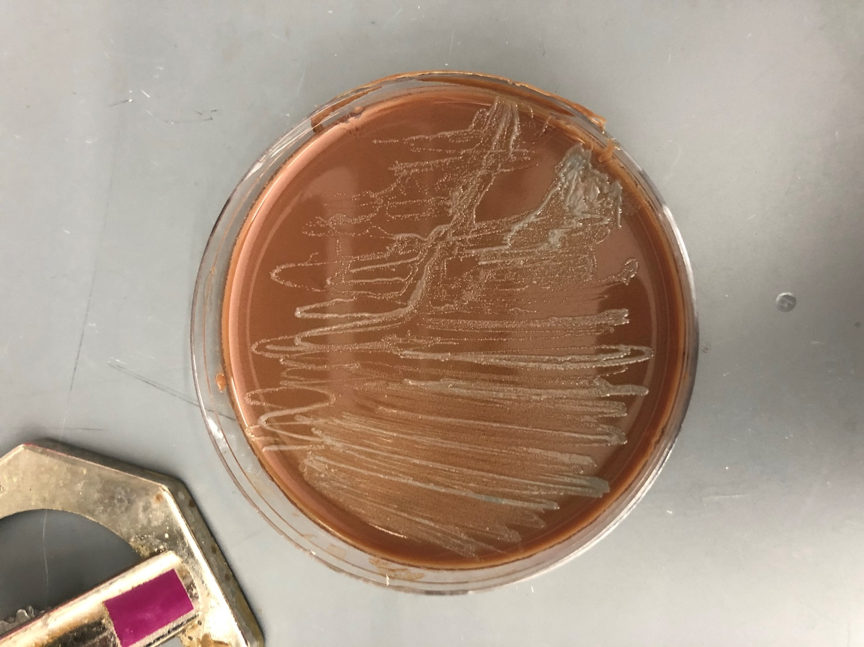

Figure 12. Picture of plate made from LVS with blue dot in colony. Light blue in areas

Tuesday, December 1, 2020
Results and Data:

Question 1. Can cells not producing lots of beta-galactosidase survive next to cells producing beta-galactosidase on plates with X-gal?
Cells not producing lots of lacZ can still survive on xgal plate despite the presence of cells with high lacz production.
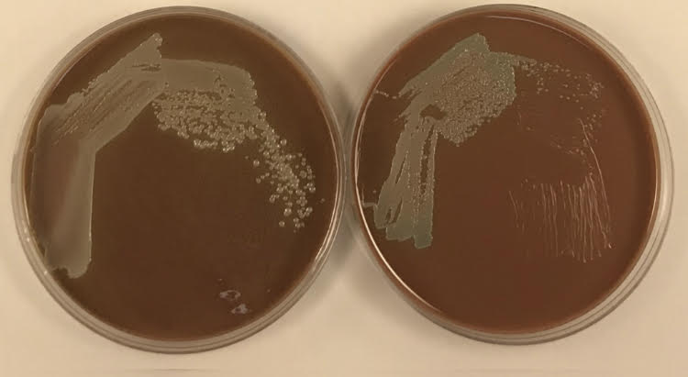

Figure 13. Cells with less lacz can survive next to those with lots. LVS and dpmrA mix on CHA (left) and CHA nat xgal (right)

Question 2. How efficient is the transformation with pSD26?
50uL plate, no cells
500uL plate, 13 colonies

TE= 11 coloniesx 80/ (1ug) = 1040 cfu/ug

Transformation efficiency (TE) equation:
TE = Colonies/µg/Dilution

Colonies = the number of colonies counted on the plate, 13
µg = the amount of DNA transformed expressed in µg, 0.2ug/uL in 5uL total = 1ug
Dilution = the total dilution of the DNA before plating, (50/4000) -> (4000/50 =x80)

Bibliography

Ramsey, K. M. and Dove, S. L. (2016) ‘ A response regulator promotes Francisella tularensis intramacrophage growth by repressing an anti-virulence factor ’, Molecular Microbiology. doi: 10.1111/mmi.13418.

