Table of Contents
September 11, 2023 4
September 12, 2023 5
Protocol for Supplemented Brain Heart Infusion Broth with Cysteine (sBHIc) 5
Reagents 5
Protocol for Receiving Primers 5
Reagents 5
September 13, 2023 6
Figure. Gel for PCR products 6
Thoughts 6
PCR Protocol (updated 7/1/19) 6
PCR Gel Protocol 8
Supplement Brain Heart Infusion Broth with Cysteine Protocol 8
September 14, 2023 9
Figure. 2nd test Gel for PCR products to create pKR187 9
Thoughts 9
PCR Protocol (updated 7/1/19) 9
PCR Gel Protocol 11
September 15, 2023 12
Measuring LVS Growth Curves in MHB and BHI Media 12
Table. Initial OD600 values of LVS cultures in MHB and BHI media. 12
Table. OD600 values of LVS cultures in MHB and BHI media after 2 hours 12
Thoughts 13
September 18, 2023 14
Test PCR Protocol (updated 7/1/19) 14
PCR Gel Protocol 16
Figure. 3rd Gel from test PCR products to create pKR187 16
Thoughts 16
Measuring LVS Growth Curves in MHB and BHI Media 16
Table. Initial OD600 values of LVS cultures in MHB and BHI media. 17
Table. OD600 values of LVS cultures in MHB and BHI media after 2 hours. 17
Table. OD600 values of LVS cultures in MHB and BHI media after 4 hours 18
Table. OD600 values of LVS cultures in MHB and BHI media after 6 hours 18
Table. OD600 values of LVS cultures in MHB and BHI media after 8 hours 18
Full PCR Protocol (updated 7/1/19) 19
Results 20
September 19, 2023 21
Measuring LVS Growth Curves in MHB and BHI Media (continued) 21
Table. OD600 values of LVS cultures in MHB and BHI media after 23 hours 21
Graph. Growth curves of OD600 values of LVS cultures in MHB and BHI media 22
Results 22
PCR Purification Protocol 22
September 20, 2023 23
PCR Gel Protocol 24
Figure. Gel testing to confirm presence of DNA fragments from PCR purification 24
Results 24
Restriction Digest Protocol 24
Figure. Restrictive enzyme digest gel (before cutting) 25
Figure. Restrictive enzyme digest gel (after cutting) 26
Results 26
September 21, 2023 27
QIAquick Gel Extraction Kit 27
Table. Nanodrop readings of the pKR187 insert and backbone. 28
Ligation 28
Transforming Chemically Competent E. coli (pKR187 Ligation) 29
Preparing Electrocompetent LVS 30
Figure. Plated ligation results for pKR187 backbone and plasmid 30
Results 31
September 22, 2023 32
Results and Data: 32
Electroporate plasmid into EC cells* 32
September 25, 2023 33
Figure. Plates of transformed LVS 33
Figure. Plates of Transformed LVS-pF 35
Results and Data 36
September 27, 2023 37
Miniprep for transformed E. Coli cells with pKR187 37
Table. Nanodrop readings of pKR187 miniprep 37
Results 37
Preparing sequencing reactions for pKR187 37
Table. Sequencing reactions for pKR187 38
September 29, 2023 39
Results and Data 39
GFP reporter assay 39
Electroporate LVS-∆2 cells with pKR187 40
October 2, 2023 41
Results and data 41
Figure. Plates from transformation of LVS with neg. controls (top row) and pKR187 (bottom row). Volumes plated were 50 uL (left column), 500 uL (middle column), and remaining culture (right column). 41
Figure. Plates from transformation of LVS DrpsU2 with neg. controls (top row) and pKR187 (bottom row). Volumes plated were 50 uL (left column), 500 uL (middle column), and remaining culture (right column). 42
Measuring LVS Growth Curves in MHB and BHI Media 43
Table. Initial OD600 values of LVS cultures in MHB and BHI media. 43
Table. OD600 values of LVS cultures in MHB and BHI media after 92 minutes. 44
Table. OD600 values of LVS cultures in MHB and BHI media after 182 minutes. 44
Table. OD600 values of LVS cultures in MHB and BHI media after 264 minutes. 44
Table. OD600 values of LVS cultures in MHB and BHI media after 356 minutes. 45
Table. OD600 values of LVS cultures in MHB and BHI media after 450 minutes. 45
GFP reporter assay 45
Table. Samples, initial OD600 values, and desired volumes to inoculate culture tubes. 46
Table. OD600 readings for GFP assay cultures at several time points. 46
Making Glycerol Stocks Protocol 47
Bibliography 48

September 11, 2023

Monday, September 11th 2023
To Do:
- Prep lab notebook, discuss scheduling
- Set up Slack Messenger Account
- Set up Notion Collaborative notebook account

September 12, 2023

Tuesday, September 12, 2023
To Do:
- Prepare Brain-Heart infusion (BHI) broth
- Supplement BHI media
- Reconstitute primers and put KROL622 and KROL623 to make working stocks

Protocol for Supplemented Brain Heart Infusion Broth with Cysteine (sBHIc)
- Combine in a 1 L bottle:
  - 18.5 g BHI
  - .5 g L-cysteine hydrochloride
- Add 480 mL type I ddiH₂O, shake to mix
- Autoclave 30’, let cool
- Store media in the dark for up to 1 month prior to adding supplements

Reagents
Brain Heart Infusion (BHI), BD Diagnostics 237500
L-cysteine hydrochloride
20% glucose (recipe below)
1 mg/mL ß-Nicotinamide Adenine Dinucleotide (ß-NAD, recipe below)
1 mg/mL heme-histidine (recipe below)
For sBHIc with 5% KCl: Potassium Chloride (KCl)

Protocol for Receiving Primers
- Spin primers at maximum speed in tabletop centrifuge for 3 minutes so desiccated primers go to the bottom of the tube.
- Add 0.1x EB to a final concentration of 100 uM. Calculate this by multiplying the reported nm by 10 and adding that volume in ul (i.e. 12.7 nmoles = add 127 uL of 0.1xEB).
- Put on 42°C heat block for 5 minutes to help primers dissolve
- Vortex and brief spin.
- Label tubes with KROL numbers on the top and put in the appropriate 100 uM stock box in the -20°C freezer.
- If a PCR primer, make a 10 uM stock by diluting 20 uL of the 100 uM stock into 180 uL of 0.1xEB. Label with purple sticker and put in appropriate freezer box.
- Put Certificate of Analysis sheet in “Oligos Spec Sheet” binder and shipping sheet in Invoices box.

Reagents
KROL622 Primer
KROL623 Primer
0.1x Elution Buffer

September 13, 2023

Wednesday, September 13, 2023
To Do:
- Supplement BHI media
- Run a test 20 uL PCR with KROL622 and KROL326, KROL623 and KROL550
- Run a test gel using KROL622 and KROL623

Data and Results

Figure. Gel for PCR products

Thoughts
Next time we run a gel for these PCR products, I will dilute the plasmid before running it through the gel. There may have also been some human errors in the PCR protocol that could be responsible for the lack of bands present in the positive control.

PCR Protocol (updated 7/1/19)
- Acquire and label PCR tubes. Be sure to include at least 1 positive and 1 negative control for each PCR experiment.
- Get a container of ice to keep the components on
- Acquire the following components and put them on ice, labeling tubes if necessary:
  - Molecular grade H2O in 1.5 mL microfuge tube
  - KOD/primestar buffer
  - dNTPs
  - oligo F (10uM)
  - oligo R (10uM)
  - template (eg. LVS gDNA, plasmid, colony, etc.)
  - Note: KOD/primestar enzyme should be kept in the freezer until it is used as it is expensive and should be added last
- Centrifuge the microfuge tubes to get any solution out of the microfuge tube cover
- If any of the solutions are frozen, be sure to vortex the microfuge tube in order to dissolve it (tubes with frozen components may not be homogenized)
  - DO NOT vortex the enzyme itself or any solution with enzyme because vortexing will expose it to oxygen and degrade it
- Use PCR_worksheet.xlsx to make establish the specifics of what will be added
  - The file is located in the Protocols folder
  - Also setup table below to specify which primers and source DNA will be used
- Add appropriate volume (based on PCR worksheet) of each experiment specific primer (forward and reverse) to PCR tubes
- Add ddi H2O to negative control tube
  - Template volume for 1 reaction
- Prepare a master-mix in a 1.5 mL microfuge tube by adding the following according to the worksheet and using micropipettes:
  - Add ddi H2O
  - Add dNTPs
  - Add KOD buffer
  - Add KOD enzyme
- Mix the master-mix solution by pipetting up and down
  - Do not vortex to mix
- Add appropriate volume of master-mix to negative control PCR tube
- Add template to Master Mix
  - Factor template volume minus 1 template reaction volume
- Add appropriate volume of master mix to each PCR tube (except negative control) and pipette up and down to mix (conserves tips)
  - * may have added dNTP to 1st reactiontube instead of master mix
- Close PCR Tubes until the caps are tight
- Place the PCR Tubes in the thermocycler on STN 1 – the following settings should be in place:
  - Heat at 94 degrees for 2 minutes,
  - 94 degrees C for 20 seconds
  - 50 degrees C for 30 seconds
  - 68 degrees C for 1 minute/kb (adjust based on expected size of product)
  - Go back to step 2
  - Repeat 32x
  - 68 degrees C for 5 minutes
  - 12 degrees C for infinity
Reaction Number | Plasmid/Region | Source DNA | Primers | Length (bps)
1 | pKR152 | same | KROL622, KROL326 | 212
2 | pKR152 | same | KROL623, KROL550 | 103
3 | + control | LVS gDNA | KROL15, KROL16 | 441
4 | - control | - | KROL622, KROL326 | -
5 | - control | - | KROL623, KROL550 | -

Master Mix | Individual Reactions
74.4 uL ddiH2O | 0.6 uL F Primer
24 uL PrimeSTAR GXL buffer | 0.6 uL R Primer
9.6 uL dNTPs | 0.4 uL Template DNA
2.4 uL PrimeSTAR GXL DNA Polymerase | 18.4 uL Master Mix

Our target plasmid to create is pKR187

PCR Gel Protocol
1. Melt 1% agarose gel at 300C and let cool in water bath to 50-55C.
2. Put the gel cast into the gel rig sideways.
3. Add 50 mL of 1% agarose gel into a flask with 5 uL SYBR safe solution, swirl the flask to mix, and then pour into the gel rig.
4. Insert a comb to mold wells in the gel.
5. Let sit until the 1% agarose – 1x SYBR safe solution has cooled and solidified into a gel.
6. Carefully remove the comb.
7. Pour 100 ml of 1x TAE buffer solution into the gel tank (add just enough to submerge the gel itself slightly).
8. Add 4 uL 6x loading dye to 20 uL PCR solutions.
9. Load 10 µL of 2x log ladder into the first well.
10. Load 15 µL of the PCR-dye mixture into the wells sequentially.
11. Insert the electrodes and run the gel at 113 volts for 30 minutes.
12. Look at the gel with the GelDoc and image in Image Lab.

Supplement Brain Heart Infusion Broth with Cysteine Protocol
- If aliquots of supplements are already made, thaw at room temperature (keeping heme-histidine away from light)
- Aseptically add:
    - 5 mL 1 mg/mL ß-NAD
    - 5 mL 1 mg/mL heme-histidine
    - 12.5 mL 20% glucose
- Use media within two weeks (9/27)

September 14, 2023

Thursday, September 14, 2023
To Do:
  - Rerun PCR
  - Rerun gel for PCR products
  - Patch a plate of LVS of F. Tularensis
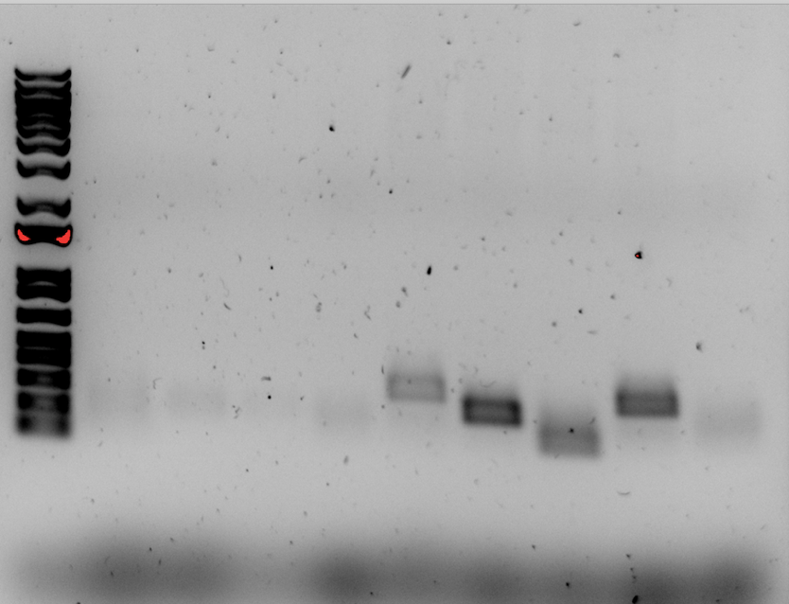

Figure. 2nd test Gel for PCR products to create pKR187

Thoughts
Significant bands did not appear in wells 1-5. We would like to redo PCR to try and get more substantial and correctly located bands. Possible errors could have occurred through pipetting water instead of dNTPs. We will redo this PCR on Monday

PCR Protocol (updated 7/1/19)
- Acquire and label PCR tubes. Be sure to include at least 1 positive and 1 negative control for each PCR experiment.
- Get a container of ice to keep the components on
- Acquire the following components and put them on ice, labeling tubes if necessary:
  - Molecular grade H2O in 1.5 mL microfuge tube
  - KOD/primestar buffer
  - dNTPs
  - oligo F (10uM)
  - oligo R (10uM)
  - template (eg. LVS gDNA, plasmid, colony, etc.)
  - Note: KOD/primestar enzyme should be kept in the freezer until it is used as it is expensive and should be added last
- Centrifuge the microfuge tubes to get any solution out of the microfuge tube cover
- If any of the solutions are frozen, be sure to vortex the microfuge tube in order to dissolve it (tubes with frozen components may not be homogenized)
  - DO NOT vortex the enzyme itself or any solution with enzyme because vortexing will expose it to oxygen and degrade it
- Use PCR_worksheet.xlsx to make establish the specifics of what will be added
  - The file is located in the Protocols folder
  - Also setup table below to specify which primers and source DNA will be used
- Add appropriate volume (based on PCR worksheet) of each experiment specific primer (forward and reverse) to PCR tubes
- Add ddi H2O to negative control tube
  - Template volume for 1 reaction
- Prepare a master-mix in a 1.5 mL microfuge tube by adding the following according to the worksheet and using micropipettes:
  - Add ddi H2O
  - Add dNTPs
  - Add KOD buffer
  - Add KOD enzyme
- Mix the master-mix solution by pipetting up and down
  - Do not vortex to mix
- Add appropriate volume of master-mix to negative control PCR tube
- Add template to Master Mix
  - Factor template volume minus 1 template reaction volume
- Add appropriate volume of master mix to each PCR tube (except negative control) and pipette up and down to mix (conserves tips)
- Close PCR Tubes until the caps are tight
- Place the PCR Tubes in the thermocycler on STN 1 – the following settings should be in place:
  - Heat at 94 degrees for 2 minutes,
  - 94 degrees C for 20 seconds
  - 50 degrees C for 30 seconds
  - 68 degrees C for 1 minute/kb (adjust based on expected size of product)
  - Go back to step 2
  - Repeat 32x
  - 68 degrees C for 5 minutes
  - 12 degrees C for infinity
Reaction Number | Plasmid/Region | Source DNA | Primers | Length (bps)
1 | pKR152 | same | KROL622, KROL326 | 212
2 | pKR152 | same | KROL623, KROL550 | 103
3 | + control | pKR152 | KROL326, KROL550 | 290
4 | - control | - | KROL550, KROL326 | -

Total reaction volume | 20
Total number of reactions | 4
 |  |  |  | Factor
Component | Stock concentration | Final concentration | 1 rxn volume | 5
ddiH2O |  |  | 12.4 | 62
PrimeSTAR GXL Buffer | 5x | 1x | 4.0 | 20
dNTPs | 2.5 mM | 0.2 mM | 1.6 | 8
oligo F | 10 uM | 0.3 uM | 0.6 | indiv
oligo R | 10 uM | 0.3 uM | 0.6 | indiv
template | 100 ng/ul | 2 ng/ul | 0.4
PrimeSTAR GXL DNA Polymerase | 1.25 U/ul | 0.025 U/ul | 0.4 | 2
 |  | Total volume | 20 | 98

Note: could have possibly mixed up water and dNTPs, also

PCR Gel Protocol
1. Melt 1% agarose gel at 300C and let cool in water bath to 50-55C.
2. Put the gel cast into the gel rig sideways.
3. Add 50 mL of 1% agarose gel into a flask with 5 uL SYBR safe solution, swirl the flask to mix, and then pour into the gel rig.
4. Insert a comb to mold wells in the gel.
5. Let sit until the 1% agarose – 1x SYBR safe solution has cooled and solidified into a gel.
6. Carefully remove the comb.
7. Pour 100 ml of 1x TAE buffer solution into the gel tank (add just enough to submerge the gel itself slightly).
8. Add 4 uL 6x loading dye to 20 uL PCR solutions.
9. Load 10 µL of 2x log ladder into the first well.
10. Load 15 µL of the PCR-dye mixture into the wells sequentially.
11. Insert the electrodes and run the gel at 113 volts for 30 minutes.
12. Look at the gel with the GelDoc and image in Image Lab.

Note: Ben accidentally loaded my reaction 2 into both the 2nd and 3rd wells

September 15, 2023

Friday, September 15, 2023
To Do:
  - Create growth curve for BHI media

Measuring LVS Growth Curves in MHB and BHI Media

1. On 9/14/23, a freezer aliquot of LVS (KRLVS120) was patched onto a plate of CHAH and
placed in the 37C incubator.
2. Today, 700 uL supplemented MHB (sMHB) was added to a sterile microfuge tube
aseptically.
3. Loopfuls of cells were scraped up from the plate and added to the microfuge tube.
4. The cells were resuspended to homogeneity using a pipette.
5. A cuvette was prepared to check OD 600 by adding 900 uL sMHB, and 100 uL
resuspended cells was added to the cuvette.
6. The OD 600 was measured. The OD 600 of resuspended cells was calculated by
multiplying the observed OD 600 by ten, and both the observed and calculated ODs
were recorded: LVS pF: 0.689 observed OD, 6.89 calculated OD
7. The volume of resuspended cells necessary to obtain a final OD 600 of 0.008 (this value
should have been 0.08) in 9 mL was calculated. LVS pF: (0.008 OD 600 )*(9,000ul)/(6.89 OD 600 ) = 10.45 uL (this volume should have been 104.5 uL)
8. 9 mL of supplemented MHB media was added to three culture tubes, and 9 mL of
supplemented BHI media was added to three other culture tubes.
9. The volume of resuspended cells necessary to obtain a final OD 600 of 0.008 (should
have been 0.08) from step 7 was used to inoculate each of the six culture tubes.
10. The culture tubes were vortexed, and 1 mL was removed from each to measure the OD:

Table. Initial OD600 values of LVS cultures in MHB and BHI media.
Sample ID | OD600 value
MHB 1 | 0.013
MHB 2 | 0.010
MHB 3 | 0.010
BHI 1 | -0.018
BHI 2 | -0.007
BHI 3 | -0.003

11. The culture tubes were incubated at 37°C shaking, starting incubation at 10:10 AM
12. The culture tubes were removed at 12:11 AM and the ODs were checked by adding .5 mL from each culture tube to a cuvetter along with 0.5 mL of ftresh media (MHB or BHI) and measuring in the spectrophotometer

Table. OD600 values of LVS cultures in MHB and BHI media after 2 hours
Sample ID | Measured OD600 | Calculated OD600
MHB 1 | 0.051 | 0.102
MHB 2 | 0.005 | 0.010
MHB 3 | 0.004 | 0.008
BHI 1 | -0.009 | 0.008
BHI 2 | -0.008 | Negative value
BHI 3 | -0.002 | Negative value

Thoughts
Since the initial calculations for inoculation were incorrect, we chose to repeat this experiment again at a later date. It is unclear why the OD600 values for BHI media were negative. Maybe the OD600 were so close to zero that the machine had trouble reading the values, or maybe, because the cells used to inoculate the cultures had been suspended in MHB media, which is lighter, the BHI media was diluted slightly

September 18, 2023

Monday, September 18, 2023
To Do:
  - Gather data for growth curve for BHI and MHB media
  - Run test PCR
  - Run test gel
  - Run full PCR

Test PCR Protocol (updated 7/1/19)
- Acquire and label PCR tubes. Be sure to include at least 1 positive and 1 negative control for each PCR experiment.
- Get a container of ice to keep the components on
- Acquire the following components and put them on ice, labeling tubes if necessary:
  - Molecular grade H2O in 1.5 mL microfuge tube
  - KOD/primestar buffer
  - dNTPs
  - oligo F (10uM)
  - oligo R (10uM)
  - template (eg. LVS gDNA, plasmid, colony, etc.)
  - Note: KOD/primestar enzyme should be kept in the freezer until it is used as it is expensive and should be added last
- Centrifuge the microfuge tubes to get any solution out of the microfuge tube cover
- If any of the solutions are frozen, be sure to vortex the microfuge tube in order to dissolve it (tubes with frozen components may not be homogenized)
  - DO NOT vortex the enzyme itself or any solution with enzyme because vortexing will expose it to oxygen and degrade it
- Use PCR_worksheet.xlsx to make establish the specifics of what will be added
  - The file is located in the Protocols folder
  - Also setup table below to specify which primers and source DNA will be used
- Add appropriate volume (based on PCR worksheet) of each experiment specific primer (forward and reverse) to PCR tubes
- Add ddi H2O to negative control tube
  - Template volume for 1 reaction
- Prepare a master-mix in a 1.5 mL microfuge tube by adding the following according to the worksheet and using micropipettes:
  - Add ddi H2O
  - Add dNTPs
  - Add KOD buffer
  - Add KOD enzyme
- Mix the master-mix solution by pipetting up and down
  - Do not vortex to mix
- Add appropriate volume of master-mix to negative control PCR tube
- Add template to Master Mix
  - Factor template volume minus 1 template reaction volume
- Add appropriate volume of master mix to each PCR tube (except negative control) and pipette up and down to mix (conserves tips)
  - Accidentally added plasmid to negative control
- Close PCR Tubes until the caps are tight
- Place the PCR Tubes in the thermocycler on STN 1 – the following settings should be in place:
  - Heat at 94 degrees for 2 minutes,
  - 94 degrees C for 20 seconds
  - 50 degrees C for 30 seconds
  - 68 degrees C for 1 minute/kb (adjust based on expected size of product)
  - Go back to step 2
  - Repeat 32x
  - 68 degrees C for 5 minutes
  - 12 degrees C for infinity
Reaction Number | Plasmid/Region | Source DNA | Primers | Length (bps)
1 | pKR152 | same | KROL622, KROL326 | 212
2 | pKR152 | same | KROL623, KROL550 | 103
3 | + control | pKR152 | KROL326, KROL550 | 290
4 | - control | - | KROL550, KROL326 | -

Total reaction volume | 20
Total number of reactions | 4
 |  |  |  | Factor
Component | Stock concentration | Final concentration | 1 rxn volume | 5
ddiH2O |  |  | 12.4 | 62
PrimeSTAR GXL Buffer | 5x | 1x | 4.0 | 20
dNTPs | 2.5 mM | 0.2 mM | 1.6 | 8
oligo F | 10 uM | 0.3 uM | 0.6 | indiv
oligo R | 10 uM | 0.3 uM | 0.6 | indiv
template | 100 ng/ul | 2 ng/ul | 0.4
PrimeSTAR GXL DNA Polymerase | 1.25 U/ul | 0.025 U/ul | 0.4 | 2
 |  | Total volume | 20 | 98

Note:

PCR Gel Protocol
1. Melt 1% agarose gel at 300C and let cool in water bath to 50-55C.
2. Put the gel cast into the gel rig sideways.
3. Add 50 mL of 1% agarose gel into a flask with 5 uL SYBR safe solution, swirl the flask to mix, and then pour into the gel rig.
4. Insert a comb to mold wells in the gel.
5. Let sit until the 1% agarose – 1x SYBR safe solution has cooled and solidified into a gel.
6. Carefully remove the comb.
7. Pour 100 ml of 1x TAE buffer solution into the gel tank (add just enough to submerge the gel itself slightly).
8. Add 4 uL 6x loading dye to 20 uL PCR solutions.
9. Load 10 µL of 2x log ladder into the first well.
10. Load 15 µL of the PCR-dye mixture into the wells sequentially.
Note: 2nd well (reaction 1) didn’t have a full 15 uL. Next time centrifuge the reactions to ensure we have at least 15 uL
11. Insert the electrodes and run the gel at 113 volts for 30 minutes.
12. Look at the gel with the GelDoc and image in Image Lab.

Figure. 3rd Gel from test PCR products to create pKR187

Thoughts
Bands appear at around 212 bps for well 1, 103 bps for well 2 and 290 bps for well 3. These length values correspond to the expected values for each desired fragment amplified in the PCR, so we are going to go ahead and perform a full 100 uL PCR today to get these same products.

Measuring LVS Growth Curves in MHB and BHI Media
1. On 9/16/23, a freezer aliquot of LVS (KRLVS120) was patched onto a plate of CHAH and
the plate was placed on the benchtop at room temperature.
2. Today, 700 uL supplemented MHB (sMHB) was added to a sterile microfuge tube
aseptically.
3. Loopfuls of cells were scraped up from the plate and added to the microfuge tube.
4. The cells were resuspended to homogeneity using a pipette.
5. A cuvette was prepared to check OD 600 by adding 900 uL sMHB, and 100 uL
resuspended cells was added to the cuvette.
6. The OD 600 was measured. The OD 600 of resuspended cells was calculated by
multiplying the observed OD 600 by ten, and both the observed and calculated ODs
were recorded:
LVS pF: 0.855 observed OD, 8.55 calculated OD
7. The volume of resuspended cells necessary to obtain a final OD 600 of 0.08 in 9 mL was
calculated.
LVS pF: (0.08 OD 600 )*(9,000ul)/(8.55 OD 600) = 84.2 uL
8. 9 mL of supplemented MHB media was added to three culture tubes, and 9 mL of
supplemented BHI media was added to three other culture tubes.
9. The volume of resuspended cells (84.2 uL) necessary to obtain a final OD 600 of 0.08
from step 7 was used to inoculate each of the six culture tubes.
10. The culture tubes were vortexed, and 1 mL was removed from each to measure the OD:

Table. Initial OD600 values of LVS cultures in MHB and BHI media.

Sample ID | OD600
MHB 1 | 0.079
MHB 2 | 0.081
MHB 3 | 0.078
BHI 1 | 0.082
BHI 2 | 0.089
BHI 3 | 0.081

11. The culture tubes were incubated at 37°C shaking, starting incubation at 10 AM.
12. The culture tubes were removed and the ODs were checked at 12:20 PM by adding 0.5
mL from each culture tube to a cuvette along with 0.5 mL of fresh media (MHB or BHI)
and reading in the spectrophotometer. The measured OD600 values were multiplied by
two to obtain the calculated OD600 values.

Table. OD600 values of LVS cultures in MHB and BHI media after 2 hours.
Sample ID | Measured OD600 | Calculated OD600
MHB 1 | 0.096 | 0.192
MHB 2 | 0.096 | 0.192
MHB 3 | 0.096 | 0.192
BHI 1 | 0.105 | 0.210
BHI 2 | 0.108 | 0.216
BHI 3 | 0.114 | 0.228

13. The culture tubes were removed and the ODs were checked at 2:20 PM by adding 0.5
mL from each culture tube to a cuvette along with 0.5 mL of fresh media (MHB or BHI)
and reading in the spectrophotometer. The measured OD600 values were multiplied by
two to obtain the calculated OD600 values.

Table. OD600 values of LVS cultures in MHB and BHI media after 4 hours
Sample ID | Measured OD600 | Calculated OD600
MHB 1 | 0.160 | 0.320
MHB 2 | 0.175 | 0.350
MHB 3 | 0.160 | 0.320
BHI 1 | 0.231 | 0.462
BHI 2 | 0.224 | 0.448
BHI 3 | 0.222 | 0.444

- The culture tubes were removed and the ODs were checked at 4:20 PM by adding 0.5
mL from each culture tube to a cuvette along with 0.5 mL of fresh media (MHB or BHI)
and reading in the spectrophotometer. The measured OD600 values were multiplied by
two to obtain the calculated OD600 values.

Table. OD600 values of LVS cultures in MHB and BHI media after 6 hours
Sample ID | Measured OD600 | Calculated OD600
MHB 1 | 0.249 | 0.498
MHB 2 | 0.257 | 0.514
MHB 3 | 0.246 | 0.492
BHI 1 | 0.419 | 0.838
BHI 2 | 0.418 | 0.836
BHI 3 | 0.415 | 0.830
- The culture tubes were removed and the ODs were checked at 5:50 PM by adding 0.5
mL from each culture tube to a cuvette along with 0.5 mL of fresh media (MHB or BHI)
and reading in the spectrophotometer. The measured OD600 values were multiplied by
two to obtain the calculated OD600 values.

Table. OD600 values of LVS cultures in MHB and BHI media after 8 hours
Sample ID | Measured OD600 | Calculated OD600
MHB 1 | 0.148 | 0.740
MHB 2 | 0.143 | 0.715
MHB 3 | 0.134 | 0.670
BHI 1 | 0.268 | 1.340
BHI 2 | 0.270 | 1.350
BHI 3 | 0.277 | 1.385

Full PCR Protocol (updated 7/1/19)
- Acquire and label PCR tubes. Be sure to include at least 1 positive and 1 negative control for each PCR experiment.
- Get a container of ice to keep the components on
- Acquire the following components and put them on ice, labeling tubes if necessary:
  - Molecular grade H2O in 1.5 mL microfuge tube
  - KOD/primestar buffer
  - dNTPs
  - oligo F (10uM)
  - oligo R (10uM)
  - template (eg. LVS gDNA, plasmid, colony, etc.)
  - Note: KOD/primestar enzyme should be kept in the freezer until it is used as it is expensive and should be added last
- Centrifuge the microfuge tubes to get any solution out of the microfuge tube cover
- If any of the solutions are frozen, be sure to vortex the microfuge tube in order to dissolve it (tubes with frozen components may not be homogenized)
  - DO NOT vortex the enzyme itself or any solution with enzyme because vortexing will expose it to oxygen and degrade it
- Use PCR_worksheet.xlsx to make establish the specifics of what will be added
  - The file is located in the Protocols folder
  - Also setup table below to specify which primers and source DNA will be used
- Add appropriate volume (based on PCR worksheet) of each experiment specific primer (forward and reverse) to PCR tubes
- Add ddi H2O to negative control tube
  - Template volume for 1 reaction
- Prepare a master-mix in a 1.5 mL microfuge tube by adding the following according to the worksheet and using micropipettes:
  - Add ddi H2O
  - Add dNTPs
  - Add KOD buffer
  - Add KOD enzyme
- Mix the master-mix solution by pipetting up and down
  - Do not vortex to mix
- Add appropriate volume of master-mix to negative control PCR tube
- Add template to Master Mix
  - Factor template volume minus 1 template reaction volume
- Add appropriate volume of master mix to each PCR tube (except negative control) and pipette up and down to mix (conserves tips)
  - Accidentally added plasmid to negative control
- Close PCR Tubes until the caps are tight
- Quickly centrifuge tubes
- Place the PCR Tubes in the thermocycler on STN 1 – the following settings should be in place:
  - Heat at 94 degrees for 2 minutes,
  - 94 degrees C for 20 seconds
  - 50 degrees C for 30 seconds
  - 68 degrees C for 1 minute/kb (adjust based on expected size of product)
  - Go back to step 2
  - Repeat 32x
  - 68 degrees C for 5 minutes
  - 12 degrees C for infinity
Reaction Number | Plasmid/Region | Source DNA | Primers | Length (bps)
1 | pKR152 | same | KROL622, KROL326 | 212
2 | pKR152 | same | KROL623, KROL550 | 103
3 | + control | pKR152 | KROL326, KROL550 | 290
4 | - control | - | KROL550, KROL326 | -

Total reaction volume | 100
Total number of reactions | 4
 |  |  |  | Factor
Component | Stock concentration | Final concentration | 1 rxn volume | 5
ddiH2O |  |  | 62.0 | 310
PrimeSTAR GXL Buffer | 5x | 1x | 20.0 | 100
dNTPs | 2.5 mM | 0.2 mM | 8.0 | 40
oligo F | 10 uM | 0.3 uM | 3.0 | 15
oligo R | 10 uM | 0.3 uM | 3.0 | 15
template | 100 ng/ul | 2 ng/ul | 2.0
PrimeSTAR GXL DNA Polymerase | 1.25 U/ul | 0.025 U/ul | 2.0 | 10
 |  | Total volume | 100 | 490

Results
After PCR, I placed my reaction tubes into the -20°C freezer for use in PCR purification tomorrow.

September 19, 2023

Tuesday, September 19, 2023
To Do:
  - Finalize growth curve and measurements for BHI and MHB media
  - Purify PCR Fragments

Measuring LVS Growth Curves in MHB and BHI Media (continued)
1. The culture tubes were removed and the ODs were checked at 9:20 AM by adding 0.1 mL from each culture tube to a cuvette along with 0.9 mL of fresh media (MHB or BHI) and reading in the spectrophotometer. The measured OD600 values were multiplied by ten to obtain the calculated OD600 values

Table. OD600 values of LVS cultures in MHB and BHI media after 23 hours
Sample ID | Measured OD600 | Calculated OD600
MHB 1 | 0.230 | 2.300
MHB 2 | 0.231 | 2.310
MHB 3 | 0.231 | 2.310
BHI 1 | 0.482 | 4.820
BHI 2 | 0.501 | 5.010
BHI 3 | 0.525 | 5.250

Graph. Growth curves of OD600 values of LVS cultures in MHB and BHI media

Results
According to our calculated growth curves, it seems as though LVS grown in the BHI media reaches an optimal optical density quicker than LVS grown in MHB media. This can be useful for collecting more live cells in log-phase

PCR Purification Protocol
All centrifugation steps are carried out at 17,900 x g (13,000 rpm) in a conventional table-top microcentrifuge at room temperature.
- Add 5 volumes Buffer PB to 1 volume of the PCR reaction and mix. If the color of the mixture is orange or violet, add 10 µl 3 M sodium acetate, pH 5.0, and mix. The color of the mixture will turn yellow.
- Place a QIAquick column in a provided 2 ml collection tube or into a vacuum manifold. For details on how to set up a vacuum manifold, refer to the QIAquick Spin Handbook.
- To bind DNA, apply the sample to the QIAquick column and centrifuge for 30–60 s or apply vacuum to the manifold until all the samples have passed through the column. Discard flow-through and place the QIAquick column back in the same tube.
- To wash, add 750 µl Buffer PE to the QIAquick column, centrifuge for 30–60 s or apply vacuum. Discard flow-through and place the QIAquick column back into the same tube.
- Centrifuge the QIAquick column once more in the provided 2 ml collection tube for 1 min to remove residual wash buffer.
- Place each QIAquick column in a clean 1.5 ml microcentrifuge tube.
- To elute DNA, add 50 µl Buffer EB (10 mM Tris·Cl, pH 8.5) or water (pH 7.0–8.5) to the center of the QIAquick membrane and centrifuge the column for 1 min. For increased DNA concentration, add 30 µl elution buffer to the center of the QIAquick membrane, let the column stand for 1 min and then centrifuge.

September 20, 2023

Wednesday, September 20, 2023
To Do:
  - Run gel to test presence of PCR products from PCR purification
  - Perform restriction digest on PCR products
  - Perform gel purification

PCR Gel Protocol
1. Melt 1% agarose gel at 300C and let cool in water bath to 50-55C.
2. Put the gel cast into the gel rig sideways.
3. Add 50 mL of 1% agarose gel into a flask with 5 uL SYBR safe solution, swirl the flask to mix, and then pour into the gel rig.
4. Insert a comb to mold wells in the gel.
5. Let sit until the 1% agarose – 1x SYBR safe solution has cooled and solidified into a gel.
6. Carefully remove the comb.
7. Pour 100 ml of 1x TAE buffer solution into the gel tank (add just enough to submerge the gel itself slightly).
8. Add 4 uL 6x loading dye to 20 uL PCR solutions.
9. Load 10 µL of 2x log ladder into the first well.
10. Load 15 µL of the PCR-dye mixture into the wells sequentially.
11. Insert the electrodes and run the gel at 113 volts for 30 minutes.
12. Look at the gel with the GelDoc and image in Image Lab.

Figure. Gel testing to confirm presence of DNA fragments from PCR purification

Results
Based on the fragment lengths of about 200 bp in well 1 and approximately 100 bp in well 2, our PCR purification for the two DNA fragments needed to create pKR187 was successful. Using these purified fragments, we will perform a restriction enzyme digest next.

Restriction Digest Protocol
1. Make a reaction table with desired digests
Tube | DNA | Enzyme(s) | DNA Volume (uL) | H₂O Volume (uL)
1 | Purified PCR | KpnI, NotI | 15 | -
2 | Backbone (pKR145) | KpnI, NotI | 5 | 10

2. Set up master mix table
 | Number of samples | 2
 | Master mix factor | 3
Components | Volumes in 1 reaction (uL) | Volumes in Master Mix (uL)
H₂O | 10.8 | 32.4
10x Buffer* | 3 | 9
DNA | (15)
Enzyme 1 | 0.6 | 1.8
Enzyme 2 | 0.6 | 1.8
Total | - (15.0 actual b/c of DNA) | 45

3. Add indicated amounts of H₂O and 10x buffer to master mix tube (MM).
  - Add indicated amount of DNA or DNA+water (for backbone tubes) to individual tubes for digest (1.5 mL microfuge tubes for digests in incubator, PCR strip tubes for reactions incubated in the thermocycler).
  - Add indicated amount of each enzyme (1.8 uL) to the master mix tube (MM).
  - Mix the master mix by pipetting up and down.
  - Add master mix to individual tubes. Volume to add to each tube is the volume in 1 reaction minus the DNA volume (15 ul).
  - Incubate at 37°C for 1 hour or up to overnight.
    - Incubated for 1.5 hours
  - If using digest for plasmid construction then after incubation at 37°C, add 0.5ul of CIP enzyme to backbone tube, mix by pipetting and put back in37°C incubator for 10 minutes. (this step removes the phosphates from the ends of the plasmid to prevent re-ligation). If using the new Quick CIP – add 1 uL, mix, incubate for 10 mins, then put at 80C for 2 minutes to inactivate the CIP.
  - Prepare gel (refer to PCR gel protocol above)
  - Load 10 µL ladder
  - Add 6 µL dye into 30 µL reaction and load into gel, leaving space between samples
  - Run digests on gel at 113V
  - Image gel, cut out bands, and image a second time

Figure. Restrictive enzyme digest gel (before cutting)

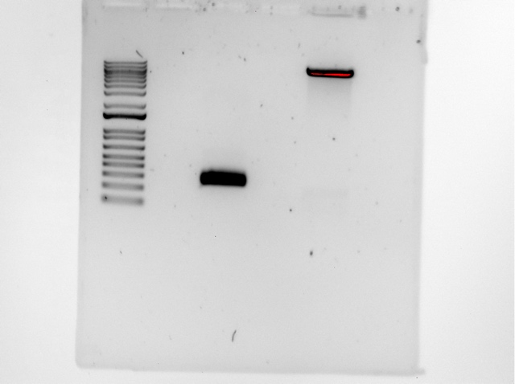

Figure. Restrictive enzyme digest gel (after cutting)
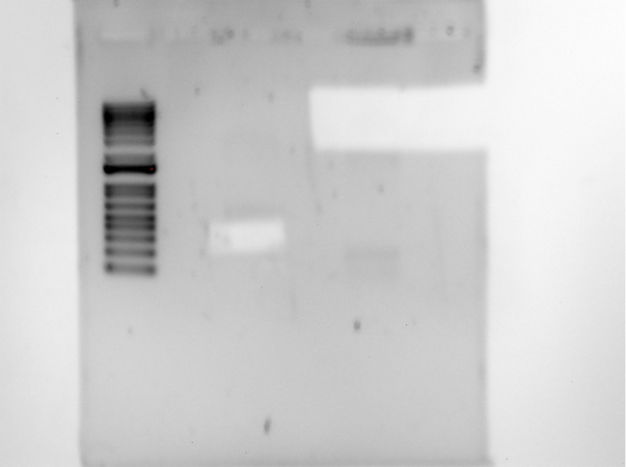

Results
When we observed the bands present in our restrictive enzyme digest gel, the band in well 1 had an approximate bp length corresponding to the purified PCR fragment we wished to digest. The band in well 2 corresponded to the approximate size of our backbone plasmid pKR145. We cut these bands out of the gel and will perform gel purification on them tomorrow.

September 21, 2023

Thursday, September 21, 2023
To Do:
  - Perform gel purification
  - Perform pKR187 ligation
  - Create electrocompetent LVS cells
  - Transform pKR187 into E. Coli K12

QIAquick Gel Extraction Kit
- All centrifugation steps are carried out at 17,900 x g (13,000 rpm) in a conventional table-top microcentrifuge.
- Excise the DNA fragment from the agarose gel with a clean, sharp scalpel.
- Weigh the gel slice in a colorless tube. Add 3 volumes Buffer QG to 1 volume gel (100 mg gel ~100 μl). The maximum amount of gel per spin column is 400 mg. For >2% agarose gels, add 6 volumes Buffer QG.
 | Gel Weight (mg) | Gel Volume (uL) | Buffer Volume (uL)
PCR product FTL0215 UTR | 580 | 580 | 1,740
pKR145 Backbone | 810 | 810 | 2,430
- Incubate at 50°C for 10 min (or until the gel slice has completely dissolved). Vortex the tube every 2–3 min to help dissolve gel. After the gel slice has dissolved completely, check that the color of the mixture is yellow (similar to Buffer QG without dissolved agarose). If the color of the mixture is orange or violet, add 10 μl 3 M sodium acetate, pH 5.0, and mix. The mixture turns yellow.
- Add 1 gel volume isopropanol to the sample and mix.
- Place a QIAquick spin column in a provided 2 ml collection tube or into a vacuum manifold. To bind DNA, apply the sample to the QIAquick column and centrifuge for 1 min or apply vacuum to the manifold until all the samples have passed through the column. Columns have a max of agarose they can handle, so you might have to split in two. Discard flow-through and place the QIAquick column back into the same tube. For sample volumes >800 μl, load and spin/apply vacuum again.
- If DNA will subsequently be used for sequencing, in vitro transcription, or microinjection, add 500 μl Buffer QG to the QIAquick column and centrifuge for 1 min or apply vacuum. Discard flow-through and place the QIAquick column back into the same tube. (Repeated this step one more time to get rid of residual agarose.)
- To wash, add 750 μl Buffer PE to QIAquick column and centrifuge for 1 min or apply vacuum. Discard flow-through and place the QIAquick column back into the same tube. (Repeated this step one more time.)
  - Note: If the DNA will be used for salt-sensitive applications (e.g., sequencing, bluntended ligation), let the column stand 2–5 min after addition of Buffer PE.
  - Centrifuge the QIAquick column in the provided 2 ml collection tube for 1 3 min to remove residual wash buffer.
- Place QIAquick column into a clean 1.5 ml microcentrifuge tube.
- To elute DNA, add 50 μl Buffer 0.1X EB (10 mM Tris·Cl, pH 8.5) or water to the center of the QIAquick membrane and centrifuge the column for 1 min. For increased DNA concentration, add 30 μl Buffer EB to the center of the QIAquick membrane, let the column stand for 1 min, and then centrifuge for 1 min. After the addition of Buffer 0.1X EB to the QIAquick membrane, increasing the incubation time to up to 4 min can increase the yield of purified DNA.
- If purified DNA is to be analyzed on a gel, add 1 volume of Loading Dye to 5 volumes of purified DNA. Mix the solution by pipetting up and down before loading the gel.
Took Nanodrop readings of the insert and backbone and stored them in Jake Grecco’s box in the -20C freezer.

Table. Nanodrop readings of the pKR187 insert and backbone.
Sample ID | ng/µl | A260 (Abs)
pKR187_insert | 37.9 | 0.757
pKR187_backbone | 22.4 | 0.449

Ligation
- Make a reaction table with desired ligations. Always include a backbone only control for each plasmid backbone used.
Tube | Product ID | Insert | Backbone
1 | pKR187 | KpnI, NotI digested, purified PCR | KpnI, NotI digested, purified pKR145
2 | Control (backbone only) | - | KpnI, NotI digested, purified pKR145
- Set up master mix tables:
Component | Reaction 1 (uL) | Reaction 2 (uL) | Master Mix (3x)
H₂O | 11.5 | 11.5 | 34.5
10x ligase buffer | 2.0 | 2.0 | 6
Insert | 4.0 | - | -
Backbone | 2.0 | 2.0 | 6
Ligase | 0.5 | 0.5 | 1.5
TOTAL | 20.0 | 20.0 | 48
- Obtain ice to assemble and keep the reactions on. This is important, as the reaction happens at 16C and the ligase buffer (which contains ATP) needs to be kept cold in order to avoid degradation. Bring over a 10 uL aliquot of 10X ligase buffer from the miscellaneous buffers box in the -20C with a cooler.
- Obtain and label PCR tubes for the reactions. Be sure to include the date and your initials.
- To the individual tubes, add indicated amounts of H2O, 10x buffer (2.0 uL), insert, and backbone.
- Add indicated amount of ligase (0.5 uL) to the individual tubes. Remember to keep the ligase in a mini cooler.
- Added insert DNA to reaction 1 and water to reaction 2.
- Made Master Mix with required amounts of water, ligase buffer, backbone, and T4 ligase and pipetted gently up and down.
- Transferred 16 uL Master Mix to each PCR tube and pipetted gently up and down.
- Place in the thermocycler or water bath overnight at 16C. Can do at room temp for 10 minutes if necessary, then place back on ice.
- Store at -20C.

Transforming Chemically Competent E. coli (pKR187 Ligation)
- Set up reaction table. Always include a positive and negative control for each antibiotic. If transforming plasmids (from previous plasmid prep), use 0.5 – 1 uL of plasmid. If transforming ligations, use 8 uL per ligation. If transforming plasmid, plate 20 uL,100 uL, and remaining volume. If transforming a ligation, plate 100 uL and remaining culture.
  - Note: The plasmid used for the positive control plates should be the regular circular plasmid, not the digest/purified one.
  - There should always be a backbone control if testing a ligation. This is the digested and ligated backbone with NO INSERT.
Tube number | Purpose | DNA | Volume of DNA | Final volume to plate | Number of carbenicillin-containing plates
1 | Plasmid with six nucleotide mutation in FTL0215 UTR | pKR187 | 8 uL | 20 uL, 200 uL | 2
2 | Backbone Ligation | pKR145 (digested) | 8 uL | 20 uL, 200 uL | 2
3 | (+) control | pKR144 | 1 uL | 100 ul | 1
4 | (-) control | None | 0 uL | 100 ul | 1
Total number of plates |  |  |  |  | 6
- Check to be sure you have enough LB plates with appropriate antibiotic. If plates were stored at 4°C, warm at 37°C until needed.
- Obtain ice. Label sterile tubes according to table and place on ice.
- Obtain DNA and thaw on ice if necessary.
- Thaw appropriate number of competent cell tubes on ice (5 reactions per tube of competent cells).
- Add indicated volume of DNA to respective tubes on ice.
- When competent cells are thawed (check by probing for frozen cells using a sterile pipette tip), gently pipette 100 uL of cells into each reaction tube directly onto DNA using aseptic technique.
- Incubate cells on ice for 20 minutes. During incubation set heat block to 42°C.
- Place tubes with cells and DNA onto 42°C heat block for 30 seconds (heat shock step).
- After heat shock, place tubes back on ice until next step (don’t keep them here too long).
- Using aseptic technique, add 1 mL LB (no antibiotic) to each microfuge tube.
- Using autoclave tape, tape microfuge tubes down in shaking incubator set to 37°C. Allow cells to recover for 1 hour at 37°C, shaking.
- Place in a rack after shaking (NOT back on ice).
- Using aseptic technique, plate indicated amount of cells on appropriate antibiotic plates (LB-Carb), spreading until plates look dry. For “remaining” volume, spin tubes at max speed in benchtop centrifuge for 30 seconds. Remove 800 uL of media. Using 200 uL pipette, resuspend cells at bottom of tube and plate all the remaining culture.

Preparing Electrocompetent LVS
From Allelic exchange protocol; Edited by Hannah Trautmann
- Scrape up entire plate of cells into 400 uL of sterile 10% sucrose and resuspend (alternately, cells can be grown to mid-log in MHB)
- Add 1.1 mL of 10% sucrose to a final volume of 1.5 mL
- Spin for 3 minutes at 10,000 rpm
- remove supernatant, throw out, and resuspend in fresh 1 mL 10% sucrose
- Repeat 3x-5x in 10% sucrose (I repeated this a total of three times.)
- After final spin, remove all supernatant.
- Resuspend cells in 10% sucrose at high density (corresponding to ~1x10¹¹ cells /mL); by slowly adding 110 uL at a time. It should be about equal amounts of cells as sucrose. (I added 110 uL twice, so there should be four electroporations.)
- For any extra EC cells, aliquot ~110 μL / sterile tube (enough for 2 electroporations) and freeze at -80°C

Figure. Plated ligation results for pKR187 backbone and plasmid
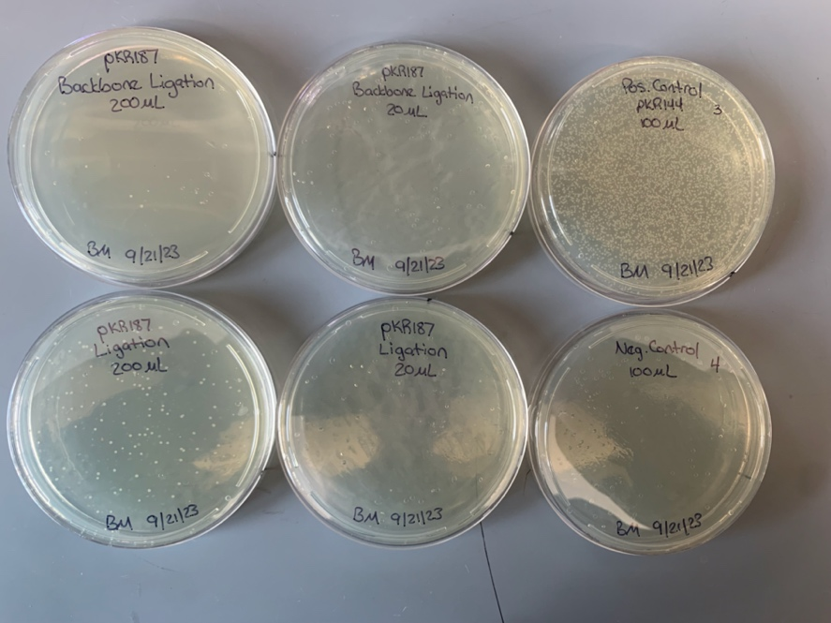

Results
Basing off of the dilution ratio after counting colonies, our different concentrations of both our backbone and our pKR187 ligation seem to be in accordance to how dilute they are. Also, with a colony count of about 200 in the pKR187 ligation and a count of about 10 in the backbone ligation, our results support the idea that the pKR187 plasmid has been ligated successfully. We now plan on electroporating the pKR187 plasmid from these E. coli cells into electrocompetent LVS cells.

September 22, 2023

Friday, September 22, 2023
To Do:
  - Make overnight cultures for pKR187
  - Electroporate LVS and plate
  - Streak out tul4 control +/- bS21-2 and 0215 UTR +/- bS21-2 to single colonies

Results and Data:
We added 5 mL LB to six separate culture tubes along with 5 uL 100 mg/mL Carbenicillin and
then inoculated the tubes with colonies from the 200 uL pKR187 Ligation plate. The tubes were
placed in the 37C shaking incubator.

Electroporate plasmid into EC cells*
1. For each electroporation, aliquot 4 mL MHB into glass test tubes for recovery, warm in shaker
at 37°C
2. For each electroporation, in a 2 mm sterile electroporation cuvette, combine:
a. 5 μL of pEX-based allelic exchange construct or Tn7 plasmids (mini-prep concentration,
at least 100 ng/μL)
b.*for pF-based plasmids, can use 3 ul 50 μL electrocompetent cells
3. Have recovery media ready
4. Electroporate using the following settings: 2.5 kV, 25 μF, and 600 Ω
5. Immediately after individual electroporations, use 1 mL warm recovery media from test tube to
wash cells out of cuvette and transfer cells to recovery test tube
6. Recover cells for 4-8 hours, shaking at 37°C
a. *For pF-based plasmids, only recover 2-3 hours (recovered for 2.5 hours)
7. For pEX plasmids: pellet cells by centrifugation in sterile 2 mL tubes, 1’ at 10,000 x g. Plate on
CHAH-Kan plates, using 1 plate for each 2 mL tube (2 plates per electroporation)
a. *For pF-plasmids: plate 10 ul and 100 ul on CHAH-kan plates
b. *For Tn7 plasmids: plate 100 ul and remaining on CHAH-kan plates
8. Incubate plates at 37°C for 3 days (or until single colonies appear)

*Always include a control electroporation with no plasmid. Eventually single break-through colonies may
start appearing; at that point, single colonies on the experimental plates are also likely to just be break-
through growth.

We streaked out tul4 control +/- bS21-2 (KRLVS180 and 182) and 0215 UTR +/- bS21-2
(KRLVS190 and 191) to single colonies on CHAH-Kan plates and put the plates in the 37C
incubator.

September 25, 2023

Monday, September 25, 2023
To Do:
  - Check transformation plates
  - Check tul4 +/- bS21-2 plates and 0215 UTR +/- bS21-2 plates

Figure. Plates of transformed LVS
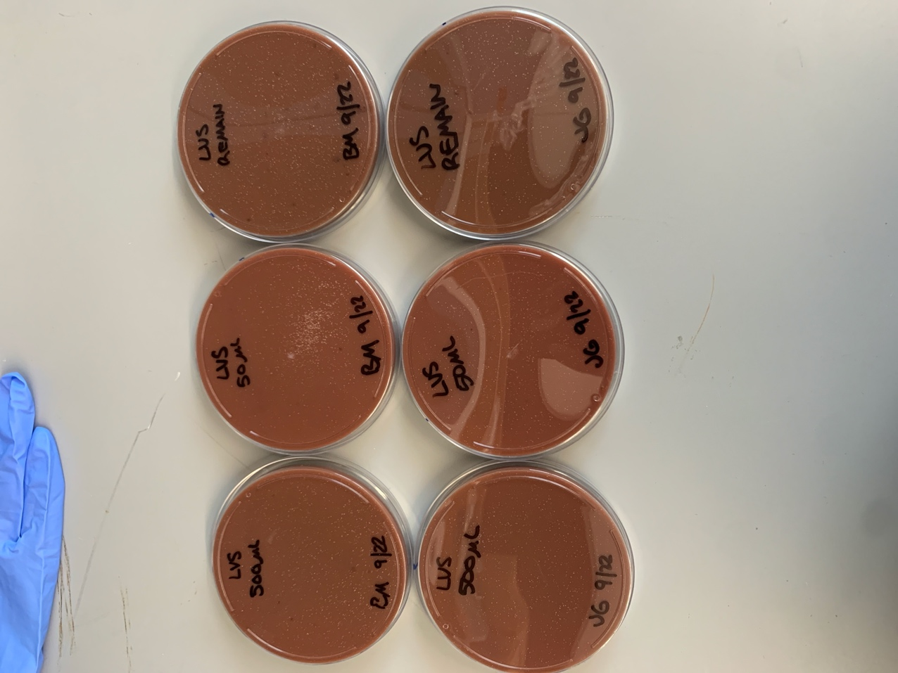
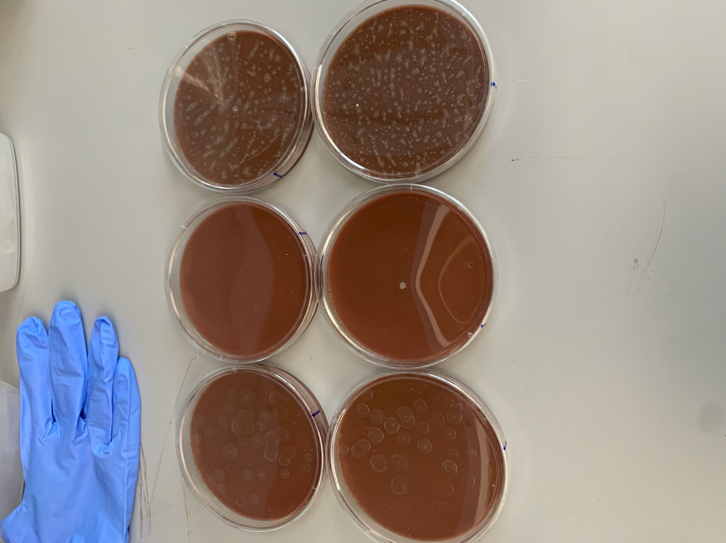

Figure. Plates of Transformed LVS-pF
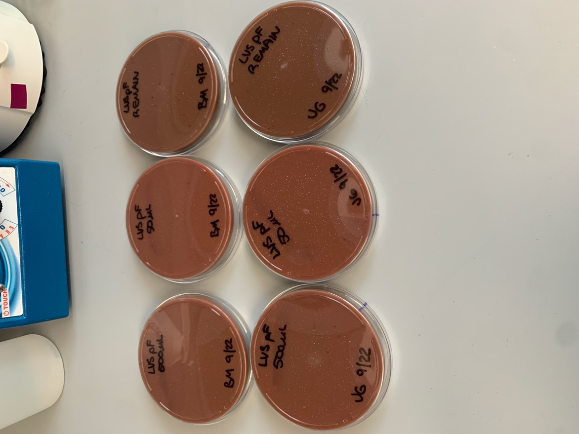
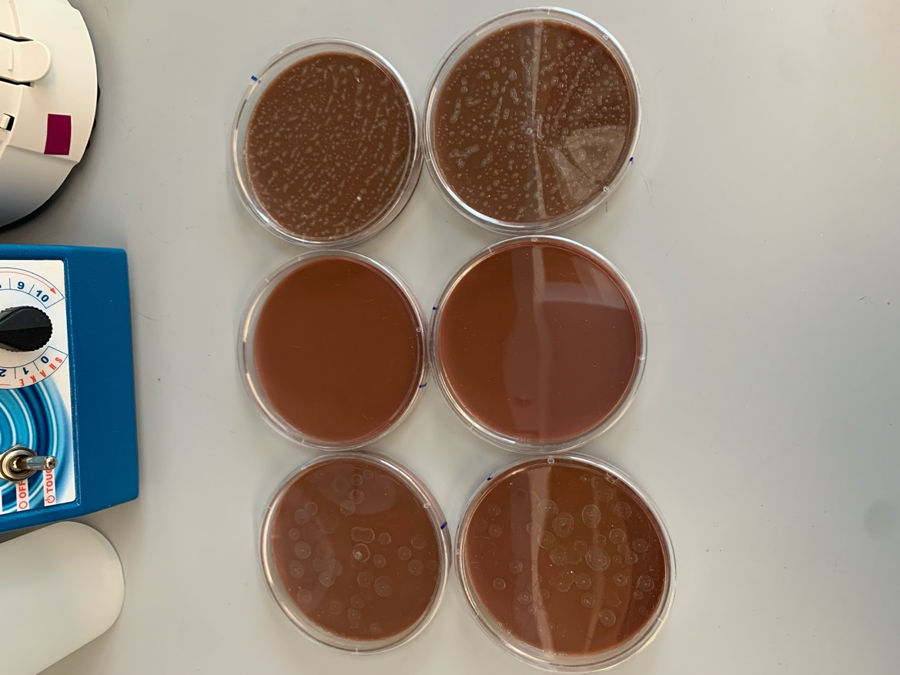

Results and Data
When plating, we accidentally plated LVS-pF on the plates that were supposed to only be LVS, which already contains the plasmid. This explains the growth seen on the LVS-only plates. For the streak plates of tul4 +/- bS21-2 and 0215 UTR +/- bS21-2, no significant isolated colonies were seen. We will re-streak these plates and incubate them for a longer period of time.

September 27, 2023

Wednesday, September 27, 2023
To Do:
  - Perform miniprep on transformed E. Coli cells
  - Prepare DNA for sequencing

Miniprep for transformed E. Coli cells with pKR187
- Resuspended pellets with 250 mL Buffer P1.
- Added 250 uL Buffer P2 and mixed thoroughly by inverting the tube 4-6 times until the solution was more translucent.
- Added 350 uL Buffer N3 and mixed immediately and thoroughly by inverting tube 4-6 times.
- Centrifuged for 10 min at 13,000 rpm.
- Applied 800 uL of supernatant from previous step to QIAprep 2.0 spin column by pipetting and centrifuged for 1 min at 13,000 rpm. Discarded the flow-through.
- Washed the QIAprep 2.0 spin column by adding 0.5 mL Buffer PB. Centrifuged for 1 minute at 13,000 rpm. Discarded flow-through.
- Washed the QIAprep 2.0 spin column by adding 0.75 mL Buffer PE. Centrifuged for 1 minute at 13,000 rpm and discarded flow-through 3 times (added 750ul of PE three times).
- Centrifuged for 3 minutes at 13,000 rpm to remove residual wash buffer.
- Placed the QIAprep 2.0 columns into clean 1.5 ml microcentrifuge tubes. To elute DNA, added 50 uL buffer 0.1xEB from a conical on the benchtop. Let them stand for 1 minute. Centrifuged for 1 minute at 13,000 rpm.
- Concentrations were obtained via Nanodrop.

Table. Nanodrop readings of pKR187 miniprep
Sample ID | Nucleic Acid | Unit | A260 (Abs)
pKR187_1 | 285 | ng/µl | 5.7
pKR187_2 | 318.9 | ng/µl | 6.379
pKR187_3 | 333.8 | ng/µl | 6.677
pKR187_4 | 256.2 | ng/µl | 5.125
pKR187_5 | 301.9 | ng/µl | 6.038
pKR187_6 | 519.2 | ng/µl | 10.383

Results
The nanodrop readings from our pKR187 miniprep are sufficiently high in concentration to proceed with preparing for sequencing.

Preparing sequencing reactions for pKR187
- Use nanodrop to check concentrations of mini preps (dilute if necessary)
- Dilute primers (2.5% - dilute 1:4 from working primer stock)
- Set up sequence reaction worksheet

Table. Sequencing reactions for pKR187
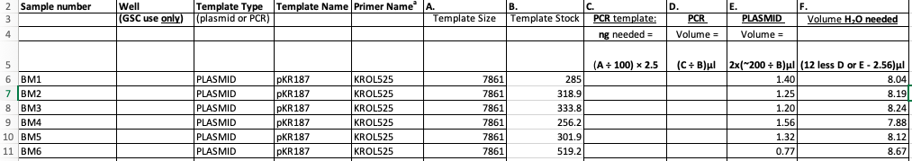
- Add appropriate primer to each tube (2.56 uL for each)
- Add appropriate miniprep to each tube
- Add appropriate volume of water to each tube
- Centrifuge tubes until all components are at bottom
- Pipette up and down to mix
- Bring PCR tubes and worksheet to genome sequencing lab
Submitted pKR187 samples 1-6 and sequenced using primer KROL525.

September 29, 2023

Friday, September 29, 2023
To Do:
  - Analyze sequencing results for pKR187
  - Prepare LVS cell cultures for GFP assay
  - Electroporate LVS-∆2 cells with pKR187

Results and Data
The sequencing reactions 1, 2 and 5 for pKR187 were confirmed to be sequenced correctly. I added reactions 1, 2 and 5 into one microfuge tube and labelled it with a yellow sticker labelled “pKR187”

GFP reporter assay
1. Have prepared 3 patches 2 patches on CHAH of biological replicates for each reporter strain, and one patch of LVS as a control
2. Scrape up cells into MHB, resuspend, measure OD, and dilute to 0.08-0.10 in 6 mL of MHB with appropriate antibiotic (6 uL Kanamycin)
3. Grow shaking at 37C until cells reach mid-log (0.3-0.4 OD). Generally takes 4-5 hours.
4. Take 1 mL from each culture tube into microcentrifuge tubes. Spin at max speed for 3 minutes
5. Remove all MHB, using 20 ul pipette to remove small amount at bottom of tube.
6. Add 1 mL of 1XPBS and resuspend the cells.
*Note: If this is the first time running a particular strain, return the culture tubes to the incubator. If the strain is not at least 5 times more fluorescent than WT LVS, you will want to concentrate the cells 2x-4x (depending on your reading). Do this by spinning down 4 mL of culture and resuspending in 1 mL PBS (for 4X, adjust for 2x). Check RFU then dilute back down to 1X to read OD600.
7. Aliquot 250 ul from each microfuge tube in triplicate into a clear 96-well plate (not tissue culture treated). Pipette PBS in triplicate as a control.
8. Go to INBRE lab with multichannel pipette, Rainin tips, black 96-well plate, and flash drive.
9. Read OD600 from clear plate on ID3 plate reader:
a. Select Absorbance, wavelength=600
b. Plate type: 96-well standard clearbtm (first option)
c. Copy and paste results into an excel file on the plate reader’s computer
10. Transfer 200 ul of each well from clear plate to black plate using the multichannel
11. Read fluorescence from black plate on ID3 plate reader:
a. Select fluorescence
b. Wavelength: 495 to 535
c. Plate type: CoStar 3789
d. Gain: Automatic
e. Integration: 380 ms
f. Copy and paste results into excel file, then save onto flash drive
12. Analyze by subtracting non-fluorescent LVS from RFU reading per biological replicate to account for basal Francisella and PBS fluorescence. Then divide that fluorescence for each replicate by OD600. Normalize each well to the wild-type strain such that wild-type is set to 1.

Electroporate LVS-∆2 cells with pKR187
1. For each electroporation, aliquot 4 mL MHB into glass test tubes for recovery, warm in shaker
at 37°C
2. For each electroporation, in a 2 mm sterile electroporation cuvette, combine:
a. 5 μL of pEX-based allelic exchange construct or Tn7 plasmids (mini-prep concentration,
at least 100 ng/μL)
b.*for pF-based plasmids, can use 3 ul 50 μL electrocompetent cells
3. Have recovery media ready
4. Electroporate using the following settings: 2.5 kV, 25 μF, and 600 Ω
5. Immediately after individual electroporations, use 1 mL warm recovery media from test tube to
wash cells out of cuvette and transfer cells to recovery test tube
6. Recover cells for 4-8 hours, shaking at 37°C
a. *For pF-based plasmids, only recover 2-3 hours (recovered for 2.5 hours)
7. For pEX plasmids: pellet cells by centrifugation in sterile 2 mL tubes, 1’ at 10,000 x g. Plate on
CHAH-Kan plates, using 1 plate for each 2 mL tube (2 plates per electroporation)
a. *For pF-plasmids: plate 50 ul and 500 ul on CHAH-kan plates
b. *For Tn7 plasmids: plate 100 ul and remaining on CHAH-kan plates
8. Incubate plates at 37°C for 3 days (or until single colonies appear)

*Always include a control electroporation with no plasmid. Eventually single break-through colonies may
start appearing; at that point, single colonies on the experimental plates are also likely to just be break-
through growth.

October 2, 2023

Monday, October 2, 2023
To Do:
  - Patch LVS plates from transformations
  - Prepare GFP assay
  - Pour CHA plates

Results and data
We looked at the results of the transformations that were run over the weekend. The plates looked good, with substantial numbers of colonies on the plates transformed with pKR187 (less growth on the DrpsU2 plates) and no background growth on the negative control plates (although there was some contamination on the DrpsU2 plates, maybe because they were cracked open
near the flame to dry?). The contaminating colonies were obviously different from LVS colonies.

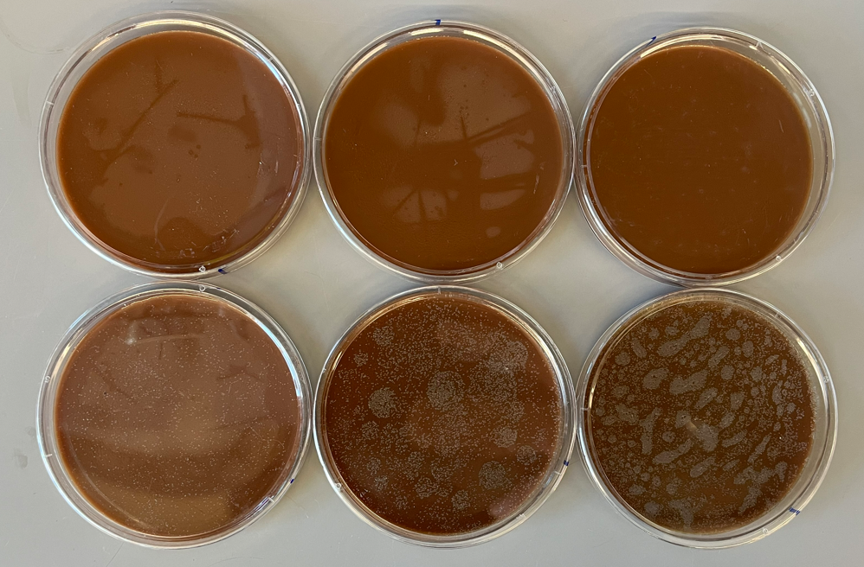

Figure. Plates from transformation of LVS with neg. controls (top row) and pKR187 (bottom row). Volumes plated were 50 uL (left column), 500 uL (middle column), and remaining culture (right column).

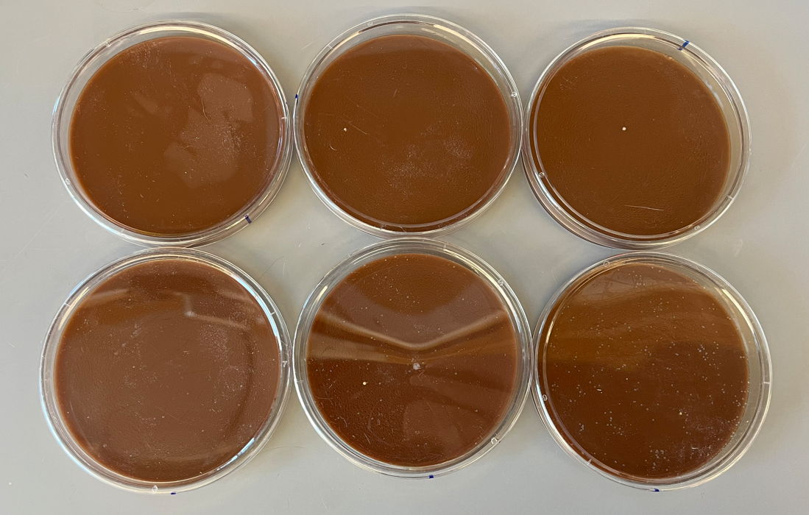

Figure. Plates from transformation of LVS DrpsU2 with neg. controls (top row) and pKR187 (bottom row). Volumes plated were 50 uL (left column), 500 uL (middle column), and remaining culture (right column).

We patched three colonies each from LVS-pKR187 and LVS DrspU2-pKR187 onto CHAH-Kan and put these in the 37C incubator. We will use these to make glycerol freezer stocks and perhaps for a GFP assay.

We were going to start the GFP assay, but I had not patched a plate of LVS for a negative control, so we patched a plate of LVS and put the rest of the plates back in the incubator. We will plan to run the assay tomorrow.

I made more CHAH and CHAH-Kan plates and more 2% hemoglobin.

No growth on negative control plates

Tuesday, October 3, 2023

To Do:
- Measure LVS growth curves in MHB and BHI (every 1.5 hours)
- GFP assay
- Make freezer stocks from LVS plates
Results and Data:

Measuring LVS Growth Curves in MHB and BHI Media

- 700 uL supplemented MHB (sMHB) was added to a sterile microfuge tube aseptically.
- Loopfuls of cells were scraped up from the LVS plate patched out yesterday and added to the microfuge tube.
- The cells were resuspended to homogeneity using a pipette.
- A cuvette was prepared to check OD 600 by adding 900 uL sMHB, and 100 uL resuspended cells was added to the cuvette.
- The OD 600 was measured. The OD 600 of resuspended cells was calculated by multiplying the observed OD 600 by ten, and both the observed and calculated ODs were recorded:
  - LVS: 0.517 observed OD, 5.17 calculated OD
- The volume of resuspended cells necessary to obtain a final OD 600 of 0.08 in 9 mL was calculated.
  - LVS: (0.08 OD 600 )*(9,000ul)/(5.17 OD 600 ) = 139.3 uL
- I realized that this desired volume of resuspended cells was larger than what I had available to inoculate six tubes, so I scraped up more cells into this tube and added 200 uL more MHB.
- The cells were resuspended to homogeneity using a pipette.
- A cuvette was prepared to check OD 600 by adding 900 uL sMHB, and 100 uL resuspended cells was added to the cuvette.
- The OD 600 was measured. The OD 600 of resuspended cells was calculated by multiplying the observed OD 600 by ten, and both the observed and calculated ODs were recorded:
  - LVS: 0.627 observed OD, 6.27 calculated OD
- The volume of resuspended cells necessary to obtain a final OD 600 of 0.08 in 9 mL was calculated.
  - LVS: (0.08 OD 600 )*(9,000ul)/(6.27 OD 600 ) = 114.8 uL
- 9 mL of supplemented MHB media was added to three culture tubes, and 9 mL of supplemented BHI media was added to three other culture tubes.
- The volume of resuspended cells (114.8 uL) necessary to obtain a final OD 600 of 0.08 from step 11 was used to inoculate each of the six culture tubes. I did not have enough volume to inoculate the third BHI tube, so I only used two BHI cultures for the experiment.
- The culture tubes were vortexed, and 1 mL was removed from each to measure the OD:

Table. Initial OD600 values of LVS cultures in MHB and BHI media.
Sample ID | OD600
MHB 1 | 0.077
MHB 2 | 0.079
MHB 3 | 0.076
BHI 1 | 0.071
BHI 2 | 0.068

- The culture tubes were incubated at 37°C shaking, starting incubation at 10:53 AM.
- The culture tubes were removed and the ODs were checked at 12:25 PM by adding 0.5 mL from each culture tube to a cuvette along with 0.5 mL of fresh media (MHB or BHI) and reading in the spectrophotometer. The measured OD600 values were multiplied by two to obtain the calculated OD600 values.

Table. OD600 values of LVS cultures in MHB and BHI media after 92 minutes.
Sample ID | Measured OD600 | Calculated OD600
MHB 1 | 0.08 | 0.16
MHB 2 | 0.074 | 0.148
MHB 3 | 0.078 | 0.156
BHI 1 | 0.08 | 0.16
BHI 2 | 0.067 | 0.134

- The culture tubes were removed and the ODs were checked at 1:55 PM by adding 0.5 mL from each culture tube to a cuvette along with 0.5 mL of fresh media (MHB or BHI) and reading in the spectrophotometer. The measured OD600 values were multiplied by two to obtain the calculated OD600 values.

Table. OD600 values of LVS cultures in MHB and BHI media after 182 minutes.
Sample ID | Measured OD600 | Calculated OD600
MHB 1 | 0.123 | 0.246
MHB 2 | 0.125 | 0.25
MHB 3 | 0.123 | 0.246
BHI 1 | 0.172 | 0.344
BHI 2 | 0.163 | 0.326

- The culture tubes were removed and the ODs were checked at 3:17 PM by adding 0.5 mL from each culture tube to a cuvette along with 0.5 mL of fresh media (MHB or BHI) and reading in the spectrophotometer. The measured OD600 values were multiplied by two to obtain the calculated OD600 values.

Table. OD600 values of LVS cultures in MHB and BHI media after 264 minutes.
Sample ID | Measured OD600 | Calculated OD600
MHB 1 | 0.19 | 0.38
MHB 2 | 0.188 | 0.376
MHB 3 | 0.195 | 0.39
BHI 1 | 0.311 | 0.622
BHI 2 | 0.291 | 0.582

- Here, the third MHB culture tube was removed to use for a GFP assay, but the first two MHB tubes were placed back in the incubator for further measurements.
- The culture tubes were removed and the ODs were checked at 4:49 PM by adding 0.25 mL from each culture tube to a cuvette along with 0.75 mL of fresh media (MHB or BHI) and reading in the spectrophotometer. The measured OD600 values were multiplied by four to obtain the calculated OD600 values.

Table. OD600 values of LVS cultures in MHB and BHI media after 356 minutes.
Sample ID | Measured OD600 | Calculated OD600
MHB 1 | 0.136 | 0.544
MHB 2 | 0.137 | 0.548
BHI 1 | 0.246 | 0.984
BHI 2 | 0.24 | 0.96

- The culture tubes were removed and the ODs were checked at 6:23 PM by adding 0.2 mL from each culture tube to a cuvette along with 0.8 mL of fresh media (MHB or BHI) and reading in the spectrophotometer. The measured OD600 values were multiplied by five to obtain the calculated OD600 values.

Table. OD600 values of LVS cultures in MHB and BHI media after 450 minutes.
Sample ID | Measured OD600 | Calculated OD600
MHB 1 | 0.156 | 0.78
MHB 2 | 0.161 | 0.805
BHI 1 | 0.306 | 1.53
BHI 2 | 0.309 | 1.545

GFP reporter assay
By: Hannah Trautmann

- Have prepared 3 patches 2 patches on CHAH of biological replicates for each reporter strain, and one patch of LVS as a control
- Scrape up cells into MHB, resuspend, measure OD, and dilute to 0.08-0.10 in 6 mL of MHB with appropriate antibiotic. (0.6 uL Kanamycin was added to all tubes except LVS. This was the correct amount of antibiotic to use in order to get a concentration of 5 ug/mL from a stock concentration of 50 mg/mL as opposed to the 6 uL that was used for the last assay.)
  - I added 100 uL of each sample to a cuvette with 900 uL MHB and took the OD600 measurement, then multiplied the measurement value by ten to get the actual OD600. I used the equation C1V1=C2V2 to calculate the desired volume of cell culture to inoculate each culture tube with. C1 was the actual OD600, V1 was the desired volume we were trying to find, C2 was 0.09 OD600, and V2 was 6,000 uL. The calculated desired volumes are listed in the table below.

Table. Samples, initial OD600 values, and desired volumes to inoculate culture tubes.
Sample | OD (diluted) | OD (actual) | Desired Volume
BM_tul4 | 0.722 | 7.22 | 74.8
BM_tul4D2 | 0.793 | 7.93 | 68.1
BM_0215 | 0.751 | 7.51 | 71.9
BM_0215D2 | 0.638 | 6.38 | 84.6
JG_tul4 | 0.57 | 5.7 | 94.7
JG_tul4D2 | 0.624 | 6.24 | 86.5
JG_0215 | 0.545 | 5.45 | 99.1
JG_0215D2 | 0.719 | 7.19 | 75.1

- Grow shaking at 37C until cells reach mid-log (0.3-0.4 OD). Generally takes 4-5 hours.
  - I put the culture tubes in the incubator around 12:09 PM.
  - The third MHB culture tube from the growth curve experiment was removed at 3:17 PM to use for this assay (with an OD600 reading of 0.39).
  - I removed the tubes and took the first OD reading at 5:00 PM by adding 250 uL of culture along with 750 uL of MHB to a cuvette and then multiplying the resulting OD by four.
  - I removed the tubes and took the second OD reading at 6:09 PM by adding 250 uL of culture along with 750 uL of MHB to a cuvette and then multiplying the resulting OD by four, then put them back in the incubator.
  - At this point, I was able to confirm that the cultures were not growing. I took another reading of the BM_tul4 sample with 1 mL and confirmed it to be 0.185, then I took a reading of the BM_tul4D2 sample with 1 mL at 7:00 PM and found it to be 0.171. I stopped the experiment and will try again later this week. Maybe the plates were too old (four days old), so we will try to harvest and use cells for the next assay after 1-2 days.

Table. OD600 readings for GFP assay cultures at several time points.
 | 1st OD | 5:00 PM | 2nd OD | 6:09 PM
Sample | Measured | Actual | Measured | Actual
BM_tul4 | 0.041 | 0.164 | 0.042 | 0.168
BM_tul4D2 | 0.039 | 0.156 | 0.038 | 0.152
BM_0215 | 0.04 | 0.16 | 0.049 | 0.196
BM_0215D2 | 0.033 | 0.132 | 0.035 | 0.14
JG_tul4 | 0.039 | 0.156 | 0.053 | 0.212
JG_tul4D2 | 0.031 | 0.124 | 0.034 | 0.136
JG_0215 | 0.038 | 0.152 | 0.046 | 0.184
JG_0215D2 | 0.033 | 0.132 | 0.031 | 0.124

I patched out fresh CHAH-Kan plates (2 per strain) of tul4 control -bS21-2 (KRLVS182) and 0215 UTR -bS21-2 (KRLVS191) as well as two more single-use aliquots of KRLVS 285.1 (see below) and put them in the 37C incubator for a third GFP assay attempt later this week.

Note: Could make single-use aliquots from remaining cells next time. From Hannah’s notebook after a GFP assay on 7/29/22: “With the remaining cells from each plate, I froze down single use aliquots by resuspending the patch in 400 ul of MHB + 100 ul 75% glycerol then making 50 ul aliquots. Put in Glycerol Stocks Box 10 in the -80C.”

Making Glycerol Stocks Protocol
For single use stocks: follow steps 2 - 5 but instead of step 6, pipet 50 – 100 ul of cells to sterile labeled microfuge tubes. Note that if you don’t have many cells, you can reduce the volume of MHB and glycerol (keep the same ratio, with a final concentration of glycerol of 15%. E.g. 800 uL MHB and 200 uL 75% glycerol).
- Make 3 cryovials for each strain (permanent stocks), label! I set up cryovials for strains KRLVS284.1-284.3 and KRLVS285.1-285.3.
- Prepare 2.4mL of MHB in a 50mL conical (adjust if you are also making single use stocks) I set up six sterile 1.5 mL microcentrifuge tubes (one for each cryovial). To the tubes corresponding to KRLVS284.1 and 285.1, I added 1.2 mL MHB, planning to make enough for the cryovials and several single-use aliquots. To the tubes corresponding to KRLVS284.2-284.3 and 285.2-285.3, I added 800 uL MHB.
- Take at least half of a thickly spread plate and add cells to the MHB tube. I added cells from the plates that were patched yesterday.
- Resuspend until there are no clumps in the MHB.
- Add 600ul of 75% glycerol to the 2.4mL mix by pipetting. To the tubes corresponding to KRLVS284.1 and 285.1, I added 300 uL 75% glycerol. To the tubes corresponding to KRLVS284.2-284.3 and 285.2-285.3, I added 200 uL 75% glycerol.
- Aliquot 1mL per cryovial, freeze at -80.
- From the tubes corresponding to KRLVS284.1 and 285.1, I also made five single-use aliquots each (with 50-100 uL) and stored these in my ‘BM Rotation’ box in the -80C freezer.

Tuesday, October 3, 2023

To Do:
- Make freezer stocks from LVS plates
- Patch plates of KRLVS284.1-284.3and KRLVS285.1-285.3
Results and Data:

Making Glycerol Stocks Protocol
For single use stocks: follow steps 2 - 5 but instead of step 6, pipet 50 – 100 ul of cells to sterile labeled microfuge tubes. Note that if you don’t have many cells, you can reduce the volume of MHB and glycerol (keep the same ratio, with a final concentration of glycerol of 15%. E.g. 800 uL MHB and 200 uL 75% glycerol).
- Make 3 cryovials for each strain (permanent stocks), label! I set up cryovials for strains KRLVS284.1-284.3 and KRLVS285.1-285.3.
- Prepare 2.4mL of MHB in a 50mL conical (adjust if you are also making single use stocks) I set up six sterile 1.5 mL microcentrifuge tubes (one for each cryovial). To the tubes corresponding to KRLVS284.1 and 285.1, I added 1.2 mL MHB, planning to make enough for the cryovials and several single-use aliquots. To the tubes corresponding to KRLVS284.2-284.3 and 285.2-285.3, I added 800 uL MHB.
- Take at least half of a thickly spread plate and add cells to the MHB tube. I added cells from the plates that were patched yesterday.
- Resuspend until there are no clumps in the MHB.
- Add 600ul of 75% glycerol to the 2.4mL mix by pipetting. To the tubes corresponding to KRLVS284.1 and 285.1, I added 300 uL 75% glycerol. To the tubes corresponding to KRLVS284.2-284.3 and 285.2-285.3, I added 200 uL 75% glycerol.
- Aliquot 1mL per cryovial, freeze at -80.
- From the tubes corresponding to KRLVS284.1 and 285.1, I also made five single-use aliquots each (with 50-100 uL) and stored these in my ‘BM Rotation’ box in the -80C freezer.

Thursday, October 5, 2023

To Do:
- Prepare GFP Assay
- Patch plates of KRLVS284.1-284.3and KRLVS285.1-285.3

GFP reporter assay
By: Hannah Trautmann

- Have prepared 3 patches 2 patches on CHAH of biological replicates for each reporter strain, and one patch of LVS as a control
- Scrape up cells into MHB, resuspend, measure OD, and dilute to 0.08-0.10 in 6 mL of MHB with appropriate antibiotic. (0.6 uL Kanamycin was added to all tubes except LVS. This was the correct amount of antibiotic to use in order to get a concentration of 5 ug/mL from a stock concentration of 50 mg/mL as opposed to the 6 uL that was used for the last assay.)
  - I added 100 uL of each sample to a cuvette with 900 uL MHB and took the OD600 measurement, then multiplied the measurement value by ten to get the actual OD600. I used the equation C1V1=C2V2 to calculate the desired volume of cell culture to inoculate each culture tube with. C1 was the actual OD600, V1 was the desired volume we were trying to find, C2 was 0.09 OD600, and V2 was 6,000 uL. The calculated desired volumes are listed in the table below.

Table. Initial OD values and desired volumes for GFP assay
Sample ID | Measured OD | Actual OD | Desired Volume
LVS | 0.622 | 6.22 | 86.81672026
180.1 | 0.512 | 5.12 | 105.46875
180.2 | 0.471 | 4.71 | 114.6496815
182.1 | 0.378 | 3.78 | 142.8571429
182.2 | 0.463 | 4.63 | 116.6306695
190.1 | 0.506 | 5.06 | 106.7193676
190.2 | 0.458 | 4.58 | 117.9039301
191.1 | 0.446 | 4.46 | 121.0762332
191.2 | 0.474 | 4.74 | 113.9240506
284.1 | 0.325 | 3.25 | 166.1538462
284.2 | 0.573 | 5.73 | 94.2408377
284.3 | 0.625 | 6.25 | 86.4
285.1 | 0.448 | 4.48 | 120.5357143
285.2 | 0.609 | 6.09 | 88.66995074
285.3 | 0.501 | 5.01 | 107.7844311

3. Grow shaking at 37C until cells reach mid-log (0.3-0.4 OD). Generally takes 4-5 hours.
  - I put the culture tubes in the incubator around x PM.
  - The third MHB culture tube from the growth curve experiment was removed at x PM to use for this assay (with an OD600 reading of 0.39).
  - I removed the tubes and took the first OD reading at 5:00 PM by adding 250 uL of culture along with 750 uL of MHB to a cuvette and then multiplying the resulting OD by four.
  - I removed the tubes and took the second OD reading at 6:09 PM by adding 250 uL of culture along with 750 uL of MHB to a cuvette and then multiplying the resulting OD by four, then put them back in the incubator.

Bibliography

Ramsey, K. M. and Dove, S. L. (2016) ‘ A response regulator promotes Francisella tularensis intramacrophage growth by repressing an anti-virulence factor ’, Molecular Microbiology. doi: 10.1111/mmi.13418.

