Table of Contents
Introduction 2
Figure 1 2
Thoughts or questions 2
Protocol 1 2
Reagents 3
File Formatting Protocol 3
October 2022 4
Tuesday October 11, 2022 5
Overview of Upcoming Experiments 5
Streak out F. Tularensis Glycerol Stocks 5
Wednesday October 12, 2022 5
Freeze Down Personal Glycerol & Single Use Stocks 5
Streak out F. Tularensis Glycerol Stocks 5
Thursday October 13, 2022 6
Describe Sierra’s Leftover Electrocompetent Cells & Image 6
Friday October 14, 2022 7
Perform Electroporation and Plate After Recovery Period 8
Tuesday October 18 8
Single Colony Streaks on CHA-H Plates 8
Wednesday October 19 9
Patch Out Single Use Stocks on CHA-H Plates 9
Thursday October 20 9
Make Electrocompetent Cells and CHA-H Plates 9
Friday October 21 10
Check Electrocompetent Cells Plate 10
Make More CHA-H Media 10
Check Single Colony CHA-H Control Plates 10
Tuesday October 25 10
Make Single Streak Colonies 10
Wednesday October 26 10
Patch Out Single Use Stocks on CHAH Plates 10
Thursday October 27 11
Make Electrocompetent Cells 11
Friday October 28 11
Electroporate the Electrocompetent Cells 11
Image the 7 Streaked Out Plates 12
Wednesday November 2 13
Patch Out Plates for Beta Galactosidase Assay 13
Thursday November 3 13
Perform a B-gal Assay 13
Bibliography

Month

Thursday, September 20, 2018
To Do:
- Explain lab notebook formatting
- Media prep
Results and Data:
For each day, copy the previous entry headers and update the date. Save the same ongoing copy of the lab notebook to the lab google drive ONLY. Do not save separate physical copies. At the 1st of each new month, a read-only PDF file of the lab notebook must be saved and given to Dr. Ramsey electronically.

File contents converted to PDF MUST NOT BE EDITED after PDF conversion. Continue to keep using the same word file until the end of the calendar year. New lab notebook files run in 6 month intervals.
For the To do list, update this each day with new tasks, as tasks are done, use the strikethrough font on the day they are completed and leave them out of the list on the next day.
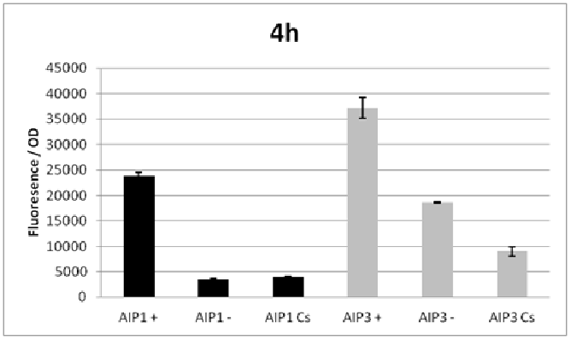

Figure 1
Figures are inserted as inline .png files when possible, .jpg, .gif, .tif otherwise are acceptable. Figure legends are always inserted in Word (right click – ‘insert caption’) and use “Heading 2” text to properly format in the TOC. Table legends are handled the same way. Figure images must be saved in a separate folder where the source data is saved.

Thoughts or questions. When you have a significant observation, question, confusing point or contradiction that you have identified in your data or protocol, use the “Heading 3” text heading on a descriptive brief title or single word heading so you can refer to it in your TOC later.

Protocol 1
1. This is the format for a protocol in your notebook.
2. The protocol title must be formatted in “Heading 2.”
3. Reagents which must be made for a specific protocol (buffers, solutions) should be listed in a “Reagents” Section, formatted in “Heading 3.”
4. The protocol must be in numerical steps.
5. Use standard notation and carefully describe units for your protocol.
6. Use ½” indent for protocol text.

Reagents
Specific buffers
For initial lab notebooks, write as much detail as possible. As time goes by you will be able to refer to written protocols by their heading and/or page number within the document. If you make any modifications to a protocol you must state how and why.

File Formatting Protocol
1. Filenames begin with your initials, an underscore, and the date, formatted as the last 2 digits of the year, the month, then the day, ex: “KMR_180920_Sample_file1v1.xls”
2. This ensures all files will be sorted by their creator and by their date. You must use this file formatting system for all data files (including photos) that will be shared with the lab.
Bibliography data will be saved as (author/date) and using Mendeley at this time with the TOC inserted by order cited at the end of the lab notebook in the Bibliography section.
Example is a recent publication (Ramsey and Dove, 2016).

Introduction
Investigating BS21-1 and BS21-3 in F. tularensis, with focus on what can cause upregulation of these less abundant ribosomal proteins

October 2022

Tuesday, October 11, 2022
To Do:
- Discuss background information and experiment overview
- Streak out plates of F. Tularensis glycerol stock strains KRLVS28 & KRLVS75

Wednesday, October 12, 2022
To Do:
- Freeze down personal stocks from plates made 11 Oct 2022
- Streak out more plates from KRLVS28 & KRLVS75 glycerol stocks

Making Glycerol Stocks Protocol (Scaled Down)
- Made personal stocks of 75% Glycerol and Mueller Hinton Broth (keep in fridge)in 50 mL conicals
- Make 1 cryovials for each strain (permanent stocks), label!
- Prepare 1.6 mL (1600 µL) of MHB in a 2mL tube (adjust if you are also making single use stocks)
- Take at least half of a thickly spread plate and add cells to the MHB tube
- Resuspend until there are no clumps in the MHB
- Put 800 µL solution in a cryovial (so mix is not overflowing) then will put 200 µL of glycerol in each
- Add 400ul of 75% glycerol to the 1.6mL mix by pipetting
- Aliquot 1mL per cryovial, freeze at -80
- For single use stocks follow the same protocol but pipet 50ul of solution to tubes
  - 10 tubes per strain (28 and 75)
- Made 2 plates per strain with 50 µL of the glycerol stock solution onto beef stock plates and spread with wooden sticks -> these will be used to make electrocompetent cells on 13 Oct 2022

Thursday, October 13, 2022
To Do:
- Make electrocompetent cells
Cells did not grow on CHA-H plates - Lac-Z in chromosome - no longer Kan resistant and we put it on Kan plates. LBS takes long time grow. Sierra has left over electrocompetent cells - enough for a negative control and 1 reaction each. Not enough for a positive control. Took images of plate using BioRad and exported to my drive folder

Protocol for Imaging Transposon Plates Using BioRad
- Change setting on side of BioRad to No Filter
- On Computer: Go to Image Lab, New, Application → Custom → Zone of Inhibition Assay
- Put gel in the bottom drawer with the top of the plate off and the gel facing up. If four quadrants of samples, put lower samples (i.e, if samples are 1-4 put samples 1 and 2) at the top to keep track of sample numbers and orient oneself.
- On Computer: Position Gel, Cancel Protocol, Run protocol, let the protocol run
  - File → Export → Export for Publication → Increase to 600 exposure → Ramsey Lab –> Individual’s Notebook File → Label it with a descriptive name (Date, Strain, # Colonies (I.e. 1, 2, 3, 4), Transposon or whatever was performed, etc. → Separate with (_) → Save → Red exit button on image → Click no on prompt to save the image, already saved it to drive.
Tube Number | Electroporation | Initial Description | My Description
1 | KRLVS28 + pKR141 | Very small dark blue colony | CHA: Growth  X-Gal: Minimal to No Growth
2 | KRLVS28 + pKR141 | Average size colony with dark blue margin and white center | CHA: Growth  X-Gal: Minimal to No Growth
3 | KRLVS28 + pKR141 | Average size dark blue colony | CHA: Growth  X-Gal: Minimal to No Growth
4 | KRLVS28 + pKR141 | Large colony with dark margin and light center | CHA: Growth  X-Gal: Minimal to No Growth
5 | KRLVS28 + pKR141 | Small dark blue colony | CHA: Growth  X-Gal: Minimal to No Growth
6 | KRLVS28 + pKR141 | Moderately small dark blue colony | CHA: Growth  X-Gal: Minimal to No Growth
7 | KRLVS28 + pKR141 | Very small colony with dark blue margin and light center | CHA: Growth  X-Gal: Minimal to No Growth
8 | KRLVS28 + pKR141 | White colony, for control | CHA: Growth  X-Gal: Minimal to No Growth

Plate Analysis: While there was no growth on samples 1-7 X-gal which was a good thing, there was also no growth on sample 8 X-gal plates. The sample 8 was the control sample, and therefore there should have been growth on the X-gal plates. Further analysis is needed to determine if this was a one-time fluke or maybe the X-gal is too toxic for any samples to grow.

Prepare Electrocompetent (EC) Cells Protocol
- Scrape up entire plate of cells into 400 uL of sterile 10% sucrose and resuspend (alternately, cells can be grown to mid-log in MHB)
  - Put both plates of each strain in one tube
- Add 1.1 mL of 10% sucrose to a final volume of 1.5 mL (however much sucrose it takes to fill the tube to the top)
- Spin for 3 minutes at 10,000 rpm
- remove supernatant, throw out, and resuspend in fresh 1 mL 10% sucrose
- Repeat 5x in 10% sucrose
- After final spin, remove all supernatant.
- Resuspend cells in 10% sucrose at high density (corresponding to ~1x10¹¹ cells /mL); these are EC cells by slowly adding 110 uL at a time. It should be about equal amounts of cells as sucrose.
- For any extra EC cells, aliquot ~110 μL / sterile tube (enough for 2 electroporations) and freeze at -80°C

Friday, October 14, 2022
To Do:
- Perform electroporation
- Allow transposon recover for 3 hours
- Streak out on plate when transposon completes recovery period

Electroporate Plasmid into EC Cells
- For each electroporation, aliquot 4 mL MHB into glass test tubes for recovery, warm in shaker at 37°C
- For each electroporation, in a 2 mm sterile electroporation cuvette, combine:
  - 3 μL of pKR141 plasmid DNA
  - 50 μL electrocompetent cells
- Have recovery media ready
- Electroporate using the EC2 program
- Immediately after individual electroporations, use 1 mL warm recovery media from test tube to wash cells out of cuvette and transfer cells to recovery test tube
- Recover cells for 3 hours, shaking at 37°C
- Plate on CHAH-Kan plates
  - Plated 10μL, 100μL, 200μL, and remaining volume of cells spun down and resuspended in ~100 μL of loqiod
- Incubate plates at 37°C for 3 days (or until single colonies appear)
*Always including a control electroporation with no plasmid. Eventually single break-through colonies may start appearing; at that point, single colonies on the experimental plates are also likely to just be break-through growth.

Analysis: All samples “Arc-ed” when put in the machine - this could mean there was still salt in the medium. Re-prep is necessary to ensure a fresh clean sample is thoroughly washed free of salt.
1 | KRLVS28 | PKR141 Diluted | Arc 2.2
2 | KRLVS75 | PKR141 Diluted | Arc
3 | KRLVS28 | Neg Control - No PKR141 | Arc 2.0
4 | KRLVS29 | Neg Control - No PKR141 | Arc 2.3

Tuesday, October 18, 2022
To Do:
- Single Colony Streaks on CHA-H Plates
Since X-gal did not grow, new single colony streaks will be made to redo making electrocompetent cells and running an electroporation. Four plates were made. One with KRLVS28, one with KRLVS75, a control mutated with less to the same amount of Beta-Galactosidase, and a random strain - I chose strain 4 from some of Sierra’s glycerol stocks. Since the beta-galactosidase is light sensitive the plates were wrapped in aluminum foil and left in the incubator to grow. They normally take around 3 days to grow and will therefore be checked on Thursday and/or Friday where grown cells will be made electrocompetent and undergo electroporation.

Wednesday, October 19, 2022
To Do:
- Patch Out Single Use Stocks on CHA-H Plates
Single use stocks made on the first day of rotation were patched out on plates (2 plates of KRLVS28 strain and 2 plates of KRLVS75 strain). They were patched out on regular CHA-H plates. The stocks were left to thaw on the bench before the full 50µL stocks was pipetted onto the plate. The liquid sample was spread throughout the plate using a sterile wooden stick and placed in the incubator to grow.

Thursday, October 20, 2022
To Do:
- Make Electrocompetent Cells
- Make CHA-H media
Used the patched out CHA-H plates to make the electrocompetent cells. Contaminated 75 plates and one of the 28 plates. Contamination of the 75 glycerol stocks, possibly the 28 as well. Continued protocol (mentioned on page 6) with the uncontaminated 28 plate. Did the 5X washing with the sucrose. Added 110μL and an additional 20μL of sucrose because the sample was still slightly too thick/clumpy. Added 20μL onto a CHA-H plate and put in an incubator to check for contamination.
Made CHA-H plates. Protocol makes 600 mL, I halved that. Added 15.3g CHA and 150 mL ddIH2O to a 1L flask, added a stir bar, and let it stir until the CHA was dissolved. Put in the pressure cook for 30 minutes. Left for the day and Sierra finished adding the hemoglobin to the bath, pouring the plates, etc.

Friday, October 21, 2022
To Do:
1 Check electrocompetent cells plate
2. Make more CHA-H media
3. Check single colony CHA-H control plates
Electrocompetent cell plates had contamination. Both glycerol stocks are contaminated. Streak out some of Sierra’s glycerol stock to grow and re-make the glycerol stocks and single use stocks on Monday and Tuesday. Do electroporation and remake electrocompetent cells after they no longer have EVERYTHING contaminated -_-.
Made half the amount as protocol calls for again. 15.3g CHA and 150 mL H2O in a flask, add stir bar and stir until dissolved at 60°C. Pressure cook for 30 minutes after the mixture dissolves completely → make sure to put the lid on correctly and turn. When done, let sit for 20 minutes so it does not overflow. Get 1:1 ratio of hemoglobin → 150 mL → already measured out in the fridge. Put the 150 mL hemoglobin in a water bath at 56°C. When done moved CHA and H2O mixture into water bath alongside the hemoglobin. Also going to add X-gal and Kan to plates. Went to A+P Lab Meeting Practical Setup and Sierra finished making/pouring the plates.

Tuesday, October 25, 2022
To Do:
1 Make single streak colonies
Single streak colonies were made with light sensitive CHAH-X Gal plates. They were streaked out using the wooden sticks. 4 streaks were made per sample, changing the stick each time. Seven plates were made in total. Each with the LVS strain, the parental strain KRLVS28, and mutant # 8. The fourth sample streaked out on these plates were the other mutants 1 - 7. They were wrapped in aluminum foil and left to grow throughout the week.

Wednesday, October 26, 2022
To Do:
1 Patch out single use stocks
Single use stocks were used to patch out cells from strains KRLVS28 and KRLVS75 on CHAH plates. This will be used to make electrocompetent cells. The whole 50µL single use aliquot was added to the plate.

Thursday, October 27, 2022
To Do:
1 Make electrocompetent cells
Sierra’s single use stocks for KRLVS75 were contaminated so just continued with the KRLVS28 plate (rpsU1 not rpsU3).Followed protocol previously written on page 7. On resuspension cells in 1-% sucrose at high density step, added a total of 270µL 10% sucrose.
Resuspend cells in 10% sucrose at high density (corresponding to ~1x10¹¹ cells /mL); these are EC cells by slowly adding 110 uL at a time. It should be about equal amounts of cells as sucrose.

Friday, October 28, 2022
To Do:
1 Electroporate the Electrocompetent Cells
2. Image the 7 streaked out plates
1.)
Due to early classes and short time frame (Sierra leaving at 1), Sierra completed a majority of the electroporation (giving it the sufficient time to recover for 3 hours). She followed the protocol on page 8 up to step 6, leaving them to shake for 3 hours. I plated the samples on CHAH-Kan plates following step 7 on page 8 and 200μL of the negative control. For the remaining volume, I spun it down (10000 rpm for 3 min), removed the supernatant except for about 100 μL, which I used to resuspend the pellet into supernatant and plate. I then incubated the plates at 37°C.
The samples arced - this could be due to the amount of sample, the sucrose may have been unable to wash all the salt out. Other potential sources of salt are from the CHAH plates that got into the sample and were again not washed out completely by sucrose or pieces of loop that came off into the plate after flaming it.

Tube # | Purpose | DNA | Vol. of DNA | Vol. Plated | Number of Plates
1 | PKR168 | PKR168 | 3 μL | 10 μL, 100 μL, 200 μL, Remaining | 4
2 | (-) Control | - | - | 200 μL | 1
- | - | - | - | Total: | 5

2.)
Imaging of the single streak plates was also completed using the BioRad (followed protocol on page 6). Images can be found in KRamsey Lab Google Drive → Brenna Levesque → Labeled 221028_BL_Transposon_Insertion_KRLVS28_Mut(1-7).tif.
Observations of the single streak plates were also written down, see table directly below:

LVS | 28 | 8 | Mutant (1-7)
Good amount of off-white growth at top and a little on sides of streaks | Dark blue colonies at top of streaks | Few dots of dark blue growth at top of initial streaks | 1  Dark blue colonies at top and along first streak
Off-white growth concentrated at top and right side of streaks | Thick dark blue growth at top of 1st streak and bottom of 2nd streak | Dark blue growth along 1st and 2nd streaks | 2  Dark blue spotted growth along 1st, 2nd, and beginning of 3rd streaks
Off-white growth on 1st and 2nd streaks (solid) | Dark blue growth along 1st and 2nd streaks | Dark blue growth along 1st streak and minimal along 2nd streak | 3  Dark blue growth along 1st and 2nd streaks
Off-white growth along 1st, 2nd, and 3rd streaks | Dark blue growth along 1st, 2nd, and 3rd streaks | Dark blue growth along edges of 1st and 2nd streaks | 4  Dark blue growth along 1st and 2nd streaks. Concentrated on edges of streaks.
Solid off-white along 1st, 2nd, 3rd, and beginning of 4th streaks | Dark blue growth along 1st and 2nd streaks | Dark blue along 1st and 2nd streaks. Single big white colony with blue coloration in center of it | 5  Dark blue along edges of streaks; especially 1st and 2nd streaks
Solid off-white along 1st, 2nd, and 3rd streaks | Dark blue growth along 1st and 2nd streaks. Single white colony | Blue along 1st and 2nd streaks | 6  Dark blue along 1st streak only
Off-white solid along 1st, 2nd, and beginning of third streaks. Dark blue and white dots along 1st streak (contamination) | Dark blue growth along 1st and 2nd streaks. Single large white colony in middle of 2nd streak | Dark blue colony along 1st and 2nd streaks | 7  Dark blue growth along 1st, 2nd, and beginning of 3rd streaks. Some blue and a lot of white dots along all 3 streaks. (Contamination)

Wednesday, November 2, 2022
To Do:
1 Patch out cells for Beta Galactosidase assay
Used CHA-H plates. Used CHA-H plates with Kanamycin for the mutant cells and a CHAH-H plate without Kanamycin for the parent cells. The mutants I used were mutants 1 and 6. The parent strand I used was KRLVS28. I took the mutants from frozen glycerol stocks and the KRLVS28 parent cells from a 50µL single-use aliquot.

Thursday, November 3, 2022
To Do:
1 Perform a Beta-Galactose Assay

Beta-Galactosidase Assay
Z-Buffer (1L)
- 16.1g Na₂HPO₄•7H₂O
- 5.5g NaH₂PO₄•H₂O
- 0.75g KCl
- 0.246g MgSO4•7H₂O
- 997.3ml ddH₂O
- pH 7
ONPG solution
- 160 mg O-Nitrophenyl-beta-galactoside (ONPG) in 40 mL (4 mg/mL) in Z-buffer.
- Store at -20°C.
Prior to assay
- Prepare Z-buffer
- Prepare ONPG solution
- Have single colonies patched out for each biological replicate (experiments should be performed in biological triplicate with technical duplicates)
- Prepare 1M Na₂CO₃
Assay
- Grow 6ml cultures until OD600 = 0.3
- Turn on 28°C water bath
- Determine amount of Z-buffer needed (0.8ml x 2 x # of cultures plus 1, the 2 is for running duplicates, the 1 is for a blank replicate). Add BME to Z-buffer (2.72 x Xml Z-buffer = _µl of BME).
- Set up reaction tubes with 800µl Z-buffer, put on lids
- Turn on spec and gather cuvettes
- Once cultures reach OD₆₀₀ = 0.3, place on ice 30 min and put ONPG in water bath
- After cells have incubated on ice, measure OD₆₀₀ of bacterial cultures
- Add 200µl culture to each reaction tube (add 200µl culture media to blank tube)
- Add 30µl 0.1% SDS to each reaction tube
- Add 60µl CHCl3 (chloroform) to each reaction tube
- Vortex reaction pairs on high for 6 secs (time precisely with timer)
- Put in water bath for 10 min
- Prepare repeater pipette with 1M Na₂CO₃ (stop)
- Add 200µl ONPG in 5 sec intervals (use timer with hours)
- Shake gently and watch for yellow (goal OD420 is 0.6-0.9)
- Stop with 500µl 1M Na₂CO₃, record time, vortex at 4 for 10 sec
- Give all reaction at least 2 hours
- Remove 1 mL from reaction (avoid chloroform at bottom), measure OD₄₂₀ and OD_{550,} using blank reaction as blank in spectrophotometer.
Calculations
- Miller Units = 1000 × [(OD420 – 1.75 × OD550)/(t x v × OD600)]
- Note that “t” is the time of the reaction in minutes, “v” is the volume of the culture used in the assay in mL (i.e., 0.2) and the OD₆₀₀ is that determined for the culture used in each assay. Use spreadsheet.

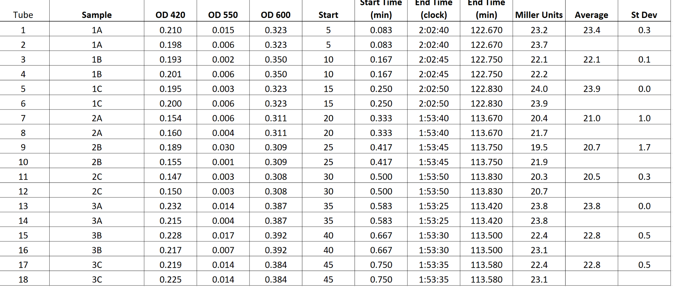
Samples 1A-1C was the KRLVS28 parent strain. Samples 2A-2C was the mutation 6 strain. Samples 3A-3C was the mutation 1 strain. We did technical trip-licates for each strain.
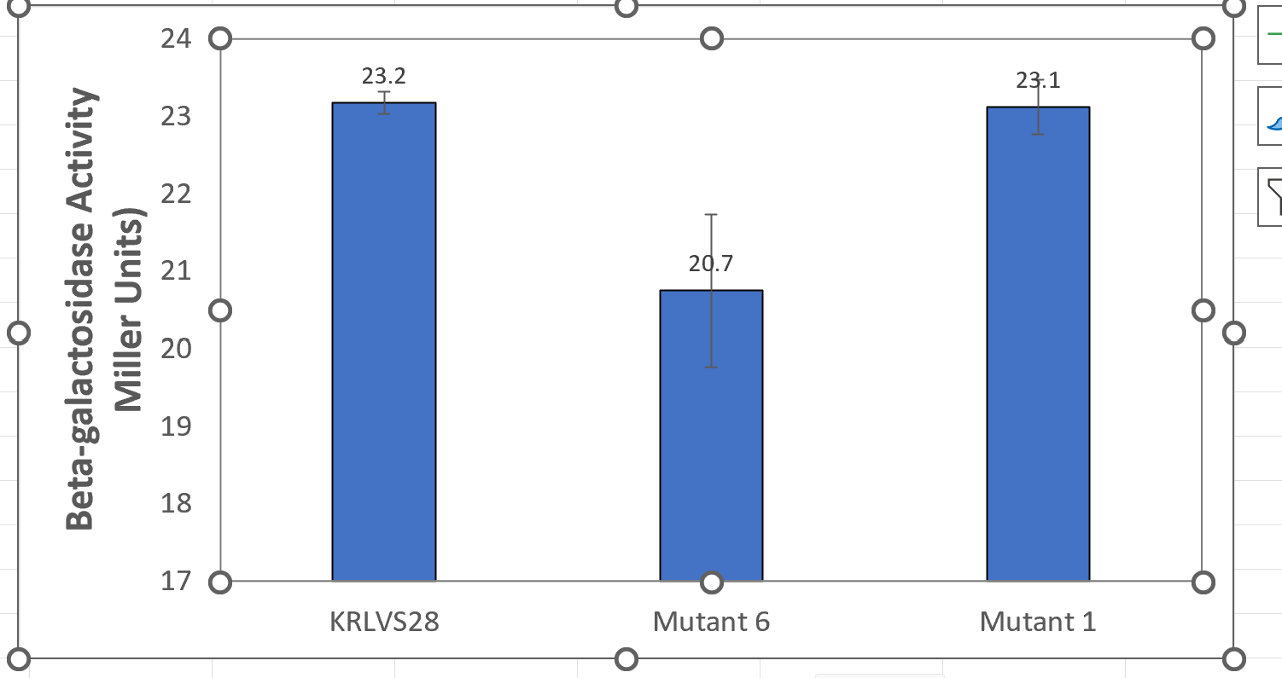
This graph shows no significant increase in Beta-Galactosidase activity in mutant 1 in relation to the parent KRLVS28 parent strain. Mutant 6 production was low, which could be due to a misinterpretation of the X-Gal overlay.
Final color of sample when taken out of the water bath and the stop ONPG added: The colors were based on Benjamin Moore yellow paint swatches we keep in the lab. Samples 1A-1C (KRLVS28) was closest to color #325 “Wildflowers.” Samples 2A-2C (Mutant 6) and samples 3A-3C (Mutant 1) had coloration closest to # 358 “Fun in the Sun.”
Results and Data:
Xxxx

Bibliography

Ramsey, K. M. and Dove, S. L. (2016) ‘ A response regulator promotes Francisella tularensis intramacrophage growth by repressing an anti-virulence factor ’, Molecular Microbiology. doi: 10.1111/mmi.13418.

