Table of Contents
July 2022 2
Friday, July 1, 2022 2
Tuesday, July 5, 2022 4
Delta Ribosome Kit Protocol 5
Nano-Glo® Luciferase Assay Protocol 5
Wednesday, July 6, 2022 6
Monday, July 11, 2022 8
Western Blot Protocol Day 1 9
Tuesday, July 12, 2022 10
Western Blot Protocol Day 2 11
Monday, July 18, 2022 13
Tuesday, July 19, 2022 16
Wednesday, July 20, 2022 17
Thursday, July 21, 2022 19
Friday, July 22, 2022 20
Monday, July 25, 2022 21
Tuesday, July 26, 2022 22
MHB Protocol 22
Thursday, July 28, 2022 23
SOC Media Protocol 23
NEB 5-alpha Competent E. coli Transformation Protocol 23
Fractionating Siderophore from Conditioned Media Protocol 24
Monday, Aug 1, 2022 26
Tuesday, Aug 2, 2022 27

July 2022

Friday, July 1, 2022

To Do:
- Analyze growth data
Side Project
I took out the overnight cultures at 10 am and checked their OD600s. The summary of all the OD600s can be seen below:
Sample | 0 (hours) | 2 (hours) | 4 (hours) | 6 (hours) | 24 (hours)
LVS Fresh | 0.0845 | 0.166 | 0.287 | 0.446 | 1.824
LVS Conditioned | 0.0895 | 0.1235 | 0.1555 | 0.188 | 0.3695
ΔrpsU2 Fresh | 0.078 | 0.137 | 0.22 | 0.2955 | 0.73
ΔrpsU2 Conditioned | 0.0835 | 0.1155 | 0.1455 | 0.171 | 0.2505

Generation Times | 0-2 (hours) | 2-4 (hours) | 4-6 (hours)
LVS Fresh | 131.0987546 | 154.0235688 | 223.0153148
LVS Conditioned | 271.1895492 | 337.591975 | 820.3827353
ΔrpsU2 Fresh | 145.3063624 | 191.7151694 | 234.795012
ΔrpsU2 Conditioned | 271.5490397 | 341.1966109 | 523.3159576
The cells grew well again, as seen by the generation times. These results also match the most recent growth experiment and validate that ΔrpsU2 loses its growth defect in conditioned media.
The next step will be to figure out a way to isolate and purify siderophore so we can add it to fresh media and determine if ΔrpsU2 loses its growth defect.

Tuesday, July 5, 2022

To Do:
- Ribosome assay

Delta Ribosome Kit Protocol
Today I will prepare my first ribosome assay using controls to validate whether the kit works with my plasmid. I used the PURExpress® Δ Ribosome Kit and followed the modified version of the protocol which Hannah made.
- Thaw all components on ice. Pulse-spin in microfuge to collect solutions to bottom of tubes. If Solution A has precipitates, mix well prior to assembling reaction
- Dilute ribosomes to 2.666 pmol/uL in H10M10A50 buffer, enough for a final volume of 15 uL per reaction and 40 pmol per reaction.
- Dilute DNA in 0.1xEB to a concentration of 125 ng/uL
- Add components in the following order:
Solution A 10 uL
Factor Mix 3 uL
Ribosomes 15 uL
Template DNA 2 uL
-------------------------------------------
Total 30 uL
- Mix gently and pulse-spin in microfuge to collect mixture at the bottom of the tube
- Incubate at 37C for 2-4 hours (incubator is preferred to water bath)
- Stop the reaction by placing tubes on ice.
To dilute the DNA I mixed 4.81 uL of 0.1X EB with 3.19 uL of phenol:chloroform purified pKR144 to make 8 uL.
I used Hannah’s diluted ribosomes.
Tube | DNA | Ribosomes
1 | Phenol:chloroform purified pKR144 | Wild-type E. coli
2 | Phenol:chloroform purified pKR144 | Wild-type F. tularensis
3 | Phenol:chloroform purified pKR144 | Nuclease-free water
I incubated the reactions in the thermocycler for 4 hours.

Nano-Glo® Luciferase Assay Protocol
Next, I prepared the Nano-Glo assay following the protocol below:
- Thaw Nano-Glo® Luciferase Assay Buffer and Nano-Glo® Luciferase Assay Substrate on ice – mix by pipetting
- Prepare appropriate volume of reconstituted reagent by combining one volume of substrate with 50 volumes of buffer – mix by pipetting
  - Example: for 150 uL of reagent mix 150 uL of buffer with 3 uL of substrate
- Pipet PURExpress ribosome kit reactions into Costar 3789A plate wells
  - Separate reactions by at least 2 wells in all directions
- Add equal volume of assay substrate to reaction volume (30 uL) – mix by pipetting
- Let stand for 3 mins
- Measure luminescence using plate reader
  - Acquisition settings: select luminescence; set wavelength to all; select plate as 96 well Costar 3789A
  - Hit read
  - Export data as text file
Note: Ensure luminescence values remain within the linear range of 10^3 and 10^8
Well | Sample
B1 | Wild-type E. coli ribosomes + substrate
A2 | Wild-type F. tularensis ribosomes + substrate
B3 | Water + substrate
A4 | H10M10A50 Buffer + substrate
A5 | H10M10A50 Buffer
Added 3 uL of substrate to 150 uL buffer to make 150 uL reagent
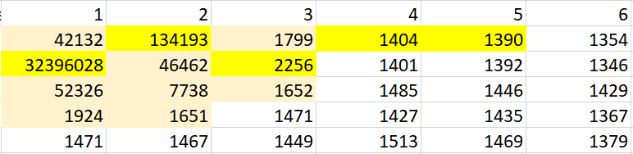
This is a small snapshot of the plate. The wells with reactions in them are bright yellow while lighter yellow wells represent values above the background. When discussing with Hannah, we determined that this is probably due to the reaction’s luminescence being strong enough to impact the wells directly surrounding them. To combat this, in the future I should spread the reactions out more, especially surrounding the E. coli ribosomes since they have such a strong signal.
The results indicate that the plasmid does work with the kit! The E. coli ribosomes had the highest luminescence while the F. tularensis ribosomes still had a significantly higher value than the negative control (59X stronger). There was also no difference between empty wells and the two buffer negative controls which means the substrate doesn’t interact with the buffer.

Wednesday, July 6, 2022

To Do:
- Ribosome assay
Ribosome Assay
Today I will do another ribosome assay, this time comparing the three rpsU ribosomes. My hypothesis is that the E. coli ribosomes will have the highest luminescence, followed by wild-type F. tularensis and rpsU2, which should have approximately the same luminescence values. rpsU1 and rpsU3 should have the lowest amount of luminescence. I also used buffer as a negative control.
Tube | DNA | Ribosomes
1 | Phenol:chloroform purified pKR144 | Wild-type E. coli
2 | Phenol:chloroform purified pKR144 | Wild-type F. tularensis
3 | Phenol:chloroform purified pKR144 | F. tularensis Tn7::rpsU1-V
4 | Phenol:chloroform purified pKR144 | F. tularensis Tn7::rpsU2-V
5 | Phenol:chloroform purified pKR144 | F. tularensis Tn7::rpsU3-V
6 | Phenol:chloroform purified pKR144 | H10M10A50 Buffer

To dilute the DNA I mixed 8.41 uL of 0.1X EB with 5.59 uL of phenol:chloroform purified pKR144 to make 14 uL.
I also had to dilute more E. coli ribosomes (2 uL control ribosomes + 8 uL H10M10A50 buffer) and mixed it with Hannah’s diluted ribosomes. For all the other ribosomes I used the ones Hannah already had diluted.
I then incubated the samples in the thermocycler for 4 hours.
After incubation, I put the samples on ice to stop the reactions. I then removed 5 uL of each sample and put it in a new set of PCR tubes to be used for a future Western blot.
Added 3.5 uL substrate to 175 uL buffer to make 175 uL reagent.
I then added 25 uL of reagent to each sample and mixed by pipetting. Let sit for 3 mins. at room temperature. Next, I added 15 uL of each sample to the wells in triplicate and measured the luminescence using the plate reader.
Well | Sample
A1 | Wild-type E. coli ribosomes + substrate A
A2 | Wild-type E. coli ribosomes + substrate B
A3 | Wild-type E. coli ribosomes + substrate C
A6 | Wild-type F. tularensis ribosomes + substrate A
A7 | Wild-type F. tularensis ribosomes + substrate B
A8 | Wild-type F. tularensis ribosomes + substrate C
E1 | F. tularensis Tn7::rpsU1-V ribosomes + substrate A
E2 | F. tularensis Tn7::rpsU1-V ribosomes + substrate B
E3 | F. tularensis Tn7::rpsU1-V ribosomes + substrate C
D6 | F. tularensis Tn7::rpsU2-V ribosomes + substrate A
D7 | F. tularensis Tn7::rpsU2-V ribosomes + substrate B
D8 | F. tularensis Tn7::rpsU2-V ribosomes + substrate C
H1 | F. tularensis Tn7::rpsU3-V ribosomes + substrate A
H2 | F. tularensis Tn7::rpsU3-V ribosomes + substrate B
H3 | F. tularensis Tn7::rpsU3-V ribosomes + substrate C
G6 | Water + substrate A
G7 | Water + substrate B
G8 | Water + substrate C
D12 | H10M10A50 Buffer
The average luminescence of each sample, with its standard deviation, can be seen below:
Averages |  |  | St Dev
E. coli | 13775570.3 |  | E. coli | 88869.1511
F. tul wt | 50989.3333 |  | F. tul wt | 378.863212
F. tul rpsU1 | 50302.6667 |  | F. tul rpsU1 | 178.746562
F. tul rpsU2 | 57978.6667 |  | F. tul rpsU2 | 202.013201
F. tul rpsU3 | 111281.333 |  | F. tul rpsU3 | 706.286297
Buffer | 988.333333 |  | Buffer | 9.86576572

As seen by the graph, wild-type, rpsU1, and rpsU2 ribosomes have pretty similar luminescence. However, rpsU3 ribosomes have over 2X the luminescence. This is not what we expected, and a Western blot should be performed to measure the levels of tul4 across all the samples. We can then calculate an NLuc/tul4 ratio for each sample to more accurately determine any differences.
Western Blot
- Add 5 uL of 2X SLB to each 5 uL sample (saved from ribosome assay) - Mix by pipetting
- Heat in thermocycler at 95C for 10 mins
- Store in -20C freezer box

Monday, July 11, 2022

To Do:
- Western Blot day 1

Western Blot Protocol Day 1
- Boil samples at 95C for 5 mins
- Assemble gel chamber
Use pre-cast NuPAGE 4-12% Bis-Tris gel
Make running buffer – 400 mL
380 mL ddiH2O
20 mL 20x MES
1 mL NuPAGE antioxidant
- Use pipet to wash wells of gel (use 200 uL set to 200 uL)
- Load 10 or 12 uL of each sample
Use 5 uL of WesternSure for the ladder (thaw and vortex to mix)
- Run at 150V until the blue dye front reaches the bottom ridge of the gel. (~40 mins)

Well | Sample | Volume (uL)
1 | 1XSLB | 10
2 | WesternSure Ladder | 5
3 | 1XSLB | 10
4 | 1XSLB | 10
5 | 1XSLB | 10
6 | 1- Wild-type F. tularensis | 10
7 | 2- F. tularensis Tn7::rpsU1-V | 10
8 | 3- F. tularensis Tn7::rpsU2-V | 10
9 | 4- F. tularensis Tn7::rpsU3-V | 10
10 | 5- H10M10A50 Buffer | 10
11 | 1XSLB | 10
12 | 1XSLB | 10
13 | 1XSLB | 10
14 | 1XSLB | 10
15 | 1XSLB | 10

Wet transfer
Make transfer buffer in a 500 mL graduated cylinder
425 mL ddiH2O
50 mL methanol
25 mL NuPAGE 20x transfer buffer
Store in freezer to chill until the gel has stopped running

When the gel has about 10 minutes remaining, begin setting up the transfer; make sure you have ice on hand.

- Remove transfer buffer from freezer and add 500 uL NuPAGE antioxidant
- Activate PVDF membrane (must use Millipore Immobilon-FL #IPFL00010) in ethanol (can do in a tip box). For a full gel, cut to approximately 6 cm x 8 cm using pre-made guide.
- In a large container (9”x9” Pyrex baking dish, for example), presoak membrane, 2 filter papers cut to membrane size, and 4 sponges in transfer buffer. Use a roller to push bubbles out of the sponges.
- Open gel case, cut off wells and at the bottom ridge on the gel and place wet sheet of filter paper on the gel.
- Peel gel and filter paper off and place wet membrane on gel.
- Place other filter paper on membrane and roll out bubbles
- Dunk the transfer cassette halves in the transfer buffer and begin assembling sandwich:
2 sponges
filter/membrane/gel/filter sandwich so that the membrane is on top of the gel
2 more sponges
- Close transfer apparatus and clamp into the gel box.
- Fill the inside chamber with transfer buffer, fill the outer chamber with dH20. Place the gel box into a large ice bucket. Close the lid, seal the hole in the lid with tape, and cover the whole gel box with ice. Clear off the top of the box to remove the tape.
- Run at 20V for 1 hour.

Blocking and probing
Block the membrane with Li-Cor Odyssey Blocking Buffer (PBS) diluted 1:5 in PBS. Use ~25 mL or enough to cover the membrane and rock overnight at room temperature. DO NOT add any detergents (Surfact-Amps, Tween, SDS) to the blocking buffer.
Store diluted blocking buffer at 4C.

Tuesday, July 12, 2022

To Do:
- Western Blot day 2

Western Blot Protocol Day 2
Make primary antibody solution:
4.5 uL anti-VSVG (bS21)
10 uL anti-tul4
10 mL diluted blocking buffer
Put in 50 mL tube and invert to mix
Rotate for 1 hour at room temperature
Meanwhile, make wash buffers:
- 100 mL PBS-T
  - 10 mL 10X PBS
  - 90 mL ddiH2O
  - 500 uL NP-40
- 30 mL PBS
  - 3 mL 10X PBS
  - 27 mL ddiH2O
Wash 4x on rotator for 10 minutes each, using 10 mL wash buffer per wash
Use 10 mL diluted blocking buffer and block again, for 15 min
Make secondary antibody solution: (keep in black box – light sensitive)
1 uL red anti-rabbit (bS21)
1 uL green anti-mouse (tul4)
10 mL PBS-T
10 uL 10X SDS
Put in 50 mL tube and invert to mix
Rotate for 1 hour at room temperature
Wash 4x on rotator for 10 minutes each, using 10 mL wash buffer per wash
Wash 2x on rotator for 10 minutes each, using 10 mL of wash buffer WITHOUT detergent
If faint bands are expected, do a quick methanol rinse by dunking the blot in methanol for 2 seconds then letting air dry for 2 minutes prior to imaging.
Imaging
Leave the membrane in the box containing the final wash buffer. Bring the box, gloves, forceps, and a timer to the imager in the INBRE facility.
Blot | Protein | kDa | Primary Dilution | Secondary Dilution
1 | bS21-VSVG (anti-VSVG) | 9 | 1:2222 | 1:10,000 anti-rabbit, 680 CW (red)
1 | Tul4 | 17 | 1:1000 | 1:10,000 anti-mouse, 800 CW (green)

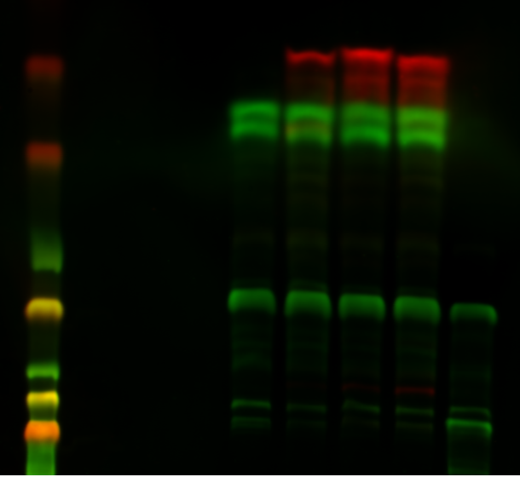

As seen above, the NLuc/tul4 ratio for each ribosome follows the same pattern as the NLuc graph. Most notably, rpsU3 has the highest expression, while rpsU1 and rpsU2 are similar to wild-type levels.

Monday, July 18, 2022

To Do:
- Ribosome assay
Ribosome Assay
Today I will repeat the ribosome assay to validate my previous results. I will modify the experiment slightly and compare the three wild-type ribosomes which were purified on three different dates.
Tube | DNA | Ribosomes
1 | Phenol:chloroform purified pKR144 | Wild-type F. tularensis 11/10/21 - 1
2 | Phenol:chloroform purified pKR144 | Wild-type F. tularensis 3/22/19
3 | Phenol:chloroform purified pKR144 | Wild-type F. tularensis 11/13/20 (used the ones diluted 6/25/21)
4 | Phenol:chloroform purified pKR144 | F. tularensis Tn7::rpsU1-V
5 | Phenol:chloroform purified pKR144 | F. tularensis Tn7::rpsU2-V
6 | Phenol:chloroform purified pKR144 | F. tularensis Tn7::rpsU3-V
7 | Phenol:chloroform purified pKR144 | H10M10A50 Buffer
To dilute the DNA I mixed 9.60 uL of 0.1X EB with 6.40 uL of phenol:chloroform purified pKR144 to make 16 uL.
I diluted the ribosomes following the chart below. There was already a tube of diluted WT from 11/13/2020.
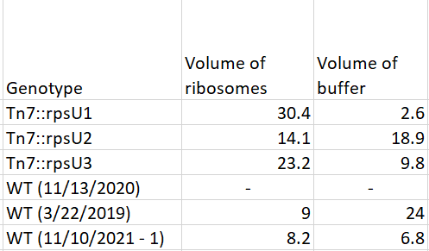
I then incubated the samples in the thermocycler for 4 hours.
After incubation, I put the samples on ice to stop the reactions. I then removed 5 uL of each sample and put it in a new set of PCR tubes to be used for a future Western blot.
Added 4 uL substrate to 200 uL buffer to make 200 uL reagent.
I then added 25 uL of reagent to each sample and mixed by pipetting. Let sit for 3 mins. at room temperature. Next, I added 15 uL of each sample to the wells in triplicate and measured the luminescence using the plate reader. I then removed 6 uL from the first well of each sample and put it in a new set of PCR tubes to be used for the Western blot. This will help determine if there is a difference in the Western blot before and after the luciferase assay. If there isn’t, it will make the protocol much easier.
Well | Sample
A1 | Wild-type F. tularensis ribosomes 11/10/21 + substrate A
A2 | Wild-type F. tularensis ribosomes 11/10/21 + substrate B
A3 | Wild-type F. tularensis ribosomes 11/10/21 + substrate C
A6 | Wild-type F. tularensis ribosomes 3/22/19 + substrate A
A7 | Wild-type F. tularensis ribosomes 3/22/19 + substrate B
A8 | Wild-type F. tularensis ribosomes 3/22/19 + substrate C
D1 | Wild-type F. tularensis ribosomes 11/13/20 + substrate A
D2 | Wild-type F. tularensis ribosomes 11/13/20 + substrate B
D3 | Wild-type F. tularensis ribosomes11/13/20 + substrate C
D6 | F. tularensis Tn7::rpsU1-V ribosomes + substrate A
D7 | F. tularensis Tn7::rpsU1-V ribosomes + substrate B
D8 | F. tularensis Tn7::rpsU1-V ribosomes + substrate C
G1 | F. tularensis Tn7::rpsU2-V ribosomes + substrate A
G2 | F. tularensis Tn7::rpsU2-V ribosomes + substrate B
G3 | F. tularensis Tn7::rpsU2-V ribosomes + substrate C
G6 | F. tularensis Tn7::rpsU3-V ribosomes + substrate A
G7 | F. tularensis Tn7::rpsU3-V ribosomes + substrate B
G8 | F. tularensis Tn7::rpsU3-V ribosomes + substrate C
A11 | H10M10A50 Buffer + substrate A
B11 | H10M10A50 Buffer + substrate B
C11 | H10M10A50 Buffer + substrate C
F12 | H10M10A50 Buffer
The average luminescence of each sample, with its standard deviation, can be seen below:
Sample | Averages | St. dev
WT 11/10/21 | 53803.3 | 546.027
WT 3/22/19 | 208403 | 4223.30
WT 11/13/20 | 49895 | 875.851
rpsU1 | 36273.3 | 884.269
rpsU2 | 35388 | 260.397
rpsU3 | 77116.6 | 804.595

Western Blot
- Add an equal volume of 2X SLB to each sample (saved from ribosome assay) - Mix by pipetting
- Heat in thermocycler at 95C for 10 mins
- Store in -20C freezer box

Tuesday, July 19, 2022

To Do:
- Western blot day 1
Western Blot Day 1
Today I will repeat the western blot to measure the levels of tul4 for each of the samples used in the assay yesterday.
Well | Sample | Volume (uL)
1 | WesternSure Ladder | 5
2 | 1- Wild-type F. tularensis 11/10/21 Before | 10
3 | 2- Wild-type F. tularensis 3/22/19 Before | 10
4 | 3- Wild-type F. tularensis 11/13/20 Before | 10
5 | 4- F. tularensis Tn7::rpsU1-V Before | 10
6 | 5- F. tularensis Tn7::rpsU2-V Before | 10
7 | 6- F. tularensis Tn7::rpsU3-V Before | 10
8 | 7- H10M10A50 Buffer Before | 10
9 | 1- Wild-type F. tularensis 11/10/21 After | 10
10 | 2- Wild-type F. tularensis 3/22/19 After | 10
11 | 3- Wild-type F. tularensis 11/13/20 After | 10
12 | 4- F. tularensis Tn7::rpsU1-V After | 10
13 | 5- F. tularensis Tn7::rpsU2-V After | 10
14 | 6- F. tularensis Tn7::rpsU3-V After | 10
15 | 7- H10M10A50 Buffer After | 10
*Before denotes samples taken before adding the luciferase assay reagent
Left the blot in blocking solution on the rocker overnight.

Wednesday, July 20, 2022

To Do:
- Western blot day 2
Western Blot Day 2
Make primary antibody solution:
4.5 uL anti-VSVG (bS21)
10 uL anti-tul4
10 mL diluted blocking buffer
Put in 50 mL tube and invert to mix
Rotate for 1 hour at room temperature
Meanwhile, make wash buffers:
- 100 mL PBS-T
  - 10 mL 10X PBS
  - 90 mL ddiH2O
  - 500 uL NP-40
- 30 mL PBS
  - 3 mL 10X PBS
  - 27 mL ddiH2O
Wash 4x on rotator for 10 minutes each, using 10 mL wash buffer per wash
Use 10 mL diluted blocking buffer and block again, for 15 min
Make secondary antibody solution: (keep in black box – light sensitive)
1 uL red anti-rabbit (bS21)
1 uL green anti-mouse (tul4)
10 mL PBS-T (wash w/ detergent)
10 uL 10X SDS
Put in 50 mL tube and invert to mix
Rotate for 1 hour at room temperature
Wash 4x on rotator for 10 minutes each, using 10 mL wash buffer per wash
Wash 2x on rotator for 10 minutes each, using 10 mL of wash buffer WITHOUT detergent
If faint bands are expected, do a quick methanol rinse by dunking the blot in methanol for 2 seconds then letting air dry for 2 minutes prior to imaging.
Imaging
Leave the membrane in the box containing the final wash buffer. Bring the box, gloves, forceps, and a timer to the imager in the INBRE facility.
Blot | Protein | kDa | Primary Dilution | Secondary Dilution
1 | bS21-VSVG (anti-VSVG) | 9 | 1:2222 | 1:10,000 anti-rabbit, 680 CW (red)
1 | Tul4 | 17 | 1:1000 | 1:10,000 anti-mouse, 800 CW (green)

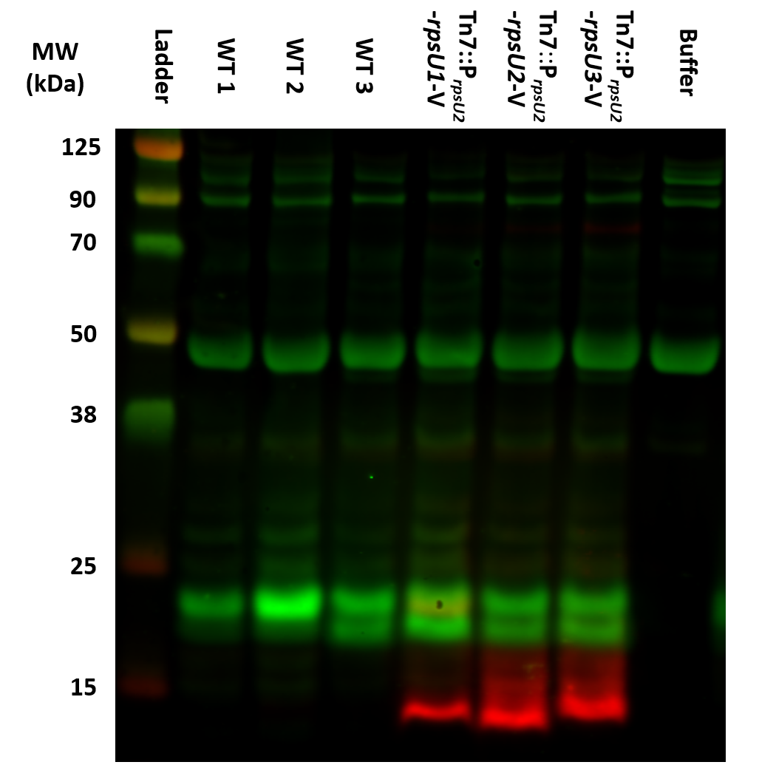

Thursday, July 21, 2022

To Do:
- Work on poster

Friday, July 22, 2022

To Do:
- Work on poster

Monday, July 25, 2022

To Do:
- Make hemoglobin
- Overnight cultures
- Add primers to reaction tubes
Transformation Analysis / Overnight Cultures
Today I checked the transformation plates Hannah prepared last week of pKR127. This plasmid is the exact same backbone as mine (pKR144) but instead of the tul4 gene it has another luciferase gene. Therefore, we can use the dual glo luciferase assay to measure the levels of translation from both the pdpA and tul4 UTRs using the luminometer instead of having to perform an additional Western blot.
There were a ton of colonies present on the positive control plate (pKR144) and no colonies on the negative control plate. For the ligation plates, Hannah did both a regular ligation and a calculated one. The colony counts and ratios for each are below:
Backbone: 30
Regular: 105 (3.5)
Calculated: 312 (10.4)

Since the ratios were good for both ligations, I will prepare overnight cultures using one small colony from the regular plate, one big colony from the calculated plate, and two small colonies from the calculated plate. Hannah will use these tomorrow to miniprep and prepare for sequencing.

- Add 5 mL of LB broth to a sterile glass culture tube
- Add 5 uL of carbenicillin (Carb) to the tube
- Vortex briefly to mix
- Warm in shaking incubator
- Using a stick, pick the isolated colony from the plate and inoculate the tube
- Place in the 37°C shaking incubator overnight. ~16-22 hours
Put in the incubator at 3:20 pm.
1: small colony from regular late
2: big colony from calculated plate
3: small colony from calculated plate
4: small colony from calculated plate

Tuesday, July 26, 2022

To Do:
- Miniprep
- Sequence reactions
- Make MHB

MHB Protocol
- Add 10.5 g MHB and 500 mL ddiH2O to 1 L orange-topped jar
- Shake to mix
- Autoclave on 30 min. liquid cycle

Hannah miniprepped the overnight cultures I made yesterday and prepared sequence reactions. Once we get the results back we can determine which miniprep has the correct sequence and proceed from there.

Thursday, July 28, 2022

To Do:
- Prepare SOC media
- Transform pKR147
- Isolate siderophore

SOC Media Protocol
- Add 95 mL dH2O to 250 mL orange-topped jar
- Add and dissolve the following:
  - 2.0 g tryptone
  - 0.5 g yeast extract
  - 1 mL 1M NaCl
    - 1 mL 5 M NaCl + 4 mL dH2O
  - 0.25 mL 1M KCl
- Adjust to pH 7.0 using pH probe in INBRE
  - Add HCl or 5 N NaOH depending on starting pH
- Autoclave in instapot for 30 mins
- Cool in water bath to temperature below 60C
- Add 1 mL filter-sterilized 2M Mg+2
  - Equal volumes sterile 1 M MgCl + sterile 1 M MgSO4
  - Used Hannah’s MgCl
  - MgSO4: 40 mL dH2O + 9.8 g MgSO4
- Add 1 mL filter-sterilized 2M glucose
  - 40 mL dH2O + 14.45 g glucose
- Add sterile dH2O to a final volume of 100 mL

NEB 5-alpha Competent E. coli Transformation Protocol
Today I will transform more pKR147 so I will have enough minipreps to phenol-chloroform purify next week. Hannah checked the sequences of the previous minipreps we sent in and one out of the four looked good, so I will use that miniprep (miniprep 1) to proceed. The protocol is below:
Reaction table
Tube number | Purpose | DNA | Volume of DNA | Final volume to plate | Number of carbenicillin-containing plates
1 | (+) control | pKR147 | 1 uL | 20 ul, 100 uL | 2
2 | (-) control | None | 0 | 20 ul, 100 uL | 2
Total number of plates |  |  |  |  | 4

- Check to be sure you have enough LB plates with appropriate antibiotic. If plates were stored at 4°C, warm at 37°C until needed
- Obtain DNA and thaw on ice if necessary
- Thaw appropriate number of competent cell tubes (1 per reaction) on ice for 10 mins.
- Add appropriate amount of DNA to each tube. Flick 4-5 times to mix. Do not vortex
- Incubate cells on ice for 30 minutes. During incubation, find or set heat block to 42°C. Do not mix
- Place tubes with cells and DNA onto 42°C heatblock for 30 seconds (heat shock step). Do not mix
- After heat shock, place tubes back on ice for 5 mins. Do not mix
- Using aseptic technique, add 950 uL of room temperature SOC media to each microfuge tube
- Using autoclave tape, tape microfuge tubes down in shaking incubator set to 37°C.
- Allow cells to recover for 1 hour at 37°C, shaking. Place in a rack after shaking (NOT back on ice).
- Using aseptic technique, plate indicated amount of cells on appropriate antibiotic plates (LB-Carb), spreading until plates look dry. For “remaining” volume, spin tubes at max speed in benchtop centrifuge for 30 seconds. Remove 800 uL of media. Using 200 uL pipette, resuspend cells at bottom of tube and plate all the remaining culture.
Left plates on bench at room temperature over the weekend.

Fractionating Siderophore from Conditioned Media Protocol
- Set up StrataX 3 mL column on vacuum manifold
- Run 2 column volumes of methanol through column
  - Collect in waste bucket
- Run 4 column volumes of water through column
  - Collect in waste bucket
- Run sample through column (initial test with 12 mL)
  - Collect flow through in medium vial
- Run 2 column volumes of water through column
  - Collect in waste bucket
- Wash column with 2.5 mL methanol
  - Collect in small vial
- Remove column from vacuum (confirm with Dr. Rowley for disposal)
- Run small sample vial in Speedvac on manual run for 1-1.5 hours (until methanol is fully gone)
- Filter-sterilize remaining conditioned media (collected in medium vial) – save in 4C fridge
Obtained approximately 125 uL of siderophore from the ~13 mL conditioned media. The OD600 of the conditioned media I used (from June 8th, 2022) was approximately 1.46.
Assuming that the siderophore bound to the membrane in the column, the remaining conditioned media should only contain any other nutrients that may be present. I left both this remaining media and the siderophore in the 4C fridge.

4 mL cultures (split siderophore 4 ways)
Measure 600 uL at time 0 (before supplementing)
Determine proportion of siderophore to media and make a blank (1 mL)
Start cultures above 4 mL, after taking OD600 should end up at 4 mL, then supplement
Save blanks for next day (put parafilm on cuvette and put in fridge)
Do 600 uL if below 0.1
Do 300 uL if above 0.1 and dilute with 300 uL MHB
(take 300 uL of supplemented blank and 300 uL MHB for blank)

125 uL siderophore:
28 uL to each culture
7 uL to blank

August 2022

Monday, August 1, 2022

To Do:
- Streak out ΔrpsU2
Growth Experiment
Today I streaked out ΔrpsU2 on a non-antibiotic CHAH plate and left it in the standing incubator. This will be used for the growth experiment on Wednesday.
Transformation Analysis
I also checked the transformation plates I had left on my bench over the weekend. There were no colonies on the negative control plates and there was growth on the two positive plates but the colonies were still very small. This was probably due to the AC being on all weekend so they did not grow very well. I put them in the 30C incubator overnight to allow them to grow.

Tuesday, August 2, 2022

To Do:
- Streak out LVS
- Prepare overnight cultures
Growth Experiment
Today I streaked out LVS on a non-antibiotic CHAH plate and left it in the standing incubator overnight. I also made preparations for the growth experiment.
Transformation Analysis / Overnight Cultures
The transformation plates looked good, with lots of growth on both positive control plates. In the future I should use 5 uL instead of 100 uL since it was difficult to pick isolated colonies.
I prepared 8 overnight cultures using LB-Carb media and left them in the shaking incubator set to 30C overnight at 2:55 pm.

Wednesday, August 3, 2022

To Do:
- Growth experiment
- Miniprep
Growth Experiment
Today I will perform a growth experiment to test if the addition of siderophore results in the loss of the growth defect in ΔrpsU2.

I will grow 8 cultures using different media and different cells and compare their growth:
2 cultures of LVS in fresh MHB
2 cultures of LVS in supplemented fresh MHB
2 cultures of ΔrpsU2 in fresh MHB
2 cultures of ΔrpsU2 in supplemented fresh MHB
I prepared the cultures by first scraping the cells into their own tubes and diluting 1:20 in a cuvette using fresh MHB.
LVS: OD600 = 0.208 (added 88.4 uL to each 4.6 mL culture tube)
ΔrpsU2: OD600 = 0.190 (added 96.8 uL to each 4.6 mL culture tube)
I then checked the starting OD600s of each culture (600 uL).
I then added 26 uL of siderophore to half of the 4 mL cultures to make supplemented fresh MHB.
Started at 10:32 am.
I then checked the OD600s every 2 hours for 6 hours total.
As a blank for the supplemented fresh MHB I added 6.5 uL of siderophore to 1 mL of fresh MHB. I stored it in the fridge covered in parafilm throughout the day and overnight.
Left in the shaking incubator to grow overnight starting around 4:50 pm.

Miniprep Protocol
Today I will miniprep the overnight cultures of pKR147. I noticed that the overnight cultures had very little growth. This is probably a result of how small the colonies were as well as growing them at a lower temperature. Also, I dropped culture 1 when taking them out of the incubator so now there are only 7 minipreps.
- Pellet bacterial overnight culture by centrifugation (max speed for 3 min.) at room temp.
- Resuspend pelleted bacterial cells in 250 uL Buffer P1 (in fridge) and transfer to micro centrifuge tube
- Add 250 uL Buffer P2 and mix thoroughly by inverting the tube 4-6 times until the solution becomes clear
- Add 350 uL Buffer N3 and mix immediately and thoroughly by inverting the tube 4-6 times
- Centrifuge for 10 min. at 13000 rpm
- Apply 800 uL supernatant from previous step to QIAprep 2.0 spin column by pipetting
- Centrifuge for 1 min and discard flow through
- Wash column with 0.5 mL Buffer PB
- Centrifuge for 1 min and discard flow through
- Wash column with 0.75 mL Buffer PE
- Centrifuge for 1 min and discard flow through (wash with PE 3x)
- Centrifuge for 3 min.
- Place column in 1.5 mL microcentrifuge tube; add 50 uL 0.1X Buffer EB to center and let stand 1 min.
- Centrifuge for 1 min.
- Save in -20 fridge
I then checked the concentrations using the nanodrop:
2: 3.5 ng/uL
3: 10.1 ng/uL
4: 4.9 ng/uL
5: 5.5 ng/uL
6: 7.4 ng/uL
7: 9.5 ng/uL
8: 5.4 ng/uL
Since all of the concentrations were extremely low, I decided not to continue on with the phenol-chloroform purification. I will prepare 8 new overnight cultures using the same transformation plate, which I had saved on my bench, using LB-Carb media. I also prepared an LB-Carb blank. Left them in Dr. Rowley’s shaking incubator set to 30C at 1 pm.

Thursday, August 4, 2022

To Do:
- Finish growth experiment
- Miniprep
Growth Experiment
I took out the culture tubes at 10:40 am and checked their final OD600s. All four ΔrpsU2 tubes visibly looked like they grew less than LVS. Also, the two LVS in supplemented media had precipitate.

When viewing the graph above, you can see that there is no difference between the strains grown in fresh MHB and siderophore supplemented MHB. ΔrpsU2 has a clear growth defect compared to LVS, which was not altered when grown in supplemented media. This means that either it is not siderophore which leads to the loss of the growth defect as seen in previous experiments, or what we fractionated from the conditioned media was not actually siderophore. Alternatively, we might not have supplemented the fresh MHB with enough of the fractionate to result in a noticeable difference.
Miniprep
The overnight cultures look like they barely grew again. They were only slightly cloudier than the LB control I used.
I took out cultures 3 and 7 from the incubator at 11 am and left the rest of the cultures to grow. I then miniprepped the two cultures, this time eluting in 30 uL of 0.1X EB. When I added the buffer to the membrane to elute, I let it sit for 1 min. and then spun down. I then pipetted the elution back onto the membrane and spun it again.
I then checked the concentrations using the nanodrop:
3: 15.3 ng/uL
7: 11.9 ng/uL

Friday, August 5, 2022

To Do:
- Clean out lab
I had left the overnight cultures from Wednesday in the shaking incubator to see if they would every grow. They did, however I decided not to miniprep them since whatever is growing most likely doesn’t contain the plasmid since it would have had time to develop antibiotic resistance.

