Table of Contents
Introduction 2
Figure 1 2
Thoughts or questions. 2
Protocol 1 2
Reagents 3
File Formatting Protocol 3
October 2018 4
November 2018 7
How to make Chemically Competent E. coli 7
QIAprep Spin Miniprep Kit Protocol: 9
PCR Protocol (Reaction Set A) 11
Agarose Gel Protocol 12
December 2018 15
PCR Protocol (Reaction Set B) 15
Agarose Gel Protocol 17
PCR Purification Protocol 18
DNA Cutting Protocol by John Church 19
DNA Size Separation Protocol 19
Gel Extraction Protocol 20
Ligations Protocol 21
Transforming Chemically Competent E. coli Cells Protocol 22
Bibliography 23

Introduction

Thursday, September 20, 2018
To Do:
- Explain lab notebook formatting
- Media prep
Results and Data:
For each day, copy the previous entry headers and update the date. Save the same ongoing copy of the lab notebook to the lab google drive ONLY. Do not save separate physical copies. At the 1st of each new month, a read-only PDF file of the lab notebook must be saved and given to Dr. Ramsey electronically. File contents converted to PDF MUST NOT BE EDITED after PDF conversion. Continue to keep using the same word file until the end of the calendar year. New lab notebook files run in 6 month intervals.
For the To do list, update this each day with new tasks, as tasks are done, use the strikethrough font on the day they are completed and leave them out of the list on the next day.
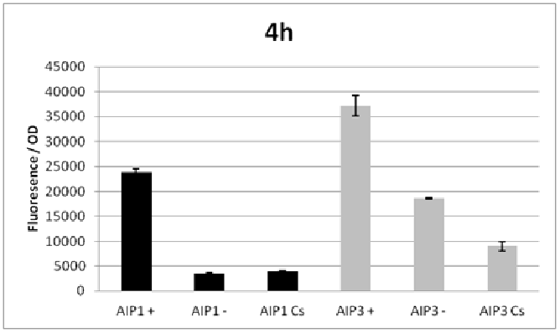

Figure 1
Figures are inserted as inline .png files when possible, .jpg, .gif, .tif otherwise are acceptable. Figure legends are always inserted in Word (right click – ‘insert caption’) and use “Heading 2” text to properly format in the TOC. Table legends are handled the same way. Figure images must be saved in a separate folder where the source data is saved.
Thoughts or questions. When you have a significant observation, question, confusing point or contradiction that you have identified in your data or protocol, use the “Heading 3” text heading on a descriptive brief title or single word heading so you can refer to it in your TOC later.

Protocol 1
1. This is the format for a protocol in your notebook.
2. The protocol title must be formatted in “Heading 2.”
3. Reagents which must be made for a specific protocol (buffers, solutions) should be listed in a “Reagents” Section, formatted in “Heading 3.”
4. The protocol must be in numerical steps.
5. Use standard notation and carefully describe units for your protocol.
6. Use ½” indent for protocol text.

Reagents
Specific buffers
For initial lab notebooks, write as much detail as possible. As time goes by you will be able to refer to written protocols by their heading and/or page number within the document. If you make any modifications to a protocol you must state how and why.

File Formatting Protocol
1. Filenames begin with your initials, an underscore, and the date, formatted as the last 2 digits of the year, the month, then the day, ex: “KMR_180920_Sample_file1v1.xls”
2. This ensures all files will be sorted by their creator and by their date. You must use this file formatting system for all data files (including photos) that will be shared with the lab.
Bibliography data will be saved as (author/date) and using Mendeley at this time with the TOC inserted by order cited at the end of the lab notebook in the Bibliography section.
Example is a recent publication (Ramsey and Dove, 2016).

October 2018

Wednesday, October 3, 2018
To Do:
- Design primers/oligos for overexpression of rpsU genes
- ?
Results and Data:
Notes on primer design
Spreadsheet in Team Drive, “DesigningPrimers.xlsx”
Goal: Sort pieces of DNA homologous to region of amplification w/ following specifications
- “Calculated melting temperature” (aka old version) = 72º C
  - Calculation: (A + T)*2 + (G + C)*4 = Tm
  - Plus or minus 2 is okay (plus being better) but match the primer melting temperatures with each other
- Choose the DNA to be amplified (amplicon) carefully, depending on goal
Today’s primer goal:
Design primers to amplify rpsU1 (FTL_0456) to clone into overexpression plasmid
- Include start codon and stop codon
- At the 5’ end, check to be sure there is a promoter and ribosome binding site (RBS); these may be on the plasmid already
1st Primer sequence: ttaaataaatgctcttctctgagaaattc
- Is homologous to the 3’ end of FTL_0456

Tuesday, October 22nd
E. coli competent cells protocol
Reagents:
- Solution A
  - 10 mL of 1.0M MnCl₂
  - 50 mL 1.0M CaCl₂
  - 200mL MES, pH 6.3
  - 740mL of ddiH2O

- Solution A + 15% glycerol
  - 10 mL of 1.0M MnCl₂
  - 50 mL 1.0M CaCl₂
  - 200mL MES, pH 6.3
  - 590mL of ddiH2O
  - 150mL of glycerol

How to make 250 mL of 55mM of MES
FW of MES = 213.25 g/mol
Calculation:
$$\frac{50mmol}{1 L soln} × \frac{1 L}{1000 mL} × \frac{250 mL}{1} × \frac{1 mol}{1000 mmol} × \frac{213.25 g}{1 mol} = 2.67g$$

Wednesday, October 24th
- Streak a nutrient agar plate with XL1 Blue E. coli and incubate it overnight

Thursday, October 25th
- 22 hours after inoculation of NA with XL1 Blue E. coli

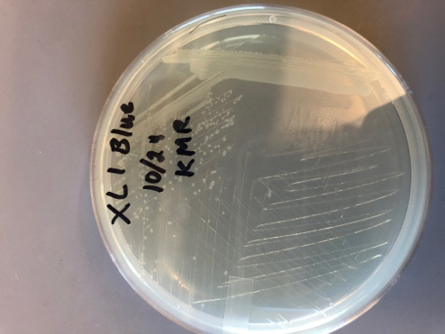
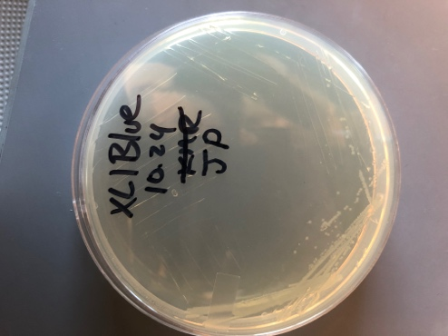

Tuesday, October 30th
Loading agarose gel (left to right)
Lane Contents Expected size
1 2-log NEB ladder varies
2 CS #1 P820 P821 994 bp
3 CS #2 P780 P781 443 bp
4 CS #3 P780 P781 0 bp
5 JC #1 P825 P825 772 bp
6 JC #2 P780 P781 443 bp
7 JC #3 P780 P781 0 bp
8 KR #1 P820 P821 994 bp
9 KR #2 P780 P781 443 bp
10 KR #3 P780 P781 0 bp
11 – 15 Empty

Loaded by me (Joe), specifically
Ran gel at 113 V for unspecified time

Wednesday, October 31st
- Inoculate LB tubes with XL1 Blue E. coli

November 2018

Thursday, November 1st
To do:
- Check lab tasks
- Making competent E. coli cells

How to make Chemically Competent E. coli

Day 1
- Streak out E. coli strain of interest on appropriate LB-agar plates (+/- antibiotic as necessary).
- Incubate overnight at 37°C.
Day 2
- Prepare a sterile test tube for E. coli culture by adding 5 mL sterile LB using aseptic technique. Add antibiotic to culture if E. coli strain contains antibiotic resistance gene.
- Inoculate media in test tube with a single well-isolated colony from plates grown overnight.
- Incubate test tube at 37°C, shaking, overnight (~15-18 hours).
- Store plates with E. coli colonies at 4°C, wrapped in parafilm.
Day 3
- Add 3 mL of sterile MgCl₂ to 200 mL LB in 1 L flask. Add antibiotic if appropriate.
We used 1-L flask that is not baffled
- Inoculate 200 mL LB with 0.5 mL of culture grown overnight.
- Incubate 200 mL culture at 37°C, shaking until culture reaches an OD600 of 0.5.
- Monitor culture growth by assessing OD600 using the spectrophotometer: At 3, 4, and 5 hours or at appropriate times between, measure OD600
Use a cuvette with 1 mL LB as a blank
Add 1 mL culture from flask to a cuvette
Use MRamsey lab spectrophotometer set to a wavelength of 600nm
After ~6 hours, OD600 = 0.55 and we split culture into 4 50-mL conicals to spin down
- When cultures approach correct OD, cool down centrifuge to 4°C (Dutta lab benchtop centrifuge)
- When culture reaches an OD600 of approximately 0.5, transfer culture volume to sterile tubes (4x 50 mL conical) to pellet bacteria
- Place tubes in cool centrifuge and pellet bacteria by spinning (in Dutta lab benchtop centrifuge, 15 minutes at 4000 rpm).
- Remove tubes from centrifuge, decant the supernatant into a waste bottle, and keep cell pellets on ice
- Add a total of 60 mL cold solution A to cell pellets from the original 200 mL culture. If you are using four 50 mL conical tubes, each tube should contain 15 mL cold solution A.
- VERY gently resuspend cell pellet by pipetting up and down. Don’t completely dispense liquid with each cycle, to prevent creating bubbles/froth. The cells should be completely homogeneous when done (no clumps or chunks)
- Incubate resuspended cells on ice for at least 20 minutes (can stay on ice for up to 3 hours).
- Place tubes in cool centrifuge and pellet bacteria by spinning (in Dutta lab benchtop centrifuge, 15 minutes at 4000 rpm).
- While cells are spinning, prepare tubes for final competent cell aliquots: label and pre-chill on ice.
- Remove tubes from centrifuge, decant the supernatant into a waste bottle, and keep cell pellets on ice
- Add a total of 12 mL cold solution A + 15% glycerol to cell pellets from the original 200 mL culture. If you are using four 50 mL conical tubes, each tube should contain 3 mL cold solution A + 15% glycerol.
- VERY gently resuspend cell pellet by pipetting up and down as previously.
- Aliquot competent cells in 550 uL volumes into sterile pre-cooled 1.5 mL microcentrifuge tubes.
- If available, freeze cells immediately upon aliquoting using using dry ice.
- Store competent cells at -80°C.
- At first use, test competency of cells by transforming with a known amount of supercoiled plasmid and record the transformation efficiency.

Required items
LB-agar plates with appropriate antibiotic
Sterile capped test tubes
1 L flask containing 200 mL sterile LB
1 M MgCl₂ sterilized by autoclaving
Sterile tubes for spinning down 200 mL culture
Sterile microfuge tubes for final competent cell aliquots
Bucket with ice
Solution A
Solution A + 15% glycerol

Solution A:
Combine 10mL of 1M MnCl₂, 50 mL 1M CaCl₂, 200 mL 50 mM 2-morpholino-ethanesulfonic acid (MES) pH 6.3, and 740 mL ddH₂O

Wednesday, November 7th
To do:
- Count colonies on plates from yesterday’s transformations
- Calculate transformation efficiency using pUC19 data (we know how much pUC19 DNA we added to the transformation, 50 pg). See below for formula and example
- Start inoculate small (5mL) cultures with colonies containing the different plasmids (pKL02, pKL80, and pF). Cultures will grow overnight and we’ll isolate the plasmid DNA tomorrow.

How to calculate Transformation Efficiency:
TE = Colonies/µg/Dilution
- Colonies = the number of colonies counted on the plate
- µg = the amount of DNA transformed expressed in µg
- Dilution = the total dilution of the DNA before plating

Plasmid Construct – Number of Colonies
Volumes Aliquoted | pKL02 | pKL80 | pF | pUC19
20 µL | 7 | 39 | 7 | 0
100 µL | 80 | 290 | 122 | 8
Remaining ~1mL | TMTC | TMTC | TMTC | 17
Transformation Efficiency |  |  |  | 1.76e6

Thursday, November 8th

QIAprep Spin Miniprep Kit Protocol:

Notes before starting:
- Optional: Add LyseBlue reagent to Buffer P1 at a ratio of 1 to 1000.

- Pellet 5 ml bacterial overnight culture by centrifugation at 10000 x g for 1 min at room temp (15-25ºC). Pipette 1.5 ml culture into the tube, spin, discard the supernatant, and repeat until all 5 ml are gone.
- Resuspend pelleted bacterial cells in 250 µl Buffer P1 (stored at 4ºC) and transfer to microcentrifuge tube.
- Add 250 µl Buffer P2 and mix thoroughly by inverting the tube 4-6 times until the solution becomes clear. Do not allow the lysis reaction to proceed for more than 5 min. If using LyseBlue reagent, the solution will turn blue.
- Add 350 µl Buffer N3 and mix immediately and thoroughly by inverting the tube 4-6 times. If using LyseBlue reagent, the solution will turn colorless.
- Centrifuge for 10 min at 13,000 rpm (~17,900 x g) / max. speed in a table-top microcentrifuge.
- Apply 800 µl supernatant from step 5 to the QIAprep 2.0 spin column by pipetting. For centrifuge processing, follow the instructions marked with a triangle. For vacuum manifold processing, follow the instructions marked with a circle. Centrifuge for 30-60s and discard the flow-through, or apply vacuum to the manifold to draw the solution through the QIAprep 2.0 spin column and switch off the vacuum source.
- Recommended: Wash the QIAprep 2.0 spin column by adding 0.5 ml Buffer PB. Centrifuge for 30-60s and discard the flow-through, or apply vacuum to the manifold to draw the solution through the QIAprep 2.0 spin column and switch off the vacuum source.
  - Note: This step is only required when using endA+ strains or other bacteria strains with high nuclease activity or carbohydrate content.
- Wash the QIAprep 2.0 spin column by adding 0.75 ml Buffer PE. Centrifuge for 30-60s and discard the flow-through, or apply vacuum to the manifold to draw the solution through the QIAprep 2.0 spin column and switch off the vacuum source. Transfer the QIAprep 2.0 spin column to the collection tube.
- Centrifuge for 3 min to remove residual wash buffer.
- Place the QIAprep 2.0 column in a clean 1.5 ml microcentrifuge tube. To elute DNA, add 50 µl 0.1x Buffer EB (10 mM TrisCl, pH 8.5) or water to the center of the QIAprep 2.0 spin column, let stand for 1 min, and centrifuge for 1 min.
- If the extracted DNA is to be analyzed on a gel, add 1 volume of Loading Dye to 5 volumes of purified DNA. Mix the solution by pipetting up and down before loading the gel.

Wednesday, November 14th

pKL116 pEX_PriM_mtip1

Reaction set A:
1 P820 & P700 = 438 bp
2 P701 & P821 = 599 bp
Amplify from LVS gDNA

Number | Primers | Target | Expected Size | For plasmid
1 | P820 and P700 | PriM mtip1 | 438 bp | pKL116
2 | P701 and P821 | PriM mtip1 | 599 bp | pKL116
3 | P820 and P821 | positive control | 1006 bp | -
4 | P820 and P821 | negative control | - | -

Total reaction volume |  | 25
Total number of reactions |  | 4
 |  |  |  | Factor
Component | Stock concentration | Final concentration | 1 rxn volume | 5.5
ddiH2O |  |  | 5 | 27.5
KOD buffer | 2x | 1x | 12.5 | 68.75
dNTPs | 2 mM | 0.4 mM | 5 | 27.5
oligo F | 10 uM | 0.3 uM | 0.75 | 4.125
oligo R | 10 uM | 0.3 uM | 0.75 | 4.125
texmplate | 100 ng/ul | 2 ng/ul | 0.5 | 2.75
KOD | 1 U/ul | 0.02 U/ul | 0.5 | 2.75
 |  | Total volume | 25 | 137.5

PCR Protocol (Reaction Set A)

- Acquire and label 4 PCR tubes with initials and designate as Tubes 1-4
  - The tubes come in strips of 8 and they can be split into 4 tube pieces so that the first 3 tubes are used and the fourth is unused
- Get a container of ice to keep the components on
- Acquire the following components and put them on ice, labeling tubes if necessary:
  - ddi H2O in 1.5 mL microfuge tube
  - 12.5 uL KOD buffer
  - dNTPs
  - oligo F
  - oligo R
  - template
  - Note: KOD enzyme should be kept in the freezer until it is used as it is expensive and should be added last
- Centrifuge the microfuge tubes to get any solution out of the microfuge tube cover
- If any of the solutions are frozen, be sure to vortex the microfuge tube in order to dissolve it (tubes with frozen components may not be homogenized)
  - DO NOT vortex the KOD enzyme itself or any solution with KOD enzyme because vortexing will expose it to oxygen and degrade it
- Use PCR_worksheet.xlsx to make establish the specifics of what will be added
  - The file is located in the Protocols folder
  - For this protocol, a “Total reaction volume” of 25 uL and 4 “Total number of reactions” were used – the following volumes are based on these specifications
- Add 0.75 uL of each experiment specific primer (forward and reverse) to PCR Tubes 1 and 2 (oligos forward and reverse)
  - The amount added should be calculated by taking the total volume for 1 reaction (in worksheet) and subtracting the volumes for 1 reaction that have not yet been added to the master-mix
- Add 0.75 uL of each control primer (oligos forward and reverse) to PCR Tubes 3 and 4
- Add 0.5 uL ddi H2O to PCR Tube 4 so that all 4 PCR Tubes have an even amount of solution
- Prepare a master-mix in a 1.5 mL microfuge tube by adding the following according to the worksheet and using micropipettes:
  - Add 27.5 uL ddi H2O
  - Add 27.5 uL dNTPs
  - Add 68.75 uL KOD buffer
  - Add 2.75 uL KOD enzyme
- Mix the master-mix solution by pipetting up and down
  - Do not vortex to mix
- Add 23 uL of master-mix to PCR Tube 4
- Add 2.25 uL template to Master Mix
- Add 23.5 uL master mix to each PCR Tube 1-3 and pipette up and down to mix (conserves tips)
- Close PCR Tubes 1-4 until the caps are tight (push until the caps do not squeak when you push on them)
- Place the PCR Tubes in the thermocycler on STN 1 – the following settings should be in place:
  - Heat at 94 degrees for 2 minutes,
  - 94 degrees C for 20 seconds
  - 50 degrees C for 30 seconds
  - 68 degrees C for 1 minute and 20 second [modified because product is 1334 bp which is over 1 kbp] (KOD polymerase functions properly at 68 degrees C; TAC polymerase is different temp)
  - Go back to step 2
  - Repeat 32x
  - 68 degrees C for 5 minutes
  - 12 degrees C for infinity

Thursday, November 15th
To do:
- Make agarose gel to run PCR samples made on Wednesday 11/14/18. Consult protocol for Agarose Gel below:

Agarose Gel Protocol
by Joe Paquette
(Note: all ddiH2O is type I)
- Mix 25x TAE buffer with ddiH₂O to obtain 1x TAE solution.

- To make 1 L of 1x TAE, add 40 mL 25x TAE into 1 L graduated cylinder and fill to 1 L with ddiH2O.

- Add 1 g agarose powder to 100 mL 1x TAE buffer in 250 mL.
- Add stirbar to container.
- Heat to dissolve the agarose while stirring (don’t let over boil, should look like clear liquid, no solids).
- Once the sugar has dissolved, make a 1x concentration of SYBR safe in the 1% agarose solution.
- To make, add 10µL of 10,000x SYBR safe dye to the 1% agarose solution
- Let the 1% agarose solution cool to approximately 50-55°C.
- Apply autoclave tape to the edges of the gel cast (ensure the tape is tightly bound).
- Pour 1% agarose - 1x SYBR safe solution into the cast and insert a comb to mold wells in the gel.
- Let sit until the 1% agarose – 1x SYBR safe solution has cooled and solidified into a gel.
- Carefully remove the comb.
- Pour the 100 ml of 1x TAE buffer solution into the gel tank (add just enough to slightly submerge the gel itself).
- Obtain 5 µL of each PCR sample.
- Make 1x loading dye in 6 µL of solution.

- To make 6 µL of 1x loading dye, combine 5 µL PCR sample with 1 µL of 6x loading dye

- Load 5 µL of the PCR-dye mixture into the wells in sequential order.
- Insert the electrodes and run the gel at about 113 volts.
Materials needed:
- 1.0g of agarose powder
- SYBR safe dye
- 1 packet of 25x TAE buffer mix

- Observe gel under UV light to determine presence of DNA.
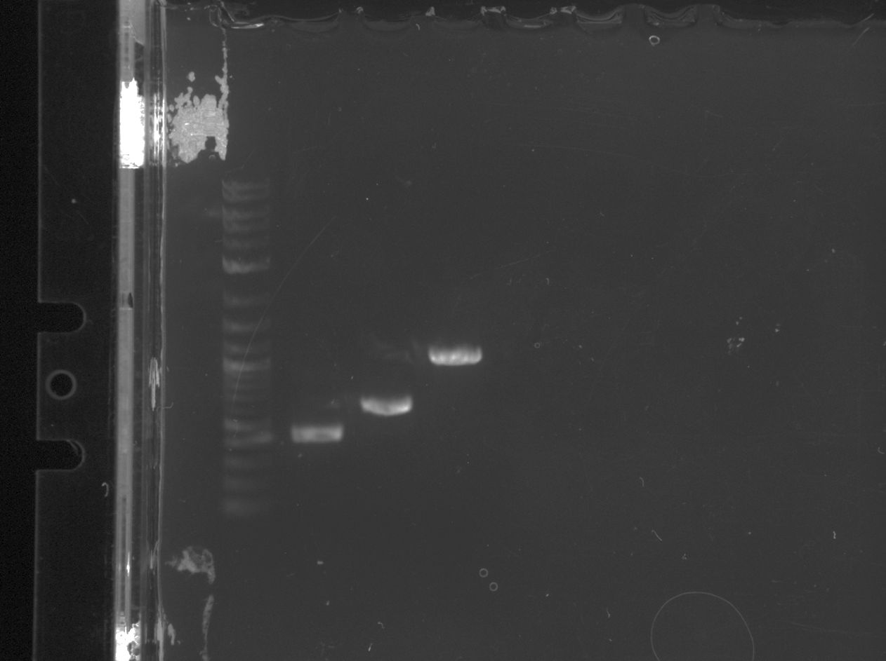
Notes:
- Sample 1 (438bp) traveled furthest
- Sample 2 (599bp) traveled second furthest
- Sample 3 (1006bp, positive control) traveled the shortest distance and is about in line with the 1kb mark on the ladder
- Sample 4 (negative control) did not show up because there was no DNA in the sample
- In Reaction set B, Samples 1 and 2 will be combined and then amplified to essentially create Sample 3, but with the mutations in the genome that will encode the PriM protein with negatively (-) charged residues at the tip rather than positively (+) residues

To do (Part II):
Reaction set B:
1 P820 & P821 = 1006
Amplify from reactions A1 & A2 diluted 1:10
- Add 1uL of 1A and 1uL of 2A to 8uL ddiH2O (creates 1:10 dilution for each sample)

December 2018

Tuesday, December 4th

To do:
- Complete PCR protocol for Reaction Set B
Number | Primers | Target | Expected Size | For plasmid
1 | P820 and P821 | PriM mtip1 | 438 bp | pKL116
2 | P820 and P821 | negative control | - | -

Total reaction volume |  | 100
Total number of reactions |  | 2
 |  |  |  | Factor
Component | Stock concentration | Final concentration | 1 rxn volume | 3.3
ddiH2O |  |  | 20 | 66
KOD buffer | 2x | 1x | 50 | 165
dNTPs | 2 mM | 0.4 mM | 20 | 66
oligo F | 10 uM | 0.3 uM | 3 | 9.9
oligo R | 10 uM | 0.3 uM | 3 | 9.9
template | 100 ng/ul | 2 ng/ul | 2 | 6.6
KOD | 1 U/ul | 0.02 U/ul | 2 | 6.6
 |  | Total volume | 100 | 330

PCR Protocol (Reaction Set B)

- Acquire and label 2 PCR tubes with initials and designate as Tubes 1-2
  - The tubes come in strips of 8 and they can be split into 4 tube pieces so that the first 3 tubes are used and the fourth is unused
- Get a container of ice to keep the components on
- Acquire the following components and put them on ice, labeling tubes if necessary:
  - ddi H2O in 1.5 mL microfuge tube
  - KOD buffer
  - dNTPs
  - oligo F
  - oligo R
  - templates (1 uL each A1 and A2)
  - Note: KOD enzyme should be kept in the freezer until it is used as it is expensive and should be added last
- Centrifuge the microfuge tubes to get any solution out of the microfuge tube cover
- If any of the solutions are frozen, be sure to vortex the microfuge tube in order to dissolve it (tubes with frozen components may not be homogenized)
  - DO NOT vortex the KOD enzyme itself or any solution with KOD enzyme because vortexing will expose it to oxygen and degrade it
- Use PCR_worksheet.xlsx to make establish the specifics of what will be added
  - The file is located in the Protocols folder
  - For this protocol, a “Total reaction volume” of 100 uL and 2 “Total number of reactions” were used – the following volumes are based on these specifications
- Add 3.0 uL of each experiment specific primer (forward and reverse) to PCR Tube 1 (oligos forward and reverse)
  - The amount added should be calculated by taking the total volume for 1 reaction (in worksheet) and subtracting the volumes for 1 reaction that have not yet been added to the master-mix
- Add 3.0 uL of each control primer (oligos forward and reverse) to PCR Tube 2
- Add 2.0 uL ddi H2O to PCR Tube 2 so that both PCR Tubes have an even amount of solution
- Prepare a master-mix in a 1.5 mL microfuge tube by adding the following according to the worksheet and using micropipettes:
  - Add 66 uL ddi H2O
  - Add 66 uL dNTPs
  - Add 165 uL KOD buffer
  - Add 6.6 uL KOD enzyme
- Mix the master-mix solution by pipetting up and down
  - Do not vortex to mix
- Add 92 uL of master-mix to PCR Tube 1 and Tube 2
- Add 2.0 uL template to PCR Tube 1
- Pipette up and down to mix (conserves tips)
- Close PCR Tubes 1 and 2 until the caps are tight (push until the caps do not squeak when you push on them)
- Place the PCR Tubes in the thermocycler on STN 1 – the following settings should be in place:
  - Heat at 94 degrees for 2 minutes,
  - 94 degrees C for 20 seconds
  - 50 degrees C for 30 seconds
  - 68 degrees C for 1 minute and 20 second [modified because product is 1334 bp which is over 1 kbp] (KOD polymerase functions properly at 68 degrees C; TAC polymerase is different temp)
  - Go back to step 2
  - Repeat 32x
  - 68 degrees C for 5 minutes
  - 12 degrees C for infinity

Wednesday, December 5th

To do:
- Make agarose gel to run PCR samples made on Wednesday 12/4/18. Consult protocol for Agarose Gel below:

Agarose Gel Protocol
by Joe Paquette
(Note: all ddiH2O is type I)
- Mix 25x TAE buffer with ddiH₂O to obtain 1x TAE solution.

- To make 1 L of 1x TAE, add 40 mL 25x TAE into 1 L graduated cylinder and fill to 1 L with ddiH2O.

- Add 1 g agarose powder to 100 mL 1x TAE buffer in 250 mL.
- Add stirbar to container.
- Heat to dissolve the agarose while stirring (don’t let over boil, should look like clear liquid, no solids).
- Once the sugar has dissolved, make a 1x concentration of SYBR safe in the 1% agarose solution.
- To make, add 10µL of 10,000x SYBR safe dye to the 1% agarose solution
- Let the 1% agarose solution cool to approximately 50-55°C.
- Apply autoclave tape to the edges of the gel cast (ensure the tape is tightly bound).
- Pour 1% agarose - 1x SYBR safe solution into the cast and insert a comb to mold wells in the gel.
- Let sit until the 1% agarose – 1x SYBR safe solution has cooled and solidified into a gel.
- Carefully remove the comb.
- Pour the 100 ml of 1x TAE buffer solution into the gel tank (add just enough to slightly submerge the gel itself).
- Obtain 5 µL of each PCR sample.
- Make 1x loading dye in 6 µL of solution.

- To make 6 µL of 1x loading dye, combine 5 µL PCR sample with 1 µL of 6x loading dye
- In this experiment, use 3 uL 6x loading dye in 8 uL solution

- Load 5 µL of the PCR-dye mixture into the wells in sequential order.
- Insert the electrodes and run the gel at about 113 volts.
Materials needed:
- 1.0g of agarose powder
- SYBR safe dye
- 1 packet of 25x TAE buffer mix

Observe gel under UV light to determine presence of DNA.

Thursday, December 6th

PCR Purification Protocol

Notes before starting:
- All centrifugation steps are carried out at 17900 x g at room temperature.
- Add 1:250 volume pH indicator I to Buffer PB. The yellow color of Buffer PB with pH indicator I indicates a pH of greater than or equal to 7.5. The absorption of DNA to the membrane is only efficient at this pH. Do not add pH indicator I to buffer aliquots.

- Add 5 volumes Buffer PB (500 uL) to 1 volume of the PCR reaction (100 uL) and mix.
- Move PCR reaction (PCR tube 1, made on 12/4/18) into a new 1.5 mL centrifuge tube
- Place a QIAquick column in a provided 2 mL collection tube.
- To bind DNA, apply the sample to the QIAquick column and centrifuge for 30-60s. Discard flow-through and place the QIAquick column back in the same tube.
- To wash, add 750 uL Buffer PE to the QIAquick column, and centrifuge for 30-60s. Discard flow-through and place QIAquick column back in the same tube.
- Centrifuge the QIAquick column once more in the provided 2 mL collection tube for 3 min to remove residual wash buffer.
- Place each QIAquick column in a clean 1.5 mL microcentrifuge tube.
- To elute DNA, add 50uL 0.1x Buffer EB (10 mM Tris-Cl, pH 8.5) to the center of the QIAquick membrane and centrifuge the column for 1 min. For increased DNA concentration, add 30 uL elution buffer to the center of the QIAquick membrane, let the column stand for 1 min, and then centrifuge.

Master Mix Solution | 1x (uL) | 3x (uL)
H2O | 10.8 | 32.4
10x Cutsmart Buffer | 3.0 | 9.0
DNA | (15.0) | -
BamHI – HF | 0.6 | 1.8
KpnI- HF | 0.6 | 1.8
Total | 30.0 (15.0 actual b/c of DNA) | 90.0

Tube | DNA | DNA Volume (uL) | H2O Volume (uL)
1 | Purified PCR | 15 | -
2 | pKL80 | 5 | 10

DNA Cutting Protocol by John Church
- To master mix tube (MM), add 32.4 uL H2O and 9.0 uL Cutsmart Buffer.
- To individual DNA tubes, add 15 uL of each DNA type (Purified PCR and pKL80 plasmid).
- Add 1.8 uL of each enzyme to the MM.
- Mix it by pipetting up and down.
- Add 15 uL of MM to individual tubes.
- Incubate at 37º C overnight.

Friday, December 7th

DNA Size Separation Protocol
To do:
- To only the reaction with the plasmid backbone (PKL80), add 0.5 uL CIP enzyme to the tube, mix by pipetting up and down, and return to 37º for 10 min.
- Make agarose gel using protocol written on 11/15/18
  - Lane 1 = purified PCR product made on 12/16/18
  - Lane 2 = plasmid PKL80
  - Changes made to agarose gel protocol:
    - Using a pre-made agarose mixture, add 10 uL SYBR safe dye directly to the gel box, pour the agarose solution on top of it. Mix and let solidify.
- Load the gel with 36 uL from each reaction with 1x loading dye
  - To make 1x loading dye in each reaction, combine 30 uL from the reaction tube to 6 uL 6x loading dye
- Run the gel

Gel Extraction Protocol

- Cut around the gel and collect the DNA from both reactions and place the cut-out gel pieces containing the DNA fragments into clean 1.5 mL microcentrifuge tubes. Label the tube containing the PCR product as Tube 1, and the tube containing the plasmid backbone (PKL80) as Tube 2.
- Weigh the gel slice. Add 3 volumes Buffer QG to 1 volume gel (100mg gel ~ 100 uL).
- Incubate at 37º - 50º for 10 min (or until gel slice has completely dissolved). Vortex the tube every 2-3 min to help dissolve the gel.
- Add 1 gel volume isopropanol to the sample and mix.
- In this experiment, 1 gel volume = 200 mg for Tube 1 and 400mg for Tube 2.
- Place a spin column in a 2 mL collection tube. To bind DNA, apply the sample to the column and centrifuge for 1 min. Discard flow-through and place the column back into the same tube.
- Add 500 uL Buffer QG to the column and centrifuge for 1 min. Discard the flow-through and place the column back into the same collection tube.
- To wash, add 750 uL Buffer PE to the column and centrifuge for 1 min. Discard flow-through and the column back into the same tube.
- Centrifuge the column in the 2 mL collection tube for 3 min to remove residual wash buffer.
- Place the column into a clean 1.5 mL centrifuge tube.
- To elute DNA, add 30 uL 0.1x Buffer EB to the center of the column membrane and centrifuge for 1 min.
Observe gel under blue light. Extract the PCR fragment and the plasmid backbone. Image the gel before and after extraction.

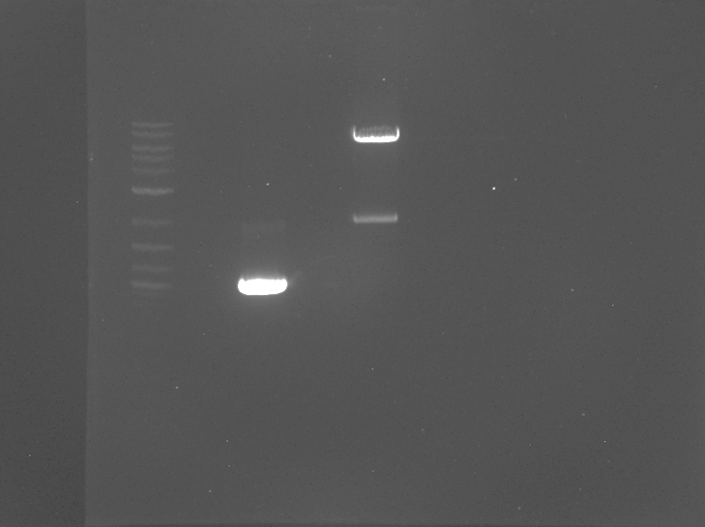

Monday, December 10th

Ligations Protocol

The purpose of this is to ligate the cut plasmid backbone to the strand of PCR DNA.

- Make a reaction table with desired ligations. Always include a backbone only control for each plasmid backbone used.
Tube | Insert | Backbone
1 | BamHI, KpnI digested, purified PCR | BamHI, KpnI digested, purified pKL80
2 | - | BamHI, KpnI digested, purified pKL80

- Set up master mix table:
Component | Reaction 1 (uL) | Reaction 2 (uL)
H₂O | 11.5 | 15.5
10x ligase buffer | 2.0 | 2.0
Insert | 4.0 | -
Backbone | 2.0 | 2.0
Ligase | 0.5 | 0.5
TOTAL | 20.0 | 20.0

- Obtain ice to assemble and keep the reactions on. This is important, as the reaction happens at 16°C and the ligase buffer (which contains ATP) needs to be kept cold in order to avoid degradation.
- Obtain and label PCR tubes for the reactions. Be sure to include the date and your initials.
- To the individual tubes, add indicated amounts of H₂O (___uL), 10x buffer (_____uL), insert (____uL), and backbone (____uL).
- Add indicated amount of ligase (___uL) to the individual tubes. Remember to keep the ligase in a mini cooler.
- After all of the components have been added, mix each tube with a pipette set to 18 uL.
- Place in the thermocycler overnight at 16ºC.

Tuesday, December 18th

Transforming Chemically Competent E. coli Cells Protocol

- Set up reaction table. Always include a positive and negative control for each antibiotic. If transforming plasmids (from previous plasmid prep), use 0.5 – 1 uL of plasmid. If transforming ligations, use 8 uL per ligation. If transforming plasmid, plate 20 uL, 100 uL, and remaining culture. If transforming a ligation, plate 100 uL and remaining culture.

Reaction table

Tube number | Purpose | DNA | Volume of DNA | Final volume to plate | Number of kanamycin-containing plates | Number of carbenicillin-containing plates
1 | (+) control | pKL80 | 1 uL | 20 ul, 100 ul, remaining | 3
2 | (-) control | None | 0 | 20 ul, 100 ul, remaining | 3
3 | Reaction 1 | Ligation of PCR + plasmid | 8 uL | 100 ul, remaining | 2
4 | Reaction 2 | Ligation of Plasmid | 8 uL | 100 ul, remaining | 2
Total number of plates |  |  |  |  | 10

Note: Add 500 uL kanamycin to 500 mL agar. Pour plates.

- Check to be sure you have enough plates with appropriate antibiotic. If plates were stored at 4°C, warm at 37°C until needed.
- Obtain DNA and thaw on ice if necessary.
- Thaw appropriate number of competent cell tubes on ice (5 reactions per tube of competent cells)
- Label sterile tubes as indicated in reaction table. Add indicated volume of indicated DNA on ice.
- When competent cells are thawed (check by probing for frozen cells using a sterile pipette tip), gently pipette 100 uL of cells into each reaction tube directly onto DNA using aseptic technique.
- Incubate cells on ice for 20 minutes. During incubation, find or set heat block to 42°C.
- Place tubes with cells and DNA onto 42°C heatblock for 30 seconds (heat shock step).
- After heat shock, place tubes back on ice until next step (don’t keep them here too long).
- Using aseptic technique, add 1 mL LB (no antibiotic) to each microfuge tube.
- Using autoclave tape, tape microfuge tubes down in shaking incubator set to 37°C.
- Allow cells to recover for 1 hour at 37°C, shaking. Place in a rack after shaking (NOT back on ice).
- Using aseptic technique, plate indicated amount of cells on appropriate antibiotic plates, spreading until plates look dry. For “remaining” volume, spin tubes at max speed in benchtop centrifuge for 30 seconds. Remove 800 uL of media. Using 200 uL pipette, resuspend cells at bottom of tube and plate all the remaining culture.
- Incubate plates at 37ºC overnight.

Bibliography

Ramsey, K. M. and Dove, S. L. (2016) ‘ A response regulator promotes Francisella tularensis intramacrophage growth by repressing an anti-virulence factor ’, Molecular Microbiology. doi: 10.1111/mmi.13418.

