CHAPTER 4

FINDINGS

The first approach we took to determine the mechanism of anti-virulence by the protein PriM was to create targeted mutations based on the structure of PriM. Three structural mutants were created, with each mutant targeting a different section of PriM (Table 1). One mutation targeted the electropositive tip region changing the tip region to a neutral charge by mutating the amino acids in the tip region to glycines, and was given the name PriM(mtip) (Table 1). The second structural mutant targeted the disulfide bond in PriM by introducing the mutation cysteine 303 to alanine, so this mutant was appropriately named PriM(C303A). The third mutant targeted a region of PriM that was identified as a possible small molecule binding pocket by mutating the charged amino acid residues to alanines, giving the name PriM(mpk).

Table 1. Overview of strains created with mutations in priM

Name | Purpose | Description | Illustration
PriM(mtip) | Changes the tip region from an electropositive charge to neutral charge | Mutations in the tip region: all amino acids in tip region (colored as red spheres) mutated to glycines | 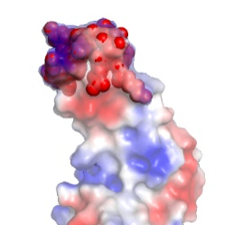
PriM(C303A) | Removes 1 of the 2 cysteines to prevent disulfide bond production | Mutation changing C303A, disulfide bond targeted is colored in yellow | 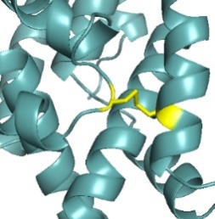
PriM(mpk) | Prevents small molecules from binding in the pocket region | Mutations in the small molecule binding pocket region: R222A, W219A, W226A, and Y270A (acetate molecule in the potential binding pocket colored in blue) | 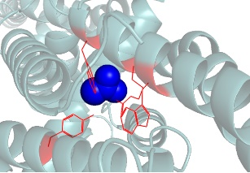

Each mutation was made in both the wild-type background, as well as in cells that are lacking the repressor pmrA, where PriM production will be most active. In order to test the significance of each region of the protein on virulence, we tested the ability of each structural mutant to replicate inside a host-like macrophage cell line. These macrophage infection assays allowed us to determine the significance of each structural element on virulence. Any mutant that was able to replicate to near wildtype levels, where priM was being expressed (i.e. in strains lacking pmrA) would indicate that the structural region being targeted by the mutation is essential for PriM to function as an anti-virulence factor.

Changes in tip region did not affect virulence

Cells lacking pmrA with mutations in the tip region of PriM were tested in intramacrophage growth assays. Results from these assays showed that the mutant strain was not able to regain the ability to replicate to wildtype levels inside macrophage cells (Figure 1). Therefore, the mutations in the tip region of PriM were not sufficient to restore virulence activity.
LVS LVS(mtip) ΔpmrA PriM(mtip) ΔpmrA
Figure 1. Survival of wild-type Live Vaccine Strain (LVS) or indicated F. tularensis mutant cells 24 hours after infection of macrophage. Data represents the fold change from 2 hours to 24 hours with error bars representing standard error. Assays were performed in duplicate with representative data shown.

Removal of disulfide did not have an effect on virulence

The next mutant to be tested in macrophage was PriM(C303A), targeting the disulfide bond in the protein. Cells lacking pmrA and containing the mutation C303A in PriM were tested in intramacrophage growth assays. Results from these assays showed that the mutant strain was not able to regain the ability to replicate to wildtype levels inside macrophage cells (Figure 2). Therefore, the mutations disrupting the disulfide bond of PriM was not sufficient to restore virulence activity.

LVS LVS(C303A) ΔpmrA PriM(C303A) ΔpmrA

Figure 2. Survival of wild-type LVS or indicated F. tularensis mutant cells 24 hours after infection of macrophage. Data represents the fold change from 2 hours to 24 hours with error bars representing standard error. Assays were performed in duplicate with representative data shown.

Disruption of pocket region restores virulence

Lastly, the mutant that targeted the potential small molecule binding pocket Prim(mpk) was tested in macrophage. Cells lacking pmrA with mutations in the pocket region of PriM were tested in intramacrophage growth assays. Results from these assays showed that the mutant strain restored the ability to replicate to wildtype levels inside macrophage cells (Figure 3). Therefore, the mutations disrupting the residues of the potential binding pocket in PriM were at least partially sufficient in restoring virulence.

LVS LVS(mpk) ΔpmrA PriM(mpk) ΔpmrA

Figure 3. Survival of wild-type LVS or indicated F. tularensis mutant cells 24 hours after infection of macrophage. Data represents the fold change from 2 hours to 24 hours with error bars representing standard error. Assays were performed in duplicate with representative data shown.

Addition of the VSV-G epitope tag does not affect virulence

Once we were able to determine how the structural mutations affected virulence, we next had to ascertain if the results we observed were due to the mutations, or due to destabilization of the PriM protein. Since there is no commercially made antibody specific for PriM, the only way to access levels of protein production of the mutants is to fuse an epitope tag to the end of PriM. In doing this, it was essential to verify that the addition of the epitope tag did not affect the anti-virulence function of PriM. DNA specifying the vesicular stomatitis virus-glycoprotein (VSV-G) epitope tag was fused in-frame to the 5’ end of priM in the ΔpmrA strain and tested in macrophage to ensure that addition of this epitope tag would not affect virulence phenotypes in mutant strains (Figure 4).
LVS ΔpmrA PriM-V ΔpmrA

Figure 4. Survival of wild-type LVS or indicated F. tularensis mutant cells 24 hours after infection of macrophage. Data represents the fold change from 2 hours to 24 hours with error bars representing standard error. Assays were performed in duplicate with representative data shown.

Mutant strains are producing detectable levels of PriM

Once it was confirmed that the VSV-G tag had no apparent effect on the antivirulence function of PriM, all strains with mutations in PriM (Table 1) were tagged with the VSV-G tag attached to the end of priM. Levels of PriM production were determined through western blotting. Results showed that the VSV-G tag on priM was detectable on all mutant strains (Figure 5).
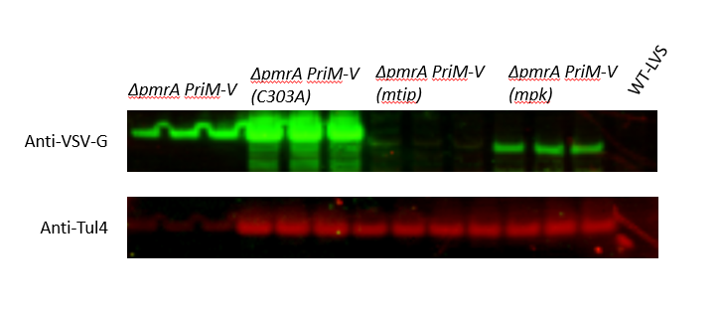

Figure 5.
Abundance of PriM-V in wildtype and mutant strains. The abundance of PriM-V was determined by Western Blotting with an antibody against the VSV-G tag. An antibody against Tul-4 was used as a loading control. Note that the LVS ΔpmrA Prim-V strain was diluted 1 to 50 to account for an overabundance in signal. Triplicate biological samples were tested for each strain, and a representative data set is shown.

Suppressor mutant strain restores virulence in cells lacking pmrA

While in the process of working with the ΔpmrA strain we identified cells that lacked pmrA and retained priM, but were still as virulent as wildtype cells. We decided to name this strain the PriM suppressor mutant because the antivirulence function of PriM seems to be suppressed by an unknown mutation. This PriM suppressor mutant was tested in intramacrophage growth assays. Results from these assays showed that the mutant strain was able to replicate to wildtype levels inside macrophage cells (Figure 6.)
LVS ΔpmrA PriM Suppressor ΔpmrA

Figure 6. Survival of wild-type LVS or indicated F. tularensis mutant cells 24 hours after infection of macrophage. Assays were performed in duplicate with representative data shown.

To further explore this PriM suppressor mutant strain we isolated genomic DNA from the suppressor mutant strain as well as from wildtype cells and from cells lacking pmrA to the Microbial Genome Sequencing Center (University of Pittsburg) for next generation sequencing. Analyzing the resulting data identified three single nucleotide polymorphisms (SNP) present in the PriM suppressor mutant that were not seen in the other two strains tested (Table 2).

Table 2. Mutations identified in whole genome resequencing data comparing the ΔpmrA PriM suppressor strain with cells lacking pmrA

Mutation Type | Gene or Region | Locus Number | Mutations
SNP | ATP Binding Protein | FTL_0146 | F315L
SNP | Proton-dependent oligopeptide transport | FTL_1339 | G421G
SNP | Upstream of hypothetical protein | Upstream of FTL_0869 | N/A

The SNP mutation in PriM partially restores virulence

The SNP that seemed most likely to have a role in suppressing the antivirulence function of PriM was the mutation in gene FTL_0146, the ATP binding protein as part of an ABC transport system. In order to more completely study the effects of this mutation, we recreated the exact SNP in both wildtype cells and in cells lacking pmrA. Cells lacking pmrA containing the mutation F315L in the ABC binding protein (FTL_0146) were tested in intramacrophage growth assays. Results from these assays showed that this mutation partially restored the ability to replicate to wildtype levels inside macrophage cells (Figure 7). Therefore, recreating one of the mutations observed in the PriM suppressor strain does seem to be contributing to the restoration of virulence.

Figure 7.
Survival of wild-type LVS or indicated F. tularensis mutant cells 24 hours after infection of macrophage. Data represents the fold change from 2 hours to 24 hours with error bars representing standard error. Assays were performed in duplicate with representative data shown.

Transcript abundance of priM is decreased in suppressor mutant strain

Knowing that an increase in intramacrophage replication and therefore virulence, was seen in the PriM suppressor mutant the next step was to look at priM transcript levels in the PriM suppressor mutant. RNA was isolated and turned into cDNA for LVS, ΔpmrA, and ΔpmrA PriM suppressor mutant. qRT-PCR was performed to observed transcript levels of priM in all three strains. There was no observable priM transcript produced in LVS, which is what was expected since PriM is not produced when the transcription factor pmrA is present. It is notable that there is less priM transcript or less stable priM transcript in the ΔpmrA PriM suppressor strain than in the ΔpmrA strain (Figure 8).

LVS ΔpmrA ΔpmrA PriM Suppressor

Figure 8.
Transcript abundance of priM was assessed in wildtype and mutant strains by qRT-PCR. Transcripts were normalized to tul4 with wildtype (LVS) set to a value of 1. Data is displayed on a logarithmic scale. Triplicate biological samples were tested for each strain, and a representative data set is shown.

