CHAPTER 1

INTRODUCTION & LITERATURE REVIEW

Francisella tularensis is a Gram-negative, facultative intracellular bacterial pathogen and is the causative agent of the potentially fatal human disease tularemia (Sjöstedt, 2007). Due to its highly infectious nature and its ability to be easily aerosolized, F. tularensis is considered a potential bioweapon (Dennis et al., 2001; Oyston et al., 2004; Sjöstedt, 2007). F. tularensis also has a wide variety of transmission vectors including small mammals, insects, and can even be water borne. During infection, F. tularensis evades the host immune system in part by replicating inside host cells; macrophage are thought to be a key niche.
PmrA is an essential virulence factor
F. tularensis encodes virulence factors essential for intramacrophage growth, such as the transcription factor PmrA (Mohapatra et al., 2007; Sammons-Jackson et al., 2008). PmrA is known as an orphan response regular meaning that it is missing a paired sensor kinase in a typical two component system. In multiple genetic screens PmrA was identified as an essential virulence factor in F. tularensis. The primary function of PmrA is to repress expression of a novel anti-virulence factor called PriM (Ramsey & Dove, 2016).
PriM functions as an anti-virulence factor
When F. tularensis is lacking the transcription factor pmrA, these cells are no longer able to replicate inside macrophage due to the presence of PriM, which is no longer being repressed. The anti-virulence factor PriM does not have clear sequence or structural homology to other studied proteins and how PriM functions to prevent intramacrophage replication is unknown. While many studies investigate virulence factors, it is also important to consider anti-virulence factors to fully understand bacterial pathogenesis (Brown et al., 2016). Other pathogens encode anti-virulence factors, but the role of anti-virulence factors in pathogenesis is still incompletely understood (Brown et al., 2016). Anti-virulence factors can play a key role in pathogenesis of some species. Some anti-virulence factors have been found to regulate production or release of virulence factors in the context of infection (Yeom et al., 2018). Other anti-virulence factors have been discovered in Mycobacterium tuberculosis and Xylella fastidiosa, pathogens that rely on establishing a latent infection (Ionescu et al., 2013) (Shimono et al., 2003). Anti-virulence factors have been discovered in both of these species that make the organism hypervirulent, which prevents the latent infection from forming and in some cases prevents transmission to a new host. PriM is the first anti-virulence factor identified in F. tularensis and our collaborators have solved a structure of PriM using X-ray crystallography (Figure 1).
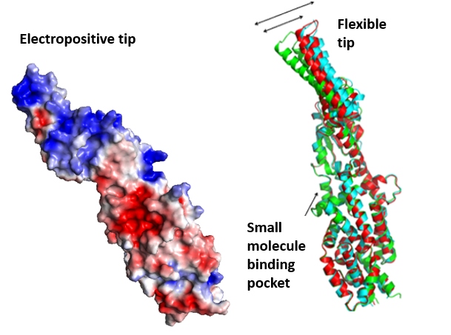
Figure 1.
Representation of the crystal structure of the PriM protein. This structure has been described as a novel fold and highlights several key features. (Unpublished data, Dr. Maria Schumacher, Duke University Department of Biochemistry)

Structure of PriM provides insight into function
The structural model of PriM reveals a novel fold with no known structural homology currently found in the Protein Data Bank. A PriM monomer is approximately 116 angstroms in length with a long coil-coil domain and flexible, electropositive tip. Additional features include a disulfide bond between two cysteines and bound acetate, which co-crystallized with PriM. The bound acetate may indicate the presence of a binding pocket. To examine which of these features are key to the function of PriM as an anti-virulence factor, we engineered mutations targeting these features. These mutations, presented in Table 1, were constructed in both wild-type LVS cells and cells lacking the repressor pmrA (i.e., cells producing PriM) and then evaluated in a macrophage infection assay. Cells expressing PriM mutant proteins that are able to replicate in macrophage will contain a mutation in a region of PriM that is essential for its function as an anti-virulence factor.
The structural targeted mutations were created based on three structural features; the electropositive tip region, the disulfide bond, and the potential small molecule binding pocket. The electropositive tip region may seem important for interacting with negatively charged DNA, however previous studies have shown no interactions between PriM and DNA (Ramsey & Dove, 2016). Instead, the tip region may be involved in transport, or protein-protein interactions that may contribute to anti-virulence. Many virulence factors are known to require disulfide bond formation for full maturation including components of the Type VI section system in F. tularensis, which is essential for virulence (Qin et al., 2016). When PriM is active, it is produced at very high levels with each individual molecule requiring formation of a disulfide bond. By targeting the disulfide bond in PriM we can explore the possibility that the high levels of PriM are titrating away the ability of disulfide bonds to be formed in other critical virulence factors. The small molecule binding pocket is also being targeted because there are a number of possible small molecules or protein-protein interactions that could have an effect on virulence.
To elucidate the molecular mechanism by which PriM inhibits intramacrophage growth, we have taken several approaches. By creating targeted mutations guided by the structure of PriM, we have assessed how specific structural features contribute to intramacrophage replication. We have also identified genes that are critical for the function of PriM by exploring genetic mutations. By increasing our understanding of bacterially-encoded anti-virulence pathways, we may be able to identify novel targets for anti-microbial therapeutics.

