Table of Contents
Introduction 2
Figure 1 2
Thoughts or questions. 2
Protocol 1 2
Reagents 3
File Formatting Protocol 3
September 2018 4
Bibliography 14

Introduction

Thursday, September 20, 2018
To Do:
- Explain lab notebook formatting
- Media prep
Results and Data:
For each day, copy the previous entry headers and update the date. Save the same ongoing copy of the lab notebook to the lab google drive ONLY. Do not save separate physical copies. At the 1st of each new month, a read-only PDF file of the lab notebook must be saved and given to Dr. Ramsey electronically. File contents converted to PDF MUST NOT BE EDITED after PDF conversion. Continue to keep using the same word file until the end of the calendar year. New lab notebook files run in 6 month intervals.
For the To do list, update this each day with new tasks, as tasks are done, use the strikethrough font on the day they are completed and leave them out of the list on the next day.
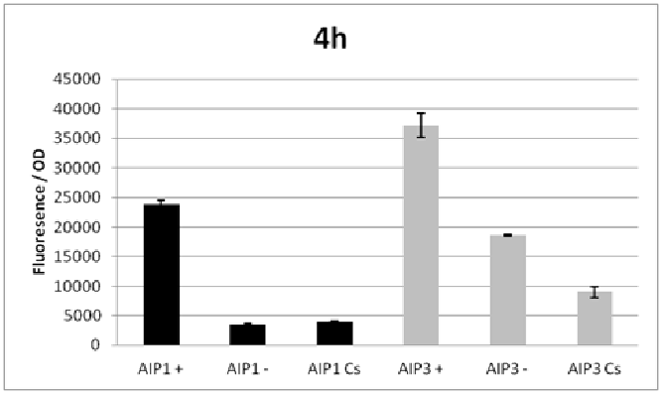

Figure 1
Figures are inserted as inline .png files when possible, .jpg, .gif, .tif otherwise are acceptable. Figure legends are always inserted in Word (right click – ‘insert caption’) and use “Heading 2” text to properly format in the TOC. Table legends are handled the same way. Figure images must be saved in a separate folder where the source data is saved.
Thoughts or questions. When you have a significant observation, question, confusing point or contradiction that you have identified in your data or protocol, use the “Heading 3” text heading on a descriptive brief title or single word heading so you can refer to it in your TOC later.

Protocol 1
1. This is the format for a protocol in your notebook.
2. The protocol title must be formatted in “Heading 2.”
3. Reagents which must be made for a specific protocol (buffers, solutions) should be listed in a “Reagents” Section, formatted in “Heading 3.”
4. The protocol must be in numerical steps.
5. Use standard notation and carefully describe units for your protocol.
6. Use ½” indent for protocol text.

Reagents
Specific buffers
For initial lab notebooks, write as much detail as possible. As time goes by you will be able to refer to written protocols by their heading and/or page number within the document. If you make any modifications to a protocol you must state how and why.

File Formatting Protocol
1. Filenames begin with your initials, an underscore, and the date, formatted as the last 2 digits of the year, the month, then the day, ex: “KMR_180920_Sample_file1v1.xls”
2. This ensures all files will be sorted by their creator and by their date. You must use this file formatting system for all data files (including photos) that will be shared with the lab.
Bibliography data will be saved as (author/date) and using Mendeley at this time with the TOC inserted by order cited at the end of the lab notebook in the Bibliography section.
Example is a recent publication (Ramsey and Dove, 2016).

October 2018

Tuesday, October 23, 2018
To Do:

- Review recipe for cystine heart agar with hemoglobin (CHA)
- Review recipe for supplemented Mueller-Hinton broth

Cystine heart agar with hemoglobin plates protocol
For 600 mL of CHA
1. Weigh out 30.6g of cystine heart agar into 1L flask (non-baffled; 10.2g/100mL)
2. Add 300mL of ddiH₂O (type I)
3. Add stirbar to flask
4. Heat on low, stirring, for about 10 minutes (media should be totally dissolved)
5. Autoclave on 30’ cycle, filling the water bin up to the height of the media
6. Cool down (ideally to ~55C)
7. Separately (before), prepare hemoglobin 2% solution
8. Add 6g freeze-dried hemoglobin to 300mL of ddiH₂O (type I)
9. Autoclave on 15’ liquid cycle with water in the bin
10. Cool down (ideally to ~55C)
11. Using sterile technique, pour hemoglobin into CHA
12. Using a 50mL pipet, aliquot 24mL of CHAH mixture into each 100mm plate (should make approximately 25 plates) Try to avoid bubbles!

Reagents
Cystine heart agar
2% hemoglobin
100mm plates

Mueller-Hinton broth protocol
For 500 mL of MHB
1. Weigh out 10.5g of Mueller-Hinton broth into 1L square-bottle
2. Add 500mL of ddiH₂O (type I)
3. Autoclave on 30’ liquid cycle, filling the water bin up
4. Cool down to 37C or cooler
5. Can keep this sterile media indefinitely without supplements
6. Add 5mL of 10% glucose
7. Add 5mL of 2.5% iron pyrophosphate
8. Add isovitalex (combine 10mL from liquid vial with solids, add entire volume to broth)
9. Can keep this supplemented media for 2 weeks, storing at 4C

Reagents
Mueller-Hinton Broth media dry
10% Glucose (filter-sterilized)
2.5% Iron pyrophosphate (1.25g iron pyrophosphate in 50mL of ddiH₂O (type 1), dissolved overnight, fresh solution every 2 weeks)
Isovitalex (commercially available)

Wednesday, October 24, 2018
To Do:

- Make cystine heart agar with hemoglobin (CHA) plates
- Compare old CHA with new CHA

Cystine heart agar with hemoglobin plates protocol
For 600 mL of CHA
1. Separately (before), prepare hemoglobin 2% solution
2. Add 6g freeze-dried hemoglobin to 300mL of ddiH₂O (type I)
3. Add stirbar to flask
3. Autoclave on 15’ liquid cycle with water in the bin
4. Cool down (ideally to ~55C)
5. Weigh out 13.3g of (old) cystine heart agar into 1L flask (non-baffled; 10.2g/100mL)
6. Weigh out 13.3g of (new) cystine heart agar into 1L flask (non-baffled; 10.2g/100mL)
7. Add 150mL of ddiH₂O (type I) to each flask
8. Add stirbar to flask
9. Heat on low, stirring, for about 10 minutes (media should be totally dissolved)
10. Autoclave on 30’ liquid cycle, filling the water bin up to the height of the media
11. Cool down (ideally to ~55C)
12. Using sterile technique, pour hemoglobin into CHA
13. Using a 50mL pipet, aliquot 24mL of CHAH mixture into each 100mm plate (should make approximately 25 plates) Try to avoid bubbles!

Reagents
Cystine heart agar
2% hemoglobin
100mm plates

Thursday, October 25, 2018
To Do:

- Make hemoglobin for CHA plates (new)
- Compare old CHA with new CHA

Making 2% Hemoglobin Solution

1. Add 3g freeze-dried hemoglobin to 150mL of ddiH₂O (type I)
2. Autoclave on 15’ liquid cycle with water in the bin
3. Allow to cool, store in cold room at 4C

Friday, October 26, 2018
To Do:

- Compare old CHA with new CHA
- Pour CHA plates (new CHA)

Monday, October 29, 2018
To Do:

- Grow up LVS
- Make buffer 1 for TAP Purification

O.D. 600 Readings for LVS Strains
Strain | 08:35 | 10:30 | 11:45
1: beta-prime-TAP | 0.171 | 0.196 | 0.216
2: beta-prime-TAP | 0.188 | 0.217 | 0.240
3: ∆pigR | 0.095 | 0.104 | 0.111

Tuesday, October 30, 2018
To Do:

- Grow up LVS
Plan for growth experiment:
3mL cultures
Tube Number | Condition
1 | MHB
2 | MHB
3 | MHB + 30ul 2.5% ironpyrophosphate
4 | MHB + 30ul 2.5% ironpyrophosphate
5 | MHB + 30ul 10% glucose
6 | MHB + 30ul 10% glucose
7 | MHB + 60ul isovitalex
8 | MHB + 60ul isovitalex
9 | MHB + all supplements
10 | MHB + all supplements
MHB = Mueller Hinton broth supplemented by Dr. Ramsey on 10/28
Target OD600 of 0.08. We’d like to inoculate about 50ul into each tube.
Calculation:
(3000ul * 0.08)/50ul= 4.8 OD600
1st OD600= 0.068 * 50 = 3.4
2nd OD600= 0.122 * 50 = 6.1
If we add 50ul at OD600 6.1 to 3mL the OD600 should be 0.102
OD600 0.381 * 20 = 7.62
If we add 50ul at OD600 7.62 to 3mL the OD 600 should be 0.127
Mock tube OD600 0.082
To take OD600 of all 10 tubes 0.5ml into 0.5MHB

Results:
Growth experiment OD600
Tube Number | 2hr 10’ (OD600) | 3hr 10’ (OD600) | 4hr (OD600) | 5.5hr (OD600)
1 | 0.294 | 0.316 | 0.428 | 0.566
2 | 0.296 | 0.304 | 0.426 | 0.586
3 | 0.302 | 0.316 | 0.432 | 0.582
4 | 0.312 | 0.344 | 0.438 | 0.598
5 | 0.294 | 0.332 | 0.434 | 0.582
6 | 0.294 | 0.320 | 0.428 | 0.582
7 | 0.136 | 0.088 | 0.134 | 0.146
8 | 0.124 | 0.096 | 0.120 | 0.126
9 | 0.126 | 0.092 | 0.124 | 0.136
10 | 0.146 | 0.108 | 0.146 | 0.158

Wednesday, October 31, 2018
To Do:

- Perform last OD from growth experiment
- Streak out plates for cell harvesting
Tube Number | 2hr 10’ (OD600) | 3hr 10’ (OD600) | 4hr (OD600) | 5.5hr (OD600) | 21.5hr (OD600)
1 | 0.294 | 0.316 | 0.428 | 0.566 | 2.19
2 | 0.296 | 0.304 | 0.426 | 0.586 | 1.86
3 | 0.302 | 0.316 | 0.432 | 0.582 | 1.94
4 | 0.312 | 0.344 | 0.438 | 0.598 | 1.92
5 | 0.294 | 0.332 | 0.434 | 0.582 | 1.85
6 | 0.294 | 0.320 | 0.428 | 0.582 | 1.95
7 | 0.136 | 0.088 | 0.134 | 0.146 | 0.530
8 | 0.124 | 0.096 | 0.120 | 0.126 | 0.350
9 | 0.126 | 0.092 | 0.124 | 0.136 | 0.400
10 | 0.146 | 0.108 | 0.146 | 0.158 | 0.480

2 plates struck out with LVS and beta-prime TAP glycerol stocks

Thursday, November 1, 2018
To Do:

- Prepare cultures of LVS and Beta prime TAP strains for cell harvesting

Cells were scraped off the plates prepared on October 31st 2018 into 3mL of S-MHB
1:20 starting OD600 calculations:
 | C1 | V1 | C2 | V2
Beta prime | 3.46 | 2.9 | 0.05017 | 200
LVS | 8 | 2.9 | 0.116 | 200
LVS | 8 | 1.25425 | 0.05017 | 200

Added 2.9mL (whole culture) of Beta Prime TAP to 200mL S-MHB
Added 1.25mL of LVS culture to 200mL S-MHB
Cultures were put in shaking incubator at 37C at 09:45
2mL of 2.5% iron pyrophosphate added to both cultures at 11:30
OD600 taken 4hrs after inoculation:
Beta Prime TAP: 0.148
LVS: 0.170
OD600 taken ~6hrs after inoculation:
Beta Prime TAP: 0.233
LVS: 0.272
Cultures stopped and harvested for protein purification at 4:15

Tuesday, November 6, 2018
To Do:

- Perform first day of TAP purification

Sample | Date Prepared | Labeled | Volume of Cells | OD600 at harvest
1 | 11/01/2018 | LVS | 200mL | 0.272
2 | 11/01/2018 | β’ TAP | 200mL | 0.233

Incubation in cold room started at 10:30
Incubation ended at 2:00

Wednesday, November 7, 2018
To Do:

- Perform second day of TAP purification
- Run protein gel

Use 10% NuPAGE Bis-Tris gels (don’t forget to take sticker off the bottom)
Add 500mL (25mL 20x stock with 475mL type I DDih20,1.25mL antioxidant stored at 4C) MES buffer in gel apparatus
Remove combs
While samples are heating, gently wash wells with running buffer from inside the chamber using a 200ul pipet, wash each well twice
Combine 25ul of each protein sample with 25ul 2x sample loading buffer
(for 20ul sample add 22ul of 2x SLB)
Heat samples at ~95C for 5 minutes, quick vortex and spin once they come off heating block ladder does not need to be heated
Load as indicated in table
Run gel using Bloom power source ~115 volts for ~1hr 20min until the dye front is just running off the gel

Gel 1: Coomassie Stain
Lane | Volume | Contents
1 | 10ul | Benchmark unstained ladder (undiluted)
2 | 20ul | LVS-Lysate
3 | 20ul | LVS- FT
4 | 20ul | LVS- E1
5 | 20ul | LVS- FT2
6 | 20ul | LVS- elution final
7 | 20ul | Beta-prime elution final
8 | 20ul | Beta-prime FT2
9 | 20ul | Beta-prime E1
10 | 20ul | Beta-prime FT
11 | 20ul | Beta-prime Lysate
12 | 10ul | 1x Sample Loading Buffer (SLB)

Gel 2: Silver Stain
Dilute ladder (1ul) into 9ul 1x sample loading buffer
Lane | Volume | Contents
1 | 10ul | Benchmark unstained ladder (1:10)
2 | 20ul | LVS-Lysate
3 | 20ul | LVS- FT
4 | 20ul | LVS- E1
5 | 20ul | LVS- FT2
6 | 20ul | LVS- elution final
7 | 20ul | Beta-prime elution final
8 | 20ul | Beta-prime FT2
9 | 20ul | Beta-prime E1
10 | 20ul | Beta-prime FT
11 | 20ul | Beta-prime Lysate
12 | 10ul | 1x Sample Loading Buffer (SLB)

Both gels started at 3:35, gels ran for ~1hour
Gels started fixing at ~4:45

Thursday, November 8, 2018
To Do:

- Stain Coomassie and silver protein gels
Followed protocols for staining for silver and Coomassie blue gels.
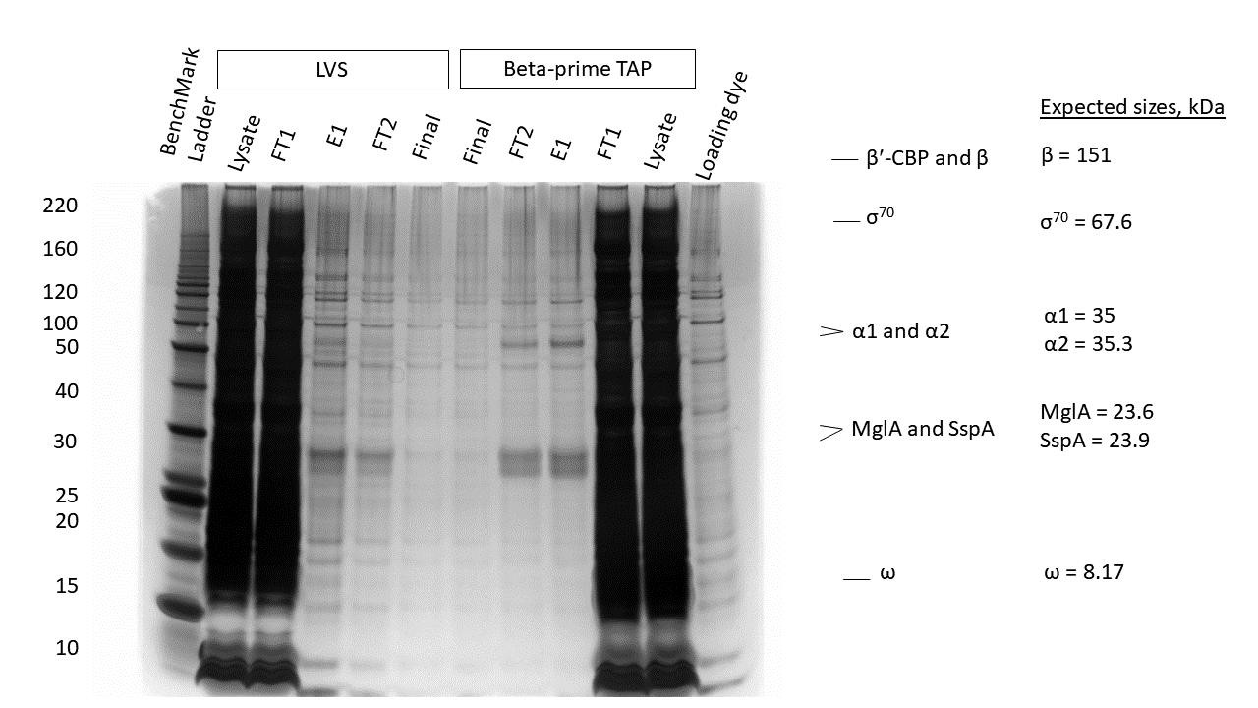

Friday, November 9, 2018
To Do:

- Make 4, 500mL bottles of media
- Make a plan to test growth conditions to induced production of the σ32 protein
- Take picture of Coomassie gel

Coomassie gel

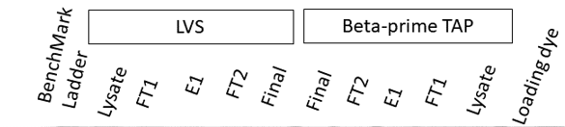
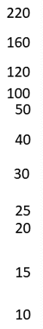

Plan to induce production of σ32 protein:
Grow 2 flasks σ32 cells overnight at 37C (target OD of 0.3-0.4)
Determine OD and split into 6 flasks (duplicates)
Keep 1 flask at 37C, put one flask at 45C, put one flask at a temperature between 37C and 45C (41C)
Take samples for protein analysis at:
T=0,10,20,30,45,60mins, 2hrs
Take an OD at each timepoint to determine cell concentration (1mL)
Take samples at each time point for a western blot (1mL)
Determine at which temperature/timepoint the most σ32 is produced.

Tuesday, November 13, 2018
To Do:

- Supplement media flasks
- Inoculate at 0.005 for overnight culture
- Make glycerol stocks with extra cells
Want to inoculate at OD600 of 0.005
LVS: 300mL (2 flasks) OD600: 23.6
Beta-prime TAP: 300mL (2 flasks) OD600: 28.6
RpoH: 2 flasks of 200mL OD600: 25.4
Started shaking at 37C at 5:00PM inoculated at OD600: 0.005

Loading Buffer Recipe: (For 20mL)
5mL of 4x dye
2mL of DTT (10%)
Type I ddiH20 up to 20mL (13mL)
Wednesday, November 14, 2018
To Do:

- Do sigma 32 experiment
- Harvest LVS and Beta-prime TAP bacteria

Temperature Incubated | Flask Number
37 A | 1
37 B | 2
41 A | 3
41 B | 4
45 A | 5
45 B | 6

Flask Number | Timepoint | OD600
1 | 0 | 0.433
1 | 10 | 0.443
1 | 20 | 0.456
1 | 30 | 0.470
1 | 45 | 0.484
1 | 60 | 0.504
1 | 2 hrs | 0.562
2 | 0 | 0.439
2 | 10 | 0.448
2 | 20 | 0.460
2 | 30 | 0.472
2 | 45 | 0.489
2 | 60 | 0.507
2 | 2 hrs | 0.565
3 | 0 | 0.438
3 | 10 | 0.444
3 | 20 | 0.460
3 | 30 | 0.473
3 | 45 | 0.493
3 | 60 | 0.516
3 | 2 hrs | 0.589
4 | 0 | 0.439
4 | 10 | 0.449
4 | 20 | 0.463
4 | 30 | 0.477
4 | 45 | 0.498
4 | 60 | 0.520
4 | 2 hrs | 0.589
5 | 0 | 0.436
5 | 10 | 0.454
5 | 20 | 0.467
5 | 30 | 0.473
5 | 45 | 0.503
5 | 60 | 0.525
5 | 2 hrs | 0.559
6 | 0 | 0.433
6 | 10 | 0.443
6 | 20 | 0.465
6 | 30 | 0.485
6 | 45 | 0.504
6 | 60 | 0.520
6 | 2 hrs | 0.559

Plan to run western blot gel:
Well Number
1. Flask 1 T=0
2. Flask 3 T=0
3. Flask 5 T=0
4. 1, T=30
5. 3, T=30
6. 5, T=30
7. 1, T=60
8. 3, T=60
9. 5, T=60
10. 1, T=2hrs
11. 3, T=2hrs
12. 5, T=2hrs

Thursday, November 15, 2018
To Do:

- Run western blot gel
- Transfer western gel to membrane

Lane | Volume | Contents
1 | 10ul | Magic Mark Ladder (2ul ladder, 8ul 1x sample loading dye)
2 | 12ul | 1, T=0
3 | 12ul | 3, T=0
4 | 12ul | 5, T=0
5 | 12ul | 1, T=30
6 | 12ul | 3, T=30
7 | 12ul | 5, T=30
8 | 12ul | 1, T=60
9 | 12ul | 3, T=60
10 | 12ul | 5, T=60
11 | 12ul | 1, T=2hr
12 | 12ul | 3, T=2hr
13 | 12ul | 5, T=2hr
14 | 10ul | Benchmark Unstained Ladder
15 | 12ul | Control

Monday, November 26, 2018
To Do:

- Run western blot gel again also run another gel of 0, 20, 30, 45 (flasks 1,3,5)
- Transfer to membrane, keep in blocking buffer
- Tuesday- Day 1 of protein purification
- Wednesday- Day 2 purification, run gels
- Thursday, gel staining and western blot development

Run 2 gels (Nu-Page 4-12% MES)
Lane | Volume | Contents
1 | 10ul | Magic Mark Ladder (2ul ladder, 8ul 1x sample loading dye)
2 | 12ul | 1, T=0
3 | 12ul | 3, T=0
4 | 12ul | 5, T=0
5 | 12ul | 1, T=30
6 | 12ul | 3, T=30
7 | 12ul | 5, T=30
8 | 12ul | 1, T=60
9 | 12ul | 3, T=60
10 | 12ul | 5, T=60
11 | 12ul | 1, T=2hr
12 | 12ul | 3, T=2hr
13 | 12ul | 5, T=2hr
14 | 10ul | Benchmark Prestained Ladder
15 | 12ul | Control (1:20)

Lane | Volume | Contents
1 | 10ul | Magic Mark Ladder (2ul ladder, 8ul 1x sample loading dye)
2 | 12ul | 1, T=0
3 | 12ul | 3, T=0
4 | 12ul | 5, T=0
5 | 12ul | 1, T=20
6 | 12ul | 3, T=20
7 | 12ul | 5, T=20
8 | 12ul | 1, T=30
9 | 12ul | 3, T=30
10 | 12ul | 5, T=30
11 | 12ul | 1, T=45
12 | 12ul | 3, T=45
13 | 12ul | 5, T=45
14 | 10ul | Benchmark Prestained Ladder
15 | 12ul | Control (1:20)

Tuesday, November 27, 2018
To Do:

- Tuesday- Day 1 of protein purification
- Wednesday- Day 2 purification, run gels
- Thursday, gel staining and western blot development

JW purifying samples 1 and 2
KMR purifying samples 3 and 4
Sample | Date Prepared | Labeled | Volume of Cells | OD600 at harvest
1 | 11/14/2018 | LVS | 300mL | 0.490
2 | 11/14/2018 | β’ TAP | 300mL | 0.427
3 | 11/14/2018 | LVS | 300mL | 0.463
4 | 11/14/2018 | β’ TAP | 300mL | 0.441

Wednesday, November 28, 2018
To Do:

- Wednesday- Day 2 purification, run gels
- Thursday, gel staining and western blot development

Use 10% NuPAGE Bis-Tris gels (don’t forget to take sticker off the bottom)
Add 500mL (25mL 20x stock with 475mL type I DDih20,1.25mL antioxidant stored at 4C) MES buffer in gel apparatus
Remove combs
While samples are heating, gently wash wells with running buffer from inside the chamber using a 200ul pipet, wash each well twice
Combine 11ul of each protein sample with 11ul 2x sample loading buffer
Heat samples at ~95C for 5 minutes, quick vortex and spin once they come off heating block ladder does not need to be heated

Gel: Silver Stain
Dilute ladder (1ul) into 9ul 1x sample loading buffer
Lane | Volume | Contents
1 | 10ul | Benchmark unstained ladder (1:10)
2 | 20ul | LVS- IgG Beads
3 | 20ul | LVS- E1
4 | 20ul | LVS- FT2
5 | 20ul | LVS- Calmodulin Beads
6 | 20ul | LVS- elution final
7 | 20ul | Beta-prime elution final
8 | 20ul | Beta-prime Calmodulin Beads
9 | 20ul | Beta-prime FT2
10 | 20ul | Beta-prime E1
11 | 20ul | Beta-prime IgG Beads
12 | 10ul | 1x Sample Loading Buffer (SLB)

Thursday, November 29, 2018
To Do:

- Silver stain gel staining
- Western blot development

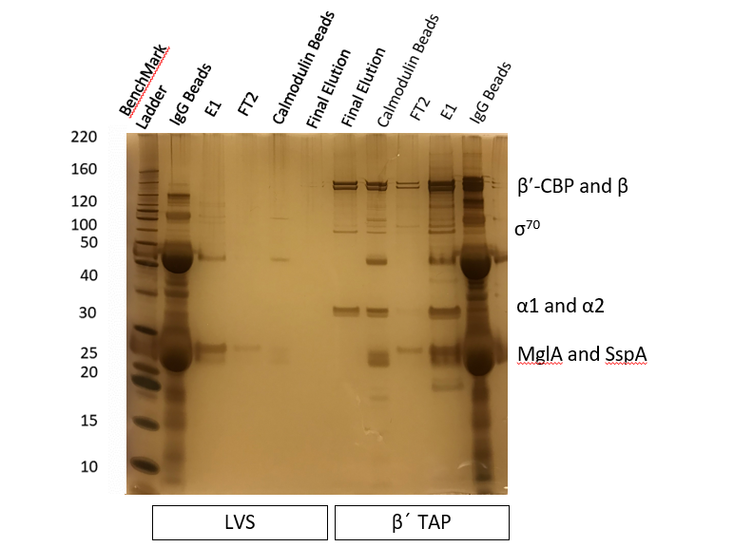

Wednesday, December 12, 2018
To Do:

- Create plan for new heat shock experiment

Plan to induce production of σ32 protein:
Grow 2 flasks σ32 TAP tagged cells overnight at 37C (target OD of 0.3-0.4)
Also grow up 1 flask of LVS and subject it to the kickdown in temperature and take timepoint at time 0
Allow cells to grow at 30C for 1-2 hours for acclimation
Determine OD and split into 6 flasks (duplicates)
Keep 2 flasks at 30C, 2 flasks at 37C, 2 flasks at 45C
Take samples for protein analysis at:
T=0,15,30,45,60mins, 2hrs
Take an OD at each timepoint to determine cell concentration (1mL)
Take samples at each time point for a western blot (1mL)
Determine at which temperature/timepoint the most σ32 is produced.

Thursday, December 13, 2018
To Do:

- Learn to and start designing primers

Monday, December 17, 2018
To Do:

- Set up flasks for heat shock experiment

Target OD600 of 0.3-0.4
Inoculate flasks at about OD600 0.005
LVS: 100mL OD600: 1.29
RpoH: 2 flasks of 200mL OD600: 1.69

Flasks started shaking at 4:45

Temperature Incubated | Flask Number
30 A | 1
30 B | 2
37 A | 3
37 B | 4
45 A | 5
45 B | 6

Tuesday, December 18, 2018
To Do:

- Perform heat shock experiment
Shaker stopped in the middle of the night (it was on a 1h timer) was started again in the morning.
9:00am OD600
LVS: 0.158
RpoH A: 0.101
RpoH B: 0.115
12:00pm OD600
LVS: 0.316
RpoH A: 0.204
RpoH B: 0.224

Flask Number | Timepoint | OD600
1 | 0 | 0.341
1 | 15 | 0.350
1 | 30 | 0.361
1 | 45 | 0.372
1 | 60 | 0.382
1 | 120 | 0.422
2 | 0 | 0.365
2 | 15 | 0.376
2 | 30 | 0.387
2 | 45 | 0.399
2 | 60 | 0.410
2 | 120 | 0.451
3 | 0 | 0.341
3 | 15 | 0.354
3 | 30 | 0.368
3 | 45 | 0.381
3 | 60 | 0.396
3 | 120 | 0.453
4 | 0 | 0.366
4 | 15 | 0.380
4 | 30 | 0.394
4 | 45 | 0.409
4 | 60 | 0.425
4 | 120 | 0.482
5 | 0 | 0.341
5 | 15 | 0.362
5 | 30 | 0.381
5 | 45 | 0.397
5 | 60 | 0.407
5 | 120 | 0.428
6 | 0 | 0.366
6 | 15 | 0.389
6 | 30 | 0.408
6 | 45 | 0.423
6 | 60 | 0.434
6 | 120 | 0.457

Wednesday, December 19, 2018
To Do:

- Run western gel and transfer

Run western gel (Nu-Page 4-12% MES)
150V for ~1hour 10mins

Lane | Volume | Contents
1 | 10ul | Magic Mark Ladder (2ul ladder, 8ul 1x sample loading dye)
2 | 12ul | 1, T=0
3 | 12ul | 3, T=0
4 | 12ul | 5, T=0
5 | 12ul | 1, T=30
6 | 12ul | 3, T=30
7 | 12ul | 5, T=30
8 | 12ul | 1, T=60
9 | 12ul | 3, T=60
10 | 12ul | 5, T=60
11 | 12ul | 1, T=2hr
12 | 12ul | 3, T=2hr
13 | 12ul | 5, T=2hr
14 | 10ul | Benchmark Prestained Ladder
15 | 12ul | LVS negative control

Thursday, December 20, 2018
To Do:

- Develop western

Primary Antibody
Anti-TAP (Rabbit IgG) 1:4000 (2.5ul in 10mL blocking buffer) (fisher catalog number CAB1001)
Anti-Tul4 (Mouse IgG) 1:50,000 (prefrozen) (NR-50326)

5 second exposure
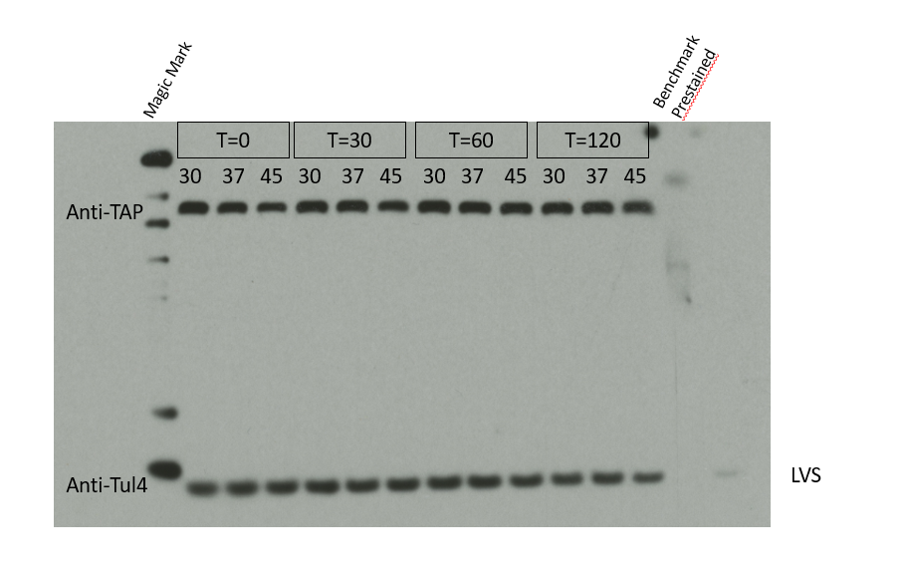
Plan: Run gel again with only 3ul of sample

Friday, December 28, 2018
To Do:
- Run western gel and transfer

Run western gel (Nu-Page 4-12% MES)
150V for ~1hour 10mins

Lane | Volume | Contents
1 | 10ul | Magic Mark Ladder (2ul ladder, 8ul 1x sample loading dye)
2 | 3ul | 1, T=0
3 | 3ul | 3, T=0
4 | 3ul | 5, T=0
5 | 3ul | 1, T=30
6 | 3ul | 3, T=30
7 | 3ul | 5, T=30
8 | 3ul | 1, T=60
9 | 3ul | 3, T=60
10 | 3ul | 5, T=60
11 | 3ul | 1, T=2hr
12 | 3ul | 3, T=2hr
13 | 3ul | 5, T=2hr
14 | 10ul | Benchmark Prestained Ladder
15 | 3ul | LVS negative control

Bibliography

Ramsey, K. M. and Dove, S. L. (2016) ‘ A response regulator promotes Francisella tularensis intramacrophage growth by repressing an anti-virulence factor ’, Molecular Microbiology. doi: 10.1111/mmi.13418.

