Table of Contents
Introduction 2
November 2021 2
Monday November 1, 2021 2
Tuesday November 2, 2021 3
Quantitative Western Blots with Near-Infrared dyes 4
Total Protein Quantification (Invitrogen No-Stain Labeling) 7
Tn7 in F. tularensis protocol 7
Allelic Exchange Protocol 12
Wednesday November 3, 2021 16
Spot Plating Assay 18
Thursday November 6, 2021 18
Friday November 5, 2021 19
Sunday November 7, 2021 20
Monday November 8, 2021 20
Preparation of 70S Ribosomes for Biochemistry 20
Tuesday November 9, 2021 23
Wednesday November 10, 2021 23
Thursday November 11, 2021 24
Friday November 12, 2021 24
Sunday November 14, 2021 25
Monday November 15, 2021 25
Tuesday November 16, 2021 25

Introduction
Investigating presence of specialized ribosomes in F. tularensis, with focus on rpsU1, rpsU2, and rpsU3 homologs.

November 2021

Monday November 1, 2021
To Do:
- Protein degradation experiment – grow cultures, add antibiotics, and take regular samples
- Image DDA plates
- Check on spot plates/make more MHA plates?
- Check on Tn7 patches, then plan to re-do it?
Methods and Results:
I setup my protein degradation experiment. First I made 2x7 mL cultures for KRLVS139.1 and 135.1, adding 0.7 ul of kan to each tube. I resuspended cells and diluted such that the 139 strain starts at about 0.105 and the 135 strain starts at about 0.135. I then let them grow at 37C shaking for 4 hours.

I imaged my DDA plates. It looks like both spec and chloramphenicol have really nice halos. I measured the radius for both using ImageJ and found an average of 37.1 mm for chlor and an average of 28.5 mm for spec. Based on this, I think chloramphenicol is a better option for the protein degradation experiment. I’m going to use 500 ug/mL based on my experiment from 10/13/21. After 4.2 hours of growth, I added 70 ul of 50 mg/ml chloramphenicol. Then I took samples as follows:
Tube number/name | Strain | Time Point (hrs) | OD600 at Harvest | 1X SLB added (uL)
LVS 1 | KRLVS139 | 0 | 0.254 | 101.6
LVS 2 | KRLVS139 | 0.5 | 0.259 | 103.6
LVS 3 | KRLVS139 | 1.25 | 0.266 | 106.4
LVS 4 | KRLVS139 | 2.25 | 0.280 | 112.0
LVS 5 | KRLVS139 | 4 | 0.292 | 116.8
d2 1 | KRLVS135 | 0 | 0.315 | 126.0
d2 2 | KRLVS135 | 0.5 | 0.323 | 129.2
d2 3 | KRLVS135 | 1.25 | 0.331 | 132.4
d2 4 | KRLVS135 | 2.25 | 0.351 | 140.4
d2 5 | KRLVS135 | 4 | 0.367 | 146.8
At each time point, I took 500 ul from one of the tubes of cells+abx and used that to check the OD. Then from the cuvette I removed 400 ul to a microfuge tube, spun down for 2 mins at max speed, removed the supernatant, and resuspended the pellet in 1XSLB based on the OD, as indicated above. Then boiled for 10 mins at 95C on the heat block, cooled and moved to my Westerns box 5 in the -20C.

I still have no colonies on my spot plates! Because the plates grew totally normally with LVS, I think I may have over diluted the cells. I’m making new MHA plates but this time just making one large flask of MHA:
To a 1 L flask add:
10.5 g MHB
6 g agar
460 mL ddiH2O
Autoclave on the 30 minute liquid cycle and then add:
25 mL 20% glucose
10 mL IsoVitaleX
5 mL 2.5% FePPi
In order to make all three types of plates, I followed this protocol for adding ATc sequentially.
First after supplementing, I poured 7x 24 mL plates. These are the 0ATc plates.
That left us with 332 mL so I added 66.4 ul of 500 ug/mL ATc to make 100 ng/mL ATc plates. Poured seven of these.
Now I have 164 mL left and need to increase the concentration by 400 ng/mL so we are adding 131.2 ul of 500 ug/mL ATc to make 500 ng/mL ATc plates. Poured 6 of these.
I’m also going to make more CHAH-kan and CHAH regular plates.

No growth on my Tn7 patches…not surprising. I might try redoing it once tomorrow to see if it’s just an issue of few colonies (like when we do pEX electroporations). I struck out LVS to CHAH regular in the hopes to do 3-4 more tomorrow.

Kathryn wants me to test whether I can exchange plasmids, so I’m streaking out the triple mutant KRLVS141 to plates with ATc so tomorrow I can electroporate with a kan plasmid (pKR7).

Tuesday November 2, 2021
To Do:
- Electroporate LVS with Tn7 linearized
- Electroporate pKR7 into triple mutant
- Streak cells for spot plating assay
- Streak cells for Oli
- Gel and transfer
Methods and Results:
I realized that I struck out LVS not LVS with the helper plasmid so I wasn’t able to make electrocompetent cells for electroporating the Tn7 linearized PCR. I decided to use old cells that I already made, because Kathryn thinks older cells are actually better. I used two sets of cells – one set from 10/26 and one from 10/7 per Tn7 in F. tularensis protocol. I did streak out KRLVS141 correctly so I made electrocompetent cells per Allelic Exchange Protocol and conducted the electroporations accordingly. Normally I use 3 ul for pF plasmids, but I did 5 this time because we don’t know how good the exchange rate is.

3x Tn7 linearized PCR in LVS + h.p.
1x no DNA LVS + h.p.
1x pKR7 in KRLVS141
1x no DNA KRLVS141
Plated the 141 samples after 2 hours, plating 10, 100, 500, and remaining on CHAH-kan.
For the Tn7 ones, plated after XX hours plating remaining for all on CHAH-kan.
For negative controls I only plated the highest volume.

I looked at my spot plates today and surprisingly there were colonies on the 500 ATc plates for LVS only. The colonies are two different sizes, and I’m thinking it’s likely because I moved them to RT then back into the incubator. So I’m still going to go ahead with the spot plate assay tomorrow. I’m streaking out KRLVS152 (LVS + pF-nat), KRLVS141 (triple mutant + pKR113) and d1/d3 pKR113 to my new MHA plates. This will be a good check that the plates are okay.
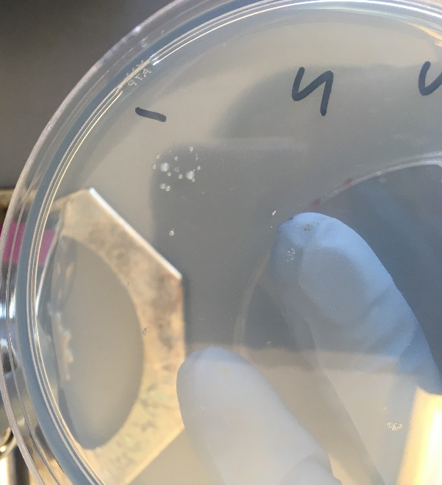

I ran a 4-12% gel with my samples from yesterday 11/1 with MOPS running buffer.
Lane | Sample | Volume of Sample (uL)
1 | BioRad | 3 (1:10 diluted)
2 | 1x SLB | 9
3 | LVS 1 | 9
4 | LVS 2 | 9
5 | LVS 3 | 9
6 | LVS 4 | 9
7 | LVS 5 | 9
8 | d2 1 | 9
9 | d2 2 | 9
10 | d2 3 | 9
11 | d2 4 | 9
12 | d2 5 | 9
13 | 1x SLB | 9
14 | 1x SLB | 9
15 | Prestained ladder | 9

Quantitative Western Blots with Near-Infrared dyes
Dove lab protocol from Tracy Kambara and Mike Gebhardt
URI modifications from KMRamsey 8/19/19

Running the gel
- Prepare 1x Loading buffer
  - 250 uL NuPage LDS sample buffer (4x, room temp)
  - 100 uL 0.5 M DTT (-20C)
  - 650 uL dH2O
- Resuspend pellet in 1x loading buffer
  - Normalize to ODs
- Sonicate on lowest setting for 5 sec
- Heat at 98C for 10 min
- Assemble gel chamber
  - Use pre-cast NuPAGE 4-12% Bis-Tris gel
- Make running buffer – 400 mL for 1 gel, 800 mL for 2 gels
  - 1 x MOPS for large proteins
  - 1x MES for <50 kD proteins
    - 380 mL ddiH2O
    - 20 mL 20x MES
    - 1 mL NuPAGE antioxidant
- Use pipet to wash wells of gel
- Load 10 or 12 uL of each sample
Use 1 uL 1:10 diluted BioRad Precision Plus Dual Color Protein Ladder (#161-0374) for the ladder.
- Run at 150V until the blue dye front reaches the bottom ridge of the gel.
Wet transfer
- Make transfer buffer in a 1 L bottle.
For transferring 1 gel:
50 mL methanol
25 mL NuPAGE 20x transfer buffer
water to 500 L
For transferring 2 gels, double above.

- Store in freezer to chill until the gel has stopped running.
- When the gel has about 10 minutes remaining, begin setting up the transfer.
- Remove transfer buffer from freezer and add 0.5 mL NuPAGE antioxidant (1 mL for 2 gels)
- Activate PVDF membrane (must use Millipore Immobilon-FL #IPFL00010) in ethanol (can do in a tip box). For a full gel, cut to approximately 6 cm x 8 cm using pre-made guide.
- In a large container (9”x9” Pyrex baking dish, for example), presoak membrane, 2 filter papers cut to membrane size, and 5 sponges in transfer buffer. Use a roller to push bubbles out of the sponges.
- Open gel case, cut off wells and at the bottom ridge on the gel and place wet sheet of filter paper on the gel.
- Peel gel and filter paper off and place wet membrane on gel.
- Place other filter paper on membrane and roll out bubbles
- Dunk the transfer cassette halves in the transfer buffer and begin assembling sandwich:
1 sponge
filter/membrane/gel/filter sandwich so that the membrane is on top of the gel
1 more sponge
- Close transfer apparatus and clamp into the gel box.
- Fill the inside chamber with transfer buffer, fill the outer chamber with dH20. Place the gel box into a large ice bucket. Close the lid, seal the hole in the lid with tape, and cover the whole gel box with ice. Clear off the top of the box to remove the tape.
- Run at 20V for 1 hour.
- Complete No-Stain total protein quantification protocol now, if applicable
Blocking and probing
- Block the membrane with Li-Cor Odyssey Blocking Buffer (PBS) diluted 1:5 in PBS. Use ~25 mL or enough to cover the membrane and rock for 1 hour or overnight at room temperature. DO NOT add any detergents (Surfact-Amps, Tween, SDS) to the blocking buffer.
- Store diluted blocking buffer at 4C.
Next day:
- Add antibodies (must be from two different species, such as mouse and rabbit, eg, rabbit anti-VSVG and mouse anti-sigma⁷⁰) in 15 mL of blocking buffer (no detergent). Rotate for 1 hour at room temperature.
- Meanwhile, make wash buffers:
1x Wash Buffer (500 mL)
50 mL 10X PBS
450 mL dH20
- Split into two separate bottles, 400 mL and 100 mL.
- To the 400 mL bottle, add 2 mL Surfact-Amps. This is your primary wash buffer. The remaining 100 mL will be for the final two washes after the secondary antibody, to remove traces of detergent, which may show up as background on the Li-Cor.
- Wash 4x on rotator for 10 minutes each, using 20-25 mL wash buffer per wash.
- Use 25 mL diluted blocking buffer and block again, for 15-30 min.
- Add 1 uL of each IRDye secondary antibody to 10 mL wash buffer (the one with Surfact-Amps, aka PBS-T). Also add 0.01% SDS to the wash buffer (10 uL of 10% SDS). These secondary antibodies are stored at 4C.
Note from Dove lab: use 800CW [green channel] if only detecting one protein; if detecting two proteins, use 800CW for the less abundant protein

- Label for 1 hour on rocker at room temperature. Cover the box with foil or use a black box (the secondary antibodies are light sensitive).
- Wash 4x on rotator for 10 minutes each, using 20-25 mL wash buffer per wash.
- Wash 2x on rotator for 10 minutes each, using 20-25 mL of wash buffer WITHOUT detergent.
- If faint bands are expected, do a quick methanol rinse by dunking the blot in methanol for 2 seconds then letting air dry for 2 minutes prior to imaging.
Imaging
- Leave the membrane in the box containing the final wash buffer. Bring the box, gloves, forceps, and a timer to the imager in the INBRE facility.
After the transfer, I did the no-stain protocol:

Total Protein Quantification (Invitrogen No-Stain Labeling)
- Prepare the No-Stain labeling buffer by diluting the 20x stock to 1x (9.5 mL ddiH2O + 0.5 mL 20x buffer).
- Thaw Activator and Derivatizer to room temperature, then add 20 uL of activator followed by 20 uL of derivatizer to 10 mL of 1X buffer. Mix in a tube prior to adding to dish with blot.
- Pre-wash the blot twice with 20 mL of ultrapure (ddiH2O) water, for 2 minutes each, on a nutator or rotating platform.
- Add 10 mL of No-stain labeling solution with all components added to the blot, and nutate or rotate for 10 minutes. Discard the solution.
- Post-wash with 20 mL of ddiH2O for 2 minutes, three times. Replace the last wash with fresh water.
- Image using the Bio-Rad imager with protocol Blot->No Stain.
- Quantify using LiCor Image Studio Lite.
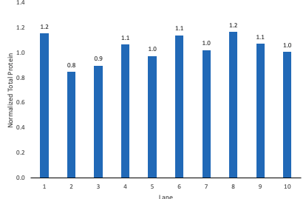

Tn7 in F. tularensis protocol

Materials:
- sterile 10% sucrose
- sterile glass culture test tubes
- solid media:
-Cystine heart agar with 1% hemoglobin (CHAH) plates
-CHAH plates containing 5 μg/mL kanamycin (CHAH-Kan)
-CHAH plates containing 200 μg/mL Hygromycin (CHAH-Hyg)
- Mueller-Hinton broth (MHB), supplemented within past 2 weeks
- sterile 1X PBS
- sterile 75% glycerol
- cryovials
- sterile water
- PCR mix for colony PCR (example: NEB OneTaq Quick-Load 2X Master Mix with Standard Buffer)
- primers for distinguishing double crossover from revertant
- optional: primers to amplify plasmid backbone

Media recipes:
Mueller-Hinton broth
Mix 10.5 g Mueller-Hinton broth (BD Difco # 275730) and 500 mL type I ddiH₂O
Autoclave 30’
When cool, supplement with 0.025% iron pyrophosphate (5 mL of 2.5% iron pyrophosphate), 0.1 % glucose (5 mL of 10% glucose), and 2% Isovitalex (10 mL vial).
Keep at 4° when not in use, good for about 2 weeks

2.5% iron pyrophosphate (keep away from light, make a new stock every 2 weeks)
Mix 1.25 g iron pyrophosphate with 50 mL type I ddiH₂O (usually overnight to dissolve)
Filter-sterilize

2% hemoglobin (can make ahead and store at 4°C)
Mix 6 g freeze-dried hemoglobin with 300 mL type I ddiH₂O in 1 L flask
Autoclave 20’
Can make extra and aliquot to sterilized 100 mL bottles for later use

Cystine heart agar with hemoglobin (CHAH plates) and CHAH plates with kanamycin and CHAH plates with hygromycin

Mix 30.6 g cystine heart agar (Difco #247100) with 300 mL type I ddiH₂O
Autoclave 30’, being very careful media does not boil over
While autoclaving, warm 300 mL of 2% hemoglobin (in 50°C oven or in water bath at 55°C)
Place CHA flask in 50°C oven or in water bath at 55°C, let temperature equilibrate
Wipe down flask and bottles with ethanol and using sterile technique, pour hemoglobin into CHA flask
For CHAH-Kan plates:
Add 60 μL of 50 mg/mL kanamycin (stored at 4 ̊C)
For CHAH-Hyg plates:
Add 2.22mL of 54mg/mL hygromycin (stored at 4 ̊C)
Mix media
Use sterile pipette, pour ~24 mL media per plate (25 plates for 600 mL media)

***Before integration of Tn7 a plasmid must be created that incorporates the gene to be inserted into the multiple cloning site of pKR55. The strategy for this plasmid construction will depend on the gene/promoter being inserted into the Tn7 site***

Protocol:
Day 1:
-Patch entire plate with strain where the gene of interest will be inserted onto CHAH

Day 2:
Prepare electrocompetent (EC) cells
-Scrape up entire plate of cells into 400 uL of sterile 10% sucrose and resuspend (alternately, cells can be grown to mid-log in MHB)
-Add 1.1 mL of 10% sucrose to a final volume of 1.5 mL
-Spin for 3 minutes at 10,000 rpm
-remove supernatant, throw out, and resuspend in fresh 1 mL 10% sucrose
-Repeat 3x-5x in 10% sucrose
-After final spin, remove all supernatant.
-Resuspend cells in 10% sucrose at high density (corresponding to ~1x10¹¹ cells /mL); these are EC cells by slowly adding 110 uL at a time. It should be about equal amounts of cells as sucrose.
-For any extra EC cells, aliquot ~110 μL / sterile tube (enough for 2 electroporations) and freeze at -80°C

Electroporate Tn7 helper plasmid (pKR54) into EC cells*
-For each electroporation, aliquot 4 mL MHB into glass test tubes for recovery, warm in shaker at 37°C
-For each electroporation, in a 2 mm sterile electroporation cuvette, combine:
3 μL of Tn7 helper plasmid (pKR54)
50 μL electrocompetent cells
-Have recovery media ready
-Electroporate using the following settings: 2.5 kV, 25 μF, and 600 Ω (setting Ec2)
-Immediately after individual electroporations, use 1 mL warm recovery media from test tube to wash cells out of cuvette and transfer cells to recovery test tube
-Recover cells for 3-4 hours, shaking at 37°C
-Plate 20 μL and 100 μL on CHAH-Hyg plates
-Incubate plates at 37°C for 3 days (or until single colonies appear)

*Always including a control electroporation with no plasmid. Eventually single break-through colonies may start appearing; at that point, single colonies on the experimental plates are also likely to just be break-through growth.

Day 5 (maybe 6):
-Pick single colonies from electroporation plates and patch onto CHAH-Hyg plates (large patches, maximum 6 per plate, ideally 3-4 per plate).

Day 6:
Take patches of strain with helper plasmid from CHAH-Hyg plates and freeze down as electrocompetent cells (same protocol as above) should get about 50-110μl of electrocompetent cells per patch.

Once you have electrocompetent cells that contain the helper plasmid you can electroporate these cells with the Tn7 plasmid that has been designed with your gene (should be in the background of pKR55). The Tn7 plasmid is Kanamycin resistant, so these electroporations should be plated onto CHA-Kan plates.

Electroporate Tn7 transposon plasmid into helper plasmid containing EC cells*
-For each electroporation, aliquot 4 mL MHB into glass test tubes for recovery, warm in shaker at 37°C
-For each electroporation, in a 2 mm sterile electroporation cuvette, combine:
5 μL of Tn7 transposon plasmid; 3 uL can be used if you find high efficiency electroporations
50 μL electrocompetent cells containing helper plasmid
-Have recovery media ready
-Electroporate using the following settings: 2.5 kV, 25 μF, and 600 Ω (setting Ec2)
-Immediately after individual electroporations, use 1 mL warm recovery media from test tube to wash cells out of cuvette and transfer cells to recovery test tube
-Recover cells for 4-8 hours, shaking at 37°C
-Plate 20 μL and 100 μL on CHAH-Kan plates
-Incubate plates at 37°C for 3 days (or until single colonies appear)

Day 9 (maybe 10):
-Pick single colonies (~3-4) from electroporations and patch them onto CHA-Kan.

Day 10:
-At this point you want to “cure” the primary integrant of the hygromycin resistance. To do this you can streak out the primary integrants (from the patches on CHAH-Kan) to single colony on regular CHAH plates (no antibiotic). Plates should be incubated at 37°C for 3 days (or until single colonies appear).
- You can freeze down the rest of the patch from the CHAH-Kan plate to go back to later if needed.

* At this point you should have the transposon and therefore your gene of interest incorporated, so you can check by colony PCR to see if your gene of interest has been incorporated into the Tn7 site.
* Primers KROL252 and KROL253 amplify the insertion region of the Tn7 transposon (~350bp)

Colony PCR from patches *

-Take small amounts of each patch and resuspend in 50 μL sterile water using a sterile toothpick.
-Heat samples at 95°C for 10’ to lyse and kill cells
-Dilute lysates 1:10
-Use 1-2 μL of heat-killed cells as template in colony PCR to check for desired mutation. As of August 2020, the KRamsey lab is primarily using PrimeStar GXL polymerase (Takara Bio). For controls, use LVS cells, LVS gDNA, the pEX-based allelic exchange vector, and water only.
Example colony PCR using KOD (use a master mix):
Water 4.0 μL
2X KOD Buffer 10.0 μL
2 mM dNTPs 4.0 μL
Forward primer (10 μM) 0.6 μL
Reverse primer (10 μM) 0.6 μL
KOD enzyme 0.4 μL
Cell lysate 1.00 μL
Total volume ~20.00 μL
Example colony PCR using PrimeSTAR GXL DNA Polymerase (use a master mix):
Water 12.5 μL
5X PrimeStar GXL buffer 4.0 μL
2.5 mM dNTPs 1.6 μL
Forward primer (10 μM) 0.6 μL
Reverse primer (10 μM) 0.6 μL
KOD enzyme 0.4 μL
Cell lysate 1.00 μL
Total volume ~20.00 μL

-Use PCR program:
1. 94°C 2'
2. 94°C 20"
3. 50°C 30"
4. 68°C (1' per kb)
5. Go to step 2, rep 32x
6. 68°C 5'
7. Hold 12°C

-For cross-outs which appear to have the desired mutation (maximum 4), streak to single colony on CHAH plates, incubate at 37° for 3 days (or until single colonies appear).

Day 13:
-Patch single colonies of potential mutants on CHAH-Kan and cross-patch to CHAH-Hyg plates (5-10 colonies are usually sufficient).

Day 14:
-Make electrocompetent cells from all patches that are hygromycin-sensitive.

-Electroporate with the resolvase plasmid (pKR56) into the electrocompetent cells that contain the transposon and have lost the helper plasmid (the ones that are now hyg-sensitive)

Electroporate Tn7 resolvase plasmid into helper plasmid containing EC cells*
-For each electroporation, aliquot 4 mL MHB into glass test tubes for recovery, warm in shaker at 37°C
-For each electroporation, in a 2 mm sterile electroporation cuvette, combine:
3 μL of Tn7 resolvase plasmid (pKR56)
50 μL electrocompetent cells (these cells should have the transposon and be Kan resistant)
-Have recovery media ready
-Electroporate using the following settings: 2.5 kV, 25 μF, and 600 Ω (setting Ec2)
-Immediately after individual electroporations, use 1 mL warm recovery media from test tube to wash cells out of cuvette and transfer cells to recovery test tube
-Recover cells for 4-8 hours, shaking at 37°C
-Plate 20 μL and 100 μL on CHAH-Hyg plates
-Incubate plates at 37°C for 3 days (or until single colonies appear)

Day 17:
-Patch out ~3-4 colonies onto CHAH-Hyg and cross-patch to CHAH-Kan.

Day 18:
-At this point if the resolvase has worked correctly the patches should be Kan-sensitive. Take one or 2 of the Kan-sensitive patches and streak to single colony on CHAH plates (no antibiotic) to cure of hygromycin resistance. Incubate plates at 37°C for 3 days (or until single colonies appear).

Day 21:
-Patch out ~5-10 colonies onto CHAH and cross-patch to CHAH-Hyg.

Day 22:
-Any patches that are now Hyg sensitive should be checked by colony PCR and frozen down as new strains, followed by sequencing or some other confirmatory method.

Allelic Exchange Protocol
Day 1:
- Patch entire plate with recipient LVS strain on CHAH
Day 2:
Prepare electrocompetent (EC) cells
- Scrape up entire plate of cells, resuspend in sterile 10% sucrose (alternately, cells can be grown to mid-log in MHB)
- Wash cells 3x in 10% sucrose
- Resuspend cells in 10% sucrose at high density (corresponding to ~1x10¹¹ cells /mL); these are EC cells.
- For any extra EC cells, aliquot ~110 μL / sterile tube (enough for 2 electroporations) and freeze at -80°C

Electroporate plasmid into EC cells*
- For each electroporation, aliquot 4 mL MHB into glass test tubes for recovery, warm in shaker at 37°C
- For each electroporation, in a 2 mm sterile electroporation cuvette, combine:
  - 5 μL of pEX-based allelic exchange construct (mini-prep concentration, at least 100 ng/μL)
  - 50 μL electrocompetent cells
- Have recovery media ready
- Electroporate using the following settings: 2.5 kV, 25 μF, and 600 Ω
- Immediately after individual electroporations, use 1 mL warm recovery media from test tube to wash cells out of cuvette and transfer cells to recovery test tube
- Recover cells for 4-8 hours, shaking at 37°C
- Pellet cells by centrifugation in sterile 2 mL tubes, 1’ at 10,000 x g.
- Plate on CHAH-Kan plates, using 1 plate for each 2 mL tube (2 plates per electroporation)
- Incubate plates at 37°C for 3 days (or until single colonies appear)

*Always include a control electroporation with no plasmid. Eventually single break-through colonies may start appearing; at that point, single colonies on the experimental plates are also likely to just be break-through growth.

Day 5 (maybe 6):
- Pick single colonies from electroporation plates and patch onto CHAH-Kan plates (large patches, maximum 6 per plate, ideally 3-4 per plate). Pick at least 4, if there are 4 colonies (preferably from different electroporations to minimize the chance of picking the same integrant).
Day 6:
- Kanamycin-resistant cells should be 1° integrants. Make stocks of up to 4 potential 1° integrants, but only move forward with identifying cross-outs from two 1° integrants per strain

To select for cross-outs using sucrose selection
- Scrape up small loop of cells and resuspend in 1X PBS
- Dilute culture 1:10 in sterile PBS to 1x10⁻⁷
- Perform first dilution 1:100 so first dilution tube is 1x10⁻², adding 5 uL of resuspended cells to 495 ul 1x PBS
- Perform subsequent dilutions 1:10, diluting 50 uL cells into 450 uL 1X PBS
- Plate 100 uL of last dilution (1x10⁻⁷) onto CHAH plate and CHAH+kan.
- Plate 100 μL of each dilution 10⁻³ – 10⁻⁷ on CHAH + 10% sucrose plates. If you have extra sucrose plates, can plate some or all dilutions twice.
- Incubate plates at 37°C for 3-4 days, or until single colonies appear. It is generally a good idea to test both large and smaller single colonies. Note that there should be many more colonies on the CHAH plate with the 1x10⁻⁷ dilution than on the sucrose plate with the corresponding dilution. If there seem to be similar numbers of colonies, the 1° integrant may have an inactivating mutation in sacB and is not worth keeping.

Make freezer stocks of 1° integrants
  - Add 800 uL MHB to cryovial per 1° integrant
  - Scrape up 1° integrant cells using loop into cryovial
  - Completely resuspend cells in cryovial
  - Add 200 uL 75% glycerol, close tube, mix by vortexing, and freeze at -80°C.
Day 9 (maybe 10):
  - Pick single colonies (cross-outs) from sucrose plates and patch onto CHAH, 8 – 16 per 1° integrant.
  - Optional: cross-patch to CHAH-Kan. Note that it is common to pick up some background cells so some amount of kanamycin-resistant growth is not yet a concern. However, if there is robust kanamycin-resistant growth from all patches from a single 1° integrant on the next day, the 1° integrant may have an inactivating mutation in sacB and is not worth keeping.

Day 10:
  - Take small amounts of each cross-out patch and resuspend in 50 uL sterile water.
  - Heat samples at 95°C for 10’ to lyse and kill cells
  - Dilute samples 1:10 by adding 2 uL of lysed cells to 18 uL of sterile water.
  - Use 1-2 μL of heat-killed cells as template in colony PCR to check for desired mutation. For controls, use:
    - LVS cells
    - LVS gDNA
    - The pEX-based allelic exchange vector
    - Water only (negative)
Example colony PCR (use a master mix with 1 more than total number of tubes):
Component | 1 rxn volume (uL) | 11X rxn (uL)
ddiH2O | 11.8 | 129.8
5x primestar buffer | 4 | 44
dNTPs | 1.6 | 17.6
oligo F | 0.6 | 6.6
oligo R | 0.6 | -
template | 1 | -
Primestar DNA polymerase | 0.4 | 4.4
 | 20 uL | 202.4 uL
Add 19.6 uL of master mix to each tube.

  - Use PCR program (STN1):
94°C 2'
94°C 20"
50°C 30"
68°C (1' per kb)
Go to step 2, rep 32x
68°C 5'
Hold 12°C

  - For cross-outs which appear to have the desired mutation (maximum 4), streak to single colony on CHAH plates, incubate at 37° for 2 days (or until single colonies appear).

Day 13:
- Patch single colonies of potential mutants on CHAH and cross-patch to CHAH-Kan plates (3 colonies are usually sufficient).

Day 14:
- Repeat colony PCR on all patches that are kanamycin-sensitive.
- Optionally, include a PCR for the plasmid backbone to confirm complete cross-out
- For patches that appear to have the desired mutation, make freezer stocks (freeze down 2 per strain if you have more than one)

Make freezer stocks of mutants
  - Label 2 cryovials per strain
  - Add 400 uL MHB to a sterile 2 mL tube per mutant
  - Scrape up mutant cells using loop into 2 mL tube
  - Completely resuspend cells
  - Add 1300 uL more MHB, completely mix cells
  - Aliquot 800 uL cells to each labeled cryovial
  - Add 200 uL 75% glycerol to each labeled cryovial, close tube, mix by vortexing, and freeze at -80°C.
Strains should be confirmed by alternate method (Southern blot, Western blot, or PCR using high-fidelity enzyme and sequencing, as is appropriate).

Reagents and Buffers
Mueller-Hinton broth
Mix 10.5 g Mueller-Hinton broth (BD Difco # 275730) and 500 mL type I ddiH₂O
Autoclave 30’
When cool, supplement with 0.025% iron pyrophosphate (5 mL of 2.5% iron pyrophosphate), 0.1 % glucose (5 mL of 10% glucose), and 2% Isovitalex (10 mL vial).
Keep at 4° when not in use, good for about 2 weeks

2.5% iron pyrophosphate (keep away from light, make a new stock every 2 weeks)
Mix 1.25 g iron pyrophosphate with 50 mL type I ddiH₂O (usually overnight to dissolve)
Filter-sterilize

2% hemoglobin (can make ahead and store at 4°C)
Mix 6 g freeze-dried hemoglobin with 300 mL type I ddiH₂O in 1 L flask
Autoclave 20’
Can make extra and aliquot to sterilized 100 mL bottles for later use

50% sucrose
Combine 300 g of sucrose and enough type I ddiH₂O to make 600 mL.
Autoclave for 20’.
Suggested method: in 1 L beaker, add ~100 g increments of sucrose into ~250 mL type I ddiH₂O, heating slightly (below boiling point!) and waiting for each addition to be completely dissolved before adding next mass of sucrose. Measure final volume in graduated cylinder and add type I ddiH₂O until volume is 600 mL.

Cystine heart agar with hemoglobin (CHAH plates) and CHAH plates with kanamycin
Mix 30.6 g cystine heart agar (Difco #247100) with 300 mL type I ddiH₂O
Autoclave 30’, being very careful media does not boil over
While autoclaving, warm 300 mL of 2% hemoglobin (in 50°C oven or in water bath at 55°C)
Place CHA flask in 50°C oven or in water bath at 55°C, let temperature equilibrate
Wipe down flask and bottles with ethanol and using sterile technique, pour hemoglobin into CHA flask
FOR CHAH-Kan plates:
Add 60 μL of 50 mg/mL kanamycin
Mix media
Use sterile pipette, pour ~24 mL media per plate (25 plates for 600 mL media)

CHAH plates with 10% sucrose
Mix:
5 g Beef Heart Infusion
5 g Protease Peptone
5 g Glucose
0.5 g L-Cystine
7.5 g Agar
with 150 mL type I ddiH₂O. Stir on low heat until completely dissolved, about 10 minutes.
Autoclave 30’, being EXTREMELY careful media does not boil over
While autoclaving, warm 250 mL of 2% hemoglobin and sterilized 50% sucrose (in 50°C oven or in water bath at 55°C)
Place CHA flask in 50°C oven or in water bath at 55°C, let temperature equilibrate
Wipe down flask and bottles with ethanol and using sterile technique, pour hemoglobin into CHA flask
Add 100 mL 50% sucrose to CHA-hemoglobin flask
Mix media
Use sterile pipette, pour ~24 mL media per plate (20 plates for 500 mL media)

Wednesday November 3, 2021
To Do:
- Western
- 20% glucose
- Spot plate assay
Methods and Results:
Continued with Quantitative Western Blots with Near-Infrared dyes protocol. Cut just above the pink band:
Blot | Protein | kDa | Primary Dilution | Secondary Dilution
1 | PdpB | 127.5 | 1:250 | 1:10,000 anti-mouse, 800 CW (green)
2 | FTL_0295-VSVG (anti-VSVG) | 35 | 1:2222 | 1:10,000 anti-rabbit, 800 CW (green)
Used an old antibody for anti-PdpB from 3/16/21. After this, I threw out that antibody.

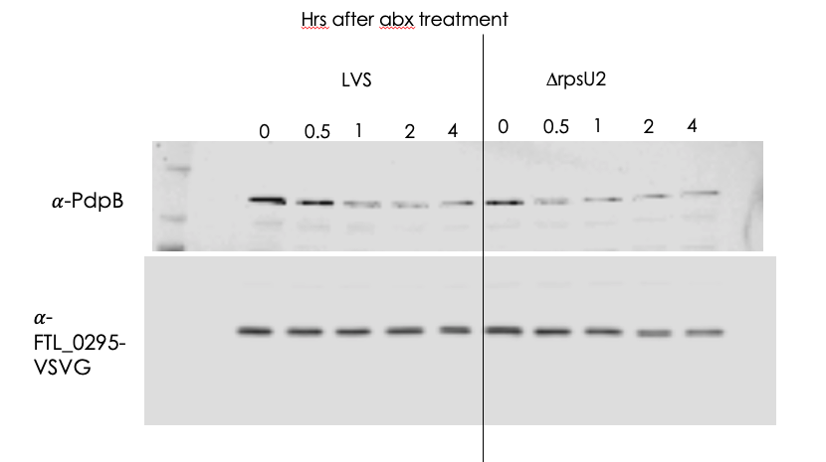
I couldn’t really settle on the best way to visualize the graphs – I tried setting t=0 to 1 for both strains, then I tried presenting just the ratio of PdpB/VSVG, then I tried doing a bar graph for the total degraded. I’ll show a few here:
Here you can see just the raw quantification for each protein relative to total protein. It seems like 0295-V is not degrading much, and if any, in drpsU2 it’s degrading more than in LVS. For PdpB, it seems like drpsU2 degrades faster at first, but then it evens out with LVS in the later time points. This might also be because of something funky happening in the 0.5 hr lane, and indicates we should do replicates in order to get a good average.
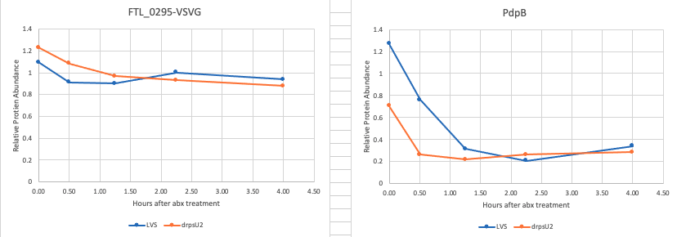

Here you can see the percent lost after 4 hours (i.e. 100-4 hrs/0hrs*100). Here it is obvious how much more PdpB degrades than 0295, and you can again see that 0295 degrades more in d2 whereas PdpB degrades less in d2.
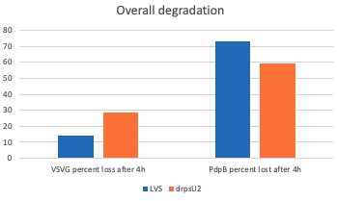
Overall, I definitely need to redo this and I think I should do multiple replicates. One major issue is that we only see 2-fold less PdpB in LVS vs. d2 at the 0 time point, whereas we are used to seeing much more than this. I think this may be because the ODs were a bit off – LVS wasn’t quite at 0.3 when I added the antibiotic.

I made 20% glucose for supplementing MHA by adding 50 g of glucose to a final volume of 250 mL water, then filter sterilized and put in the fridge.

Then I setup my spot plate assay using the following three strains, numbered as indicated here:
Sample Number | Genotype | KRLVS Number
1 | LVS pF-nat | 152
2 | drpsU1/drpsU3 pKR113 | -
3 | Triple mutant pKR113 | 141
I plated all three in technical triplicate on the following plate types: MHA no abx, MHA + 100 ng/mL ATc, MHA + 500 ng/mL ATc. Before plating, I dried the plates for 20 mins in the biosafety cabinet, putting tin foil up to block out the light.

Spot Plating Assay

- Take a small loop of each bacterial strain/replicate and resuspend in 0.5 mL of MHB in a sterile Eppendorf tube.
- Make a 1:10 dilution of each in cuvettes (900 ul of MHB, 100 ul of cells) and check OD
- Calculate dilution using C1V1=C2V2 formula to reach 0.10 OD in a final volume of 500 uL
- Serially dilute 1:10 in sterile tubes (i.e. 450 uL MHB + 50 uL cells), all the way to 10⁻⁸. Mix well and change pipette tips each time.
- Spot 10 uL of tubes 10⁻³ to 10⁻⁸ of each strain on one plate. Repeat on a second plate.
- Put in 37C incubator. Check for single colonies after 3-4 days.
After plating, I let the plates dry on the counter top then wrapped all of them in tin foil and put at 37C.

Thursday November 6, 2021
To Do:
- Calculate half-life from degradation experiment
Methods and Results:
After talking with Kathryn, she wanted me to try calculating the half-life of each protein from the degradation experiment. Essentially what we want to do is take the natural log (ln) of each raw protein concentration (do NOT normalize to total protein). Then plot that on a graph with time on the x-axis, and find the trendline. The slope from that trendline is alpha, or the removal rate. To get the half-life, you just do T_{1/2} = LN(2)/α.
Here’s the half-life calculations for PdpB:
 | Removal rate (α) | Half-life (min)
LVS | 1.0987 | 37.85276
drpsU2 | 0.9096 | 45.72211

Here’s the half-life calculations for FTL_0295-V:
 | Removal rate (α) | Half-life (min)
LVS | 0.1256 | 331.1213
drpsU2 | 0.2235 | 186.0798

Friday November 5, 2021
To Do:
- Check on spot plates
- Check on Eps, patch to RT
- Return spec and take sample of their brij
- Streak LVS for ribosomes
- Make media
Methods and Results:
Checked on my spot plates – nothing really has grown yet. Going to leave in the 37C incubator until Sunday.

My electroporations for linearized pKR74 didn’t work, again However, my electroporation to put pKR7 in the triple mutant had lots of colonies and nothing on the no DNA control. I patched 4 to CHAH-kan and left at room temp for the weekend.

I struck out 3 different bio replicates of LVS (from my box and Jamie’s box, different dates) to CHAH regular and put in the incubator. I checked that I have enough HEPES and MgCl2 for the ribosome purification, and I prepped more ammonium chloride by adding 32.08 g NH4Cl to 120 mL of water, letting dissolve on spin plate. Used good nuclease free water.

I made 3x 500 mL MHB in 1L baffled flasks and autoclaved for 30’. Then left on my benchtop. I checked and the iron should be good until Monday so I’ll just use that.

I will need about 3 mL of 5% Brij58, which I got from the Gregory lab. I also found out that they order it from sigma, so I’ll pass that info onto Kathryn.

Sunday November 7, 2021
To Do:
- Overnight cultures
- Check on spot plates.
Methods and Results:
My spot plates had some (very very small) colonies for LVS only on the 500 ng/mL ATc plates. Totally don’t understand that since it’s exactly the same as the regular plates. Returned everything to the incubator. I might ask Kathryn about doing this on CHAH plates.

I made overnight cultures of 3 LVS strains, using 500 mL MHB which I supplemented today. Set the starting OD to 0.004 so hopefully I won’t be too rushed tomorrow morning. The volumes I added were all between 130-180 uL. I then put the baffled flasks in the shaking incubator at 37C, 250 rpm.

Monday November 8, 2021
To Do:
- Prep all buffers for ribosome purification
- Freeze down pKR7 KRLVS141
- Part 1 of ribosome purf
- Make CHAH-nat plates and cross-patch pKR7 141
- Streak 0295 strains
- Setup for spot plate assay
Methods and Results:
I checked my cultures for LVS for the ribosome purification. They were all pretty good first thing this morning, but two were slightly slower than the others so I put them on ice at different time points. The time I put on ice is in parentheses below:
LVS 1 – 0.299 (17 hrs)
LVS 2 - 0.303 (15:40 hrs)
LVS 3 – 0.306 (16:15 hrs)

While those finished growing, I prepared the H10M10A1000 and H10M10A50 buffers using nuclease-free molecular grade or autoclaved water, as shown in the protocol below. Then continued with the protocol, including the high salt wash, through step 4. All of the spins for this part were on the benchtop centrifuge. I used the swinging rotor for the first spin and then fixed angle rotor for the remaining, by splitting 100 mL into 2x50 mL conicals. Once I switched to the fixed angle rotor, I did 15 minute spins at 12,000xg.

Preparation of 70S Ribosomes for Biochemistry
(Updated from original protocol of J. Thompson and S. Gregory from 3.22.03)

1. Scrape up a plate of Francisella into 1.5 mL tube of MHB.
2. Inoculate 500 ml of MHB in 1 liter baffled flasks with correct volume of culture. The initial OD₆₀₀ should be around 0.005. Incubate with shake at 37 °C to an OD₆₀₀ = 0.3-0.4.
*Take a 1 mL sample for whole cell proteins. Add equal amounts OD of 1x SLB (i.e. 0.3 OD, add 0.3 mL 1x SLB). Store sample at -20C.*
3. Chill the cultures on ice for 20 minutes, then harvest the cells by centrifuging at max speed for 30 minutes, at 4˚C if using benchtop centrifuge. Using JA-10 rotor in floor centrifuge, use 8,000 rpm for 5 mins (11,295xg).
4. Resuspend the cell pellet in a total of 100 ml H10M10A1000 (optional). Pellet the cells in centrifuge as above. This wash step is intended to remove any ribonucleases that might be sticking to the cell exterior. Resuspend the cells in 100 ml H10M10A50, pellet again. Resuspend the cell pellet in 30 ml H10M10A50 and pellet the cells in a 50 mL screw-cap tube. If using benchtop, do max speed for 30 mins, if using JA-20 rotor, do 8,000 rpm for 15 mins (7,720xg). Freeze the cell pellet at -80C.
5. Thaw the cell pellet and resuspend it in 2.5 ml H¹⁰M¹⁰A⁵⁰ per gram of cells (recommended: add bufer to increase volume for French Press, so it is at least 13 mL per sample). Add 20 μl of 1 U/ul DNase and pass three times through the French Press set on high until about 800 on the gauge. Collect the lysate in a glass beaker then transfer to a 30 ml Oakridge tube (red caps).
6. Pellet the cell debris in a 70 Ti rotor at 30,000 rpm, 15 minutes, 4 °C.
7. Transfer the S30 supernatant avoiding the pellet, to a 15 ml conical tube and add Brij 58 to 0.5 % (1/10 vol of 5 % stock; optional). Incubate on ice for 30 minutes or more.
8. Layer the S30 over a 10 ml sucrose cushion, H¹⁰M¹⁰A⁵⁰⁰ + 20 % sucrose being sure not to let the two layers mix. Centrifuge in a 70 Ti rotor at 40,000 rpm, 4 hours, 4 °C. An orange layer of carotenoids and membrane should appear at the interface and a glassy 70S ribosome pellet should be at the bottom of the tube. Rinse the ribosome pellet with 10 mL H¹⁰M¹⁰A⁵⁰ twice, without disturbing the pellet, and resuspend it in 1.0 ml of H¹⁰M¹⁰A⁵⁰. This may take a while. Do not pipet or vortex. Microfuge the suspension for 5 minutes at max speed and keep the supernatant.
9. Layer 1 ml of ribosomes onto 15 ml H¹⁰M¹⁰A⁵⁰ + 40 % sucrose. Centrifuge in a 70 Ti rotor at 30,000 rpm, 14 hours, 4 °C.
10. Rinse the pellet with 10 mL H¹⁰M¹⁰A⁵⁰ twice, without disturbing the pellet. Dissolve the ribosome pellet in 250 μl or less (minimal volume, start with 150 uL) of H¹⁰M¹⁰A⁵⁰. Pellet any remaining debris in the microfuge (max speed for 5 mins). Dispense into small aliquots (20 μl) in small Eppendorf tubes and freeze at -80 °C.
11. Calculate concentration: Take the A260 of a 1:200 dilution of ribosomes (in water). Multiply the resulting A260 by 200, then divide by 14.5 to give you the concentration in microgram per microliter. Take that number and divide by 2.7, and that will give you the concentration in pmol per microliter. If the concentration is still too high to read, make a greater dilution (1:500 or 1:1000) and multiply by the appropriate dilution factor.
H¹⁰M¹⁰A¹⁰⁰⁰ (if using)
10 mM Hepes KOH pH7.6 4 ml 1M Hepes KOH pH 7.6
10 mM MgCl₂ 4 ml 1M MgCl₂
1M NH₄Cl 80 ml 5M NH₄Cl
312 ml H₂O
400 ml
H¹⁰M¹⁰A⁵⁰
10 mM Hepes KOH pH7.6 6 ml 1M Hepes KOH pH 7.6
10 mM MgCl₂ 6 ml 1M MgCl₂
50 mM NH₄Cl 6 ml 5M NH₄Cl
H₂O to 600 mL
600 ml
H¹⁰M¹⁰A⁵⁰⁰ + 20 % sucrose
10 mM Hepes KOH pH7.6 1 ml 1M Hepes KOH pH 7.6 300 uL 1 M HEPES
10 mM MgCl₂ 1 ml 1M MgCl₂ 300 uL 1M MgCl₂
500 mM NH₄Cl 10 ml 5M NH₄Cl 3 ml 5M NH₄Cl
Sucrose 20 g 6 g
H₂O to 100 ml H₂O to 30 ml
100 ml 30 ml
H¹⁰M¹⁰A⁵⁰ + 40 % sucrose
10 mM Hepes KOH pH7.6 2 ml 1M Hepes KOH pH 7.6 400 uL 1M HEPES
10 mM MgCl₂ 2 ml 1M MgCl₂ 400 uL 1M MgCl₂
50 mM NH₄Cl 2 ml 5M NH₄Cl 400 uL 5M NH₄Cl
Sucrose 80 g 16 g
H₂O to 200 ml H₂O to 40 ml
200 ml 40 ml

Stock Solutions

Brij 58 stock 5 % (w/v) Brij 58 in H¹⁰M¹⁰A⁵⁰

1M MgCl₂ 203.3 g/mol = 20.33 g/ 100 ml

1M Hepes pH 7.6 238.3 g/mol = 23.83 g/ 100 ml = 47.66 g/ 200 ml
pH with 2.14 g KOH/ 100 ml = 4.28 g/ 200 ml

5M NH₄Cl 53.489 g/mol = 8.02 g / 30 mL for 5M
32.08/120 mL for 5 M

Make all stock solutions using good H₂O and good, clean glassware. Autoclave buffers before adding sucrose.
Use disposable plastic pipets, not the glass ones.

I froze down the four patches of pKR7 in KRLVS141. I also made CHAH-nat by adding 15 ul of nat to 300 mL CHAH and cross-patched extra cells from each of these patches, streaking to single colony, and put at 37C.

Kathryn wants me to re-do the spot plate assay with some different conditions and CHAH plates, so I struck out LVS pF-nat, KRLVS141, and d1/d3 pKR113 to CHAH-no abx. I also made CHAH-500 ng/ul ATc plates by first pouring regular CHAH plates until there was only 150 mL of CHAH left, then adding 150 ul of ATc.

Hopefully later this week I will be able to do the degradation experiment again, so I struck KRLVS135 and 139 to single colony.

Tuesday November 9, 2021
To Do:
- Continue ribosome purf
- Spot plate assay
- Check on nat plates
Methods and Results:
Continued with the Preparation of 70S Ribosomes for Biochemistry, starting at step 5 through 9. After the French press, I had slightly less of LVS1 than I did of 2 or 3 so I only saved the same volume for each (i.e. I took 10 mL of each and added 1 mL of Brij58 for a final volume of 11 mL before the first sucrose cushion). After the 4 hours spin, it was clear my pellets are a lot smaller than they have been in previous purifications, so I think that’s promising that the high salt wash had an effect. The glassy pellet had sort of an orange-y pellet on top that slunk to the bottom of the tube when I was washing it with H10M10A50, but it didn’t completely dislodge so both pellets were dissolved. The orange-y one was mostly removed during the 5 min spin, though.

Looked at my nat plates – they don’t seem to have any growth yet, but I’ll give it a few days since I wasn’t starting with a lot of cells.

Then I did my Spot Plating Assay. Three strains:
1- LVS + pF-nat
2- d1/d3 pKR113
3- KRLVS141 (triple mutant with pKR113)/
I used four different types of plates and plated different dilutions based on the plate. I started by diluting to OD 1.0 this time and plated as follows:
2x MHA 0 ATc – 1.0 through 10⁻⁵
2x MHA 500 ATc – 1.0 through 10⁻⁵
2x CHAH 0 ATc – 10⁻² through 10⁻⁷
2x CHAH 500 ATc – 10⁻² through 10⁻⁷
I had let the cHAH plates dry for >20 mins in the biosafety cabinet, but they were still a little wet. The spots weren’t running into each other but they were a bit larger in diameter than the ones on the MHA plates. This is just a trial run anyway. The MHA 500 plates didn’t dry after I put the liquid on them, and I waited like 2 hours. When I tried to move them into the incubator the dots all ran into each other. Ughhhh.

Wednesday November 10, 2021
To Do:
- Finish ribosome purf
- Patch out 0295 strains
Methods and Results:
The pellets for the ribosome purification looked pretty large today. I first added 250 ul of H10M10A50 buffer and let incubate for 3 hours. Then I added 100 ul more. I decided to leave in the fridge on ice overnight so that they would completel resuspend.

Unfortunately my KRLVS135 strain didn’t have single colonies today, so I’ll have to patch out tomorrow and delay the experiment until Monday.

Thursday November 11, 2021
To Do:
- Check on nat plates again
- Patch out 0295-V
- Freeze ribosomes and check concentrations
Methods and Results:
This morning my ribosomes were resuspended and looked great. I made aliquots in sterile 1.5 mL tubes as follows:
3x 100 ul per strain
6x 20 ul per strain
1x remaining per strain (25-100ul)
Put these aliquots in the -80C in a new box called ribosomes box 3. This was kept on shelf 7G.

I then took 1 ul of each ribosome sample, put in 99 ul of water, and checked the A260 with the nanodrop. As a blank, I used 1 ul of H10M10A50 mixed with 99 ul of water. I then used these readings to calculate the concentration:
Sample ID | A260 (Abs) | Calculated concentration ug/ul. | pmol/ul
WT 1 11/10/21 | 1.899 | 13.097 | 4.851
WT 2 11/10/21 | 2.077 | 14.324 | 5.305
WT 3 11/10/21 | 1.606 | 11.076 | 4.102
I will normalize the concentrations once I know the final volume. Kathryn still needs to ask the mass spec people about shipping without doing a stacking gel.

The nat plates all have single colonies, indicating that the pKR7 in KRLVS141 strains are all still holding onto the plasmid pKR113. Tomorrow I will streak these to single colony on kan plates.

Patched out 4x colonies from KRLVS139 and KRLVS135, each, to CHAH-kan and put in the standing 37C incubator.

My spot plates are very interesting – I’m starting to see single colonies on the CHAH plates but they are very small so I’ll wait until tomorrow to image them. The MHA plates will probably need at least another 1-2 days. It does seem like on 0 ATc CHAH the triple mutant with inducible rpsU2 has a lot fewer colonies which is restored substantially (but not completely) on 500 ATc. Weirdly, the d1/d3 pKR113 seems to be VERY impaired on 500 ATc but wild-type on 0 ATc. No idea why that is…I’ll do official counts tomorrow. In the meantime, returned to 37C.

Friday November 12, 2021
To Do:
- Freeze down 0295 strains
- Check on/image spot plates
- Streak pKR7 KRLVS141 to single colony on kan plates
Methods and Results:
I struck pKR7 KRLVS141 (four integrants) to single colony on kan plates then put at 37C. I also noticed some smaller colonies on the original EP plates that might be smaller because they only have one rpsU gene, so I tried cross-patching those to CHAH-kan and CHAH-nat (three total) and left the plaes at room temp.

I took pictures of my spot plates and counted what I could.
CHAH 500 ATc:
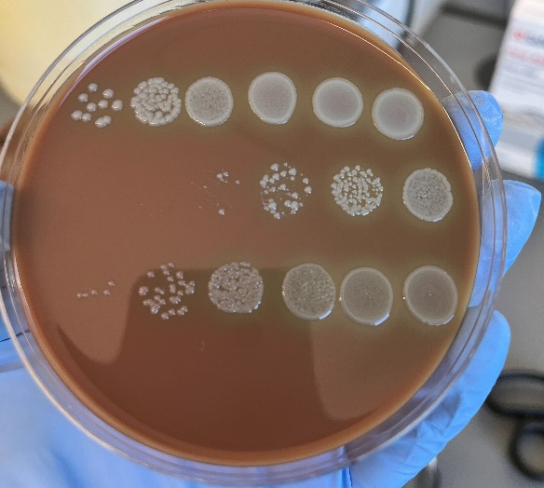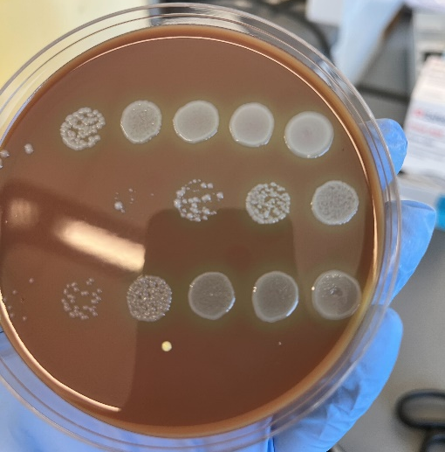
CHAH 0 ATc:
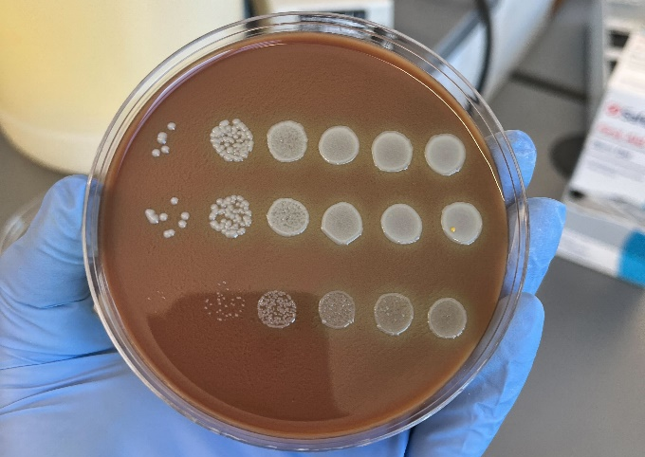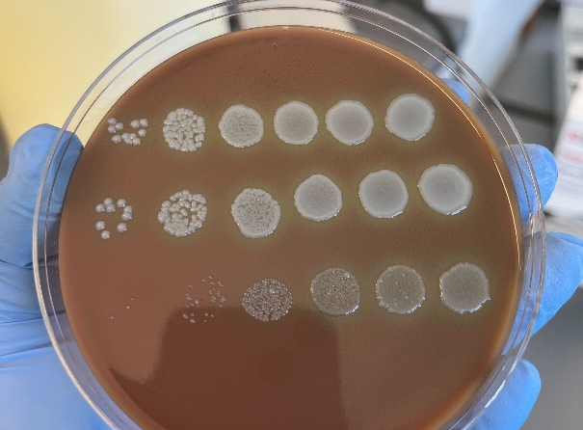

Sunday November 14, 2021
To Do:
- Patch out 0295 strains
Methods and Results:
I took KRLVS135 and 139 biological replicates from my glycerol stocks box 8 and patched to CHAH-kan.

I also cross-patched singles colonies from all four of the KRLVS141 w/ pKR7 replacements (3 from each so 12 patches total) to CHAH-kan and CHAH-nat.

Monday November 15, 2021
To Do:
- Overnight cultures for degradation experiment
- Ship out ribosomes
- Check on cross-patches, freeze down/restreak if necessary
- Finish counting spot plates
Methods and Results:
I counted the 0 ATc MHA plates today since they had grown up some more over the weekend. At this point, they’ve been in the incubator for 6 days:
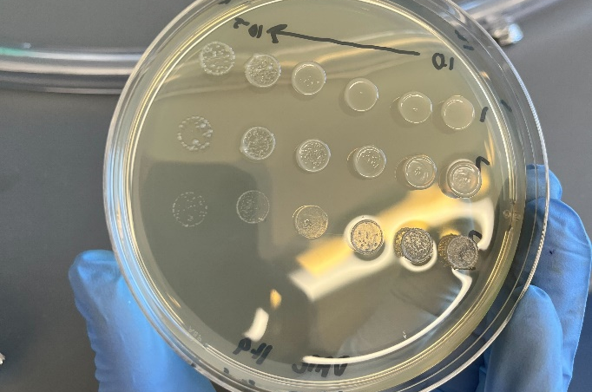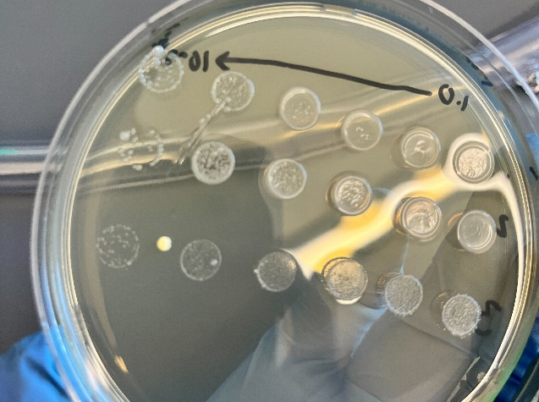
The LVS ones were a little overgrown so hard to count, but I got a decent estimate.

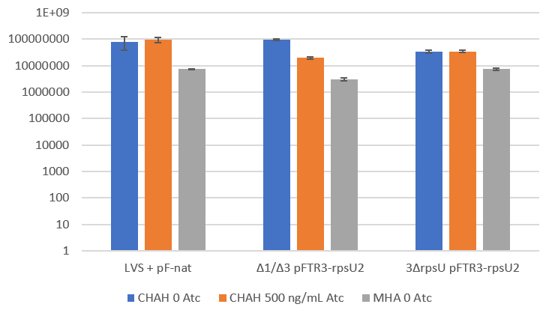
There doesn’t seem to be much of a difference between the triple mutant with and without ATc, so we are going to leave this method for now.

I made fresh iron then supplemented a new flask of MHB. I then aliquoted 50 mL into 6 baffled flasks of 125 mL for my overnight degradation experiment.
Because drpsU2 has a growth defect, I aimed to start those cultures a little bit higher.
Genotype | KRLVS Number | Flask Number | Goal Starting OD
LVS FTL_0295-V | 139 | 1 | 0.005
LVS FTL_0295-V | 139 | 2 | 0.005
LVS FTL_0295-V | 139 | 3 | 0.005
ΔrpsU2 FTL_0295-V | 135 | 4 | 0.00525
ΔrpsU2 FTL_0295-V | 135 | 5 | 0.00525
ΔrpsU2 FTL_0295-V | 135 | 6 | 0.00525

It looks like there’s no growth from my cross-patches on CHAH-nat yet, but there is growth on CHAH-kan. I want to wait until tomorrow to confirm for sure, though, because sometimes it takes the second plate an extra day to grow because the starting number of cells is so small.

I got ready to ship out my ribosome samples. First, I diluted them all to the lowest concentration (sample 3) with 100 ul total volume:
Sample ID | A260 (Abs) | Calculated concentration ug/ul. | pmol/ul |  | Ribosomes | Buffer
WT 1 11/10/21 | 1.899 | 13.097 | 4.851 |  | 84.6 | 15.4
WT 2 11/10/21 | 2.077 | 14.324 | 5.305 |  | 77.3 | 22.7
WT 3 11/10/21 | 1.606 | 11.076 | 4.102 |  | 100.0 | 0.0
Then we realized that there’s no dry ice in the chemistry building anymore, so we have to wait until tomorrow when we can buy some from air gas.

I made more CHAH and CHAH-kan plates today.

Tuesday November 16, 2021
To Do:
- Degradation experiment
- Ship out ribosomes
- Check on Oli’s plates and streak out for her growth curve
Methods and Results:
I checked on my overnight cultures and they were not good at all:

Genotype | KRLVS Number | Flask Number | OD at 8:30 am
LVS FTL_0295-V | 139 | 1 | 0.467
LVS FTL_0295-V | 139 | 2 | 0.499
LVS FTL_0295-V | 139 | 3 | 0.516
ΔrpsU2 FTL_0295-V | 135 | 4 | 0.061
ΔrpsU2 FTL_0295-V | 135 | 5 | 0.080
ΔrpsU2 FTL_0295-V | 135 | 6 | 0.062

These just aren’t nearly close enough to do the assay, so I’ll have to bleach my cells and try again tonight. This time, I’ll try with different starting concentrations. I had to make more MHB but we have an isovitalex shortage so I made only 200 mL by adding 4.2 g of MHB powder to 200 mL of water, sterilizing in the instant pot for 30’. Then I added 2 mL iron, 2 mL glucose, and 4 mL isovitalex (2 of the small bottles). I then added 100 mL from the stock of MHB in the fridge to total 300 mL and added 30 ul of kan. I aliquoted 50 mL into each of 6 baffled flasks (125 mL). Then resuspended cells to the starting ODs described below. Kathryn thinks we should generally go for 0.005 with LVS and 0.010 with drpsU2, but I have a thing tomorrow morning so I’ll be in a little late, and therefore I’m starting my cells at the ODs below:

Genotype | KRLVS Number | Flask Number | Goal Starting OD
LVS FTL_0295-V | 139 | 1 | 0.0035
LVS FTL_0295-V | 139 | 2 | 0.0035
LVS FTL_0295-V | 139 | 3 | 0.0035
ΔrpsU2 FTL_0295-V | 135 | 4 | 0.007
ΔrpsU2 FTL_0295-V | 135 | 5 | 0.007
ΔrpsU2 FTL_0295-V | 135 | 6 | 0.007

I checked on my plasmid replacement plates – the ones that were small colonies from the original EP plates did grow on nat today, but the ones I had struck to single colony on kan and then cross-patched didn’t grow at all on nat after it’s been 2 days. On kan we have nice robust growth. I’m saving two patches of these cells as strain KRLVS153.1 and 2, which ended up in strains box 6. I’ll also start designing inducible plasmids for rpsU1 and rpsU3 – pKR126 and 127.

I checked on Oli’s transformation plates and they looked good so I moved them to the fridge. I also struck out LVS and d2/d3 for her to do a growth curve tomorrow.

Kathryn picked up some dry ice for me today so I was able to ship the ribosomes out via UPS tracking number: 1Z5412RV1323137240
to Northwestern Proteomics. Young Ah Goo no longer works there so our primary contact is Tori Sosnowski.

Wednesday November 17, 2021
To Do:
- Degradation experiment
- Send sequencing for Janet
Methods and Results:
My cultures for LVS were a little high and for drpsU2 were a little low, but they were close enough so I just went for it. Gosh it sure is hard to get overnight cultures just right. At each time point I put 1 mL in the cuvette to check the OD, then I took 400 uL from that cuvette into a 1.5 mL tube, spun down at max speed, removed the supernatant, and resuspended the pellet in 1XSLB. At t=0, I added 490 uL of 50 mg/mL chloramphenicol to each flask then returned to the shaking incubator. This should result in 500 ug/mL because there were 49 mL left after checking the OD.

Genotype | KRLVS Number | Flask Number | OD600 t=0 | 1XSLB t=0 (ul) | OD600 t=0.5 | 1XSLB t=0.5 (ul) | OD600 t=1 | 1XSLB t=1 (ul)
LVS FTL_0295-V | 139 | 1 | .418 | 167.2 | .432 | 172.8 | .430 | 172
LVS FTL_0295-V | 139 | 2 | .478 | 191.2 | .490 | 196 | .494 | 197.6
LVS FTL_0295-V | 139 | 3 | .514 | 205.6 | .526 | 210.4 | .531 | 212.4
ΔrpsU2 FTL_0295-V | 135 | 4 | .254 | 101.6 | .258 | 103.2 | .263 | 105.2
ΔrpsU2 FTL_0295-V | 135 | 5 | .247 | 98.8 | .255 | 102 | .255 | 102
ΔrpsU2 FTL_0295-V | 135 | 6 | .263 | 105.2 | .269 | 107.6 | .270 | 108

Genotype | KRLVS Number | Flask Number | OD600 t=2 | 1XSLB t=2 (ul) | OD600 t=4 | 1XSLB t=4 (ul) | OD600 t=8 | 1XSLB t=8 (ul)
LVS FTL_0295-V | 139 | 1 | .437 | 174.8 | .438 | 175.2 | .426 | 170.4
LVS FTL_0295-V | 139 | 2 | .502 | 200.8 | .510 | 204 | .485 | 194
LVS FTL_0295-V | 139 | 3 | .533 | 213.2 | .527 | 210.8 | .493 | 197.2
ΔrpsU2 FTL_0295-V | 135 | 4 | .258 | 103.2 | .246 | 98.4 | .238 | 95.2
ΔrpsU2 FTL_0295-V | 135 | 5 | .254 | 101.6 | .242 | 96.8 | .234 | 93.6
ΔrpsU2 FTL_0295-V | 135 | 6 | .266 | 106.4 | .252 | 100.8 | .243 | 97.2

Aisling’s sequencing still didn’t come out very good. Janet had me submit the same exact thing I did on 10/26/21 to see if it’s an issue with the sequencer or the undergrads. I also had Aisling remake all of the primer stocks and start over with the original PCR from the gDNA. I’ll help her with the PCR purification on Friday.

Thursday November 18, 2021
To Do:
- Finish degradation experiment
- Gel and transfer for degradation experiment
- Digest for blunt end ligation for pYES2
Methods and Results:
Genotype | KRLVS Number | Flask Number | OD600 t=24 | 1XSLB t=24 (ul)
LVS FTL_0295-V | 139 | 1 | .374 | 149.6
LVS FTL_0295-V | 139 | 2 | .425 | 170
LVS FTL_0295-V | 139 | 3 | .444 | 177.6
ΔrpsU2 FTL_0295-V | 135 | 4 | .221 | 88.4
ΔrpsU2 FTL_0295-V | 135 | 5 | .217 | 86.8
ΔrpsU2 FTL_0295-V | 135 | 6 | .225 | 90

I ran three 4-12% gels with my samples from today and yesterday 11/17 with MOPS running buffer. On each gel I put one biological replicate of LVS (samples 1-3) and one bio replicate of drpsU2 (samples 4-6).
Lane | Sample | Volume of Sample (uL)
1 | BioRad | 3 (1:10 diluted)
2 | Sample 1 0 h | 9
3 | Sample 1 0.5 h | 9
4 | Sample 1 1 h | 9
5 | Sample 1 2 h | 9
6 | Sample 1 4 h | 9
7 | Sample 1 8 h | 9
8 | Sample 1 24 h | 9
9 | Sample 4 0 h | 9
10 | Sample 4 0.5 h | 9
11 | Sample 4 1 h | 9
12 | Sample 4 2 h | 9
13 | Sample 4 4 h | 9
14 | Sample 4 8 h | 9
15 | Sample 4 24 h | 9
16 | 1X SLB | 9
17 | Prestained ladder | 9
Lane | Sample | Volume of Sample (uL)
1 | BioRad | 3 (1:10 diluted)
2 | Sample 2 0 h | 9
3 | Sample 2 0.5 h | 9
4 | Sample 2 1 h | 9
5 | Sample 2 2 h | 9
6 | Sample 2 4 h | 9
7 | Sample 2 8 h | 9
8 | Sample 2 24 h | 9
9 | Sample 5 0 h | 9
10 | Sample 5 0.5 h | 9
11 | Sample 5 1 h | 9
12 | Sample 5 2 h | 9
13 | Sample 5 4 h | 9
14 | Sample 5 8 h | 9
15 | Sample 5 24 h | 9
16 | 1X SLB | 9
17 | Prestained ladder | 9

Lane | Sample | Volume of Sample (uL)
1 | BioRad | 3 (1:10 diluted)
2 | Sample 3 0 h | 9
3 | Sample 3 0.5 h | 9
4 | Sample 3 1 h | 9
5 | Sample 3 2 h | 9
6 | Sample 3 4 h | 9
7 | Sample 3 8 h | 9
8 | Sample 3 24 h | 9
9 | Sample 6 0 h | 9
10 | Sample 6 0.5 h | 9
11 | Sample 6 1 h | 9
12 | Sample 6 2 h | 9
13 | Sample 6 4 h | 9
14 | Sample 6 8 h | 9
15 | Sample 6 24 h | 9
16 | 1X SLB | 9
17 | Prestained ladder | 9

Friday November 19, 2021
To Do:
- Western
Methods and Results:

Upcoming experiments

- Order of priority – redo the 70S first, then degradation assay, and hold off on gradients
- Redo gradients western
  - go from fraction 1 to 21
  - normalize in the loading step – load 13 ul of rpsU3, 6.5 of rpsU1, and so on
  - try a new tip box for midi gels – orange ones? Or find something to order on amazon
- B-gals
  - Analyze ideal and tul4 SD via B-gal assay
  - WT pdpA, WT tul4
  - Confirm all of our Tn7 plans will work using overlap extension calculator – done! See below
  - Ideal SD
    - PCR 1:
      - pKR74 KROL476 and 257 :524 bps
      - pKR74 KROL475 and 363 : 5697
    - PCR 2:
      - KROL257 and 363 :6191
  - tul4 SD
    - PCR 1:
      - pKR74 KROL477 and 257 :524 bps
      - pKR74 KROL478 and 363 : 5696
    - PCR 2:
      - KROL257 and 363 :6191
  - to create pKR122 insert.
    - for region 1 – Use pKR121 with KROL482 and 257 :529 bps
    - for region 2 – Use pKR89 with KROL 483 and 488 : 5486
    - second PCR – 257 and 488: 5995

- Protein degradation experiment
  - Start them so they reach mid-log after overnight and check 8 hours after abx then 24 hrs after abx. Make 50 mL cultures * 6 in 125 mL culture tubes
- Phylogenetic tree
  - Finish clustering – make sure representative is consistent
  - Find outgroup
  - Figure out array to restore names to tree
- Ask Kathryn
  - gel order for degradation experiment
    - 1 bio replicate of LVS and 1 bio replicate of drpsU2 on each gel
  - gblocks ordered? replacing with rpsU1 when already has rpsU2 may be difficult
    - streak to single colony on plates with nat and 500 ATc and wait an extra day for small colonies
  - gradient gels normalizing?
  - blunt end ligation tips and tricks? Gel purf says to let sit 2-5min with buffer PE in it
    - less efficient so try the 3x 5x ligation thing
    - CIPped well

Blot | Protein | kDa | Primary Dilution | Secondary Dilution
1 | Tul4 | 17 | 1:1000 | 1:10,000 anti-mouse, 800 CW (green)
2 | IglA | 20.9 | 1:1000 | 1:10,000 anti-rabbit, 800 CW (green)
3 | IglB | 57.9 | 1:1000 | 1:10,000 anti-mouse, 800 CW (green)
4 | IglC | 22.1 | 1:1000 | 1:10,000 anti-mouse, 800 CW (green)
5 | IglD | 46.4 | 1:1000 | 1:10,000 anti-mouse, 800 CW (green)
6 | Sigma70 | 70 kDa | 1:250 | 1:10,000 anti-mouse, 800 CW (green)
7 | PdpB | 127.5 | 1:250 | 1:10,000 anti-mouse, 800 CW (green)
8 | PdpA | 95.3 | 1:250 | 1:10,000 anti-mouse, 800 CW (green)
9 | bS21-VSVG (anti-VSVG) | 9 | 1:2222 | 1:10,000 anti-rabbit, 800 CW (green)
10 | B-gal | 116 | 1:2500 | 1:10,000 anti-rabbit, 800 CW (green)
11 | Bfr | 16 | 1:500 | 1:5,000 anti-mouse
12 | rplL | 12 | 1:200 | 1:10,000 anti-mouse, 800 CW (green)
13 | GFP | 27 | 1:2000 | 1:10,000 anti-rabbit, 800 CW (green)
14 | FTL_0295-VSVG (anti-VSVG) | 35 | 1:2222 | 1:10,000 anti-rabbit, 800 CW (green)

For copying and pasting:
Tuesday July 19, 2021
To Do:
- Setup sequencing reactions, including pKR81 samples
- Western
- Transform more pKR89
- Redo PCRs from yesterday
- Check cross patches
Methods and Results:

