Table of Contents
Introduction 3
September 2022 3
Thursday September 1, 2022 3
Allelic exchange in F. tularensis LVS with pEX 4
Ligation Protocol 9
Friday September 2, 2022 10
Purification of plasmid DNA from S. aureus by alkaline Lysis 10
Transform chemically competent E. coli cells 12
Tuesday September 6, 2022 13
Wednesday September 7, 2022 13
Electroporation into S. aureus 14
Thursday September 8, 2022 16
Gene Deletion construct in S. aureus. 18
Friday September 9, 2022 19
Monday September 12, 2022 19
BCA Protein Assay Protocol 20
Tuesday September 13, 2022 22
Wednesday September 14, 2022 23
Thursday September 15, 2022 27
Friday September 16, 2022 30
Freezing permanent bacterial strain stocks 31
Monday September 19, 2022 32
Tuesday September 20, 2022 34
Wednesday September 21, 2022 37
GFP reporter assay 38
Thursday September 22, 2022 40
Friday September 23, 2022 40
Monday September 26, 2022 41
Tuesday September 27, 2022 41
Wednesday September 28, 2022 43
Thursday September 29, 2022 45
Friday September 30, 2022 49
October 2022 52
Monday October 3, 2022 52
Upcoming experiments 52

Introduction
Investigating presence of specialized ribosomes in F. tularensis, with focus on rpsU1, rpsU2, and rpsU3 homologs.

September 2022

Thursday September 1, 2022
To Do:
- Miniprep
- Diagnostic gel
- Make EC KMLFT97
- Gel purify
- Ligation
Methods and Results:
I miniprepped my overnight cultures of Staph. Tubes 4 and 6 had this very chunky mucus-y pellet that I couldn’t resuspend in buffer P1. I did my best but it wasn’t successful. The tubes also all had this weird sedimentation stuff at the bottom. I followed the usual QIAgen miniprep protocol but I added 2.5 ul of 10 mg/mL lysostaphin to buffer p1 in each tube and incubated at 37C for 30 mins before continuing with Buffer P2. I eluted in 30 ul of 0.1xEB and ran elution buffer over the columns twice. Here are my nanodrop readings:
Sample ID | Nucleic Acid (ng/ul)
mp rn 1 | 13
mp rn 2 | 6.4
mp rn 3 | 20
mp rn 4 | 23.5
mp rn 5 | 41
mp rn 6 | 20
They are concerningly low, but I ran 5 ul from each on a 1% agarose gel, along with 5 ul of my E coli prepped pKR148 plasmid:
E.c 1 2 3 4 5 6 Ec 1 2 3 4 5 6
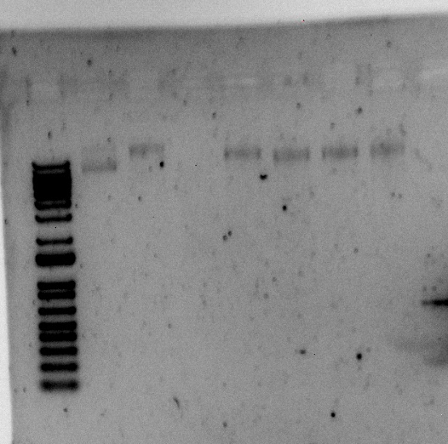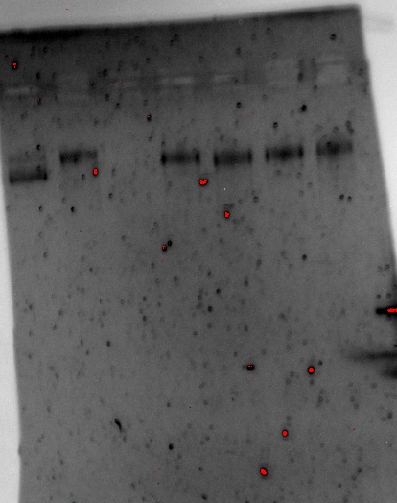

None of them seem to have the supercoiled band like pKR148 from E coli does, but the bands are similar sizes…I’ll ask Kathryn’s opinion. I want to try to get more DNA for doing a diagnostic digest, so I’m going to try miniprepping 4 cultures form a single colony. I picked two single colonies into 4 mL of TSB+tet each. I let shake all together for half an hour at 30C, then split into 4 tubes and added 4 mL more of TSB+tet so there was a total of 5 mL in each tube. I also put 100 ul from the initial 4 mL tube onto a TSA-tet plate so if either of them look good, I’ll have a patch to work with. Left shaking at 30C overnight.
45 mL LB + 13.5 ul tet

My KMLFT97 grew up finally, so I made electrocompetent cells using the protocol below, and put in my EC box 1 in the -80C.

Allelic exchange in F. tularensis LVS with pEX

Materials:
- pEX-based allelic exchange construct
- recipient LVS strain
- sterile 10% sucrose
- sterile glass culture test tubes
- solid media:
-Cystine heart agar with 1% hemoglobin (CHAH) plates
-CHAH plates containing 5 μg/mL kanamycin (CHAH-Kan)
-CHAH plates with 10% sucrose
- Mueller-Hinton broth (MHB), supplemented within past 2 weeks
- sterile 1X PBS
- sterile 75% glycerol
- cryovials
- sterile water
- PCR mix for colony PCR (example: NEB OneTaq Quick-Load 2X Master Mix with Standard Buffer)
- primers for distinguishing double crossover from revertant
- optional: primers to amplify plasmid backbone

Media recipes:
Mueller-Hinton broth
Mix 10.5 g Mueller-Hinton broth (BD Difco # 275730) and 500 mL type I ddiH₂O
Autoclave 30’
When cool, supplement with 0.025% iron pyrophosphate (5 mL of 2.5% iron pyrophosphate), 0.1 % glucose (5 mL of 10% glucose), and 2% Isovitalex (10 mL vial).
Keep at 4° when not in use, good for about 2 weeks

2.5% iron pyrophosphate (keep away from light, make a new stock every 2 weeks)
Mix 1.25 g iron pyrophosphate with 50 mL type I ddiH₂O (usually overnight to dissolve)
Filter-sterilize

2% hemoglobin (can make ahead and store at 4°C)
Mix 6 g freeze-dried hemoglobin with 300 mL type I ddiH₂O in 1 L flask
Autoclave 20’
Can make extra and aliquot to sterilized 100 mL bottles for later use

50% sucrose
Combine 360 g of sucrose and enough type I ddiH₂O to make 720 mL.
Autoclave for 20’.
Suggested method: in 1 L beaker, add ~100 g increments of sucrose into ~250 mL type I ddiH₂O, heating slightly (below boiling point!) and waiting for each addition to be completely dissolved before adding next mass of sucrose. Measure final volume in graduated cylinder and add type I ddiH₂O until volume is 720 mL.

Cystine heart agar with hemoglobin (CHAH plates) and CHAH plates with kanamycin
Mix 30.6 g cystine heart agar (Difco #247100) with 300 mL type I ddiH₂O
Autoclave 30’, being very careful media does not boil over
While autoclaving, warm 300 mL of 2% hemoglobin (in 50°C oven or in water bath at 55°C)
Place CHA flask in 50°C oven or in water bath at 55°C, let temperature equilibrate
Wipe down flask and bottles with ethanol and using sterile technique, pour hemoglobin into CHA flask
FOR CHAH-Kan plates:
Add 60 μL of 50 mg/mL kanamycin
Mix media
Use sterile pipette, pour ~24 mL media per plate (25 plates for 600 mL media)

CHAH plates with 10% sucrose
Mix:
5 g Beef Heart Infusion
5 g Protease Peptone
5 g Glucose
0.5 g L-Cystine
7.5 g Agar
with 150 mL type I ddiH₂O. Stir on low heat until completely dissolved, about 10 minutes.
Autoclave 30’, being EXTREMELY careful media does not boil over
While autoclaving, warm 250 mL of 2% hemoglobin and sterilized 50% sucrose (in 50°C oven or in water bath at 55°C)
Place CHA flask in 50°C oven or in water bath at 55°C, let temperature equilibrate
Wipe down flask and bottles with ethanol and using sterile technique, pour hemoglobin into CHA flask
Add 100 mL 50% sucrose to CHA-hemoglobin flask
Mix media
Use sterile pipette, pour ~24 mL media per plate (~20 plates for 500 mL media)

Protocol:
Day 1:
-Patch entire plate with recipient LVS strain on CHAH

Day 2:
Prepare electrocompetent (EC) cells
-Scrape up entire plate of cells into 400 uL of sterile 10% sucrose and resuspend (alternately, cells can be grown to mid-log in MHB)
-Add 1.1 mL of 10% sucrose to a final volume of 1.5 mL
-Spin for 3 minutes at 10,000 rpm
-remove supernatant, throw out, and resuspend in fresh 1 mL 10% sucrose
-Repeat 3x-5x in 10% sucrose
-After final spin, remove all supernatant.
-Resuspend cells in 10% sucrose at high density (corresponding to ~1x10¹¹ cells /mL); these are EC cells by slowly adding 110 uL at a time. It should be about equal amounts of cells as sucrose.
-For any extra EC cells, aliquot ~110 μL / sterile tube (enough for 2 electroporations) and freeze at -80°C

Electroporate plasmid into EC cells*
-For each electroporation, aliquot 4 mL MHB into glass test tubes for recovery, warm in shaker at 37°C
-For each electroporation, in a 2 mm sterile electroporation cuvette, combine:
5 μL of pEX-based allelic exchange construct (mini-prep concentration, at least 100 ng/μL)
50 μL electrocompetent cells
-Have recovery media ready
-Electroporate using the following settings: 2.5 kV, 25 μF, and 600 Ω
-Immediately after individual electroporations, use 1 mL warm recovery media from test tube to wash cells out of cuvette and transfer cells to recovery test tube
-Recover cells for 4-8 hours, shaking at 37°C
-Pellet cells by centrifugation in sterile 2 mL tubes, 1’ at 10,000 x g.
-Plate on CHAH-Kan plates, using 1 plate for each 2 mL tube (2 plates per electroporation)
-Incubate plates at 37°C for 3 days (or until single colonies appear)

*Always including a control electroporation with no plasmid. Eventually single break-through colonies may start appearing; at that point, single colonies on the experimental plates are also likely to just be break-through growth.

Day 5 (maybe 6):
-Pick single colonies from electroporation plates and patch onto CHAH-Kan plates (large patches, maximum 6 per plate, ideally 3-4 per plate). Pick at least 4, if there are 4 colonies (preferably from different electroporations to minimize the chance of picking the same integrant).

Day 6:
-Kanamycin-resistant cells should be 1° integrants. Make stocks of up to 4 potential 1° integrants, but only move forward with identifying cross-outs from two 1° integrants per strain

To select for cross-outs using sucrose selection
-Scrape up small loop of cells and resuspend in 1X PBS
-Dilute culture 1:10 in sterile PBS to 1x10⁻⁷
Perform first dilution 1:100 so first dilution tube is 1x10⁻², adding 10 uL of resuspended cells to 990 ul 1x PBS
Perform subsequent dilutions 1:10, diluting 25 uL cells into 225 uL 1X PBS
-Plate 100 uL of last dilution (1x10⁻⁷) onto CHAH plates.
-Plate 100 μL of each dilution 10⁻² – 10⁻⁷ on CHAH + 10% sucrose plates. If you have extra sucrose plates, can plate some or all dilutions twice.
-Incubate plates at 37°C for 3-4 days, or until single colonies appear. It is generally a good idea to test both large and smaller single colonies. Note that there should be many more colonies on the CHAH plate with the 1x10⁻⁷ dilution than on the sucrose plate with the corresponding dilution. If there seem to be similar numbers of colonies, the 1° integrant may have an inactivating mutation in sacB and is not worth keeping.

Make freezer stocks of 1° integrants
-Add 800 uL MHB to cryovial per 1° integrant
-Scrape up 1° integrant cells using loop into cryovial
-Completely resuspend cells in cryovial
-Add 200 uL 75% glycerol, close tube, mix by vortexing, and freeze at -80°C.

Day 9 (maybe 10):
-Pick single colonies (cross-outs) from sucrose plates and patch onto CHAH, 8 – 16 per 1° integrant.
-Optional: cross-patch to CHAH-Kan. Note that it is common to pick up some background cells so some amount of kanamycin-resistant growth is not yet a concern. However, if there is robust kanamycin-resistant growth from all patches from a single 1° integrant on the next day, the 1° integrant may have an inactivating mutation in sacB and is not worth keeping.

Day 10:
-Take small amounts of each cross-out patch and resuspend in sterile water.
-Heat samples at 95°C for 10’ to lyse and kill cells
-Dilute lysates 1:10
-Use 1-2 μL of heat-killed cells as template in colony PCR to check for desired mutation. As of August 2019, the KRamsey lab is primarily using PrimeStar GXL polymerase (Takara Bio). For controls, use LVS cells, LVS gDNA, the pEX-based allelic exchange vector, and water only.
Example colony PCR using KOD (use a master mix):
Water 4.0 μL
2X KOD Buffer 10.0 μL
2 mM dNTPs 4.0 μL
Forward primer (10 μM) 0.6 μL
Reverse primer (10 μM) 0.6 μL
KOD enzyme 0.4 μL
Cell lysate 1.00 μL
Total volume ~20.00 μL
Example colony PCR using PrimeSTAR GXL DNA Polymerase (use a master mix):
Water 12.5 μL
5X PrimeStar GXL buffer 4.0 μL
2.5 mM dNTPs 1.6 μL
Forward primer (10 μM) 0.6 μL
Reverse primer (10 μM) 0.6 μL
KOD enzyme 0.4 μL
Cell lysate 1.00 μL
Total volume ~20.00 μL

-Use PCR program:
1. 94°C 2'
2. 94°C 20"
3. 50°C 30"
4. 68°C (1' per kb)
5. Go to step 2, rep 32x
6. 68°C 5'
7. Hold 12°C

-If necessary, PCR purify and digest only LVS gDNA control and your potential mutants. Diagnostic digest should be 20 uL per reaction with 0.5 uL of enzyme.
-For cross-outs which appear to have the desired mutation (maximum 4), streak to single colony on CHAH plates, incubate at 37° for 3 days (or until single colonies appear).

Day 13:
-Patch single colonies of potential mutants on CHAH and cross-patch to CHAH-Kan plates (3 colonies are usually sufficient).

Day 14:
-Repeat colony PCR on all patches that are kanamycin-sensitive.
-Optionally, include a PCR for the plasmid backbone to confirm complete cross-out
-For patches that appear to have the desired mutation, make freezer stocks (freeze down 2 per strain if you have more than one)

Make freezer stocks of mutants
-Label 2 cryovials per strain
-Add 800 uL MHB to a sterile 2 mL tube per mutant
-Scrape up mutant cells using loop into 2 mL tube
-Completely resuspend cells
-Add 800 uL more MHB, completely mix cells
-Aliquot 800 uL cells to each labeled cryovial
-Add 200 uL 75% glycerol to each labeled cryovial, close tube, mix by vortexing, and freeze at -80°C.

Strains should be confirmed by alternate method (Southern blot, Western blot, or PCR using high-fidelity enzyme and sequencing, as is appropriate).

Sierra ran a gel with the overlap extension PCR from yesterday that didn’t work (PCR 2) and it seems like the overlap extension worked as the main product is around 850 nts:
Most likely I just missed an enzyme in my digest, so I redid just this digest using the remaining PCR purified piece:

Components | Volumes in 1 reaction (uL)
H₂O | 10.8
10x Buffer* | 3
DNA | (15)
Enzyme 1 | 0.6
Enzyme 2 | 0.6
Total | 30.0 (15.0 actual b/c of DNA)
Then I ran this on a 1% agarose gel as well:
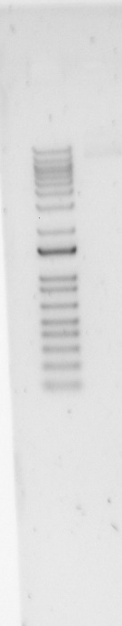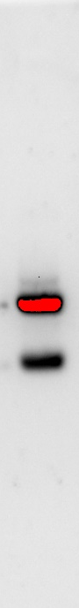
I think the band looks right this time..maybe… I decided to cut it out and gel purify it. I also gel purified all the pieces that I cut out yesterday. Then I setup the ligation and put at 16C overnight.

Ligation Protocol
Protocol by John Church
The purpose of this is to ligate the cut plasmid backbone to the strand of PCR DNA.

- Make a reaction table with desired ligations. Always include a backbone only control for each plasmid backbone used.
Tube | Inserts | Backbone | Plasmid to Make
1 | Gel tube 1 | Gel tube 7 | pKR155
2 | Gel tube 2 | Gel tube 6 | pKR156
3 | Gel tube 3 | Gel tube 6 | pKR157
4 | Gel tube 4 | Gel tube 8 | pKR158
5 | Gel tube 5 | Gel tube 7 | pKR159
6 | - | Gel tube 6 | BB control
7 | - | Gel tube 7 | BB control
8 | - | Gel tube 8 | BB control

- Set up master mix table:
Components | Volumes in 1 reaction (uL) | Volumes in Master Mix (uL)
H₂O | 11.5 | 103.5
10x ligase buffer | 2.0 | 18
Insert | 4.0
Backbone | 2.0
Ligase | 0.5 | 4.5
Total | 20 | 144

- Obtain ice to assemble and keep the reactions on. This is important, as the reaction happens at 16°C and the ligase buffer (which contains ATP) needs to be kept cold in order to avoid degradation. Take a 10 uL aliquot of 10X ligase buffer from the miscellaneous buffers box in the -20C.
- Obtain and label PCR tubes for the reactions. Be sure to include the date and your initials.
- To the individual tubes, add indicated amounts of H₂O (___uL), 10x buffer (_____uL), insert (____uL), and backbone (____uL).
- Add indicated amount of ligase (___uL) to the individual tubes. Remember to keep the ligase in a mini cooler.
- After all of the components have been added, mix each tube with a pipette set to 18 uL.
- Place in the thermocycler or water bath overnight at 16ºC. Can do at room temp for 10 minutes if necessary.

Friday September 2, 2022
To Do:
- Transform ligations
- Move EP plates to RT
- Miniprep
Methods and Results:
I miniprepped my 8 overnight samples according to the previous protocol I used that resulted in better lysis. Notable was that the pellets were much stickier and larger in minipreps 2A-D than 1A-D. I let incubate at 37C for 2 hours then I continued with the protocol. All four tubes for each individual colony were combined into 1 column after lysis and eluted in 35 ul of 0.1xEB

Purification of plasmid DNA from S. aureus by alkaline Lysis

Birnbiom, H. C. 1983. A rapid alkaline extraction method for the isolation of plasmid DNA Methods Enzymol 100:243-255.

QIAprep Spin Miniprep Kit Protocol adapted to S. aureus (Marco Palma)

- This protocol is designed for purification of up to 20 μg of high-copy plasmid DNA from 1-5 ml overnight cultures of S. aureus. (Overloading the system with too many cells will reduce the yield.)
- Grow 5 ml broth culture or plate of S. aureus.
- Spin culture at 4000 rpm for 10 min. Remove supernatant and add, (OR, suspend 2 loops of culture from a plate in) 700 μl TE (10 mM TrisCl, pH 8.0, 1 mM EDTA)
- Add 500 μl cold Acetone mix (50% acetone, 50% absolute ETOH, kept in freezer).
- Incubate 5 min on ice
- Spin 2 min at 14000 rpm
- Wash the pellet with 1 ml TE (it helps to completely resuspend the pellet), spin and discard sup.
- Add 3 μl 10 mg/mL lysostaphin to the cell pellet. (Vortexing the dry pellet briefly at this point helps resuspend the pellet when buffer is added, and seems to help lysis).
- Resuspend pelleted bacterial cells in 250 μl of Buffer P1 and transfer to a microcentrifuge tube.
- Incubate at 37° C for at least 1 hr. (Check for clearing)
- Proceed with QIAprep protocol at step 2:
“Add 250 μl of buffer P2 and gently invert the tube 4-6 times to mix, or until the solution becomes viscous and slightly clear.” Do not allow the lysis reaction to proceed for more than 5 min.
etc.

Sample ID | Nucleic Acid (ng/uL)
mp 4x 1 | 15.2
mp 4x 2 | 91.4

The concentrations weren’t great, but the second might be sufficient to see on a digest. I used 15 ul of each sample and setup a digest with BamHI/KpnI. I used the 1:100 diluted pKR148 as a positive control. The bands should be 2000 bps and 7000 bps.

Components | Volumes in 1 reaction (uL) | Volumes in Master Mix (uL)
H₂O | 2 | 8
10x Buffer* | 2 | 8
DNA | (15)
Enzyme 1 | 0.5 | 2
Enzyme 2 | 0.5 | 2
Total | 20.0 (5.0 actual b/c of DNA) | 20
Put at 37C for about an hour then ran on a 1% agarose gel.

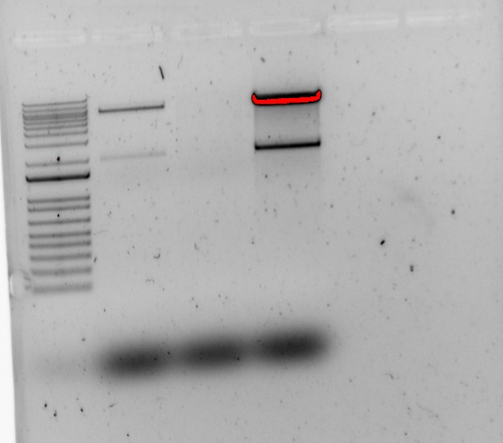
It looks like miniprep 2 is correct! Even though the concentration is pretty low, Kathryn thinks I might still get colonies from HG003 considering how effective it was with RN4220. If I don’t next week, I’ll try maxi-prepping from the cells of MP2.

I took my ligations out of the thermocycler and setup a transformation with XL1 blue cells.

Transform chemically competent E. coli cells

- Set up reaction table. Always include a positive and negative control for each antibiotic. If transforming plasmids (from previous plasmid prep), use 0.5 – 1 uL of plasmid. If transforming ligations, use 8 uL per ligation. If transforming plasmid, plate 20 uL and 100 uL. If transforming a ligation, plate 100 uL and remaining culture.
  - Note: The plasmid used for the positive control plates should be the regular circular plasmid, not the digest/purified one.
  - There should always be a backbone control if testing a ligation. This is the digested and ligated backbone with NO INSERT.

Reaction table
Tube number | Purpose | DNA |  | Volume of DNA | E coli strain | Final volume to plate | Number of kan-containing plates
1 | pKR155 | Ligation 1 |  | 8 uL | XL1-Blue | 100 ul, remaining | 2
2 | pKR156 | Ligation 2 |  | 8 uL | XL1-Blue | 100 ul, remaining | 2
3 | pKR157 | Ligation 3 |  | 8 uL | XL1-Blue | 100 ul, remaining | 2
4 | pKR158 | Ligation 4 |  | 8 uL | XL1-Blue | 100 ul, remaining | 2
5 | pKR159 | Ligation 5 |  | 8 uL | XL1-Blue | 100 ul, remaining | 2
6 | BB control | Ligation 6 |  | 8 uL | XL1-Blue | 100 ul, remaining | 2
7 | BB control | Ligation 7 |  | 8 uL | XL1-Blue | 100 ul, remaining | 2
8 | BB control | Ligation 8 |  | 8 uL | XL1-Blue | 100 ul, remaining | 2
9 | (+) control | pF |  | 1 uL | XL1-Blue | 20 ul | 1
10 | (-) control | - |  | 0 | XL1-Blue | 20 ul | 1
 |  |  | Total number of plates |  |  |  | 18

- Check to be sure you have enough LB-Kan plates with appropriate antibiotic. If plates were stored at 4°C, warm at 37°C until needed.
- Obtain DNA and thaw on ice if necessary.
- Thaw appropriate number of competent cell tubes on ice (5 reactions per tube of competent cells)
- Label sterile tubes as indicated in reaction table. Add indicated volume of indicated DNA on ice.
- When competent cells are thawed (check by probing for frozen cells using a sterile pipette tip), gently pipette 100 uL of cells into each reaction tube directly onto DNA using aseptic technique.
- Incubate cells on ice for 20 minutes. During incubation, find or set heat block to 42°C.
- Place tubes with cells and DNA onto 42°C heatblock for 30 seconds (heat shock step).
- After heat shock, place tubes back on ice until next step (don’t keep them here too long).
- Using aseptic technique, add 1 mL LB (no antibiotic) to each microfuge tube.
- Using autoclave tape, tape microfuge tubes down in shaking incubator set to 37°C.
- Allow cells to recover for 1 hour at 37°C, shaking. Place in a rack after shaking (NOT back on ice).
- Using aseptic technique, plate indicated amount of cells on appropriate antibiotic plates (LB-Kan), spreading until plates look dry. For “remaining” volume, spin tubes at max speed in benchtop centrifuge for 30 seconds. Remove 800 uL of media. Using 200 uL pipette, resuspend cells at bottom of tube and plate all the remaining culture.
Left plates at room temp over the weekend.

Tuesday September 6, 2022
To Do:
- Check on transformation plates and make overnight cultures
- Patch out from EP plates
Methods and Results:
I only had colonies on ligation 4 which makes pKR158. No idea why! However, I made three overnight cultures in LB-kan at 37C shaking and moved those plates to the fridge. I put the remaining plates at 37C just in case they have a really slow growth phenotype (which would be weird).

I also have no colonies on my electroporation plates I put those at 37C too to see if anything pops up because I would expect pretty slow growth considering it’s a drpsU2 strain.

Finally, I moved the S aureus plate with cells from my two minipreps to the fridge so if I need to maxiprep, I can get more plasmid.

Wednesday September 7, 2022
To Do:
- Official count of transformation colonies
- Re-do ligation
- Miniprep
- Electroporate into HG003
- Setup sequencing of pKR158
- Overnight cultures of transformation 2
Methods and Results:
I miniprepped the three overnight colonies I made for pKR158. I also counted my transformation plates and I actually see two colonies on the second transformation so that’s exciting. I’ll make overnight cultures tonight. I setup sequencing for the three pKR158 colonies:

Sample number | Template Name | Primer Nameª | A. | B. | E. | F.
 |  |  | Template Size (bases) | Template Stock Conc. (ng/μl) | PLASMID template: | Volume H₂O needed
 |  |  |  |  | Volume =
 |  |  |  |  | 2x(~200 ÷ B)μl | (12 less D or E - 2.56)μl
HT1 | pKR158-1 | KROL7 | 5300 | 670.5 | 0.60 | 8.84
HT2 | pKR158-2 | KROL7 | 5300 | 675.5 | 0.59 | 8.85
HT3 | pKR158-3 | KROL7 | 5300 | 574.3 | 0.70 | 8.74

Transformation number | 100 ul | Remaining
1 | 0 | 0
2 | 0 | 2
3 | 0 | 0
4 | 4 | 110
5 | 0 | 0
6 | 0 | 0
7 | 0 | 0
8 | 0 | 4
9 | 420 | -
10 | 0 | -

I electroporated 5 ul of my miniprep 2 from last week into HG003 aliquots. I did 2 with DNA and 1 without DNA, and both of the ones with DNA arced I may need to maxiprep and do a better job of washing the plasmid. I let recover for 1 hour at 30C then plated for each with DNA: 100 ul of 1:100 diluted in TSB, 100 ul of 1:10 diluted in TSB, 100 ul of undiluted, remaining onto TSA+tet plates. For the neg control, I just plated 100 and remaining.

Electroporation into S. aureus
From: Matthew Ramsey
Edited by: Hannah Trautmann 8/8/2022

Competent cells
Overnight culture in TSB at 37°C with shaking. 4ml in 30ml tube.
Dilute overnight culture of S. aureus back to about an OD600nm of 0.5 in 50ml of
prewarmed TSB. Approx.: 3 ml of overnight culture + 47ml prewarmed TSB.
Re-incubate for 30 min. After 30 min the culture is usually between OD600nm 0.8-0.9.
Transfer to 50ml tubes and let in ice-water slurry for 10 min (keep cold from now on).
Harvest the cells in centrifuge at 4105 x g for 10 minutes at 4°C.
Discard the supernatant, add 45ml sterile ice cold milliQ water. No need to resuspend the pellet yet.
Harvest the cells in centrifuge at 4105 x g for 10 minutes at 4°C.
Discard the supernatant, resuspended the pellet in 10ml sterile ice cold 10% glycerol.
Harvest the cells in centrifuge at 4105 x g for 10 minutes at 4°C.
Discard the supernatant, resuspended the pellet in 1.8ml sterile ice cold 10% glycerol. Transfer to 2ml tubes.
Harvest the cells in microcentrifuge (12000rpm) for 2 minutes at 4°C.
Discard the supernatant, resuspended the pellet in 1ml sterile ice cold 10% glycerol. Transfer to 2ml tubes.
Harvest the cells in microcentrifuge (12000rpm) for 2 minutes at 4°C.
Discard the supernatant, resuspended the pellet in 250ul sterile ice cold 10% glycerol.
Dispense 5 x 50ul aliquots and freeze at -80°C.

Electroporation
Thaw out aliquots on ice for 5 min then place at room temperature for 5 min (and follow the rest of the protocol at RT).
Centrifuge at 5,000xg for 1 min. Discard the supernatant and resuspend the cells in 50 ul of 10% glycerol / 500 mM sucrose.
Add up to 5ug-purified plasmid to the cells, mix and add to 0.1 cm electroporation cuvette. Up to 5ul of plasmid (dialyzed 20’ against H₂O with Millipore filters).
Pulse 21 kV/cm, 100 Ω and 25uF. Time constant usually about 2.0-2.4 ms.
Immediately add 1ml of TSB + 500mM sucrose and mix. (Dissolve 6.85g of sucrose in 40ml TSB and filter sterilize)
Transfer to a new tube and incubate at adequate temperature for 1-1.5h. (30C for RN4220; 42C for HG003)
Plate out on TSA + antibiotic. (3 ug/mL tet; 500 ul on 2 plates)

I checked the concentrations of my gel purifications to set up a molar ratio ligation. I’m going to re-do ligation 2 because I only have 2 colonies so it might not have worked, but I’m no going to re-do ligation 4 since that almost certainly worked out.
Sample ID | Nucleic Acid
gel purf 1 | 56.7
gel purf 2 | 24.2
gel purf 3 | 33.7
gel purf 5 | 60.4
gel purf 6 | 16.3
gel purf 7 | 16.5

Tube | Inserts | Backbone | Plasmid to Make
1 | Gel tube 1 | Gel tube 7 | pKR155
2 | Gel tube 2 | Gel tube 6 | pKR156
3 | Gel tube 3 | Gel tube 6 | pKR157
5 | Gel tube 5 | Gel tube 7 | pKR159
6 | - | Gel tube 6 | BB control
7 | - | Gel tube 7 | BB control
I had to dilute the inserts 1:10 in 0.1xEB to make it work.

Ligation 1 + 5
 | 5X Tube 1 | 5X Tube 5 | BB only Tube 7
Water | 10.46 | 10.71 | 14.47
Ligation Buffer | 2 | 2 | 2
Backbone | 3.03 | 3.03 | 3.03
Insert | 4.01 | 3.76 | -
Ligase | 0.5 | 0.5 | 0.5
 | 20.00 | 20.00 | 20.00
Ligation 2 + 3
 | Tube 2 | Tube 3 | BB only Tube 6
Water | 12.52951403 | 13.06596841 | 14.43251534
Ligation Buffer | 2 | 2 | 2
Backbone | 3.067484663 | 3.067484663 | 3.067484663
Insert | 1.903001305 | 1.366546931 | -
Ligase | 0.5 | 0.5 | 0.5
 | 20 | 20 | 20

I put them in the thermocycler at 16C overnight. I also made more LB-kan plates so that I can re-do the transformation tomorrow.

Thursday September 8, 2022
To Do:
- Electroporation of pKR11 into KMLFT strain
- Re-transform new plasmids
- Check on S aureus EPs
- Miniprep and setup sequencing
- Make CHAH plates
Methods and Results:
Miniprepped the two overnight cultures for pKR156 (ligation 2). Then I used them to setup more sequencing reactions:
Sample number | Template Name | Primer Nameª | A. | B. | E. | F.
 |  |  | Template Size (bases) | Template Stock Conc. (ng/μl) | PLASMID template: | Volume H₂O needed
 |  |  |  |  | Volume =
 |  |  |  |  | 2x(~200 ÷ B)μl | (12 less D or E - 2.56)μl
HT1 | pKR158-1 | KROL7 | 5300 | 670.5 | 0.60 | 8.84
HT2 | pKR158-2 | KROL7 | 5300 | 675.5 | 0.59 | 8.85
HT3 | pKR158-3 | KROL7 | 5300 | 574.3 | 0.70 | 8.74
HT4 | pKR156-1 | KROL525 | 7800 | 419.30 | 0.95 | 8.49
HT5 | pKR156-2 | KROL525 | 7800 | 388.80 | 1.03 | 8.41

I helped Ellen make CHAH-kan plates and I made CHAH plates.

I did a transformation with the ligations from last night per Transform chemically competent E. coli cells. I let recover for 1 hour at 37C then plated as indicated below and put at 37C overnight.
Tube number | Purpose | DNA |  | Volume of DNA | E coli strain | Final volume to plate | Number of kan-containing plates
1 | pKR155 | Ligation 1 |  | 8 uL | XL1-Blue | 100 ul, remaining | 2
2 | pKR156 | Ligation 2 |  | 8 uL | XL1-Blue | 100 ul, remaining | 2
3 | pKR157 | Ligation 3 |  | 8 uL | XL1-Blue | 100 ul, remaining | 2
5 | pKR159 | Ligation 5 |  | 8 uL | XL1-Blue | 100 ul, remaining | 2
6 | BB control | Ligation 6 |  | 8 uL | XL1-Blue | 100 ul, remaining | 2
7 | BB control | Ligation 7 |  | 8 uL | XL1-Blue | 100 ul, remaining | 2
9 | (+) control | pKR11 |  | 1 uL | XL1-Blue | 20 ul | 1
10 | (-) control | - |  | 0 | XL1-Blue | 20 ul | 1
 |  |  | Total number of plates |  |  |  | 14

Since I didn’t get any colonies when trying to put the hfq deletion plasmid into drpsU2, I’m going to the reverse way. Last week I made competent cells for KMLFT97 so today I electroporated pKR11 into it using 5 ul of plasmid, 50 ul of cells, per Allelic exchange in F. tularensis LVS with pEX protocol, in quadruplicate. I let recover for 5 hours and plated remaining to CHAH-kan plates.

I see a few single colonies on my S. aureus plates but it definitely looks like the EP worked because the comparison between the negative control and the ones with DNA is stark in color difference:
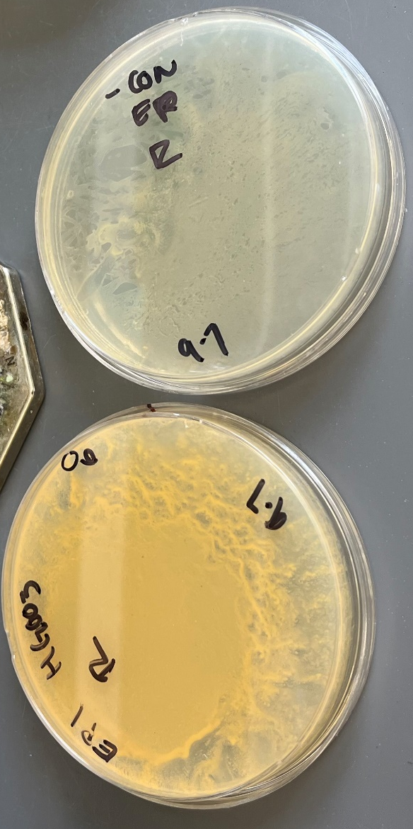
I circled ~6 potential colonies from each electroporation across different plates, but I decided to return the plates to the incubator as I previously found more colonies appear after 2 days. I also tried streaking to single colony from each remaining plate onto a new TSA-tet plate to see if I get single colonies that way, as I mostly have a lawn here. Kathryn also suggested that I try streaking one of my single colonies to single colony to see if there’s a phenotypic difference (i.e. is the single colony quite different from the lawn). From here on, I am loosely following this protocol from Matthew’s old coworker.

Gene Deletion construct in S. aureus.
Protocol: L Foulston
- Transform RN4220 with the deletion construct and select transformants on TSB containing 3 µg/ml tetracycline at 30°C (may need 24 hours or more).
- Inoculate two clones into TSB containing 3 µg/ml tetracycline grow overnight with shaking at 30°C.
- Purify the plasmid DNA by miniprep. Transform HG003 with the construct and select transformants on TSB containing 3 µg/ml tetracycline at 30°C (may need 24 hours or more).
- Restreak clones for single colonies on TSB containing 3 µg/ml tetracycline at 30°C.
- Pick two clones to inoculate into TSB containing 3 µg/ml tetracycline and grow overnight with shaking at 30°C. As a control for tet stability, grow a WT HG003 colony in TSB-tet as well.
- Store clones as glycerol stocks at -80°C. Restreak clones on TSB containing 3 µg/ml tetracycline and grow at 42°C.
-If integration is not successful by growing at 42C on plates, try growing in liquid culture. Dilute a 30C overnight culture 1:5000 in TSB-tet and grow throughout the day. Then plate dilutions on TSA-tet and put plates at 42C.
- Check individual colonies (8-10, to start) for integration of the plasmid by single crossover by colony PCR using primers flanking the deletion in the chromosome and a primer in the vector (such as LF019F; GGGGATGTGCTGCAAGGCGA ).
-First screen for tet cassette. Then do 2 additional colony PCRs for any that have the tet cassette, one for each side of integration.
-If no amplification on either integration side, try two primers on the plasmid outside of the flanking region to determine if the vector is still replicating.
- Select clones which have integrated the plasmid to inoculate into TSB without selection and grow at 25°C for 24h.
- Sub-culture 1 in 1000 into TSB without selection and grow at 25°C for a further 24h.
- Make serial dilutions of this culture and plate out on TSB without selection at 42°C overnight (a 10⁻⁶ dilution works well in most cases).
- Replica plate colonies on TSB containing 3 µg/ml tetracycline and on TSB without selection and grow at 37°C overnight. (starting with 25, up to 100).
- Select clones which are Tet^{S} and patch on TSB containing 3 µg/ml tetracycline and on TSB without selection and grow at 37°C overnight.
- Check colonies which are Tet^{S} by colony PCR using primers flanking the deletion in the chromosome. Also PCR the tet cassette to confirm it is fully resolved.
- Restreak colonies which are double crossover deletion mutants on TSB and grow at 37°C overnight.
- Inoculate single colonies into TSB and grow overnight at 37°C.
- Make glycerol stocks.
- Prepare gDNA from 1.5ml overnight culture. Confirm deletion is correct by PCR with primers flanking the deletion in the chromosome. Purify the resulting PCR product and sequence using the same primers.

Friday September 9, 2022
To Do:
- Check on transformation plates – count and move to fridge
- Analyze sequencing results
- Streak LVS and drpsU2 to RT for comp cells
- Check on s aureus plates
Methods and Results:
All my sequencing results are back and correct! I updated the plasmids list and moved the tubes to the -20C and -80C.

Since pKR158 is correct, I’ll try electroporating on Monday. I struck out LVS and drpsU2 to CHAH plates so that I can make electrocompetent cells Monday. Left the plates at RT.

My transformation plates don’t have an colonies with the exception of the positive control I’m going to leave at room temp over the weekend just in case any pop up. The positive control I wrapped in parafilm and moved to the fridge so that I can miniprep more pKR11.

My negative control S aureus plates were all orange today which likely means that I just started with too many cells. There are a few more potential colonies on the 1:100 plates that I struck to single colony again. The SCP plates I made yesterday have growth but no single colonies just yet. I am going to put all of these plates at RT for the weekend. I also wrapped up the 1:100 EP plates and put in the fridge in case I need to get some more single colonies later.

Monday September 12, 2022
To Do:
- Electroporate pKR158 into LVS and drpsU2
- Re-do transformations
- BCA assay with the ribosomes Kathryn isolated
- Check on electroporations and patch out if any primaries
Methods and Results:
I made electrocompetent cells of LVS and drpsU2 according to Allelic exchange in F. tularensis LVS with pEX protocol. I then electroporate 5 ul of pKR158:
2x pKR158 in LVS
2x pKR158 in drpsU2
I let recover in 4 mL MHB for 5 hours then plated remaining on CHAH-kan plates.

No luck on my transformations it’s surprising that I didn’t even get any colonies on the ligation 2 plate when I did on the original ligations. I think it’s possible that our cells aren’t good enough, so I’m going to try transforming from that first ligation (from 9/1) using the commercially competent DH5a cells:
Tube number | Purpose | DNA |  | Volume of DNA | E coli strain | Final volume to plate | Number of kan-containing plates
1 | pKR155 | Ligation 1 |  | 8 uL | XL1-Blue | 100 ul, remaining | 2
3 | pKR157 | Ligation 3 |  | 8 uL | XL1-Blue | 100 ul, remaining | 2
5 | pKR159 | Ligation 5 |  | 8 uL | XL1-Blue | 100 ul, remaining | 2
 |  |  | Total number of plates |  |  |  | 18

I have not colonies on my pKR11 KMLFT97 plates, sadly. I’m going to leave in the incubator another day and if still no colonies, I’ll plan to do an electroporation on Thursday. I made more CHAH-kan plates under the assumption that I will need to do more.

Kathryn wants me to do BCA assay with the ribosomes she isolated from the TAP purification. The diluent in this case will be the modified TEV cleavage buffer that’s in the refrigerator.

BCA Protein Assay Protocol
- Prepare diluted albumin (BSA) standards according to the table below. Use the same diluent as the samples.
Vial | Volume of diluent (uL) | Volume and source of BSA (uL) | Final BSA Concentration (ug/mL)
A | 0 | 300 of stock | 2000
B | 125 | 375 of stock | 1500
C | 325 | 325 of stock | 1000
D | 175 | 175 of vial B | 750
E | 325 | 325 of vial C | 500
F | 325 | 325 of vial E | 250
G | 325 | 325 of vial F | 125
H | 400 | 100 of vial G | 25
I | 400 | 0 | 0=blank
- Calculate how much working reagent is required using this formula:
(#standards + #unknowns) x (#replicates) x (200 uL) = volume WR needed
(9+2) x (3) x (200) = 6.6 mL
- Prepare working reagent by mixing 50 parts of BCA reagent A with 1 part of BVA reagent B.
Ex. For 50 mL of WR needed, combine 50 mL of A with 1 mL of B.
7 mL of A w/ 140 ul of B
- Pipette 25 uL of each standard or unknown sample replicate into a microplate well.
- Add 200 uL of the working reagent to each well (using multichannel) and mix thoroughly on a plate shaker for 30 seconds.
- Cover plate and incubate at 37C for 30 minutes.
- Cool plate to RT. Measure the absorbance at or near 562 nm on a plate reader.
- Subtract the average absorbance of the blank standard from all other standard and unknown sample replicates.
- Prepare a standard curve by plotting the average blank-corrected measurement for each BSA standard vs. its concentration in ug/mL. Use the standard curve to determine the protein concentration of each unknown sample.
A1 | A2 | A3 | I1 | I2 | I3
B1 | B2 | B3
C1 | C2 | C3 | bS21-TAP 1 | bS21-TAP 2 | bS21-TAP 3
D1 | D2 | D3 | LVS pF 1 | LVS pF 1 | LVS pF 1
E1 | E2 | E3
F1 | F2 | F3
G1 | G2 | G3
H1 | H2 | H3

Here was my standard curve:
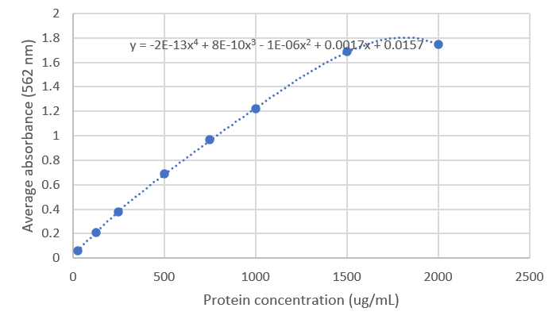
Based on the readings for my TAP samples, I narrowed it down to just the four lowest concentration ones:
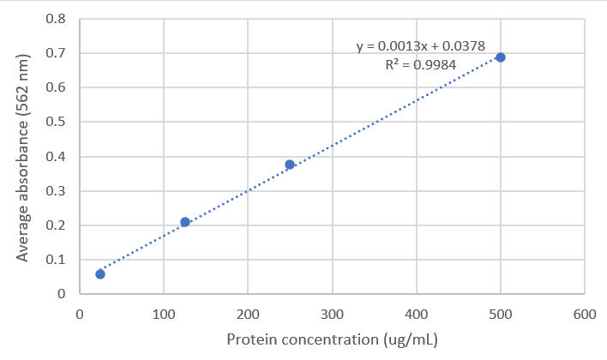
I used this formula: y=0.0013x + 0.0378 to calculate the concentration for my TAP samples:
 | Calculated concentration (ug/mL)
bS21-TAP | 256.74359
- TAP | 111.230769
Since like half of the concentration is TAP purification components and not the ribosomes, we can assume we need about 4x as many cells to reach a minimum of 500 ug/mL of ribosomes. Or potentially we could concentrate this sample more as there’s >1 mL of it. If we reduce the volume to ~250 ul we could have enough protein in this sample here.

I checked on my single colony plates of S. aureus today. At this point, I have 4 single colonies that have been struck out and 2 streaks from the remaining patch (many cells).
Name | Source | Date struck out | Status
E1 | Remaining plate | 9/8 | Tiny colonies w/ one large
E2 | Remaining plate | 9/8 | Tiny colonies
E1-1 | 1:100 plate | 9/9 | Not yet at single colony
E2-1 | 1:100 plate | 9/9 | Not yet at single colony
E1-3 | 1:10 plate | 9/8 | Tiny colonies
E2-5 | 1:10 plate | 9/8 | Tiny colonies
I think I’ll leave all the plates at 30C one more night. Perhaps at room temp they didn’t have enough time to grow? The one large one that’s from E1 I decided to patch out to a new TSA-tet plate and make an overnight culture at 30C. I used 5 mL TSB with 1.5 ul of tet for a final concentration of 3 ug/mL.

Tuesday September 13, 2022
To Do:
- Check on transformation plates
- Overnight cultures for minipreps
- Overnight culture of S. aureus and streak to single colony 42C (same stick)
- TSA tet
Methods and Results:
I checked on my transformation, it looks like they worked!
Ligation number | 20 ul | 100 ul | Remaining
1 | - | 1 | 4
3 | - | 0 | 127
5 | - | 0 | 12
I was a little confused with my plating piles so there’s a chance that the plasmids are mixed up, so I want to do overnight cultures with 4 from each plate. 5 mL LB + 5 ul kan x 4 per strain + 2 from pKR11 + control from 9/8/22. Put at 37C overnight.

My overnight cultures of S. aureus at 30C didn’t seem to grow. Perhaps I didn’t start with enough cells. I also checked on the plate at 42C and there’s some faint growth but no single colonies yet this morning. I’ll leave it until this afternoon to be sure. Update: there were single colonies this afternoon! I patched 7 of them to TSA-tet plates and put back at 42C so I can do a colony PCR tomorrow.

Looking at the S aureus plates that have been at 30C, there seem to be more single colonies for me to pick from. I’ll try streaking out 4 single colonies, 1 from each patch that was struck out on 9/8/22 (i.e. E1, E2, E1-3, and E2-5) and putting those plates at 42C, then making day cultures at 30C with the cells as well. I named these colonies: E1-0-1, E2-0-1, E1-3-1, and E2-5-1 so I can keep track of them. I also made more TSA-tet plates:
TSA w/ 3 ug/mL tet: Make 500 mL
-15 g of TSB + 7.5 g agar + 500 mL water
-autoclave liquid 30’
-add 150 ul of 10 mg/mL tet
-pour plates, protect from light
This afternoon the 30C day cultures hadn’t grown but Kathryn thinks they may need more time so I put them shaking at 30C overnight.

Wednesday September 14, 2022
To Do:
- Streak KMLFT97 out for EP
- Minipreps
- Setup sequencing
- Colony PCR on potential patches
- Freeze down overnight cultures from 30C
- Freeze down patches if colony PCR looks good
- Patch out more colonies if colony PCR is not good.
Methods and Results:
My 30C cultures of HG003 with replicating pKR148 grew – two a lot and two a little. I added 800 ul of culture to 200 ul of 75% glycerol in a cryovial, vortexed, then put in my primary integrants box 2.

Of the 7 patches at 42C, only patch 4 had robust growth. The rest had very faint growth but they started from small colonies. I took some of each anyway to do the colony PCR, but only diluted the lysate from patch 4.

Controls: SA gDNA 1:10, pKR148 1:100, water, + 7 patches
Primer Set | Expect if gDNA NO plasmid | Expect if gDNA with replicating plasmid | Expect if integration into FR1 | Expect if integration into FR2 | Expect if double deletion
KROL534 and KROL458 | - | 2066 | 2066 | 2226 | -
KROL535 and KROL460 | - | 2066 | 2266 | 2066 | -
KROL536+493 | 2173 | 2173 | - | - | 2009
KROL398+397 | - | 1461 | 1461 | 1461 | -
Master mix for each primer set:
Components | Volumes in 1 reaction (uL) | Volumes in Master Mix (uL)
H₂O | 11.8 | 129.8
5X Primestar GXL buffer | 4 | 44
2.5 mM dNTPS | 1.6 | 17.6
Forward primer (10 uM) | 0.6 | 6.6
Reverse primer (10 uM) | 0.6 | 6.6
Primestar DNA polymerase | 0.4 | 4.4
Cell lysate | 1
Total | 20 | 209
Put in STN1 with a 2:15 extension time then ran on 1% agarose gels.

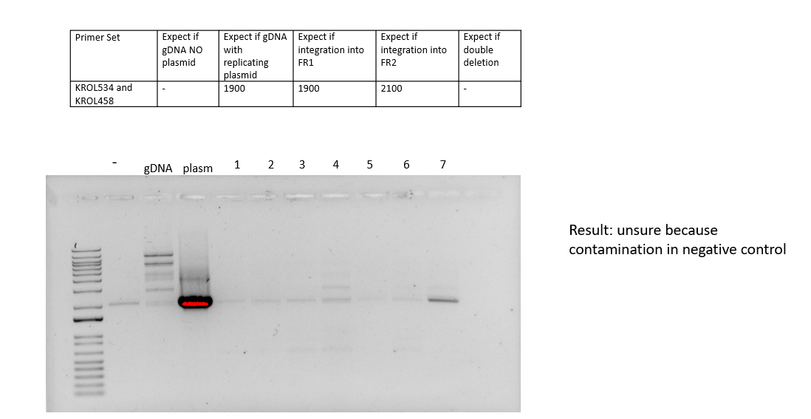
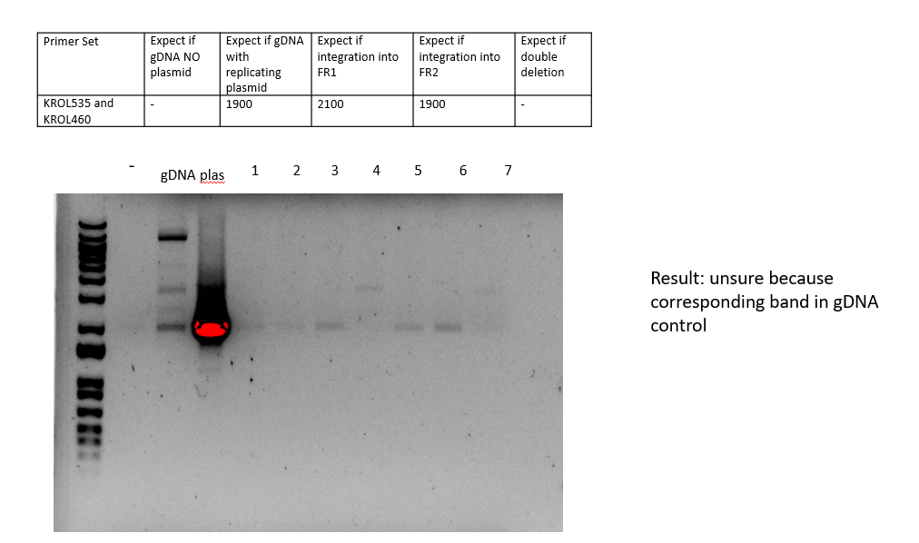
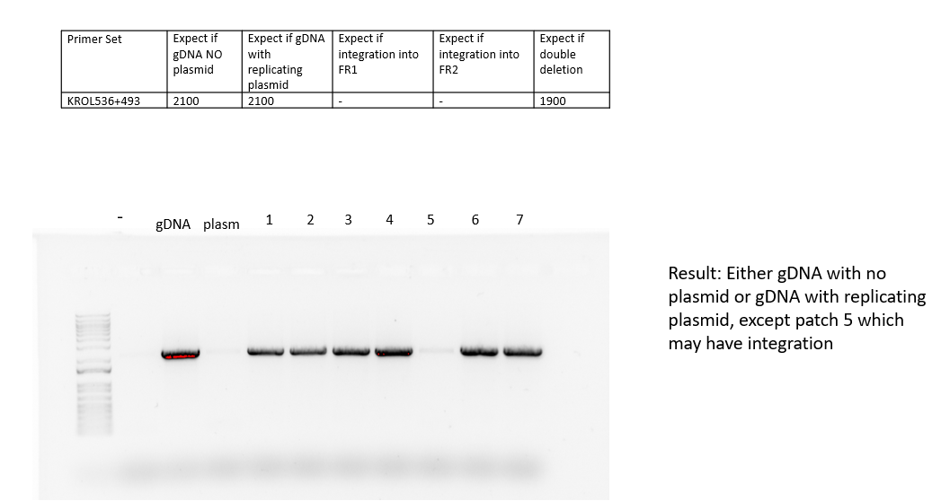
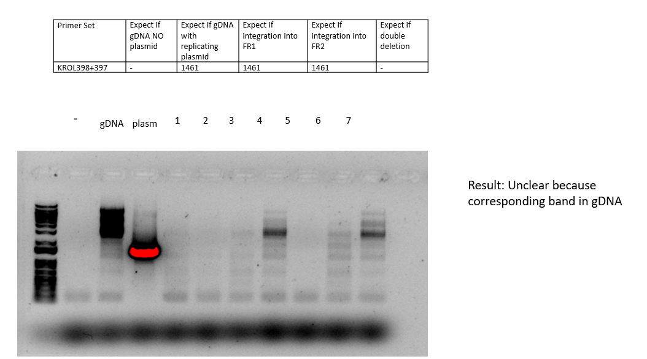
Based on these results, I think I should try patching out new ones to screen tomorrow from the ones I placed at 42C yesterday. I patched 3 from each of the 4 I had struck to single colony, for a total of 12 patches and put at 42C. I also think it might be better to narrow down our colony PCR to just one or two so I can screen more at once.

I miniprepped all of my overnight samples with the potential new plasmids, eluting in 50 ul of 0.1xEB. I checked the concentrations with the nanodrop, then setup sequencing reactions:
Sample number | Template Name | Primer Nameª | A. | B. | E. | F.
 |  |  | Template Size (bases) | Template Stock Conc. (ng/μl) | PLASMID template: | Volume H₂O needed
 |  |  |  |  | Volume =
 |  |  |  |  | 2x(~200 ÷ B)μl | (12 less D or E - 2.56)μl
HT1 | pKR155-1 | KROL525 | 7800 | 227.6 | 1.76 | 7.68
HT2 | pKR155-2 | KROL525 | 7800 | 182 | 2.20 | 7.24
HT3 | pKR155-3 | KROL525 | 7800 | 73.9 | 5.41 | 4.03
HT4 | pKR155-4 | KROL525 | 7800 | 380.9 | 1.05 | 8.39
HT5 | pKR157-1 | KROL525 | 7800 | 255.2 | 1.57 | 7.87
HT6 | pKR157-2 | KROL525 | 7800 | 237.2 | 1.69 | 7.75
HT7 | pKR157-3 | KROL525 | 7800 | 255.9 | 1.56 | 7.88
HT8 | pKR157-4 | KROL525 | 7800 | 246.6 | 1.62 | 7.82
HT9 | pKR159-1 | KROL525 | 7800 | 338.6 | 1.18 | 8.26
HT10 | pKR159-2 | KROL525 | 7800 | 195.1 | 2.05 | 7.39
HT11 | pKR159-3 | KROL525 | 7800 | 244.1 | 1.64 | 7.80
HT12 | pKR159-4 | KROL525 | 7800 | 539.8 | 0.74 | 8.70
The pKR11 samples had great concentrations – around 850 ng/uL, so I combined those into the plasmids box already in the -20C.

Since I never got colonies for the double hfq/rpsU2 mutant, I struck out more KMLFT97 to CHAH plates. I struck out two plates so I can make single use aliquots and electrocompetent cells and used KMLFT97.2 since that one seemed to be more robust.

Thursday September 15, 2022
To Do:
- Colony PCR on new patches
- Try adjusting melting temperature to get specificity for ps1 and ps2
- Streak no. 4 to single colony
- Freeze down RN4220 miniprep 2 from plate in fridge
- Patch out potential pKR158 patches
Methods and Results:
My KMLFT plates hadn’t grown up enough so I’ll do electrocompetent cells and EPs tomorrow.

I have at least 1 potential colony on each of my hfq-V electroporations which I patched to CHAH-kan and put at 37C.

The patches of S aureus from yesterday hardly grew at all, so I patched out 16 more. Hopefully these grow as they are bigger colonies today than they were yesterday. I also struck the E2-0-2-4 to single colony since Kathryn thinks it might be a mixed population. I won’t do the colony PCR until I have some more to screen.

I am trying to check a range of new melting temperatures that would allow the 1st and 2nd primer set to be more specific. I used the gradient setting for the annealing temperature on the thermocycler. Since our normal annealing temperature is 50C, I picked 8 temperatures that went from 50C to 65C. I included three samples for each temperature: water, 1:10 SA gDNA, and 1:1000 pKR148. The two primer sets are:
Primer Set | Expect if gDNA NO plasmid | Expect if gDNA with replicating plasmid | Expect if integration into FR1 | Expect if integration into FR2 | Expect if double deletion
KROL534 and KROL458 | - | 2066 | 2066 | 2226 | -
KROL535 and KROL460 | - | 2066 | 2266 | 2066 | -
I remade primers KROL534 and 458 because they had contamination last time.

Components | Volumes in 1 reaction (uL) | Volumes in Master Mix (uL)
H₂O | 11.8 | 106.2
5X Primestar GXL buffer | 4 | 36
2.5 mM dNTPS | 1.6 | 14.4
Forward primer (10 uM) | 0.6 | 5.4
Reverse primer (10 uM) | 0.6 | 5.4
Primestar DNA polymerase | 0.4 | 3.6
Cell lysate | 1 | 9
Total | 20 | 180
Here are the gradient parameters:
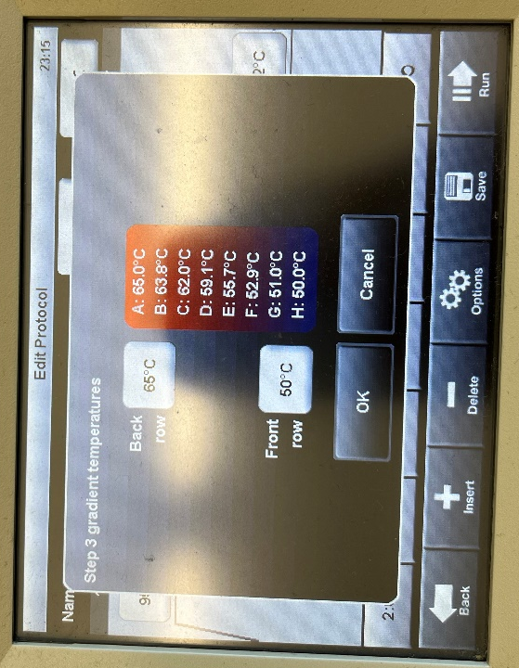
Everything else was the same as our usual STN1 and I used a 2:15 extension time.
After, I ran all my samples on a 1% agarose gel.
I did a lighter exposure for the plasmid samples because they’re so bright, but I tried to align them well:
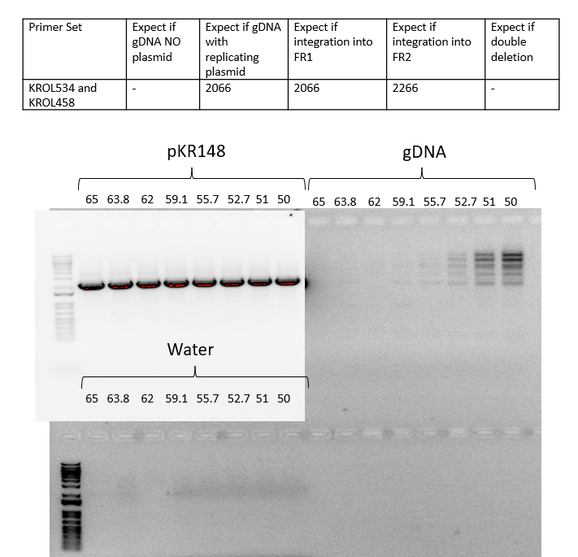
For this primer set, it seems like 62C is the temperature where I really don’t see a product in the gDNA sample.
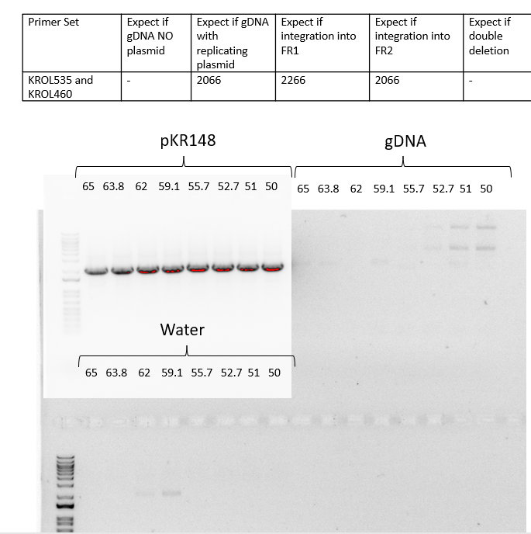
For this primer set, it seems like 55.7C is where I don’t see a product in the gDNA. It’s weird that I see something in the 59.1C tube for both gDNA and water – must be that I got some contamination in that master mix tube.

Kathryn wants to consider just doing the cloning in RN4220 so I froze down miniprep 2 which has the replicating plasmid and put in primary integrants box 2. She also wants me to try electroporating into HG003 again but to plate on both TSB and TSB-tet so I made more plates of both and will do that EP on Monday. I also made more TSB-500 mM sucrose, this time doing only 20 mL: Dissolve 3.43g of sucrose in 20ml TSB and filter sterilize

TSA w/ 3 ug/mL tet: Make 250 mL
-7.5 g of TSB + 3.75 g agar + 500 mL water
-autoclave liquid 30’
-add 75 ul of 10 mg/mL tet
-pour plates, protect from light

Friday September 16, 2022
To Do:
- Analyze sequencing results
- Electroporate new plasmids into d2 and LVS
- Make single use aliquots of KMLFT97
- Freeze pKR158 patches
- Move S aureus plates to RT or fridge
Methods and Results:
I got my sequencing results back.
For pKR155 - minipreps 2 and 3 are correct
For pKR157 – minipreps 2, 3, and 4 are correct
For pKR159 – none are correct
I combined the appropriate tubes for pKR155 and 157, made the 5 ul aliquot, put things in the freezer, then updated the strains list. I’ll revisit pKR159 next week.

I electroporated 3 ul of plasmid into 50 ul of LVS and drpsU2 electrocompetent cells that I had stored. The plasmids were: pKR155, pKR156, and pKR157 for a total of 6 EPs. I let recover for 2 hours then plated 10 ul and 100 ul on CHAH-kan plates. I also struck out controls – regular mraY UTR and tul4 UTR for the GFP assay to single colony on CHAH-kan plates.

My LVS patch with hfq-V grew up nicely today but of course the drpsU2 are slow growers. I’m leaving the drpsU2 plate at room temp over the weekend to grow up some more and I’ll freeze down and do colony PCRs on all of them on Monday. For now, I’m freezing the LVS patch as KRLVS194 but I’ll wait to put it in the strains box until the colony PCR confirmation. I put in my primary integrants box 2 for now. I also froze a small amount as a pellet for isolating gDNA and a small amount in water for doing the colony PCR (already lysed).

Freezing permanent bacterial strain stocks

Add strain to strain list
If you are freezing down a strain generated by allelic exchange, remember to add the 1° integrant that generated the final strain. Include it on the strain list first.
For each strain you add, include:
- Genotype
- Notes (for example, FTL number corresponding to a gene name or vice versa)
- Location (Strain boxes are stored at -80°C)
- The genotype of the original strain you started with (Background)
- Any integrated plasmid (no plasmids in clean deletions, but plasmids are in 1° integrants)
- The descriptive name of any integrated plasmid
- Strain verification data: should include the name of the person who verified and the date for each type of verification
- Any additional notes (notable phenotypes, etc)

Freeze down strain
Use aseptic technique
- Per strain, label 2 cryotubes with strain number. Include LVS, strain number, genotype, date.
- Add 200 uL sterile 75% glycerol to each tube (2 per strain).
- In a sterile 2 mL tube (1 per strain), add 400 uL of MHB
- Resuspend patch (all of what you have) in MHB to homogeneity
- Correct volume to 1700 uL (add 2x 650 uL MHB)
- Transfer 800 uL to each cryotube (final volume should be 1 mL)
- Vortex cryotube
- Quickly spin (mini-fuge) to get liquid to the bottom of the tube
- Freeze at -80°C in appropriate strain box

Next I made my personal glycerol stock of KMLFT97.2 which is dhfq along with 8 single use aliquots that have 100 ul in them each.

I checked on my S aureus plate. Nothing from 9/14 had grown but a bunch of them from 9/15 had grown so I moved to room temp and I’ll try to do a colony PCR on Monday.

Monday September 19, 2022
To Do:
- Redo electroporation into HG003
- Overnight cultures of pKR159 (ligation 5)
- Streak out KMLFT97
- Move LVS EP plates to RT
- Freeze down hfq-V strains
- Colony PCR on hfq-V KROL240 + KROL543 (487)
- Colony PCR on S aureus patches (only primer set 3)
- Make CHAH and CHAH-kan plates
Methods and Results:
I did the Electroporation into S. aureus using 1 negative control and 1 with 5 ul of pKR148 (passed through RN4220) with HG003 cells. The negative control arced but the other did not and the time constant was 3.1. I let recover one hour then plated the following for each EP on both TSA+tet and TSA no tet: 100 ul, 100 ul of 10⁻¹ diluted, 100 ul of 10⁻² diluted, 100 ul of 10⁻³ diluted, 100 ul of 10⁻⁴ diluted. Plates were put at 30C.

Next I froze down KRLVS195 which was the only patch that grew up from the drpsU2 hfq-V strain. I saved a small amount of the pellet for isolating gDNA and some for colony PCR. I also did the colony PCR with KRLVS194. The primers were KROL543 (on the genome) and KROL240 (on the plasmid). As controls I used water, LVS gDNA, and 1:100 pKR158, all of which should have no band.
Components | Volumes in 1 reaction (uL) | Volumes in Master Mix (uL)
H₂O | 11.8 | 70.8
5X Primestar GXL buffer | 4 | 24
2.5 mM dNTPS | 1.6 | 9.6
Forward primer (10 uM) | 0.6 | 3.6
Reverse primer (10 uM) | 0.6 | 3.6
Primestar DNA polymerase | 0.4 | 2.4
Cell lysate | 1
Total | 20 | 114
Ran on STN1 with a 30 second extension time, then ran on a 1% agarose gel.
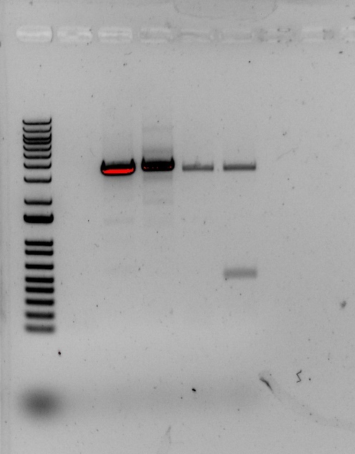
The expected band for plasmid integration is around 500 nts, so it looks like only KRLVS195 is correct. I updated the strains list to reflect this. There was one more colony on the original EP plates for LVS hfq-V which I patched out to CHAH-kan and I can check that by colony PCR tomorrow.

I looked at all my EPs from last week and they seemed to work. I moved to room temp because I want to patch out tomorrow for the GFP assay with the exception of a few drpsU2 ones that didn’t grow very much. I also made more CHAH-kan plates and regular CHAH plates today.

Shockingly, I got a single colony on my pKR11 in KMLFT97 (attempting to make the double deletion). I’m quite surprised because this EP was done 11 days ago but they both have terrible growth defects so it’s possible its correct? I patched out to CHAH-kan but don’t expect it to grow up right away. Because of this, I’m going to hold off on doing another EP.

The S aureus patches I made from plates at 42C had about 10 that grew up well which is progress! The ones that grew well were patches 13, 14, 15, 16, 17, 21, 23, 25, and 27. I did a colony PCR only with this primer set:
Primer Set | Expect if gDNA NO plasmid | Expect if gDNA with replicating plasmid | Expect if integration into FR1 | Expect if integration into FR2 | Expect if double deletion
KROL536+493 | 2173 | 2173 | - | - | 2009
For controls I have water, 1:1000 pKR148, and 1:10 SA gDNA, making a total of 13 reactions:
Components | Volumes in 1 reaction (uL) | Volumes in Master Mix (uL)
H₂O | 11.8 | 165.2
5X Primestar GXL buffer | 4 | 56
2.5 mM dNTPS | 1.6 | 22.4
Forward primer (10 uM) | 0.6 | 8.4
Reverse primer (10 uM) | 0.6 | 8.4
Primestar DNA polymerase | 0.4 | 5.6
Cell lysate | 1
Total | 20 | 266
Ran on STN1 with a 2:15 extension time then ran on a 1% agarose gel.
- gdna plas 13 14 15 16 17 21 23 25 27 28
Because there are bands in all lanes, that means none of these patches have integration of the plasmid at this site So sad! I’m going to backtrack to the EPs I did today and try to find more definite plasmids with integration.

Since I never got the correct plasmid for pKR159, I made overnight cultures of LB+kan using 4 more colonies from ligation 5 from last week (9/12).

Tuesday September 20, 2022
To Do:
- Miniprep
- Patch out electroporations from GFPs (extra for strains box)
- Prep for GFP assay
- Check on S aureus plates
- Check on possible primary integrant for double mutant
- Colony PCR with potential LVS hfq-v
Methods and Results:
I miniprepped the overnight cultures containing possible pKR159, eluting in 50 ul of 0.1xEB, and sent them out for sequencing:

Sample number | Template Name | Primer Nameª | A. | B. | E. | F.
 |  |  | Template Size (bases) | Template Stock Conc. (ng/μl) | PLASMID template: | Volume H₂O needed
 |  |  |  |  | Volume =
 |  |  |  |  | 2x(~200 ÷ B)μl | (12 less D or E - 2.56)μl
HT1 | pKR159-1 | KROL525 | 7800 | 658.6 | 0.61 | 8.83
HT2 | pKR159-2 | KROL525 | 7800 | 607.8 | 0.66 | 8.78
HT3 | pKR159-3 | KROL525 | 7800 | 202.2 | 1.98 | 7.46
HT4 | pKR159-4 | KROL525 | 7800 | 158.2 | 2.53 | 6.91

Next I patched out colonies for my GFP reporters to CHAH-kan. I patched out 3 for the ones I already have saved as strains and 5 for the ones that I need to save down still, with the exception of pKR155 in drpsU2 which only had three colonies. I was surprised that the colony sizes varied quite significantly – pKR156 in LVS was much smaller than pKR157 in LVS. No idea why that might be but I’ve decided not to worry about it just yet. I also struck out LVS to CHAH as a control. I prepared 31 culture tubes with 6 ml of MHB-kan and 31 microfuge tubes with 0.5 mL MHB-kan for the assay tomorrow.

The patch of LVS hfq-V grew up rather well so I’m checking by colony PCR. The primers were KROL543 (on the genome) and KROL240 (on the plasmid). As controls I used water, LVS gDNA, and 1:100 pKR158, all of which should have no band, whereas if the plasmid integrated into my colony there should be a band around 500.
Components | Volumes in 1 reaction (uL) | Volumes in Master Mix (uL)
H₂O | 11.8 | 59
5X Primestar GXL buffer | 4 | 20
2.5 mM dNTPS | 1.6 | 8
Forward primer (10 uM) | 0.6 | 3
Reverse primer (10 uM) | 0.6 | 3
Primestar DNA polymerase | 0.4 | 2
Cell lysate | 1
Total | 20 | 95
Ran on STN1 with a 30 second extension time, then ran on a 1% agarose gel.

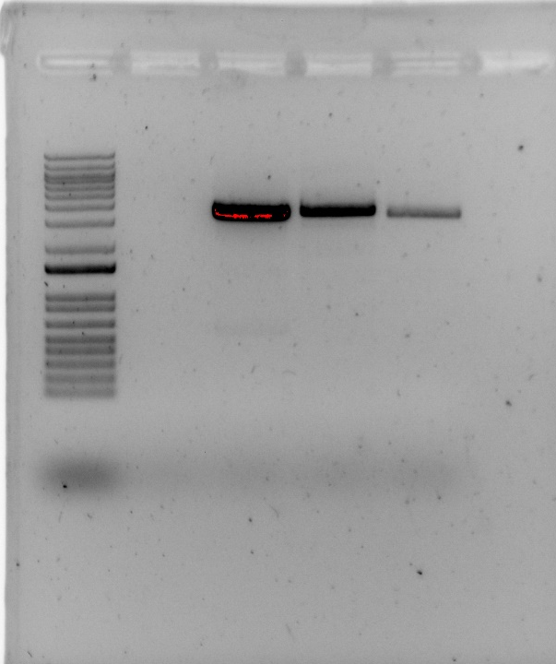
No band at 500 so this plasmid must have integrated elsewhere. I will not save down this patch and will plan to re-do the EP next Monday.

The primary integrant for the double mutant did not grow up today. I think there’s a strong possibility that it just has a serious growth defect so I’m going to give it at least one more day.

I checked on my S aureus electroporation plates. There are single colonies on the EP with plasmids on the 100 ul plate all the way through the 10⁻² tet plate. There looks to be some cells on the negative control tet plates but they are not forming single colonies with the exception of one on the 10⁻² plate which looks like contamination. You can see here both tet plates for 10-2 and 10-1:
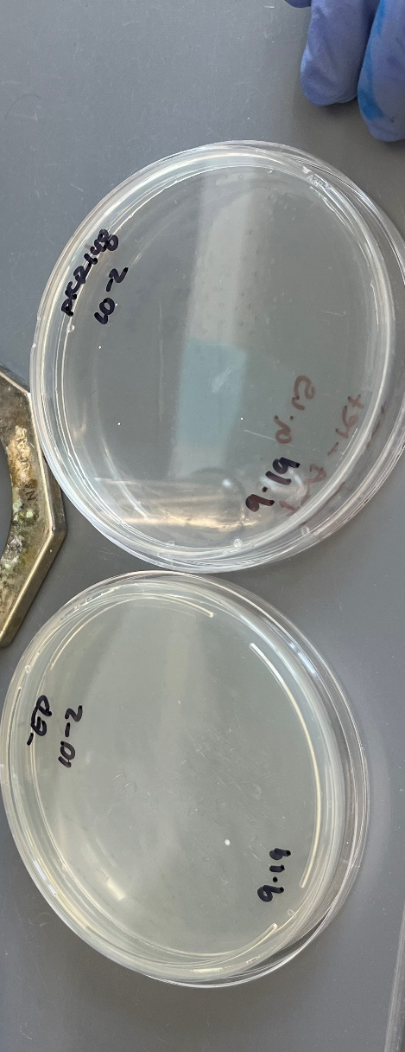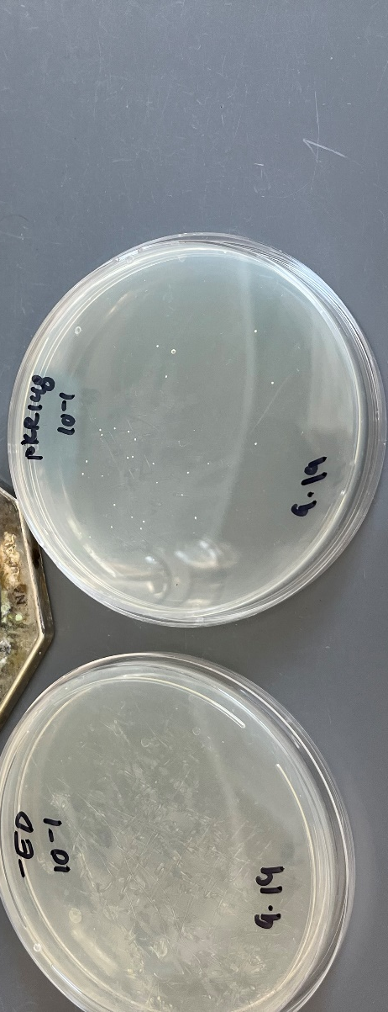
On the no abx plates, there is a lawn on the 100 ul plates and single colonies on all the others. It does look like there are more cells on the negative control plates with no abx than the DNA plates with no abx.
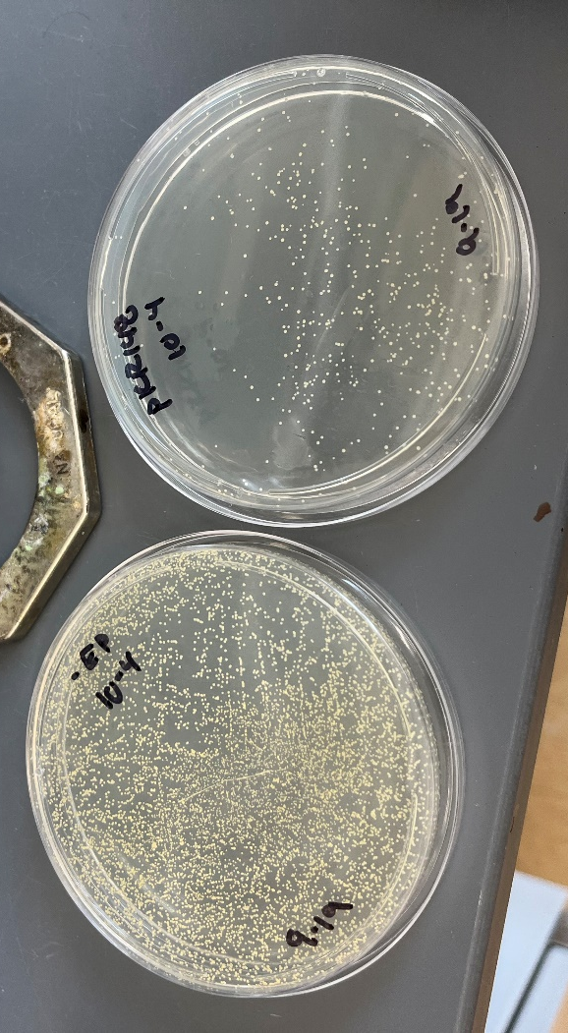
Based on these results, I picked 3 colonies from the 10-2 plate with DNA and struck to single colony on TSA-tet plates then put at 30C. I held onto the DNA containing plates from 10-1 to 10-3 and put at room temp.

Wednesday September 21, 2022
To Do:
- GFP assay
- Freeze down extra patches as strains
- Check on S aureus plates
- Check on primary for double mutant
- Help with overnight cultures
- Analyze sequencing results
Methods and Results:
I made my 31 cultures for the GFP assay but accidentally closed out of the spec before I had recorded all the t=0 times. However, none of them seemed too outside of the normal range – nothing below 0.09 and nothing above 0.135. Strangely, pKR156 in LVS grew VERY poorly on plates. It was worse than a drpsU2 strain would be! I had enough to make the cultures but I’m suspicious of this one. I checked at almost 5 hours and there was good growth on most of my cultures except those pKR156 in LVS ones which grew terrible. Nevertheless, I did the GFP assay.

GFP reporter assay
By: Hannah Trautmann

- Have prepared 3 patches on CHAH of biological replicates for each reporter strain, and one patch of LVS as a control
- Scrape up cells into MHB, resuspend, and dilute to 0.08-0.10 in 6 mL of MHB with appropriate antibiotic.
- Grow shaking at 37C until cells reach mid-log (0.3-0.4 OD). Generally takes 4-5 hours.
- Take 1 mL from each culture tube into microcentrifuge tubes. Spin at max speed for 3 minutes
- Remove all MHB, using 20 ul pipette to remove small amount at bottom of tube.
- Add 1 mL of 1XPBS and resuspend the cells.
*Note: If this is the first time running a particular strain, return the culture tubes to the incubator. If the strain is not at least 5 times more fluorescent than WT LVS, you will want to concentrate the cells 2x-4x (depending on your reading). Do this by spinning down 4 mL of culture and resuspending in 1 mL PBS (for 4X, adjust for 2x). Check RFU then dilute back down to 1X to read OD600.
- Aliquot 250 ul from each microfuge tube in triplicate into a clear 96-well plate (not tissue culture treated). Pipette PBS in triplicate as a control.
- Go to INBRE lab with multichannel pipette, Rainin tips, black 96-well plate, and flash drive.
- Read OD600 from clear plate on ID3 plate reader:
  - Select Absorbance, wavelength=600
  - Plate type: 96-well standard clearbtm (first option)
  - Copy and paste results into an excel file on the plate reader’s computer
- Transfer 200 ul of each well from clear plate to black plate using the multichannel
- Read fluorescence from black plate on ID3 plate reader:
  - Select fluorescence
  - Wavelength: 495 to 535
  - Plate type: CoStar 3789
  - Gain: Automatic
  - Integration: 380 ms
  - Copy and paste results into excel file, then save onto flash drive
- Analyze by subtracting non-fluorescent LVS from RFU reading per biological replicate to account for basal Francisella and PBS fluorescence. Then divide that fluorescence for each replicate by OD600. Normalize each well to the wild-type strain such that wild-type is set to 1.
I excluded mutation 2 from the analysis entirely since it didn’t seem to be helpful:
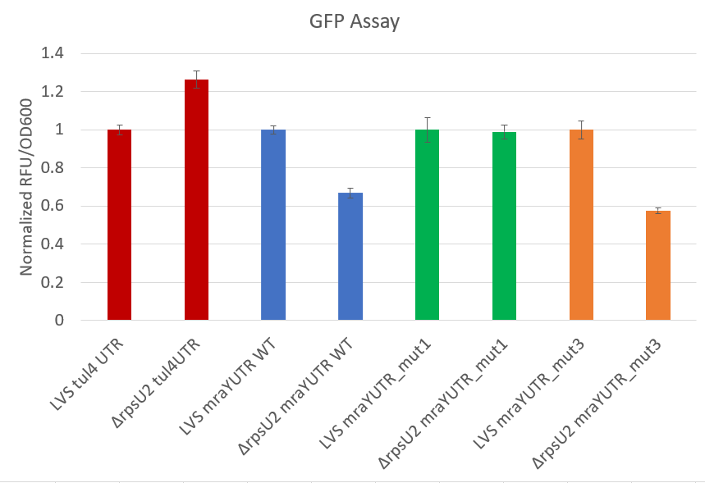
 | ttests | ratio
tul4 UTR | 0.000852 | 0.79204
mraY UTR WT | 7.16E-05 | 1.495054
mraY mut1 | 0.803185 | 1.011684
mraY mut3 | 0.000133 | 1.735304
Mutation 1, which cleaved off everything including and upstream of our motif of interest, seemed to impact translation a lot! I do want to look at mutation 2 again, so I’ll try redoing the EP on Friday if it doesn’t grow up any better tomorrow.

Because pKR156 in LVS grew so poorly, I put the patches back in the incubator overnight to grow up some more. I also patched out 2 more colonies from the EP plate to see if those grow any better. The remaining patches I froze down as strains KRLVS197-202.

I got my sequencing results back for plasmid pKR159. Plasmids 1 and 2 had large deletions starting at the PacI site but extending beyond the GFP cutsite. Plasmids 3 and 4 were actually pKR158. I think I’ll need to go back to the beginning on this one, but it isn’t my top priority right now.

My S aureus plates have small single colonies. I inoculated 2 from each restreak into TSA-tet (5 mL TSB + 1.5 ul of 10 mg/mL tet for final conc of 3 ug/mL) and grew overnight at 30C. I was worried they would grow kind of slow so I actually inoculated them at like 2 pm. I held onto these restreak plates on my bench top. My original EP plates from Monday had grown up quite a bit so I wrapped in parafilm and put in the fridge.

There is some very faint growth on my possible primary for the double deletion but it isn’t enough to freeze down. I’ll let it grow one more day.

Thursday September 22, 2022
To Do:
- Help with lysis stuff
- Freeze down overnight cultures of staph
- Freeze down extra patches of GFP strains
- Streak plates to 42C
- Make more TSA-tet plates
- Check on double mutant primary
Methods and Results:
All of my overnight staph cultures grew well so I froze them down by adding 800 ul of culture to 200 ul of 75% glycerol into a cryovial. Vortexed and put in -80C primary integrants 2 box. I then took 10 ul from each of the 6 cultures and struck to single colony on TSA-tet plates which I put in the 42C incubator.

I made 250 mL more of TSA-tet plates (7.5 g trypto soy broth, 3.75 g agar, 250 mL water), autoclaved on liquid 30C. Added 75 ul of 10 mg/mL tetracycline then poured plates and covered to protect from light.

My double deletion primary integrant did not grow neither did the patches for pKR156 in LVS. I’ll have to plan to redo both of those electroporations. I can redo the pKR156 EP tomorrow because I have cells in the freezer. The pKR155 in drpsU2 patches did grow up so I froze them down as KRLVS198.1 and .2.

After chatting with Kathryn about the GFP assay, I’m going to redo it with hopefully mutation 2 next week, so tomorrow I’ll streak out cells. In the meantime, I made more CHAH-kan plates.

Friday September 23, 2022
To Do:
- Streak LVS to RT for electroporating and KMLFT97 to 37C
- Redo EP for pKR156 in LVS
- Check on 42C plates
- Streak out mraY WT and mut 1 + 2 to single colony
Methods and Results:
I did an electroporation to put pKR156 into LVS. I had 2 EPs each with 5 ul of plasmid and 50 ul of cells. I recovered at 37C in MHB for 3.5 hours then plated 20 ul and 500 ul on CHAH-kan plates. For the GFP assay I also struck out KRLVS188, 189, 197, 198, 200, 201, and 202 to single colony on CHAH-kan plates.

I checked on my S aureus 42C plates and there were lots of single colonies! I wrapped the plates in parafilm and stuck in the 4C fridge.

I struck out LVS to RT and dhfq to 37C over the weekend for doing electroporations on Monday.

Monday September 26, 2022
To Do:
- Gradients
- Electroporate pKR158 in LVS and pKR11 in KMLFT97
- Patch single colonies from 42C plate AND streak to single colony on 42C again from glycerol stocks
- Patch from pKR156 EPs
Methods and Results:
I’ve helped Ellen with making gradients for LVS and drpsU2.

I made electrocompetent cells for LVS. Unfortunately dhfq was contaminated. Did so according to Allelic exchange in F. tularensis LVS with pEX, then electroporated 4 times 5 ul of pKR158. Let recover for 5 hours then plated entire volume (remaining) onto CHAH-kan plates.

I patched out 10 single colonies form the staph plates to TSA-tet and put at 42C. I also restruck from glycerol stocks 1 and 2 to single colony and put at 42C as well.

It looks like my electroporation for pKR156 into LVS worked really well! I patched out 3 of the single colonies so I can make glycerol stocks tomorrow.

Tuesday September 27, 2022
To Do:
- Colony PCR on S aureus using tetR primers
- Save pKR156 in LVS as strain
- Patch out for GFP assay
- Get tubes ready for GFP assay
- Streak out delta hfq
Methods and Results:
My S aureus patches had only sporadic growth. Perhaps if they had been smaller patches they would’ve grown up better? Not totally sure. I did a colony PCR with KROL555 and 556 to amplify that tetR gene– expected size of 327 bps. Controls: 1:10 SA gDNA, water, and 1:1000 pKR148. Only using 7 of 10 patches that had growth.

Components | Volumes in 1 reaction (uL) | Volumes in Master Mix (uL)
H₂O | 11.8 | 129.8
5X Primestar GXL buffer | 4 | 44
2.5 mM dNTPS | 1.6 | 17.6
Forward primer (10 uM) | 0.6 | 6.6
Reverse primer (10 uM) | 0.6 | 6.6
Primestar DNA polymerase | 0.4 | 4.4
Cell lysate | 1
Total | 20 | 209
Ran on STN1 with a 25 second extension time then ran on a 1% agarose gel:
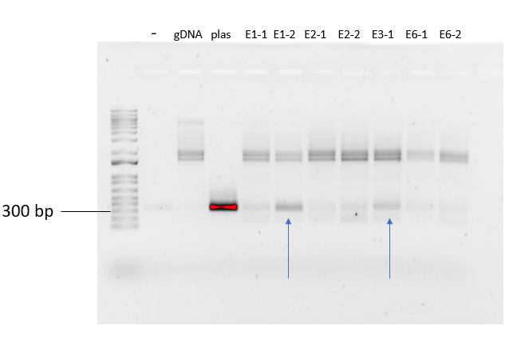
Not the cleanest gel, but I think the band in E1-2 and E3-1 are convincing so I’m going to go ahead with a follow up PCR where I look for plasmid integration by using primers on the plasmid and on the genome:
Primers | Integration into FR1 | Integration into FR2
KROL493  (outside FR1 on genome)  +  KROL458  (outside FR2 on plasmid) | 0 | 2100
KROL536  (outside FR2 on genome)  +  KROL460  (outside FR1 on plasmid) | 2050 | 0
Controls: 1:10 SA gDNA, water, and 1:1000 pKR148. Only using E1-2 and E3-1.
Components | Volumes in 1 reaction (uL) | Volumes in Master Mix (uL)
H₂O | 11.8 | 70.8
5X Primestar GXL buffer | 4 | 24
2.5 mM dNTPS | 1.6 | 9.6
Forward primer (10 uM) | 0.6 | 3.6
Reverse primer (10 uM) | 0.6 | 3.6
Primestar DNA polymerase | 0.4 | 2.4
Cell lysate | 1
Total | 20 | 114
I ran with a new protocol called SA62 which is identical to our usual STN1 but with a 62C annealing temperature, based on the gradient from last week which used many of the same primers. I did a 2:10 extension time.

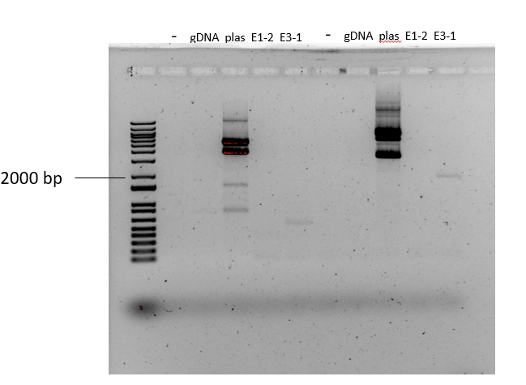
It looks like there’s a very faint band from primer set 2 in E3-1. Woohoo! Kathryn wants me to proceed with the 25C stuff and also make an overnight cultures to save this down. I thus made 2x5 mL TSB cultures tubes. One had 3 ug/mL tet and went at 37C, one had no tet and went at 25C. They each had a small amount of the patch from E3-1. I also wrapped the patch and the single colony streak in parafilm and put in the fridge. Cultures went in at around 4 pm.

The patches of pKR156 in LVS grew up well so I saved down permanent strains as KRLVS199.1 and KRLVS199.2. I patched 3 colonies from each of the GFP reporters to CHAH-kan plates and patched out some LVS pF then put at 37C overnight.

I couldn’t streak out dhfq because there were no regular CHAH plates! Aisling told me she made more but she did not.

Wednesday September 28, 2022
To Do:
- GFP assay
- Freeze down overnight of staph
- Subculture 25C staph
- CHAH plates
- Streak dhfq
Methods and Results:
I setup a GFP assay with all my patches. Here were my starting ODs:
KRLVS no. | Genotype | Tube | OD600 diluted 1:20 | OD600 t=0
188 | LVS pF-mraYUTR-GFP | 1 | 0.269 | 0.089
188 | LVS pF-mraYUTR-GFP | 2 | 0.347 | 0.1
188 | LVS pF-mraYUTR-GFP | 3 | 0.366 | 0.101
189 | LVS ∆rpsU2 pF-mraYUTR-GFP | 4 | 0.174 | 0.121
189 | LVS ∆rpsU2 pF-mraYUTR-GFP | 5 | 0.124 | 0.097
189 | LVS ∆rpsU2 pF-mraYUTR-GFP | 6 | 0.25 | 0.123
197 | LVS pF-mraYUTR_mut1-GFP | 7 | 0.336 | 0.101
197 | LVS pF-mraYUTR_mut1-GFP | 8 | 0.225 | 0.093
197 | LVS pF-mraYUTR_mut1-GFP | 9 | 0.217 | 0.096
198 | LVS ∆rpsU2 pF-mraYUTR_mut1-GFP | 10 | 0.085 | 0.117
198 | LVS ∆rpsU2 pF-mraYUTR_mut1-GFP | 11 | 0.157 | 0.127
198 | LVS ∆rpsU2 pF-mraYUTR_mut1-GFP | 12 | 0.184 | 0.123
199 | LVS pF-mraYUTR_mut2-GFP | 13 | 0.277 | 0.095
199 | LVS pF-mraYUTR_mut2-GFP | 14 | 0.3 | 0.097
199 | LVS pF-mraYUTR_mut2-GFP | 15 | 0.145 | 0.103
200 | LVS ∆rpsU2 pF-mraYUTR_mut2-GFP | 16 | 0.182 | 0.121
200 | LVS ∆rpsU2 pF-mraYUTR_mut2-GFP | 17 | 0.167 | 0.118
200 | LVS ∆rpsU2 pF-mraYUTR_mut2-GFP | 18 | 0.113 | 0.12
201 | LVS pF-mraYUTR_mut3-GFP | 19 | 0.234 | 0.114
201 | LVS pF-mraYUTR_mut3-GFP | 20 | 0.298 | 0.101
201 | LVS pF-mraYUTR_mut3-GFP | 21 | 0.31 | 0.108
202 | LVS ∆rpsU2 pF-mraYUTR_mut3-GFP | 22 | 0.119 | 0.119
202 | LVS ∆rpsU2 pF-mraYUTR_mut3-GFP | 23 | 0.137 | 0.133
202 | LVS ∆rpsU2 pF-mraYUTR_mut3-GFP | 24 | 0.167 | 0.124
120 | LVS | 25 | 0.185 | 0.099
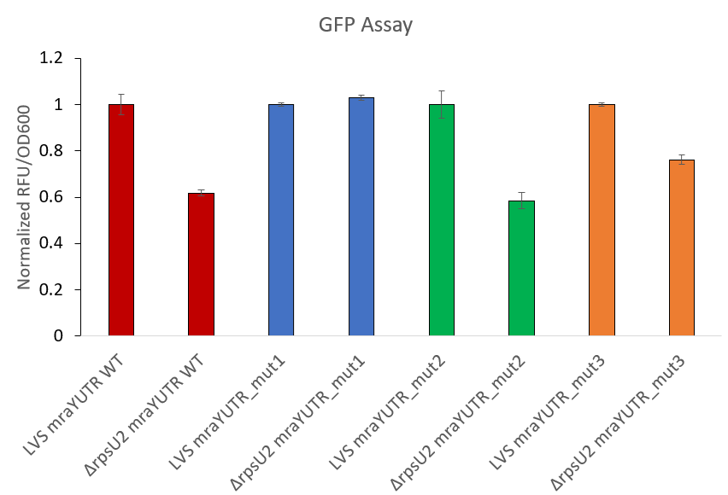
 | ttests | ratio
mraY UTR WT | 0.000132 | 1.61763
mraY mut1 | 0.011098 | 0.971476
mraY mut2 | 0.000428 | 1.708859
mraY mut3 | 4.81E-05 | 1.312764
It looks like mutation 1, which cuts off the whole 5’ end, is the only change the makes the difference. This suggests that the motif we are looking at isn’t so meaningful, but I do want to look at the other AU-rich motif that is in the 5’ end that got cut off. Tomorrow I’ll design primers. I also want to repeat the mut2 assay as I’ve only done this one once. I patched out more single colonies to CHAH-kan plates and will repeat tomorrow.

The 37C overnight cultures of Staph grew up really well! I froze down 2 glycerol stocks in cryovials by adding 200 ul of 75% glycerol to 800 ul of overnight culture. Vortexed then put in my primary integrants box 2.

I made a whole flask of CHAH plates as well. Once they had solidified, I struck out an aliquot of Δhfq.

At 4 pm (approx. 24 hours after initially inoculating), I took 5 ul of my overnight 25C staph cultures and put into 5 mL of TSB then returned to the 25C shaking incubator overnight. I also patched out 16 more colonies from the 42C single colony plate to TSA-tet and put at 42C to hopefully get some more primary integrants.
It looks like I have a single colony on the pkR158 in LVS electroporations! Woohoo! I patched to CHAH-kan and put at 37C. I also returned the EP plates there in case some more things pop up.

Thursday September 29, 2022
To Do:
- GFP assay
- Plate staph
- Colony PCR on new staph patches
- Colony PCR on hfq-V
Methods and Results:
I setup cultures to redo the GFP on only WT mraY and the mutation 2 as I needed to have a second experimental replicate of that assay.
KRLVS no. | Genotype | Tube | OD600 diluted 1:20 | OD600 t=0
188 | LVS pF-mraYUTR-GFP | 1 | 0.202 | 0.114
188 | LVS pF-mraYUTR-GFP | 2 | 0.188 | 0.111
188 | LVS pF-mraYUTR-GFP | 3 | 0.204 | 0.106
189 | LVS ∆rpsU2 pF-mraYUTR-GFP | 4 | 0.11 | 0.134
189 | LVS ∆rpsU2 pF-mraYUTR-GFP | 5 | 0.184 | 0.115
189 | LVS ∆rpsU2 pF-mraYUTR-GFP | 6 | 0.132 | 0.129
199 | LVS pF-mraYUTR_mut2-GFP | 7 | 0.181 | 0.103
199 | LVS pF-mraYUTR_mut2-GFP | 8 | 0.191 | 0.125
199 | LVS pF-mraYUTR_mut2-GFP | 9 | 0.16 | 0.103
200 | LVS ∆rpsU2 pF-mraYUTR_mut2-GFP | 10 | 0.184 | 0.118
200 | LVS ∆rpsU2 pF-mraYUTR_mut2-GFP | 11 | 0.202 | 0.123
200 | LVS ∆rpsU2 pF-mraYUTR_mut2-GFP | 12 | 0.161 | 0.133
120 | LVS | 13 | 0.03 | 0.087
Cultures 1 and 8 were ready at 3:15 but the rest I left until 4 hours. I left 1 and 8 as pellets at room temp until the others were ready as well.

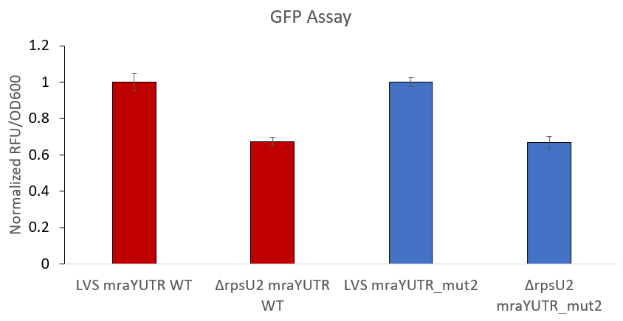
The results are consistent with yesterdays.
 | ttests | ratio
WT mraY UTR | 0.000494 | 1.482841
mut2 | 0.000148 | 1.492277

Next I setup a PCR for the potential hfq-V mutant. As controls I have water, LVS gDNA, and 1:100 pKR158. The primers were KROL543 (on the genome) and KROL240 (on the plasmid) which should produce a band around 500 bps.
Components | Volumes in 1 reaction (uL) | Volumes in Master Mix (uL)
H₂O | 11.8 | 59
5X Primestar GXL buffer | 4 | 20
2.5 mM dNTPS | 1.6 | 8
Forward primer (10 uM) | 0.6 | 3
Reverse primer (10 uM) | 0.6 | 3
Primestar DNA polymerase | 0.4 | 2
Cell lysate | 1
Total | 20 | 95
Ran on STN1 with a 30 second extension time then ran entire volume on a 1% agarose gel.

- gDNA plas E3-1
No band at 500 It’s probably integrating into the groES promoter which is a larger region of homology than hfq on the plasmid. No more colonies on the EP plates so I’ll have to push ahead with more electroporations. I made more CHAH-kan plates so that I can do a bunch tomorrow, and struck out more LVS.

My S aureus patches don’t look stellar but I think there’s decent enough growth on 10 of them to do the colony PCR. KROL555 and 556 to amplify that tetR gene– expected size of 327 bps. Controls: 1:10 SA gDNA, water, and 1:1000 pKR148.
Components | Volumes in 1 reaction (uL) | Volumes in Master Mix (uL)
H₂O | 11.8 | 165.2
5X Primestar GXL buffer | 4 | 56
2.5 mM dNTPS | 1.6 | 22.4
Forward primer (10 uM) | 0.6 | 8.4
Reverse primer (10 uM) | 0.6 | 8.4
Primestar DNA polymerase | 0.4 | 5.6
Cell lysate | 1
Total | 20 | 266
Ran on STN1 with a 25 second extension time then ran on a 1% agarose gel.

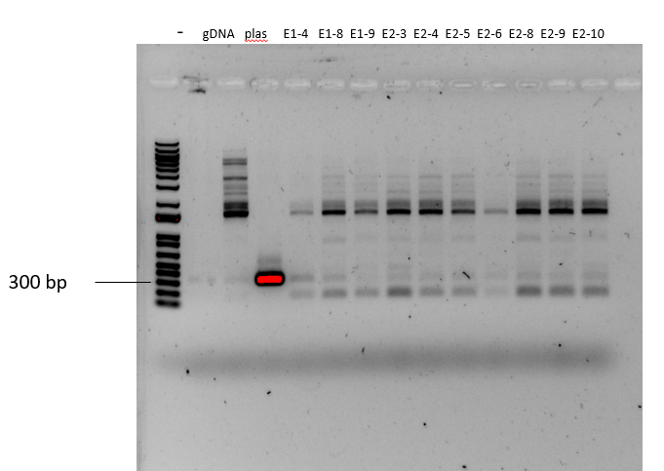
It looks like almost all of them have a band around 300 bps with the exception of E1-9 and E2-9. I’m therefore going forward with the colony PCR where I look for plasmid integration by using primers on the plasmid and on the genome:
Primers | Integration into FR1 | Integration into FR2
KROL493  (outside FR1 on genome)  +  KROL458  (outside FR2 on plasmid) | 0 | 2100
KROL536  (outside FR2 on genome)  +  KROL460  (outside FR1 on plasmid) | 2050 | 0
Controls: 1:10 SA gDNA, water, and 1:1000 pKR148. Including 8 of 10 lysates indicated above. For E1-4 and E2-6 I’m using slightly more lysate than last time.

Components | Volumes in 1 reaction (uL) | Volumes in Master Mix (uL)
H₂O | 11.8 | 141.6
5X Primestar GXL buffer | 4 | 48
2.5 mM dNTPS | 1.6 | 19.2
Forward primer (10 uM) | 0.6 | 7.2
Reverse primer (10 uM) | 0.6 | 7.2
Primestar DNA polymerase | 0.4 | 4.8
Cell lysate | 1
Total | 20 | 228
Ran on SA with a 58C annealing temp and a 2:10 extension time. I’ll run the gel tomorrow so I have the plate with patches still at 42C.

My overnight culture of staph is to be plated on TSA plates with no tetracycline. The protocol says 10⁻⁶ is usually a good dilution, but since this is my first time I’m going to plate 10⁻³ through 10⁻⁸, plating 100 ul on each. This requires 6 TSA plates with no abx but I only have 4, so I made a new 250 mL batch. I also made a 250 mL flask of TSA to keep on the shelf and re-melt when I need more. Put plates at 42C.

Friday September 30, 2022
To Do:
- Electroporate pKR158 in LVS
- Electroporate pKR11 in dhfq
- Check on Staph plates
- Run gel from colony PCR
- Design new plasmids
Methods and Results:
I made electrocompetent cells for LVS and Δhfq using 5 sucrose washes. I then electroporated 5 ul of plasmid into 50 ul of dense cells:
3x pKR158 in LVS
3x pKR11 in Δhfq
I let recover in 4 mL of MHB for 5 hours then plated remaining on CHAH-kan plates and put at 37C.

I ran a gel for the colony PCRs.
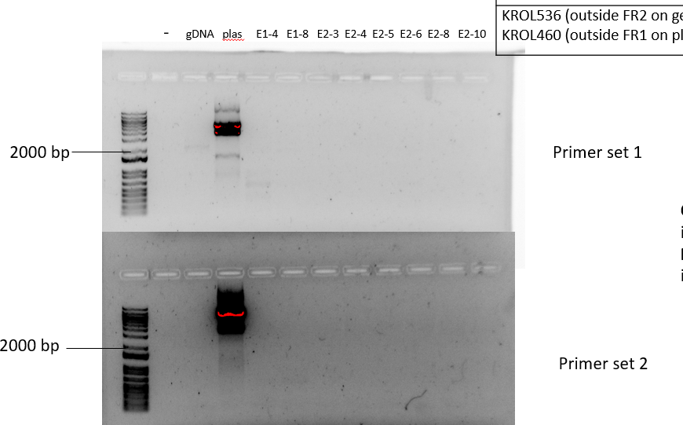
There were no bands around 2000 bps in any of my colonies indicating that I do not have integration. Bummer! At least I can proceed with the one good one that I have.

My staph plates had single colonies! Here were the counts:
Dilution | Colony Count
10⁻³ | TMTC
10⁻⁴ | TMTC
10⁻⁵ | TMTC
10⁻⁶ | 564
10⁻⁷ | 71
10⁻⁸ | 10
I wrapped up plates 10⁻⁶ to 10⁻⁸ in parafilm and put in the fridge.

Next I started thinking about the other mraY reporters to make. The other interesting AU-rich motif to us was motif 5.
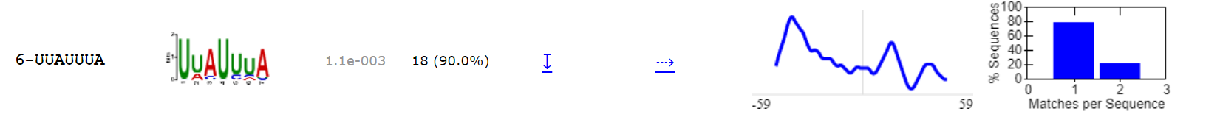

Here are 3 possible findings in the mraY UTR:
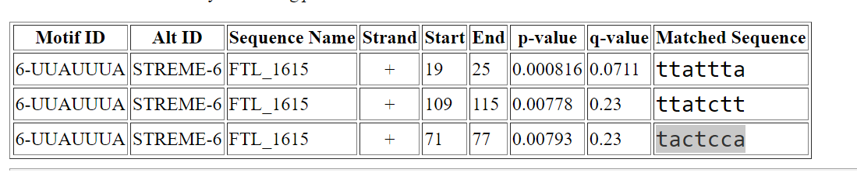
I have annotated them on my LVS genome snapgene file. I think the most likely is the first, from 19-25, as that’s the only one that was cleaved off in mraY-mut1 where we saw a loss of regulation. A possible modification to make would be to:
- Cleave off 5’ end from base 25 upwards (completely removing motif 5)
- Cleave off but keeping the motif in the UTR (i.e. 19 and up)
- Cleave off to remove the other AU stretch between motif 4 and motif 5
- Change motif5 option 1 from ttattta to GGCGGGC
- Make another reporter with iglA FTL_0111 UTR
- Check three others using the 100 nt upstream region as well
This led to the design of 8 plasmids. Here is the cloning strategy:
  - pKR160 – iglA UTR
    - Backbone: pKR150, KpnI/NotI digested
    - Insert: KROL569 + 326, KpnI/NotI digested (218 bps) off gDNA
  - pKR161 – FTL_0222 UTR
    - Backbone: pKR149,150,1,or 2, PacI/NotI
    - Insert: KROL570 + 571, PacI/NotI (157 bps) off gDNA
  - pKR162 – FTL_0881 UTR
    - Backbone: pKR149,150,1,or 2, PacI/NotI
    - Insert: KROL572 + 573, PacI/NotI (157 bps) off gDNA
  - pKR163 – FTL_2093 UTR
    - Backbone: pKR149,150,1,or 2, PacI/NotI
    - Insert: KROL574 + 575, PacI/NotI (157 bps) off gDNA
  - pKR164 – mraY mut4
    - Backbone: pKR149,150,1,or 2, PacI/MfeI
    - Insert: KROL576 + 560, MfeI/NotI (701 bps) off pKR151
  - pKR165 – mraY mut5
    - Backbone: pKR149,150,1,or 2, PacI/MfeI
    - Insert: KROL577 + 560, MfeI/NotI (694 bps) off pKR151
  - pKR166 – mraY mut6
    - Backbone: pKR149,150,1,or 2, PacI/MfeI
    - Insert: KROL578 + 560, MfeI/NotI (682 bps) off pKR151
  - pKR167 – mraY mut7
    - Backbone: pKR151, KpnI/MfeI digested
    - Insert:
      - First PCR: KROL579 + 560 (684 bps) off pKR151 AND KROL326 + 580 (195) also off pKR151
      - Second PCR: KROl 326 + 560 (852 bps), digest with KpnI/MFeI
Here are all the mutations:
Yellow = motif 4
Blue = motif 5
mraY WT UTR:
auaaaaaauuugaaccaauuauuuagacgcuaauuuugacucuauuaaaaaaauaacauaucuauuauaauacuccaaggucauuaaacauuuuaaauau AUG cugauuuaucuuuuu
mraY mutation 4:
__________________uuauuuagacgcuaauuuugacucuauuaaaaaaauaacauaucuauuauaauacuccaaggucauuaaacauuuuaaauau AUG cugauuuaucuuuuu
mraY mutation 5:
_________________________gacgcuaauuuugacucuauuaaaaaaauaacauaucuauuauaauacuccaaggucauuaaacauuuuaaauau AUG cugauuuaucuuuuu
mraY mutation 6:
_____________________________________gacucuauuaaaaaaauaacauaucuauuauaauacuccaaggucauuaaacauuuuaaauau AUG cugauuuaucuuuuu
mraY mutation 7:
auaaaaaauuugaaccaaGGCGGGCgacgcuaauuuugacucuauuaaaaaaauaacauaucuauuauaauacuccaaggucauuaaacauuuuaaauau AUG cugauuuaucuuuuu

After chatting with Kathryn, to move forward the hfq investigation I’m going to just look at our T6SS protein abundances in LVS and dhfq via Western blot. Today I struck dhfq and LVS to single colony and put at 37C.

October 2022

Monday October 3, 2022
To Do:
- Check on EPs and patch if any colonies
- Cross patch from S aureus plates to TSA-tet and TSA
- Check on pKR151 and transform if necessary (need at least 30 ul); also transform pKR158
- Check on dhfq plate – patch out if they are large enough
- Setup PCR and digest tables for when primers come in – include pKR159
Methods and Results:
It looks like I have colonies on my pKR158 in LVS plates! In fact I had 2-8 on each electroporation so I patched out 6 colonies (2 per EP) to CHAH-kan plates and put at 37C. Nothing yet on the dhfq electroporations but I’m not in a rush.

The single colony streaks I made for LVS and dhfq are in different stages. LVS is to single colony but dhfq is not. I moved LVS to room temp and dhfq tomorrow.

I cross-patched the S aureus colonies from dilution plates 10⁻⁸ and 10⁻⁷ to TSA-tet then TSA regular, patching a total of 42 colonies across 2 plates each. Then I put at 37C overnight. By the end of the day, though, I could already see that there was growth on the tet plates on almost all of the colonies. This worries me…I want to have more primaries to try in case this one doesn’t work out. I decided to try growing in liquid at 42C to encourage integration. Dr. Ramsey suggested I make a 30C overnight culture then tomorrow I can dilute and put at 42C. I’m using some old single colony streaks of 30C (from 9/20). Since the only successful colony I got came from streak 3, I made 2 overnight cultures of streak 3 and one from streak 1 and one from streak 2 colonies using TSB-tet3. I also decided to patch out another 42 colonies from the dilution plates to TSA-tet and TSA and put at 37C.

Since I’ll be using a lot of pKR151 and I’m starting to run low on pKR158 and pKR152, I decided to transform more of both according to Transform chemically competent E. coli cells using XL-1 Blue cells and 1 ul of DNA:
Tube number | Purpose | DNA |  | Volume of DNA | E coli strain | Final volume to plate | Number of kan-containing plates
1 | Make more | pKR151 |  | 1 uL | XL1-Blue | 20 ul, 100 ul | 2
2 | Make more | pKR152 |  | 1 uL | XL1-Blue | 20 ul, 100 ul | 2
3 | Make more | pKR158 |  | 1 uL | XL1-Blue | 20 ul, 100 ul | 2
4 | (-) control | - |  | 0 | XL1-Blue | 20 ul | 1
 |  |  | Total number of plates |  |  |  | 7
Put plates at 37C.

Tuesday October 4, 2022
To Do:
- Check on dhfq EPs and patch if any colonies
- Colony PCR on pKR158 colonies
- Check on replica plates for S aureus
- Make overnight cultures of transformations
- Back dilute culture and put at 42C
- Plate on TSA-tet from 42C cultures
Methods and Results:
I back diluted the 30C S aureus cultures 1:5000 in TSB-tet by adding 1 ul of the overnight culture to 5 mL of TSB-tet. I then put all 4 of the cultures in the 42C shaking incubator at 9 am. As a control to check for tet stability, I also included one TSB-tet with regular S aureus cells (no plasmid) which should not grow if the tet is good. At about 3 pm I checked the cultures and they had grown abundantly but the regular cells one had not grown at all (image below). I went ahead and diluted all 4 of the cultures individually down to 10⁻⁶ and plated 10⁻⁵ and 10⁻⁶ on TSA-tet plates (100 ul per plate) and put at 42C.

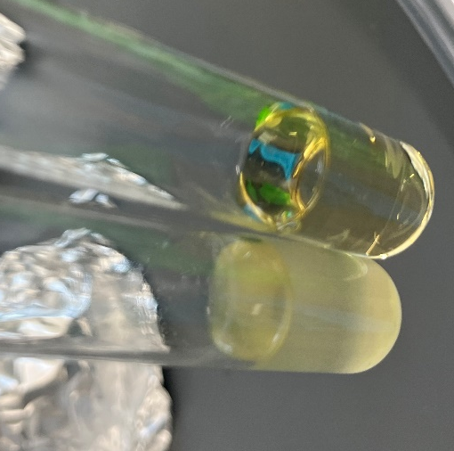

I checked on my replica plates for S aureus and unfortunately, all 84 of the patches had growth on tet. Here is a sample, but they all looked the same:
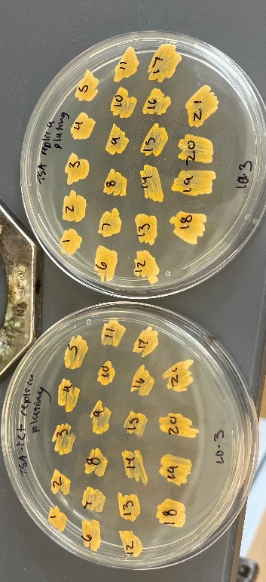
Matthew suggested screen 100 so I patched out another 30 or so for a total of 112 colonies screened. I’m hoping that a new primary will have better luck, but also might try subculturing 3 times at 25C next time.

Next I ran a colony PCR with the 6 potential hfq-V integrants. As controls I have water, LVS gDNA, and 1:100 pKR158. The primers were KROL543 (on the genome) and KROL240 (on the plasmid) which should produce a band around 500 bps.

Components | Volumes in 1 reaction (uL) | Volumes in Master Mix (uL)
H₂O | 11.8 | 118
5X Primestar GXL buffer | 4 | 40
2.5 mM dNTPS | 1.6 | 16
Forward primer (10 uM) | 0.6 | 6
Reverse primer (10 uM) | 0.6 | 6
Primestar DNA polymerase | 0.4 | 4
Cell lysate | 1
Total | 20 | 190
Ran on STN1 with a 30 second extension time. Then ran on a 1% agarose gel.

- gDNA plas 7-1 7-2 8-1 8-2 9-1 9-2
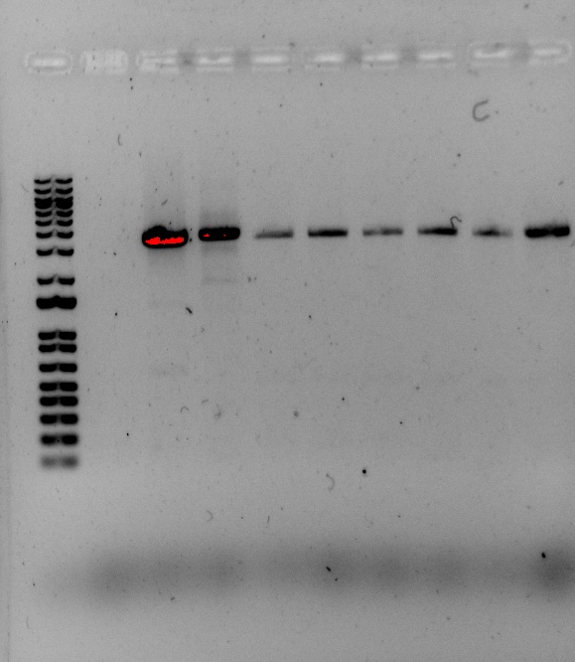
None of them have the correct band…again. There are more colonies to screen though so I patched out another 18 and will hope for the best.

None of my dhfq electroporations have colonies, nor does my streak of dhfq to single colony. Kathryn suggested I just go ahead with technical replicates of dhfq for the Western rather than biological replicates since it isn’t growing well enough. I decided a good control would also be drpsU2 so I struck that out and LVS from single use aliquots to regular CHAH plates.

My transformations worked! Here are the counts:
Tube Number | Plasmid | 20 ul plate | 100 ul plate
1 | pKR151 | 58 | TMTC
2 | pKR152 | 103 | TMTC
3 | pKR158 | 221 | TMTC
4 | - | 0 | -
I made 2x 5mL cultures in LB-kan overnight at 37C for each plasmid.

Wednesday October 5, 2022
To Do:
- Grow cultures of LVS, drpsU2, and dhfq for Western
- Miniprep
- Patch out single S aureus colonies from 42C
- Check on replica plating
- Colony PCR on pKR158 in LVS
- Freeze down correct strains for hfq-V
- Preliminary PCR for new plasmids
Methods and Results:
I grew up cultures in technical triplicate for LVS, drpsU2, and dhfq. Unfortunately drpsU2 hadn’t grown up enough on plates for me to do that one in triplicate so I just did duplicate and I’ll load one of them twice into the protein gel. I started LVS with an OD of 0.1, drpsU2 with an OD of 0.13, and dhfq with an OD of 0.15.
Strain | Tube | OD600 t=2 | OD600 t=4.25 | OD600 t=5
LVS | 1 | .172 | .318 | -
LVS | 2 | .173 | .338 | -
LVS | 3 | .177 | .333 | -
drpsU2 | 4 | .163 | .229 | .253
drpsU2 | 5 | .130 | .205 | .240
dhfq | 7 | .152 | .178 | .190
dhfq | 8 | .172 | .205 | .233
dhfq | 9 | .150 | .186 | .194
I harvested the LVS samples at 4.25 hours and the rest at 5 hours even though they hadn’t grown super well. Dhfq is a horrendous grower. Spun down 1 mL at max speed, removed the supernatant, added 1XSLB equivalent to 1 OD unit (i.e. 318 ul for tube 1), put at 95C for 10 mins, then put in the -20C.

Next I ran a colony PCR with the 17 potential hfq-V integrants. As controls I have water, LVS gDNA, and 1:100 pKR158. The primers were KROL543 (on the genome) and KROL240 (on the plasmid) which should produce a band around 500 bps.
Components | Volumes in 1 reaction (uL) | Volumes in Master Mix (uL)
H₂O | 11.8 | 247.8
5X Primestar GXL buffer | 4 | 84
2.5 mM dNTPS | 1.6 | 33.6
Forward primer (10 uM) | 0.6 | 12.6
Reverse primer (10 uM) | 0.6 | 12.6
Primestar DNA polymerase | 0.4 | 8.4
Cell lysate | 1
Total | 20 | 399
Ran on STN1 with a 30 second extension time then ran on a 1% agarose gel.

- gDNA plas 7-3 7-4 7-5 8-3 8-4 8-5 8-6 8-7
8-8 8-9 8-10 8-11 8-12 8-13 9-3 9-4 9-5
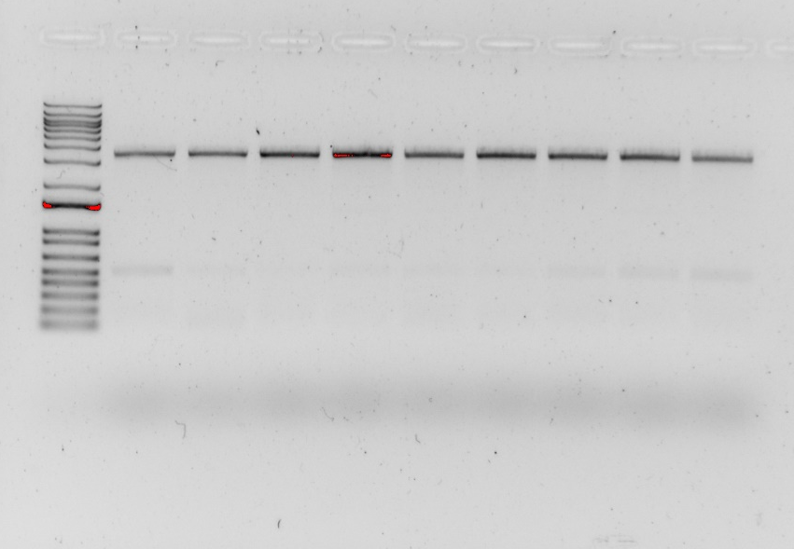
I finally got one! The brightness of the bands and the lack of background band is actually making me kind of nervous because my drpsU2 one was not so bright, but I’ll isolate gDNA tomorrow and find out. I froze down the two patches as KRLVS194.1 and 194.2. I also saved a small amount of the cells as pellets to do gDNA extraction tomorrow.

All of my replica plates grew on tet again For the dilution plates of the potential primary integrants I did have multiple colonies on each of the cultures I had made. There were a few large ones and multiple teeny tiny pinpricks on each. I decided that the pinpricks were probably just outgrowing the tet so I decided to patch out 2 large colonies for each to TSA-tet. I specifically chose ones from the 10⁻⁶ plates because I’m less likely to grab a secondary colony with it. Put the plate with patches at 42C and put the old plates at 42C to see if they grow up any more in case I need to screen more tomorrow.

I miniprepped my overnight E coli cultures, eluting in 50 ul of 0.1xEB then checked the concentration.
Sample ID | Nucleic Acid (ng/uL)
151-1 | 417.5
151-2 | 460
152-1 | 451.4
152-2 | 466.1
158-1 | 660.1
158-2 | 651
The concentrations all look good so I put them in their corresponding tubes in plasmid box 2 in the -20C.

I received all of the primers for making the many new GFP reporters. I resuspended, made 10 uM aliquots, then setup the preliminary PCR:

Reaction Number | Plasmid/Region | Source DNA | Primers | Length (bps)
1 | iglA UTR | LVS gDNA | KROL569, 326 | 218
2 | FTL_0222 UTR | LVS gDNA | KROL570, 571 | 157
3 | FTL_0881 UTR | LVS gDNA | KROL572, 573 | 157
4 | FTL_1093 UTR | LVS gDNA | KROL574, 575 | 157
5 | mraY mut4 | pKR151 | KROL576, 560 | 701
6 | mraY mut5 | pKR151 | KROL577, 560 | 694
7 | mraY mut6 | pKR151 | KROL578, 560 | 782
8 | mraY mut7 region1 | pKR151 | KROL579, 560 | 684
9 | mraY mut7 region2 | pKR151 | KROL326, 580 | 195
10 | FTL_0144UTR_short | 1:100 pKR150 | KROL565, 560 | 644
11 | - control | - | KROL565, 560 | -
Since I don’t really need to do the 100 ul PCR for 8, 9, or 11, I just put in 20 ul of the master mix into each of those and used only 0.6 of primers and 0.4 of DNA.

Total reaction volume | 100
Total number of reactions | 10
 |  |  |  | Factor
Component | Stock concentration | Final concentration | 1 rxn volume | 11
ddiH2O |  |  | 62.0 | 682
PrimeSTAR GXL Buffer | 5x | 1x | 20.0 | 220
dNTPs | 2.5 mM | 0.2 mM | 8.0 | 88
oligo F | 10 uM | 0.3 uM | 3.0
oligo R | 10 uM | 0.3 uM | 3.0
template | 100 ng/ul | 2 ng/ul | 2.0
PrimeSTAR GXL DNA Polymerase | 1.25 U/ul | 0.025 U/ul | 2.0 | 22
 |  | Total volume | 100 | 1078
Ran on STN1 with a 50 second extension time.

Thursday October 6, 2022
To Do:
- Colony PCR on S aureus patches
- Isolate gDNA
- Secondary PCR
- PCR purify for new plasmids
- Setup a digest for new plasmids
- PCR on isolated gDNA
- Streak out hfq-V strains
Methods and Results:
I setup a secondary PCR for my the overlap extension plasmid:
Reaction Number | Plasmid/Region | Source DNA | Primers | Length (bps)
8B | mraY mut7 OE | 1:10 PCR 8 + 9 | KROL326+560 | 852
2 | - control | - | KROL326+560 | -

 |  |  |  | Factor
Component | Stock concentration | Final concentration | 1 rxn volume | 1.5
ddiH2O |  |  | 62.0 | 93
PrimeSTAR GXL Buffer | 5x | 1x | 20.0 | 30
dNTPs | 2.5 mM | 0.2 mM | 8.0 | 12
oligo F | 10 uM | 0.3 uM | 3.0 | 4.5
oligo R | 10 uM | 0.3 uM | 3.0 | 4.5
template | 100 ng/ul | 2 ng/ul | 2.0
PrimeSTAR GXL DNA Polymerase | 1.25 U/ul | 0.025 U/ul | 2.0 | 3
 |  | Total volume | 100 | 147
Ran on STN1 with a 55 second extension time.

Friday October 7, 2022
To Do:
- Freeze down small amount of hfq-V strains for Western
- Single use aliquots of hfq-V strains
Methods and Results:

Monday October 10, 2022
To Do:
- Gel and transfer for VSVG-tagged proteins
Methods and Results:

Digest:
Tube | DNA | Enzyme(s) | DNA Volume (uL) | H₂O Volume (uL)
1 | Purified PCR 1 | KpnI/NotI | 15 | -
2 | Purified PCR 2 | PacI/NotI | 15 | -
3 | Purified PCR 3 | PacI/NotI | 15 | -
4 | Purified PCR 4 | PacI/NotI | 15 | -
5 | Purified PCR 5 | PacI/MfeI | 15 | -
6 | Purified PCR 6 | PacI/MfeI | 15 | -
7 | Purified PCR 7 | PacI/MfeI | 15 | -
8 | Purified PCR 8B | KpnI/MfeI | 15 | -
9 | Purified PCR 10 | PacI/MfeI | 15 | -
10 | pKR151 | KpnI/NotI | 5 | 10
11 | pKR151 | PacI/NotI | 5 | 10
12 | pKR151 | PacI/MfeI | 5 | 10
13 | pKR151 | KpnI/MfeI | 5 | 10

Ligation:
Tube | Insert | Backbone | Desired plasmid
1 | Gel purf 1 | Gel purf 10 | pKR160
2 | Gel purf 2 | Gel purf 11 | pKR161
3 | Gel purf 3 | Gel purf 11 | pKR162
4 | Gel purf 4 | Gel purf 11 | pKR163
5 | Gel purf 5 | Gel purf 12 | pKR164
6 | Gel purf 6 | Gel purf 12 | pKR165
7 | Gel purf 7 | Gel purf 12 | pKR166
8 | Gel purf 8 | Gel purf 13 | pKR167
9 | Gel purf 9 | Gel purf 12 | pKR159
10 | - | Gel purf 10 | BB control
11 | - | Gel purf 11 | BB control
12 | - | Gel purf 12 | BB control
13 | - | Gel purf 13 | BB control

Upcoming experiments

- UTR reporters
  - Make a shorter UTR for FTL_0144 – redo EP
  - Hfq-V: colony PCR then isolate gDNA and sequence
  - mraY reporters – make new modifications to other AU-rich motif
- Westerns
  - Just try probing delta hfq for pdpB, iglA, and iglB
  - Start Δhfq at 0.15 for the day
- Start thinking about impacts of drpsU2 on assembly
  - Hfq is important for assembly (and maybe a regulator of T6SS production)
  - More Hfq and proQ in drpsU2 but not significant
    - We have an hfq mutant so we can do quite a few experiments with it
  - Look at experiments in the paper Kathryn is sending: McAteer et al.
  - Also look for proteases or RNases that might not hit significant threshold
- Admin stuff
  - Start planning ahead for meeting with the committee in early fall
  - Figure out deadlines for dissertation and stuff
    - Jan 27 – nomination for graduation
    - Feb. 5 – ABD for Spring
    - Mar 24 – request to schedule an oral defense
    - Apr 21 – formatted dissertation due to grad school
- Plasmid design:
  - pKR160 – iglA UTR
    - Backbone: pKR150, KpnI/NotI digested
    - Insert: KROL569 + 326, KpnI/NotI digested (218 bps) off gDNA
  - pKR161 – FTL_0222 UTR
    - Backbone: pKR149,150,1,or 2, PacI/NotI
    - Insert: KROL570 + 571, PacI/NotI (157 bps) off gDNA
  - pKR162 – FTL_0881 UTR
    - Backbone: pKR149,150,1,or 2, PacI/NotI
    - Insert: KROL572 + 573, PacI/NotI (157 bps) off gDNA
  - pKR163 – FTL_2093 UTR
    - Backbone: pKR149,150,1,or 2, PacI/NotI
    - Insert: KROL574 + 575, PacI/NotI (157 bps) off gDNA
  - pKR164 – mraY mut4
    - Backbone: pKR149,150,1,or 2, PacI/MfeI
    - Insert: KROL576 + 560, MfeI/PacI (701 bps) off pKR151
  - pKR165 – mraY mut5
    - Backbone: pKR149,150,1,or 2, PacI/MfeI
    - Insert: KROL577 + 560, MfeI/PacI (694 bps) off pKR151
  - pKR166 – mraY mut6
    - Backbone: pKR149,150,1,or 2, PacI/MfeI
    - Insert: KROL578 + 560, MfeI/PacI (682 bps) off pKR151
  - pKR167 – mraY mut7
    - Backbone: pKR151, KpnI/MfeI digested
    - Insert:
      - First PCR: KROL579 + 560 (684 bps) off pKR151 AND KROL326 + 580 (195) also off pKR151
      - Second PCR: KROl 326 + 560 (852 bps), digest with KpnI/MFeI
- On hold:
  - Overexpression of 7 proteins to complement virulence defect; must have pF-rpsU3 on the same plasmid
  - Clone alpha complementation cassettes
    - omega portion should be entire lacZ with residues 11-41 deleted
    - alpha portion should have at least residues 1-41 but the length doesn’t matter. Maybe do 50 to be safe?
    - doi:10.1002/pro.2165

Blot | Protein | kDa | Primary Dilution | Secondary Dilution
1 | Tul4 | 17 | 1:1000 | 1:10,000 anti-mouse, 800 CW (green)
2 | IglA | 20.9 | 1:1000 | 1:10,000 anti-rabbit, 800 CW (green)
3 | IglB | 57.9 | 1:1000 | 1:10,000 anti-mouse, 800 CW (green)
4 | IglC | 22.1 | 1:1000 | 1:10,000 anti-mouse, 800 CW (green)
5 | IglD | 46.4 | 1:1000 | 1:10,000 anti-mouse, 800 CW (green)
6 | Sigma70 | 70 kDa | 1:250 | 1:10,000 anti-mouse, 800 CW (green)
7 | PdpB | 127.5 | 1:250 | 1:10,000 anti-mouse, 800 CW (green)
8 | PdpA | 95.3 | 1:250 | 1:10,000 anti-mouse, 800 CW (green)
9 | bS21-VSVG (anti-VSVG) | 9 | 1:2222 | 1:10,000 anti-rabbit, 800 CW (green)
10 | B-gal | 116 | 1:2500 | 1:10,000 anti-rabbit, 800 CW (green)
11 | Bfr | 16 | 1:500 | 1:5,000 anti-mouse
12 | rplL | 12 | 1:200 | 1:10,000 anti-mouse, 800 CW (green)
13 | GFP | 27 | 1:2000 | 1:10,000 anti-rabbit, 800 CW (green)
14 | FTL_0295-VSVG (anti-VSVG) | 35 | 1:2222 | 1:10,000 anti-rabbit, 800 CW (green)

For copying and pasting:
Tuesday January 19, 2022
To Do:
- Setup sequencing reactions, including pKR81 samples
- Western
- Transform more pKR89
- Redo PCRs from yesterday
- Check cross patches
Methods and Results:

