Supplemental Figures
ΔrpsU2
Figure S1. pF plasmid copy number is not affected by presence of bS21-2. Quantitative real-time PCR of total DNA from wild-type (WT) cells and cells lacking bS21-2 (∆rpsU2) was used to assess the relative abundance of the multi-copy plasmid used in GFP experiments. An opening reading frame on the plasmid, ORF3, was amplified and normalized to chromosomally-encoded tul4, whose expression is not influenced by bS21-2. Error bars represent 1 SD from the mean value (calculated using the mean threshold cycle). Experiments were repeated three times and data from a representative experiment are shown.

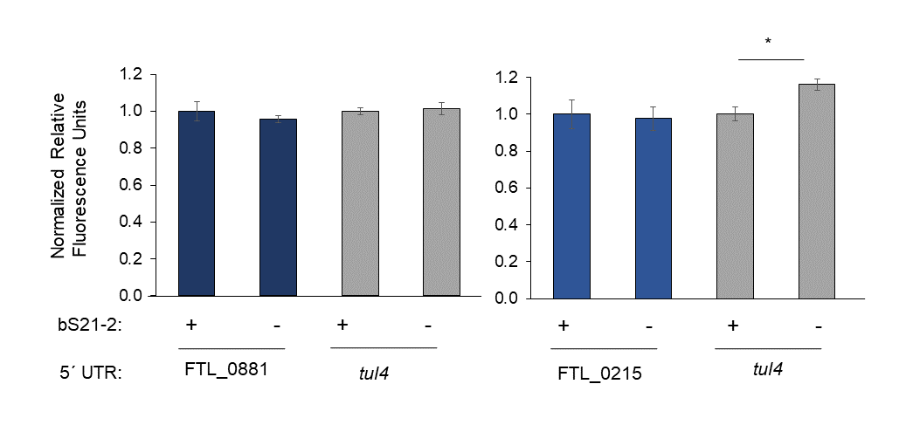
Figure S2. Predicted 5´ UTR of some genes is not sufficient for bS21-2 to affect translation.
Green fluorescence was measured for indicated 5´ UTR reporter constructs in cells with (+; WT) or without (-; ΔrpsU2) bS21-2 and normalized to OD600 and a nonfluorescent strain. FTL_0881 and FTL_0215 were found to be less abundant at the protein level in cells lacking bS21-2 in a proteomics screen (Trautmann & Ramsey, 2022). tul4 5´ UTR is included as a control. Error bars represent 1 SD. Experiments were repeated twice and data from representative experiments are shown. * p<0.05.

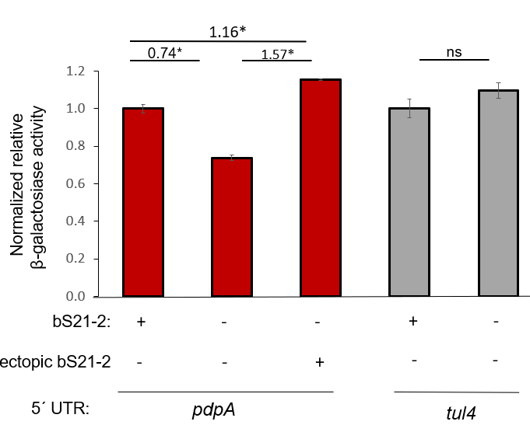
Figure S3. Defects in protein production can be complemented by ectopic expression of bS21-2.
Relative β-galactosidase activity of pdpA or tul4 5´ UTRs in cells with (+; WT) or without (-; ΔrpsU2) native bS21-2, or with ectopically expressed bS21-2. β-galactosidase reporters were located at the Tn7 site on the chromosome and ectopic expression of bS21-2 was from a multicopy plasmid, pF-nat. Strains without ectopically expressed bS21-2 contained an empty vector. β-galactosidase activity was normalized to OD600 and a nonfluorescent strain. Error bars represent 1 SD. * p<0.05. ns = not significant.

5´ UTR
pdpA idealSD
pdpA WT
mraY idealSD
mraY WT
Figure S4. Modifications adding ideal Shine-Dalgarno sequences increase reporter protein production relative to unmodified 5´ UTRs.
Total β-galactosidase activity or green fluorescence of pdpA or mraY 5´ UTRs, respectively, in cells with bS21-2. Reporter production is relative to unmodified (WT) 5´ UTR for each gene. Production was normalized to OD600 (both constructs) and a nonfluorescent strain (GFP only). Error bars represent 1 SD. Experiments were repeated twice and data from representative experiments are shown.

5´ UTR | Sequence | MXFold2 | Ufold | ViennaRNA
mraY WT | auaaaaaauuugaaccaauuauuuagacgcuaauuuugacucuauuaaaaaaauaacauaucuauuauaauacuccaaggucauuaaacauuuuaaauauAUGcugauuuaucuuuuu | 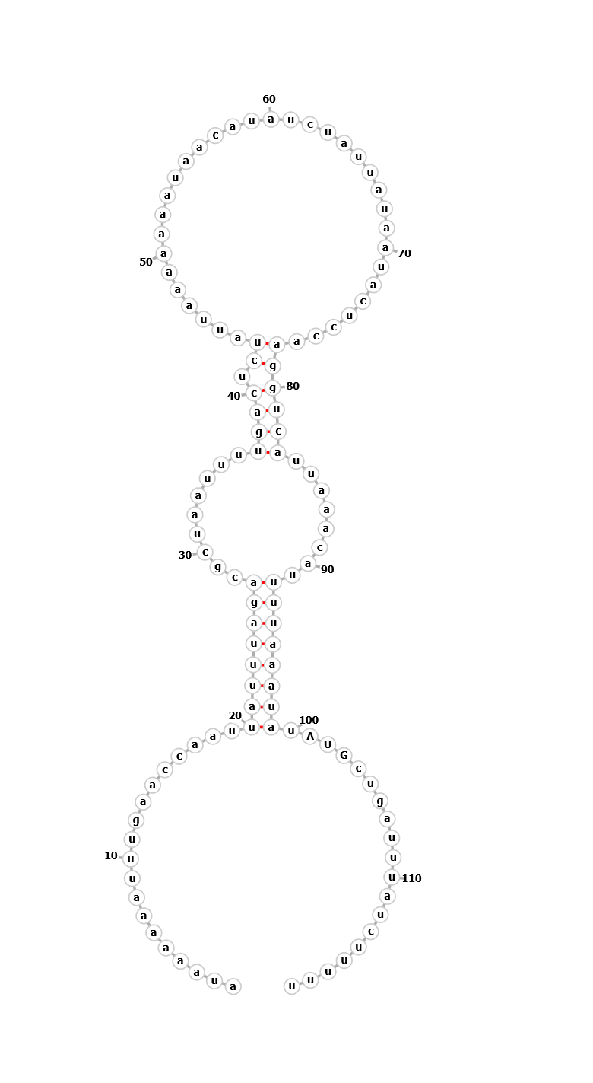 | 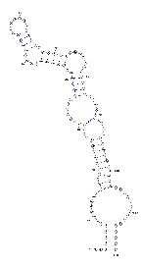
mraY mut3 | auaaaaaauuugaaccaauuauuuagacgcuaauuuugacucuauuaaaaaaauaacauaucuauuauaauacuccaCUACUauuaaacauuuuaaauau AUG cugauuuaucuuuuu | 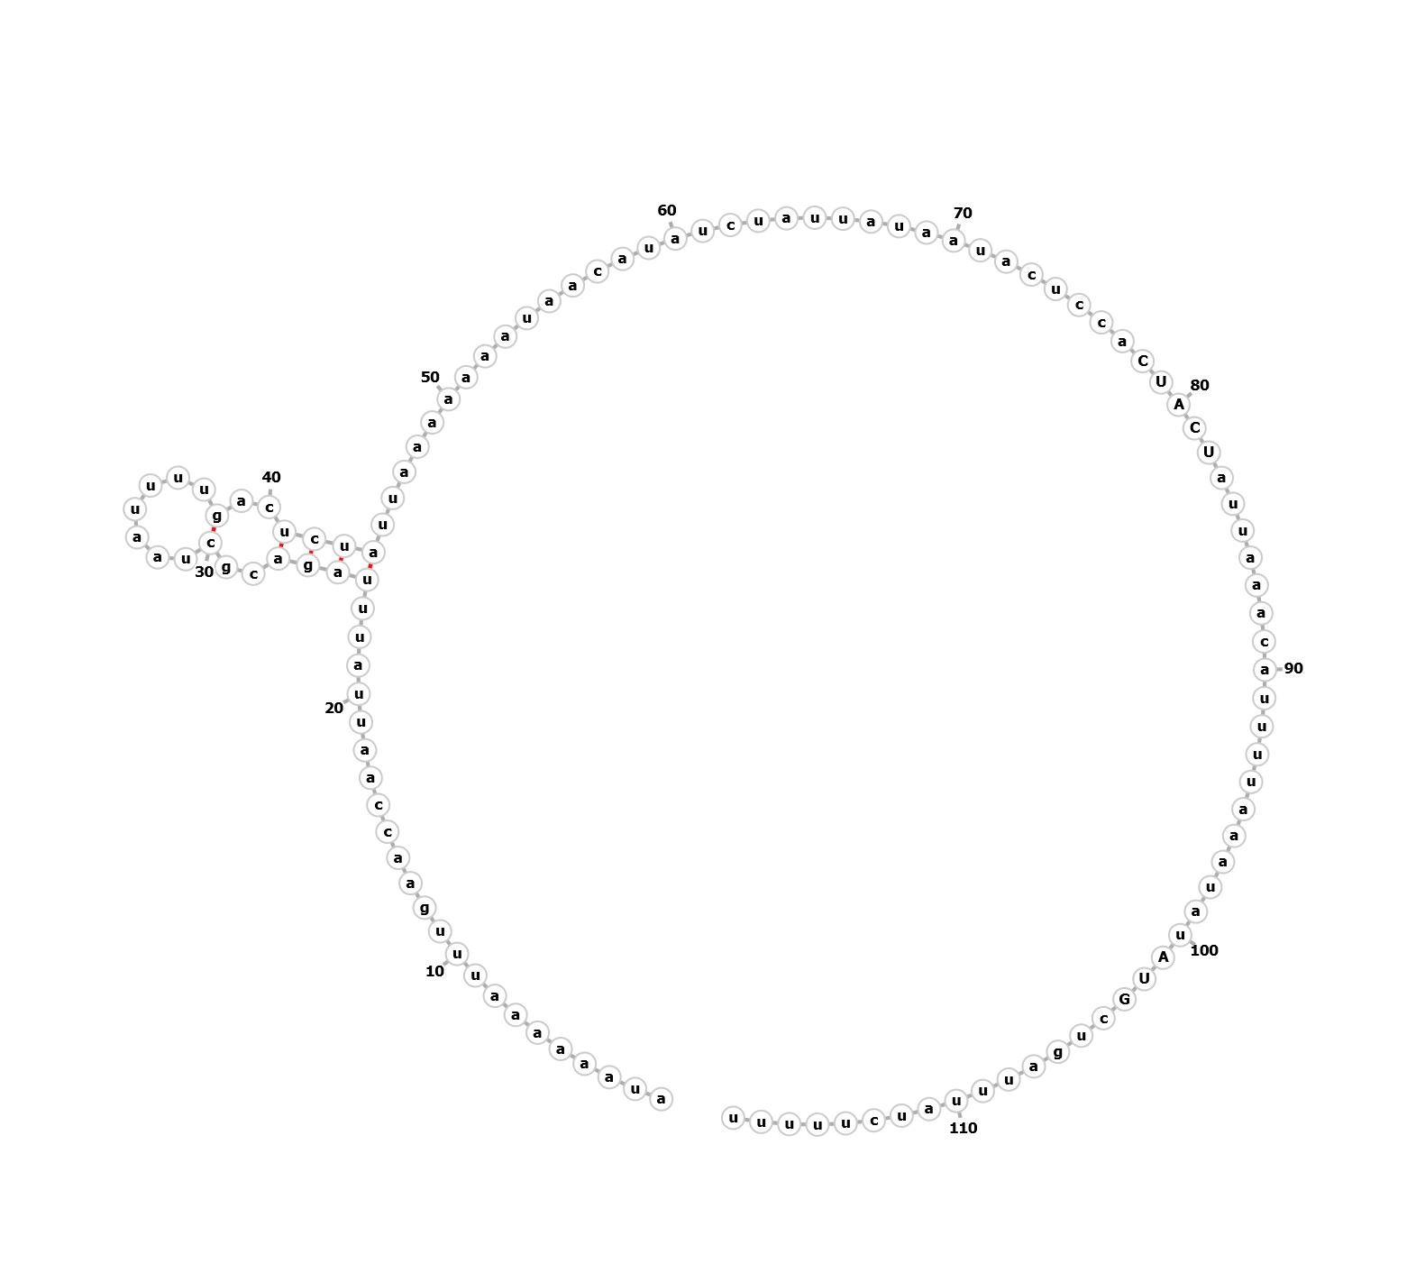 | Server unavailable
mraY mut4 | auaaaaaauuugaaccaauuauuuagacgcuaauuuuAGUGAGauuaaaaaaauaacauaucuauuauaauacuccaCUACUauuaaacauuuuaaauau AUG cugauuuaucuuuuu | 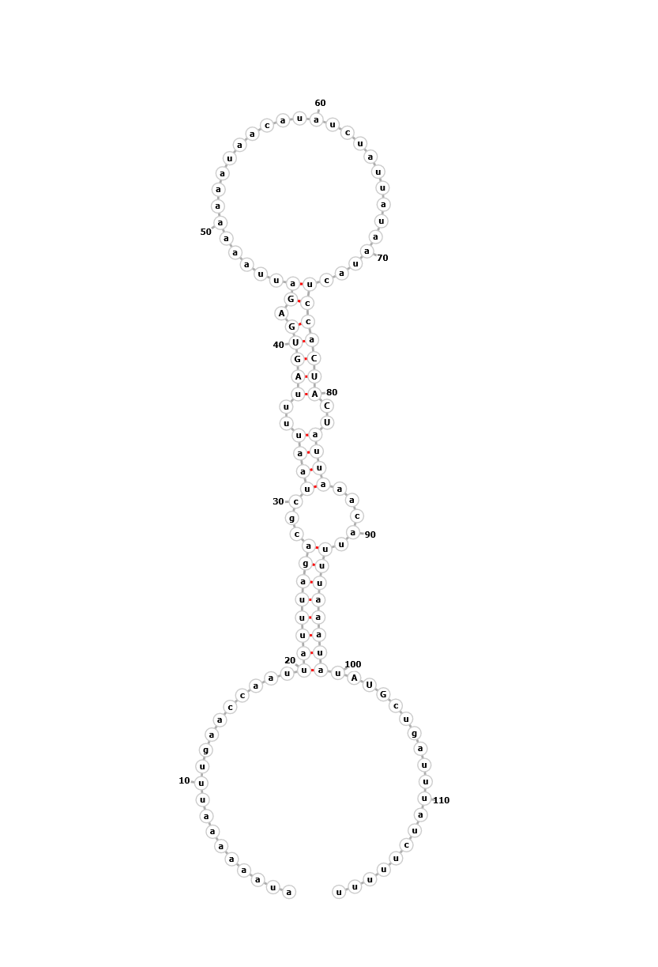 | Server unavailable
pdpA WT | aguuauguucuaauuaaguagacaaugauagcaguaaaagau | 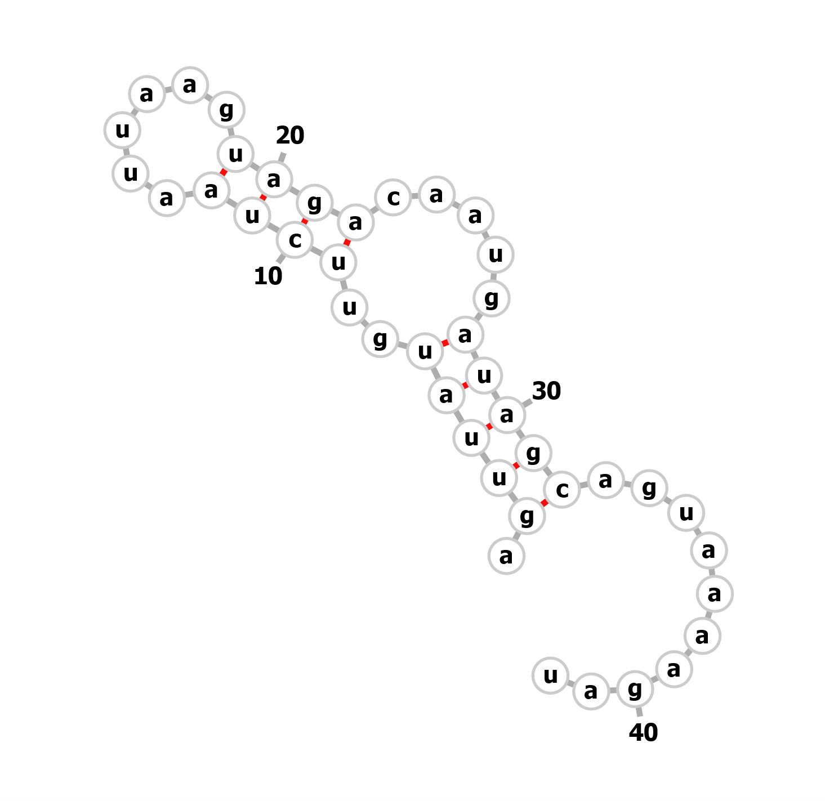 | 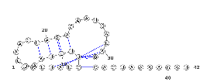
pdpA mut1 | aguuauguucuaauuaaguaCUcaaugauUgcaguaaaagau | 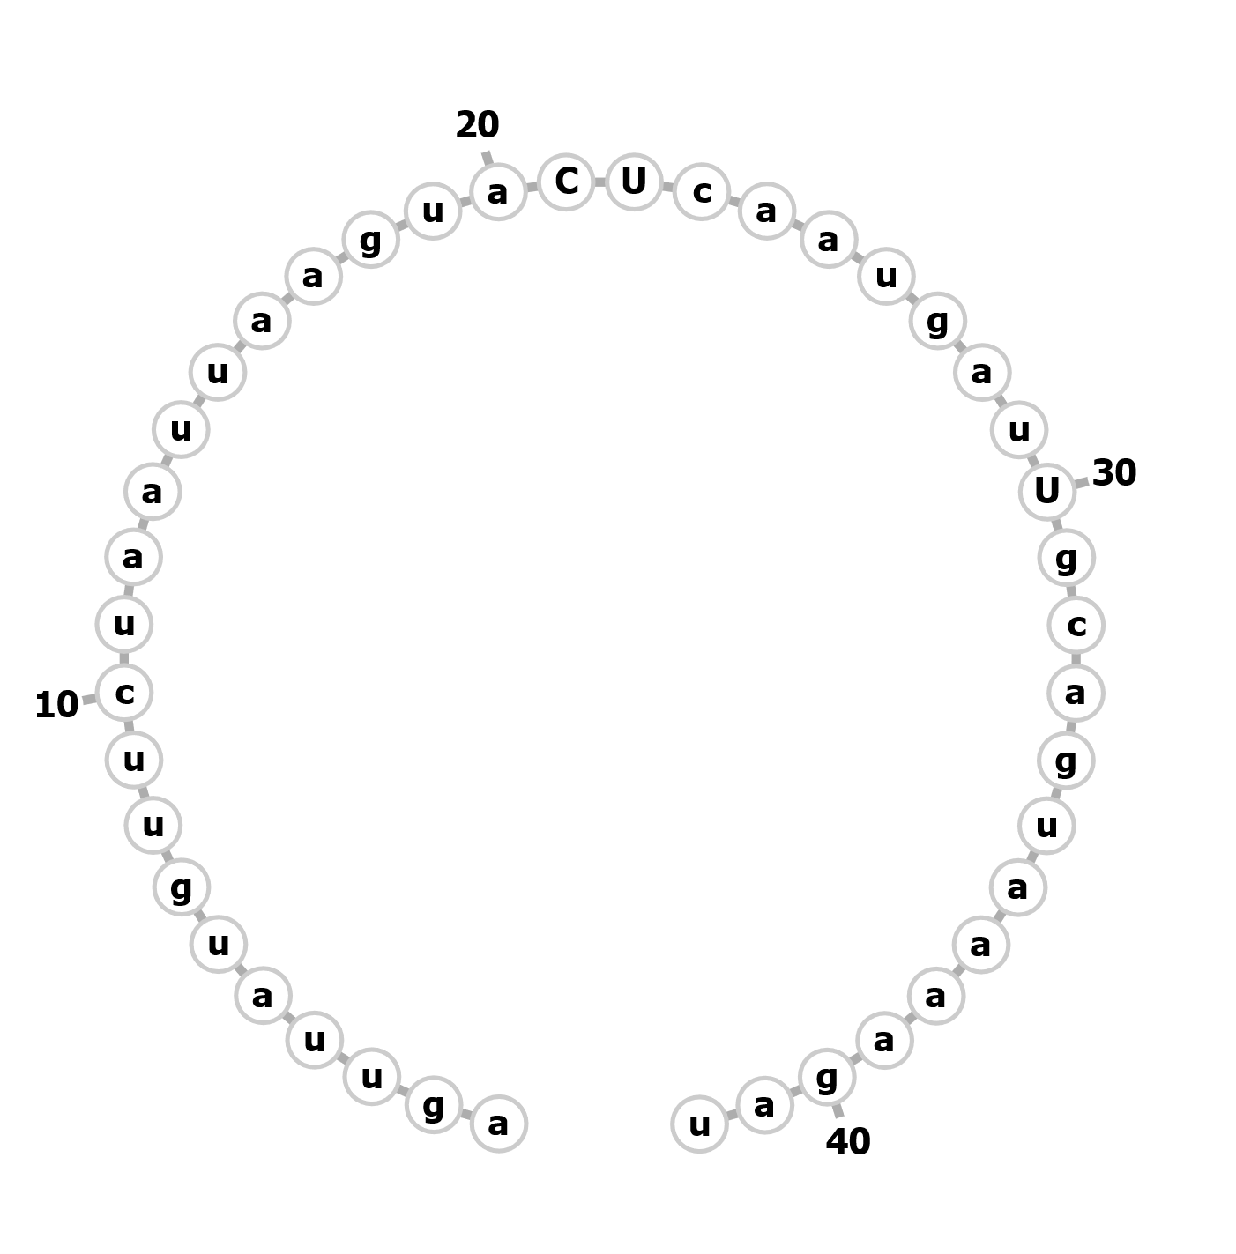 | 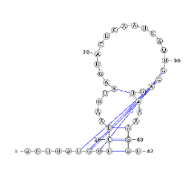
pdpA mut2 | aguuauguAGuaauuaaguaCUcaaugauAgcaguaaaagau | 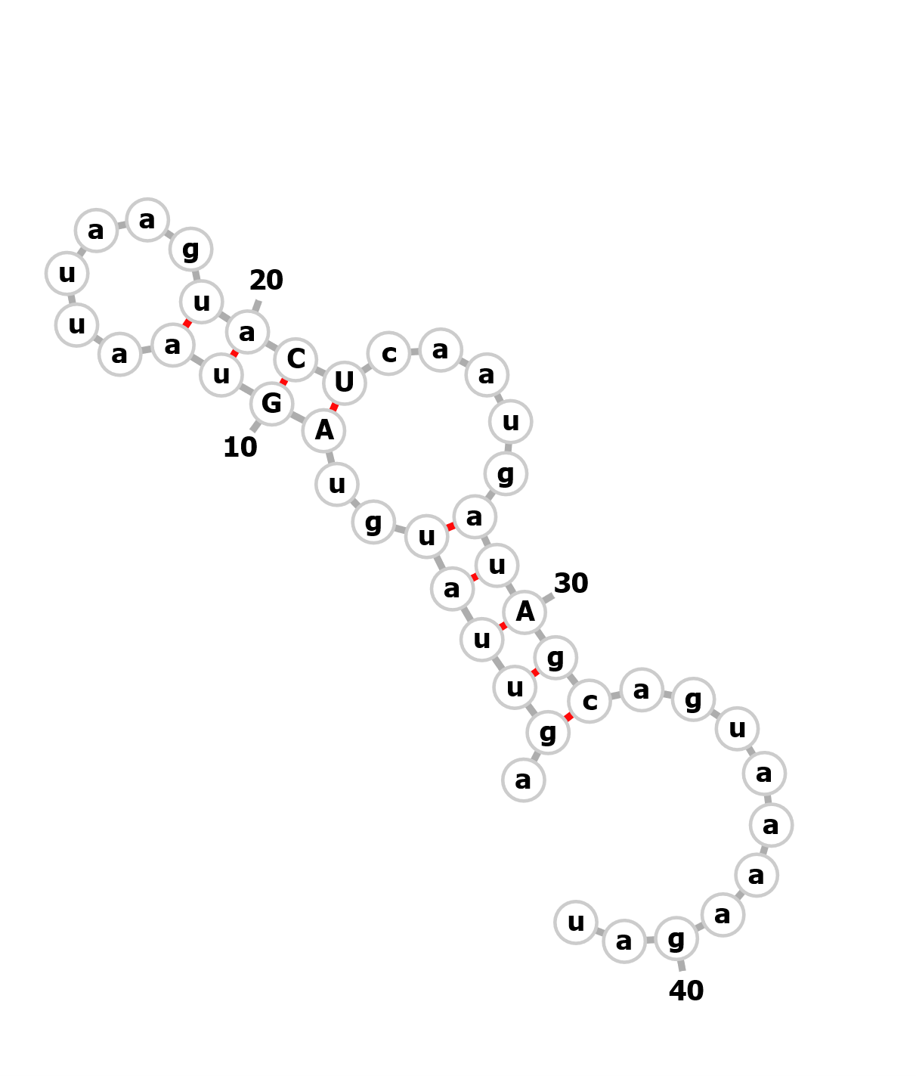 | 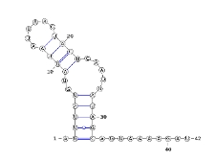

Figure S5. Comparison of secondary structure prediction software.
Predicted structures of wild-type or modified mraY and pdpA 5´ UTRs from three secondary structure prediction programs: MxFold2 (Sato et al. 2021), Ufold (Fu et al. 2022), and ViennaRNA (Lorenz et al. 2011).

