(a) INSERT GRAPH KATHRYN MADE FOR GRANT – THIS IS JUST A PLACEHOLDER
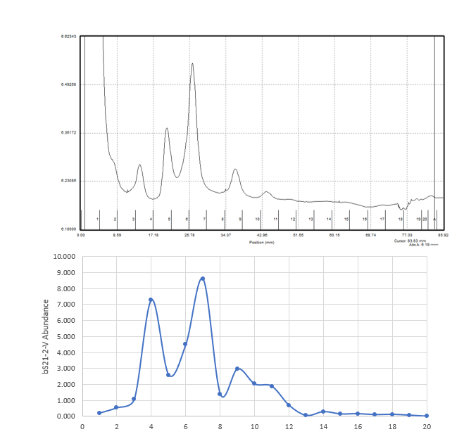
(b)
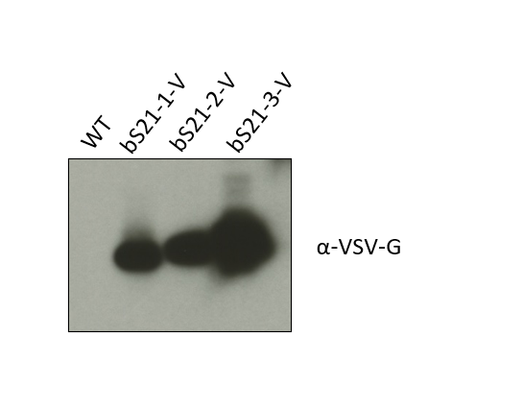
Figure 1: bS21 homologs are found in ribosomes in Francisella tularensis LVS.
(a) Sucrose sedimentation analysis of ribosomes with VSV-G-tagged bS21-2 and quantification of western blot analysis of recovered fractions with anti-VSV-G.
(b) Western blot analysis of purified ribosomes from wild-type cells and cells with ectopically expressed bS21 homologs with VSV-G tags.
(c) Normalized spectral counts from mass spectrometry analysis of wild-type cells. will need to be re-done?

(a) *make these plots on R*

(b)

Figure 2: Loss of bS21-2 leads to a growth defect in vitro. (a) Growth of wild-type or ΔrpsU2 strains containing either empty vector or overexpression vector for each bS21 paralog. (b) Generation times (minutes) of wild-type or ΔrpsU2 strains containing either empty vector or overexpression vector for each bS21 paralog.

Figure 3: Loss of bS21-2 leads to changes in expression of specific genes. (a) Comparison of the total protein abundance detected by quantitative mass spectrometry between wild-type and ΔrpsU2 cells. Red dots represent genes with log₂FC (WT/ ΔrpsU2) > 1.5; green dots represent genes with log₂FC (WT/ ΔrpsU2) < 1.5; grey dots indicate genes where the difference was not statistically significant. (b) Western blot analyses and corresponding quantifications of whole cell lysates from wild-type cells or ΔrpsU2 with either empty vectors or vectors ectopically expressing rpsU homologs. Antibodies specific to Francisella pathogenicity island (FPI) genes were used. *use images and quantification from 3/16/21; only have PdpB, IglD, and VSVG – should I do more?*

