Figures
1. F. tularensis ribosome are heterogeonous
- Pie chart of purified ribosome mass spec data comparing spectral counts for ribosome, translation/transcription, and other
- table of # unique peptides corresponding to bS21 homologs in each sample
- Gradients of Ft lysates with WB from fractions with OE of bS21-V homologs
  - TIFs in folder (_dark)

2. Whole genome Gene expression comparing ∆rpsU2 vs LVS
- Mass spec vs RNA-Seq - Made

3. Change in FPI gene expression
- WB of T6SS proteins
- Quantification

4. Intramacrophage growth data

5. Model

S1. Alignment of bS21 homologs
Something like this:
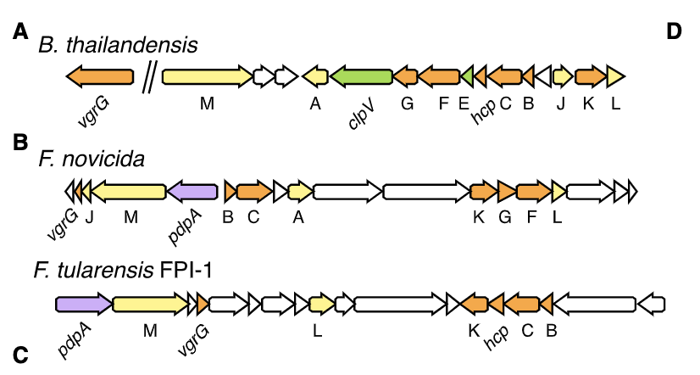
which is from Russell et al., 2014
In particular keep the colors the same for homologs

S2. Amino acid identity matrix- comparing E. coli with F. tularensis bS21 homologs
S3. individual gradients + WB data

S4. qRTPCR for FPI genes LVS vs ∆rpsU2
200203 data

Table S1. Purified ribosome mass spec data
Table S2. Mass spec data, whole cell lysates
Table S3. RNA-Seq data
Table S4. Intramacrophage vs in vitro growth rates

