Chapter 1- Literature Review
Ribosomes may be heterogenous in structure and function
The ribosome, which translates mRNA into protein, is highly conserved in all domains of life and consists of two subunits composed of ribosomal RNAs (rRNAs) and ribosomal proteins (r-proteins). Typically, the ribosome is viewed as acting constitutively and without variability, translating every mRNA with equal efficiency. However, heterogeneity in ribosomes exists and arises via a number of mechanisms. These include diversity in rRNA sequences, r-proteins encoded by distinct homologs within the same cell, post-transcriptional modification of rRNA, and post-translational modification of r-proteins (Byrgazov et al., 2013; Sauret et al., 2015). The presence of these physical differences raises the possibility that heterogeneous ribosomes within the same organism have functional differences. The term “specialized ribosomes” describes structurally diverse ribosomes that may have altered activity (Xue & Barna, 2012). It should be noted that the concept of ribosomes with specialized functions has faced controversy due to conflicting results and claims that are insufficiently supported by the data. However, ribosome diversity is well documented and the scientific community agrees that thoughtful research into this field is warranted (Barna et al. 2022; Ferretti & Carbstein 2019; Genuth & Barna 2018).
In the context of eukaryotic organisms, there are a significant number of studies focused on specialized ribosomes (reviewed in Xue & Barna, 2012). For example, in multiple species of the parasitic pathogen that causes malaria, Plasmodium, rRNA usage correlates to stages of the parasitic life-cycle and the distinct rRNAs have functional differences (Gunderson et al. 1987; Velichutina et al. 1998). When the parasite is growing in mosquitoes, one 18S rRNA is expressed (termed “S-type”), and when in mammals, a different 18S rRNA is expressed (termed “A-type”). When either A- or S-type P. berghei rRNAs were introduced to the yeast genome in the absence of native 18S rRNA, only cells with pure populations of A-type rRNA could be recovered. The inability for S-type rRNA cells to grow suggests that the two rRNAs have different functions (Velichutina et al. 1998). This raises the possibility not only that ribosomes are not homogenous in Plasmodium species, but that their ribosomes also function differently to influence gene expression based on the life-cycle requirements of the parasite.
In bacteria, recent studies have identified heterogeneous ribosomes may have functional differences. In Mycobacterium tuberculosis, two genes encode the small r-protein bS18, but only one, the canonical bS18, can coordinate zinc (Prisic et al. 2015). In high zinc conditions, expression of the alternative bS18 is repressed by a zinc uptake regulator (Zur), leading to a population of ribosomes with mostly the primary bS18 present. In low-zinc conditions, repression of the secondary bS18 protein does not occur, leading to ribosomes with both canonical and alternative bS18 proteins, creating a more heterogeneous ribosome population (Prisic et al. 2015). The functional consequences of the distinct ribosome classes were analyzed in M. smegmatis using ribosome profiling (Chen et al. 2020). While ribosomes with alternative bS18 and canonical bS18 were both able to partake in protein synthesis, the two subsets of ribosomes had distinct translational profiles with different efficiencies in translation of particular genes (Chen et al. 2020).
An example of specialized ribosomes in bacteria that has caused some controversy is in the case of toxin-induced mutants of Escherichia coli (Vesper et al. 2011; Culviner and Laub, 2018). These studies took advantage of E. coli cells with induced expression of an endoribonuclease toxin called MazF. Initial studies suggested that the MazF toxin cleaves rRNA at sequence-specific sites and creates subsets of ribosomes lacking the anti-Shine-Dalgarno sequences in the 16S rRNA (Vesper et al. 2011). These studies led to a model proposing that the modified ribosomes consequently recognize leaderless mRNAs, also generated by MazF cleavage, which is supported by pulse labeling results in vivo and in vitro showing preferential translation of leaderless mRNA when MazF is active. These studies suggested that a class of ribosomes lacking the anti-Shine-Dalgarno sequences differentially translates subsets of mRNA to adapt to stress. However, a follow-up study published conflicting results, specifically finding that the 16S rRNAs lacking the anti-Shine-Dalgarno sequence were cleaved at additional sites and usually were not incorporated into mature ribosomes (Culviner and Laub, 2018). Additionally, MazF activity led to such substantial RNA cleavage throughout the cells that very few full-length leaderless mRNA transcripts were present. This suggests that the “specialized” ribosomes are not controlling translation or gene regulation but instead that MazF activation results in major disruptions to ribosome biogenesis and overall cell growth (Culviner and Laub, 2018). Given these conflicting results, additional studies would be necessary prior to citing toxin-induced ribosomes as bona fide specialized ribosomes. Based on the promising results in Mycobacterium, further research into heterogeneous ribosomes in bacteria is merited, but warrants a system in which ribosome heterogeneity is inherent, as in a species with multiple r-protein homologs.
Translation initiation is a target for regulation
**read Duval et al.
There are a number of mechanisms by which gene expression may be regulated at the level of translation, including variations in recruitment of mRNA to the ribosome and factors that affect assembly of the translation initiation complex (Milón & Rodnina, 2012). Small RNAs (sRNAs) can also contribute to gene regulation post-transcriptionally in multiple ways, including binding to mRNAs to prevent or promote translation (Harris et al., 2013).
bS21 plays an important role in translation
bS21 is a small ribosomal protein in the small subunit of many bacterial ribosomes. Early research investigating E. coli r-protein identified that bS21 plays an important role in translation initiation. Using MS2 RNA, a model system for studying translation, it was discovered that ribosomes lacking bS21 are unable to bind mRNA, but are fully functional in fMet-tRNA binding. These results suggest that bS21 is necessary to mediate the interaction between the ribosome and mRNA molecules during translation initiation (van Duin & Wijands, 1981). In further support of this role, chemically modified ribosomes that lost their ability to bind bacteriophage RNA regained binding capabilities when four untreated purified r-proteins were added: bS1, uS12, uS13, and bS21 (Chang &Craven, 1977). Crystallographic and cryogenic electron microscopy data in E. coli shows that bS21 is found close to the exit channel of mRNA on the small subunit (Berk et al., 2006; Watson et al. 2020). In fact, there are direct interactions predicted between the anti-Shine Dalgarno and bS21 in both the E. coli and Flavobacterium johnsoniae ribosomes, bolstering support for a role of bS21 in translation initiation (Figure X) (Kaledhonkar et al., 2019; Jha et al. 2020).
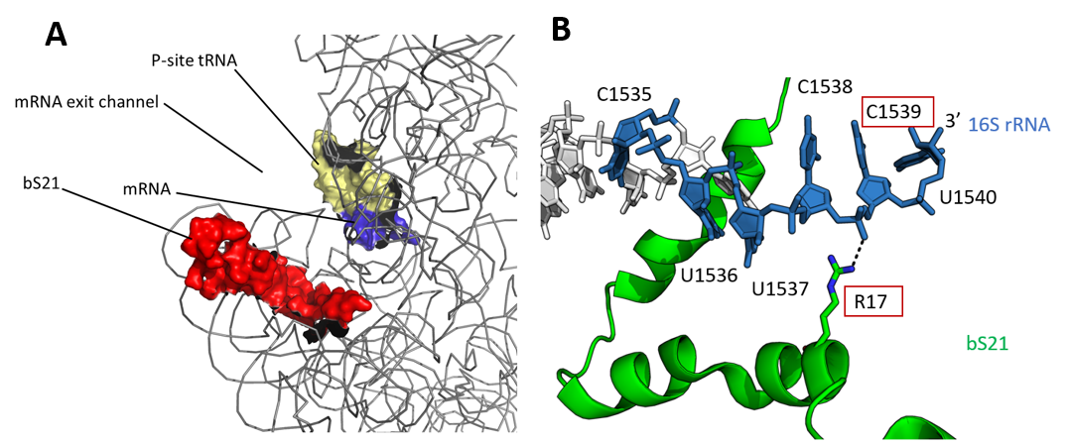
Figure X: bS21 location in E. coli ribosome. (A) Partial 30S subunit of E. coli ribosome by cryogenic electron microscopy (cryoEM) showing bS21 location relative to mRNA. Red = bS21; blue = mRNA; grey = 16S rRNA and other 30S ribosomal proteins. PDB entry 4V50. (B) Predicted hydrogen bond interaction between R17 of bS21 and C1539 of 16S rRNA in E. coli ribosome. Blue = anti-Shine Dalgarno; white = other 16S rRNA residues; green = bS21. PDB entry 6O7K.
In several species where the gene that encodes bS21, rpsU, has been mutagenized, distinct phenotypes have been observed. In Bacillus subtilis, bS21 mutants have defects in motility and biofilm formation (Takada et al., 2014) and in Listeria monocytogenes, null mutants have increased acid stress resistance and changes in transcription of stress resistance genes (Metselaar et al., 2015). In Staphylococcus aureus, some clinical isolates with mutations in rpsU have increased resistance to daptomycin and vancomycin (Basco et al. 2019; Blake & O’Neill 2013; Friedman et al. 2006). In Burkholderia pseudomallei, bS21 was identified as a potential virulence factor during a transposon-sequencing (Tn-seq) mutagenesis screen in lung infections (Guttierez et al. 2015); similarly, in Francisella tularensis, one of the bS21-encoding genes, rpsU1, was flagged as a virulence gene in a transposon mutagenesis screen using a mouse infection model (Su et al. 2007). These data support a role for bS21 in regulation of specific processes. In conflict with the important role that bS21 plays in initiation, many bacterial species lack rpsU, suggesting that bS21 is not essential for all bacterial translation.
Recent research points towards bS21 playing a regulatory role in some bacteria. In the Bacteriodetes species F. johnsoniae, structural data revealed binding between the anti-Shine Dalgarno (ASD) of the 16S rRNA and bS21 residues (Jha et al. 2020). These results suggest bS21 sequesters the ASD, consistent with the fact that most genes in F. johnsoniae do not have Shine Dalgarno sequences. rpsU, on the other hand, has a perfect Shine Dalgarno, suggesting that bS21 may be autoregulating (Jha et al. 2020).
Interestingly, a large number of rpsU homologs have been found in high abundance in bacteriophage genomes. Over 1300 bS21 homologs were found in viral genomes, infecting a wide range of bacterial clades (Al-Shayeb et al., 2020; Mizuno et al. 2019). Metatranscriptomic analyses identified bS21 transcripts associated with late stages of viral replication (Chen et al. 2022). At least one bS21 homolog was found to be encoded by a cultivated pelagiphage, Pelagibacter phage HTVC008M, and the purified viral bS21 proteins were able to be incorporated into E. coli ribosomes (Mizuno et al., 2019). This is possible because bS21 is one of the last-assembled r-proteins and is easily exchanged in E. coli (Mizushima & Nomura, 1970). Together, these findings raise the possibility that viruses may be utilizing bS21 to influence gene expression in host cells to increase viral replication.
While many of the bacteria like E. coli encode only one bS21 protein, some bacterial species, such as Crocosphaera watsonii, Nostoc punctiforme, Francisella tularensis and Burkholderia pseudomallei, encode multiple homologs of bS21. Francisella in particular provides an ideal model organism to study the role of bS21 homologs as there are three distinct rpsU genes, but no other r-proteins or rRNA with multiple homologs. The retention of these three homologs (rpsU1, rpsU2, and rpsU3, encoding bS21-1, bS21-2, and bS21-3, respectively) is especially noteworthy given the significantly reduced genome in F. tularensis (~1.8 Mbp).
Francisella tularensis must regulate virulence genes to infect hosts
Francisella tularensis is a highly infectious, Gram-negative, facultative intracellular bacteria that causes the human disease tularemia (Sjöstedt, 2007). Infection of humans can occur through respiration, insect bites, and ingestion of contaminated food or water (McLendon et al. 2006). With a low infectious dose (as few as 10 organisms are able to cause the disease) and the potential to be fatal, F. tularensis is considered a bioweapon (Dennis et al. 2001).
While capable of replicating in a wide variety of cell types, F. tularensis must be able to replicate in macrophage to cause disease (Nano et al., 2004). Survival in macrophage requires a Type VI secretion system (T6SS) which allows for escape from the host phagosome (Barker et al. 2009). The T6SS is encoded on the Francisella Pathogenicity Island (FPI), a set of 16 genes across two operons that is duplicated in the F. tularensis genome (Nano & Schmerk, 2007). The FPI is known to be controlled at the level of transcription by the coordinate action of several factors, including MglA, SspA, PigR, and ppGpp (Brotcke et al., 2006; Brotcke & Monack, 2008; Charity et al., 2007; Ramsey et al., 2015; Rohlfing et al., 2018; Cuthbert et al., 2017). While significant research has been done on the transcriptional-regulation of the T6SS, there is much to learn about other virulence factors and post-transcriptional regulation of virulence genes in this pathogen.

