Summary of phylogenetic tree inputs:
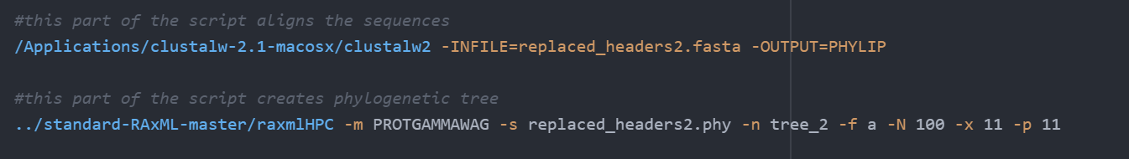
(option -m PROTGAMMAWAG) specifies three important parts: first, that we are using protein data (the PROT part); second, that we are accounting for rate heterogeneity among sites in our alignment by using the gamma distribution (the GAMMA part); and third, that we are employing the Whelan and Goldman (Whelan and Goldman, 2001) amino acid substitution matrix (the WAG part).

-s is input file name
-n is output file name
-f a calls an algorithm to perform rapid bootstrapping and identification of the best tree
-x sets a random seed and turns on rapid bootstrapping
-p Specify a random number seed for the parsimony inferences. This allows you to reproduce your results and will help me debug the program. For all options/algorithms in RAxML that require some sort of randomization, this option must be specified. Make sure to pass different random number seeds to RAxML and not only 12345 as I have done in the examples. When not specifying -p when it is required by RAxML, the program will exit with a respective error message
-T gives threads number, justneeds to be great than 1 I think

--trying to pick an outgroup, I copied the amino acid sequence for bS21-2 (francisella) into pfam. Clicked on the domain organization tab: http://pfam.xfam.org/family/PF01165.20#tabview=tab1
found this as a potential outgroup:
Kathryn thinks this one is better because it has 6 sequences so it’s not probably a sequencing error:
The “clan” tab was greyed out:
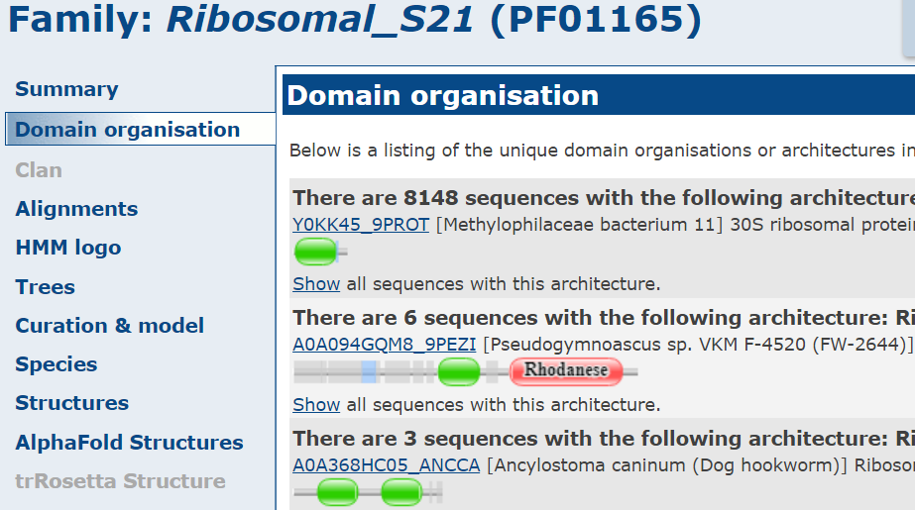
I’m going to try a mini-tree with the rhodanese option:

https://github.com/weizhongli/cdhit/wiki
https://uni-tuebingen.de/fakultaeten/mathematisch-naturwissenschaftliche-fakultaet/fachbereiche/informatik/lehrstuehle/algorithms-in-bioinformatics/software/dendroscope/

To address the long edge attraction problem, wherein the branches of Francisella are too far away from close-by groups, I’ll try aligning it with other gamma proteobacteria like Kangiella koreensis and Colwellia to see if there are big sections of differences:

