Summary of phylogenetic tree inputs:
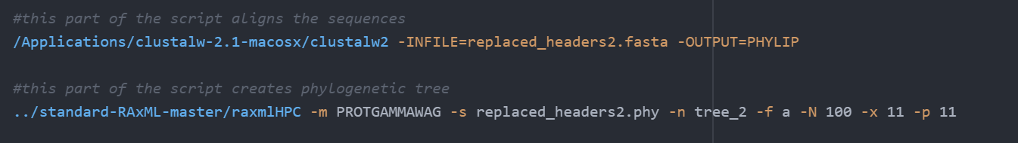
(option -m PROTGAMMAWAG) specifies three important parts: first, that we are using protein data (the PROT part); second, that we are accounting for rate heterogeneity among sites in our alignment by using the gamma distribution (the GAMMA part); and third, that we are employing the Whelan and Goldman (Whelan and Goldman, 2001) amino acid substitution matrix (the WAG part).

-s is input file name
-n is output file name
-f a calls an algorithm to perform rapid bootstrapping and identification of the best tree
-x sets a random seed and turns on rapid bootstrapping
-p Specify a random number seed for the parsimony inferences. This allows you to reproduce your results and will help me debug the program. For all options/algorithms in RAxML that require some sort of randomization, this option must be specified. Make sure to pass different random number seeds to RAxML and not only 12345 as I have done in the examples. When not specifying -p when it is required by RAxML, the program will exit with a respective error message
-T gives threads number, justneeds to be great than 1 I think

--trying to pick an outgroup, I copied the amino acid sequence for bS21-2 (francisella) into pfam. Clicked on the domain organization tab: http://pfam.xfam.org/family/PF01165.20#tabview=tab1
found this as a potential outgroup:
Kathryn thinks this one is better because it has 6 sequences so it’s not probably a sequencing error:
The “clan” tab was greyed out:
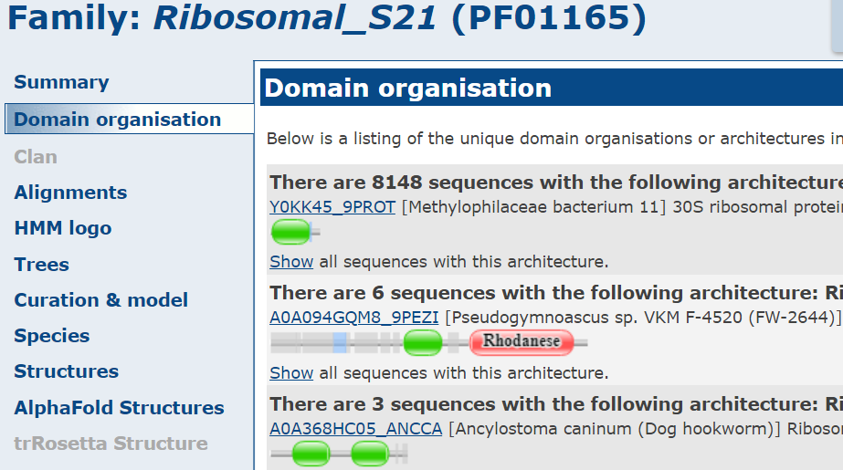
I’m going to try a mini-tree with the rhodanese option:
Well using the rhoadense, it didn’t show up as the actual outgroup with a set of only 7 sequences – rather the nostoc species (no.4) was the outgroup. I’ll try again using Ham1p. Still didn’t outgroup. Tried two more from that website:
A0A674HUB4_TAEGU [Taeniopygia guttata (Zebra finch) (Poephila guttata)] - didn’t outgroup (this time no. 3 did)
and
A0A6A6MTQ8_HEVBR [Hevea brasiliensis (Para rubber tree) – didn’t outgroup (this time no. 7 was the outgroup)

My next plan is to try to run Phyre2 and see if there are similar structures that aren’t ribosomal proteins. I used rpsU3’s amino acid sequence and my results are at this link here:
http://www.sbg.bio.ic.ac.uk/phyre2/phyre2_output/f95ead01c2582e2b/summary.html
I’m going to try the mitochondrial s21 first. It looks like it’s the outgroup in the small set of 7 samples! Now I’m going to run it with the large set of 800 or so (I haven’t done the clustering thing yet). We shall see how it goes!

https://github.com/weizhongli/cdhit/wiki
https://uni-tuebingen.de/fakultaeten/mathematisch-naturwissenschaftliche-fakultaet/fachbereiche/informatik/lehrstuehle/algorithms-in-bioinformatics/software/dendroscope/

To address the long edge attraction problem, wherein the branches of Francisella are too far away from close-by groups, I’ll try aligning it with other gamma proteobacteria like Kangiella koreensis and Colwellia to see if there are big sections of differences:
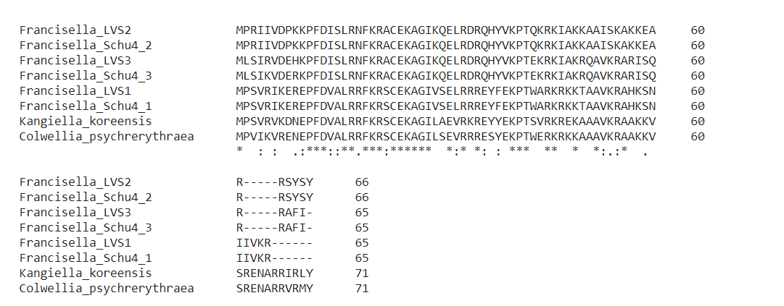
There are deletions in the francisella ones compared to the colwellia and kangiella on the C terminus, but they aren’t very long. I’m not sure if this is enough to explain the long branching problem. I’ll hope that the outgroup solves this problem as well.

Running CD-Hit to reduce redundancy:
module load CD-HIT/4.8.1-foss-2018b
cd-hit -i $1 -o Prot_rep_head_Reduced -c 0.8
-I input file name
-o output file name
-c 1.0 means 100% is the clustering to threshold; default is 0.9 so if I don’t get any removed this way, I will try 0.9
-n 5 is the word size. recommended for -c greater than 0.7
-M is memory limit, don’t think I need to worry about that
-d 0 something to do with white spaces in the fasta file header, so I just need to make sure to use the replaced headers file
-T is number of threads used
-s 0.8 length sequence needs to be at least 80% of representative
The output .clstr file looks like
>Cluster 0
0 2799aa, >PF04998.6|RPOC2_CHLRE/275-3073... *
>Cluster 1
0 2214aa, >PF06317.1|Q6Y625_9VIRU/1-2214... at 80%
1 2215aa, >PF06317.1|O09705_9VIRU/1-2215... at 84%
2 2217aa, >PF06317.1|Q6Y630_9VIRU/1-2217... *
3 2216aa, >PF06317.1|Q6GWS6_9VIRU/1-2216... at 84%
4 527aa, >PF06317.1|Q67E14_9VIRU/6-532... at 63%
>Cluster 2
0 2202aa, >PF06317.1|Q6UY61_9VIRU/8-2209... at 60%
1 2208aa, >PF06317.1|Q6IVU4_JUNIN/1-2208... *
2 2207aa, >PF06317.1|Q6IVU0_MACHU/1-2207... at 73%
3 2208aa, >PF06317.1|RRPO_TACV/1-2208... at 69%

where
a ">" starts a new cluster
a "*" at the end means that this sequence is the representative of this cluster
a "%" is the identity between this sequence and the representative

