-10 proposed mutations (pdpA UTR)

Original: (-10 in yellow) atcaatacactttttataactttatcgtcagaccaattagctgtaaacatatagtcaatagataagtgcttatgtaaaatgactttagttatgttctaattaagtagacaatgatagcagtaaaagat
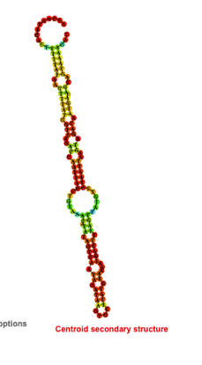
Proposed mutation:
atcaatacactttttataactttatcgtcagaccaattagctgtaaacatatagtcaatagataagtgcttatgtCaaGtgactttagttatgttctaattaagtagacaatgatagcagtaaaagat
