Summary of Tested UTRs
GFP assays:
Description of UTR | Sequence | Ratio LVS/drpsU2 (* if signif) | Date of Assay | Relative production to WT UTR | Secondary structure w/ 6 codons
pdpA WT | aguuauguucuaauuaaguagaca aug auagcaguaaaagau | 0.8* | 220815 |  | 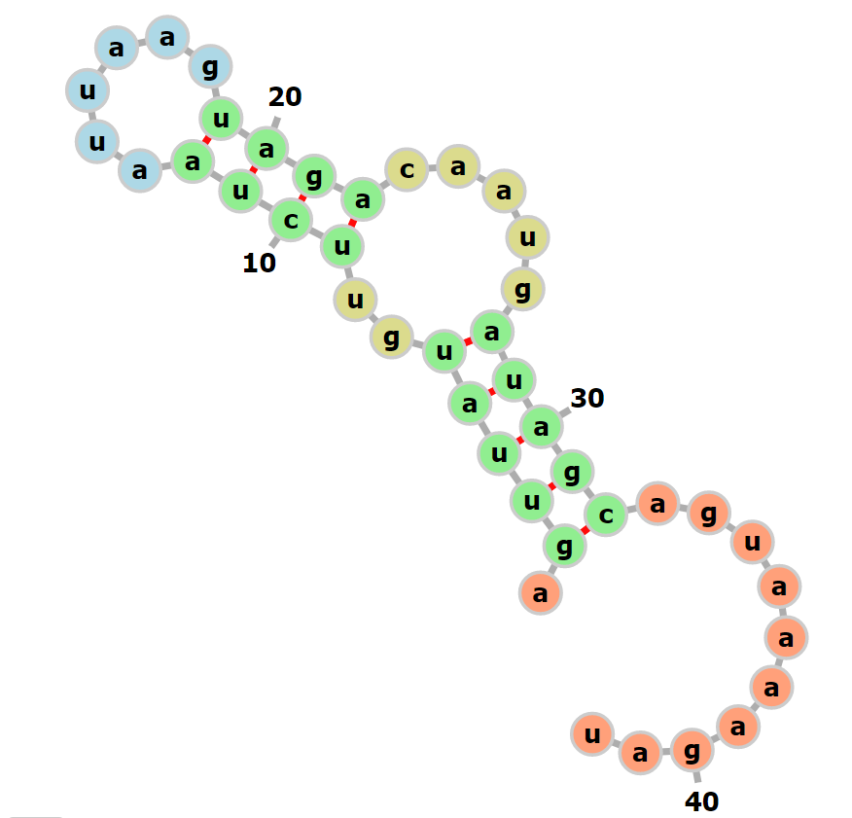
tul4 WT | gaguauaugugaauauuuaaaaauaggaguaucuau aug aaaaaaauaauuaag | 1.1* | 220815 |  | 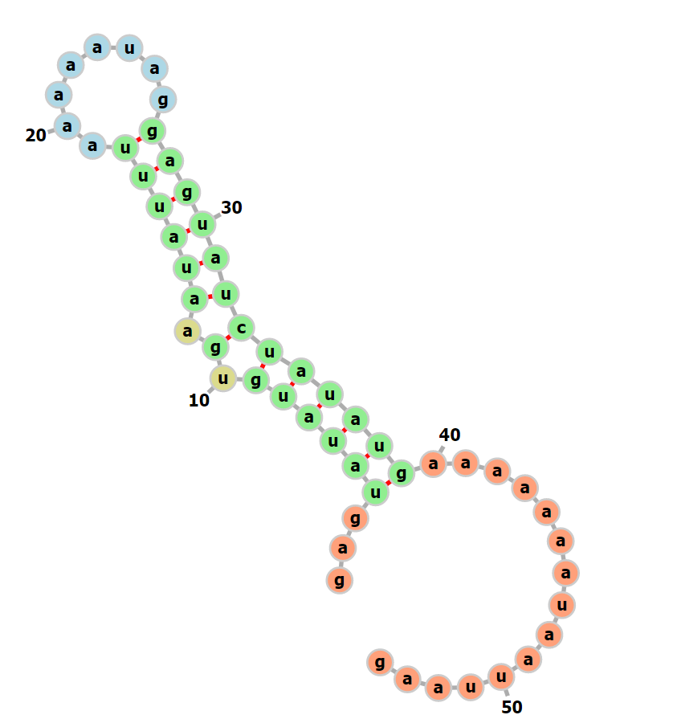
Hfq WT | uugcugauagauauaaaucuugcuagaauauacgcgaaguuuaauuguuaaacuugauaaaauaauaacuauaacaaaauaauuaaaaggaagugagaua aug ucaagaauaucaucu | 1.82* | 220825 |  | 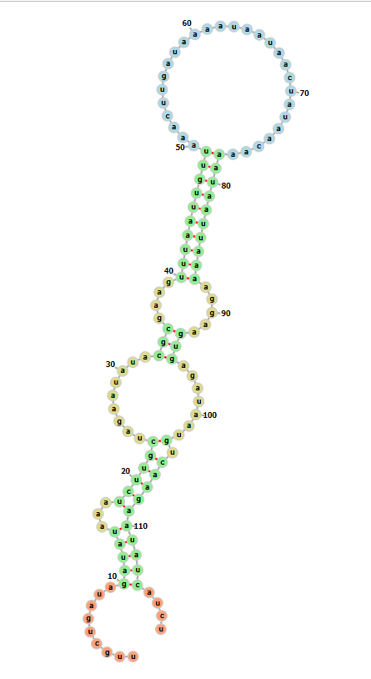
mraY WT | auaaaaaauuugaaccaauuauuuagacgcuaauuuugacucuauuaaaaaaauaacauaucuauuauaauacuccaaggucauuaaacauuuuaaauau AUG cugauuuaucuuuuu | .66* | 220825 |  | 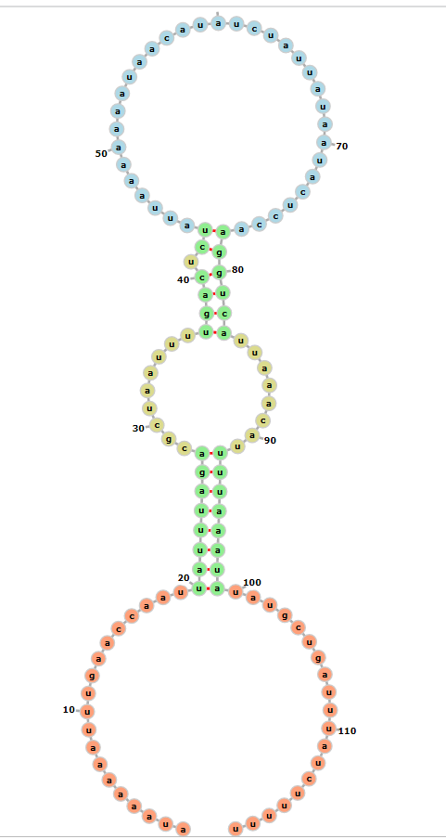
FTL_0144 (long) | gcuguuaguauaaguuauuuauauuuauuuuuguauuacuaauuugauaauauuuuuguuaaaauuuagcuauugaauaguugcuagauuuuaaaauacgaugaaaaaagagcaaaaa | .65* | 220825 |  | 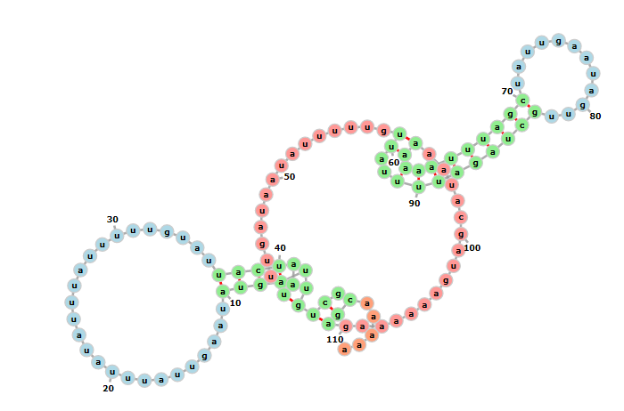
FTL_0215 | auaauuacaaaaaaauaaaaauaucucuagccuaaaaaacauuguugaaaaauuuuuuauaaaauauacugauugaaaccuuuaagauuuuauuuuuauuaugaauauaguugacuac | .97 | 220823 |  | 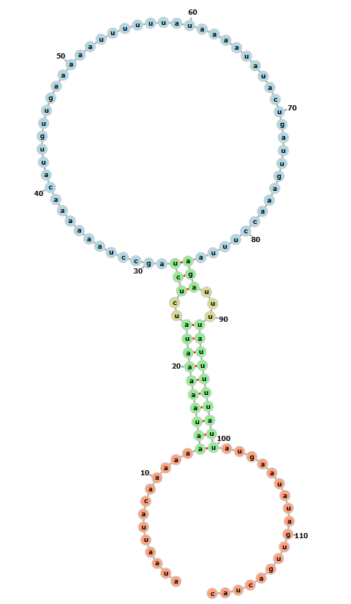
mraY mutation 1 (truncate) | ________________________________________________________auaucuauuauaauacuccaaggucauuaaacauuuuaaauau AUG cugauuuaucuuuuu | 1.03* | 220928 | 1.19 | 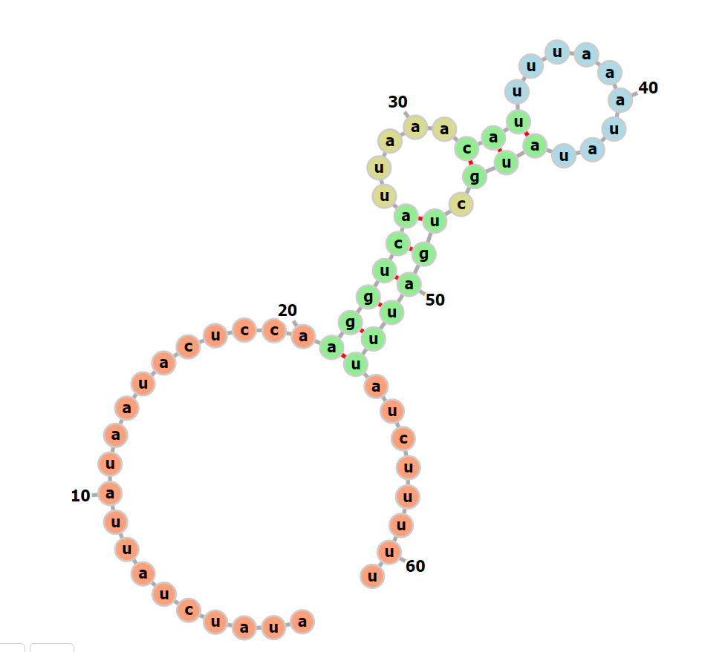
mraY mutation 2 (modify motif4) | auaaaaaauuugaaccaauuauuuagacgcuaauuuugacucuauuaaaCCCCGCCGauaucuauuauaauacuccaaggucauuaaacauuuuaaauau AUG cugauuuaucuuuuu | 0.59* | 220928 | 1.06 | 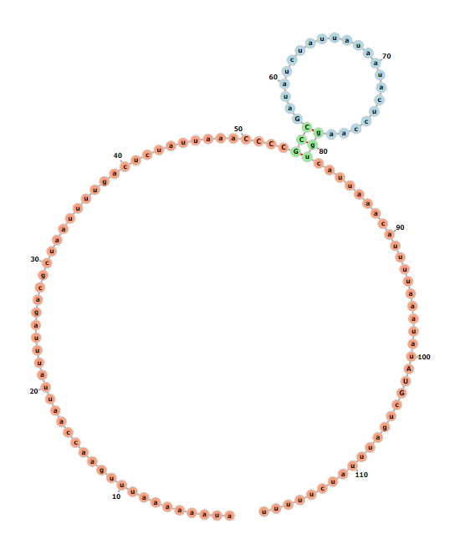
mraY mutation 3 (modify motif4) | auaaaaaauuugaaccaauuauuuagacgcuaauuuugacucuauuaaaaaaUAUacauaucuauuauaauacuccaaggucauuaaacauuuuaaauau AUG cugauuuaucuuuuu | 0.76* | 220928 | 0.92 | 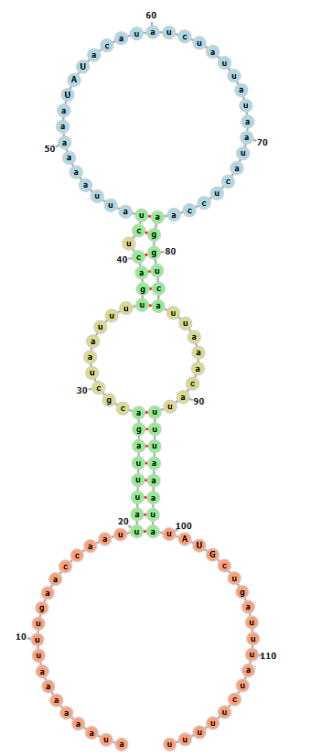
iglA | aagguguugugaaaaaaaggacaauaag aug gcaaaaaauaaaauc | 0.71* | 221020 |  | 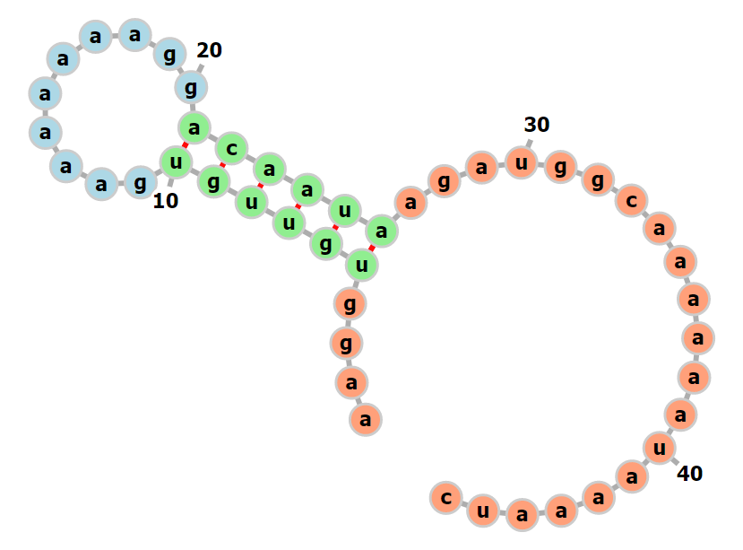
FTL_0222 | aaaaaauaaaaauuuguaauuuagucagaccauuuaaguagaauuuugaguaaucauaauguagauuuaaauuacacagaauauuaaauuuuuuaaucca aug ucagcucaagucuc | 0.44* | 221020 |  | 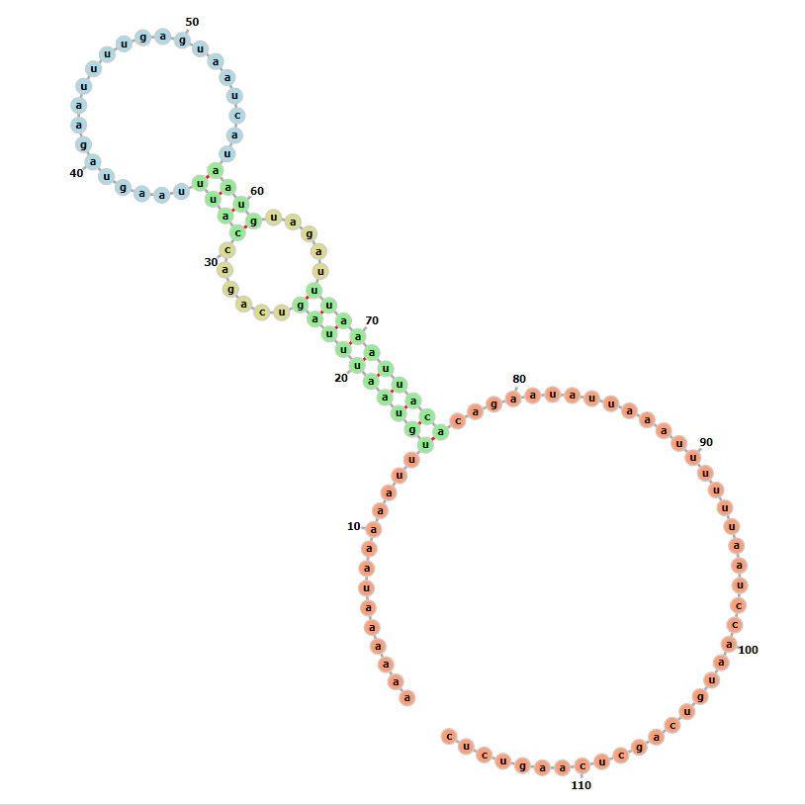
FTL_0881 | aaaauuuuuacuggauaaaaaaguuucaugcagauguuuuuauuuacuauuuagauuuuaacaaacauaaaacaaauaauaguaaauuaaggagaaaaaa aug aaaaagauaauuaca | 0.96 | 221020 |  | 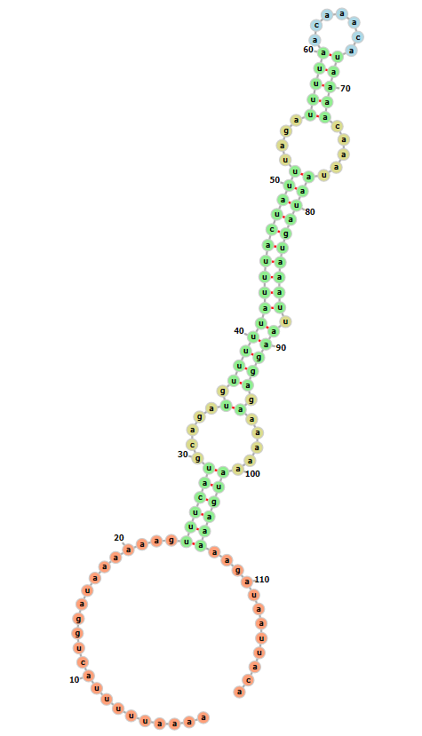
FTL_1093 | cuuucaauuuagacuagauauuguagauuagaauauacuuuuucuaaaguuuauaucauaauuauuaacaauuauuuaacaaauuaauaagguaaguag aug cuaaaaacuaagagca | 0.53* | 221026 |  | 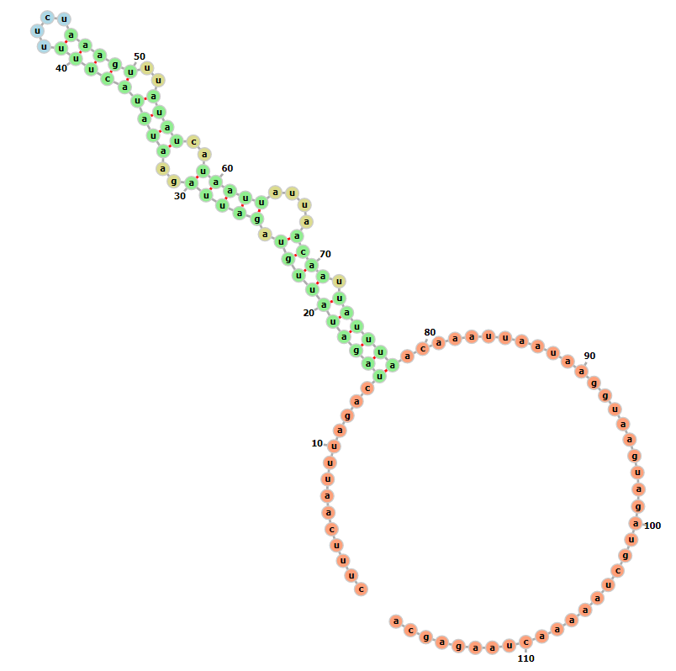
mraY mutation 5  (truncate 25 nt) | _________________________gacgcuaauuuugacucuauuaaaaaaauaacauaucuauuauaauacuccaaggucauuaaacauuuuaaauau AUG cugauuuaucuuuuu | 0.68* | 221026 | 0.91 | 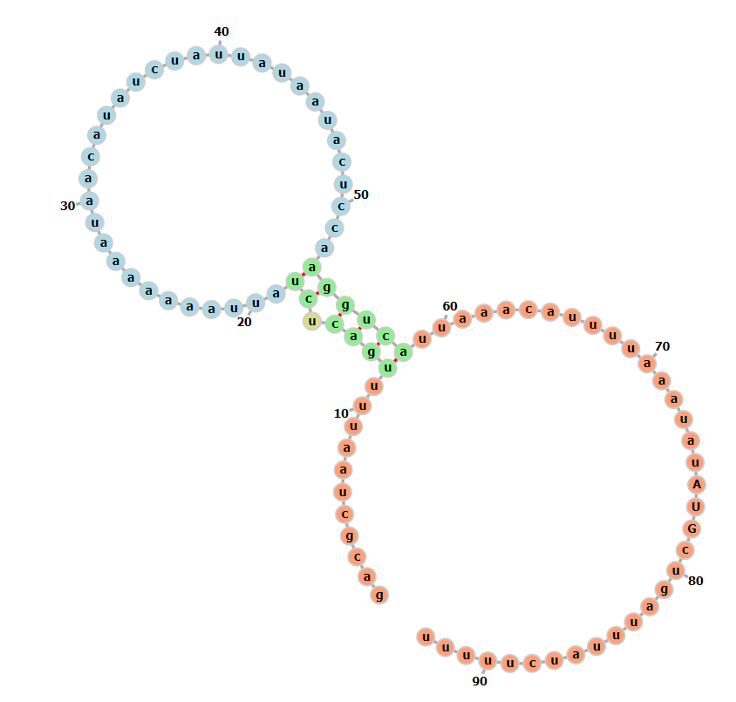
mraY mutation 4 (18 nt truncation) | __________________uuauuuagacgcuaauuuugacucuauuaaaaaaauaacauaucuauuauaauacuccaaggucauuaaacauuuuaaauau AUG cugauuuaucuuuuu | --no fluorescence | 221109 |  | 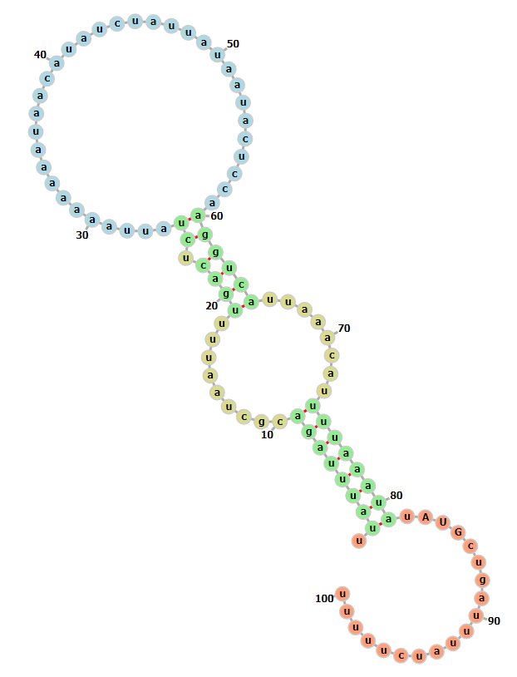
mraY mutation 8 (ideal SD) | auaaaaaauuugaaccaauuauuuagacgcuaauuuugacucuauuaaaaaaauaacauaucuauuauaauacuccaaggucauuaAGGAGGuuaaauau AUG cugauuuaucuuuuu | 1.07 | 221109 | 3.37 | 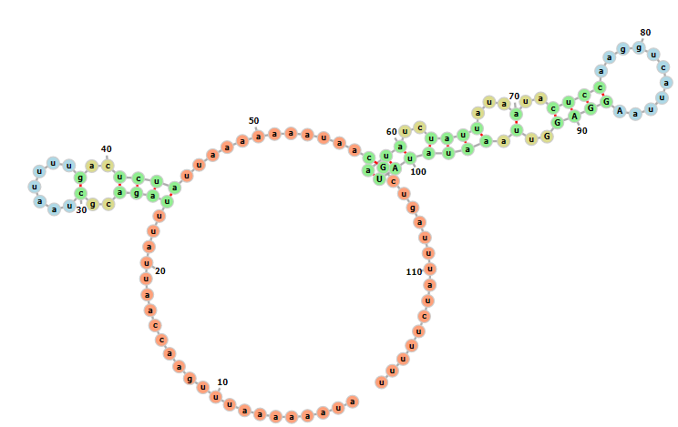
pdpC WT | ugaaauaucaauugaaaauaauaaaaaaaaucagauauaccuaaguuauuuuaauuuaugaaaaauccgaaucacuaucugauaaauuaaggaggcacau AUG aacgacaaauaugaa | 1.47* | 221109 |  | 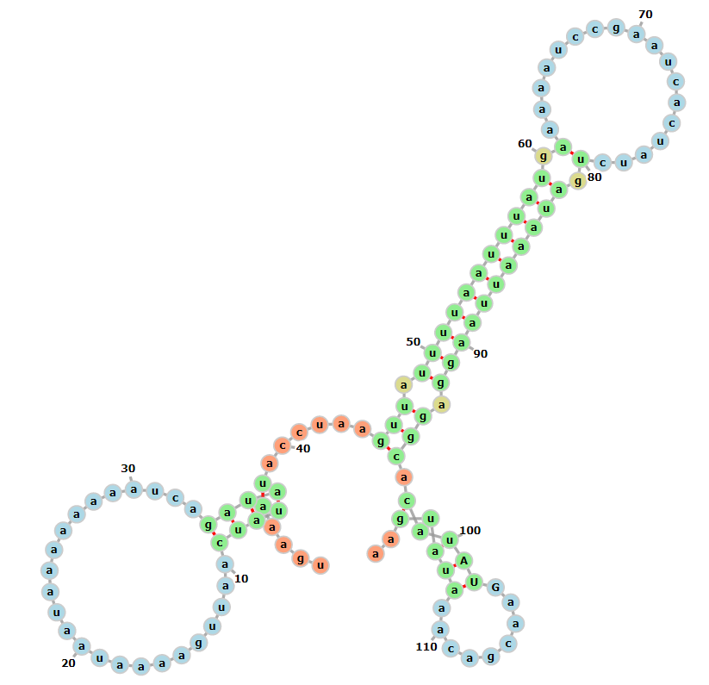
Hfq mut 1 (7 nt truncation) | _______uagauauaaaucuugcuagaauauacgcgaaguuuaauuguuaaacuugauaaaauaauaacuauaacaaaauaauuaaaaggaagugagaua aug ucaagaauaucaucu | 1.75* | 221109 | 2.43 | 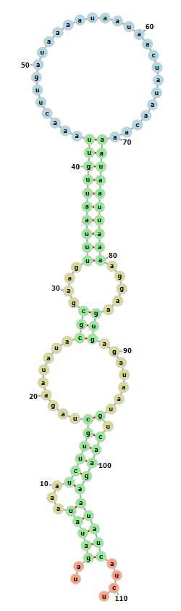

B-gal assay
Description of UTR | Sequence | Ratio drpsU2/LVS (* if signif) | Date of Assay | Relative production to WT UTR | Secondary structure w/ 6 codons
pdpA WT | aguuauguucuaauuaaguagaca aug auagcaguaaaagau | 0.71* | 220201
tul4 WT | gaguauaugugaauauuuaaaaauaggaguaucuau aug aaaaaaauaauuaag | 1.02 | 220201
pdpA Tul4 SD | aguuauguucuaAGGAGUAUCaca aug auagcaguaaaagau | 0.71* | 220201 | 4.53 | 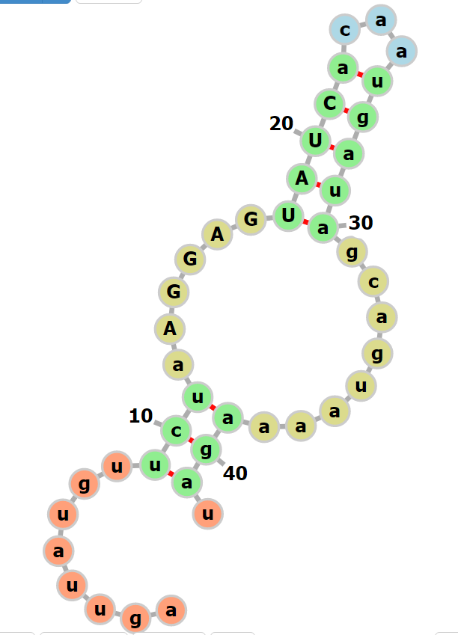
pdpA Ideal SD | aguuauguucuaAGGAGGUCAaca aug auagcaguaaaagau | 1.20* | 220201 | 5.16 | 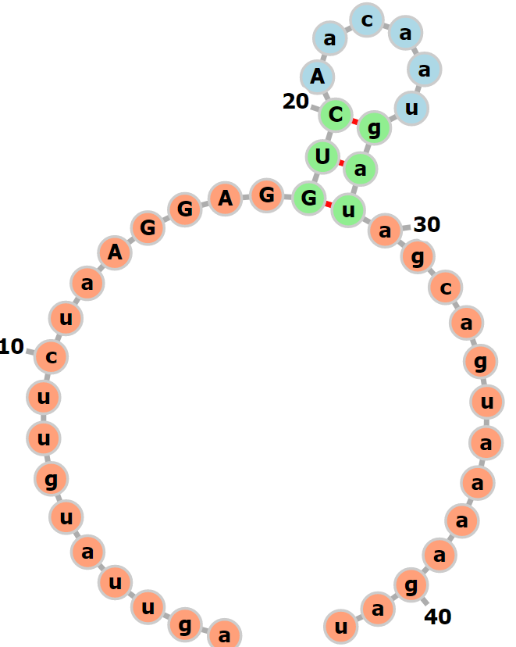
pdpA tul4SD mod1 | aguuauguucuaAGGAGGAUCaca aug auagcaguaaaagau | 0.90* | 220315 | 4.38 | 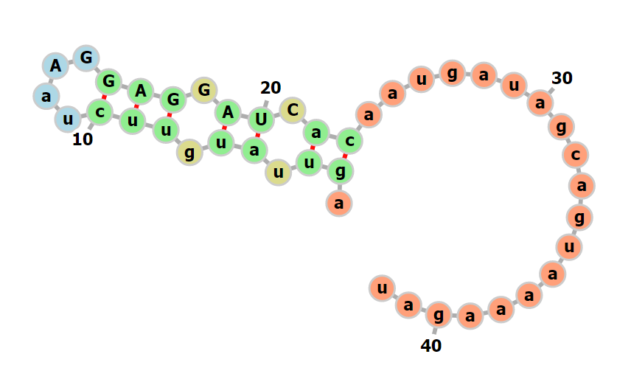
pdpA tul4SD mod2 | aguuauguucuaAGGAGUUCAaca aug auagcaguaaaagau | 0.85* | 220315 | 3.42 | 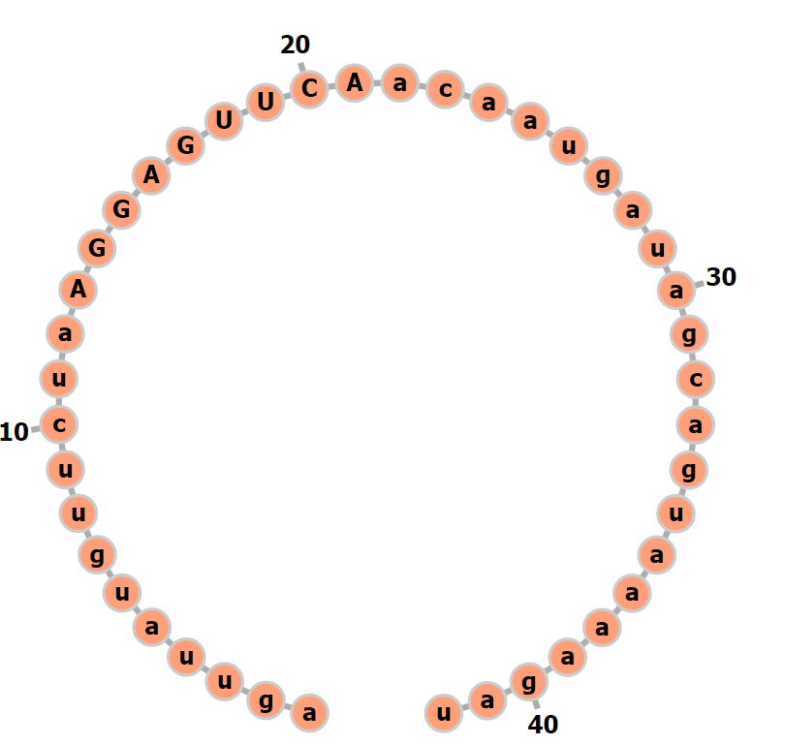
pdpA badSD | aguuauguucuCCuuCCAUCAaca aug auagcaguaaaagau | 0.70* | 210817 | 0.33 | 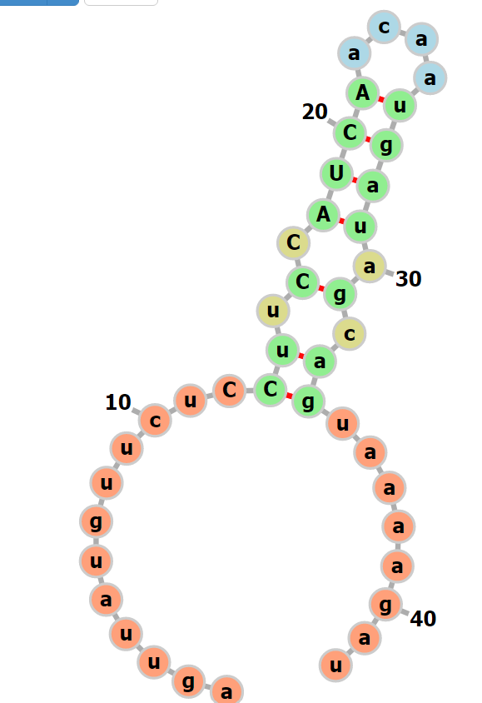
pdpA movedSD | aguuaugAAGGAGGUCCAUCAaca aug auagcaguaaaagau | 1.20* | 210817 | 0.28 | 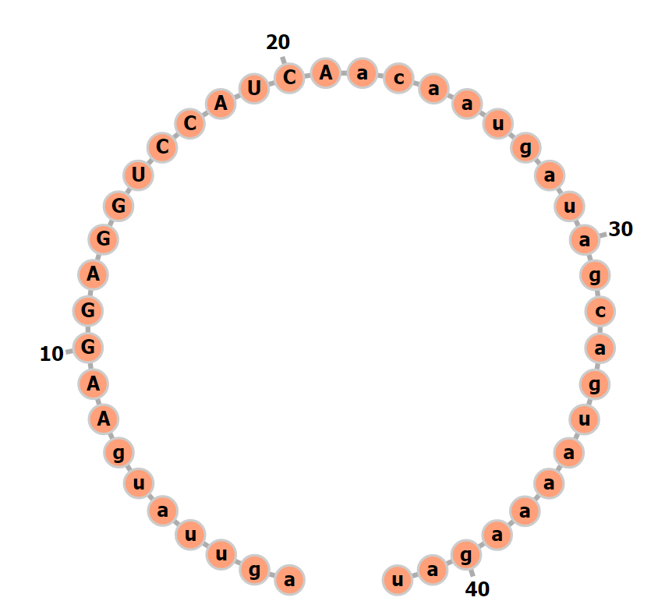
Tul4 small space | gaguauaugugaauauuuaaaaauaggaguaca aug aaaaaaauaauuaag | 0.94 | 210810 | 0.28 | 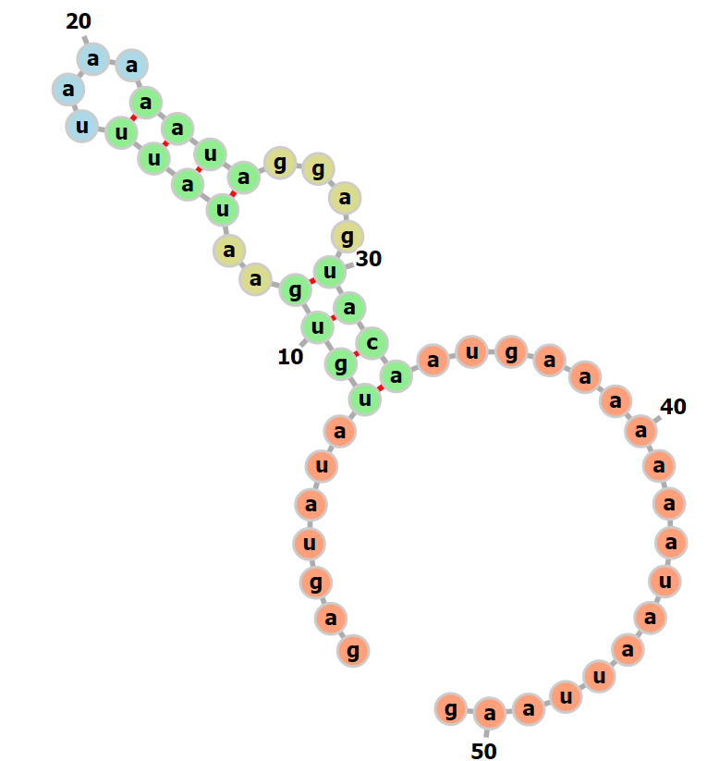
Tul4 truncated | gauauuuaaaaauaggaguaucuau aug aaaaaaauaauuaag | 1.47* | 210810 | 0.73 | 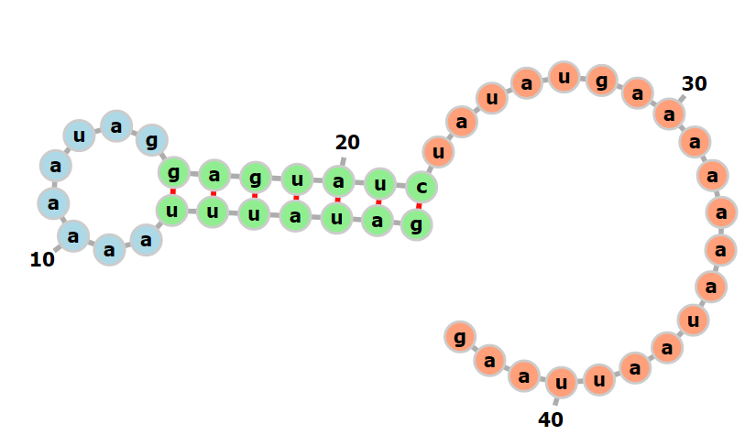
pdpA secondary structure mod 1 | aguuauguucuaauuaaguaCUca aug auUgcaguaaaagau | 0.63* | 210209 | 0.82 | 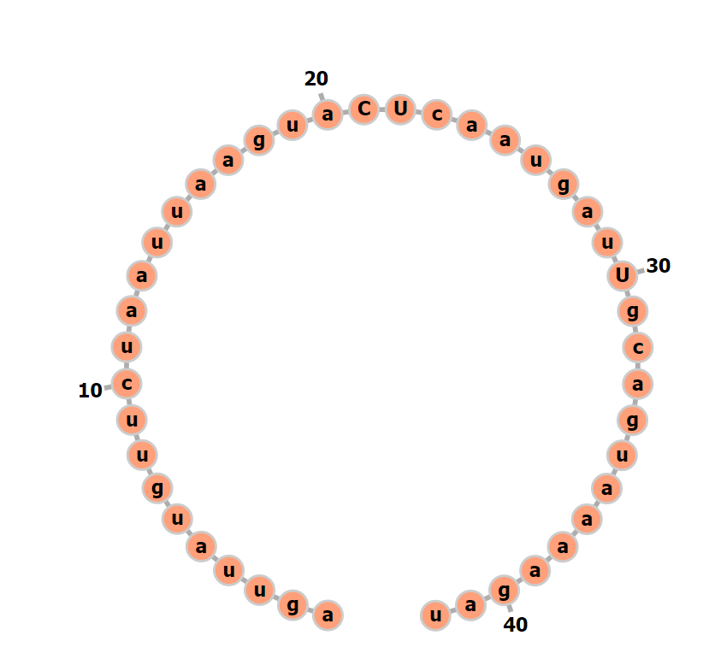
pdpA secondary structure mod 1 restored | aguuauguAGuaauuaaguaCUca aug auAgcaguaaaagau | 0.67* | 210209 | 0.57 | 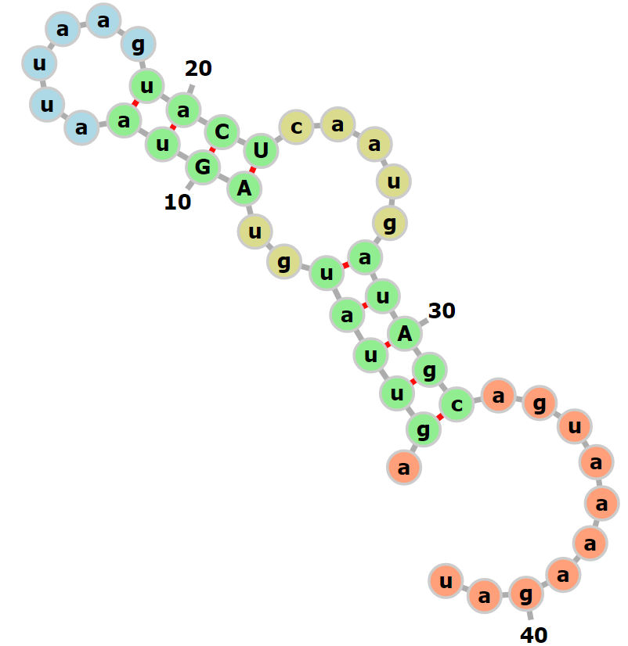
pdpA secondary structure mod 2 | aguuauguAcuGauuaaguagaca aug auagcaguaaaagau | 0.57* | 210209 | 0.29 | 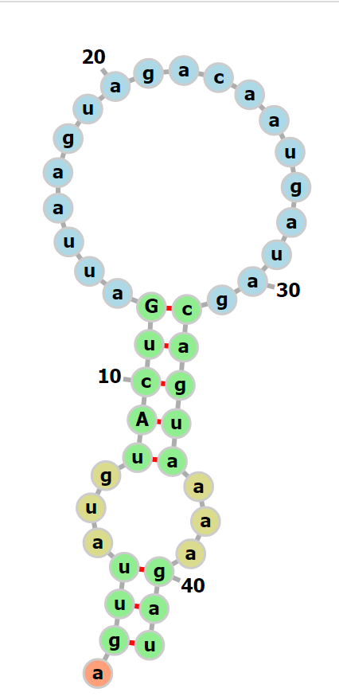
pdpA secondary structure mod 2 restored | aguuauguAcuGauuaagCagUca aug auagcaguaaaagau | 0.58* Miller units close to 0 | 210209 | 0.01 | 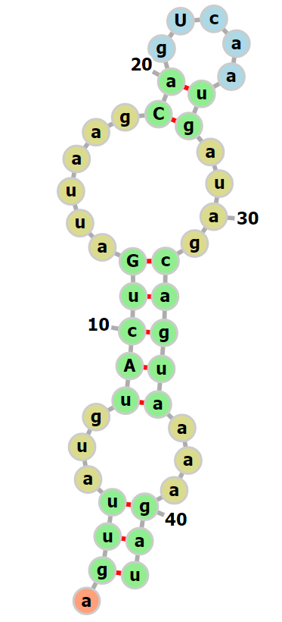

**design a new tul4 UTR that includes the unstructured 5’ tail
-last digit in SD is a g?
-if NO secondary structure, very little translation
-internal loops?

Lower in d2:
>pdpA_WT
Aguuauguucuaauuaaguagacaaugauagcaguaaaagau
>mraY_WT
auaaaaaauuugaaccaauuauuuagacgcuaauuuugacucuauuaaaaaaauaacauaucuauuauaauacuccaaggucauuaaacauuuuaaauau AUG cugauuuaucuuuuu
>FTL_0144 (long)
gcuguuaguauaaguuauuuauauuuauuuuuguauuacuaauuugauaauauuuuuguuaaaauuuagcuauugaauaguugcuagauuuuaaaauacgaugaaaaaagagcaaaaa
>mraY_mutation_2 (modify motif4)
auaaaaaauuugaaccaauuauuuagacgcuaauuuugacucuauuaaaCCCCGCCGauaucuauuauaauacuccaaggucauuaaacauuuuaaauau AUG cugauuuaucuuuuu
>mraY_mutation_3 (modify motif4)
auaaaaaauuugaaccaauuauuuagacgcuaauuuugacucuauuaaaaaaUAUacauaucuauuauaauacuccaaggucauuaaacauuuuaaauau AUG cugauuuaucuuuuu
>iglA
aagguguugugaaaaaaaggacaauaag aug gcaaaaaauaaaauc
>FTL_0222
aaaaaauaaaaauuuguaauuuagucagaccauuuaaguagaauuuugaguaaucauaauguagauuuaaauuacacagaauauuaaauuuuuuaaucca aug ucagcucaagucuc
>mraY_mutation_5
gacgcuaauuuugacucuauuaaaaaaauaacauaucuauuauaauacuccaaggucauuaaacauuuuaaauau AUG cugauuuaucuuuuu
>FTL_1093
cuuucaauuuagacuagauauuguagauuagaauauacuuuuucuaaaguuuauaucauaauuauuaacaauuauuuaacaaauuaauaagguaaguag aug cuaaaaacuaagagca
>pdpA_Tul4_SD
aguuauguucuaAGGAGUAUCaca aug auagcaguaaaagau
>pdpA_badSD
aguuauguucuCCuuCCAUCAaca aug auagcaguaaaagau
>pdpA_secondary_structure_mod_1
aguuauguucuaauuaaguaCUca aug auUgcaguaaaagau
>pdpA_secondary_structure_mod_1_restored
aguuauguAGuaauuaaguaCUca aug auAgcaguaaaagau
>pdpA_secondary_structure_mod_2
aguuauguAcuGauuaaguagaca aug auagcaguaaaagau
>pdpA_secondary_structure_mod_2_restored
aguuauguAcuGauuaagCagUca aug auagcaguaaaagau

Higher or non-diff in d2:

>tul4_WT
gaguauaugugaauauuuaaaaauaggaguaucuau aug aaaaaaauaauuaag
>Hfq_WT
uugcugauagauauaaaucuugcuagaauauacgcgaaguuuaauuguuaaacuugauaaaauaauaacuauaacaaaauaauuaaaaggaagugagaua aug ucaagaauaucaucu
>FTL_0215
auaauuacaaaaaaauaaaaauaucucuagccuaaaaaacauuguugaaaaauuuuuuauaaaauauacugauugaaaccuuuaagauuuuauuuuuauuaugaauauaguugacuac
>mraY_mutation_1 (truncate)
auaucuauuauaauacuccaaggucauuaaacauuuuaaauau AUG cugauuuaucuuuuu
>FTL_0881
aaaauuuuuacuggauaaaaaaguuucaugcagauguuuuuauuuacuauuuagauuuuaacaaacauaaaacaaauaauaguaaauuaaggagaaaaaa aug aaaaagauaauuaca
>pdpA_Ideal_SD
aguuauguucuaAGGAGGUCAaca aug auagcaguaaaagau
>pdpA_movedSD
aguuaugAAGGAGGUCCAUCAaca aug auagcaguaaaagau
>Tul4_small_space
gaguauaugugaauauuuaaaaauaggaguaca aug aaaaaaauaauuaag
>Tul4_truncated
gauauuuaaaaauaggaguaucuau aug aaaaaaauaauuaag
>mraY_mutation_8 (ideal SD)
auaaaaaauuugaaccaauuauuuagacgcuaauuuugacucuauuaaaaaaauaacauaucuauuauaauacuccaaggucauuaAGGAGGuuaaauau AUG cugauuuaucuuuuu
>pdpC_WT
ugaaauaucaauugaaaauaauaaaaaaaaucagauauaccuaaguuauuuuaauuuaugaaaaauccgaaucacuaucugauaaauuaaggaggcacau AUG aacgacaaauaugaa
>Hfq_mut_1 (7 nt truncation)
uagauauaaaucuugcuagaauauacgcgaaguuuaauuguuaaacuugauaaaauaauaacuauaacaaaauaauuaaaaggaagugagaua aug ucaagaauaucaucu

