Similarities between f tul mraY and s aureus mraY
  - In S aureus, mraY is in an operon with murD and pbp1
  - In F. tul, mraY is also with murD but not pbp1, instead ftsW
UTR predictions
>s_aureus_mraY
Aaaaattataaattttgattacaactttgtttatttaattgaaaaattgataatatattagtggttaaaaaagtctggattaagaagaggagatagttatgatttttgtatatgcg
>f_tul_mraY
ataaaaaatttgaaccaattatttagacgctaattttgactctattaaaaaaataacatatctattataatactccaaggtcattaaacattttaaatatatgctgatttatcttttt
Alignment of UTRs
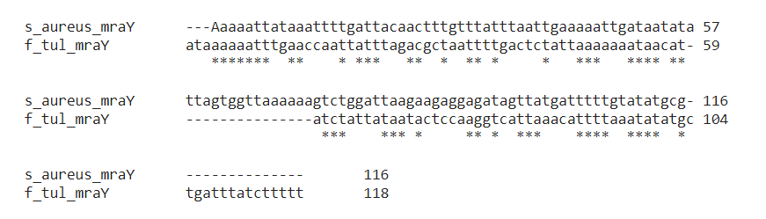
GACUCU was not conserved with this alignment, but there is a tct? Maybe the first three can be wobbles, or it can be purine-adenine-any-tct? i.e. RANUCU?
>s_aureus_mraY
Aaaaattataaattttgattacaactttgtttatttaattgaaaaattgataatatattagtggttaaaaaagtctggattaagaagaggagatagttatgatttttgtatatgcg
I tried inputting RANUCU into FIMO and it was not enriched in the down-reg vs the up-reg
Then tried RASUCU in FIMo and only the top 20 (.001)
Down-reg – 2 of 20 or 8 of 74
Up-reg – 2 of 20, or 10 of 84

