Saved Motifs Log
Motif 1- Found in up-regulated genes both in classic and discriminative searches, under different background models. 31 sites of 84 inputs.
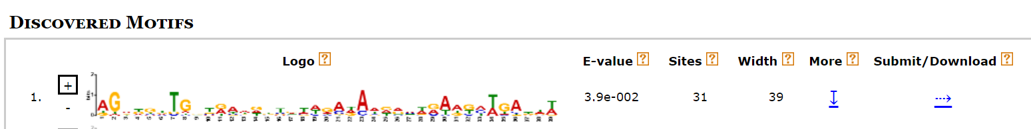
Motif 2- Found in Down-regulated top 20 only search with a minimum of 10 sites (ZOOPs). 15 sites of 20 inputs.
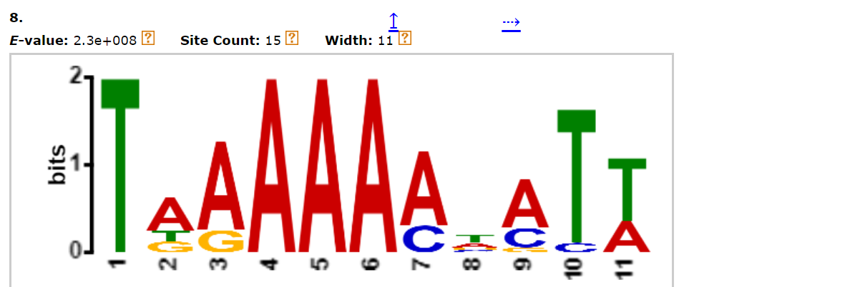
Motif 3 - Found in Up-regulated top 20 only search with a minimum of 10 sites (ZOOPs). 19 sites of 20 inputs.
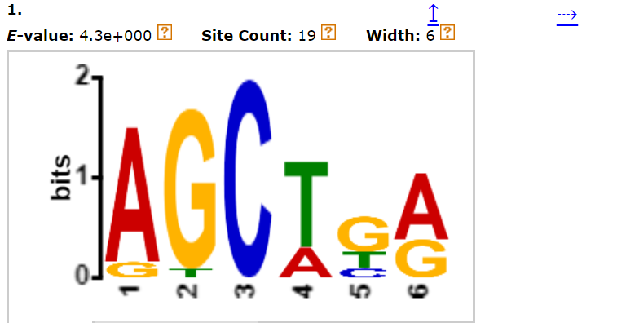
Motif 4 - Found in STREME search of down-regulated top 20 only vs shuffled sequences. 19 sites of 20 inputs.
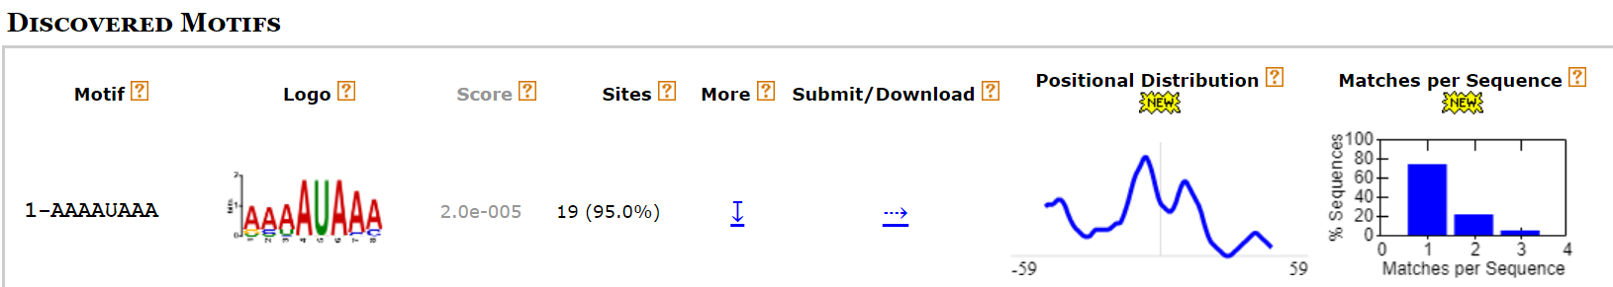
Motif 5 - Found in STREME search of down-regulated top 20 only vs shuffled sequences. 18 sites of 20 inputs.
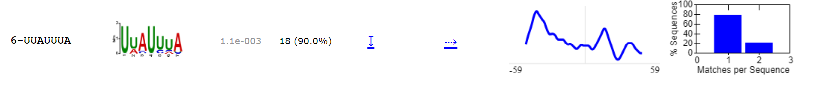
Motif 6 – Found in STREME search of up-regulated top 20 vs non-regulated middle 20. 19 sites of 20 inputs. Almost identical to motif 3.
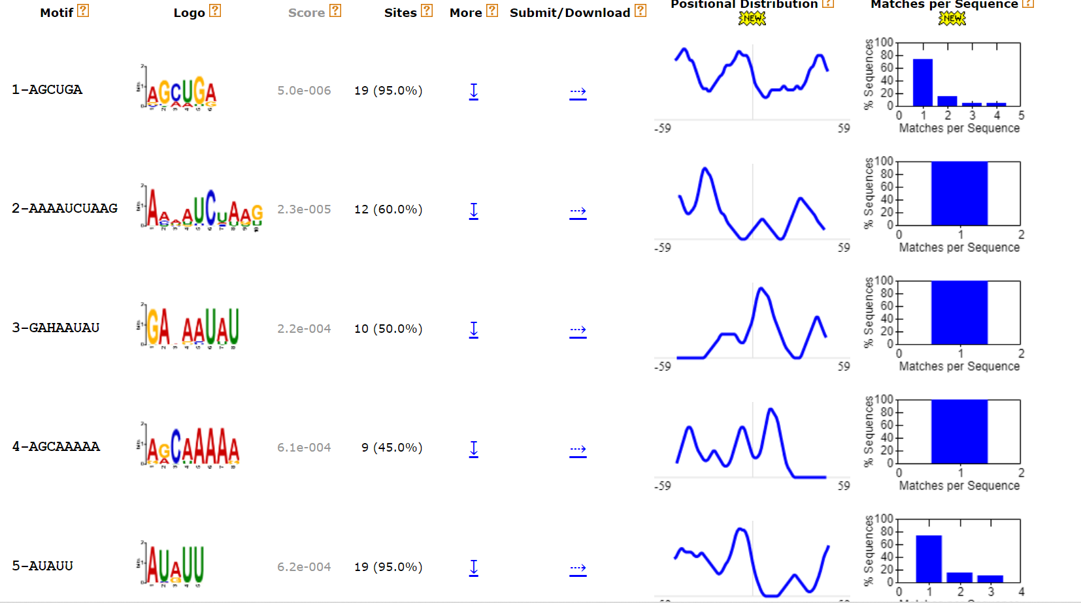
Motif 7 – Found in STREME search of up-regulated top 20 vs non-regulated middle 20. 19 sites of 20 inputs.

