I’m still curious about what in the 5’UTR is affecting translation, so I am working on looking for motifs in the 5’UTR of genes affected based on our proteomics results. I am taking the sequence from 30 nts upstream of the translation start site and 15 nts into the gene for genes that are different between Tn7::rpsU1 and WT but aren’t different between Tn7::rpsU2 and WT. I am then putting into a motif finder called MEME. The options I chose for the MEME submission were: classic mode, zero or one occurrence per sequence, 3 motifs. The sequences I submitted were:
>FTL_0097 hypothetical protein
aaaattacaaactccttaagaggatttagtatgtcacttataaac

>FTL_0116 pdpC
atcactatctgataaattaaggaggcacatatgaacgacaaatat

>FTL_0115 pdpE
aatatcatcataggttaaggatacaaatatatgagtaaaaaaata

>FTL_0117 iglJ
accccgtagaaaaaatttcaaataaaatagatgaagactattttg

>FTL_0120 iglH
aatgtaaaaacatcttagaaggtcattatcatggatgaaaaaaga

>FTL_1164 iglI
agctggtaataagggtaagaggagatttatatgagtcagataata

>FTL_1165 dotU
ttaaataactctatataaaggatattataaatgaaagactttaaa

>FTL_1168 iglF
gttctacagcaacaatggttggataataatatgaataataatatt

>FTL_1246 hypothetical protein
ttgtgttgacggtggtggaagtttataacaatgtactatatttat

>FTL_1601 tRNA/rRNA methyltransferase
ggatgtggctaattggttaaaggtttaaatatgataagtattgct

>FTL_1685 major facilitator transporter
cttattcattattaaatttaggattagtatatgtctaatgatcct

>FTL_1854 hypothetical protein
cctcttcactaatagcgatagggtattgttatgattataatcaaa

>FTL_1883 potassium transporting ATPase subunit A
cagataaattttaacttataggagtaagttatgatttctaatttt

>FTL_0126 pdpA
gactttagttatgttctaattaagtagacaatgatagcagtaaaa

The first motif it found was:
Motif AGGAKWWWRWTATG MEME-1 block diagrams
--------------------------------------------------------------------------------
SEQUENCE NAME POSITION P-VALUE MOTIF DIAGRAM
------------- ---------------- -------------
FTL_1854 5.3e-07 19_[+1]_12
FTL_1883 6.1e-07 19_[+1]_12
FTL_1164 9.1e-07 19_[+1]_12
FTL_0116 2e-06 19_[+1]_12
FTL_0115 1.1e-05 17_[+1]_14
FTL_1685 4e-05 19_[+1]_12
FTL_1168 4e-05 19_[+1]_12
FTL_0120 4.7e-05 19_[+1]_12
FTL_1246 7e-05 23_[-1]_8
FTL_0097 9.4e-05 2_[-1]_29
FTL_0126 0.00014 22_[+1]_9
FTL_1601 0.00015 19_[+1]_12

The second motif it found was:
Motif GGWKGTGG MEME-2 block diagrams
--------------------------------------------------------------------------------
SEQUENCE NAME POSITION P-VALUE MOTIF DIAGRAM
------------- ---------------- -------------
FTL_1246 1.4e-06 10_[+2]_27
FTL_1601 5.3e-06 [+2]_37

The third motif it found was:
Motif SCYGTAG MEME-3 block diagrams
--------------------------------------------------------------------------------
SEQUENCE NAME POSITION P-VALUE MOTIF DIAGRAM
------------- ---------------- -------------
FTL_0117 1.1e-05 2_[+3]_36
FTL_1168 4e-05 3_[-3]_35

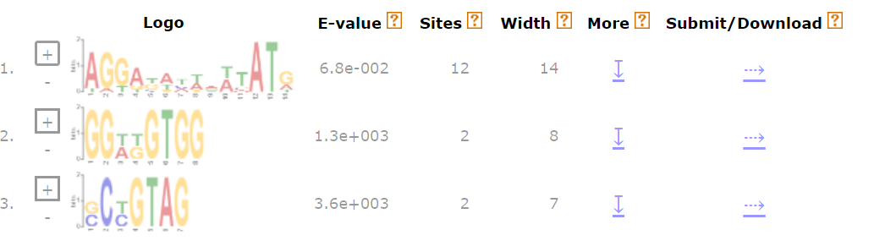

I’m most interested in motif 1 because it matches 12/14 sequences. I then tried resubmitting using the same region from tul4 and tul4 matches motif 1 ALMOST except that the R in the middle (meaning guanine or adenine) was changed to D (guanine adenine or thymine).

I then repeated it with these settings (and no tul4): classic mode, any number of repetitions, 5 motifs. This didn’t report any that had more than 5 genes in common:
Motif RRTTAAGDAKACAHWTATADGAGTMAR MEME-1 block diagrams
--------------------------------------------------------------------------------
SEQUENCE NAME POSITION P-VALUE MOTIF DIAGRAM
------------- ---------------- -------------
FTL_0115 6.2e-12 12_[+1]_6
FTL_1164 8.8e-12 12_[+1]_6
FTL_0126 5.2e-11 17_[+1]_1
FTL_0116 4.8e-10 14_[+1]_4
FTL_1883 3.1e-09 1_[+1]_17
Motif BTTHTTCAYYAATARWDWTARGRTWWTAATATG MEME-2 block diagrams
--------------------------------------------------------------------------------
SEQUENCE NAME POSITION P-VALUE MOTIF DIAGRAM
------------- ---------------- -------------
FTL_1854 1.4e-14 [+2]_12
FTL_1168 4.9e-12 [+2]_12
FTL_1685 5.5e-10 [+2]_12
FTL_0120 8.4e-10 10_[-2]_2
FTL_1601 1.5e-09 [+2]_12

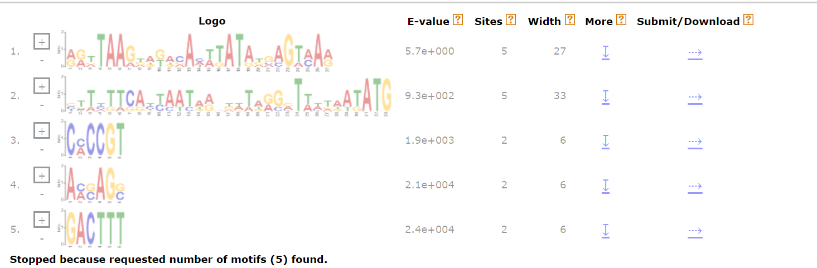
I then realized there were “advanced” settings. I tried again using:
classic mode, zero or one per sequence, 10 motifs, 0 order background model (single nt biases looked for), 4-50 width, minimum 5 sites, search given strand only
With these settings, it found:
Motif CTTMTWMABTAWTAAWKWTAGGAKWAWNWTATGAWT MEME-1 block diagrams
--------------------------------------------------------------------------------
SEQUENCE NAME POSITION P-VALUE MOTIF DIAGRAM
------------- ---------------- -------------
FTL_1854 5.7e-15 [+1]_9
FTL_1685 2e-12 [+1]_9
FTL_1168 1.6e-11 [+1]_9
FTL_0116 1.1e-10 [+1]_9
FTL_1883 1.4e-10 [+1]_9
There was also no difference when I tried 1-order background model.

I also tried one with these settings:
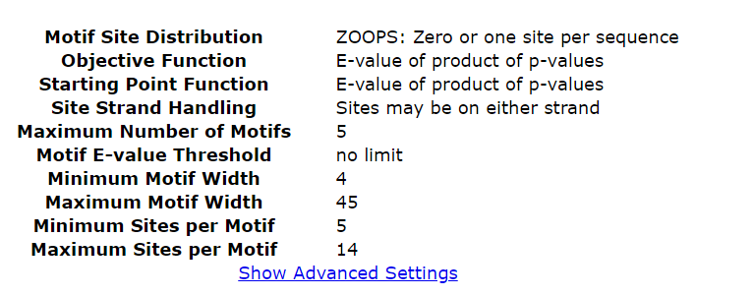
And it came up with one that included ALL of the sites, but it seems mostly to just be because it’s the RBS and start codon.
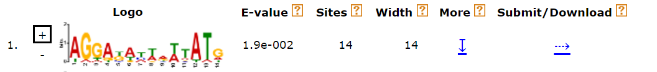
Motif AGGAKAYWRWTATG MEME-1 block diagrams
--------------------------------------------------------------------------------
SEQUENCE NAME POSITION P-VALUE MOTIF DIAGRAM
------------- ---------------- -------------
FTL_1854 6.7e-07 19_[+1]_12
FTL_1164 1.1e-06 19_[+1]_12
FTL_1883 1.2e-06 19_[+1]_12
FTL_0116 3.5e-06 19_[+1]_12
FTL_0115 1.4e-05 17_[+1]_14
FTL_1168 2.6e-05 19_[+1]_12
FTL_0097 4.4e-05 2_[-1]_29
FTL_0120 5.4e-05 19_[+1]_12
FTL_1685 9.1e-05 19_[+1]_12
FTL_1246 0.00011 23_[-1]_8
FTL_0126 0.00019 22_[+1]_9
FTL_1601 0.00033 19_[+1]_12
FTL_0117 0.00047 31_[+1]
FTL_1165 0.0007 18_[+1]_13

