CheR sequences – KEGG - https://www.genome.jp/dbget-bin/www_bfind_sub?mode=bfind&max_hit=1000&locale=en&serv=gn&dbkey=bbu&keywords=cheR&page=1
CheR1 – bb0040 – NT sequence - atgaacacgaatcaaaacaaattcaaccttaatataaatataactaaggacgaactttca
agattaataaaaatagtttacaataattttggaatcaatctcagcgaaaaaaaaaagctg
ctaattgaaagcagattatcatctcttctgaaagttaaaggttttaaaaattttactgaa
tacatcaactttttagaaaaaagcactggaaatattcaattaatcgaattaatagacaaa
atatcaacaaatcatacctattttttcagagaatctaagcattttgattttttaaataat
aaaatattacccaaacttactgaaaaaatattaaactcagaaaactcagaaattagaata
tggtcagctggctgttcaagtggtgaagagccttatacaattgcaatgatgctaaaagaa
tatatggaacataatagagtaaattttaaagtcaaaatcttagcaacagacatttcaatt
agcgttctaaatgaggctcgtgaagggatttatcctgaagatcgcataataaatttgccc
aaatatttaaaaattaaatatttaaatcaacttcaagatgataaatttcaagttaaagaa
attttaaaaaaaatggtttactttaaaaaattaaatttaatggatgagaaatttccattt
agcaaaaaatttgacctaatattttgcagaaatgtcatgatctattttgatgaaaaaact
aggaataaccttgccaataaattcaactcctaccttaaaaaggattcttatcttttaatt
ggacattcagaaacaatcagaggaaacaaaaatcttgaatacataatgcctgccacctat
aaaaagaattaa
AA sequence –
MNTNQNKFNLNINITKDELSRLIKIVYNNFGINLSEKKKLLIESRLSSLLKVKGFKNFTE
YINFLEKSTGNIQLIELIDKISTNHTYFFRESKHFDFLNNKILPKLTEKILNSENSEIRI
WSAGCSSGEEPYTIAMMLKEYMEHNRVNFKVKILATDISISVLNEAREGIYPEDRIINLP
KYLKIKYLNQLQDDKFQVKEILKKMVYFKKLNLMDEKFPFSKKFDLIFCRNVMIYFDEKT
RNNLANKFNSYLKKDSYLLIGHSETIRGNKNLEYIMPATYKKN
CheR2- bb0414
NT sequence - atgctagaaattgaagataaactatttttaaaattttgtgattttatatataacaacagt
ggaattcgttttgatgaaaaaaataaatttgttcttcaaagcagagtgaatgatgcagta
cgagctcttgctcttgaaaacccatcacaactttataatttaataattagtgaaaaatta
aaaaaagaatatttcttagatttggtcacaacaaatttaacaagattttttagaaattcg
ctacattttcaaacttttgaaaaatttgtaattccgaatttaattaatattaaaaacata
gaaaaaaaaaataggattatcatctggtctgcgggatgttcaacaggagaagagccttat
tcattagcatttgtactcaaatcaaagcttccaaaagaaatagattttgttattattgct
tctgatttaagcttaaaatctttgatgatagcaaaggaaggatattactcatcaaataaa
tgtgaaaatattcctaaagaataccgacactacatatattctcattcaaacggatataaa
attaaaaatgaaattaaaaatcacataagatttgattatcataacttaaactttgaaagt
aatttttcggaaattgatgttgttttttgtagaaatgttttaatatactttgatgaaaaa
tcaaaaataaaagtacttaaaaaattttacaacaatatgtctaaaaacagctatttattt
ataggacactcagaatcactttttgggctcaaccttccttttaaatttttaaaaacacct
tgggcaataatatatgaaaaaaaagatactggctgtcaaaaagaaaaattcaaatcacaa
aataaatataagttataa
AA sequence - MLEIEDKLFLKFCDFIYNNSGIRFDEKNKFVLQSRVNDAVRALALENPSQLYNLIISEKL
KKEYFLDLVTTNLTRFFRNSLHFQTFEKFVIPNLINIKNIEKKNRIIIWSAGCSTGEEPY
SLAFVLKSKLPKEIDFVIIASDLSLKSLMIAKEGYYSSNKCENIPKEYRHYIYSHSNGYK
IKNEIKNHIRFDYHNLNFESNFSEIDVVFCRNVLIYFDEKSKIKVLKKFYNNMSKNSYLF
IGHSESLFGLNLPFKFLKTPWAIIYEKKDTGCQKEKFKSQNKYKL

Amino acid level identity – 34% on BlastP
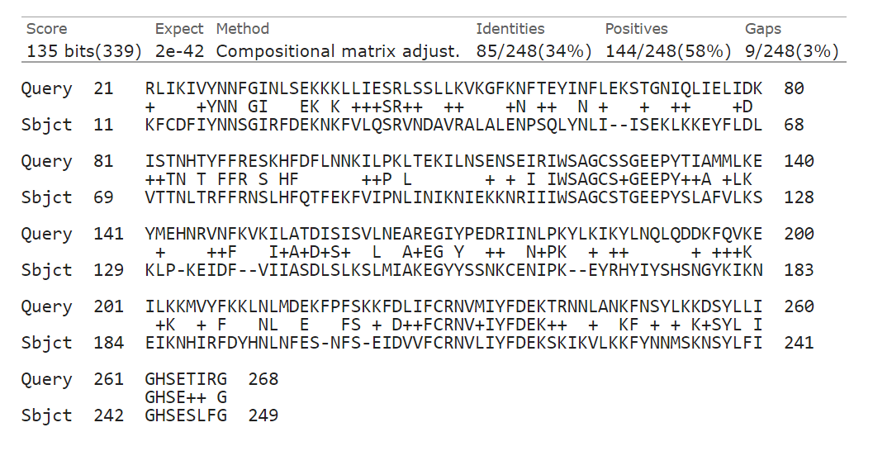
30% on Emboss
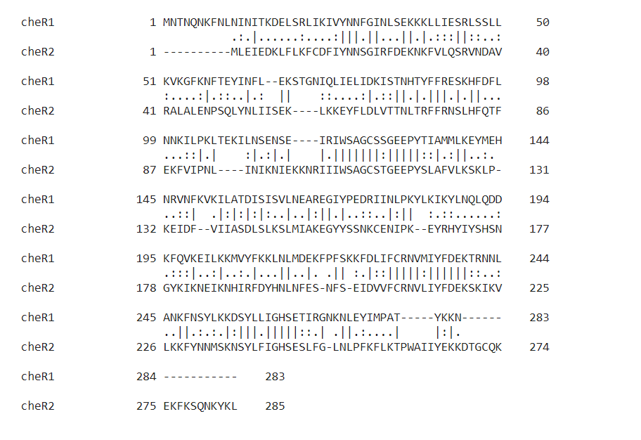

If you blast cheR2, it is 47% similar to t. pallidum which only has one CheR
Compared to the P. putida sequences:
P.putida.cheR1 100.00 21.65 24.52 22.09 20.80
2: P.putida.cheR3 21.65 100.00 21.62 23.17 26.46
3: P.putida.cheR2 24.52 21.62 100.00 29.48 29.17
4: B.burg.cheR1 22.09 23.17 29.48 100.00 32.20
5: B.burg.cheR2 20.80 26.46 29.17 32.20 100.00
Compared to E. coli:
1: B.burg.CheR2 100.00 32.20 28.91
2: B.burg.CheR1 32.20 100.00 31.99
3: E.coli.CheR 28.91 31.99 100.00

CheR1 location – 39826
CheR2 location – 424694
384 kb away

P.putida.CheR3 MTSE----------------RNTDIEIRLLIEAIYLKYSYDFRNYSGASIKRRILHALRQ 44
P.putida.CheR1 ------------------------MNEQRFFRFLRERIGLDVESVGAPMVERALRQRCVA 36
P.putida.CheR2 -------------------MSTGNLDFEQFRVFLEKACGILLGENKQYLVSSRLNKLMEQ 41
B.burg.CheR2 ------------------MLEIEDKLFLKFCDFIYNNSGIRFDEKNKFVLQSRVNDAVRA 42
B.burg.CheR1 ----MNTNQN----KFNLNINITKDELSRLIKIVYNNFGINLSEKKKLLIESRLSSLLKV 52
E.coli.CheR MTSSLPCGQTSLLLQMTERLALSDAHFRRISQLIYQRAGIVLADHKRDMVYNRLVRRLRS 60
: : . . . : :

P.putida.CheR3 FDCLTVSALQERVLHDP--GMFMQLLQYLTIPVSEMFRDPDHFLAVRNEVVPLLRT---- 98
P.putida.CheR1 AGAMDLDDYWLRLQQSA--DEQQALIEAVIVPETWFFRYPESFTALASLAHKRLAQ---L 91
P.putida.CheR2 QGIKSLGELVQRIQAQPRGGLREQVVDAMTTNETLWFRDTYPFEVLKNKVIPEFIR---N 98
B.burg.CheR2 LALENPSQLYNLIISEKLK--KEYFLDLVTTNLTRFFRNSLHFQTFEKFVIPNLINIKNI 100
B.burg.CheR1 KGFKNFTEYINFLEKSTGNIQLIELIDKISTNHTYFFRESKHFDFLNNKILPKLTEKILN 112
E.coli.CheR LGLTDFGHYLNLLESNQHSGEWQAFINSLTTNLTAFFREAHHFPLLADHA---------R 111
: . .:: : : ** * . .

P.putida.CheR3 --WPSIKVWIAGCSTGEEVYSMAILLREEGL------LERTIIYATDINPHSLDRAKQGI 150
P.putida.CheR1 AGARPLRLLSLPCSTGEEPYSLAMALFDA-GMAPGAF----LVDGMDISPSSVAKAGQAV 146
P.putida.CheR2 NPGQRLRMWSAACSSGQEPYSISMAIDEFERSNLGQLKMGAQIVATDLSGTMLTNCKTGE 158
B.burg.CheR2 EKKNRIIIWSAGCSTGEEPYSLAFVLKSKLP---KEI--DFVIIASDLSLKSLMIAKEGY 155
B.burg.CheR1 SENSEIRIWSAGCSSGEEPYTIAMMLKEYMEHNRVNF--KVKILATDISISVLNEAREGI 170
E.coli.CheR RRSGEYRVWSAAASTGEEPYSIAMTLADTLGTAPGRW----KVFASDIDTEVLEKARSGI 167
: .*:*:* *:::: : . : . *:. : . .

P.putida.CheR3 YSMQSMR-EYEENYRLAGGRRDFAEYYTA-----AYGNAIMDSSLRDNVTFADHSLATDS 204
P.putida.CheR1 YGRNAFR-GSELG---------FRERYFDALD----EGHRLHERVRQQVSLRVGNVLDPA 192
P.putida.CheR2 YDSLAIARGLSQE---------RLQRYFDPK---GPGRWAVKPAIRSRVEFRSFNLLD-S 205
B.burg.CheR2 YSSNKCE-NIPKE---------YRHYIYS-----HSNGYKIKNEIKNHIRFDYHNLNFES 200
B.burg.CheR1 YPEDRII-NLPKY---------LKIKYLNQL---QDDKFQVKEILKKMVYFKKLNLMDEK 217
E.coli.CheR YRHEELK-NLTPQ---------QLQRYFMRGTGPHEGLVRVRQELANYVDFAPLNLLAKQ 217
* : : . : : .:

P.putida.CheR3 ---VFSETQLVSCRNVLIYFNKDLQDRALGLFHESLCHRGFLVLGSKESVDFSAYSDRFE 261
P.putida.CheR1 LASRDGLYDFVFCRNLLIYFDVPTQQRVFEVLKRLLHPQGVLFIGPAEGSLL--ARMGMR 250
P.putida.CheR2 YA-SLGKFDIVFCRNVLIYFSAQVKKDILLRIHSTLKPGGYLFLGASEALNG--LPDHYQ 262
B.burg.CheR2 ---NFSEIDVVFCRNVLIYFDEKSKIKVLKKFYNNMSKNSYLFIGHSESLFG--LNLPFK 255
B.burg.CheR1 FP-FSKKFDLIFCRNVMIYFDEKTRNNLANKFNSYLKKDSYLLIGHSETIRG--NKNLEY 274
E.coli.CheR YT-VPGPFDAIFCRNVMIYFDQTTQQEILRRFVPLLKPDGLLFAGHSENFSH--LERRFT 274
: : ***::***. : : : . *. * *

P.putida.CheR3 PLVKPQRI-FRKS----------------------------------------------- 273
P.putida.CheR1 PLGIAQSFAYVRHEGDSAPLAAAPAQTAKRAFTTLPAPVYPQPSVPLPRSRRVLPVAARP 310
P.putida.CheR2 MVQCSPGIIYQAK----------------------------------------------- 275
B.burg.CheR2 FLKTPWAIIYEKKDTGCQK----------EKFKSQN--KYKL------------------ 285
B.burg.CheR1 IM-PA---TYKKN----------------------------------------------- 283
E.coli.CheR LRGQT---VYALSKD--------------------------------------------- 286
:

P.putida.CheR3 ------------------------------------------------------------ 273
P.putida.CheR1 ARAREHSHEGASELLAGIARLANAGASEQARSECQRYLSQYPPSAQVYYWLGLLSDTEGD 370
P.putida.CheR2 ------------------------------------------------------------ 275
B.burg.CheR2 ------------------------------------------------------------ 285
B.burg.CheR1 ------------------------------------------------------------ 283
E.coli.CheR ------------------------------------------------------------ 286

P.putida.CheR3 ------------------------------------------------------ 273
P.putida.CheR1 AQQALSHYRKALYLEPQHPEALVHLAALLAAQGDLAGARRLQERAARAGRESER 424
P.putida.CheR2 ------------------------------------------------------ 275
B.burg.CheR2 ------------------------------------------------------ 285
B.burg.CheR1 ------------------------------------------------------ 283
E.coli.CheR ------------------------------------------------------ 286

1: P.putida.CheR3 100.00 21.46 22.57 27.56 23.02 25.30
2: P.putida.CheR1 21.46 100.00 25.00 20.07 22.96 30.20
3: P.putida.CheR2 22.57 25.00 100.00 29.66 29.48 29.50
4: B.burg.CheR2 27.56 20.07 29.66 100.00 32.20 28.91
5: B.burg.CheR1 23.02 22.96 29.48 32.20 100.00 31.99
6: E.coli.CheR 25.30 30.20 29.50 28.91 31.99 100.00

>R. sphaeroides.cheR2
MNQMLRCPHDQRFSDLIRSRTGIQLPVHRRQMIESRLRPRISAVGASGFDNYLSRLFDDG
LLEEELPLVIDLLTTNKTDFYRESVHFDVLVREIVPEAIRRTAPHAPRLKIWSAASSEGA
EAYTTAIVLAEAQRAGQRFSYAILGTDISRRMLERAQRAIYSTEQLAPVPAELRARYTMK
ARAPTHAGTARIVPELRDRVQFMHLNLMDQTYSVDRDVDVIFLRNVLIYFGAEDQAAVVS
RMVSHLRPGGYLMVGHSESMVVSHPHLTQHSPSIFRKT
>R. sphaeroides.cheR3
cheR3 - MTIREEAGYEAIRIWLSRRCGIAYPEHKGEMLRQRLSRVRRAYDLGSLADLAIRLNAAGS
HDLELAVMHAASTNHTYFCREPDVLDAFRAMVLPVLARRDEIRIWSAACSSGDEVYTIAM
MIAETLGPEGLARTQILGTDISAPMVEQAEQGIYRRRHLEQVPDAVLRRWFVPLGNDTFR
VAPELAAACVFRRMNLKTRPFPFRKPFQAIFCRNVLYYFDRADQAETLRALHDATEPGGW
LVTSVTESLRDHDSGWRSIGGGLHQKEAR
>R. sphaeroides.cheR1
MTGAPRHLSSVDRDLHLSPEDFRRLADLAYSEAGIAVPWAKEPLVYARLVRRLRELSLPS
FGAYVDLLTCTEAAEERALFVSAMTTNTTRFFREQHHFDLLADRVLAPLIAAARRGARVR
LWSAGCSSGEEPFSIAITVLSICPEAPTLDLKILATDIDHEVLTTARTGNFTAASLACLP
ESTLKAHFGQPDPEGGRQVASDLRALVSFKIMNLVRPWPMTGPFDVIFCRNVAIYFDSAT
QDRIWKSFAATLTPGGHLFIGHSERLSRSVRHEFETIGMTSFRLRAPQSPSGTV
>E.coli.CheR
MTSSLPCGQTSLLLQMTERLALSDAHFRRISQLIYQRAGIVLADHKRDMVYNRLVRRLRS
LGLTDFGHYLNLLESNQHSGEWQAFINSLTTNLTAFFREAHHFPLLADHARRRSGEYRVW
SAAASTGEEPYSIAMTLADTLGTAPGRWKVFASDIDTEVLEKARSGIYRHEELKNLTPQQ
LQRYFMRGTGPHEGLVRVRQELANYVDFAPLNLLAKQYTVPGPFDAIFCRNVMIYFDQTT
QQEILRRFVPLLKPDGLLFAGHSENFSHLERRFTLRGQTVYALSKD
>P.putida.CheR1
MNEQRFFRFLRERIGLDVESVGAPMVERALRQRCVAAGAMDLDDYWLRLQQSADEQQALI
EAVIVPETWFFRYPESFTALASLAHKRLAQLAGARPLRLLSLPCSTGEEPYSLAMALFDA
GMAPGAFLVDGMDISPSSVAKAGQAVYGRNAFRGSELGFRERYFDALDEGHRLHERVRQQ
VSLRVGNVLDPALASRDGLYDFVFCRNLLIYFDVPTQQRVFEVLKRLLHPQGVLFIGPAE
GSLLARMGMRPLGIAQSFAYVRHEGDSAPLAAAPAQTAKRAFTTLPAPVYPQPSVPLPRS
RRVLPVAARPARAREHSHEGASELLAGIARLANAGASEQARSECQRYLSQYPPSAQVYYW
LGLLSDTEGDAQQALSHYRKALYLEPQHPEALVHLAALLAAQGDLAGARRLQERAARAGR
ESER
>P.putida.CheR2
MSTGNLDFEQFRVFLEKACGILLGENKQYLVSSRLNKLMEQQGIKSLGELVQRIQAQPRG
GLREQVVDAMTTNETLWFRDTYPFEVLKNKVIPEFIRNNPGQRLRMWSAACSSGQEPYSI
SMAIDEFERSNLGQLKMGAQIVATDLSGTMLTNCKTGEYDSLAIARGLSQERLQRYFDPK
GPGRWAVKPAIRSRVEFRSFNLLDSYASLGKFDIVFCRNVLIYFSAQVKKDILLRIHSTL
KPGGYLFLGASEALNGLPDHYQMVQCSPGIIYQAK
>P.putida.CheR3
MTSERNTDIEIRLLIEAIYLKYSYDFRNYSGASIKRRILHALRQFDCLTVSALQERVLHD
PGMFMQLLQYLTIPVSEMFRDPDHFLAVRNEVVPLLRTWPSIKVWIAGCSTGEEVYSMAI
LLREEGLLERTIIYATDINPHSLDRAKQGIYSMQSMREYEENYRLAGGRRDFAEYYTAAY
GNAIMDSSLRDNVTFADHSLATDSVFSETQLVSCRNVLIYFNKDLQDRALGLFHESLCHR
GFLVLGSKESVDFSAYSDRFEPLVKPQRIFRKS
>B.burgdorferi.CheR1
MNTNQNKFNLNINITKDELSRLIKIVYNNFGINLSEKKKLLIESRLSSLLKVKGFKNFTE
YINFLEKSTGNIQLIELIDKISTNHTYFFRESKHFDFLNNKILPKLTEKILNSENSEIRI
WSAGCSSGEEPYTIAMMLKEYMEHNRVNFKVKILATDISISVLNEAREGIYPEDRIINLP
KYLKIKYLNQLQDDKFQVKEILKKMVYFKKLNLMDEKFPFSKKFDLIFCRNVMIYFDEKT
RNNLANKFNSYLKKDSYLLIGHSETIRGNKNLEYIMPATYKKN
>B.burgdorferi.CheR2
MLEIEDKLFLKFCDFIYNNSGIRFDEKNKFVLQSRVNDAVRALALENPSQLYNLIISEKL
KKEYFLDLVTTNLTRFFRNSLHFQTFEKFVIPNLINIKNIEKKNRIIIWSAGCSTGEEPY
SLAFVLKSKLPKEIDFVIIASDLSLKSLMIAKEGYYSSNKCENIPKEYRHYIYSHSNGYK
IKNEIKNHIRFDYHNLNFESNFSEIDVVFCRNVLIYFDEKSKIKVLKKFYNNMSKNSYLF
IGHSESLFGLNLPFKFLKTPWAIIYEKKDTGCQKEKFKSQNKYKL

R.sphaeroides.CheR1

P.putida.CheR2

R.sphaeroides.CheR2

R.sphaeroides.CheR3

B.burgdorferi.CheR1

B.burgdorferi.CheR2

P.putida.CheR1

P.putida.CheR3
E.coli.CheR

P.putida.CheR3 100.00 21.57 27.91 22.57 22.69 21.71 26.07 23.46 24.41
P.putida.CheR1 21.57 100.00 20.29 23.83 21.71 23.75 27.03 23.60 28.74
B.burgdorferi.CheR2 27.91 20.29 100.00 22.87 31.82 29.28 26.14 26.84 28.68
R.sphaeroides.CheR3 22.57 23.83 22.87 100.00 29.10 28.90 30.68 30.00 32.06
B.burgdorferi.CheR1 22.69 21.71 31.82 29.10 100.00 29.21 30.63 30.82 31.73
P.putida.CheR2 21.71 23.75 29.28 28.90 29.21 100.00 30.60 31.34 29.12
R.sphaeroides.CheR2 26.07 27.03 26.14 30.68 30.63 30.60 100.00 29.78 33.83
R.sphaeroides.CheR1 23.46 23.60 26.84 30.00 30.82 31.34 29.78 100.00 43.53
E.coli.CheR 24.41 28.74 28.68 32.06 31.73 29.12 33.83 43.53 100.00

>tr|O33559|O33559_RHOSH Transducer-like protein, TlpC OS=Rhodobacter sphaeroides OX=1063 GN=tlpC PE=4 SV=1
MKLEPDLPEAIRMAQPAHPLDFVLLSTEQTFLRAGETLAQAVRHLNDLRVDFGRLDAALG
PGQARRFLSLTAETGTQASCLAGEFVQFEEASRALRTAVGAMRAEVTDLMATIRAISIVK
LQARIIGNMLTGSRQRVEAFTGGLTRMAAEAADLVAEVDEAMNEIAAETAAMDDEAAHLS
QTLRELVLPNLTAIGAAAAEVSLDRQRMAEGHEALARRMEAIFGAVSHLILALQAGDSAR
QRFEHVRHLTSDALAAAAGETGLEAVLLDLGVAQTAATVRGLTVHLGAAQDTFLEVQGSA
SAAIGLASGLYLGDASRGSGAIQTMMGRAQTVETGLTRCGAHLHRLAGHAARVAAHLEKI
RHHEGRMRRIEDQVRLFGLNAVIVCAKLGQEGRALQEISRQLRDLTQISAEVFTRLHGRL
ERTQERAAAIGSEAVAGLEREMGRVADGAQAVQALLEEAEAAHAAAGNAFGKAGRILTSS
LEHAAGLMGNYRRNLVSLQAFEEQLVRRRAVVSGPLDLTPAAEGLLAAVRKSYTVPEERE
IHDAIVRAALPSHTEEEAAPPRVEAGPGAGSEEDLADIFF

