Table of Contents
DNA Ladder 3
January 2022 4
pKR95 Cloning Plan 4
Jan 31, 2022 5
February 2022 7
Feb 2, 2022 7
DNA Digests Protocol 7
Feb 3, 2022 9
QIAquick Gel Extraction 9
Feb 7, 2022 10
Ligation Protocol 11
Chemical Transformation in E. coli Protocol 11
Plasmidsaurus Link 12
Feb 8, 2022 13
● Beta-Gal 2/9 Assay Prep: 13
● COVID Exposure 13
Feb 10, 2022 13
Receiving Primers Protocol 14
Feb 11, 2022 15
● Agarose gel 17
● Transformation efficiency 17
Feb 14, 2022 18
● Sterilizing the cuvettes 19
Feb 15, 2022 19
Feb 16, 2022 20
Making 50% Sucrose 20
Making 1X TAE New 21
Feb 17, 2022 21
Counted plates from second ligation transformation 21
Feb 18, 2022 21
LB-chlor/XGAL plates 21
Feb 22, 2022 22
Third Ligation with 3X Ligation 22
Feb 23, 2022 23
Third Transformation 23
For Autoclaving Plate waste 24
2/23/22 KRLab Meeting 24
Feb 24, 2022 24
XGAL Function 24
Feb 28, 2022 25
Plates from third ligation 25
Plasmid Construction Troubleshooting 26
Large Batch CHA Powder 26
March 2022 26
March 1, 2022 26
MiniPrep Spin Kit Protocol 26
RNA Plan 27
March 2, 2022 27
DNA Digests Protocol 27
Streaking out KRLVS 148 29
New Chlor/XGAL Plates 29

DNA Ladder
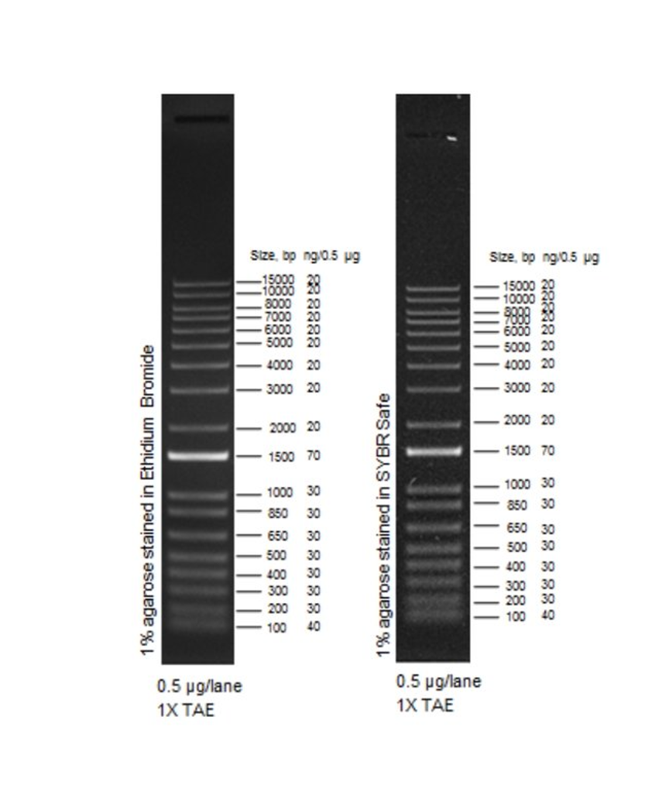

January 2022

pKR95 Cloning Plan

1. Run a 100 ul PCR:
Reaction Number | Plasmid/Region | Source DNA | Primers | Length (bps)
1 | Flanking Region 1 | SA gDNA | KROL419, 420 | 1015
2 | Flanking Region 2 | SA gDNA | KROL421, 422 | 969
3 | - control | - | KROL421, 422 | -
*Hannah has SA gDNA in her

2. PCR purify samples 1 and 2, elute in 35 ul 0.1xEB; hold onto sample 3 in -20C
3. Digest for ~ 1hr at 37C, total volume of 30 ul:
Tube | DNA | Enzyme(s) | DNA Volume (uL) | H₂O Volume (uL)
1 | Purified PCR 1 (FR1) | KpnI, NotI | 15 | -
2 | Purified PCR 2 (FR2) | NotI, BamHI | 15 | -
3 | Backbone (pIMAY-Z) | BamHI, KpnI | 5 | 10
*pIMAY-Z is in plasmids Box 0 “others” in the big -20C
4. Run entire digest on 1% agarose gel SKIPPING LANES BETWEEN SAMPLES. Also run negative control from PCR
5. If band are appropriate sizes (pIMAY-Z should be ~8.7kb), cut out with razor blade and gel purify with QIAgen kit, eluting in 35 ul of 0.1xEB
6. Ligate overnight, 20 ul, at 16C. Adjust water so that each insert is 4 ul:
Tube | Insert 1 | Insert 2 | Backbone
1 | Gel purified FR1 | Gel purified FR2 | Gel purified pIMAY-Z
2 | - | - | Gel purified pIMAY-Z
7. Transform into E. coli IM08B. Use pIMAY-Z from the plasmid box as a positive control. Plate on LB-chloramphenicol
8. Check plates. If ratios of ligation 1 and ligation 2 look good (>2-fold), pick single colonies into LB-chlor and grow at 37C overnight. The next day, miniprep.
9. Send minipreps out for sequencing.

Jan 31, 2022
- First day back in lab; worked on my honors project following the cloning plan Hannah made
  - Made 15 LB-Chloramphenicol plates for the E. coli transformation (made them early so they would be ready)
    - Ended up making the LB-agar with too high of a concentration of chloramphenicol (100 ul/mg)
    - Hannah made me new plates with correct concentration
  - Performed a 100 ul PCR on the SA gDNA using PCR protocol
    - SA gDNA that Hannah made was only 73 ng/ul so we had to accommodate for that

Reaction Number | Plasmid/Region | Source DNA | Primers | Length (bps)
1 | Flanking Region 1 | SA gDNA | KROL419, 420 | 1015
2 | Flanking Region 2 | SA gDNA | KROL421, 422 | 969
3 | - control | - | KROL421, 422 | -

- Using the primer table above, I ran three reactions following the Primestar mix calculations
  - I messed up the first round of the PCR (used wrong primer volumes for the tubes; Accidentally pipetted the master mix volumes into the tubes instead of the 1 reaction volumes) so we do not have a lot of the gDNA from S. aureus left.

Total reaction volume | 100
Total number of reactions | 3
 |  |  |  | Factor
Component | Stock concentration | Final concentration | 1 rxn volume | 4
ddiH2O |  |  | 61.3 | 245.
PrimeSTAR GXL Buffer | 5x | 1x | 20.0 | 80
dNTPs | 2.5 mM | 0.2 mM | 8.0 | 32
oligo F | 10 uM | 0.3 uM | 3.0 | 12
oligo R | 10 uM | 0.3 uM | 3.0 | 12
template | 73 ng/ul | 2 ng/ul | 2.7
PrimeSTAR GXL DNA Polymerase | 1.25 U/ul | 0.025 U/ul | 2.0 | 8
 |  | Total volume | 100 | 389.0

February 2022

Feb 2, 2022

- Ran a digest for the PCR from Jan 31st, following digest protocol exactly
  - Ran PCR purification beforehand for tubes 1 and 2 (FR1 and FR2)

DNA Digests Protocol
- Add indicated amounts of H₂O and 10x buffer to the master mix tube (MM).
- Add indicated amount of DNA or DNA+water (for backbone tubes) to individual tubes for digest (1.5 mL microfuge tubes for digests in incubator, PCR strip tubes for reactions incubated in the thermocycler).
- Add the indicated amount of each enzyme (___uL) to the master mix tube (MM).
- Mix the master mix by pipetting up and down.
- Add master mix to individual tubes. Volume to add to each tube is the volume in 1 reaction minus the DNA volume (____ul).
- Incubate at 37°C for 1 hour or up to overnight.
- If using a digest for plasmid construction then after incubation at 37°C, add 0.5ul of CIP enzyme to the backbone tube, mix by pipetting and put back in the 37°C incubator for 10 minutes. (this step removes the phosphates from the ends of the plasmid to prevent re-ligation). If using the new Quick CIP – add 1 uL, mix, incubate for 10 mins, then put at 80C for 2 minutes to inactivate the CIP.
  - Tube one: SA gDNA Flanking region 1
  - Tube two: SA gDNA Flanking region 2
  - Tube three: pIMAY-Z backbone

For cloning:
 | Number of samples | 3
 | Master mix factor | 4
Components | Volumes in 1 reaction (uL) | Volumes in Master Mix (uL)
H₂O | 10.8 | 43.2
10x Buffer* | 3 | 12
DNA | (15)
Enzyme 1 | 0.6
Enzyme 2 | 0.6
Total | 30.0 (15.0 actual b/c of DNA) | 55.2

- The table above was the mixture for each tube
  - Master mix contained only the water and buffer
  - Tube 1 (FR1) used KpnI and NotI + 15 ul of the PCR product
  - Tube 2 (FR2) used NotI and BamHI + 15 ul of the PCR product
  - Tube 3 (pIMAY-Z) used KpnI and BamHI + 5 ul pIMAY-Z + 10 ul H2O
- Ran DNA digests on a gel with the negative control from January 31st
  - Lane 1: Ladder
  - Lane 2: DNA Digest 1 (SA gDNA FR1) ~1015 bp
  - Lane 3: DNA Digest 2 (SA gDNA FR2) ~968 bp
  - Lane 4: DNA Digest 3 (pIMAY-Z backbone) ~8.7 kb
  - Lane 5: (-) control from PCR
  - Accidently forgot to do the CIP protocol so the ladder was inserted into the dye an hour before the other lanes were filled (flushed most of the ladder out though)

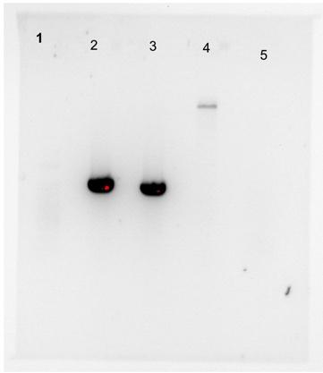

- I accidently put in 10 ul of the 6x loading dye instead of the ladder so it was not visible in this picture although Hannah and I agreed the bands seemed to be in the correct position so we went and cut them out for the gel extraction
  - Lane 2 was supposed to be around 1015 bp
  - Lane 3 was supposed to be around 969 bp
  - Lane 4 was supposed to be around 8,700 bp (we only used 5 ul of the backbone and it was very light so we may use 15 ul next time)
  - Lane 5 was supposed to have no bands

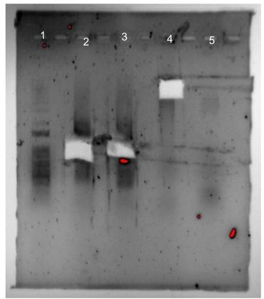

- This gel is after we removed the bands with the razor blade; the ladder is much more visible

Feb 3, 2022

- Performed a gel extraction for the bands obtained from the digest gel ran on Feb 2

QIAquick Gel Extraction
  - Weigh out the gels taken from the digest gel electrophoresis
    - FR1 was 0.53g; too big, so Hannah split the fragment into two different tubes, weighing 0.31g and 0.16g
    - FR2 was 0.33g
    - Backbone was 0.32g
      - All volumes were too big for 1.5ml tubes, had to transfer to 2ml tubes
  - Add three volumes buffer QG to 1 volume gel in each tube
    - FR1a - 930 ul FR1b - 480 ul
    - FR2 - 990 ul
    - BB - 960 ul
  - Incubate at 42 degrees for 10 minutes, vortexing every 2-3 minutes
    - Turned on heat block to too high a temperature during melting step for about 6 minutes, might have ruined the digest, we will see after transformation
  - Once gel has dissolved, add one volume 100% isopropanol to each tube
    - FR1a - 310 ul FR1b - 160 ul
    - FR2 - 330 ul
    - BB - 320 ul
  - Begin to transfer the volumes from each tube to the spin columns, 750ul at a time; spin at 13,000 rpm for 1 minute, discarding the flow through after
    - Had to spin each reaction multiple times since there was too much for the spin columns to hold
  - Add 500ul buffer QG to each spin column and spin for another minute, discarding the flow through
  - to wash, add 750 ul buffer PE to the column and spin for 1 minute, discarding the flow through; to removes residual buffer, spin for 3 minutes after wash
  - Place spin column in clean 1.5 ml tube, adding 35 ul 0.1x EB to elute DNA, let stand for 1 minute, then spin for 1 minute

Feb 7, 2022
- Performed ligation reactions on the gel extraction samples from the 3rd

Tube | Insert 1 | Insert 2 | Backbone
1 | Gel purified FR1 | Gel purified FR2 | Gel purified pIMAY-Z
2 | - | - | Gel purified pIMAY-Z

 | Number of samples | 2
 | Master mix factor | 3
Components | Volumes in 1 reaction (uL) | Volumes in Master Mix (uL)
H2O | 7.5 | 22.5
10x ligase buffer | 2.0 | 6
Insert | 8.0
Backbone | 2.0 | 6
Ligase | 0.5 | 1.5
Total | 20 | 36

Ligation Protocol
- Obtain ice to assemble and keep the reactions on. This is important, as the reaction happens at 16°C and the ligase buffer (which contains ATP) needs to be kept cold in order to avoid degradation. Take a 10 uL aliquot of 10X ligase buffer from the miscellaneous buffers box in the -20C.
- Obtain and label PCR tubes for the reactions. Be sure to include the date and your initials.
- To the individual tubes, add indicated amounts of H₂O (___uL), 10x buffer (_____uL), insert (____uL), and backbone (____uL).
- Add indicated amount of ligase (___uL) to the individual tubes. Remember to keep the ligase in a mini cooler.
- After all of the components have been added, mix each tube with a pipette set to 18 uL.
- Place in the thermocycler overnight at 16ºC.
  - We left the ligation reactions out for 10 minutes at room temperature instead of overnight so we could perform the transformation right after

Chemical Transformation in E. coli Protocol

Tube # | Purpose | DNA | Volume of DNA | Final Volume to Plate | # of chlor plates
1 | (+) control |  | 1 ul | 20 ul, 100 ul | 2
2 | (-) control |  | 0 ul | 20 ul, 100 ul | 2
3 | Ligation 1 |  | 8 ul | 100 ul, remaining | 2
4 | Backbone Ligation |  | 8 ul | 100 ul, remaining | 2

- Obtain DNA and thaw on ice if necessary.
  - I did not vortex the pIMAY-Z backbone (straight from big -20) which Hannah said is very important
    - All the plasmid backbone was on bottom of tube
- Thaw appropriate number of competent cell tubes on ice (5 reactions per tube of competent cells)
- Label sterile tubes as indicated in reaction table. Add indicated volume of indicated DNA on ice.
- When competent cells are thawed (check by probing for frozen cells using a sterile pipette tip), gently pipette 100 uL of cells into each reaction tube directly onto DNA using aseptic technique.
  - I added DNA first and gently added the cells, but pipetted to mix (slowly and gently) which I should not have done
- Incubate cells on ice for 20 minutes. During incubation, find or set heat block to 42°C.
- Place tubes with cells and DNA onto a 42°C heat block for 30 seconds (heat shock step).
  - Made sure I did only 30 seconds, used timer to check
  - I added first tube at 0 seconds, added second at 10 seconds, third at 20 seconds, and took the first tube off at 30 seconds, second off at 40 seconds, third off at 50 seconds, and finally added fourth tube at 60 seconds and removed at 90 seconds (should just add two at a time next time, one pair at 0 seconds and second pair within 5 seconds)
- After heat shock, place tubes back on ice until the next step (don’t keep them here too long).
  - On ice for less than 3 minutes
- Using aseptic technique, add 1 mL LB (no antibiotic) to each microfuge tube.
- Using autoclave tape, tape microfuge tubes down in a shaking incubator set to 37°C. (save the tape!)
- Allow cells to recover for 1 hour at 37°C, shaking. Place in a rack after shaking (NOT back on ice).
- Using aseptic technique, plate indicated amount of cells on appropriate antibiotic plates (LB-Kan), spreading until plates look dry. For “remaining” volume, spin tubes at max speed in a benchtop centrifuge for 30 seconds. Remove 800 uL of media. Using 200 uL pipette, resuspend cells at bottom of tube and plate all the remaining culture.
  - Should add beads before pipetting culture onto the plate next time.
- We used LB - chloramphenicol plates instead of LB-Kan plates
  - IMPORTANT - was talking to Hannah when plating the tubes, might have plated tube #3 on the 100 ul negative control plate by accident; compared the volumes in all tubes, did not seem like I messed up since tubes 3 and 4 had similar volumes and tubes 1 and 2 were also similar
  - In the future, vortex the plasmid before using it for the positive control
- I also calculated the amounts of certain things we need for the beta-gal on Wednesday; we have enough of everything, just need to make more before next beta-gal
  - Z-buffer - 23 ml
  - BME - 62.56 ul
  - 1% SDS - 0.78 ml
  - Na2CO3 (stop) - 11.5 ml
  - ONPG - 5.2 ml

Plasmidsaurus Link
https://www.plasmidsaurus.com/instructions/
- For when I do the PCR with the primers (KROL 493 and KROL 494): Wildtype should be 2159 and the delta_rpsu 2000
  - Primers:
    - KROL 493 drpsU_SA_ck_F
      - taaaagattataacttggcccaattatta
    - KROL 494 drpsU_SA_ck_R
      - acttaaactaaacatggtatcgctcc

Feb 8, 2022
- Helped prepare for tomorrow’s beta-gal assay
- Aisling added 6 ml to 12 different test tubes
  - I prepared 12 sterile 1.5 microcentrifuge tubes with 500 ul MHB
  - 12 cuvettes with 950 ul MHB
    - Both went into the fridge

Beta-Gal 2/9 Assay Prep:
  - WARM EVERYTHING UP AT 37 DEGREES
  - Loop and scrape up all cells from designated patches on the plates
    - Label which patches were used on the back of the plates
  - Add the cells to the 1.5ml sterile tubes filled with 500ul MHB from earlier
    - Use blue pipette set at 400ul to resuspend cells, vortex if clumps still remain
  - Take 50ul of the sample tubes and add to empty cuvettes that have 950ul MHB already added
    - Cover with parafilm and invert 3x to mix
  - Check the OD600 (using the prepared blank)
  - Use spreadsheet to calculate V1
    - C1V1=C2V2
    - delta_rpsu strains should be 0.13
    - LVS strains should be 0.10
      - If OD600 is not high enough, repeat previous steps until high enough (using all cells from patches so should be high enough)
  - Add calculated V1 to the 6ml MHB tubes Aisling prepared
  - Take 500ul from the 6ml tubes, gently swirling to mix, and add to the empty cuvettes
  - Put the tubes into the shaker for around 3.5 hours, starting timer counting up
  - Check OD600

COVID Exposure
  - To all that read this, I sincerely apologize for not being able to be there, it was out of my control and I really don’t want anyone to get themselves or others sick because I did not speak up about an exposure

Feb 10, 2022
- I tested negative! Aisling successfully completed the beta-gal with help from Hannah
- The two control plates from the transformation grew colonies so they were parafilmed by Hannah so I will calculate the transformation efficiency
- The ligation plates did not grow (Hannah left them out in room temp after no growth was seen) so I will redo them starting at the digest step
  - I will use 15 ul of the backbone for the digest this time, making sure the concentration is at least 70 ng/ul
- Primers came so I will get them ready at some point, maybe today when I go in

Receiving Primers Protocol
By: Hannah Trautmann

- Spin primers at maximum speed in tabletop centrifuge for 3 minutes so dessicated primers go to the bottom of the tube.
- Add 0.1x EB to a final concentration of 100 uM. Calculate this by multiplying the reported nm by 10 and adding that volume in ul (i.e. 12.7 nmoles = add 127 uL of 0.1xEB).
- Put on 42°C heat block for 5 minutes to help primers dissolve
- Vortex and brief spin.
- Label tubes with KROL numbers on the top and put in the appropriate 100 uM stock box in the -20°C freezer.
- Optional: Make dilution for the intended purpose of the primer.
  - If a PCR primer, make a 10 uM stock by diluting 20 uL of the 100 uM stock into 180 uL of 0.1xEB. Label with purple sticker and put in the appropriate freezer box.
  - If a sequencing primer, make a 2.5 uM stock by diluting 5 uL of the 100 uM stock into 195 uL of 0.1x EB. Label with a blue sticker and put in the appropriate freezer box.
- Put Certificate of Analysis sheet in “Oligos Spec Sheet” binder and shipping sheet in Invoices box.
- I made the 100 mM and 10 mM aliquots for primers KROL493 and KROL494
- Packed up the plate bin for the autoclave
  - Going to wait for another bag before taking down to the autoclave
- For tomorrow:
  - Prepare 5 ml of TE for the blanking for pIMAY-Z nanodrop concentration
  - 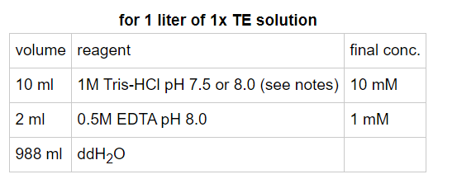
  - 50 ml ratio calculations are:
    - 1M Tris-HCL 500 ul
    - 0.5M EDTA 100 ul
    - ddH2O 49.4 ml
  - Redo recent experiments starting with the DNA Digest from the PCR purification

Feb 11, 2022
- Redoing the digest from Feb 2nd
- Made the 50 ml 0.1x TE buffer to measure concentration of the pIMAY-Z plasmid for the digest (needs to be ~70 ng/ul) and for the transformation efficiency calculation
  - 49.8 ng/ul
Tube | DNA | Enzyme(s) | DNA Volume (uL) | H₂O Volume (uL)
1 | Purified PCR 1 (FR1) | KpnI, NotI | 15 | -
2 | Purified PCR 2 (FR2) | NotI, BamHI | 15 | -
3 | Backbone (pIMAY-Z) | BamHI, KpnI | 25.8 | -
- Using 25.8 ul of the backbone this time instead of 5 ul
- The following table is just for the back bone, Hannah calculated how much backbone we’d need to use for the digest (no master mix, just one reaction tube)
Components | Volumes in 1 reaction (uL) | Volumes in Master Mix (uL)
H2O | 0
10x Buffer* | 3
BackBone | 25.8
Enzyme 1 | 0.6
Enzyme 2 | 0.6
Total | 30

- The two inserts can be made with a master mix following the restriction enzyme worksheet calculator

For cloning:
 | Number of samples | 2
 | Master mix factor | 3
Components | Volumes in 1 reaction (uL) | Volumes in Master Mix (uL)
H2O | 10.8 | 32.4
10x Buffer* | 3 | 9
DNA | 15
Enzyme 1 | 0.6
Enzyme 2 | 0.6
Total | 30.0 (15.0 actual b/c of DNA) | 41.4

- Following the digest protocol, I let all tubes incubate at 37 degrees for 1 hour
  - The backbone will be treated with QuickCIP to remove phosphates from the ends to prevent joining of the ends
- From the tables:
  - Master mix contained only the water and buffer
  - Tube 1 (FR1) used KpnI and NotI + 15 ul of the PCR product
  - Tube 2 (FR2) used NotI and BamHI + 15 ul of the PCR product
  - Tube 3 (pIMAY-Z) used KpnI and BamHI + 25.8 ul of the pIMAY-Z plasmid
- Ran DNA digests on a gel
  - Lane 1: Ladder
  - Lane 2: DNA Digest 1 (SA gDNA FR1) ~1015 bp
  - Lane 3: DNA Digest 2 (SA gDNA FR2) ~968 bp
  - Lane 4: DNA Digest 3 (pIMAY-Z backbone) ~8.7 kb

Lane | Contents | Expected bp
1 | Ladder | —----------------
2 | DNA Digest 1 (SA gDNA FR1) | 1,015
3 | DNA Digest 2 (SA gDNA FR2) | 968
4 | DNA Digest 3 (pIMAY-Z) | 8,700

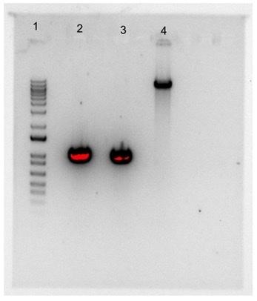
- The gel I ran from the digest looked good; last time the backbone band was really dull, which is why we increased volume of the backbone more than five fold
  - This new band is significantly darker than the previous gel, so it worked

Agarose gel
  - 5 g agarose
  - 500 ml ddih2o
  - Spun and heated at 300 degrees until clear
  - Updated the tape on agarose flask
- Performed the QIAquick gel extraction to obtain the inserts and backbone from the gel I ran, following the QIAquick gel extraction protocol I have in this notebook
  - Made sure to follow exactly and not touching the heat block settings; the temperature was 42 degrees
- Did not start the ligation since I could not come in tomorrow to put overnight ligation reactions in the freezer, going to do ligation and transformation next week

Transformation efficiency
  - 100 ul positive control plate from Feb 7th (pIMAY-Z plasmid straight from -20 freezer)
  - TE = colony count/ug/dilution
    - Colonies = 107 (88 small, 14 medium, 5 large)
    - ug = 49.8 ng/ul converted to 0.0498 ug
    - 1.101 ml total, 100 ul of cells = 100/1,101 -> 0.0908
  - TE = 107/0.0498/0.0908 = 2.4 x 10^4 cells per ug
  - Used same equation to calculate the expected amount of transformed colonies where the ug is 20 ng (Hannah wrote “Input 20 ng of DNA + dilution + plating 1 ml/1.1 ml”)
  - 2.4x10^4 = x/20 ng/(1 ml/1.1 ml) -> 2.4x10^4 = x/0.02 ug/0.909
    - x = 2.4 x 10^4 x 0.022 = 528 expected colonies
    - 528 is expecting every last insert is ligated into the backbones; Hannah said 10% is a reasonable expectation so 53 colonies can be expected during a successful transformation

Feb 14, 2022
- Performed the second ligation with a higher backbone concentration
 | Sample Name |  |  | Desired Ratio | Sample Concentration (ng/ul) | size (kb)
Backbone | pIMAY-Z |  |  | 1 | 7.6 | 8815
Insert 1 | FR1 |  |  | 5 | 10.12 | 1015
Insert 2 | FR2 |  |  | 5 | 5.48 | 969
desired amount of backbone (ng)= |  | 50
ul needed of backbone |  | 6.578947368

Reaction Mix | ul needed | BB only control
Backbone | 6.58 | 6.58
Insert 1 | 2.84 | -
Insert 2 | 5.01 | -
T4 Ligase buffer | 2.00 | 2.00
T4 ligase | 0.50 | 0.50
water | 3.06 | 10.92
total | 20 ul | 20.00

Tube | Insert 1 | Insert 2 | Backbone
1 | Gel purified FR1 | Gel purified FR2 | Gel purified pIMAY-Z
2 | - | - | Gel purified pIMAY-Z

- The concentrations of the digests are as follows:
  - Backbone - 7.6 ng/ul (we expected a concentration around here)
  - FR1 - 101.2 ng/ul (really high; Hannah had not seen this before)
  - FR2 - 54.8 ng/ul (also high)
  - The flanking region concentrations were too high, so I diluted 2 ul of each insert in 18 ul of ddiH2O so the amounts were pipetteable.

Sterilizing the cuvettes
  - Once ethanol has dried, put in the cancer microwave for 10 minutes
    - Should be preset for 10 minutes on high
  - Put caps back on before removing from microwave and put in the “Ready for EP” cuvette box

Feb 15, 2022
- Performed the transformation of chemically competent E. coli cells (IMO8B cells); referred back to the protocol in my notebook (under Feb 7, 2022)

Tube # | Purpose | DNA | Volume of DNA | Final Volume to Plate | # of chlor plates
1 | (+) control |  | 1 ul | 20 ul, 100 ul | 2
2 | (-) control |  | 0 ul | 20 ul, 100 ul | 2
3 | Ligation 1 |  | 8 ul | 100 ul, remaining | 2
4 | Backbone Ligation |  | 8 ul | 100 ul, remaining | 2

- Same set up as the transformation done on the 7th, but with the digest/ligations that were done yesterday (8 plates labeled referring to their contents from the table)
  - Higher concentration of backbone and I made sure to learn from the mistakes I made last time
    - I put the gel extraction tubes on the heat block at 42 degrees instead of ~92 degrees
    - Vortexed pIMAY-Z plasmid before adding to the positive control tube
    - All tubes were heat shocked for exactly 30 seconds
- I have class at 2 so Hannah had to plate the transformation tubes on the 8 LB-chloramphenicol plates
  - I labeled the plates and put beads on them, so Hannah just has to pipette the cultures onto the respective plates
- Only the positive control plates grew last time, hoping for the other plates to grow this time
  - Since positive control plates grew, it can be inferred that the chloramphenicol concentration may be ok, but maybe too high since other plates had no growth, will talk to Hannah about it tomorrow.

Feb 16, 2022
- To do list:
  - Check plates
  - Make more 50% sucrose (lab task)
  - Make more 1X TAE (New)
- Looked at all plates that Hannah plated for me yesterday; she added two new controls (10 ul of stock IMO8B and 5 ul IMO8B on no antibiotic)
  - No growth on any of the plates besides the No Antibiotic Control 5 ul
    - There was a lawn (very high cell density), indicating that the chloramphenicol concentration may be too high (25 ug/ml right now) or that the promoter for the Chlor-Resistance gene may not be strong enough
    - Going to wait longer for cells to grow since the positive control plates took two days to grow last time
    - When plating S. aureus, we will reduce chlor concentration from 25 ug/ml to 10 ug/ml in the LB plates and in XGAL plates (look up concentration in paper Hannah sent me)
    - Will test those 10 ug/ml chlor plates with the XGAL plates by streaking out with our stock of S. aureus
      - XGAL stock is 50 ug/ml, need to dilute before putting into plates
      - There should be no growth on these plates
    - XGAL needs to be protected by light; when making these plates, wrap in tin foil

Making 50% Sucrose
  - Combine 360 g of sucrose and enough type I ddiH₂O to make 720 mL.
  - Autoclave for 20’.
  - Suggested method: in 1 L beaker, add ~100 g increments of sucrose into ~250 mL type I ddiH₂O, heating slightly (below boiling point!) and waiting for each addition to be completely dissolved before adding next mass of sucrose. Measure final volume in graduated cylinder and add type I ddiH₂O until volume is 720 mL.

Making 1X TAE New
- For 2 L:
  - Mix 40 ml 50X TAE into 1,960 ml H2O
    - I added 40 ml 50x TAE to a 1 L graduated cylinder, filled with water until 1 L, poured that into the 1X TAE NEW container, then added another liter of water

Feb 17, 2022
- To do list:
  - Count plates from ligation transformation

Counted plates from second ligation transformation
  - No growth except on the (+) control plates again
    - 102 on the 100 ul, 2 on the 20 ul
  - I may have not been pipetting accurately and this could have been the reason for the failed ligation; the tube for the insert ligation had a slightly higher volume than the backbone ligation tube
    - Need to talk to Kathryn about troubleshooting
    - I should try constructing a set-up which allows me to pipette more easily
      - Tube rack is elevated around eye level so I can see the volumes being pipetted in and out of tip
      - Always double check that the volumes are correct
- Kathryn said to re-do the ligation because they are finicky and need to have exact amounts
  - This IMO8B strain has a lower transformarion efficiency than the E. coli strains previously used in lab
  - We are going to do a 3X ligation
- XGAL concentration and volume for plates (both papers sent by Hannah say 100 ug/ml when cultivating S. aureus, whereas one paper says 100 ug/ml in E.coli and another says 50 ug/ml)
- X-Gal (5-bromo-4-chloro-3-indolyl-β-d-galactopyranoside; Melford) was used at 50 µg/ml in E. coli and 100 µg/ml in S. aureus.
  - For E. coli: 250 ml XGAL into 250ml LB broth
  - For S. aureus: 500 ml XGAL into 250ml LB broth

Feb 18, 2022
- To do:
  - Make the LB-chlor/XGAL plates
  - Check my plates
- The insert ligation plate had a large colony on it, but the backbone ligation plate had a small colony so there’s a high chance the backbone religated
  - I kept the insert ligation plate just in case it does have a successful ligation; I am still going to re do the ligation though

LB-chlor/XGAL plates
  - 500 ml LB (which I stupidly let boil over)
  - Chlor stock concentration is 50 mg/ml
XGAL stock concentration is 50 mg/ml
  - After calculations, I will add 100 ul of chloramphenicol and 1000 ul XGAL to the 500 ml of LB (used the C1V1=C2V2 equation to obtain proper volumes)
  - XGAL is sensitive to light so the plates need to be wrapped in foil once they solidified
    - While plates were setting, I kept them under a box
    - Also had the LB flask wrapped in foil while it was mixing and when I poured the plates
    - Wrapped the plates in stacks of six (24 plates total)

Feb 22, 2022
- To do list:
  - 3X and 5X ligation on LB-chlor/XGAL plates
  - Put plates into the fridge

Third Ligation with 3X Ligation
The desired amount of backbone was reduced from 50 ng to 40 ng so I would have enough gel purified backbone for all three reaction tubes
ul needed of backbone | 5.26 ul
Tube | Insert 1 | Insert 2 | Backbone
1 (BB ligation) | - | - | Gel Purified pIMAY-Z
2 (3X ligation) | Gel Purified FR1 | Gel Purified FR2 | Gel Purified pIMAY-Z
3 (5X ligation) | Gel Purified FR1 | Gel Purified FR2 | Gel Purified pIMAY-Z

- 3X ligation
 | Sample Name | Desired Ratio | Sample Concentration (ng/ul) | size (kb)
Backbone | pIMAY-Z | 1 | 7.6 | 8815
Insert 1 | FR1 | 3 | 10.12 | 1015
Insert 2 | FR2 | 3 | 5.48 | 969

Reaction Mix | ul needed
Backbone | 5.26
Insert 1 | 1.37
Insert 2 | 2.41
T4 Ligase buffer | 2.00
T4 ligase | 0.50
water | 8.46
total | 20 ul

- 5X ligation
 | Sample Name | Desired Ratio | Sample Concentration (ng/ul) | size (kb)
Backbone | pIMAY-Z | 1 | 7.6 | 8815
Insert 1 | FR1 | 5 | 10.12 | 1015
Insert 2 | FR2 | 5 | 5.48 | 969

Reaction Mix | ul needed | BB only control
Backbone | 5.26 | 5.26
Insert 1 | 2.28 | -
Insert 2 | 4.01 | -
T4 Ligase buffer | 2.00 | 2.00
T4 ligase | 0.50 | 0.50
water | 5.95 | 12.24
total | 20 ul | 20.00
- I followed the ligation protocol noted higher up in this lab notebook
  - Since previous ligations have not gone right, I made sure to pipette the exact amounts of each reaction part
  - This included elevating the PCR tube rack to near eye level so I could see the volumes I pipetted more easily
  - Whenever I pipetted an amount, I would put the liquid back and pipette again to make sure I got the right amount
  - All tubes had the same volume before I added the ligase, and I added the 0.5 ul directly into the reaction volumes and pipetted with the 18 ul after
    - This made some bubbles at the top of the reactions after the mixing, but almost all the reaction volume was liquid at the bottom

Feb 23, 2022
- To do list:
  - Sterilize some cuvettes
  - Perform transformation for the new ligation from yesterday (BB, 3X, and 5X)
  - Autoclave plate waste
  - Fill carboy

Third Transformation
Tube # | Purpose | Volume of DNA | Final Volume to Plate | # of chlor/XGAL plates
1 | (+) control | 1 ul | 20 ul, 100 ul | 2
2 | (-) control | 0 ul | 20 ul, 100 ul | 2
3 | 3X Ligation | 8 ul | 100 ul, remaining | 2
4 | 5X Ligation | 8 ul | 100 ul, remaining | 2
5 | BB Ligation | 8 ul | 100 ul, remaining | 2

- 5 reaction tubes this time since we added the 3X ligation
- Added volumes of DNA and the cells to the reaction tubes on ice and close to the flame
  - Made sure to vortex the pIMAY-Z plasmid beforehand and I did not mix the cells and DNA once they were together in the tube
- PRO TIP: Hannah saw me put my arm over an open container that is supposed to stay sterile; this could result in contamination since my skin and jacket are covered in microbes
  - Rearrange my area before hand and rehearse moving around to make sure I am not going over the flam or an open container
- Just a reminder: “For “remaining” volume, spin tubes at max speed in a benchtop centrifuge for 30 seconds. Remove 800 uL of media. Using 200 uL pipette, resuspend cells at bottom of tube and plate all the remaining culture.”

For Autoclaving Plate waste
- Make sure both bags of plates are double bagged and taped close
- Liquid 20 (20’) setting on autoclave (no water)

2/23/22 KRLab Meeting
- pKR122 can be put on back burner
- We are going to do a qt-PCR for the strains used in the last beta-gal
  - This will be a fun time; going to start on Monday, March 7th

Feb 24, 2022
- To do:
  - Clear bin from the autoclave accident yesterday
  - Check the transformation plates
- Transformation plates
  - There was no growth on any plates which was to be expected since they have taken at least two days to grow in the past transformations
  - Roads will be bad tomorrow so I probably won’t come in; cannot leave the plates in the incubator over the weekend, Hannah said they can be left out in room temp for three days, will check again on Monday
    - Hannah said don’t panic if there’s no growth on Monday, room temperature incubation can take up to five days

XGAL Function
- XGAL is a reporter chemical for b-galactosidase/lac z activity
- Only cells with lac z activity will turn blue; they must have the plasmid within them since pIMAY-Z has the chloramphenicol resistance gene
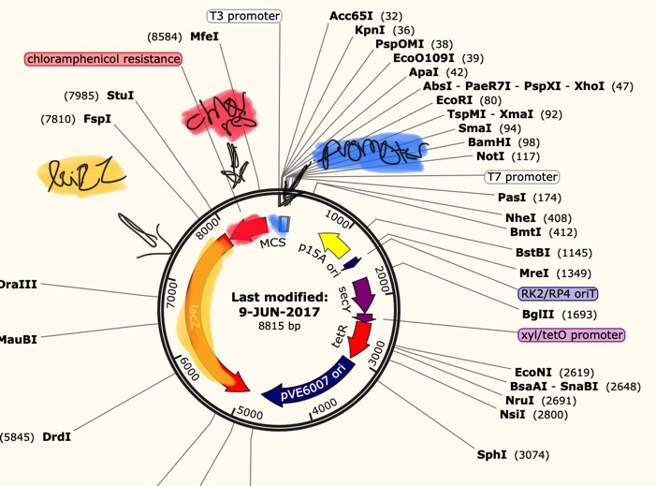
      - Positive control should be blue
      - Negative should have no growth
      - 3X should be blue
      - 5X should be blue
      - BB should have no growth

Feb 28, 2022
- To do:
  - Check Plates
  - Streak out stock IMO8B on a Chlor/XGAL plate
  - Prepare cultures for MiniPrep tomorrow

Plates from third ligation
  - + control plates:
    - 20 ul: 12 blue colonies – means that the transformation worked, and the plasmid was expressed in the cells
    - 100 ul: 72 blue colonies and 7 white colonies – some cells were transformed, and some were not, but the cells without the plasmid should not have grown
  - – control plates:
    - 20 ul: 0 colonies
    - 100 ul: 24 white colonies – once again, these white colonies should not have grown
  - 3X Ligation:
    - 100 ul: 13 white colonies, no plasmid in the cells
    - Remaining ul: 12 white colonies, no plasmid in the cells
  - 5X Ligation:
    - 100 ul: 12 white colonies, no plasmid in the cells
    - Remaining ul: 5 white colonies, no plasmid in the cells
  - BB Ligation:
    - 100 ul: 17 white colonies, 1 blue colony, and 2 yellow colonies – most of the cells did not have the plasmid, only 1 colony had religated plasmids, and the 2 yellow colonies means that I contaminated the plate with another species of bacteria
  - In the end, the ligation failed, and I was not sufficiently aseptic

Plasmid Construction Troubleshooting
- NEED TO MIX EVERYTHING BY EITHER VORTEXING OR PIPETTING BEFORE ADDING TO THE REACTION TUBES!!!
- Since there were white colonies on the chlor plates, Kathryn and Hannah think 10 ug/ml may not be a high enough concentration
  - Testing this out by streaking stock IMO8B cells on a10 ug/ml chlor/100 ug/ml XGAL plate
- We are also going to try the ligation and transformation again, still doing a 3X and 5X
  - I do not have enough plasmid backbone left so I need to collect some from the + control plates
    - MiniPrep
  - Along with this, we are going to do an identical transformation with 5-alpha E. coli cells, which are highly competent and sensitive to chloramphenicol
    - I will do the IMO8B cells first, then do the 5-alpha cells separately afterwards
- IMO8B stock streaking
  - I struck out 50 ul of the stock IMO8B cells onto a 10 ug/ml chlor/100 ug/ml XGAL plate to see if the chloramphenicol concentration is high enough; if colonies show up, we will most likely increase the concentration of chloramphenicol in the next plates
- I ran out of backbone for the next ligation and did not have enough of the pIMAY-Z plasmid, so I must MiniPrep some of the backbone from the + control colonies from my last transformation
  - Started by adding 5 ml of LB to two vials, then adding 1 ul of chloramphenicol to the tubes (the culture tubes must have the same concentration of chloramphenicol as the plates; got 1 ul volume from a C1V1=C2V2 calculation)
  - Used a sterile stick to pick up blue colonies from the + control plates, violently shook the stick around in each of the tubes, then stuck them in the shaking incubator overnight

Large Batch CHA Powder
- Add the following to the Cysteine Heart Agar container:
  - 75 g Proteose Peptone
  - 75 g Beef Heart Infusion
  - 75 g Glucose
  - 112.5 g Agar
  - 7.5 g NaCl

March 2022

March 1, 2022
- To do list:
  - MiniPrep the overnight cultures from yesterday

MiniPrep Spin Kit Protocol
- Pellet all 5 ml bacterial overnight culture by spinning at >8000 rpm for 3 min at room temp
  - Put in 2 ml tubes; spin and discard the supernatant; must do this 3 times for 5 ml
- Resuspend pelleted cells in 250 ul Buffer p1 from fridge
- Add 250 ul buffer p2 and mix by inverting tube 4-6 times; do not let this step proceed for more than 5 minutes
- Add 350 ul buffer n3 and mix immediately by inverting 4-6 times
- Centrifuge for 10 minutes at 13,000 rpm
- Apply 750 ul from step 5 into spin column and spin for 1 minute, then discard flowthrough
  - Do this until all the solution from the previous step is gone
- Wash with 500 ul buffer PB; spin for 1 min and discard flow through
- Wash again with 750 ul buffer PE; spin for 1 minute, discard flowthrough, and do these two more times
- Centrifuge for 3 min to remove residual buffer
- Place column in a 1.5 ml tube and elute DNA with 50 ul 0.1X EB; let stand for 1 min before spinning for 1 min

RNA Plan
- Planning for Monday March 7 (KRLVS 149 and KRLVS 149)
  - On Saturday, 148 must be streaked out to single colonies for the RNA on Monday
  - On Sunday, cells must be streaked to single colonies for RNA; need single colonies (149)
  - On Wednesday, I will streak out 148 since delta_rpsu takes a long time to grow
  - On Thursday, we will streak out 149

March 2, 2022
- To do list:
  - Perform digest on the plasmids recovered from the positive control plates from the third transformation
  - Fourth ligation
  - Check the stock IMO8B test plate from Monday; determine whether the chloramphenicol concentration is high enough
  - Streak out KRLVS 148
- pIMAY-Z from + control digest
  - Check concentration

DNA Digests Protocol
- Add indicated amounts of H₂O and 10x buffer to the master mix tube (MM).
- Add indicated amount of DNA or DNA + water (for backbone tubes) to individual tubes for digest (1.5 mL microfuge tubes for digests in incubator, PCR strip tubes for reactions incubated in the thermocycler).
- Add the indicated amount of each enzyme (___uL) to the master mix tube (MM).
- Mix the master mix by pipetting up and down.
- Add master mix to individual tubes. Volume to add to each tube is the volume in 1 reaction minus the DNA volume (____ul).
- Incubate at 37°C for 1 hour or up to overnight.
- If using a digest for plasmid construction then after incubation at 37°C, add 0.5ul of CIP enzyme to the backbone tube, mix by pipetting and put back in the 37°C incubator for 10 minutes. (this step removes the phosphates from the ends of the plasmid to prevent re-ligation). If using the new Quick CIP – add 1 uL, mix, incubate for 10 mins, then put at 80C for 2 minutes to inactivate the CIP.
- The concentrations from the pIMAY-Z MiniPrep cultures are as follows:
  - Tube 1: 60.5 ug/ml
  - Tube 2: 74.0 ug/ml
Components | Volumes in 1 reaction (uL)
H₂O | 0
10x Buffer* | 3
DNA | 25.8
Enzyme 1 | 0.6
Enzyme 2 | 0.6
Total | 30.0 (15.0 actual b/c of DNA)

- The table above is for the digest run with both enzymes which I will be cutting out
Components | Volumes in 1 reaction (uL)
H₂O | 19.4
10x Buffer* | 3
DNA | 7
Enzyme 1 | 0.6
Enzyme 2 | 0
Total | 30.0 (15.0 actual b/c of DNA)
- This is the table for the linear plasmid digests, using one of the two enzymes
  - One digest with BamHI and one digest with KpnI
Components | Volumes in 1 reaction (uL)
H₂O | 20
10x Buffer* | 3
DNA | 7
Enzyme 1 | 0
Enzyme 2 | 0
Total | 30.0 (15.0 actual b/c of DNA)
- This is the table I used for the digest with no enzymes
- Only did the QuickCIP protocol on the full digest tube since that’s the plasmid we want to cut for the ligation
- For the stock IMO8B cell 10 ug/ml plate, there were two white colonies that grew
  - Going back up to 25 ug/ml of chlor in the next set of plates

Streaking out KRLVS 148
- Pipetted 100 ul (whole tube) onto corner of the plate; used sterile stick to streak it out in a small area
- Used a clean stick to go twice into first zone and then struck out again in second quadrant
- Repeated the same process for the third and fourth quadrants, then put into standing incubator

New Chlor/XGAL Plates
- Since stock IMO8B grew on the 10 ug/ml chlor plates, we are increasing the concentration from 10 ug/ml t0 25 ug/ml
  - 500 ml LB
    - 250 ul of the 50 mg/ml stock Chloramphenicol
    - 1000 ul of the 50 mg/ml stock XGAL
  - Made 25 plates total; two are very full since I tried to go light on most of them
- ACCIDENTLY PUT TWO RED STRIPES ON THESE PLATES INSTEAD OF ONE RED STRIPE
  - This makes the plates look like 10 ug/ml chlor when they are really 25 ug/ml
- Gel table
Lane # | Contents
1 | 10 ul Ladder
2 | 30 ul No Enzyme Plasmid Digest
3 | 30 ul BamHI Plasmid Digest
4 | 30 ul KpnI Plasmid Digest
5 | 30 ul Both Enzyme Plasmid Digest

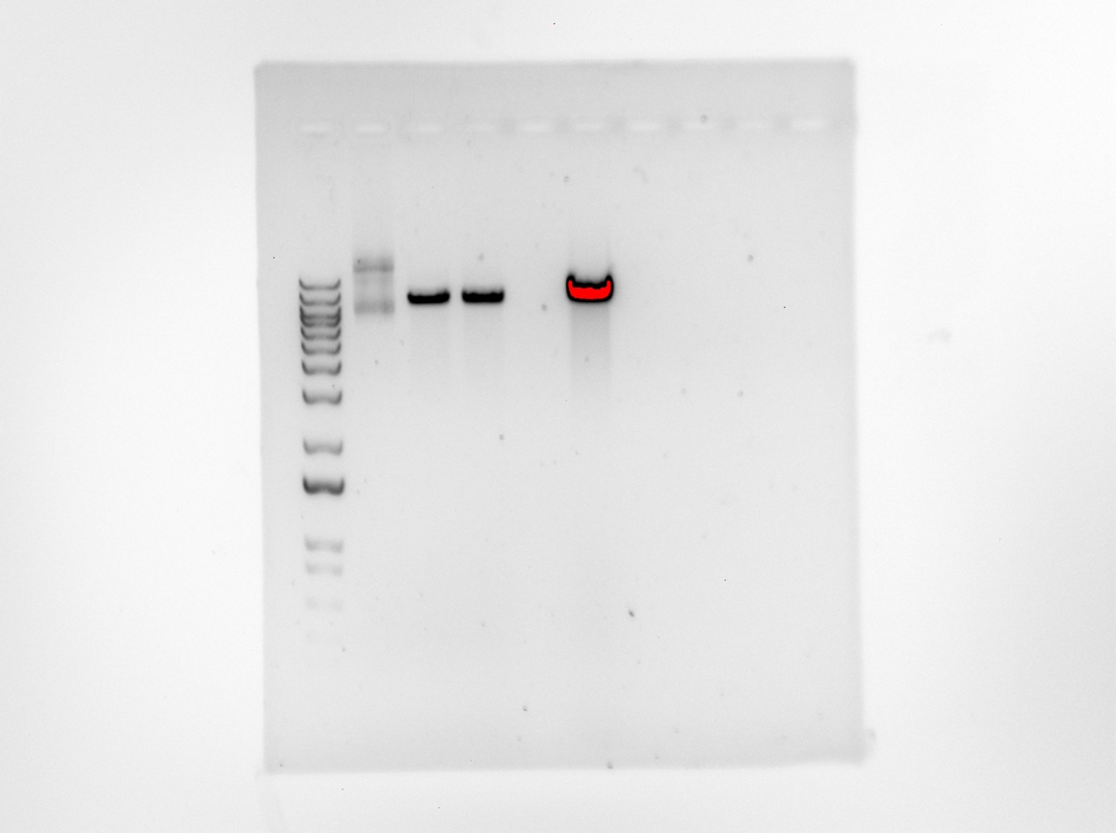
- First picture of the gel; I cut the full digest plasmid out for gel extraction (0.19 g) and left the rest of the lanes to migrate longer (15 minutes at 50 V, 20 minutes at 110 V)
- The single enzyme bands are the same distance, which is expected, while the no enzyme digest lane has two bands
  - The two bands are due to supercoiling; the higher up band is a plasmid with a single strand nick (this causes more friction with the agarose) while the band further down is a supercoiled plasmid which has less friction with the agarose

March 3, 2022
- To do list:
  - Perform fourth ligation

Ligation Protocol
- Obtain ice to assemble and keep the reactions on. This is important, as the reaction happens at 16°C and the ligase buffer (which contains ATP) needs to be kept cold in order to avoid degradation. Take a 10 uL aliquot of 10X ligase buffer from the miscellaneous buffers box in the -20C.
- Obtain and label PCR tubes for the reactions. Be sure to include the date and your initials.
- To the individual tubes, add indicated amounts of H₂O (___uL), 10x buffer (_____uL), insert (____uL), and backbone (____uL).
- Add indicated amount of ligase (___uL) to the individual tubes. Remember to keep the ligase in a mini cooler.
- After all of the components have been added, mix each tube with a pipette set to 18 uL.
- Place in the thermocycler overnight at 16ºC.

Fourth Ligation
- Made sure I was pipetting the correct amounts of everything, comparing the volumes between all tubes to make sure they all had the same by the end
  - Had Aisling pipette the 0.5 ul of the T4 Ligase just to be cautious with my shaky hand
  - I vortexed everything I could and I mixed the ligase into the reaction tubes using 18 ul pipette

Tube | Insert 1 | Insert 2 | Backbone
1 (BB ligation) | - | - | Gel Purified pIMAY-Z
2 (3X ligation) | Gel Purified FR1 | Gel Purified FR2 | Gel Purified pIMAY-Z
3 (5X ligation) | Gel Purified FR1 | Gel Purified FR2 | Gel Purified pIMAY-Z
Desired amount of backbone: 50 ng; Backbone concentration from digest: 12.5 ng/ul

 | Sample Name | Desired Ratio | Sample Concentration (ng/ul) | size (kb)
Backbone | pIMAY-Z | 1 | 12.5 | 8815
Insert 1 | FR1 | 5 | 10.12 | 1015
Insert 2 | FR2 | 5 | 5.48 | 969
 | Sample Name | Desired Ratio | Sample Concentration (ng/ul) | size (kb)
Backbone | pIMAY-Z | 1 | 12.5 | 8815
Insert 1 | FR1 | 3 | 10.12 | 1015
Insert 2 | FR2 | 3 | 5.48 | 969

- The table directly below is for the 5X and Backbone ligation and the table below that is for the 3X Ligation
Reaction Mix | ul needed | BB only control
Backbone | 4.00 | 5.26
Insert 1 | 2.84 | -
Insert 2 | 5.01 | -
T4 Ligase buffer | 2.00 | 2.00
T4 ligase | 0.50 | 0.50
water | 5.64 | 12.24
total | 20 ul | 20.00
Reaction Mix | ul needed
Backbone | 4.00
Insert 1 | 1.71
Insert 2 | 3.01
T4 Ligase buffer | 2.00
T4 ligase | 0.50
water | 8.78
total | 20 ul

March 4, 2022
- To do list:
  - Perform the transformations on on the IMO8B and 5-alpha E. coli

5-alpha E. coli Protocol
- Thaw the tubes of competent cells on ice for 10 minutes (5E box in -80 freezer)
  - Need to thaw 5 tubes since each tube contains the right amount for one transformation
- Add appropriate amounts of plasmid DNA to each tube, pipetting gently
  - 1 ul pIMAY-Z plasmid for the positive control
  - 0 ul for the negative control
  - 8 ul ligation to the 3X, 5X, and backbone tubes
- Place tubes on ice for 30 minutes, do not mix
- Heat shock at 42 degrees for exactly 30 seconds, place on ice for 5 minutes right after
- Add 950 ul SOC (right next to the parafilm)
- Incubate in shaking incubator for 1 hour and make sure the plates are warmed also
- Mix tubes by flicking, then apply correct volume of cells to each plate
- Put in incubator or keep at room temp over weekend

- IMO8B transformation
Tube # | Purpose | Volume of DNA | Final Volume to Plate | # of chlor/XGAL plates
1 | (+) control | 1 ul | 20 ul, 100 ul | 2
2 | (-) control | 0 ul | 20 ul, 100 ul | 2
3 | 3X Ligation | 8 ul | 100 ul, remaining | 2
4 | 5X Ligation | 8 ul | 100 ul, remaining | 2
5 | BB Ligation | 8 ul | 100 ul, remaining | 2

- 5-alpha transformation
  - This will be completed after the IMO8B transformation to reduce the chances of cross contamination
Tube # | Purpose | Volume of DNA | Final Volume to Plate | # of chlor/XGAL plates
1 | (+) control | 1 ul | 20 ul, 100 ul | 2
2 | (-) control | 0 ul | 20 ul, 100 ul | 2
3 | 3X Ligation | 8 ul | 100 ul, remaining | 2
4 | 5X Ligation | 8 ul | 100 ul, remaining | 2
5 | BB Ligation | 8 ul | 100 ul, remaining | 2

- Performed the IMO8B transformation as I have in the past; following the tables I created and using cautious aseptic technique
  - While the IMO8B cultures were incubating for the 1 hour, I prepared the 5-alpha cells, making sure the wipe everything down and I even changed gloves
- For the 5-alpha cells:
  - Thawed on ice and added indicated volumes of DNA to each tube
  - Let them sit on ice for 30 minutes before the 30 second heat shock
    - Made sure each tube was heat shocked for 30 seconds
  - Put back on ice for 5 minutes after heat shock; I then added 950 ul of the SOC to each tube before putting into the shaking incubator for 1 hour

March 5, 2022

5-alpha Transformation plates
  - It worked! All colonies were small and uniform in morphology
  - – control
    - 0 colonies on either plate
  - + control
    - 60 blue colonies on the 20 ul plate, ~150 blue colonies on the 100 ul plate
  - 3X Ligation
    - 28 blue colonies on the 100 ul plate, ~110 blue colonies on the remaining plate
  - 5X Ligation
    - 30 blue colonies on the 100 ul plate, 119 blue colonies on the remaining plate
  - BB Ligation
    - 0 colonies on either plate
- I wrapped the 3X and 5X plates in parafilm, put back in the foil and placed them in the fridge

March 6, 2022

IMO8B Transformation plates
- These plates did not work; colony size and morphology varied, just like these plates in the past
  - – control
    - 0 colonies on either plate
  - + control
    - 30 blue colonies on the 20 ul plate, 51 blue colonies on the 100 ul plate
  - 3X Ligation
    - There was a very dense blue lawn on the 100 ul plate, but nothing grew on the remaining plate (weird)
  - 5X Ligation
    - ~217 blue colonies on the 100 ul plate, and a very dense blue lawn on the remaining plate
  - BB Ligation
    - Unfortunately, there was growth; 1 large blue colony on the 100 ul plate, 21 large blue colonies on the remaining plate
- I put both the 5X ligation plates and the 100 ul 3X ligation plate in the fridge just in case

RNA Sequencing Protocol Prep
- Aisling and I prepared the plates for RNA isolation over this past week and patched out the single colonies on plates for tomorrow; each plate has six patches
- We also prepared eight sterile 1.5 tubes with 300 ul MHB, eight culture tubes with 7 ml MHB

Culture Growth for RNA Isolation
- Scrape up patches from the plates and mix into the 1.5 ml tubes containing 300 ul MHB; add another 700 ul MHB and make sure cells are resuspended
- Check OD600
  - Dilute cells by adding 100 ul of resuspended cells into 900 ul MHB (1:10 Dilution) and check OD600, using a MHB cuvette to blank
  - The actual OD600 can be calculated by multiplying the measured OD600 by the dilution factor
- Calculate the volume of cells needed to get an OD600 of 0.08 in 10 ml
  - Say the OD600 of the resuspended cells is 4.0 and we want it to be 0.08,
    - (10 ml) (0.08)/(4.0) = 0.2 ml resuspended cells needed
- Swirl the tubes to distribute cells and take 1 ml out to measure the OD600 again, making sure its 0.08
- Place tubes in the shaking incubator for around 2 hours to see that cells are close to doubling, then taking out to measure the OD600 after around 4-6 hours when the OD600 is between 0.3-0.4
- Once the tubes are between 0.3-0.4, transfer 1.8 ml into 2 ml tube, spinning at max speed at 4 degrees for 3 minutes to pellet cells
- Resuspend cell pellet in 1 ml TRI-Reagent

March 7, 2022
- Aisling and I completed the first steps of the RNA culturing protocol
- Kathryn had to make the MHB-Kan culture tubes; I scraped up all the patches from the plates and suspended them in 300 ul MHB in the sterile 1.5 ml tubes
  - Tubes 1-4 are the ΔrpsU2 strain (148.1)
  - Tubes 5-8 are the LVS strain (149.1)

RNA Culturing
Tube | OD600 measured | Actual OD600 | Vol. of cells | OD600 0 hrs
1 | 0.118 | 1.18 | 793 | 0.100
2 | 0.268 | 2.68 | 349 | 0.098
3 | 0.318 | 3.18 | 294 | 0.109
4 | 0.344 | 3.44 | 272 | 0.087
5 | 0.345 | 3.45 | 271 | 0.098
6 | 0.284 | 2.84 | 330 | 0.095
7 | 0.332 | 3.32 | 282 | 0.082
8 | 0.363 | 3.63 | 258 | 0.112

- We prepared the culture tubes by calculating the volume of cells needed and removing that same volume of MHB-Kan media from the appropriate culture tube and adding that volume of cells so that each tube would have the same volume even with different volumes of cells needed to get the desired OD600 at T=0
  - For ΔrpsU2, we wanted the OD600 to be around 0.117 at T=0, so the equation we used to get the volume of cells was V = (0.117) (8,000 ul) / (measured OD600 x 10)
  - For LVS the same equation was used, except we wanted to the T=0 OD600 to be around 0.9, so V = (0.9) (8,000 ul) / (measured OD600 x 10)
- The table above shows the measured OD600s of each tube and the calculated volume of cells needed to get the desired OD600
- When measuring the T=0 OD600 for each tube, Aisling and I forgot to swirl the culture tubes, so the OD600s we got for T=0 was not accurate
  - Hannah said to juts check again at 2 hours so we wouldn’t use anymore of the cultures
- After two hours (2:04:06 I went over to take them out), I checked the culture OD600s again, where they should’ve doubled in value
  - Aisling forgot to hit start on the shaking incubator
  - That may be the reason the cultures did not double in OD600 value
Tube | OD600 measured | actual OD600 | Vol. of cells | OD600 0 hrs | OD600 2 hrs
1 | 0.118 | 1.18 | 793 | 0.100 | 0.134
2 | 0.268 | 2.68 | 349 | 0.098 | 0.132
3 | 0.318 | 3.18 | 294 | 0.109 | 0.126
4 | 0.344 | 3.44 | 272 | 0.087 | 0.122
5 | 0.345 | 3.45 | 271 | 0.098 | 0.127
6 | 0.284 | 2.84 | 330 | 0.095 | 0.126
7 | 0.332 | 3.32 | 282 | 0.082 | 0.152
8 | 0.363 | 3.63 | 258 | 0.112 | 0.138

Since the culture OD600 values did not double, I am going to check again in an hour (

Preparation for the RNA Isolation
- To do:
  - Get heat block to 60 degrees
  - After 2-hour OD600 readings, set large centrifuge to 4 degrees
  - Prepare the working area
    - Moving the centrifuge into hood, wiping everything down with water, ethanol, and RNAse-away

RNA Isolation Protocol
- Purify Nucleic Acids
  - Resuspend cell pellets in 1 ml TRI-Reagent (Under hood)
  - Incubate at 60 degrees on heat block for 10 minutes (to lyse cells)
  - Spin at 4 degrees for 10 minutes at max speed (to get rid of cell debris)
    - The rest of the steps in this part of the protocol are all under a hood
  - Transfer the supernatant to new 2 ml tube (this will contain the nucleic acids)
  - Add equal volume 100% ethanol to the tubes (this will be around 950 ul of ethanol, 1900 ul total)
  - Pass sample over Directzol column, 600 ul at a time, spin 30 seconds at max speed, and discard flowthrough; do this until all the sample has been passed through the column
  - Place the columns in new collection tubes before washing twice with 400 ul RNA PreWash buffer, discarding the flow through in phenol/methanol waste
  - Add 700 ul of wash buffer, letting it sit for 3 minutes, then spinning for 2 minutes at max speed
  - Place column in new collection tube
  - Spin again at max speed for 3 minutes before placing column in clean 1.5 ml tube
  - Add 90 ul RNase-free water, letting it sit for 2 minutes before spinning at max speed for 1 minute
  - Place the flow through on the column again and spinning for 1 minute again
  - Store nucleic acids at -80 degrees until tomorrow when Aisling and Kathryn begin the DNase step
- DNase Treatment

