Table of Contents
Introduction 2
Figure 1 2
Thoughts or questions. 2
Protocol 1 2
Reagents 3
File Formatting Protocol 3
September 2018 4
Bibliography 5

Introduction

Thursday, September 20, 2018
To Do:
- Explain lab notebook formatting
- Media prep
Results and Data:
For each day, copy the previous entry headers and update the date. Save the same ongoing copy of the lab notebook to the lab google drive ONLY. Do not save separate physical copies. At the 1st of each new month, a read-only PDF file of the lab notebook must be saved and given to Dr. Ramsey electronically.

File contents converted to PDF MUST NOT BE EDITED after PDF conversion. Continue to keep using the same word file until the end of the calendar year. New lab notebook files run in 6 month intervals.
For the To do list, update this each day with new tasks, as tasks are done, use the strikethrough font on the day they are completed and leave them out of the list on the next day.
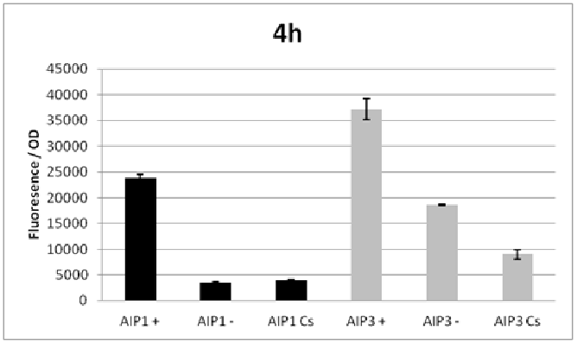

Figure 1
Figures are inserted as inline .png files when possible, .jpg, .gif, .tif otherwise are acceptable. Figure legends are always inserted in Word (right click – ‘insert caption’) and use “Heading 2” text to properly format in the TOC. Table legends are handled the same way. Figure images must be saved in a separate folder where the source data is saved.

Thoughts or questions. When you have a significant observation, question, confusing point or contradiction that you have identified in your data or protocol, use the “Heading 3” text heading on a descriptive brief title or single word heading so you can refer to it in your TOC later.

Protocol 1
1. This is the format for a protocol in your notebook.
2. The protocol title must be formatted in “Heading 2.”
3. Reagents which must be made for a specific protocol (buffers, solutions) should be listed in a “Reagents” Section, formatted in “Heading 3.”
4. The protocol must be in numerical steps.
5. Use standard notation and carefully describe units for your protocol.
6. Use ½” indent for protocol text.

Reagents
Specific buffers
For initial lab notebooks, write as much detail as possible. As time goes by you will be able to refer to written protocols by their heading and/or page number within the document. If you make any modifications to a protocol you must state how and why.

File Formatting Protocol
1. Filenames begin with your initials, an underscore, and the date, formatted as the last 2 digits of the year, the month, then the day, ex: “KMR_180920_Sample_file1v1.xls”
2. This ensures all files will be sorted by their creator and by their date. You must use this file formatting system for all data files (including photos) that will be shared with the lab.
Bibliography data will be saved as (author/date) and using Mendeley at this time with the TOC inserted by order cited at the end of the lab notebook in the Bibliography section.
Example is a recent publication (Ramsey and Dove, 2016).

September 2018

Thursday, September 20, 2018
To Do:
- Media prep
- ?
Results and Data:
Xxxx

Bibliography

Ramsey, K. M. and Dove, S. L. (2016) ‘ A response regulator promotes Francisella tularensis intramacrophage growth by repressing an anti-virulence factor ’, Molecular Microbiology. doi: 10.1111/mmi.13418.

