Table of Contents
Introduction 2
Figure 1 2
Protocol 1 2
Reagents 3
File Formatting Protocol 3
September 2019 4
Bibliography 12

Introduction

Thursday, September 20, 2018
To Do:
- Explain lab notebook formatting
- Media prep
Results and Data:
For each day, copy the previous entry headers and update the date. Save the same ongoing copy of the lab notebook to the lab google drive ONLY. Do not save separate physical copies. At the 1st of each new month, a read-only PDF file of the lab notebook must be saved and given to Dr. Ramsey electronically. File contents converted to PDF MUST NOT BE EDITED after PDF conversion. Continue to keep using the same word file until the end of the calendar year. New lab notebook files run in 6 month intervals.
For the To do list, update this each day with new tasks, as tasks are done, use the strikethrough font on the day they are completed and leave them out of the list on the next day.
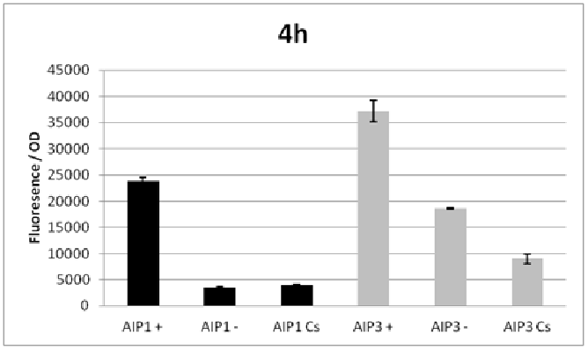

Figure 1
Figures are inserted as inline .png files when possible, .jpg, .gif, .tif otherwise are acceptable. Figure legends are always inserted in Word (right click – ‘insert caption’) and use “Heading 2” text to properly format in the TOC. Table legends are handled the same way. Figure images must be saved in a separate folder where the source data is saved.
Thoughts or questions. When you have a significant observation, question, confusing point or contradiction that you have identified in your data or protocol, use the “Heading 3” text heading on a descriptive brief title or single word heading so you can refer to it in your TOC later.

Protocol 1
1. This is the format for a protocol in your notebook.
2. The protocol title must be formatted in “Heading 2.”
3. Reagents which must be made for a specific protocol (buffers, solutions) should be listed in a “Reagents” Section, formatted in “Heading 3.”
4. The protocol must be in numerical steps.
5. Use standard notation and carefully describe units for your protocol.
6. Use ½” indent for protocol text.

Reagents
Specific buffers
For initial lab notebooks, write as much detail as possible. As time goes by you will be able to refer to written protocols by their heading and/or page number within the document. If you make any modifications to a protocol you must state how and why.

File Formatting Protocol
1. Filenames begin with your initials, an underscore, and the date, formatted as the last 2 digits of the year, the month, then the day, ex: “KMR_180920_Sample_file1v1.xls”
2. This ensures all files will be sorted by their creator and by their date. You must use this file formatting system for all data files (including photos) that will be shared with the lab.
Bibliography data will be saved as (author/date) and using Mendeley at this time with the TOC inserted by order cited at the end of the lab notebook in the Bibliography section.
Example is a recent publication (Ramsey and Dove, 2016).

September 2019

Monday, September 16, 2019
To Do:
- Pour LB agar plates with Jamie.
  - LB with added hygromycin
- Streak E. coli on plates to selectively grow for bacteria that utilize hygromycin.
  - Mini prep kit and transformation
Calculations:
(54 mg/ 1 mL) * (1000 ug/ 1 mg) * 500 mL
(500 mL * 200 / 54) / 1000
= 1.85185 mg/mL (to make)

25 mL * (1000 uL / 1 mL) = 25,000 uL total
C1V1=C2V2
25,000 = x * 200 ug/mL
25,000 * 200 ug/mL = x * 54,000 ug/mL
x = 92.5925 uL (hygromycin added to LB)
Procedure:
- Hygromycin 200 ug/mL
- 4 tubes that are 5 mL each
- 25 mL hygromycin supplemented LB media
- Kanamycin + LB 15 mL
- Add 25 mL kanamycin to 15 mL of LB
Tuesday, September 17, 2019
To Do:
- Make LB plates
  - 25 mL of LB for hygromycin
  - 15 mL of LB for kanamycin
- Add 15 uL of kanamycin to LB
- Add 92.6 uL of hygromycin to LB
Procedures:
- 5 mL of LB in each sterile tube (6 tubes total)
  - 2 kanamycin LB tubes
  - 4 hygromycin LB tubes
- pMP749 (kan)
- pMP720 (hyg)
- pMP672 (hyg)
- Culture tubes incubated overnight

Wednesday, September 18, 2018
To do:
- Culture tubes incubated overnight and mini prepped DNA
- Make CHA plates
- Electroporate cells

Procedures:
CHA Plates:
- 200 ug/mL of hygromycin
- 600 mL total CHA needed for plates
C1V1=C2V2
(54,000 ug/mL)(V1) = (200 ug/mL)(600 mL)
= 2.22 mL
Electroporations:
- 0.1x EB to clear the machine and set a standard
- Load 2 uL buffer solution onto the drop plate and click blank
- Press measure for DNA (2 uL)
Results and Data:
pMP720
- 215.0 ng/uL (Tube 1)
- 210.7 ng/uL (Tube 2)
pMP672
- 117.3 ng/uL (Tube 1)
- 102.5 ng/uL (Tube 2)
pMP749
- 543.2 ng/uL (Tube 1)
- 479.5 ng/uL (Tube 2)

Monday, September 23, 2019
To Do:
- Patch out Tn7 plates
- Count Tn7 plate colony numbers
Procedures:
- Take about 2 colonies from each plate
  - Refer to dilution table (LVS or deltaPmrA)
- Take well isolated colony and patch out onto agar plate, streaking the entire plate.

Results and Data:
- Plated on 9/20/19
- Controls for both = no colonies
  - Plated highest concentration of bacteria (remaining amount)
- LVS Control = 0 colonies (dilution of remaining amount plated)
- DeltaPmrA control = 0 colonies (dilution of remaining amount plated)
LVS-1 (pKR54)
500 uL : 88 colonies
100 uL : 20 colonies
20 uL : 4 colonies
Remaining : ~ 200 colonies
LVS-2 (pKR54)
500 uL : TMTC
100 uL : ~ 400-500 colonies
20 uL : 133 colonies
Remaining : TMTC
DeltaPmrA-1
500 uL : 39 colonies
100 uL : 17 colonies
20 uL : 2 colonies
Remaining : ~ 142 colonies
DeltaPmrA-1
500 uL : 24 colonies
100 uL : 10 colonies
20 uL : 0 colonies
Remaining : 36 colonies
Wednesday, September 25, 2019
To Do:
- Check plate results from previous experiment

Results and Data:
- (+) controls had the most amount of growth, both 100 uL and 20 uL.
  - Robust growth, lots of colonies
- (-) controls both has no growth in all plates
- Ligation 1 (100 uL): less growth when compared to ligation 1 with the remaining volume plated onto it. ~ 50 colonies and medium amount of growth
- Ligation 1 (remaining): most growth, hundreds of colonies
- Backbone ligation (100 uL): minimal growth, 1 colony seen
- Backbone ligation (remaining): ~ 30 colonies, less growth compared to ligation 1 with 100 uL plated
Thursday, September 26, 2019
To Do:
- Miniprep samples
- Nanodrop samples

Results and Data:
Nanodrop Data (blanked with EB):
Lig 1-1: 163.5 ng/uL
Lig 1-2: 268.7 ng/uL
Lig 1-3: 142.0 ng/uL
pKR47-1: 662.6 ng/uL
pKR47-2: 624.3 ng/uL
pKR47-3: 672.0 ng/uL

Monday, September 30, 2019
To Do:
- Diagnostic digests
  - Cut pKR56 using enzyme EcoR1 (expected bands at 2446 and 3296)
  - pKR57 – digest with EcoR1 and BamH1 (expected bands at 1694 and 4715)
  - pKR54 – cut with Pst1 (full size of plasmid band expected)
  - pKR55 – cut with Dra1 (expected bands at 4041 and 692)
Results and Data:
- used enzymes EcoR1, BamH1, Pst1, and Dra1 as explained.

October 2019

Tuesday, October 1, 2019
To Do:
- Pour LB Kanamycin plates with Dan
  - Agar/media premade by Jamie
Monday, October 7, 2019
To Do:
- Make MHB broth on Thursday or Friday
Results and Data:
Colony Counts
 | 20 uL | 500 uL | Remaining
pKR57  LVS Tn7 | TMTC | 96 | ~346
pKL02  LVS Tn7 | TMTC | No growth | No growth
LVS Tn7 control |  |  | No growth
pKR57-2  LVS Tn7 |  | 47 | ~99

Tuesday, October 8, 2019
To Do:
- Subculture bacteria and grow for 1 day
  - 1:10 ratio subculture
- Transfer 0.5 mL MHB into sterile tubes and place in shaking incubator to warm
- Supplement MHB
Wednesday, October 9, 2019
To Do:
- Use subcultures to plate bacteria to obtain isolated colonies
  - Trying to get rid of plasmid coding for hygromycin resistance

Wednesday, October 16, 2019
To Do:
- Nanodrop samples for Jamie.

Data:

Nanodrop data (for Jamie)
Sample | ng/uL
pKL116-1 | 273.4
pKL116-2 | 354.3
pKL116-3 | 167.9
pKL117-1 | 42.4
pKL117-2 | 30.5
pKL117-3 | 24.3

- Blanked with 0.1x EB

Tuesday, October 22, 2019
To Do:
- Supplement MHB agar (expires tomorrow)
  - 10 mL isovitalex
  - 5 mL 10% glucose
  - 5 mL 2.5% iron pyrophosphate

Thursday, October 24, 2019
To Do:
- Plating bacteria to lose hygromycin resistance
  - Already lost the kanamycin resistance
- Hygromycin plates:
  - LVS + pKR56 (resolvase)
  - 2 tubes
  - Plate: (2) 100 uL, (2) 500 uL, (4) remaining
- Kanamycin plates:
  - DeltaPmrA (Tn7 + PriM)
  - 3 tubes
  - Plate: (3) 500 uL, (6) remaining
Data:
- Hygromycin plates
  - LVS pKR56-1 and LVS pKR56-2
    - 100 uL (2 plates total), 500 uL (2 plates total), remaining amount (4 plates total)
- Kanamycin plates
  - DeltaPmrA + pKR57
    - 500 uL (1 plate), remaining amount (2 plates total)
- DeltaPmrA control
  - 1 kanamycin plated with the remaining amount

Monday, October 28, 2019
To Do:
- Lab meeting
- Work on presentation for lab meeting this week
- Make 10% glucose this week/before supplementing MHB
- Check on iron pyrophosphate stock and amount left

Monday, October 28, 2019
To Do:
- Work on lab presentation
  - How efficient is each plasmid?
  - Electroporations? Recovery time?
  - Include diagnostic digest data, important electroporation data
  - Take from Jamie’s Tn7 power point for reference
  - Why we want to use Tn7 and how Tn7 works
  - What does Tn7 allow us to do? What makes it so useful?

November 2019

Wednesday, November 6, 2019
To Do:
- Count colonies for pKR56 AFTER resolvase
- Plate cells grown on 10/29
- Make MHB and Iron pyrophosphate tomorrow
Data and Results:
Strain | Amount plated | Colony counts
 | 20 uL | ~ 184
pKR56-1 LVS Tn7 | 50 uL | ~ 360
 | 100 uL | ~ 612

Thursday, November 7, 2019
To Do:
- Supplement MHB broth
- Make 2.5% iron pyrophosphate
  - 1.25 g in 50 mL of type 1 DI H2O
  - We only make half of that so: 0.625g in 25 mL DI water

Thursday, November 14, 2019

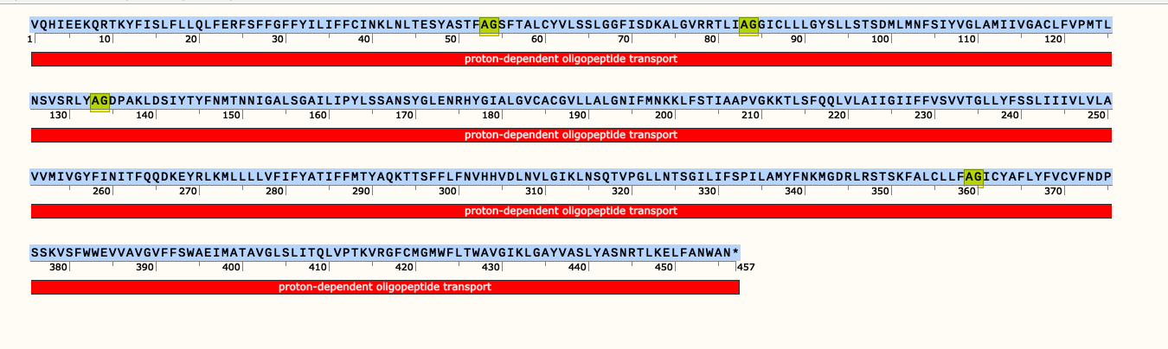

# WEBSEQUENCE Length: 456
# WEBSEQUENCE Number of predicted TMHs: 13
# WEBSEQUENCE Exp number of AAs in TMHs: 278.92565
# WEBSEQUENCE Exp number, first 60 AAs: 35.28826
# WEBSEQUENCE Total prob of N-in: 0.99766
# WEBSEQUENCE POSSIBLE N-term signal sequence
WEBSEQUENCE TMHMM2.0 inside 1 12
WEBSEQUENCE TMHMM2.0 TMhelix 13 35
WEBSEQUENCE TMHMM2.0 outside 36 47
WEBSEQUENCE TMHMM2.0 TMhelix 48 70
WEBSEQUENCE TMHMM2.0 inside 71 74
WEBSEQUENCE TMHMM2.0 TMhelix 75 97
WEBSEQUENCE TMHMM2.0 outside 98 106
WEBSEQUENCE TMHMM2.0 TMhelix 107 129
WEBSEQUENCE TMHMM2.0 inside 130 141
WEBSEQUENCE TMHMM2.0 TMhelix 142 164
WEBSEQUENCE TMHMM2.0 outside 165 178
WEBSEQUENCE TMHMM2.0 TMhelix 179 198
WEBSEQUENCE TMHMM2.0 inside 199 218
WEBSEQUENCE TMHMM2.0 TMhelix 219 238
WEBSEQUENCE TMHMM2.0 outside 239 241
WEBSEQUENCE TMHMM2.0 TMhelix 242 261
WEBSEQUENCE TMHMM2.0 inside 262 273
WEBSEQUENCE TMHMM2.0 TMhelix 274 291
WEBSEQUENCE TMHMM2.0 outside 292 316
WEBSEQUENCE TMHMM2.0 TMhelix 317 339
WEBSEQUENCE TMHMM2.0 inside 340 351
WEBSEQUENCE TMHMM2.0 TMhelix 352 371
WEBSEQUENCE TMHMM2.0 outside 372 385
WEBSEQUENCE TMHMM2.0 TMhelix 386 408
WEBSEQUENCE TMHMM2.0 inside 409 420
WEBSEQUENCE TMHMM2.0 TMhelix 421 443
WEBSEQUENCE TMHMM2.0 outside 444 456

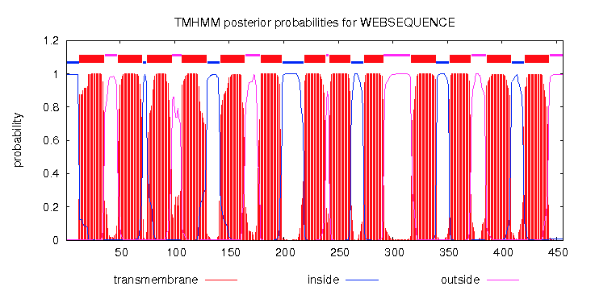
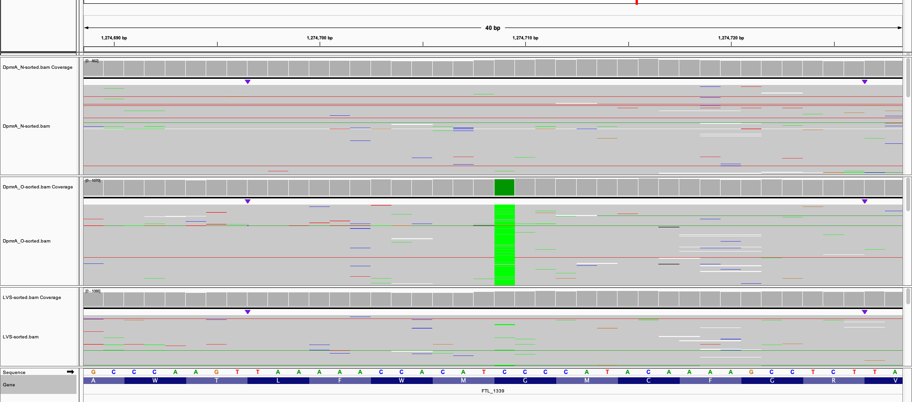
Friday, November 15, 2019
To do:
- Electroporate cells and let recover for 3 hours
- Plate cells after recovery and let incubate overnight

- 7 mL of MHB into 2 aliquoted tubes
- pKR54 helper plasmid
  - one sample (pKR54) and one control (delta pMRa)
- add 5 uL into the cuvette (at the notch on the side)
- Read in micropulser
  - 4.8= time constant shock pkr54
  - 4.9 = control time constant
- Wait 3 hours for cells to recover in shaking incubator
  - Put in at 11:20 AM
  - Take out and plate at 2:20 PM
- Plated 100 uL and remaining amount of both pKR57 and the delta pMRa control.
  - Spun down remaining for 1 minute at ???
- Plates put in incubator and left to grow for 3 days

Monday, November 18, 2019
To Do:
- Cross patch out 8 colonies on CHA and hygromycin plates
- Testing to see if we lost the hygromycin resistance
- Make new MHB broth and aliquot out 5 mL to put in shaking incubator
Completed:
- Cross patched to get rid of resolvase plasmid onto hygromycin and CHA plates
- Patched out pKR54 deltaPmrA onto hygromycin plates to test if we got rid of the hygromycin resistance

Wednesday, November 20, 2019
To Do:
- Start making electrocompetent cells
Procedure:
- 5 mL 10% sucrose – 5 washes and spinning them down
- Scraped up cells (DeltaPmrA Tn7) from CHA plate
- 500 uL sucrose to resuspend then add 500 uL more to mix resuspension, then centrifuge.
- Repeat adding 1 mL of sucrose each time and washing, then centrifuging tube for 3 minutes each time.
- Remove sucrose each time (leave pellet) after centrifuge (3 minutes at 10,000 rpm)
- Resuspend with new 1000 uL sucrose and centrifuge again
- After 5th and final wash, remove all the sucrose
- Add 50 uL sucrose and resuspended the cell pellet
- Transfer 150 uL of suspended cells into a new tube and freeze (labeled: “DeltaPmrA helper Tn7 electrocompetent 11/20”)

Wednesday, November 20, 2019
To do:
- Freeze down cells to start make electrocompetent cells tomorrow

Completed:
- Scraped up cells from plate and transferred to tube
- Froze cells overnight

Thursday, November 21, 2019
To Do:
- Electroporate DeltaPmrA helper Tn7 cells
- Spread plate cells
Procedure:
- Aliquot 7 mL of MHB into 2 tubes (14 mL total of MHB)
- Put tubes into shaking incubator to warm agar
- 5 mL of pKR57 plasmid into each sample
- Add 50 uL of cells
Readings/Data:
Sample 1 – 0.70 ng/uL
Sample 2 – 1.30 ng/uL
*Finished around 9:25 AM and put in incubator
- *around 2:45 PM* plated the cells on 4 kanamycin plates using the spread plate method
- spread plated remaining (entire) amounts
- Incubated plates at 37 Degrees Celsius

December 2019

Thursday, November 21, 2019
To Do:
- Curing strains of hygromycin resistance
- Use CHA plates with no added antibiotics
  - DeltaPmrA PriM+ 1-1
  - DeltaPmrA PriM+ 2-1
  - DeltaPmrA PriM+ 2-2
  - DeltaPmrA PriM+ 2-3
- Streaked for isolation using single colonies

Bibliography

Ramsey, K. M. and Dove, S. L. (2016) ‘ A response regulator promotes Francisella tularensis intramacrophage growth by repressing an anti-virulence factor ’, Molecular Microbiology. doi: 10.1111/mmi.13418.

