Transposon Insertion Sequencing
https://training.galaxyproject.org/training-material/topics/genome-annotation/tutorials/tnseq/tutorial.html
- Functionally annotate bacterial genomes
- Transposon inserts itself into gene -> function is disrupted
- To determine the insertion site, sequence genome, whatever is blocked then the gene was responsible for the loss of function
- 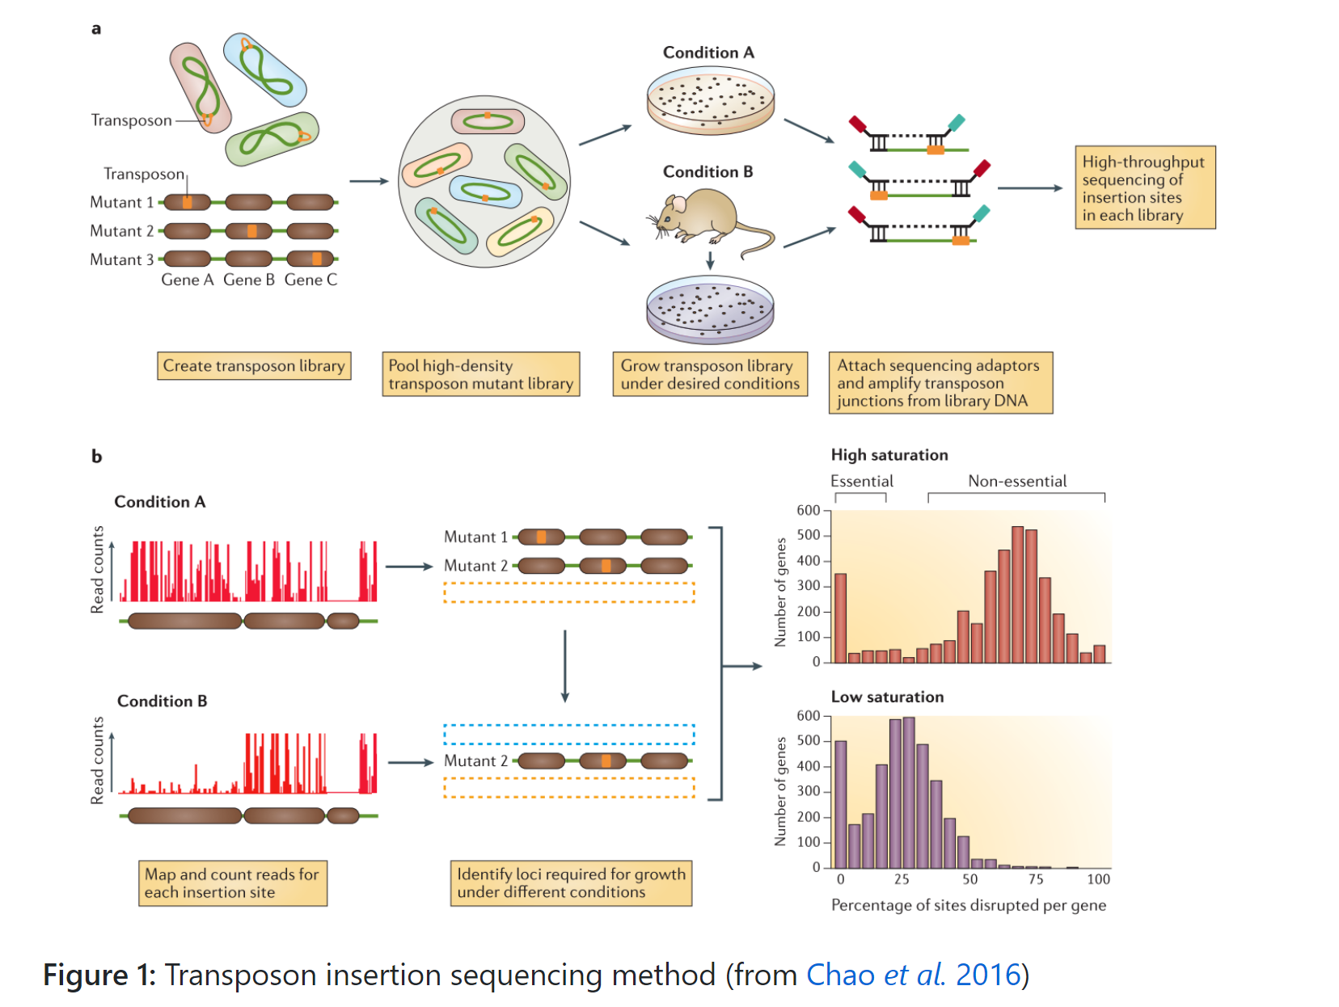
- Building a TnSeq library
  - Randomly pooled transposon
    - Mariner-based
    - Tn5-based
  - Defined sequence transposon

