Plating protocol
- Prepare 96 well plate, cuvette, parafilm, freshwater samples, 6 square CHAH-KAN plates, and 1xPBS
- Test plate to see if it is dry enough by pipetting 10 uL of freshwater and watching it drip.
- Pipette 180 uL of 1 x PBS into wells row B1/2/3-F1/2/3.
  - Use multichannel and a reservoir.
  - 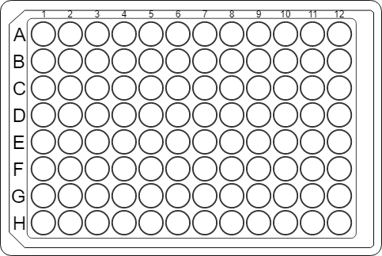
- Swirl for 10-15 seconds, then pipette 200 uL from 250 mL flask of resuspended cells and freshwater into A1 and A2 and A3 (this is in the 4°C environmental room on the left hand side shelf towards door)
  - Use a 200 uL pipette.
  - At this time, you can take out 15 mL into a 50 mL conical to pellet later for all three flasks.
- Using the multichannel pipette, pipette 20 uL from A into B. Mix 150 uL of the volume three times.
- Repeat step 3 for B to C, C to D.
  - hint = say it out loud so you don’t lose your place.
  - Change the tip each time!
- Use the less volume multichannel pipette set to 10 uL and change the orientation of the plate to vertical before starting the dripping process.
- Pipette 10 ul from A1-F1 onto the plate, letting each drip down the plate.
  - Remember to stay within the 6 inches of the flame, don’t put the handle of the multichannel pipette to the flame, have the plates at roughly a 45-degree angle, and place to dry in between two pipette boxes at the same angle.
  - Two plates for each column. So should be 6 total plates
  - Place in incubator for 2 days and then pull out and count (asked Kathryn to count)

Pelleting
- Take 15 mL from each flask into a 50 mL conical and max spin for 5 minutes
        - Should have three 50 mL
        - Remove supernatant as best as possible
    - Removing the supernatant was a tad tricky, the pellet was very loose.
- Freeze (I have put them in the -80 bottom rack)
  - Label with day 14, LVS+pKR141, and date

