Table of Contents
Introduction 2
Figure 1 2
Thoughts or questions. 2
Protocol 1 2
Reagents 3
File Formatting Protocol 3
September 2018 4
Bibliography 5

May 2023

Wednesday, May 24, 2023
To Do:
- Tour lab and go over basic information
- Practice micropipetting.
- Observe Kira conduct Electroporatiom into S. Aureus with smaller measurements (smaller scale)
- Box up and clean glass waste and bring to dumpster
—Today was my first time in the lab as a surf student! I got an overview and layout of the lab and practiced micropipetting. I also observed Kira making competent cells for our experiment, and we scaled down in our measurements to work with a smaller unit. We all took a trip to the 2nd floor as well to see how to properly dispose of clean glass and bring it to the dumster.
Results and Data:
Competent cells
- Overnight culture in TSB at 37°C with shaking. 4 ml in 30ml tube.
- Dilute overnight culture of S. aureus back to about an OD600nm of 0.5 in 50 ml of
- prewarmed TSB. Approx.: 3 ml of overnight culture + 47ml prewarmed TSB.
- Re-incubate for 30 min. After 30 min the culture is usually between OD600nm 0.8-0.9.
- Transfer to 50ml tubes and let in ice-water slurry for 10 min (keep cold from now on).
- Harvest the cells in a centrifuge at 4105 x g for 10 minutes at 4°C.
- Discard the supernatant, add 45 ml sterile ice cold milliQ water. No need to resuspend the pellet yet.
- Harvest the cells in a centrifuge at 4105 x g for 10 minutes at 4°C.
- Discard the supernatant, resuspended the pellet in 10ml sterile ice cold 10% glycerol.
- Harvest the cells in a centrifuge at 4105 x g for 10 minutes at 4°C.
- Discard the supernatant, resuspended the pellet in 1.8ml sterile ice cold 10% glycerol. Transfer to 2 ml tubes.
- Harvest the cells in a microcentrifuge (12000 rpm) for 2 minutes at 4°C.
- Discard the supernatant, resuspended the pellet in 1ml sterile ice cold 10% glycerol. Transfer to 2 ml tubes.
- Harvest the cells in a microcentrifuge (12000 rpm) for 2 minutes at 4°C.
- Discard the supernatant, resuspended the pellet in 250 ul sterile ice cold 10% glycerol.
- Dispense 5 x 50 ul aliquots and freeze at -80°C.

Electroporation
- Thaw out aliquots on ice for 5 min then place at room temperature for 5 min (and follow the rest of the protocol at RT).
- Centrifuge at 5,000xg for 1 min. Discard the supernatant and resuspend the cells in 50 ul of 10% glycerol / 500 mM sucrose.
- Add up to 5ug-purified plasmid to the cells, mix and add to 0.1 cm electroporation cuvette. Up to 5ul of plasmid (dialyzed 20’ against H₂O with Millipore filters).
- Pulse 21 kV/cm, 100 Ω and 25uF. Time constant is usually about 2.0-2.4 ms.
- Immediately add 1 ml of TSB + 500mM sucrose and mix. (Dissolve 6.85g of sucrose in 40ml TSB and filter sterilize)
- Transfer to a new tube and incubate at adequate temperature for 1-1.5h. (30C for RN4220; 42C for HG003)
- Plate out on TSA + antibiotic. (3 ug/mL tet)

June 2023
Thursday June 1st, 2023
To Do:
- Follow S. Aureus protocol with given measeurments
- Aliquoting Western Shore Ladder and micropipetting
- Make MHB unsupplemented stored in cabinet indefinitely (media)

—Kira and I successfully prepared KRSA-2 competent cells by strictly adhering to the protocol without any scaling down. We then proceeded to perform an electroporation using an empty pEPSA5 vector, as well as a control without any DNA.

Results and Data:
Competent cells
- Overnight culture in TSB at 37°C with shaking. 4 ml in 30ml tube.
- Dilute overnight culture of S. aureus back to about an OD600nm of 0.5 in 50 ml of
- prewarmed TSB. Approx.: 3 ml of overnight culture + 47ml prewarmed TSB.
- Re-incubate for 30 min. After 30 min the culture is usually between OD600nm 0.8-0.9.
- Transfer to 50ml tubes and let in ice-water slurry for 10 min (keep cold from now on).
- Harvest the cells in a centrifuge at 4105 x g for 10 minutes at 4°C.
- Discard the supernatant, add 45 ml sterile ice cold milliQ water. No need to resuspend the pellet yet.
- Harvest the cells in a centrifuge at 4105 x g for 10 minutes at 4°C.
- Discard the supernatant, resuspended the pellet in 10ml sterile ice cold 10% glycerol.
- Harvest the cells in a centrifuge at 4105 x g for 10 minutes at 4°C.
- Discard the supernatant, resuspended the pellet in 1.8ml sterile ice cold 10% glycerol. Transfer to 2 ml tubes.
- Harvest the cells in a microcentrifuge (12000 rpm) for 2 minutes at 4°C.
- Discard the supernatant, resuspended the pellet in 1ml sterile ice cold 10% glycerol. Transfer to 2 ml tubes.
- Harvest the cells in a microcentrifuge (12000 rpm) for 2 minutes at 4°C.
- Discard the supernatant, resuspended the pellet in 250 ul sterile ice cold 10% glycerol.
- Dispense 5 x 50 ul aliquots and freeze at -80°C.

Electroporation
- Thaw out aliquots on ice for 5 min then place at room temperature for 5 min (and follow the rest of the protocol at RT).
- Centrifuge at 5,000xg for 1 min. Discard the supernatant and resuspend the cells in 50 ul of 10% glycerol / 500 mM sucrose.
- Add up to 5ug-purified plasmid to the cells, mix and add to 0.1 cm electroporation cuvette. Up to 5ul of plasmid (dialyzed 20’ against H₂O with Millipore filters).
- Pulse 21 kV/cm, 100 Ω and 25uF. Time constant is usually about 2.0-2.4 ms.
- Immediately add 1 ml of TSB + 500mM sucrose and mix. (Dissolve 6.85g of sucrose in 40ml TSB and filter sterilize)
- Transfer to a new tube and incubate at adequate temperature for 1-1.5h. (30C for RN4220; 42C for HG003)
- Plate out on TSA + antibiotic. (3 ug/mL tet)

Mueller-Hinton broth protocol- by Jamie Wandzilak
For 500 mL of MHB
1. Weigh out 10.5g of Mueller-Hinton broth into 1L square-bottle
2. Add 500mL of ddiH₂O (type I)
3. Autoclave on 30’ liquid cycle, filling the water bin up
4. Cool down to 37 ̊C or cooler
5. Can keep this sterile media indefinitely without supplements
6. Add 5mL of 10% glucose
7. Add 5mL of 2.5% iron pyrophosphate
8. Add isovitalex (combine 10mL from liquid vial with solids, add entire volume to broth)
9. Can keep this supplemented media for 2 weeks, storing at 4 ̊C

Reagents
Mueller-Hinton Broth media dry
10% Glucose (filter-sterilized)
2.5% Iron pyrophosphate (1.25g iron pyrophosphate in 50mL of ddiH₂O (type 1), dissolved overnight, fresh solution every 2 weeks (filter-sterilized)
Isovitalex (commercially available)

Friday June 2nd, 2023
To Do:
1. Observe transformation plates made from previous day
2. Make 1 kb ladder
1)Transformation plates:
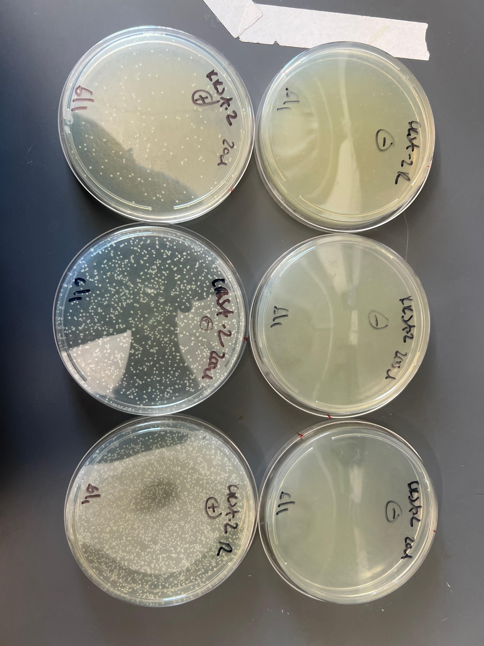
–-The top KRSA-2 Negative, The bottom are KRSA-2 positive (lots of activity shown). We were able to successfully grow the cultures and view them at different densities. KRSA-1 didn't do as well as KRSA-2 did when growing them. We essentially put a plasmid into plates that have antibiotics. With this experiment it is considered an empty vector as they do not have genes of interest for our larger experiment. This is all done to test if they can take up the exogenous dna.-cells that now have a foreign plasmid in them. (extrogenous dna)

2) Making ready-to-load 1 Kb Plus DNA ladder stock
Combine:
60 uL 1 Kb Plus DNA ladder
100 uL 6x Orange-G dye
140 uL water (molecular biology grade)
300 uL total volume
Load 10 uL ladder per lane

—When making this we scaled it up so that we had 5 aliquots of it. With a volume totaling 1,500.

Monday June 5th, 2023
To Do:
1. Transformation Wild type MT into KRSA-2 with electroporation.
2. Patching cells and streaking for isloation
3. Pour LBcm¹⁰ Plates

—Layout of the plan for today:
- Settings up pKR185(wt MT strain of SA) For the transformation. Concentration is 74.3ng/ul. So we will add 3ul to the component cells. We will be following the S. aureus Protocol to do this. Combining the two strains for a permanent stock, later on.
- -Consolidate each miniprep into one tube for storage in -20 C (yellow sticker)
- -take out 5ul of each of those to store in permanent plasmid stocks in -80 C (green sticker)

- LB Plates Protocol

-If pouring plates later:
Let LB-agar solidify and keep in the lab. When you want to pour plates, heat up LB-agar on hotplate, stirring, until entirely melted (watch carefully so it doesn’t boil over! Don’t walk away). Let agar cool down or place in a warm oven (50°C) until ready to pour plates.
-If pouring plates the same day:
After autoclaved, keep in warm oven (50°C) until ready to pour plates

Pouring plates
- Add antibiotic using aseptic technique if necessary. Typical antibiotic concentrations:
Antibiotic | Stock Concentration | Working Concentration (Concentration in plates)
Ampicillin | 100 mg/mL | 100 µg/mL
Carbenicillin | 100 mg/mL | 100 µg/mL
Kanamycin | 50 mg/mL | 50 µg/mL
- Keep antibiotic stocks on ice. For kanamycin, add 500 uL to 500 mL of LB-agar media. Stir on stirplate to mix media.
- Open a new sleeve of sterile plates. Don’t open plates unless next to flame.
- Next to flame, open foil top of flask. Pass flask opening through flame.
- Open a plate next to flame and pour ~20-25 mL LB-agar into plate; the bottom of the plate should be covered in media.
- Continue to pour media into plates until media is gone.
- Immediately rinse out flask
- Stack plates and mark the side to indicate which antibiotic is used. (blue = kanamycin, black = carbenicillin / ampicillin).
- Let plates sit at room temperature for one night, then store at 4°C with tape indicating date poured. Don’t use antibiotic plates older than 3 months.
Tuesday June 6th, 2023
To Do:
1. Make new LB
2. Follow Freeze down Strain (S. Aureus) protocol. (Glycerol Stock)
3. Transfromations Pkr199 and Pkr186 mt.

- Preparing LB-agar
- For 500 mL of LB-agar, weigh out the following components and add to a 1 L (non-baffled) flask:
  - 6 g agar
  - 5 g NaCl
  - 5 g Tryptone
  - 2.5 g Yeast extract
- Add stirbar to flask
- Add 500 mL ddiH20
- Mix on stirplate until components are dissolved
- Cover top of flask with foil and add a small piece of autoclave tape
- Autoclave on 30 minute liquid cycle

2 batches of 500 ml.

Make Glycerol Stock
Use aseptic technique
- Per strain, label 2 cryotubes with strain number. Include SA, strain number, genotype, date.
- Add 200 uL sterile 75% glycerol to each tube (2 per strain).
- In a sterile 2 mL tube (1 per strain), add 400 uL of LB
- Resuspend patch (all of what you have) in LBto homogeneity
- Correct volume to 1700 uL (add 2x 650 uL LB)
- Transfer 800 uL to each cryotube (final volume should be 1 mL)
- Vortex cryotube
- Quickly spin (mini-fuge) to get liquid to the bottom of the tube
Strains that were froze down
-SA LR-M1
-SA LR-M3
-SA-LR-M4
SA-113
- Transformed pKR186 and pKR199 into KRSA-2.
- Got an Arc on the negative control.

Wednesday June 7th, 2023
To Do:
1. Make SA LR-M1 competent
2. Make Glycerol stocks

Competent cells
- Overnight culture in TSB at 37°C with shaking. 4 ml in 30ml tube.
- Dilute overnight culture of S. aureus back to about an OD600nm of 0.5 in 50 ml of
- prewarmed TSB. Approx.: 3 ml (5ml) of overnight culture + 47ml 50ml prewarmed TSB.
- Re-incubate for 30 min. After 30 min the culture is usually between OD600nm 0.8-0.9.
- Transfer to 50ml tubes and let in ice-water slurry for 10 min (keep cold from now on).
- Harvest the cells in a centrifuge at 4105 x g for 10 minutes at 4°C.
- Discard the supernatant, add 45 ml sterile ice cold milliQ water. No need to resuspend the pellet yet.
- Harvest the cells in a centrifuge at 4105 x g for 10 minutes at 4°C.
- Discard the supernatant, resuspended the pellet in 10ml sterile ice cold 10% glycerol.
- Harvest the cells in a centrifuge at 4105 x g for 10 minutes at 4°C.
- Discard the supernatant, resuspended the pellet in 1.8ml sterile ice cold 10% glycerol. Transfer to 2 ml tubes.
- Harvest the cells in a microcentrifuge (12000 rpm) for 2 minutes at 4°C.
- Discard the supernatant, resuspended the pellet in 1ml sterile ice cold 10% glycerol. Transfer to 2 ml tubes.
- Harvest the cells in a microcentrifuge (12000 rpm) for 2 minutes at 4°C.
- Discard the supernatant, resuspended the pellet in 250 ul sterile ice cold 10% glycerol.
- Dispense 5 x 50 ul aliquots and freeze at -80°C.

Electroporation
- Thaw out aliquots on ice for 5 min then place at room temperature for 5 min (and follow the rest of the protocol at RT).
- Centrifuge at 5,000xg for 1 min. Discard the supernatant and resuspend the cells in 50 ul of 10% glycerol / 500 mM sucrose.
- Add up to 5ug-3ml purified plasmid to the cells, mix and add to 0.1 cm electroporation cuvette. Up to 5ul of plasmid (dialyzed 20’ against H₂O with Millipore filters).
- Pulse 21 kV/cm, 100 Ω and 25uF. Time constant is usually about 2.0-2.4 ms.
- Immediately add 1 ml of TSB + 500mM sucrose and mix. (Dissolve 6.85g of sucrose in 40ml TSB and filter sterilize)
- Transfer to a new tube and incubate at adequate temperature for 1-1.5h. (30C for RN4220; 42C for HG003)
- Plate out on TSA + antibiotic. (3 ug/mL tet)

Highlighted in red are the changes we made to the protocol

Make Glycerol Stock
Use aseptic technique
- Per strain, label 2 cryotubes with strain number. Include SA, strain number, genotype, date.
- Add 200 uL sterile 75% glycerol to each tube (2 per strain).
- In a sterile 2 mL tube (1 per strain), add 400 uL of LB
- Resuspend patch (all of what you have) in LBto homogeneity
- Correct volume to 1700 uL (add 2x 650 uL LB)
- Transfer 800 uL to each cryotube (final volume should be 1 mL)
- Vortex cryotube
- Quickly spin (mini-fuge) to get liquid to the bottom of the tube
Strain that were froze down (KRSA-2 PKR-185 1,2,3,4)
Thursday June 8th, 2023
To Do:
1. Miniprep cultures

Purification of plasmid DNA from S. aureus by alkaline Lysis

Birnbiom, H. C. 1983. A rapid alkaline extraction method for the isolation of plasmid DNA Methods Enzymol 100:243-255
.QIAprep Spin Miniprep Kit Protocol adapted to S. aureus (Marco Palma)

- This protocol is designed for purification of up to 20 mg of high-copy plasmid DNA from 1-5 ml overnight cultures of S. aureus. (Overloading the system with too many cells will reduce the yield.)
- Grow 5 ml broth culture or plate of S. aureus.
- Spin culture at 4000 rpm for 10 min. Remove supernatant and add, (OR, suspend 2 loops of culture from a plate in) 700 ml TE (10 mM TrisCl, pH 8.0, 1 mM EDTA)
- Add 500 ml cold Acetone mix (50% acetone, 50% absolute ETOH, kept in freezer).
- Incubate 5 min on ice
- Spin 2 min at 14000 rpm
- Wash the pellet with 1 ml TE (it helps to completely resuspend the pellet), spin and discard sup.
- Add 3 ml 10 mg/mL lysostaphin to the cell pellet. (Vortexing the dry pellet briefly at this point helps resuspend the pellet when buffer is added, and seems to help lysis).
- Resuspend pelleted bacterial cells in 250 ml of Buffer P1 and transfer to a microcentrifuge tube.
- Incubate at 37° C for at least 1 hr. (Check for clearing)
- Proceed with QIAprep protocol at step 2:

“Add 250 ml of buffer P2 and gently invert the tube 4-6 times to mix, or until the solution becomes viscous and slightly clear.” Do not allow the lysis reaction to proceed for more than 5 min. etc.

4. Add 350 pl Buffer N3 and mix immediately and thoroughly by inverting the tube 4-6
times. If using LyseBlue reagent, the solution will turn colorless.

5. Centrifuge for 10 min at 13,000 rpm (~17,900 x g) in a table-top microcentrifuge.

6. Apply 800 pl supernatant from step 5 to the QiAprep 2.0 spin column by pipetting. For
centrifuge processing, follow the instructions marked with a triangle (A). For vacuum
manifold processing, follow the instructions marked with a circle (®). A Centrifuge for
30-60 s and discard the flow-through, or • apply vacuum to the manifold to draw the
solution through the QIAprep 2.0 spin column and switch off the vacuum source.

7.Recommended; Wash the QIAprep 2.0 spin column by adding 0.5 ml Buffer PB.
Centrifuge for 30-60s and discard the flow-through, or • apply vacuum to the manifold
to draw the solution through the QIAprep 2.0 spin column and switch off the vacuum
source. Note: This step is only required when using endA+ strains or other bacteria strains with
high nuclease activity or carbohydrate content.

8. Wash the Q/Aprep 2.0 spin column byadding 0 75 ml Bulfer PE. A Centrifuge for
30-60s and discard the flow-through, or © apply vacuum to the manifold to draw the
solution through the QAprep 2.0 spin column and switch off the vacuum source. Transfer
the QIAprep 2.0 spin column to the collection tube.

9. Centrifuge for 2 min to remove residual wash buffer.

10. Place the QIAprep/2.0 column in a clean 1.5 ml microcentrifuge tube. To elute DNA,
add 50 ul Buffer"EB (10 mM TrisCI, pH 8.5) or water to the center of the QIAprep 2.0
spin column, let stand for 1 min, and centrifuge for 1 min.

11. If the extracted DNA is to be analyzed on a gel, add 1 volume of Loading Dye to 5
volumes of purified DNA. Mix the solution by pipetting up and down before loading the
gel.

Additional Steps:
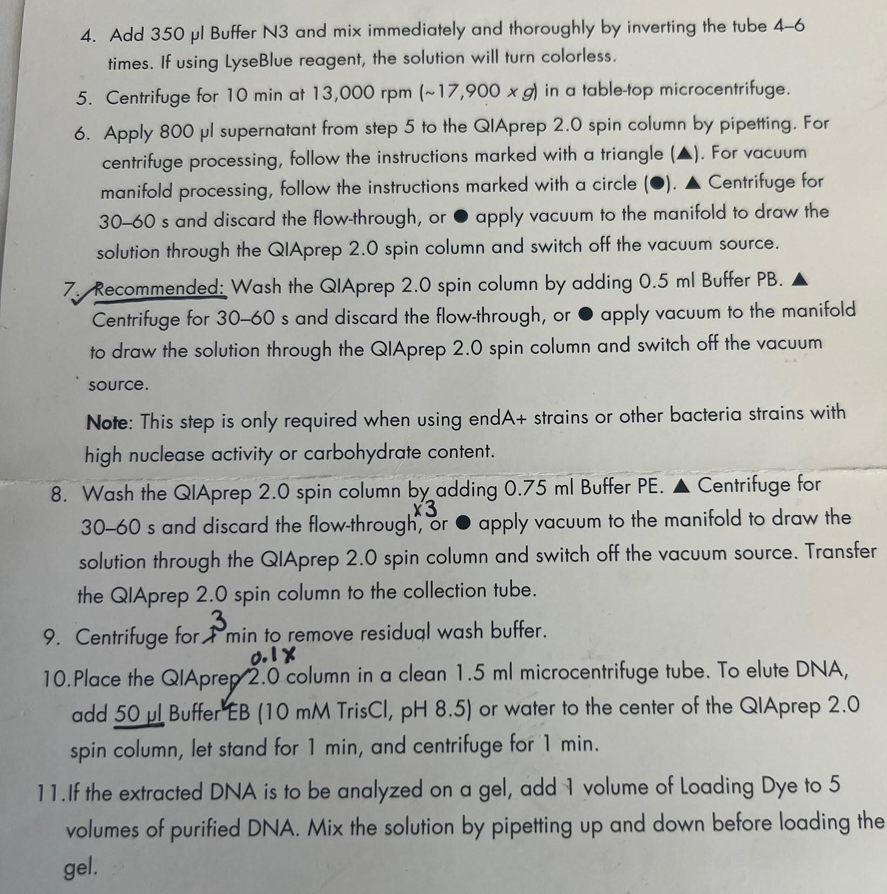

NANODROP RESULTS:
# | Sample ID | Nucleic Acid | Unit | A260 (Abs) | A280 (Abs) | 260/280 | 260/230 | Sample Type | Factor
1 | pKR199-1 | 85.1 | ng/µl | 1.702 | 0.91 | 1.87 | 2.65 | DNA | 50
2 | pKR199-2 | 71.3 | ng/µl | 1.427 | 0.727 | 1.96 | 2.01 | DNA | 50
3 | pKR199-3 | 93.2 | ng/µl | 1.865 | 0.977 | 1.91 | 2.59 | DNA | 50
4 | pKR199-4 | 70.8 | ng/µl | 1.416 | 0.722 | 1.96 | 2.87 | DNA | 50
5 | pKR186-1 | 43.2 | ng/µl | 0.864 | 0.472 | 1.83 | 1.84 | DNA | 50
6 | pKR186-2 | 66.4 | ng/µl | 1.328 | 0.728 | 1.82 | 1.93 | DNA | 50
7 | pKR186-3 | 48.2 | ng/µl | 0.964 | 0.531 | 1.82 | 1.89 | DNA | 50
8 | pKR186-4 | 45 | ng/µl | 0.899 | 0.491 | 1.83 | 1.85 | DNA | 50

Friday June 9th, 2023
To Do:
1. Make KRSA-1 competent

Making cells components

- We took out our overnight culture in LB at 37 ºC shaking

- Diluted culture of SA OD600nm 500ul of LB and 500ul of culture
  - Dilution concentration of Sample 1-(0.347), Sample 2- (0.328)
  - Original concentration (Actual reading)- Sample 1-(0.694), Sample 2(0.656)

- Incubate for 30 min in sha

- Checked concentration for 2nd time
  - Dilution concentration of Sample 1 (0.445), Sample 2 - (0.420)
  - Original concentration (Actual reading)- Sample 1- (0.89), Sample 2- (0.84)

- Get Culture cold, and place 50ml tube in ice water for 10 mins

- Get centrifuge cold with snowflake button

- Harvest cells in centrifuge at 4105x g for 10 min at 4ºC.

- Remove supernatant and add 45 ml Sterile Ice cold milliQ water.

- Harvest the cells

- Remove supernatant then resuspend pellet in 10 ml sterile ice cold 10% glycerol

- Harvest the cells

- Remove supernatant resuspended in 1.8ml sterile ice cold 10% glycerol and transfer to 2ml Tubes

- Harvest the cells in microcentrifuge (12000 rpm) for 2 min at 4ºC.

- Remove supernatant and resuspend pellet in 1 ml sterile ice cold 10% glycerol

- Harvest the cells in microcentrifuge

- Remove supernatant and resuspend in 250ul sterile ice cold 10% glycerol

- Dispense 5 x 50 ul aliquots and freeze at -80ºC

Wednesday June 10th, 2023
To Do:
- Make LB Agar and Pour Plates
- Make More LB Broth

-Making LB-agar plates

Preparing LB-agar
- For 500 mL of LB-agar, weigh out the following components and add to a 1 L (non-baffled) flask:
  - 6 g agar
  - 5 g NaCl
  - 5 g Tryptone
  - 2.5 g Yeast extract
- Add stirbar to flask
- Add 500 mL ddiH20
- Mix on stirplate until components are dissolved
- Cover top of flask with foil and add a small piece of autoclave tape
- Autoclave on 30 minute liquid cycle

If pouring plates later:
Let LB-agar solidify and keep in lab. When you want to pour plates, heat up LB-agar on hotplate, stirring, until entirely melted (watch carefully so it doesn’t boil over! Don’t walk away). Let agar cool down or place in warm over (50°C) until ready to pour plates.
If pouring plates the same day:
After autoclaved, keep in warm oven (50°C) until ready to pour plates

Pouring plates
- Add antibiotic using aseptic technique if necessary. Typical antibiotic concentrations:
Antibiotic | Stock Concentration | Working Concentration (Concentration in plates)
Ampicillin | 100 mg/mL | 100 µg/mL
Carbenicillin | 100 mg/mL | 100 µg/mL
Kanamycin | 50 mg/mL | 50 µg/mL
- Keep antibiotic stocks on ice. For kanamycin, add 500 uL to 500 mL of LB-agar media. Stir on stirplate to mix media.
- Open a new sleeve of sterile plates. Don’t open plates unless next to flame.
- Next to flame, open foil top of flask. Pass flask opening through flame.
- Open a plate next to flame and pour ~20-25 mL LB-agar into plate; the bottom of the plate should be covered in media.
- Continue to pour media into plates until media is gone.
- Immediately rinse out flask
- Stack plates and mark the side to indicate which antibiotic is used. (blue = kanamycin, black = carbenicillin / ampicillin).
- Let plates sit at room temperature for one night, then store at 4°C with tape indicating date poured. Don’t use antibiotic plates older than 3 months.

LB Media

Preparing LB media
- For 250 mL of LB, weigh out the following components and add to a 500 mL bottle:
  - 2.5 g NaCl
  - 2.5 g Tryptone
  - 1.25 g Yeast extract
- Add 250 mL type I ddiH20
- Close tightly and shake to mix
- Loosen cap and add a small piece of autoclave tape with the date
- Autoclave on 30 minute liquid cycle
- Sterile media can be stored indefinitely

Thursday June 11th , 2023
To Do:
- Transform minipreps into KRSA-1

Electroporation
- Thaw out aliquots on ice for 5 min then place at room temperature for 5 min (and follow the rest of the protocol at RT).
- Centrifuge at 5,000xg for 1 min. Discard the supernatant and resuspend the cells in 50 ul of 10% glycerol / 500 mM sucrose.
- Add up to 5ug-purified plasmid to the cells, mix and add to 0.1 cm electroporation cuvette. Up to 5ul of plasmid (dialyzed 20’ against H₂O with Millipore filters).
-Used 3ul plasmid for KRSA-186 and Empty Vector, and used 5ul plasmid for 199ul
- Pulse 21 kV/cm, 100 Ω and 25uF. Time constant is usually about 2.0-2.4 ms.
-Got Arcs on KRSA-186, No DNA and Empty Vector
- Immediately add 1 ml of TSB + 500mM sucrose and mix. (Dissolve 6.85g of sucrose in 40ml TSB and filter sterilize)
- Transfer to a new tube and incubate at adequate temperature for 1-1.5h. (30C for RN4220; 42C for HG003)
- Plate out on TSA + antibiotic. (3 ug/mL tet)

Friday June 16th, 2023
To Do:
- View Transformations
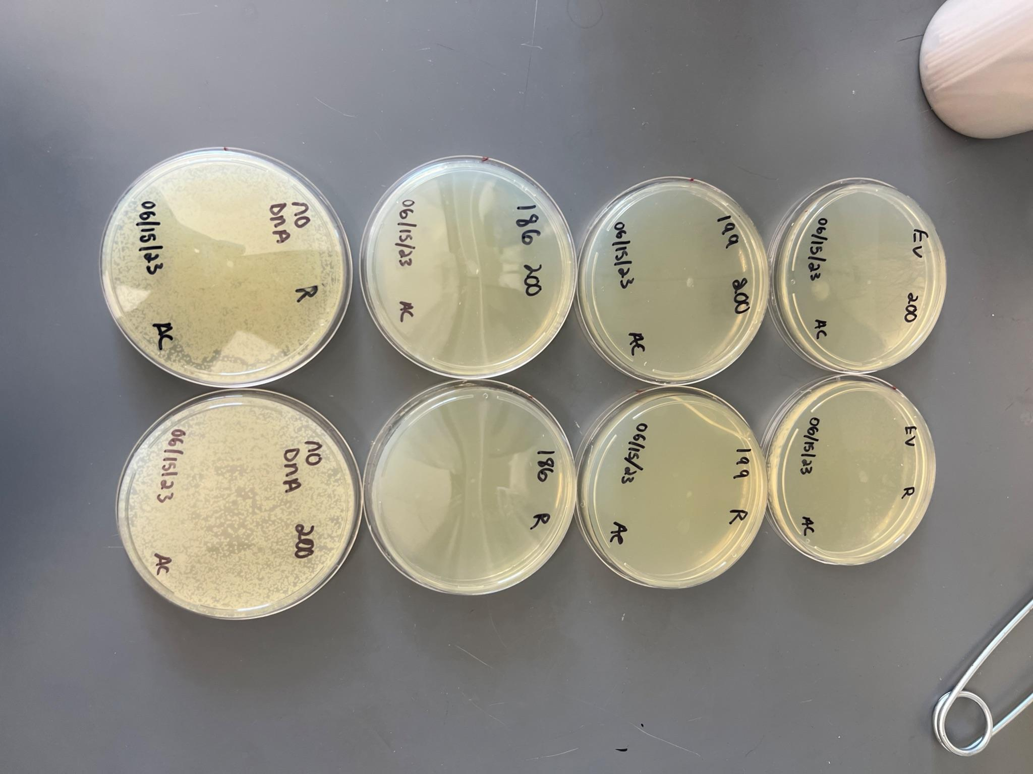

This was my first time doing transformations on my own and I believe the acs and the mistakes resulted in me having cells growing in the No Dna plates. I also got a few arcs the other day and could have led to these results.

Tuesday June 20th, 2023
To Do:
- Pour LB Agar plates.

If pouring plates later:
Let LB-agar solidify and keep in lab. When you want to pour plates, heat up LB-agar on hotplate, stirring, until entirely melted (watch carefully so it doesn’t boil over! Don’t walk away). Let agar cool down or place in warm over (50°C) until ready to pour plates.
If pouring plates the same day:
After autoclaved, keep in warm oven (50°C) until ready to pour plates

Pouring plates
- Add antibiotic using aseptic technique if necessary. Typical antibiotic concentrations:
Antibiotic | Stock Concentration | Working Concentration (Concentration in plates)
Ampicillin | 100 mg/mL | 100 µg/mL
Carbenicillin | 100 mg/mL | 100 µg/mL
Kanamycin | 50 mg/mL | 50 µg/mL
- Keep antibiotic stocks on ice. For kanamycin, add 500 uL to 500 mL of LB-agar media. Stir on stirplate to mix media.
- Open a new sleeve of sterile plates. Don’t open plates unless next to flame.
- Next to flame, open foil top of flask. Pass flask opening through flame.
- Open a plate next to flame and pour ~20-25 mL LB-agar into plate; the bottom of the plate should be covered in media.
- Continue to pour media into plates until media is gone.
- Immediately rinse out flask
- Stack plates and mark the side to indicate which antibiotic is used. (blue = kanamycin, black = carbenicillin / ampicillin).
- Let plates sit at room temperature for one night, then store at 4°C with tape indicating date poured. Don’t use antibiotic plates older than 3 months.

Wednesday June 21st, 2023
To Do:
1. Miniprep cultures

Purification of plasmid DNA from S. aureus by alkaline Lysis

Birnbiom, H. C. 1983. A rapid alkaline extraction method for the isolation of plasmid DNA Methods Enzymol 100:243-255
.QIAprep Spin Miniprep Kit Protocol adapted to S. aureus (Marco Palma)

- This protocol is designed for purification of up to 20 mg of high-copy plasmid DNA from 1-5 ml overnight cultures of S. aureus. (Overloading the system with too many cells will reduce the yield.)
- Grow 5 ml broth culture or plate of S. aureus.
- Spin culture at 4000 rpm for 10 min. Remove supernatant and add, (OR, suspend 2 loops of culture from a plate in) 700 ml TE (10 mM TrisCl, pH 8.0, 1 mM EDTA)
- Add 500 ml cold Acetone mix (50% acetone, 50% absolute ETOH, kept in freezer).
- Incubate 5 min on ice.
- Spin 2 min at 14000 rpm
- Wash the pellet with 1 ml TE (it helps to completely resuspend the pellet), spin and discard sup.
- Add 3 ml 10 mg/mL lysostaphin to the cell pellet. (Vertexing the dry pellet briefly at this point helps resuspend the pellet when buffer is added and seems to help lysis).
- Resuspend pelleted bacterial cells in 250 ml of Buffer P1 and transfer to a microcentrifuge tube.
-For number 9 I used P1 Buffer Aliquot instead of the Cold Buffer P1 RNAse
-Only D has the cold P1.
-Disregarded the experiment and going to repeat possibly Friday.

- Incubate at 37° C for at least 1 hr. (Check for clearing)
- Proceed with QIAprep protocol at step 2:

“Add 250 ml of buffer P2 and gently invert the tube 4-6 times to mix, or until the solution becomes viscous and slightly clear.” Do not allow the lysis reaction to proceed for more than 5 min. etc.

4. Add 350 pl Buffer N3 and mix immediately and thoroughly by inverting the tube 4-6
times. If using LyseBlue reagent, the solution will turn colorless.

5. Centrifuge for 10 min at 13,000 rpm (~17,900 x g) in a table-top microcentrifuge.

6. Apply 800 pl supernatant from step 5 to the QiAprep 2.0 spin column by pipetting. For
centrifuge processing, follow the instructions marked with a triangle (A). For vacuum
manifold processing, follow the instructions marked with a circle (®). A Centrifuge for
30-60 s and discard the flow-through, or • apply vacuum to the manifold to draw the
solution through the QIAprep 2.0 spin column and switch off the vacuum source.

7.Recommended; Wash the QIAprep 2.0 spin column by adding 0.5 ml Buffer PB.
Centrifuge for 30-60s and discard the flow-through, or • apply vacuum to the manifold
to draw the solution through the QIAprep 2.0 spin column and switch off the vacuum
source. Note: This step is only required when using endA+ strains or other bacteria strains with
high nuclease activity or carbohydrate content.

8. Wash the Q/Aprep 2.0 spin column byadding 0 75 ml Bulfer PE. A Centrifuge for
30-60s and discard the flow-through, or © apply vacuum to the manifold to draw the
solution through the QAprep 2.0 spin column and switch off the vacuum source. Transfer
the QIAprep 2.0 spin column to the collection tube.

9. Centrifuge for 2 min to remove residual wash buffer.

10. Place the QIAprep/2.0 column in a clean 1.5 ml microcentrifuge tube. To elute DNA,
add 50 ul Buffer"EB (10 mM TrisCI, pH 8.5) or water to the center of the QIAprep 2.0
spin column, let stand for 1 min, and centrifuge for 1 min.

11. If the extracted DNA is to be analyzed on a gel, add 1 volume of Loading Dye to 5
volumes of purified DNA. Mix the solution by pipetting up and down before loading the
gel.

Thursday June 22nd, 2023
To Do:
1.Minipreps

Purification of plasmid DNA from S. aureus by alkaline Lysis

Birnbiom, H. C. 1983. A rapid alkaline extraction method for the isolation of plasmid DNA Methods Enzymol 100:243-255.

QIAprep Spin Miniprep Kit Protocol adapted to S. aureus (Marco Palma)

Edited by Kira Bernabe

This protocol is designed for purification of up to 20 μg of high-copy plasmid DNA from 1-5 ml overnight cultures of S. aureus. (Overloading the system with too many cells will reduce the yield.)

Materials:
- Sterile culture tubes
- LB or TSB broth
- Appropriate antibiotic
- Sterile 1.5ml microfuge tubes
- Ice
- 1X TE (10 mM TrisCl, pH 8.0, 1 mM EDTA)
- Acetone mix (50% acetone, 50% absolute ETOH)
- Lysostaphin (10mg/ml)
- Qiagen Miniprep kit reagents

Methods:
- Grow 1-5 ml broth culture S. aureus overnight.
- Move liquid cultures to sterile 1.5ml microfuge tubes 1 ml at a time.
- Spin 1 ml culture at 4000 rpm for 10 min.
- Remove supernatant and add more culture (if using more than 1 ml).
- Repeat Step 4 until desired amount is used.
- Add 700 μl 1X TE and resuspend the pellet.
- Add 500 μl cold Acetone mix, kept in -20ºC freezer.
- Incubate 5 min on ice.
- Spin 2 min at 14000 rpm.
- Wash the pellet with 1 ml 1X TE (it helps to completely resuspend the pellet), spin again for 2 minutes at 14000 rpm and discard supernatant.
- Vortex the dry pellet briefly (seems to help lysis), then add 3 μl 10 mg/mL lysostaphin to the cell pellet.
- Resuspend pelleted bacterial cells in 250 μl of Buffer P1 (supplemented with RNAse, kept in refrigerator).
- Incubate at 37° C for at least 1 hr. (Check for clearing).
- Proceed with QIAprep protocol at step 3 (buffer P2)

Nanodrop concentration:

# | Sample ID | Date and Time | Nucleic Acid | Unit | A260 (Abs) | A280 (Abs) | 260/280 | 260/230 | Sample Type | Factor
1 | SA_a | 6/22/2023 4:16:24 PM | 109.5 | ng/µl | 2.191 | 1.159 | 1.89 | 2.21 | DNA | 50
2 | SA_b | 6/22/2023 4:17:10 PM | 114.3 | ng/µl | 2.285 | 1.202 | 1.9 | 2.17 | DNA | 50
3 | SA_c | 6/22/2023 4:17:46 PM | 117.9 | ng/µl | 2.358 | 1.209 | 1.95 | 2.34 | DNA | 50
4 | SA_d | 6/22/2023 4:18:23 PM | 78.2 | ng/µl | 1.564 | 0.799 | 1.96 | 1.99 | DNA | 50
5 | SA_e | 6/22/2023 4:19:02 PM | 70.8 | ng/µl | 1.417 | 0.729 | 1.94 | 2.11 | DNA | 50
6 | SA_f | 6/22/2023 4:19:39 PM | 57.1 | ng/µl | 1.141 | 0.565 | 2.02 | 1.84 | DNA | 50

Friday June 23rd, 2023
To Do:
1.Redigest plasmids

DNA digest
Protocol by John Church
- Make a reaction table with desired digests:
Tube | DNA | Enzyme(s) | DNA Volume (uL) | H₂O Volume (uL)
1 | rplU wt pcr product | BAMHI, KpnI | 15 | -
2 | Backbone pEPSA5 | BAMHI, KpnI | 5 | 10

- Set up master mix table:
Components | Volumes in 1 reaction (uL) | Volumes in Master Mix 3x (uL)
H₂O | 10.8 | 43.2
10x Buffer* | 3.0 | 12
DNA | (15.0) | -
Enzyme 1 | 0.6 | 2.4
Enzyme 2 | 0.6 | 2.4
Total | 30.0 (15.0 actual b/c of DNA) | 60
*Cutsmart Buffer is used for all the “HF” enzymes. Check the NEB website for buffer compatibility with non-HF restriction enzymes.

- Add indicated amounts of H₂O and 10x buffer to master mix tube (MM).
- Add indicated amount of DNA or DNA+water (for backbone tubes) to individual tubes for digest (1.5 mL microfuge tubes for digests in incubator, PCR strip tubes for reactions incubated in the thermocycler).
- Add indicated amount of each enzyme (___uL) to the master mix tube (MM).
- Mix the master mix by pipetting up and down.
- Add master mix to individual tubes. Volume to add to each tube is the volume in 1 reaction minus the DNA volume (____ul).
- Incubate at 37°C for 1 hour or up to overnight. 11:49-12:49
- If using digest for plasmid construction then after incubation at 37°C, add 0.5ul of CIP enzyme to backbone tube, mix by pipetting and put back in37°C incubator for 10 minutes. (this step removes the phosphates from the ends of the plasmid to prevent re-ligation). If using the new Quick CIP – add 1 uL, mix, incubate for 10 mins, then put at 80C for 2 minutes to inactivate the CIP. 1:27 end time

Monday June 26th, 2023
To Do:
1.Purify the digest (rplU)
2.Set up sequencing for tomorrow
Weight with gel (1.36)
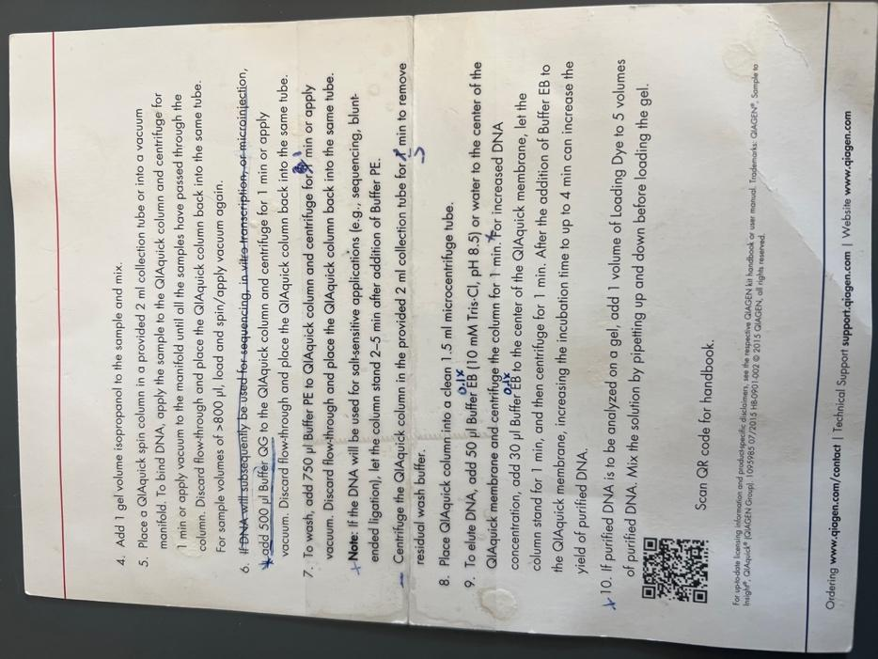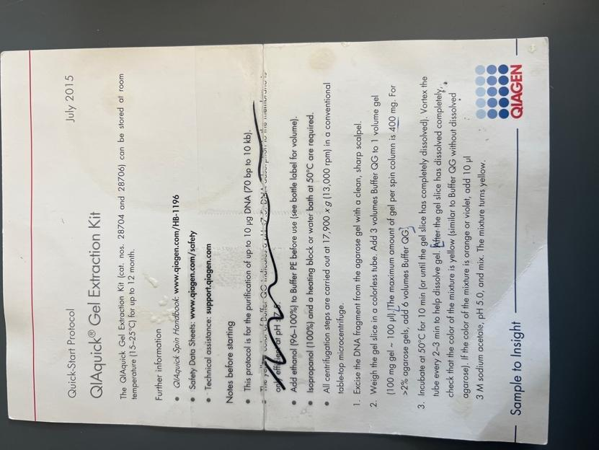

Sample number | Well | Template Type | Template Name | Primer Nameª | A. | B. | C. | D. | E. | F.
 | (GSC use only) | (plasmid or PCR) |  |  | Template Size (bases) | Template Stock Conc. (ng/μl) | PCR template: | PCR template: | PLASMID template: | Volume H₂O needed
 |  |  |  |  |  |  | ng needed = | Volume = | Volume =
 |  |  |  |  |  |  | (A ÷ 100) × 2.5 | (C ÷ B)μl | 2x(~200 ÷ B)μl | (12 less D or E - 2.56)μl
AC1 |  | plamid | pKR185-A | KROL664 | 2327 | 109.5 |  |  | 3.65 | 5.79
AC2 |  | plamid | pKR185-B | KROL664 | 2327 | 114.3 |  |  | 3.50 | 5.94
AC3 |  | plamid | pKR185-C | KROL664 | 2327 | 117.9 |  |  | 3.39 | 6.05
AC4 |  | plamid | pKR185-D | KROL664 | 2327 | 78.2 |  |  | 5.12 | 4.32
AC5 |  | plamid | pKR185-E | KROL664 | 2327 | 70.8 |  |  | 5.65 | 3.79
AC6 |  | plamid | pKR185-F | KROL664 | 2327 | 57.1 |  |  | 7.01 | 2.43
Sequencing Order

Tuesday June 27h, 2023
To Do:
1. Follow Ligation Protocol

Ligation Protocol
Protocol by John Church
The purpose of this is to ligate the cut plasmid backbone to the strand of PCR DNA.

- Make a reaction table with desired ligations. Always include a backbone only control for each plasmid backbone used.
Tube | Insert | Backbone
1 | BamHI, KpnI digested, purified PCR pKR198 | BamHI, KpnI digested, purified pEPSA5
2 | - | BamHI, KpnI digested, purified  pEPSA5

- Set up master mix table:
Component | Reaction 1 (uL) | Reaction 2 (uL) | Master Mix (3x)
H₂O | 11.5 | 11.5 | 34.5
10x ligase buffer | 2.0 | 2.0 | 6
Insert | 4.0 | - | -
Backbone | 2.0 | 2.0 | 6
Ligase | 0.5 | 0.5 | 1.5
TOTAL | 20.0 | 20.0 | 48

- Obtain ice to assemble and keep the reactions on. This is important, as the reaction happens at 16°C and the ligase buffer (which contains ATP) needs to be kept cold in order to avoid degradation. Take a 10 uL aliquot of 10X ligase buffer from the miscellaneous buffers box in the -20C.
- Obtain and label PCR tubes for the reactions. Be sure to include the date and your initials.
- To the individual tubes, add indicated amounts of H₂O (___uL), 10x buffer (_____uL), insert (____uL), and backbone (____uL).
- Add indicated amount of ligase (___uL) to the individual tubes. Remember to keep the ligase in a mini cooler.
- After all of the components have been added, mix each tube with a pipette set to 18 uL.
- Place in the thermocycler or water bath overnight at 16ºC. Can do at room temp for 10 minutes if necessary.

Thursday June 28h, 2023
To Do:
1. Make LB-Agar
-Making LB-agar plates
Protocol written by KMR
Preparing LB-agar
- For 500 mL of LB-agar, weigh out the following components and add to a 1 L (non-baffled) flask:
  - 6 g agar
  - 5 g NaCl
  - 5 g Tryptone
  - 2.5 g Yeast extract
- Add stirbar to flask
- Add 500 mL ddiH20
- Mix on stirplate until components are dissolved
- Cover top of flask with foil and add a small piece of autoclave tape
- Autoclave on 30 minute liquid cycle

Out from June 29th-July 4th

Wednesday July 5th, 2023
To Do:
  - Transformation of pKR186 into krsa1

Electroporation
- Thaw out aliquots on ice for 5 min then place at room temperature for 5 min (and follow the rest of the protocol at RT).
- Centrifuge at 5,000xg for 1 min. Discard the supernatant and resuspend the cells in 50 ul of 10% glycerol / 500 mM sucrose.
- Add up to 5ug-purified plasmid to the cells, mix and add to 0.1 cm electroporation cuvette. Up to 5ul of plasmid (dialyzed 20’ against H₂O with Millipore filters).
- Pulse 21 kV/cm, 100 Ω and 25uF. Time constant is usually about 2.0-2.4 ms.
- Immediately add 1 ml of TSB + 500mM sucrose and mix. (Dissolve 6.85g of sucrose in 40ml TSB and filter sterilize)
- Transfer to a new tube and incubate at adequate temperature for 1-1.5h. (30C for RN4220; 42C for HG003)
- Plate out on TSA + antibiotic. (3 ug/mL tet)

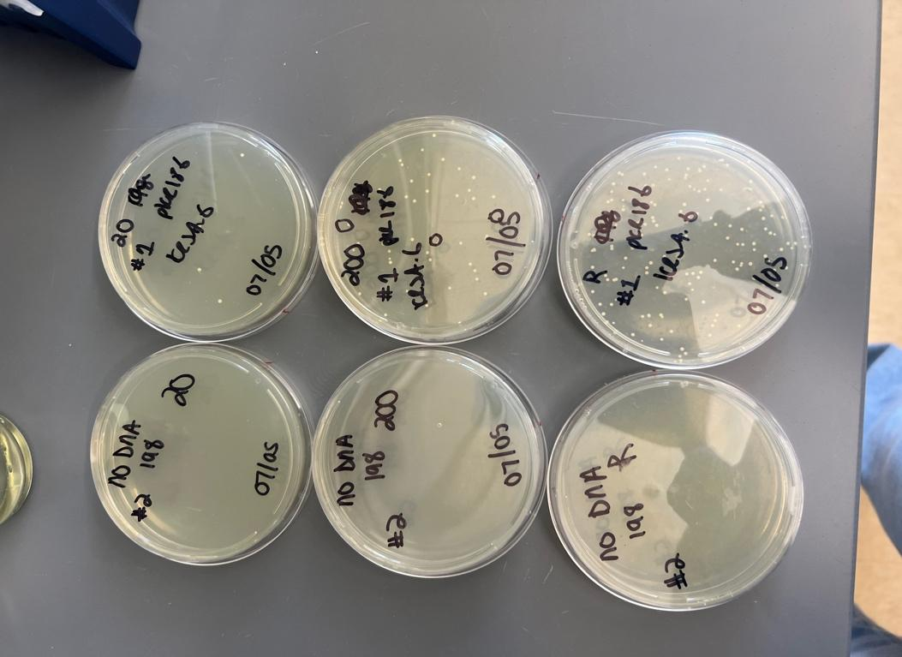
The labels are messed up, but this picture depicts a successful transformation of PKR 186 into KRSA1! Along with No DNA controls.

Thursday July 6th, 2023
To Do:
1.Practice Diffusion Assays

Disk Diffusion Assay for Staph

S. aureus Edited 5/27/22

- Pour fresh LB plates (24ml per plate) day before DDA to have more consistent results.
- Resuspend cells (half of a loopful) for the strain being tested in about 400 µL of LB media. Measure the OD600.
  - Put 950 ul of LB into cuvette and then 50 ul of the bacteria.
- Aim for a final OD600 of 0.05. Dilute the appropriate amount of culture in a 50 mL conical or serially dilute in 1.5ml tubes that contains LB media to get required OD600, for a final volume of 1 mL. [Use C1V1=C2V2] Repeat steps 1 and 2 for a separate strain if necessary.
- Add 100 µL each of S. aureus cells at OD600 0.05 to 3 LB agar plates and spread with glass beads. Repeat this a second time with new plates if testing another strain. Allow plates to dry.
- Using sterile tweezers, add sterile filter paper discs to a sterile plate and then add 20 µL methanol and antimicrobial to respective discs. Allow these discs to dry for 20 minutes.
- Using sterile tweezers, transfer discs from sterile plate to LB agar plates that have been spread with S. aureus so that there is a water disc and antibiotic disc on each LB agar plate and gently press them into plate without breaking the agar.
- Place into incubator and take note when, needs ~24 hours.

-Kira and I looked over the protocol and made sense of it. We didn’t go through with the whole process because we were focused on getting the correct OD to use.

Friday July 7th, 2023
To Do:
1.Lab Chours.
2. Lab outing (grant party)

Monday July 10th, 2023
To Do:
1.Make More LB x2
2. Make More LB Agar x3
3. Practice Disk Diffusion

Making LB-agar plates

Preparing LB-agar
- For 500 mL of LB-agar, weigh out the following components and add to a 1 L (non-baffled) flask:
  - 6 g agar
  - 5 g NaCl
  - 5 g Tryptone
  - 2.5 g Yeast extract
- Add stirbar to flask
- Add 500 mL ddiH20
- Mix on stirplate until components are dissolved
- Cover top of flask with foil and add a small piece of autoclave tape
- Autoclave on 30 minute liquid cycle

LB Media

Preparing LB media
- For 250 mL of LB, weigh out the following components and add to a 500 mL bottle:
  - 2.5 g NaCl
  - 2.5 g Tryptone
  - 1.25 g Yeast extract
- Add 250 mL type I ddiH20
- Close tightly and shake to mix
- Loosen cap and add a small piece of autoclave tape with the date
- Autoclave on 30 minute liquid cycle
- Sterile media can be stored indefinitely

DISK DIFFFUSION ASSAY NOTES
-More Practice finding the correct OD for my practice disk difusion
-Used Kanamycin for antibiotic and water for my control.
-Followed DDA protocol
-Had an OD of (1.058) and diluted it into a new 1.5 tube 1:10 ratio to get a new concentration of 0.029
-91ul LB and 9ul of KRSA-1 for each plate.

Tuesday July 11th, 2023
To Do:
1.Disk diffusion assay with LVS and Staph
DDA
- Pour fresh LB plates (24ml per plate) day before DDA to have more consistent results
- Resuspend cells (half of a loopful) for the strain being tested in about 400 µL of LB media. Measure the OD600.
  - Put 950 ul of LB into cuvette and then 50 ul of the bacteria
- Aim for a final OD600 of 0.05. Dilute the appropriate amount of culture in a 50 mL conical or serially dilute in 1.5ml tubes that contains LB media to get required OD600, for a final volume of 1 mL. [Use C1V1=C2V2] Repeat steps 1 and 2 for a separate strain if necessary.
- Add 100 µL each of S. aureus cells at OD600 0.05 to 3 LB agar plates and spread with glass beads. Repeat this a second time with new plates if testing another strain. Allow plates to dry.
- Using sterile tweezers, add sterile filter paper discs to a sterile plate and then add 20 µL methanol and antimicrobial to respective discs. Allow these discs to dry for 20 minutes.
- Using sterile tweezers, transfer discs from sterile plate to LB agar plates that have been spread with S. aureus so that there is a water disc and antibiotic disc on each LB agar plate and gently press them into plate without breaking the agar.
- Place into incubator and take note when, needs ~24 hours

DDA NOTES:
-Staph: LB solid/ liquid
-LVS: MHB liquid/ CHA solid
-KRSA1: 5.2ul and 494.8LB
-LVS: 11.4ul and 488.6MHB
-Disk Diffusion Assay Results:
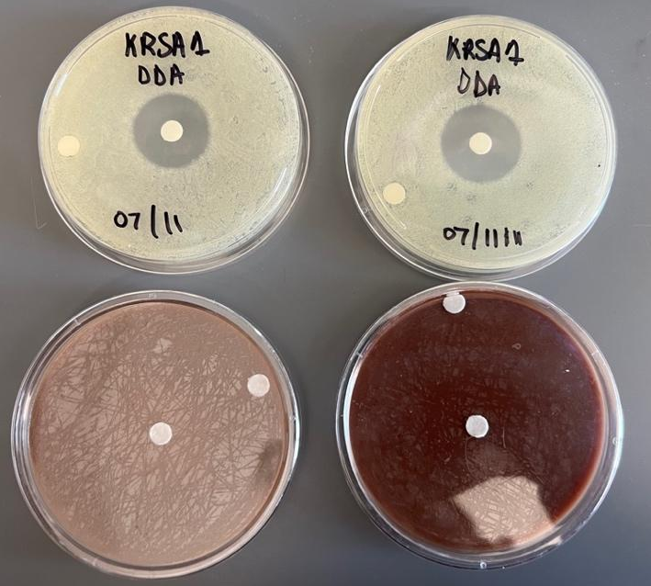

Wednesday July 12th, 2023
To Do:
1.Disk Diffusion Assay
2. Patch out cells on a plate for DDA tomorrow

DDA
- Pour fresh LB plates (24ml per plate) day before DDA to have more consistent results
- Resuspend cells (half of a loopful) for the strain being tested in about 400 µL of LB media. Measure the OD600.
  - Put 950 ul of LB into cuvette and then 50 ul of the bacteria
- Aim for a final OD600 of 0.05. Dilute the appropriate amount of culture in a 50 mL conical or serially dilute in 1.5ml tubes that contains LB media to get required OD600, for a final volume of 1 mL. [Use C1V1=C2V2] Repeat steps 1 and 2 for a separate strain if necessary.
- Add 100 µL each of S. aureus cells at OD600 0.05 to 3 LB agar plates and spread with glass beads. Repeat this a second time with new plates if testing another strain. Allow plates to dry.
- Using sterile tweezers, add sterile filter paper discs to a sterile plate and then add 20 µL methanol and antimicrobial to respective discs. Allow these discs to dry for 20 minutes.
- Using sterile tweezers, transfer discs from sterile plate to LB agar plates that have been spread with S. aureus so that there is a water disc and antibiotic disc on each LB agar plate and gently press them into plate without breaking the agar.
- Place into incubator and take note when, needs ~24 hours

--Followed the same procedure from yesterday without LVS these times.
--Patched out single use aliquot of KRSA1 on an LB plate with no Antibiotic
Results:
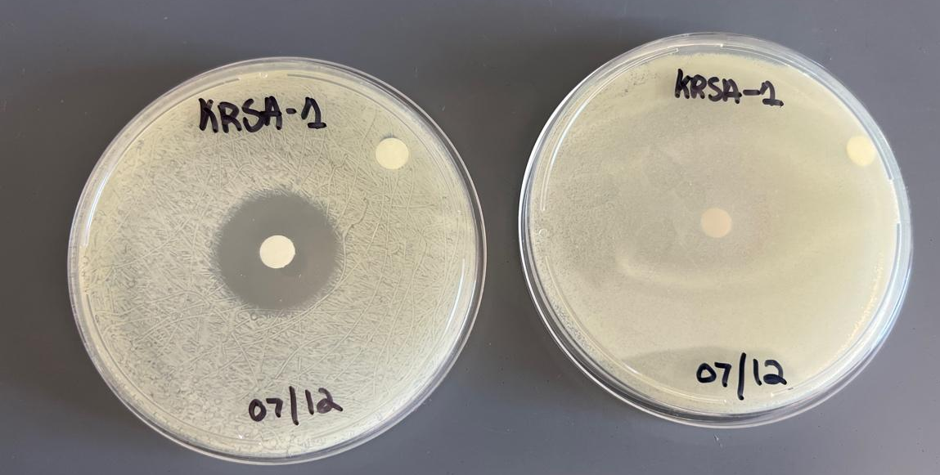
Thursday July 13th, 2023
To Do:
1. DDA practice with KRSA1

DDA
- Pour fresh LB plates (24ml per plate) day before DDA to have more consistent results
- Resuspend cells (half of a loopful) for the strain being tested in about 400 µL of LB media. Measure the OD600.
  - Put 950 ul of LB into cuvette and then 50 ul of the bacteria
- Aim for a final OD600 of 0.05. Dilute the appropriate amount of culture in a 50 mL conical or serially dilute in 1.5ml tubes that contains LB media to get required OD600, for a final volume of 1 mL. [Use C1V1=C2V2] Repeat steps 1 and 2 for a separate strain if necessary.
- Add 100 µL each of S. aureus cells at OD600 0.05 to 3 LB agar plates and spread with glass beads. Repeat this a second time with new plates if testing another strain. Allow plates to dry.
- Using sterile tweezers, add sterile filter paper discs to a sterile plate and then add 20 µL methanol and antimicrobial to respective discs. Allow these discs to dry for 20 minutes.
- Using sterile tweezers, transfer discs from sterile plate to LB agar plates that have been spread with S. aureus so that there is a water disc and antibiotic disc on each LB agar plate and gently press them into plate without breaking the agar.
- Place into incubator and take note when, needs ~24 hours

Friday July 14th, 2023
To Do:
1. DDA practice with KRSA1

DDA
- Pour fresh LB plates (24ml per plate) day before DDA to have more consistent results
- Resuspend cells (half of a loopful) for the strain being tested in about 400 µL of LB media. Measure the OD600.
  - Put 950 ul of LB into cuvette and then 50 ul of the bacteria
- Aim for a final OD600 of 0.05. Dilute the appropriate amount of culture in a 50 mL conical or serially dilute in 1.5ml tubes that contains LB media to get required OD600, for a final volume of 1 mL. [Use C1V1=C2V2] Repeat steps 1 and 2 for a separate strain if necessary.
- Add 100 µL each of S. aureus cells at OD600 0.05 to 3 LB agar plates and spread with glass beads. Repeat this a second time with new plates if testing another strain. Allow plates to dry.
- Using sterile tweezers, add sterile filter paper discs to a sterile plate and then add 20 µL methanol and antimicrobial to respective discs. Allow these discs to dry for 20 minutes.
- Using sterile tweezers, transfer discs from sterile plate to LB agar plates that have been spread with S. aureus so that there is a water disc and antibiotic disc on each LB agar plate and gently press them into plate without breaking the agar.
- Place into incubator and take note when, needs ~24 hours

Monday July 17th, 2023
To Do:
1.Work on Presentation Poster and abstract
2. Transform pEPSA5 into KRSA1

Electroporation
- Thaw out aliquots on ice for 5 min then place at room temperature for 5 min (and follow the rest of the protocol at RT).
- Centrifuge at 5,000xg for 1 min. Discard the supernatant and resuspend the cells in 50 ul of 10% glycerol / 500 mM sucrose.
- Add up to 5ug-2ul purified plasmid to the cells, mix and add to 0.1 cm electroporation cuvette. Up to 5ul of plasmid (dialyzed 20’ against H₂O with Millipore filters).
- Pulse 21 kV/cm, 100 Ω and 25uF. Time constant is usually about 2.0-2.4 ms.
- Immediately add 1 ml of TSB + 500mM sucrose and mix. (Dissolve 6.85g of sucrose in 40ml TSB and filter sterilize)
- Transfer to a new tube and incubate at adequate temperature for 1-1.5h. (30C for RN4220; 42C for HG003)
- Plate out on TSA + antibiotic. (3 ug/mL tet)

-Need empty vectors for final experiment so I did this transformation into KRSA-1 and we still need to do KRSA-4
-(Used 2ul of plasmid) because Kira found a lot of DNA in her nanodrop results’
-pEPSA5 into KRSA1 transformation successful

SUCCESFUL RESULTS:
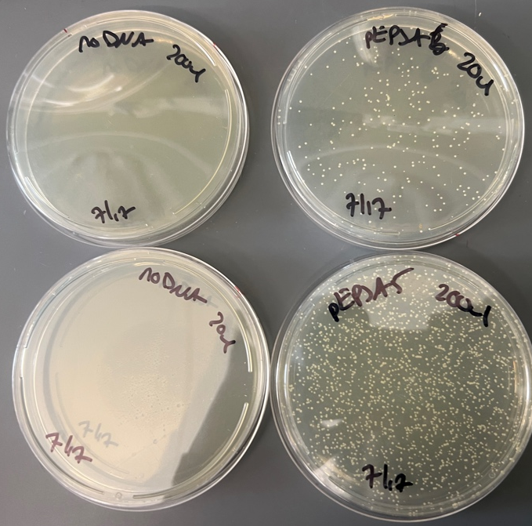

Tuesday July 18th, 2023
To Do:
1.Work on Presentation Poster and abstract
2. Make Agar plates for Disk Diffusion
3.
- Preparing LB-agar
- For 500 mL of LB-agar, weigh out the following components and add to a 1 L (non-baffled) flask:
  - 6 g agar. 9g
  - 5 g NaCl 7.5g
  - 5 g Tryptone 7.5g
  - 2.5 g Yeast extract. 3.75g
  - Add 3.75g of zilos
- Add stirbar to flask
- Add 500 mL ddiH20 750 ml
- Mix on stirplate until components are dissolved
- Cover top of flask with foil and add a small piece of autoclave tape
- Autoclave on 30 minute liquid cycle

NOTES:
-All changes made in yellow and red
-Doing Disk Diffusion assays need 21 LB Agar plates.
-Divide Everything by ½ then multiply by 3 to get 750 ml of LB agar and divide it into 3 flasks afterwards
-Measure .5% of xylols (1.25 for every 250ul) in this case I need 3.75g

-When pouring you need to measure out 24 ml into each plate and use a 25ml serological pipette.

NEW:07/19
We couldn’t use the plates used from yesterday as the sugar didn’t mix properly so we are going to redo it today differently

Wednesday July 19th, 2023
To Do:
1. Remake LB Agar plates

Making LB-agar plates

Preparing LB-agar
- For 500 mL of LB-agar, weigh out the following components and add to a 1 L (non-baffled) flask:
  - 6 g agar
  - 5 g NaCl
  - 5 g Tryptone
  - 2.5 g Yeast extract
- Add stirbar to flask
- Add 500 mL ddiH20
- Mix on stirplate until components are dissolved
- Cover top of flask with foil and add a small piece of autoclave tape
- Autoclave on 30 minute liquid cycle

Thursday July 20th, 2023
To Do:
1.Final Disk Diffusion

DDA
- Pour fresh LB plates (24ml per plate) day before DDA to have more consistent results
- Resuspend cells (half of a loopful) for the strain being tested in about 400 µL of LB media. Measure the OD600.
  - Put 950 ul of LB into cuvette and then 50 ul of the bacteria
- Aim for a final OD600 of 0.05. Dilute the appropriate amount of culture in a 50 mL conical or serially dilute in 1.5ml tubes that contains LB media to get required OD600, for a final volume of 1 mL. [Use C1V1=C2V2] Repeat steps 1 and 2 for a separate strain if necessary.
- Add 100 µL each of S. aureus cells at OD600 0.05 to 3 LB agar plates and spread with glass beads. Repeat this a second time with new plates if testing another strain. Allow plates to dry.
- Using sterile tweezers, add sterile filter paper discs to a sterile plate and then add 20 µL methanol and antimicrobial to respective discs. Allow these discs to dry for 20 minutes.
- Using sterile tweezers, transfer discs from sterile plate to LB agar plates that have been spread with S. aureus so that there is a water disc and antibiotic disc on each LB agar plate and gently press them into plate without breaking the agar.
- Place into incubator and take note when, needs ~24 hours

 | Observed OD600 | Calculated OD600 | Starting Volume for OD600 0.05 (ul) | times 5 | medium
KRSA1 | 0.168 | 3.36 | 1.5 | 7.4 | 492.6
KRSA4 | 0.135 | 2.7 | 1.9 | 9.3 | 490.7
KRSA5 | 0.143 | 2.86 | 1.7 | 8.7 | 491.3
KRSA6 | 0.153 | 3.06 | 1.6 | 8.2 | 491.8
KRSA8 | 0.124 | 2.48 | 2.0 | 10.1 | 489.9
KRSA1-pEPSA | 0.208 | 4.16 | 1.2 | 6.0 | 494.0
KRSA4-pEPSA | 0.232 | 4.64 | 1.1 | 5.4 | 494.6

Bibliography
Ramsey, K. M. and Dove, S. L. (2016) ‘ A response regulator promotes Francisella tularensis intramacrophage growth by repressing an anti-virulence factor ’, Molecular Microbiology. doi: 10.1111/mmi.13418.

