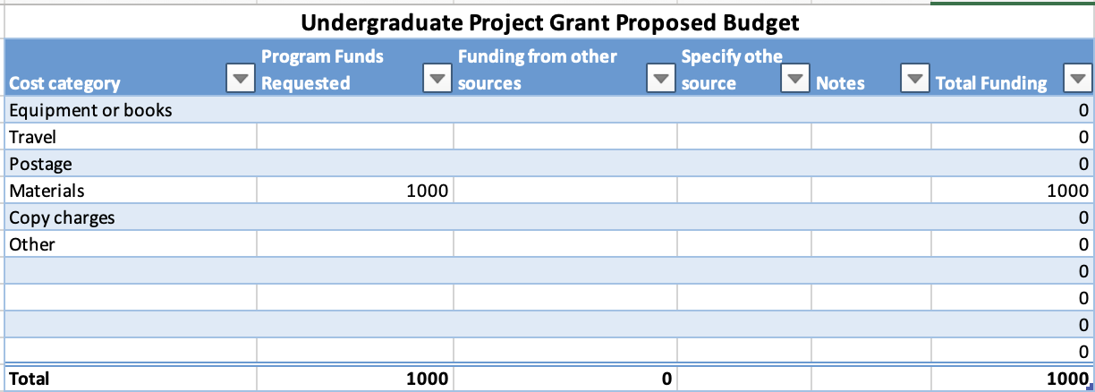

Budget Justification

Vendor | Catalog Number | Item | Purpose | Cost
Millipore Sigma | S2876-5G | Spermine tetrahydrochloride | Specialized media supplement for growth of F. tularensis LVS on clear plates | $268
Wilkem Scientific | LCEL229707 | 500mL Filter System | Sterilize specialized media for F. tularensis LVS growth on clear plates | $226
Wilkem Scientific | LABBA01-102-2KG | Agar for bacteriology | For specialized media for growth of F. tularensis LVS on clear plates | $490
Thermo Fisher | 10336022 | Custom oligonucleotides | For use in validating F. tularensis LVS reporter strain | $16
 |  |  | Total | $ 1,000

