Investigating the regulation of a protein required for virulence in a bacterial pathogen
Christina Surace
Project Start Date: September 3, 2024
Project End Date: December 20, 2024
Amount of Funding Requested: $1,000
Introduction
Francisella tularensis is a highly infectious intracellular pathogen which causes the disease tularemia, also known as rabbit fever. As an intracellular pathogen, growth and replication inside a cell is essential for F. tularensis to cause disease. F. tularensis is considered as a potential bioweapon because of key features such as: it can be easily aerosolized, very few cells are required for infection, and it has the potential to cause lethal disease. In Dr. Kathryn Ramsey’s laboratory, we work with a specific strain, F. tularensis subspecies holarctica LVS (live vaccine strain). LVS is an attenuated strain that does not cause disease in humans but maintains its ability to cause disease in animal models. The Ramsey lab is interested in finding out how genes important for virulence are regulated.
Previous findings of the Ramsey lab have established that the ribosomal protein, bS21-2 is important for virulence of F. tularensis (Trautmann and Ramsey 2022). The protein bS21-2 is encoded by the gene called rpsU2 in the LVS strain. The gene rpsU2 is located in an operon with multiple other genes (Figure 1). An operon is a cluster of genes that are transcribed at the same time into a single mRNA and are controlled by the same promoter.
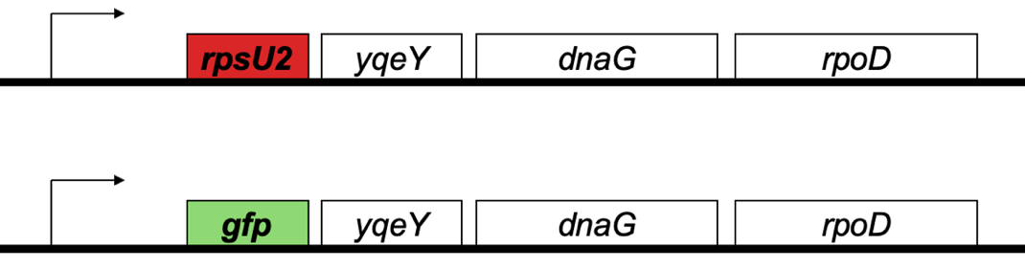
Figure 1. Illustration of the rpsU2 operon. Top: the rpsU2 gene (represented by the red box labeled “rpsU2”) is encoded in an operon with multiple other genes (yqeY, dnaG, rpoD) which are all controlled by the same promoter (arrow). Bottom: Representation of the reporter strain I will generate by replacing the rpsU2 gene with the gene for green fluorescent protein (gfp).

Notably, when cells lack the bS21-2 protein, there is an unusual change in the amount of mRNA transcript and protein corresponding to the rpsU2 operon. Specifically, compared to cells with bS21-2, there is a large increase in rpsU2 operon transcript amount but no apparent change in protein abundance (Figure 2). According to the Central Dogma of Molecular Biology, DNA is transcribed into RNA, which is then translated into proteins. Due to this theory, any changes in transcript amount should be proportional to changes in protein amount in a cell. We hypothesize that the lack of translation of the additional rpsU2 operon transcript into more protein is due to an unknown regulatory factor limiting translation.
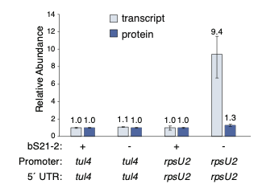
Figure 2. The above figure indicates the relationship between the presence of bS21-2 in the cell and its effect on the relative abundance of rpsU2 operon transcript and protein in the cell. Cells lacking bS21-2 have more transcript, yet no change in relative protein amount.

Project Objectives
The goal of this research project is to further investigate the regulation of a protein important for pathogenesis in F. tularensis, bS21-2 (encoded in the rpsU2 operon). Specifically, I aim to identify what gene(s) influence translation of the rpsU2 operon in cells lacking bS21-2. To do this, I will first create a F. tularensis LVS reporter strain to easily assess rpsU2 operon protein abundance, then mutagenize this strain to identify what mutations may lead to increased rpsU2 operon protein abundance. I expect to find that the reporter strain will be similar to other cells lacking bS21-2, which have more rpsU2 operon transcript but no corresponding increase in relative protein amount. In the mutants of interest, I will be looking for cells that defy this regulation of translation and in which the increased mRNA amount leads to higher reporter protein abundance. This increase in protein abundance could indicate that inhibitory factors of translation were removed. Through my research, my goal is to identify these factors limiting rpsU2 operon protein translation in cells lacking bS21-2.

Project Plan
I will modify the F. tularensis LVS genome by replacing the gene encoding bS21-2 (rpsU2) with the reporter gene encoding green fluorescent protein (gfp). In these cells, I expect to find that there will be increased transcription of the rpsU2 operon, which will contain the gfp transcript, but no relative increase in GFP protein abundance. The use of GFP as a reporter will allow us to easily and directly measure the abundance of rpsU2 operon protein abundance in the cell by measuring the amount of fluorescence. In order to modify the genome and create this reporter strain, I will first clone a plasmid that contains the gfp gene in place of rpsU2, as well as a selection marker for kanamycin resistance and the sacB gene which is a sucrose sensitivity gene. After creating the plasmid, I will use it in a well-established protocol called allelic exchange to create a strain of F. tularensis that lacks the rpsU2 gene but contains the gfp gene in its place.
Once I have successfully replaced rpsU2 with gfp, I will create mutants of this strain using a well-established system of transposon mutagenesis. When the mutants are created, I will pick which ones to investigate by visually looking for more GFP. Colonies that appear greener in color will indicate a higher amount of green fluorescent protein in the cell. I will study these colonies and identify which genes have been mutated. I expect these genes might encode factors such as translation inhibitors, whose loss would lead to this increase in protein abundance in the cell. Upon completion of this project, I hope to identify factors that control the production of the virulence factor bS21-2 in F. tularensis.

Timeline
As of Spring 2024, I have begun creating the plasmid, and plan to have it completed by the end of the semester. For Fall 2024, I will create the F. tularensis LVS strain lacking the rpsU2 gene, instead having the gfp in its place. This should be completed within the first month of the Fall 2024 semester. The remainder of the semester will be dedicated to the transposon mutagenesis and investigation of mutants with high GFP production.

Contribution
As a microbiology enthusiast with a particular interest in pathogenic bacteria, I came across Dr. Kathryn Ramsey’s lab website while searching for research opportunities on campus. I reviewed Dr. Ramsey’s research descriptions and sent her an email which expressed my interest in the lab’s research on pathogenic gene expression in F. tularensis. Soon after, I met with her, and she offered me an opportunity to work on my own project in her lab regarding the regulation of the virulence gene rpsU2. I was intrigued and excited by the opportunity to uncover some of the mystery behind the pathogenic mechanisms of this potentially lethal pathogen. I decided that I wanted to further understand this mechanism in attempts to prevent human infection. In my career as a research scientist, I hope to work on projects that advance scientific knowledge in a way that can also improve human health.

Expected Outcomes
The knowledge acquired from the completion of this project will impact the general understanding of gene regulation for pathogenic mechanisms in F. tularensis. This will benefit the scientific community, especially those studying similar pathogens, as we will be able to provide insight into factors important for virulence which may be present in other species.
Not only will this project advance scientific knowledge and human health, but it is also of immeasurable value to me. I am very passionate about the biomedical sciences and hope to dedicate my career to helping people by performing research in these disciplines. This project aligns with my moral values as well as my career goals. To continue working on biomedical research at a high level, I plan on pursuing a PhD in the biological and biomedical sciences. To be accepted to graduate school in this field, having research experience as an undergraduate is a necessity. Being able to work on my own project provides me with invaluable experience where I am able to gain technical skills as well as skills in critical thinking and problem solving, scientific communication, and data analysis.
References

Trautmann, H. S., & Ramsey, K. M. (2022). A Ribosomal Protein Homolog Governs Gene Expression and Virulence in a Bacterial Pathogen. Journal of Bacteriology, 204(10), e0026822. https://doi.org/10.1128/jb.00268-22

