Thesis Outline
Abstract
Acknowledgements
List of Tables
List of Figures
Introduction & Review of Literature
Methodology
Findings
Conclusion
Bibliography

Timeline
Item Due | Date
Ch. 2: Methodology & Bibliography (1st draft) | Sep 6
Ch. 1: Intro/Lit. Review & Bibliography (1st draft) | Sep 13
Ch. 2: Methodology & Bibliography (2nd draft) | Sep 20
Ch. 1: Intro/Lit. Review & Bibliography (2nd draft) | Sep 27
Ch. 3: Findings & Bibliography (1st draft) | Oct 4
Ch. 3: Findings & Bibliography (2nd draft) | Oct 11
Ch. 4: Conclusion & Bibliography (1st draft) | Oct 18
Ch. 4: Conclusion & Bibliography (2nd draft) | Oct 25
Distribute Thesis to Committee | Oct 28?
Thesis Defense | Nov 12

Abstract
Francisella tularensis is a Gram-negative, facultative, intracellular bacterium which causes the disease tularemia. Previous research has demonstrated that F. tularensis ribosomes are heterogeneous and that a specific ribosomal protein, bS21-2, regulates translation. To study the regulation of translation by ribosomes in Francisella tularensis, I will use an in vitro system. I aim to develop a reporter construct for use in an in vitro translation assay that is sensitive and easy to modify and to reproducibly purify active ribosomes from F. tularensis for use in this assay.
Methods Used
- Bacterial strains and growth conditions
- Plasmid design and construction
- 70S ribosome purification
- Sucrose gradient sedimentation
- In vitro assays
- PureExpress ∆ Ribosome Kit Protocol
- Nano-Glo® Luciferase Assay
Successful creation of a reporter construct that is sensitive and easy to modify
Successful and reproducible purification of active ribosomes
Translation efficiency is affected by growth media, strain, 5’ UTR, lysis method, and amount of ribosomes in the assay.
Loading smaller amounts of ribosomes onto sucrose gradients leads to sharper 70S peaks
Lower ribosome concentrations have higher luminescence/pmol
Using 2 pmol of LVS ribosomes in vitro works well for luminescence and gives fairly consistent and reproducible results

Acknowledgements
Person | Acknowledgement
University of Rhode Island
Dr. Kathryn Ramsey
Hannah Trautmann
Sierra Schmidt
Kira Bernabe
Alexandra Farah
Johanyx Rodriguez
Christina Surace
George Madave
Sara Negash
Aisling Macaraeg
Oli Horyn
Dr. Steven Gregory Lab
Janet Atoyan

List of Tables

List of Figures

Introduction & Review of Literature (Does it provide all the background necessary to set up the findings of the experiments?)
Francisella tularensis is a Gram-negative, facultative, intracellular bacterium. F. tularensis causes the disease tularemia, which can be transmitted by rabbits, small rodents, or arthropods (Sjöstedt, 2007). This disease manifests at the onset with flu-like symptoms and can develop into several forms, of which the ulceroglandular form is the most common and the pneumonic form can be fatal (Degabriel et al., 2023). Because a relatively small exposure to the bacterium can cause an infection and it can be easily dispersed through the air, it has been classified as a potential bioweapon (Oyston et al., 2004). The Ramsey lab uses F. tularensis subspecies holarctica, specifically the live vaccine strain (LVS), as a model organism, because it is not infectious to humans but retains its virulence in animal models. The Ramsey lab studies post-transcriptional regulation of virulence genes in F. tularensis, specifically how changes in ribosome composition impact virulence gene expression.
Key virulence genes in F. tularensis are located within the Francisella Pathogenicity Island (FPI), a region of the genome that codes for the type 6 secretion system (T6SS). The T6SS is a protein complex necessary for bacterial intracellular survival and growth within host cells. This cluster of genes is tightly regulated at the level of transcription. Specifically, transcription increases during the stringent stress response when the alarmone (p)ppGpp binds to transcription factors MglA and SspA associated with RNA polymerase and recruits another transcription factor, PigR. This increases transcription from promoters that contain short motifs called PigR response elements (PREs), including those found on the FPI (Degabriel et al., 2023). Recent work has demonstrated that the expression of FPI virulence genes is further controlled by regulating the translation of the mRNA into proteins by a specific ribosomal protein, bS21-2 (Trautmann & Ramsey, 2022).
Most bacteria encode one bS21 homolog or none at all. In the ribosome, bS21 is located in the small subunit near the anti-Shine Dalgarno sequence and the channel where mRNA exits the ribosome. Its location suggests that bS21 may interact directly with the 5’ untranslated region (5’ UTR) of mRNA molecules during the initiation phase of translation. Several studies have implicated bS21 in translation initiation by E. coli ribosomes (van Duin & Wijnands, 1981; Chang & Craven, 1977).
F. tularensis is unusual in that it has three homologs of bS21. The Ramsey lab found that F. tularensis ribosomes can incorporate any one of the three bS21 homologs and that the second homolog, bS21-2, is the most abundant when cells are grown in the laboratory (Trautmann & Ramsey, 2022). Additionally, in the absence of bS21-2, the abundance of certain proteins, including T6SS proteins, decreased, yet mRNA abundance remained the same (Trautmann & Ramsey, 2022). This suggests that, when bS21-2 is absent, ribosomes cannot translate these genes as efficiently. We also found that the ability of cells to replicate within macrophage decreased when bS21-2 was absent (Trautmann & Ramsey, 2022). These data lead to the development of a model in which bS21-2 allows for more efficient translation of virulence genes.
In support of a model in which bS21-2 controls translation initiation, it was found that the presence of bS21-2 can affect the translation of mRNAs with specific 5' UTR sequences and that altering the 5' UTR sequences can lead to a loss of this regulatory effect (Trautmann et al., 2023). In particular, the Ramsey lab studied these effects in vivo using a reporter assay to examine how the presence of bS21-2 alters translation of particular mRNAs in F. tularensis. These reporters consisted of a control promoter, the promoter for the gene tul4 (tul4 is not regulated by bS21-2 (Trautmann & Ramsey, 2022)), driving the transcription of an mRNA containing the 5´ UTR of a control gene or gene of interest fused to a green fluorescent protein (GFP) coding sequence. GFP production was used as a measure of translation efficiency for each mRNA. The 5' UTRs tested in this reporter assay were selected based on a proteomics analysis in which the absence of bS21-2 led to a downregulation in protein production from the selected genes (Trautmann & Ramsey, 2022). These genes included the FPI genes pdpA and iglA. When bS21-2 was absent, reporter output decreased for the selected genes but did not decrease for tul4 (Figure 1; Trautmann & Ramsey, 2022). Since changes in reporter output correlate with the amount of protein in cells with and without bS21-2, these data indicate that the 5´ UTR is sufficient to influence translation by bS21-2 in vivo. Additionally, because 5´ UTRs are generally important for initiation, these results strongly suggest that bS21-2 regulates translation during initiation.
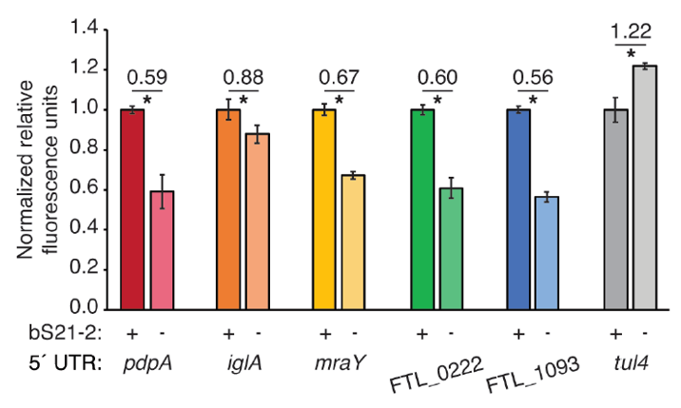
Figure 1. 5´ UTRs are sufficient to lead to bS21-2-mediated changes in translation. Relative fluorescence for indicated GFP translational fusion reporters in cells with (+; WT) or without (−; ΔrpsU2) bS21-2. The tul4 5´ UTR serves as a control. Figure and legend are from Trautmann et al., 2023.
After determining that the 5´ UTR is sufficient to allow bS21-2-mediated changes in translation, the Ramsey lab further investigated 5´ UTR sequences to identify specific elements that lead to regulation. In most bacterial 5´ UTRs, a particular sequence called the Shine-Dalgarno (SD) pairs with the anti-Shine-Dalgarno (aSD) sequence in the 16S rRNA of the 30S ribosomal subunit. This pairing is not strictly necessary for translation initiation but increases its efficiency. Structures of E. coli ribosomes reveal that bS21 likely directly contacts the aSD sequence (Kaledhonkar et al., 2019), implicating the SD-aSD pairing as a potential candidate for regulation by bS21-2 in F. tularensis. Upon testing translation efficiency of mRNAs with different SD sequences, the Ramsey lab found that 5´ UTRs with ideal SDs lost responsiveness to bS21-2 (Figure 2A, Trautmann et al., 2023), suggesting that bS21-2 interacts with the 5ˊ UTR in certain ways, but that the presence of a perfect SD can override these effects so that they are not as significant. In other genes, however, imperfect SD sequences do not automatically lead to regulation, so the search for other regulatory elements continues.
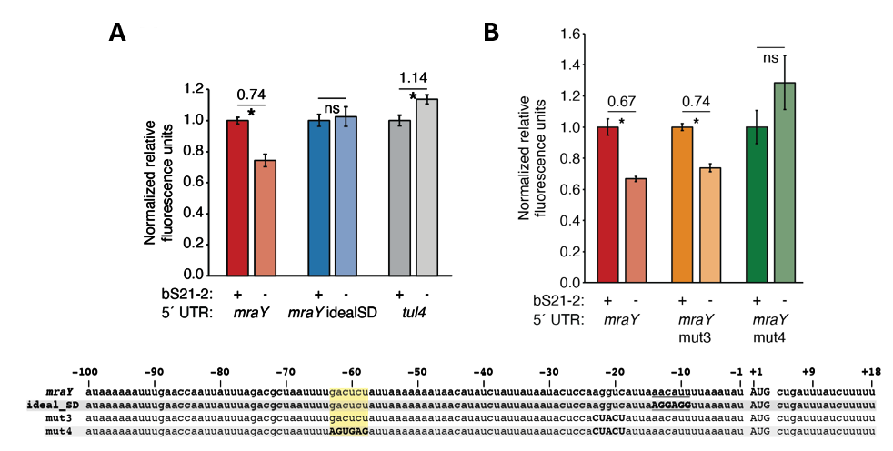
Figure 2. bS21-2-mediated translation of mraY depends on a weak Shine-Dalgarno and a specific six nucleotide sequence. Charts show relative fluorescence for indicated gfp translation fusion reporters in cells with (+; WT) or without (−; ΔrpsU2) bS21-2. (A) Introduction of an ideal SD in the mraY leader leads to loss of bS21-2 responsiveness. (B) The nucleotides between −58 and −63 in the mraY 5´ UTR, GACUCU, are essential for responsiveness to bS21-2. (A–B) Lines above bars indicate comparisons, values above line indicate ratio of reporter activity in cells lacking bS21-2 to wild-type cells. Error bars represent 1 SD. *P < 0.05 by t-test. ns = not significant. Experiments were repeated at least twice in biological triplicate, and data from a representative experiment are shown. Figure and legend are from Trautmann et al., 2023.
To find elements necessary for regulation by bS21-2, the Ramsey lab investigated the 5´ UTR of mraY. Hannah Trautmann tested the contribution of two motifs (AAAAUAAA and UUAUUUA) that are enriched in the 5´ UTR of genes regulated by bS21-2 as well as the predicted secondary structure of 5´ UTRs, but these did not contribute to regulation by bS21-2. Through further testing and modification of the mraY 5´ UTR, she identified a 6-nucleotide motif in the mraY 5´ UTR GACUCU (Figure 2B, Trautmann et al., 2023) that is necessary for regulation by bS21-2.
These studies have allowed significant progress in understanding how bS21-2 controls translation of mRNAs with specific 5’ UTRs, but we would like to go further and address several other questions. In particular, we would like to determine if these results can be recapitulated in vitro. Once a working in vitro system has been established, we can also test whether the GACUCU motif is sufficient for regulation by bS21-2 and whether there are other sequence motifs that confer regulation. By developing an in vitro assay that allows us to examine translation efficiency, we can build upon previous experimental data and develop a more comprehensive model of regulation by bS21-2.
The goal of my thesis project is to develop an in vitro translation assay for F. tularensis. In developing this assay, I will use the PURExpress® Δ Ribosome Kit from New England Biolabs which contains all the factors necessary for transcription and translation except ribosomes and permits the user to translate any protein as a reporter. When the kit components are combined with a DNA template and purified ribosomes, transcription and translation of a DNA-encoded reporter will occur, resulting in a signal that can be measured to assess translation efficiency. To use this kit for our studies, we must clone a plasmid template and purify active ribosomes from F. tularensis.
Preliminary work towards developing an in vitro translation assay performed by Hannah Trautmann used F. tularensis ribosomes and the tul4 5’ UTR – GFP reporter. While the reaction with E. coli ribosomes (provided by the kit) yielded signal in the assay, showing the reaction was properly set up, the ribosomes purified from F. tularensis did not translate detectable amounts of product (Figure 3). These results suggested to us that we should try to find a more sensitive reporter and that we should ensure that the ribosomes we are purifying are sufficiently active.
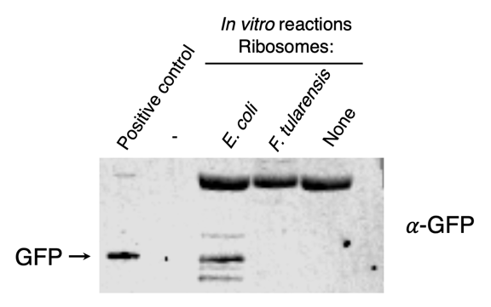
Figure 3. Ribosomes purified from F. tularensis exhibited poor activity in initial in vitro assays. In vitro translation assays were performed using a DNA template specifying an mRNA with the tul4 5’ UTR fused to the GFP gene (pKR107). Reactions contained either control ribosome from the kit (from E. coli), ribosomes purified from F. tularensis LVS, or no ribosomes (as indicated at the top of the image). No fluorescence was detected from the reaction containing F. tularensis ribosomes, so samples were analyzed by immunoblot using an antibody to GFP. The positive control lane contains cell lysate from F. tularensis expressing GFP.

Methodology
Bacterial strains and growth conditions
Plasmid design and construction (tell the reader how to specifically recreate each plasmid)
70S ribosome purification
Sucrose gradient sedimentation
In vitro assays
PureExpress ∆ Ribosome Kit Protocol
Nano-Glo® Luciferase Assay

Findings (think about figures and in what order they come in; question, method, figure, interpretation)
Demonstrated that nLuc was the most sensitive reporter tested
Successful creation of a reporter construct that is sensitive and easy to modify
Successful and reproducible purification of active ribosomes
Demonstrated inhibition of translation by Kasugamycin using in vitro assay
Demonstrated that LVS grows better in BHI media than in MHB
Demonstrated that heat-activation did not increase ribosome activity
Demonstrated that ribosome concentration affects translation efficiency
Lower ribosome concentrations have higher luminescence/pmol
Demonstrated that UTR affects translation efficiency
tul4 UTR translated more efficiently by LVS than by EC
Demonstrated that growth media affects translation efficiency
tul4 UTR translated more efficiently by LVS from MHB than from BHI
Demonstrated that LanYFP fluorescence and nLuc luminescence did not correlate when used in a dual-reporter system and driven by different UTRs
Demonstrated that dialysis of ribosomes into low Mg buffer separates subunits
Dialysis of dissociated ribosomes in high Mg buffer reassociates subunits
Incubation of dissociated ribosomes in high Mg buffer reassociates subunits
Incubation for two hours in high Mg buffer is sufficient
Steps can be taken to increase consistency of ribosome concentration measurements
Bug Buster chemical lysis can be used to purify active ribosomes
Different lysis methods have different sucrose gradient profiles
Deleting relA and spot does not affect LVS sucrose gradient profile
Loading smaller amounts of ribosomes onto sucrose gradients leads to sharper 70S peaks
Lower ribosome concentrations have higher luminescence/pmol
Using 2 pmol of LVS ribosomes in vitro works well for luminescence and gives fairly consistent and reproducible results
Demonstrated that lysis method affects translation efficiency

Conclusion
I modified an existing plasmid containing nLuc fused to the 5’ UTR for pdpA. This has provided us with a reporter construct that is sensitive and easy to modify for use in our in vitro translation assay. I demonstrated that the E. coli ribosomes were active using the in vitro assay and replicated these results using ribosomes from multiple purification attempts, showing that purification of E. coli ribosomes using the sucrose cushion method is reproducible. I found that translation efficiency is affected by growth media, strain, 5’ UTR, lysis method, and concentration of ribosomes in the assay.
My current experiments focus on isolating homogenous 70S ribosomes to further ensure consistency between in vitro assays. I found that loading smaller amounts of ribosomes onto sucrose gradients leads to sharper 70S peaks and that lower ribosome concentrations have higher luminescence/pmol Finally, I concluded that using 2 pmol of LVS ribosomes works well for luminescence in vitro and gives consistent and reproducible results. These findings can be applied to future in vitro assays that seek to measure the effects of bS21 homologs on translation of specific 5’ UTRs and contribute to an understanding of how bS21 homologs regulate translation in F. tularensis and modify the proteome to respond to different requirements or conditions.

Bibliography
Chang, C., & Craven, G. R. (1977). Identification of several proteins involved in the messenger RNA binding site of the 30 S ribosome by inactivation with 2-methoxy-5-nitrotropone. Journal of Molecular Biology, 117(2), 401–418. https://doi.org/10.1016/0022-2836(77)90135-8
Degabriel, Manon et al. “Pathogenicity and virulence of Francisella tularensis.” Virulence vol. 14,1 (2023): 2274638. doi:10.1080/21505594.2023.2274638
Dennis D, Inglesby T, Henderson D, et al. Tularemia as a biological weapon. Journal of the American Medical Association. 2001; 285: 2763-2773.
Kaledhonkar, S., Fu, Z., Caban, K., Li, W., Chen, B., Sun, M., Gonzalez, R. L., Jr, & Frank, J. (2019). Late steps in bacterial translation initiation visualized using time-resolved cryo-EM. Nature, 570(7761), 400–404. https://doi.org/10.1038/s41586-019-1249-5
Oyston CFP, Sjöstedt A, Titball RW. Tulareamia: bioterrorism defense renews interest in Francisella tularensis. Nature Reviews Microbiology. 2004; 2:967-978.
Prossliner T, Skovbo Winther K, Sørensen MA, Gerdes K. Ribosome Hibernation. Annu Rev Genet. 2018 Nov 23;52:321-348. doi: 10.1146/annurev-genet-120215-035130. PMID: 30476446.
Sjöstedt A. Tularemia: history, epidemiology, pathogen physiology, and clinical manifestations. Annals of the New York Academy of Sciences. 2007; 1105:1–29.
Trautmann, H., & Ramsey, K. (2022). A Ribosomal Protein Homolog Governs Gene Expression and Virulence in a Bacterial Pathogen. Journal of Bacteriology, 204(10), e00268-22. https://doi.org/10.1128/jb.00268-22
Trautmann, H. S., Schmidt, S. S., Gregory, S. T., & Ramsey, K. M. (2023). Ribosome heterogeneity results in leader sequence-mediated regulation of protein synthesis in Francisella tularensis. Journal of bacteriology, 205(9), e0014023. https://doi.org/10.1128/jb.00140-23
Van Duin, J., & Robert, W. (1981). The Function of Ribosomal Protein S21 in Protein Synthesis. European Journal of Biochemistry, 118(3), 615–619. https://doi.org/10.1111/j.1432-1033.1981.tb05563.x
Watson, Z. L., Ward, F. R., Méheust, R., Ad, O., Schepartz, A., Banfield, J. F., & Cate, J. H. (2020). Structure of the bacterial ribosome at 2 Å resolution. ELife, 9, e60482. https://doi.org/10.7554/eLife.60482

