Thesis Findings and Figures

Finding |  |  |  | Question (What) |  |  |  |  |  |  |  |  |  |  | Method (How) |  |  |  | Data (Figure) | Interpretation (Why)
Demonstrated that nLuc was the most sensitive reporter tested |  |  |  | Which is the most sensitive reporter? |  |  |  |  |  |  |  |  |  |  | Luminescence and fluorescence in vitro assays |  |  |  | 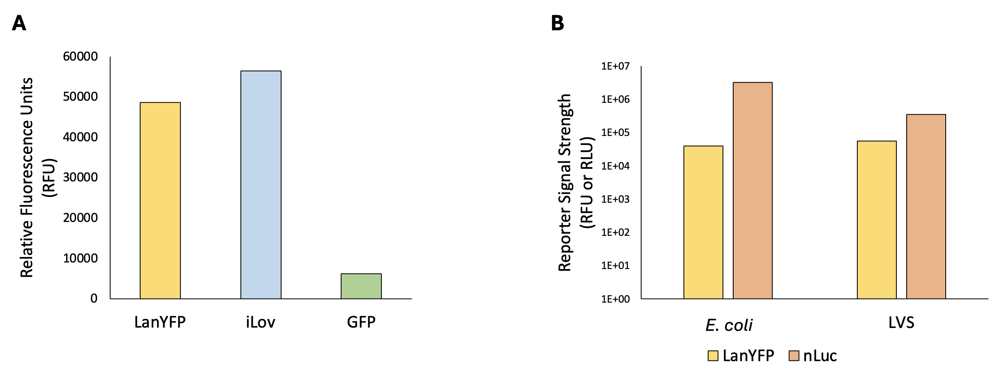 | nLuc is the most sensitive reporter.
Successful creation of a reporter construct that easy to modify |  |  |  | Can we create a reporter construct that is easy to modify?  [You addressed sensitivity in the previous experiment] |  |  |  |  |  |  |  |  |  |  | Molecular cloning |  |  |  | 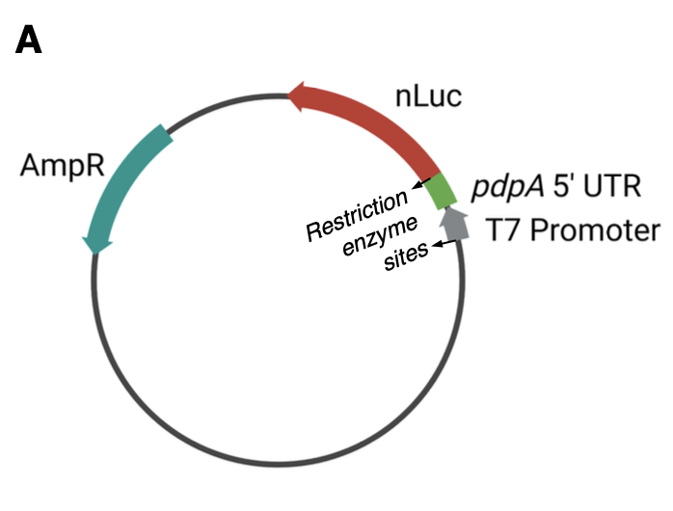 | A single-reporter plasmid containing nLuc fused to the 5’ UTR of a gene of interest, flanked by NotI restriction enzyme cut sites, is sensitive and easy to modify.
Successful and reproducible purification of active E. coli ribosomes  [The key here is that lots of folks have purified E. coli ribosomes using the protocols you’re using – you performed these experiments to ensure that you were executing the protocols correctly and to become trained in ribosome isolation. This is your positive control for ribosome isolation / activity] |  |  |  | Can we reproducibly purify active E. coli ribosomes? |  |  |  |  |  |  |  |  |  |  | French press lysis and sucrose cushion purification |  |  |  |  | E. coli ribosomes purified using the sucrose cushion method are active enough to measure and reproducible.
Demonstrated inhibition of translation by kasugamycin using in vitro assay |  |  |  | Does kasugamycin inhibit translation?  [kasugamycin is not a proper noun and is not capitalized] |  |  |  |  |  |  |  |  |  |  | Luminescence in vitro assays |  |  |  | 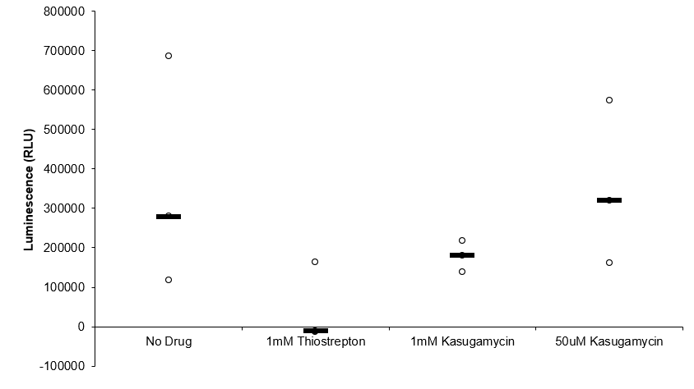 | Kasugamycin inhibits translation in a dose of 1mM.
Demonstrated that LVS grows better in BHI media than in MHB |  |  |  | Will LVS reach mid-log phase at a higher OD in a different kind of growth media? |  |  |  |  |  |  |  |  |  |  | Growth curves |  |  |  |  | LVS grows faster and reaches mid-log phase at a higher OD in BHI media than in MHB media.
Missing: Isolation of LVS ribosomes
The next logical step is the isolation of ribosomes from LVS grown in BHI, and also provide evidence that ribosomes purified *just like E. coli* have more variability in activity – that sets you us for the next experiments which address variability.
Demonstrated that heat-activation did not increase ribosome activity  [I think we should cut this – given that it wasn’t clear it would be necessary anyway] |  |  |  | Will a heat-activation step increase ribosome activity in vitro? |  |  |  |  |  |  |  |  |  |  | Heat activation followed by in vitro assay |  |  |  |  | Heat-activated samples demonstrated lower signal in vitro than unheated samples.
Bug Buster chemical lysis can be used to purify active ribosomes |  |  |  | Can Bug Buster chemical lysis be used to purify active ribosomes?  [If you include this, you would want to demonstrate activity using |  |  |  |  |  |  |  |  |  |  | Bug Buster lysis followed by sucrose cushion and in vitro assays |  |  |  |  | Bug Buster lysed and purified ribosomes are measurably active in vitro.
Purified E. coli and LVS ribosome samples have different ribosome composition – profile? |  |  |  | Do purified E. coli and LVS ribosome samples have similar ribosome composition?  [This isn’t quite the question you were addressing – can you reframe this, in the context of your earlier results?] Are we isolating 70s ribosomes from LVS/ |  |  |  |  |  |  |  |  |  |  | French press or Bug Buster lysis and sucrose cushion followed by sucrose gradients |  |  |  |  | Purified LVS ribosomes have broader 70S peaks, a 50S shoulder, and a distinct 100S peak when compared to E. coli ribosomes.
Demonstrated that dialysis of ribosomes into low Mg buffer separates subunits |  |  |  | Will dialyzing ribosomes in low Mg cause the 50S and 30S subunits to dissociate?  [Is this really what you were asking?] |  |  |  |  |  |  |  |  |  |  | Overnight dialysis followed by sucrose gradient |  |  |  | 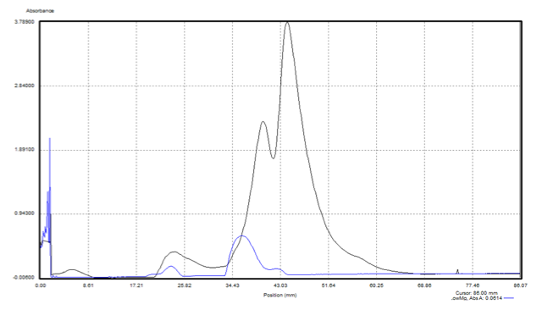 | Successful dissociation into 30S and 50S subunits.
Dialysis or incubation of dissociated ribosomes in high Mg buffer reassociates subunits |  |  |  | Can 30S and 50S subunits be reassociated into active 70S ribosomes by dialyzing/incubating in high Mg?  [Is this really what you were asking?] |  |  |  |  |  |  |  |  |  |  | Overnight dialysis or incubation (overnight or two hours) followed by sucrose gradient |  |  |  |  | Incubation for two hours in high Mg buffer is sufficient to reassociate 70S ribosomes.
Demonstrated that ribosome concentration affects translation efficiency |  |  |  | Does ribosome concentration (aggregation at higher concentrations) affect ribosome activity? |  |  |  |  |  |  |  |  |  |  | Dilution series with luminescence in vitro assay |  |  |  |  | Lower ribosome concentrations have higher luminescence/pmol.
Lower pmol -> more translation
Demonstrated that UTR affects translation efficiency [Let’s discuss this one – in the 2 pmol samples, does this hold up?] |  |  |  | Is there a difference in how well ribosomes translate specific UTRs? |  |  |  |  |  |  |  |  |  |  | In vitro assays with different reporter fusions. |  |  |  |  | tul4 UTR translated more efficiently by LVS than by EC.
Demonstrated that growth media affects translation efficiency |  |  |  | Does growth media affect ribosome activity? |  |  |  |  |  |  |  |  |  |  | In vitro assay with ribosomes from different growth media. |  |  |  |  | tul4 UTR translated more efficiently by LVS from MHB than from BHI.  [Given your extensive characterization of LVS ribosomes purified from cells grown in BHI and their variability – do you think there was enough experimentation to draw this conclusion?]
Demonstrated that LanYFP fluorescence and nLuc luminescence did not correlate when used in a dual-reporter system and driven by different UTRs  [I would cut the dual reporter system stuff] |  |  |  | Does LanYFP fluorescence and nLuc luminescence correlate when used in a dual-reporter system, and can this system be used to measure control and experimental UTR translation simultaneously? |  |  |  |  |  |  |  |  |  |  | In vitro assay measuring fluorescence then luminescence. |  |  |  |  | LanYFP fluorescence and nLuc luminescence do not sufficiently correlate enough to be reliably used in a dual-reporter system.
Steps can be taken to increase consistency of ribosome concentration measurements  [this doen’t need to be a figure, you can simply include it as part of your methods] |  |  |  | Can steps be taken to increase consistency of ribosome concentration measurements? |  |  |  |  |  |  |  |  |  |  | Take several initial readings for concentration |  |  |  |  | Ribosome concentration measurements are consistent and reproducible.
[This is above]  Different lysis methods have different sucrose gradient profiles |  |  |  | Does lysis method affect the ribosome profile on sucrose gradients? |  |  |  |  |  |  |  |  |  |  | French press or Bug Buster lysis and sucrose cushion followed by sucrose gradients |  |  |  |  | The lysis method does affect the appearance of the sucrose gradient profile.
Deleting relA and spoT does not affect LVS sucrose gradient profile  [We might cut this – it was worth a try but it was a long shot, considering that we don’t *really* know if the second peak is due to hibernation factors at all. |  |  |  | Does the deletion of relA and spoT (and the subsequent inactivity of ppGpp) affect the presence of hibernation factors in a way that would show up on a gradient? |  |  |  |  |  |  |  |  |  |  | Pelleting of WT and mutant LVS followed by sucrose cushion and sucrose gradient |  |  |  | 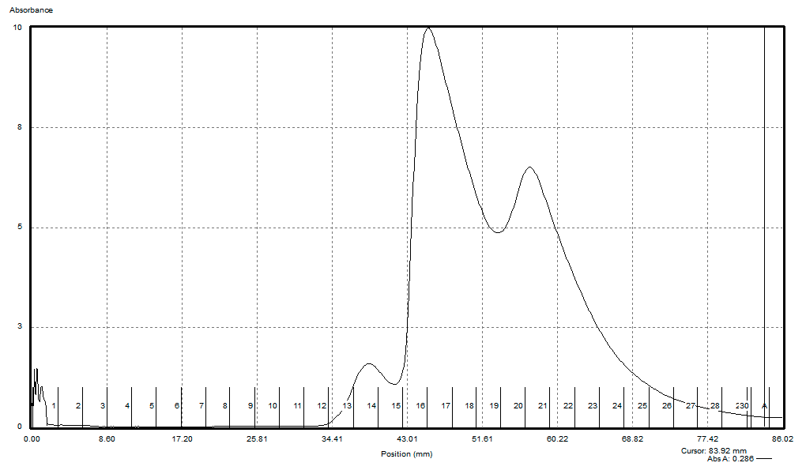  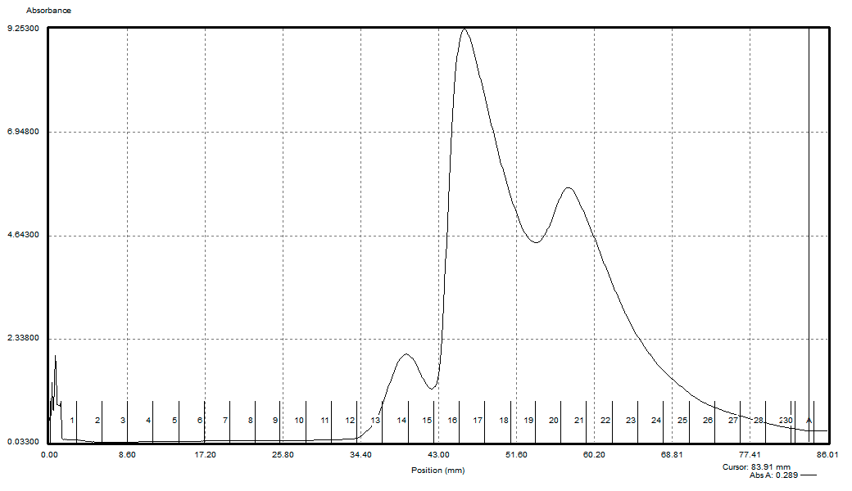 | Deleting relA and spoT does not affect the presence of hibernation factors in a way that can be detected by a sucrose gradient profile.
[see above]Loading smaller amounts of ribosomes onto sucrose gradients leads to sharper 70S peaks |  |  |  | Does the amount of ribosomes loaded onto a sucrose gradient affect the subsequent profile? |  |  |  |  |  |  |  |  |  |  | Sucrose gradient with varying amount of ribosomes loaded |  |  |  |  | Loading fewer ribosomes onto sucrose gradients leads to sharper 70S peaks.
[see above]Lower ribosome concentrations have higher luminescence/pmol |  |  |  | Does the amount of ribosomes in an in vitro assay affect luminescence/pmol of the reading? |  |  |  |  |  |  |  |  |  |  | Serial dilution followed by in vitro luminescence assays. |  |  |  |  | Lower ribosome concentrations have higher luminescence/pmol.
Using 2 pmol of LVS ribosomes in vitro works well for luminescence and gives fairly consistent and reproducible results |  |  |  | Does using 2 pmol of LVS ribosomes in vitro deliver measurable and consistent results for luminescence across purifications? |  |  |  |  |  |  |  |  |  |  | In vitro assays with 2 pmol LVS ribosomes from different purifications |  |  |  |  | Using 2 pmol of LVS ribosomes in vitro gives measurable and consistent results for luminescence across most purifications.
Demonstrated that lysis method affects translation efficiency |  |  |  | Does the method lysis (French Press or Bug Buster) affect the translation efficiency of ribosomes from the subsequent purification? |  |  |  |  |  |  |  |  |  |  | In vitro assays with LVS ribosomes purified from French Press or Bug Buster lysis |  |  |  |  | LVS ribosomes purified from French Press lysed cells are consistently more active than those purified from Bug Buster lysed cells.
Demonstrated that lysis method affects processing of ribosomal RNA |  |  |  | Does the method lysis (French Press or Bug Buster) affect the processing of ribosomal RNA as seen on a gel? |  |  |  |  |  |  |  |  |  |  | RNA extracted from ribosomes purified from French Press or Bug Buster lysed cells and run on an RNA gel |  |  |  | 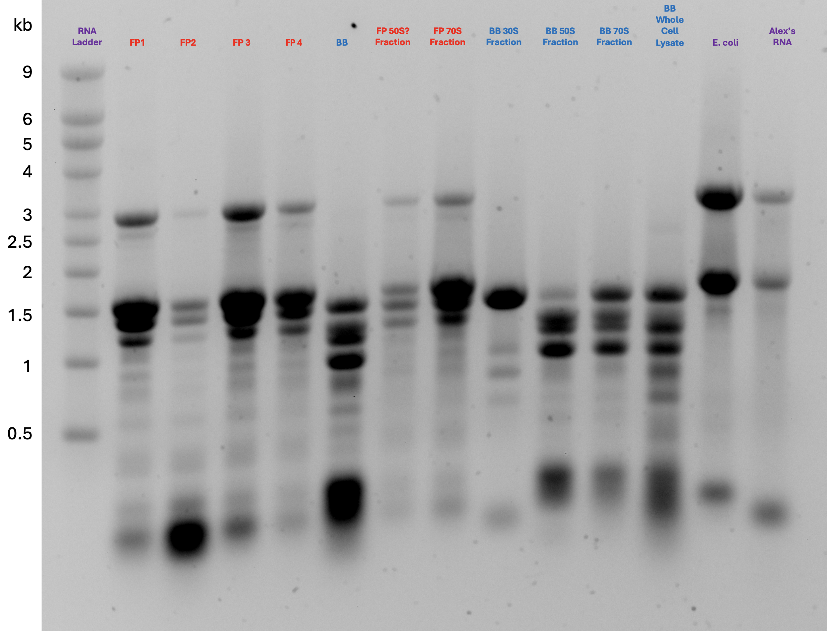 | LVS ribosomes purified from Bug Buster lysed cells display more RNA processing than those purified from French Press lysed cells.

