Thesis Findings and Figures

Finding | Question (What) | Method (How) | Data (Figure) | Interpretation (Why)
Demonstrated that nLuc was the most sensitive reporter tested | Which is the most sensitive reporter? | Luminescence and fluorescence in vitro assays | 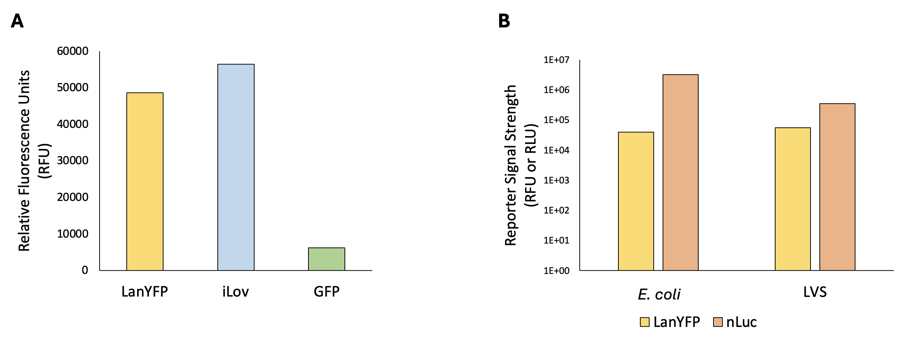 | nLuc is the most sensitive reporter.
Successful creation of a reporter construct that is sensitive and easy to modify | Can we create a reporter construct that is sensitive and easy to modify? | Molecular cloning | 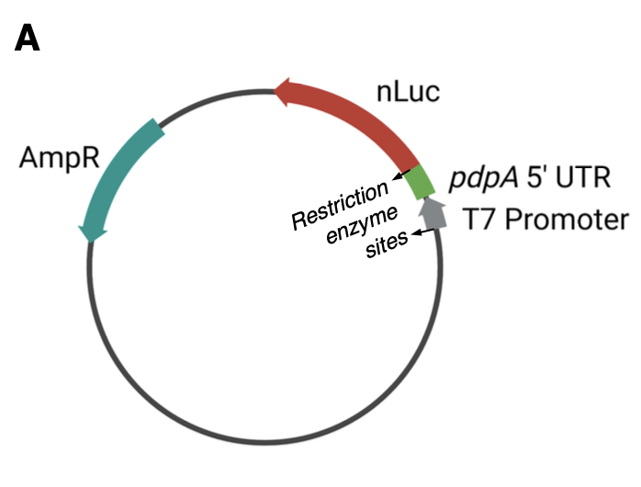 | A single-reporter plasmid containing nLuc fused to the 5’ UTR of a gene of interest, flanked by NotI restriction enzyme cut sites, is sensitive and easy to modify.
Successful and reproducible purification of active ribosomes | Can we reproducibly purify active ribosomes? | French press lysis and sucrose cushion purification |  | Ribosomes purified using the sucrose cushion method are active enough to measure and reproducible.
Demonstrated inhibition of translation by Kasugamycin using in vitro assay | Does Kasugamycin inhibit translation? | Luminescence in vitro assays | 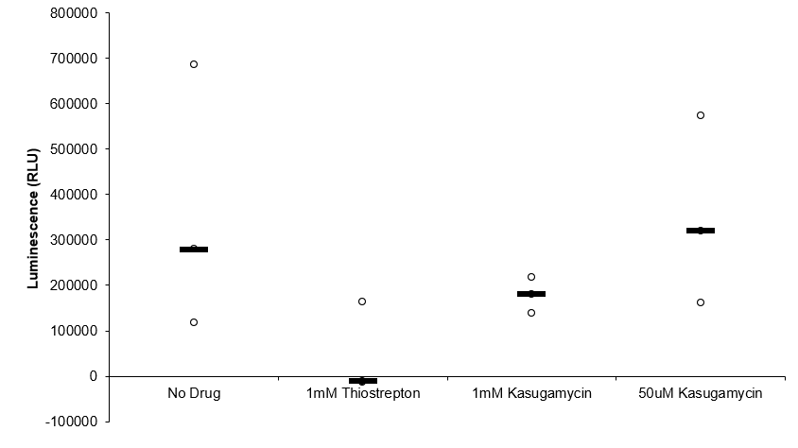 | Kasugamycin inhibits translation in a dose of 1mM.
Demonstrated that LVS grows better in BHI media than in MHB | Will LVS reach mid-log phase at a higher OD in a different kind of growth media? | Growth curves |  | LVS grows faster and reaches mid-log phase at a higher OD in BHI media than in MHB media.
Demonstrated that heat-activation did not increase ribosome activity | Will a heat-activation step increase ribosome activity in vitro? | Heat activation followed by in vitro assay |  | Heat-activated samples demonstrated lower signal in vitro than unheated samples.
Demonstrated that ribosome concentration affects translation efficiency | Does ribosome concentration (aggregation at higher concentrations) affect ribosome activity? | Dilution series with luminescence in vitro assay |  | Lower ribosome concentrations have higher luminescence/pmol.
Demonstrated that UTR affects translation efficiency | Is there a difference in how well ribosomes translate specific UTRs? | In vitro assays with different reporter fusions. |  | tul4 UTR translated more efficiently by LVS than by EC.
Demonstrated that growth media affects translation efficiency | Does growth media affect ribosome activity? | In vitro assay with ribosomes from different growth media. |  | tul4 UTR translated more efficiently by LVS from MHB than from BHI.
Demonstrated that LanYFP fluorescence and nLuc luminescence did not correlate when used in a dual-reporter system and driven by different UTRs | Does LanYFP fluorescence and nLuc luminescence correlate when used in a dual-reporter system, and can this system be used to measure control and experimental UTR translation simultaneously? | In vitro assay measuring fluorescence then luminescence. |  | LanYFP fluorescence and nLuc luminescence do not sufficiently correlate enough to be reliably used in a dual-reporter system.
Demonstrated that dialysis of ribosomes into low Mg buffer separates subunits | Will dialyzing ribosomes in low Mg cause the 50S and 30S subunits to dissociate? | Overnight dialysis followed by sucrose gradient | 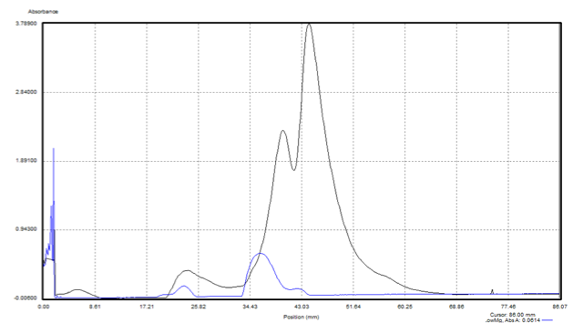 | Successful dissociation into 30S and 50S subunits.
Dialysis or incubation of dissociated ribosomes in high Mg buffer reassociates subunits | Can 30S and 50S subunits be reassociated into active 70S ribosomes by dialyzing/incubating in high Mg? | Overnight dialysis or incubation (overnight or two hours) followed by sucrose gradient |  | Incubation for two hours in high Mg buffer is sufficient to reassociate 70S ribosomes.
Steps can be taken to increase consistency of ribosome concentration measurements | Can steps be taken to increase consistency of ribosome concentration measurements? | Take several initial readings for concentration |  | Ribosome concentration measurements are consistent and reproducible.
Bug Buster chemical lysis can be used to purify active ribosomes | Can Bug Buster chemical lysis be used to purify active ribosomes? | Bug Buster lysis followed by sucrose cushion and in vitro assays |  | Bug Buster lysed and purified ribosomes are measurably active in vitro.
Purified E. coli and LVS ribosome samples have different ribosome composition | Do purified E. coli and LVS ribosome samples have similar ribosome composition? | French press or Bug Buster lysis and sucrose cushion followed by sucrose gradients |  | Purified LVS ribosomes have broader 70S peaks, a 50S shoulder, and a distinct 100S peak when compared to E. coli ribosomes.
Different lysis methods have different sucrose gradient profiles | Does lysis method affect the ribosome profile on sucrose gradients? | French press or Bug Buster lysis and sucrose cushion followed by sucrose gradients |  | The lysis method does affect the appearance of the sucrose gradient profile.
Deleting relA and spoT does not affect LVS sucrose gradient profile | Does the deletion of relA and spoT (and the subsequent inactivity of ppGpp) affect the presence of hibernation factors in a way that would show up on a gradient? | Pelleting of WT and mutant LVS followed by sucrose cushion and sucrose gradient | 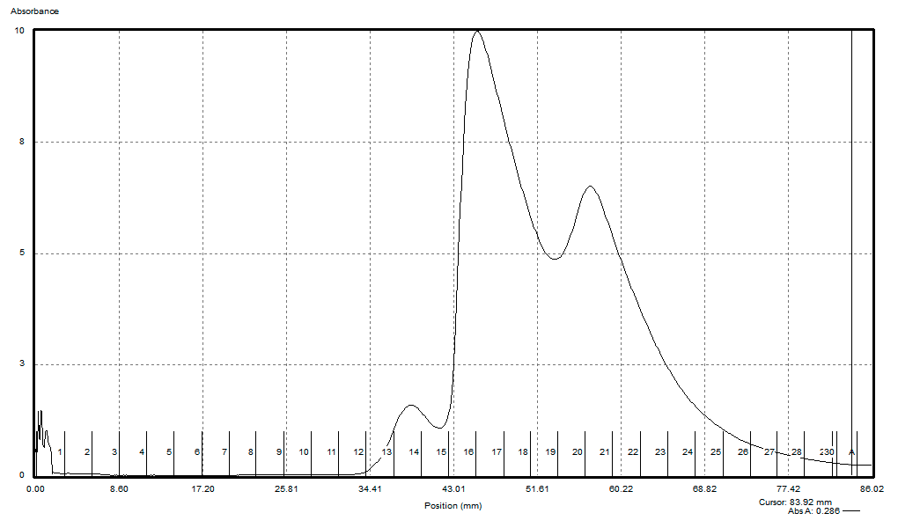  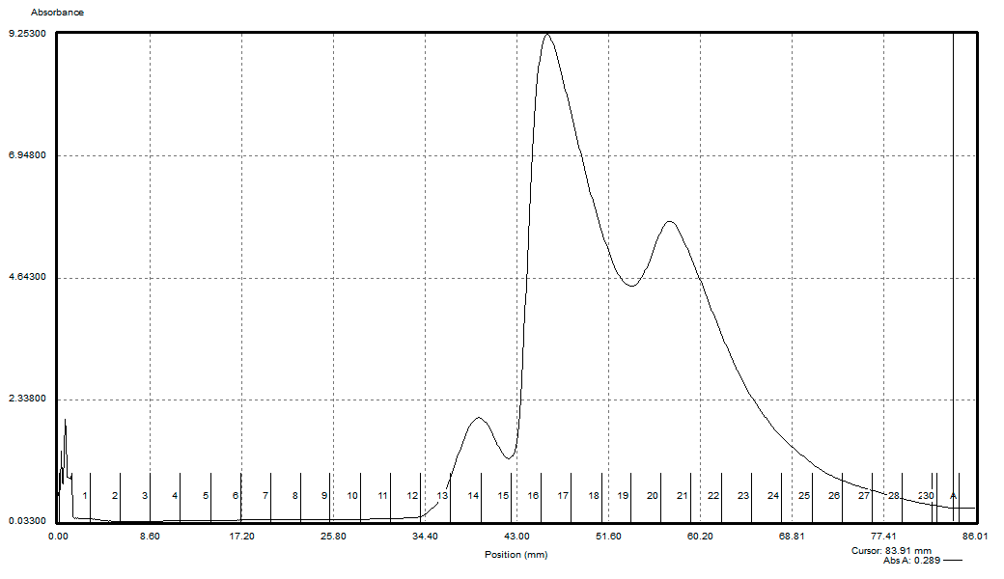 | Deleting relA and spoT does not affect the presence of hibernation factors in a way that can be detected by a sucrose gradient profile.
Loading smaller amounts of ribosomes onto sucrose gradients leads to sharper 70S peaks | Does the amount of ribosomes loaded onto a sucrose gradient affect the subsequent profile? | Sucrose gradient with varying amount of ribosomes loaded |  | Loading fewer ribosomes onto sucrose gradients leads to sharper 70S peaks.
Lower ribosome concentrations have higher luminescence/pmol | Does the amount of ribosomes in an in vitro assay affect luminescence/pmol of the reading? | Serial dilution followed by in vitro luminescence assays. |  | Lower ribosome concentrations have higher luminescence/pmol.
Using 2 pmol of LVS ribosomes in vitro works well for luminescence and gives fairly consistent and reproducible results | Does using 2 pmol of LVS ribosomes in vitro deliver measurable and consistent results for luminescence across purifications? | In vitro assays with 2 pmol LVS ribosomes from different purifications |  | Using 2 pmol of LVS ribosomes in vitro gives measurable and consistent results for luminescence across most purifications.
Demonstrated that lysis method affects translation efficiency | Does the method lysis (French Press or Bug Buster) affect the translation efficiency of ribosomes from the subsequent purification? | In vitro assays with LVS ribosomes purified from French Press or Bug Buster lysis |  | LVS ribosomes purified from French Press lysed cells are consistently more active than those purified from Bug Buster lysed cells.
Demonstrated that lysis method affects processing of ribosomal RNA | Does the method lysis (French Press or Bug Buster) affect the processing of ribosomal RNA as seen on a gel? | RNA extracted from ribosomes purified from French Press or Bug Buster lysed cells and run on an RNA gel | 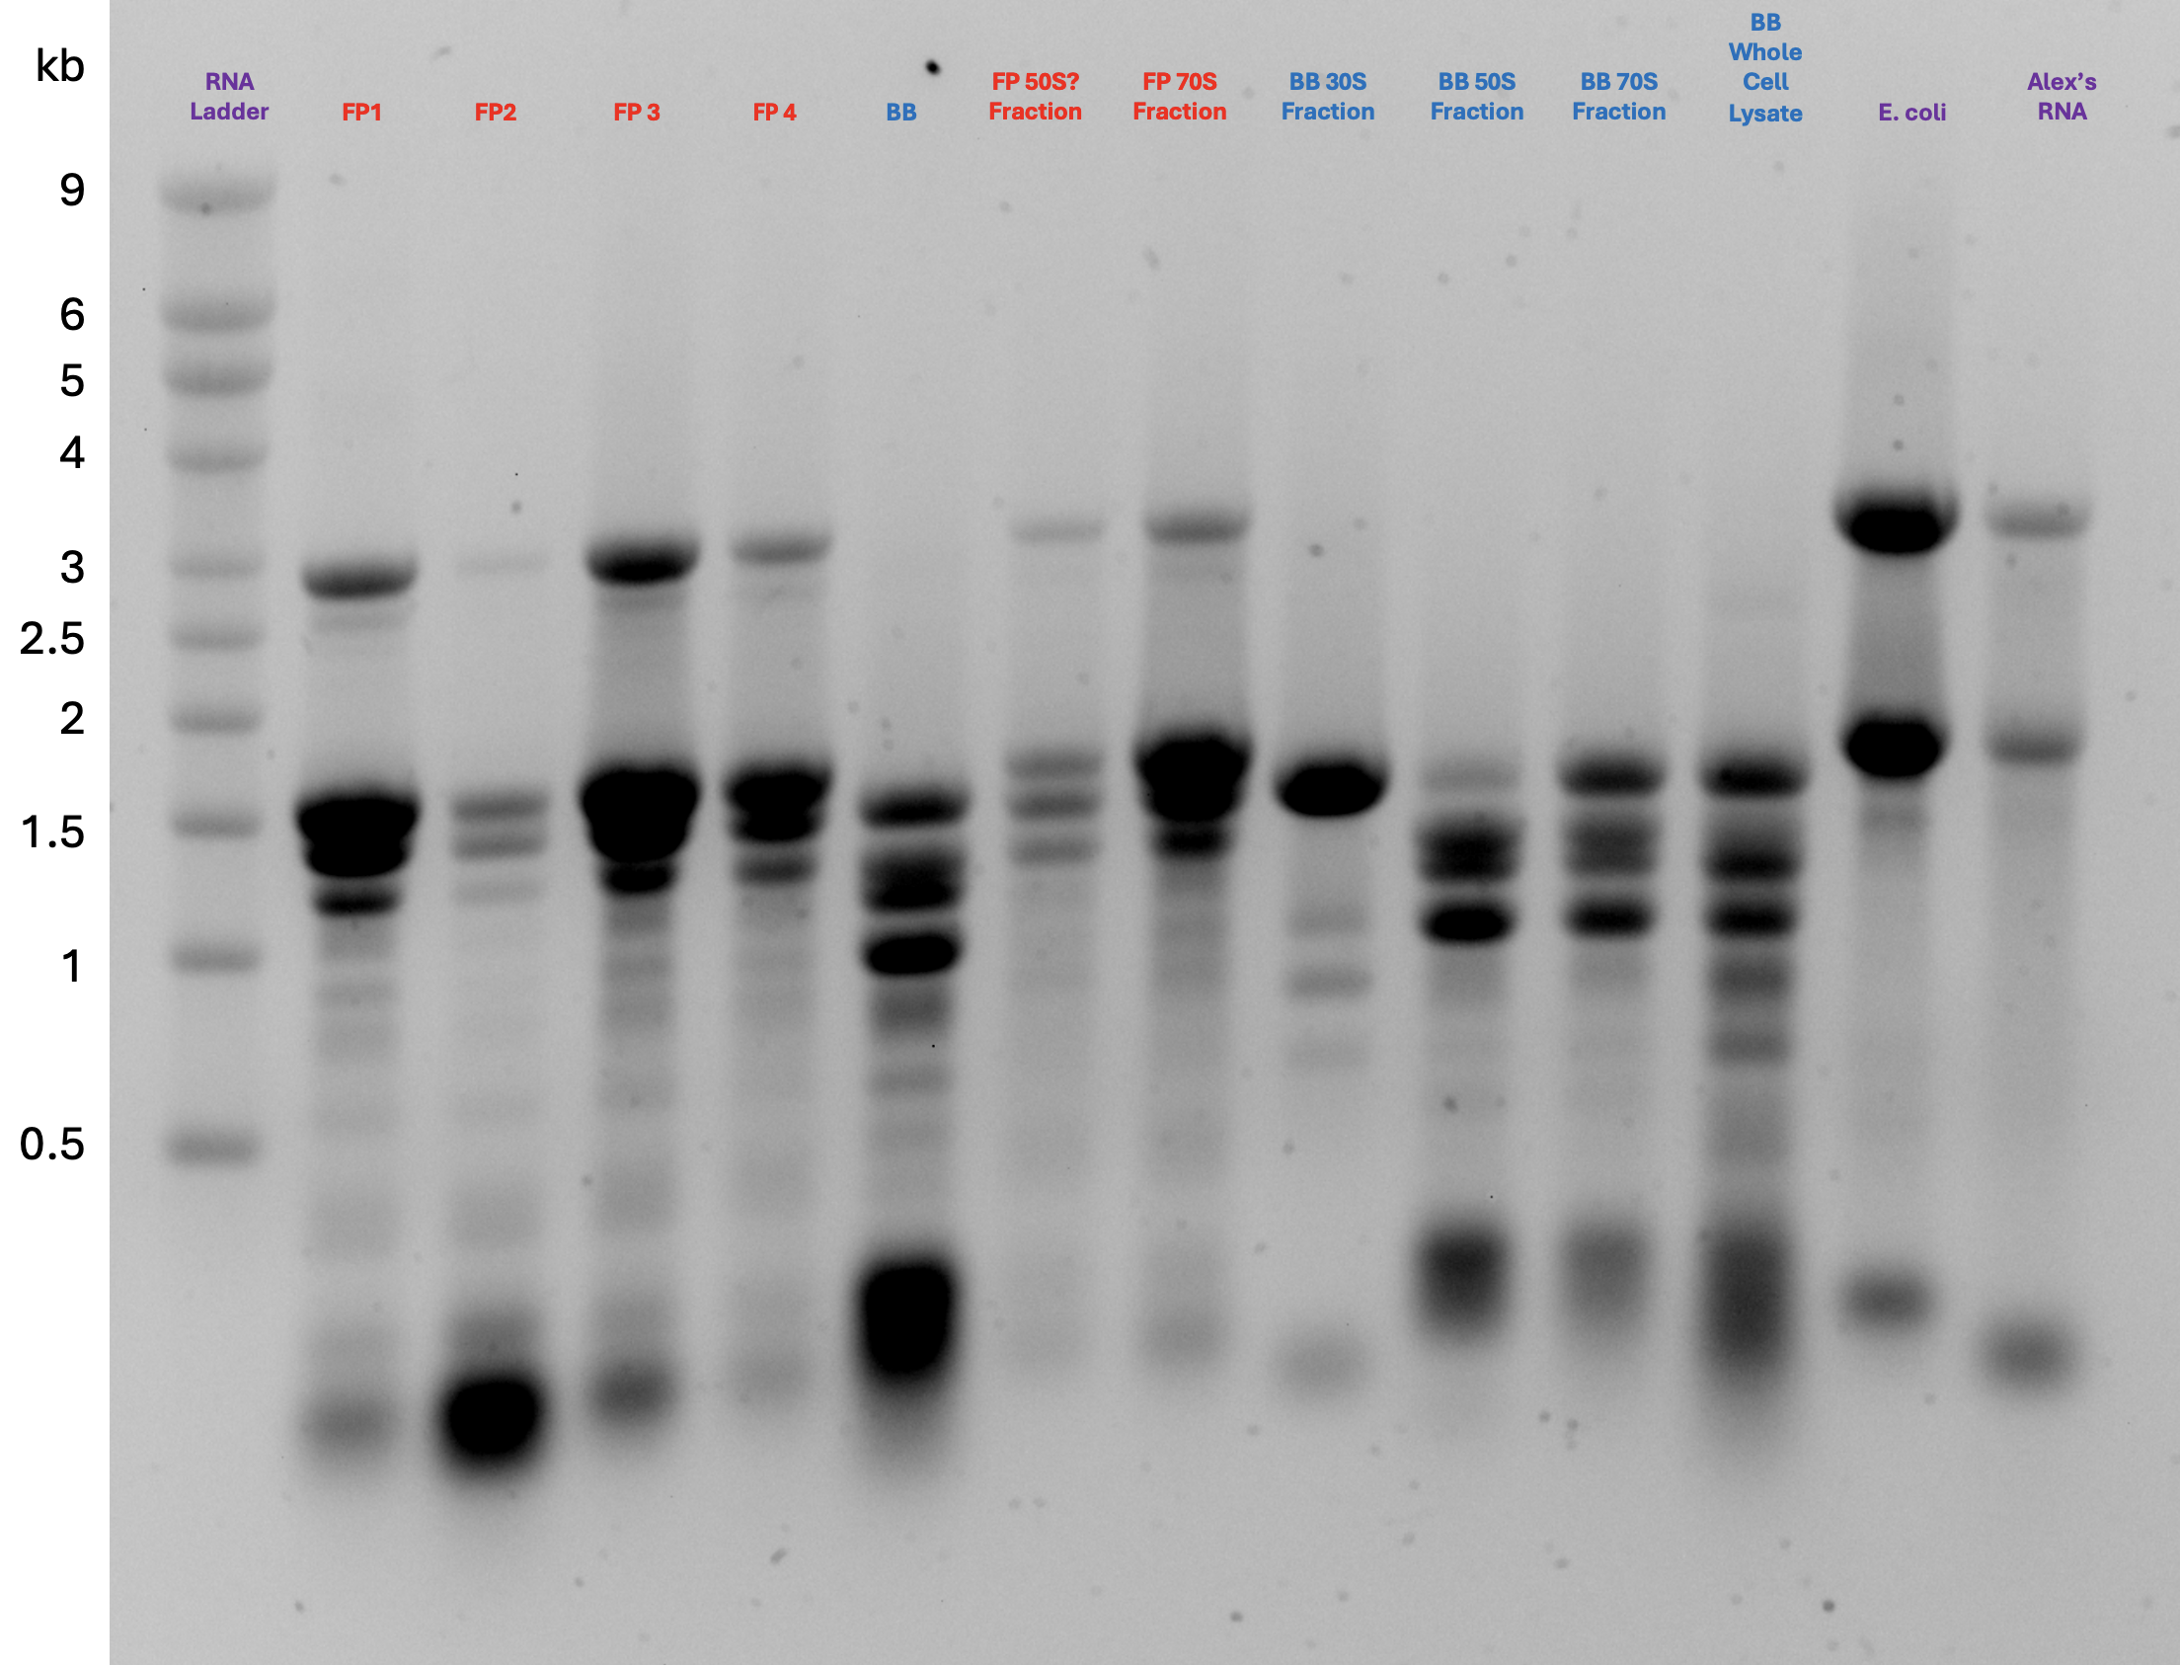 | LVS ribosomes purified from Bug Buster lysed cells display more RNA processing than those purified from French Press lysed cells.

