Thesis Findings and Figures

# | Finding | Question (What) | Method (How) | Data (Figure) | Interpretation (Why)
1 | nLuc was the most sensitive reporter tested | Which is the most sensitive reporter? | Luminescence and fluorescence in vitro assays | 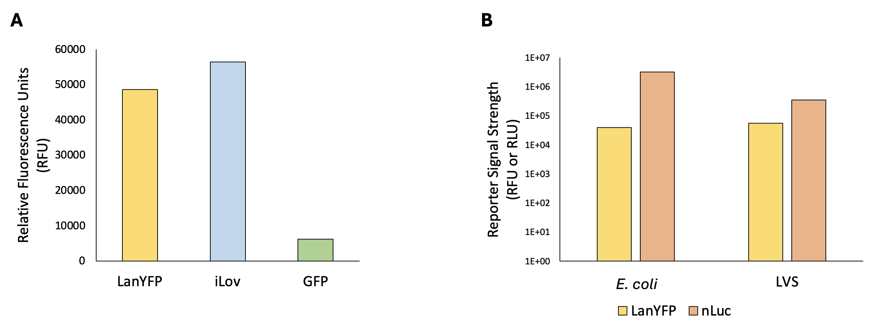 | nLuc is the most sensitive reporter.
2 | An easily modifiable reporter construct can be created | Can we create a reporter construct that is easy to modify? | Molecular cloning | 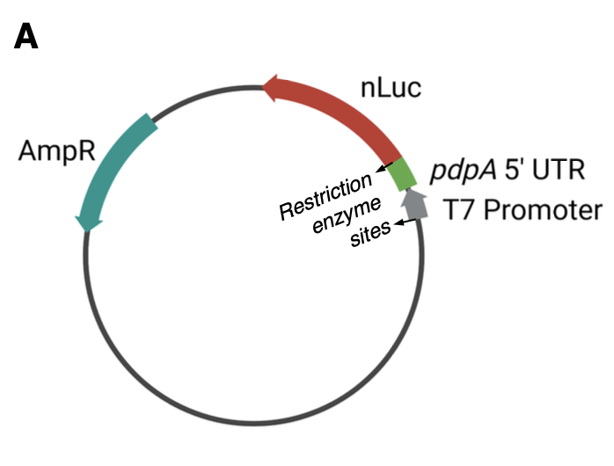 | A single-reporter plasmid containing nLuc fused to the 5’ UTR of a gene of interest, flanked by NotI restriction enzyme cut sites, is easy to modify.
3 | Active E. coli ribosomes were reproducibly purified using the sucrose cushion method  [Positive control for ribosome isolation / activity] | Can we reproducibly purify active E. coli ribosomes? | French press lysis and sucrose cushion purification |  | E. coli ribosomes purified using the sucrose cushion method are active enough to measure and reproducible.
4 | Kasugamycin can inhibit translation in vitro | Does kasugamycin inhibit translation? | Luminescence in vitro assays |  | Kasugamycin inhibits translation in a dose of 1mM.
5 | LVS grows better in BHI media than in MHB | Will LVS reach mid-log phase at a higher OD in a different kind of growth media? | Growth curves |  | LVS grows faster and reaches mid-log phase at a higher OD in BHI media than in MHB media.
6 | Active ribosomes from LVS grown in BHI can be reproducibly purified using the sucrose cushion method
7 | LVS ribosomes purified just like E. coli have more variability in activity
8 | Bug Buster chemical lysis can be used to purify active ribosomes | Can Bug Buster chemical lysis be used to purify active ribosomes?  [If you include this, you would want to demonstrate activity using | Bug Buster lysis followed by sucrose cushion and in vitro assays |  | Bug Buster lysed and purified ribosomes are measurably active in vitro.
9 | Purified E. coli and LVS ribosome samples have different ribosome profiles | Given the observed variability, are we isolating 70s ribosomes from LVS? | French press or Bug Buster lysis and sucrose cushion followed by sucrose gradients |  | Purified LVS ribosomes have broader 70S peaks, a 50S shoulder, and a distinct 100S peak when compared to E. coli ribosomes.
10 | Different lysis methods have different sucrose gradient profiles | Does lysis method affect the ribosome profile on sucrose gradients? | French press or Bug Buster lysis and sucrose cushion followed by sucrose gradients |  | The lysis method does affect the appearance of the sucrose gradient profile.
11 | Dialysis of ribosomes into low Mg buffer separates subunits | Will dialysis allow us to isolate pure 70S ribosomes? | Overnight dialysis followed by sucrose gradient | 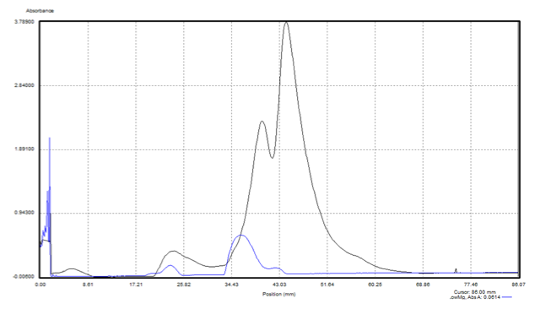 | Successful dissociation into 30S and 50S subunits.
12 | Incubation of dissociated ribosomes in high Mg buffer reassociates subunits | Will dialysis allow us to isolate pure 70S ribosomes? | Overnight dialysis or incubation (overnight or two hours) followed by sucrose gradient |  | Incubation for two hours in high Mg buffer is sufficient to reassociate 70S ribosomes.
13 | Lower pmol ribosomes leads to sharper 70S peaks | Does the amount of ribosomes loaded onto a sucrose gradient affect the subsequent profile? | Sucrose gradient with varying amount of ribosomes loaded |  | Loading fewer ribosomes onto sucrose gradients leads to sharper 70S peaks.
14 | Ribosome concentration affects translation efficiency (Lower pmol -> more translation) | Does the amount of ribosomes in an in vitro assay affect translation efficiency? | Serial dilution followed by in vitro luminescence assays |  | Lower ribosome concentrations have higher luminescence/pmol.
15 | Using 2 pmol of LVS ribosomes in vitro works well for luminescence and gives consistent and reproducible results | Does using 2 pmol of LVS ribosomes in vitro deliver measurable and consistent results for luminescence across purifications? | In vitro assays with 2 pmol LVS ribosomes from different purifications |  | Using 2 pmol of LVS ribosomes in vitro gives measurable and consistent results for luminescence across most purifications.
16 | Lysis method affects translation efficiency | Does the method of lysis (French Press or Bug Buster) affect the translation efficiency of ribosomes from the subsequent purification? | In vitro assays with LVS ribosomes purified from French Press or Bug Buster lysis |  | LVS ribosomes purified from French Press lysed cells are more active than those purified from Bug Buster lysed cells. This depends on pmol ribosomes used.
17 | Lysis method affects processing of ribosomal RNA | Does the method lysis (French Press or Bug Buster) affect the processing of ribosomal RNA as seen on a gel? | RNA extracted from ribosomes purified from French Press or Bug Buster lysed cells and run on an RNA gel | 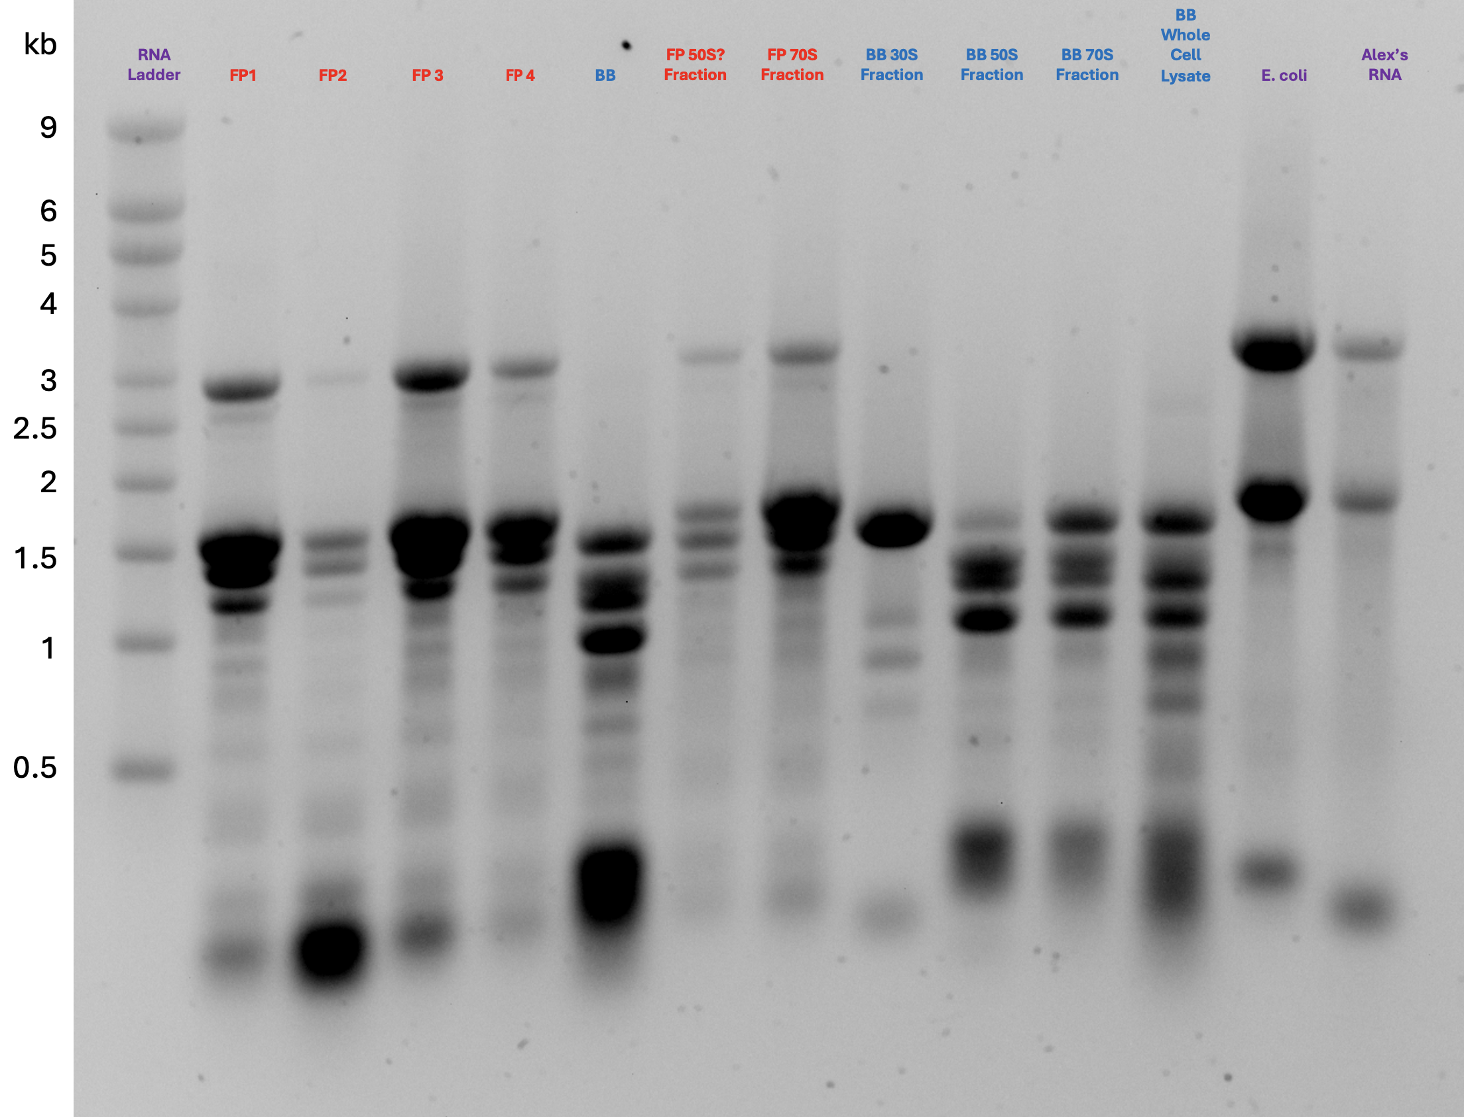 | LVS ribosomes purified from Bug Buster lysed cells display more RNA processing than those purified from French Press lysed cells.

