Time | Experiments | Figures | Notes
Previous | Testing 5’ UTRs in vivo  Testing modifications to 5’ UTRs  Testing activity of LVS ribosomes | 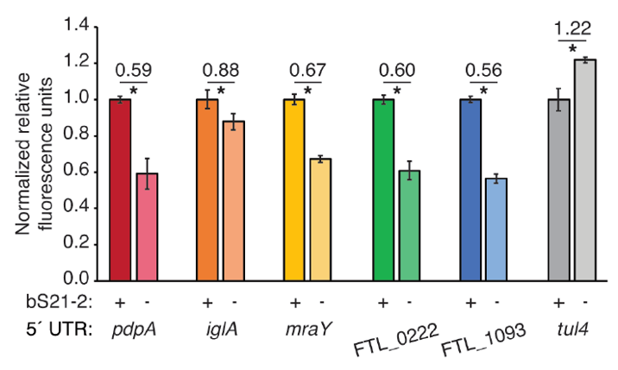  5´ UTRs are sufficient to lead to bS21-2-mediated changes in translation.  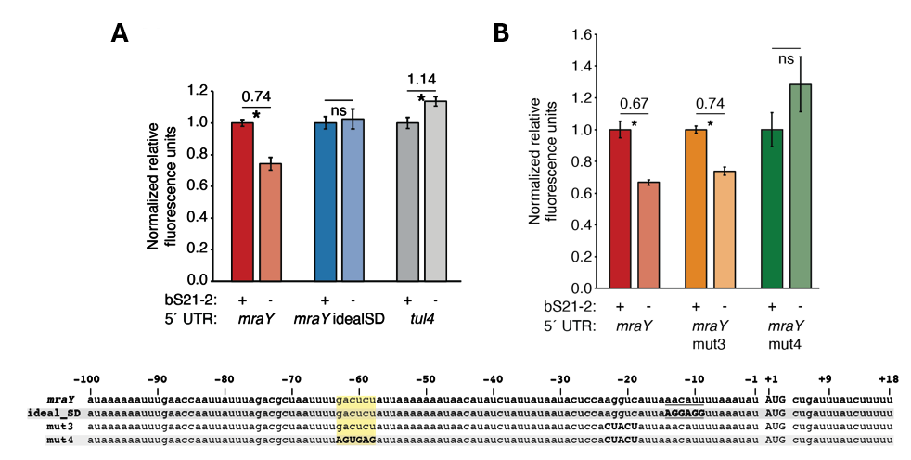  bS21-2-mediated translation of mraY depends on a weak Shine-Dalgarno and a specific six nucleotide sequence.  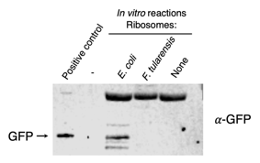  Ribosomes purified from F. tularensis exhibited poor activity in initial in vitro assays.
General | - Growing cells in MHB and BHI  - Designing and cloning double- and single-reporter plasmids  - Sucrose cushion ribosome purification  - Sucrose gradient sedimentation  - PureExpress Ribosome Kit assay and reading  - Nano-Glo Luciferase assay and reading
Jan-23 | TAP Purification  SDS-PAGE Gel  Coomassie and silver stains  Western blot
Feb-23 | Submitting sample to Duke  Attempts to purify more pKR147
Mar-23 | pKR144 and pKR147  Sequencing pKR147  Growing pKR147 at low temp  Growing pKR147 in DH5-a
Apr-23 | Investigating alternate reporters  Cloning dual-reporter plasmids with LanYFP and iLov  Growing pKR147 in minimal media  MRE600 cell pelleting  Sucrose cushion ribosome purification
May-23 | pH-adjustment of minimal media  Testing luminescence of MRE600 and kit ribosomes  Sucrose cushion purification in triplicate  Washing off orange film from ribosome pellets  Cloning dual-reporter plasmids with LanYFP and iLov
Jun-23 | Successful harvesting of pKR147 from XL1-Blue grown in MM at 27C  Cloning of plasmids with dual NotI cut sites  Comparison of multiple in vitro assays with MRE600 ribosomes  Removal of orange film  Successful cloning of dual-reporter plasmids with LanYFP and iLov | Relative luminescence values for nLuc after translation by purified E. coli ribosomes.  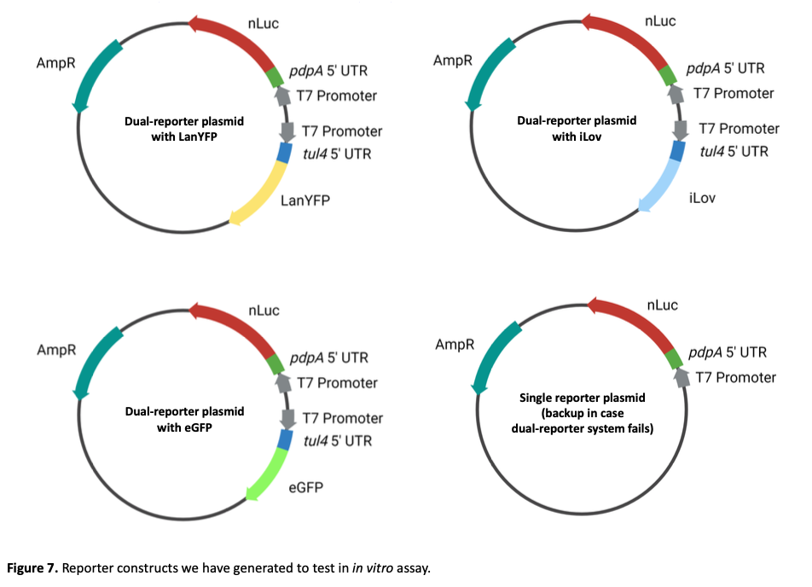  Figure of different cloned plasmids.
Jul-23 | LVS cell pelleting  Successful cloning of plasmids with dual NotI cut sites  Assessment of LanYFP and iLov in vivo  Testing plate readers | 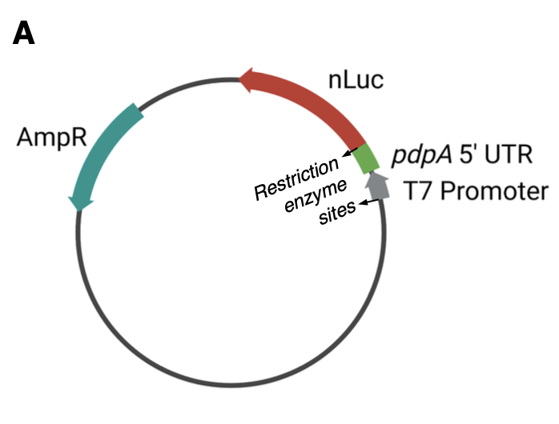  Diagram of NotI cut sites.
Aug-23 | LVS ribosome purification  Cloning of plasmids with ideal pdpA SD (pKR206/207)  Cloning of plasmid with tul4-nLuc fusion (pKR208)
Sep-23 | Luminescence standard curve  LVS plotted on standard curve  Kasugamycin test  Testing BHI media  LVS growth curves in MHB and BHI media | 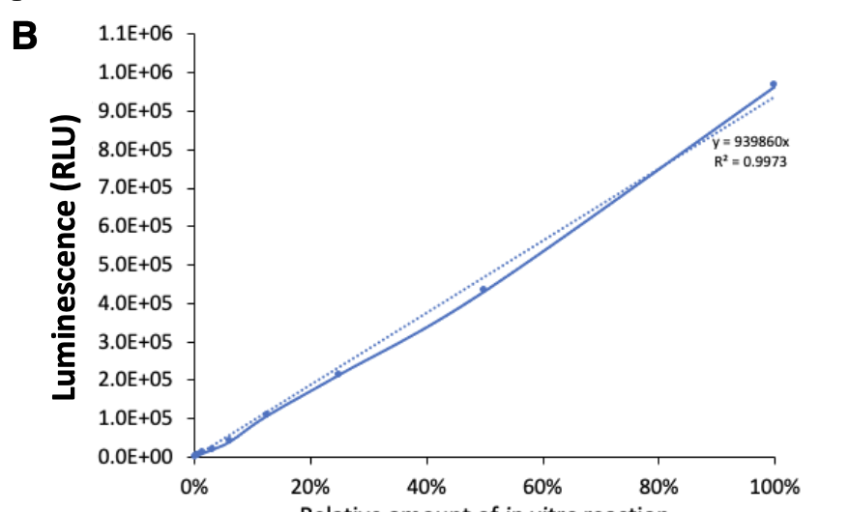  Luminescence standard curve.  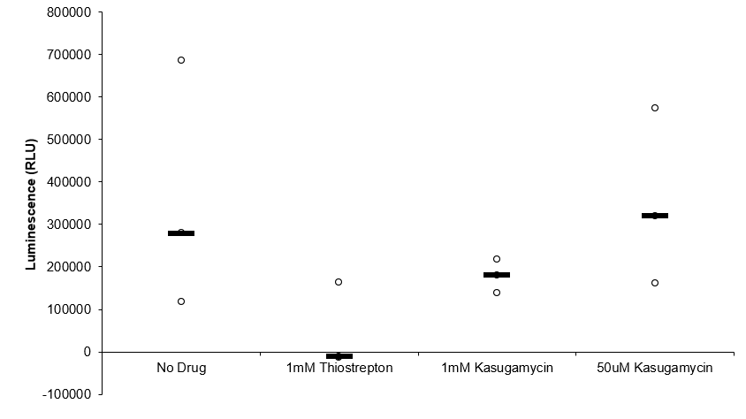  Ksg inhibition assays.  LVS growth curves in MHB and BHI.
Oct-23 | Heat activation of ribosomes  In vitro assay with tul4-nLuc  Luminescence standard curve  Laurenobiolide inhibition assay
Nov-23 | In vitro assays with different ribosome concentrations (nLuc & GFP)  In vitro assays testing inhibitory effects of LVS ribosomes (nLuc & GFP)  Comparing signal from different UTR-reporter fusions in E. coli & LVS
Dec-23 | In vitro assay with tul4-nLuc and LVS from MHB and BHI  Testing LanYFP/nLuc dual-reporter system  Cloning nLuc single-reporter plasmids pKR212, 213, 214 | 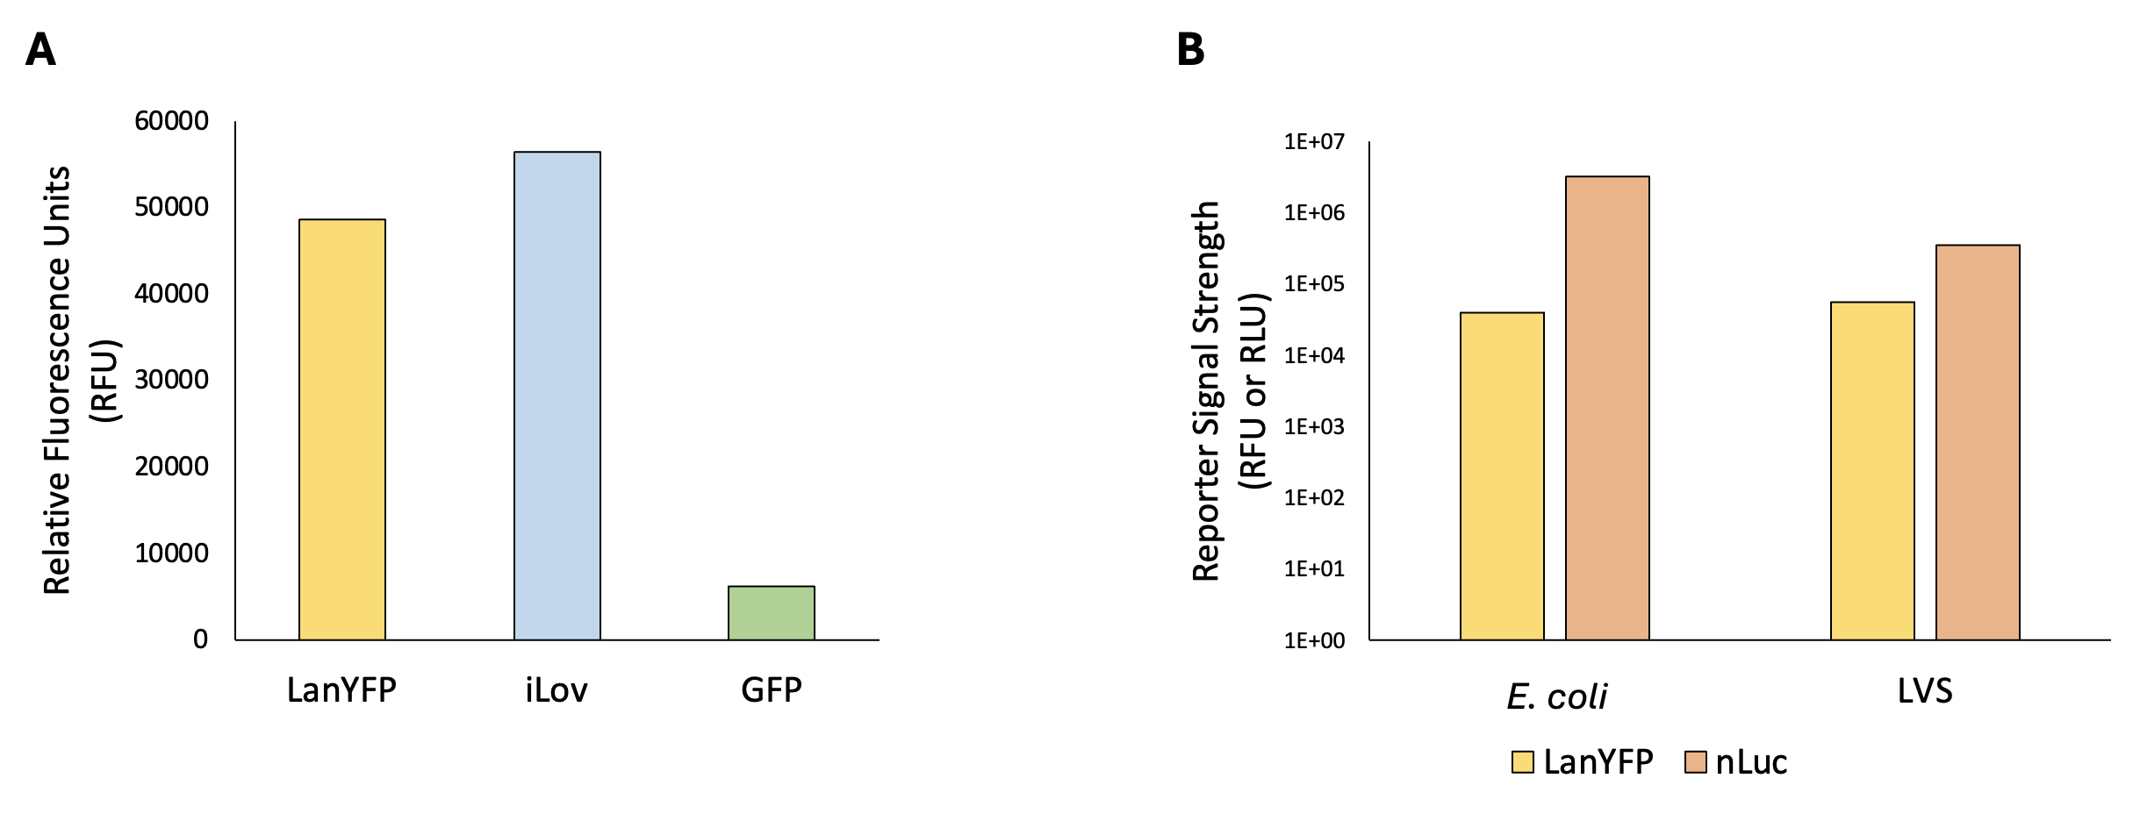  Comparison of reporters demonstrates that nLuc is the most sensitive reporter tested. | White/black plates?  Growth media and UTR affect translation
Jan-24 | Improving consistency of signal from ribosome samples  Testing consistency of concentration measurements
Feb-24 | Testing reproducibility of E. coli ribosomes  Kasugamycin inhibition assay
Mar-24 | Purification of LVS ΔrpsU1 ΔrpsU3 ribosomes  Testing reproducibility of LVS ribosomes  Purification of tight-coupled ribosomes | E. coli  F. tularensis  Assessing translation by ribosomes from E. coli and F. tularensis.
Apr-24 | Testing consistency of concentration measurements  Testing ribosome heterogeneity  Sucrose gradient after dialysis into low/high Mg  Testing effectiveness of lysis methods (Brij & Bug Buster) and ribosome composition with sucrose gradients
May-24 | Rerunning sucrose gradient fractions  Sucrose gradients with different Mg concentrations  Sucrose gradients after incubation in high Mg ON vs 2 hours  RNA extractions  RNA gels | 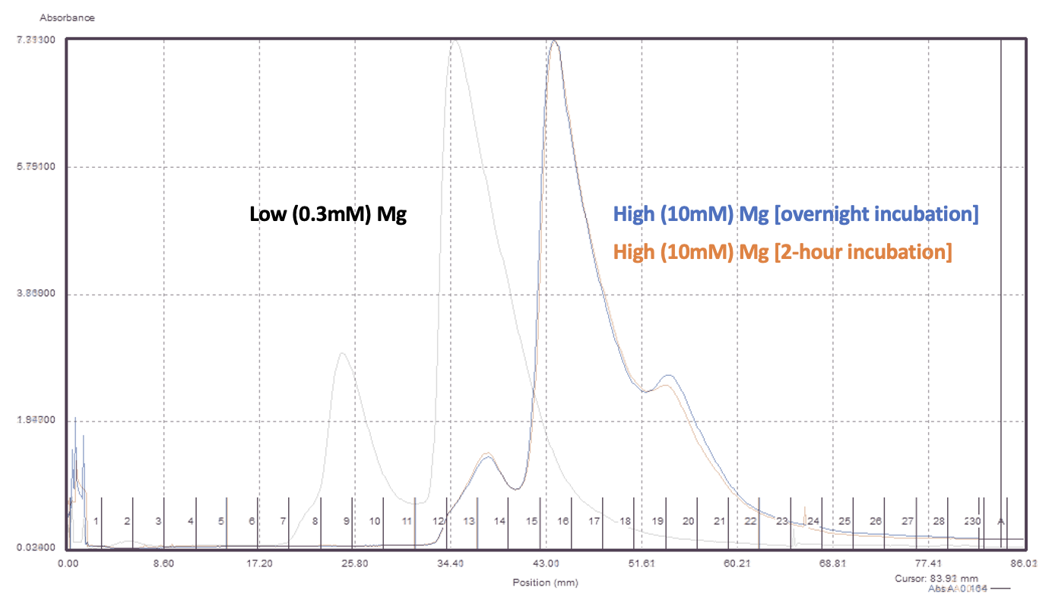  Sucrose gradients after incubation in high Mg ON vs 2 hours. | Sucrose not removed/dialyzed
Jun-24 | Sucrose gradient of LVS whole cell lysate  RNA extraction of sucrose gradient fractions  Testing LVS ΔrelA ΔspoT | Sucrose gradient sedimentation profiles of purified ribosomes from indicated species.
Jul-24 | Sucrose gradients with different amounts of ribosomes loaded  Rerunning 70S fraction on gradient | 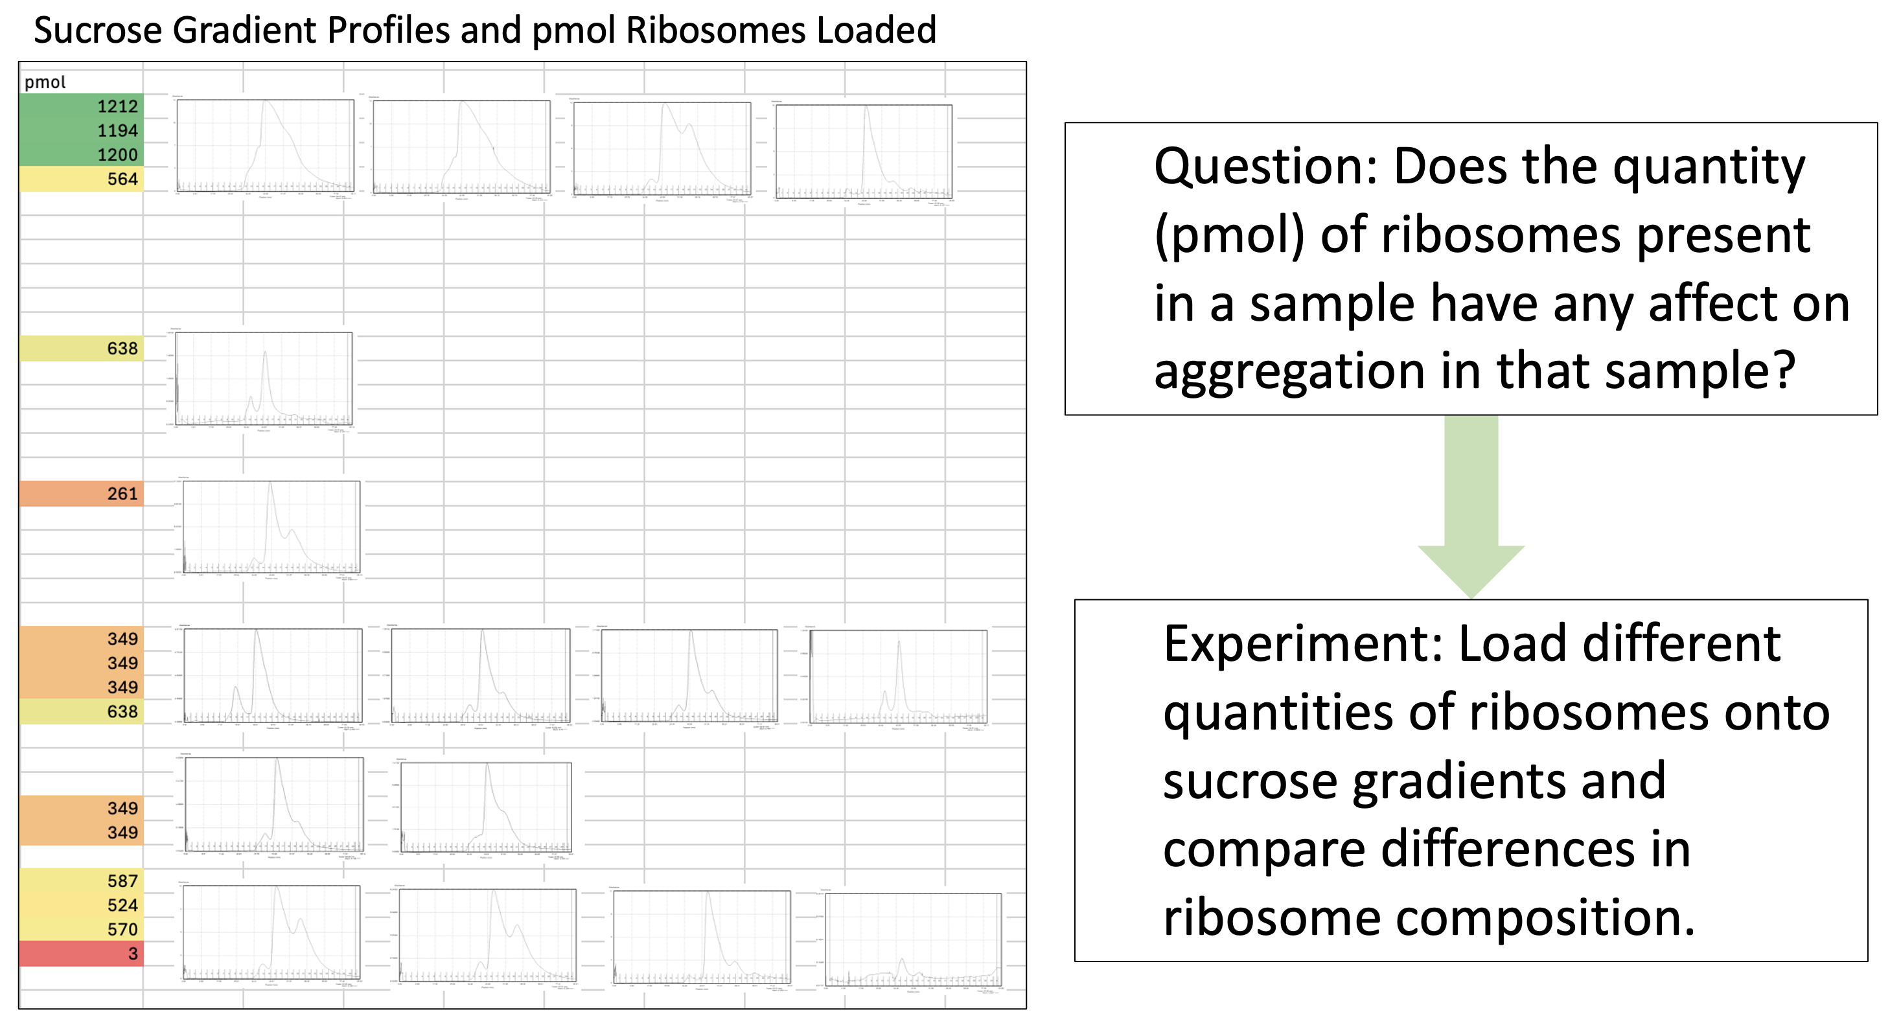  Sucrose gradients with different amounts of ribosomes loaded  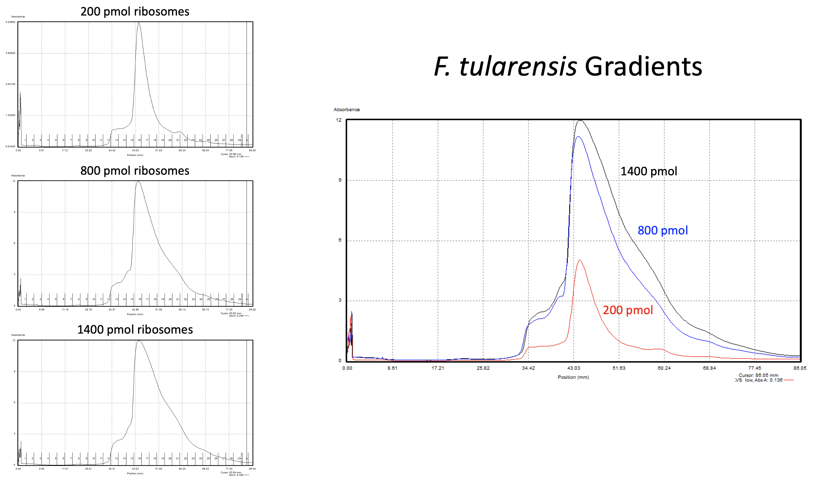  Sucrose gradients with different amounts of ribosomes loaded  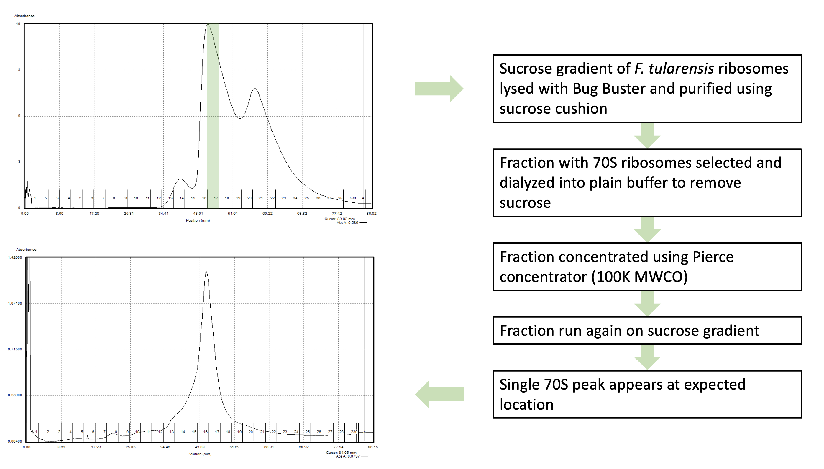  Rerunning 70S fraction on gradient
Aug-24 | Dilution series with nLuc and GFP  Testing luminescence/pmol  Testing luminescence with 2 pmol ribosomes | Dilution series with nLuc.  Testing luminescence/pmol.  Testing luminescence with 2 pmol ribosomes. | Lysis method affects translation

Specific Aim #1: Develop a reporter construct for use in an in vitro translation assay that is sensitive and easy to modify.
Specific Aim #2: Reproducibly purify active ribosomes from E. coli and F. tularensis.

