Additional Findings
Purified E. coli and LVS ribosome samples have different ribosome profiles
Figure X. Sucrose gradient profiles of purified E. coli and LVS ribosomes. Purified LVS ribosomes have broader 70S peaks, a 50S shoulder, and a distinct 100S peak when compared to E. coli ribosomes.

Different lysis methods have different sucrose gradient profiles
I also purified ribosomes from LVS cells lysed with the BugBuster© chemical, hoping that this method would provide a simpler alternative to French press lysis and yield more ribosomes. Initial experiments were promising, showing that ribosomes could be purified with this method at a relatively high yield (____ pmol/uL). I ran these samples on sucrose gradients and saw that instead of a broad, sloping 70S peak, the gradient profile contained a rounded 70S peak followed by another rounded peak that looked like 100S ribosome dimers. The discreet separation between 70S and 100S ribosome populations contrasted with the continuous sloping curve from French press lysed ribosomes and might indicate a continuum of associating and dissociating ribosome dimers. I also saw that these ribosome samples appeared to display less “stickiness” on their sucrose gradient profiles. There are still many questions to be answered, particularly in relation to sucrose gradient profiles and potential aggregation of LVS ribosomes purified from French press-lysed cells.
Figure X. Sucrose gradient profiles of LVS ribosomes from French Press and Bug Buster-lysed cells. The lysis method affects the appearance of the sucrose gradient profile.

Dialysis of ribosomes into low Mg buffer separates subunits and incubation of dissociated ribosomes in high Mg buffer reassociates subunits.
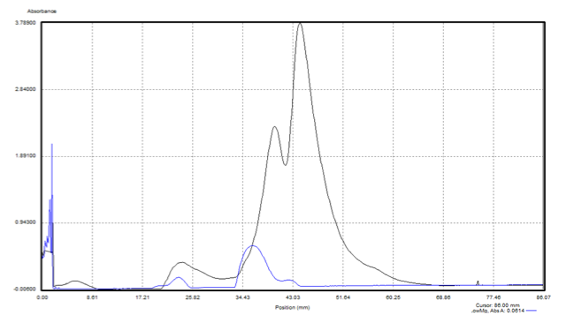
Figure X. Sucrose gradient profiles of LVS ribosomes after dialysis into low and high Mg. Successful dissociation into 30S and 50S subunits. Incubation for two hours in high Mg buffer is sufficient to reassociate 70S ribosomes.

