EVALUATING FRANCISELLA TULARENSIS
TRANSLATION IN VIVO
BY
BENJAMIN MOORE

A THESIS SUBMITTED IN PARTIAL FULFILLMENT OF THE
REQUIREMENTS FOR THE DEGREE OF
MASTER OF SCIENCE
IN
BIOLOGICAL AND ENVIRONMENTAL SCIENCES

UNIVERSITY OF RHODE ISLAND
2024
MASTER OF SCIENCE THESIS

OF

BENJAMIN MOORE

APPROVED:

Thesis Committee:

Major Professor Kathryn Ramsey

Steven Gregory

David Rowley

Brenton DeBoef
DEAN OF THE GRADUATE SCHOOL

UNIVERSITY OF RHODE ISLAND
2024

ABSTRACT
Francisella tularensis is a Gram-negative, facultative, intracellular bacterium which causes the disease tularemia. Previous research demonstrated that F. tularensis ribosomes are heterogeneous and that a specific ribosomal protein, bS21-2, regulates translation by interacting with the leader sequences of mRNAs (Trautmann and Ramsey 2022). Studies using reporter assays in bacterial cells (in vivo) made significant progress towards identifying leader sequences that confer regulation by bS21 (Trautmann et al. 2023), but we would like to determine if these results can be recapitulated using purified ribosomes (in vitro). Once a working in vitro system has been established, we can build upon experimental data from in vivo studies and develop a more comprehensive model of regulation by bS21. The primary goal of this research project was to develop an in vitro assay for translation using F. tularensis Live Vaccine Strain (LVS) ribosomes with the NEB PURExpress in vitro translation kit. When the kit components are combined with a DNA template and purified ribosomes, transcription and translation of a DNA-encoded reporter occurs, resulting in a signal that can be measured to assess translation efficiency. To achieve this goal, I developed a sensitive and easily modifiable reporter construct, purified active ribosomes from E. coli and F. tularensis LVS, and optimized the reproducibility of the in vitro assay.
Using standard cloning techniques, I generated a reporter construct for the in vitro translation assay that is sensitive and easy to modify. I also purified E. coli MRE600 ribosomes using the sucrose cushion method and determined that they were translationally active in the in vitro assay. Then, I replicated these results using ribosomes from multiple purification attempts, validating that we can reproducibly isolate active ribosomes. In addition, I demonstrated that E. coli ribosomes are inhibited by kasugamycin and thiostrepton, indicating that we can use the assay to measure translation inhibition by antibiotics. I found that F. tularensis ribosomes appear to aggregate or clump more readily than E. coli ribosomes, but that when there are fewer ribosomes in a sample, there is less aggregation. This aggregation appears to impact translational activity, as I found that luminescence per picomole (pmol) of ribosomes increases as ribosome concentration decreases. After further testing, I concluded that using 2 pmol of F. tularensis LVS ribosomes in the in vitro assay yields a measurable and consistent signal across multiple ribosome purifications. This optimized in vitro assay that I developed can be used in future research to easily measure translation efficiency of mRNAs with different leader sequences and will contribute to a better understanding of how bS21 homologs regulate translation in F. tularensis.

ACKNOWLEDGMENTS
University of Rhode Island; Dr. Kathryn Ramsey (Hannah Trautmann, Sierra Schmidt, Kira Bernabe, Alexandra Farah, Johanyx Rodriguez, Christina Surace, George Madave, Sara Negash, Aisling Macaraeg, Oli Horyn); Dr. Steven Gregory; Janet Atoyan.

TABLE OF CONTENTS

LIST OF FIGURES vii
CHAPTER 1 9
INTRODUCTION & REVIEW OF LITERATURE 9
CHAPTER 2 17
METHODOLOGY 17
CHAPTER 3 23
FINDINGS 23
CHAPTER 4 40
CONCLUSIONS 40
BIBLIOGRAPHY 47

LIST OF FIGURES

FIGURE PAGE
CHAPTER 1: INTRODUCTION & REVIEW OF LITERATURE

Figure 1. 5´ UTRs are sufficient to lead to bS21-2-mediated changes in translation 12

Figure 2. bS21-2-mediated translation of mraY depends on a weak Shine-Dalgarno and a specific six nucleotide sequence 13

Figure 3. Ribosomes purified from F. tularensis exhibited poor activity in initial in vitro assays 15
CHAPTER 3: FINDINGS

Figure 1. Comparison of reporters demonstrates that nLuc has the highest signal strength of reporters tested 24

Figure 2. A sensitive and easily modifiable reporter plasmid for testing translation of 5′ UTRs 26

Figure 3. Relative luminescence produced by nLuc translated by purified E. coli ribosomes shows reproducible ribosome activity 27

Figure 4. In vitro translation can be inhibited by ribosome-targeting drugs 28

Figure 5. F. tularensis LVS grows faster and to a higher density in sBHIc medium than in sMHB medium 30

Figure 6. Assessment of translation by ribosomes from E. coli and F. tularensis shows variability in signal for F. tularensis ribosomes 31

Figure 7. Sucrose gradient sedimentation profiles reveal differences in composition between E. coli and F. tularensis LVS ribosomes 32

Figure 8. Loading fewer F. tularensis ribosomes onto sucrose gradients results in less aggregation 33

Figure 9. Lower ribosome concentrations in the in vitro translation assay leads to higher signal per ribosome 35

Figure 10. F. tularensis LVS ribosomes purified from French press-lysed cells are more active than those purified from BugBuster-lysed cells 36

Figure 11. F. tularensis LVS ribosomes purified from BugBuster-lysed cells have fragmented 23S rRNA 38

Figure 12. Comparison of luminescence data for several assays shows reproducible translation signal with 2 or 2.5 pmol F. tularensis LVS ribosomes 39

CHAPTER 1

INTRODUCTION & REVIEW OF LITERATURE
Francisella tularensis is a Gram-negative, facultative, intracellular bacterium. F. tularensis causes the disease tularemia, which can be transmitted by rabbits, small rodents, or arthropods (Sjöstedt, 2007). This disease manifests at the onset with flu-like symptoms and can develop into several forms, of which the ulceroglandular form is the most common and the pneumonic form can be fatal (Degabriel et al., 2023). Because a relatively small exposure to the bacterium can cause an infection and it can be easily dispersed through the air, it has been classified as a potential bioweapon (Oyston et al., 2004). The Ramsey lab uses F. tularensis subspecies holarctica, specifically the live vaccine strain (LVS), as a model organism, because it is not infectious to humans but retains its virulence in animal models. The Ramsey lab studies post-transcriptional regulation of virulence genes in F. tularensis, specifically how changes in ribosome composition impact virulence gene expression.
Key virulence genes in F. tularensis are located within the Francisella Pathogenicity Island (FPI), a region of the genome that codes for the type 6 secretion system (T6SS). The T6SS is a protein complex necessary for bacterial intracellular survival and growth within host cells. This cluster of genes is tightly regulated at the level of transcription. Specifically, transcription increases during the stringent stress response when the alarmone (p)ppGpp binds to transcription factors MglA and SspA, associated with RNA polymerase, and recruits another transcription factor, PigR. This increases transcription from promoters that contain short motifs called PigR response elements (PREs), including those found on the FPI (Cuthbert et al., 2017; Ramsey et al., 2015; Travis et al., 2021). Recent work has demonstrated that the expression of FPI virulence genes is further controlled by regulating the translation of the mRNA into proteins by a specific ribosomal protein, bS21-2 (Trautmann & Ramsey, 2022).
Most bacteria encode one bS21 homolog or none at all. In the ribosome, bS21 is located in the small subunit near the anti-Shine Dalgarno sequence and the channel where mRNA exits the ribosome. Its location suggests that bS21 may interact directly with the 5’ untranslated region (5’ UTR) of mRNA molecules during the initiation phase of translation. Several studies have implicated bS21 in translation initiation by E. coli ribosomes (van Duin & Wijnands, 1981; Chang & Craven, 1977).
F. tularensis is unusual in that it has three homologs of bS21. The Ramsey lab found that F. tularensis ribosomes can incorporate any one of the three bS21 homologs and that the second homolog, bS21-2, is the most abundant when cells are grown in the laboratory (Trautmann & Ramsey, 2022). Additionally, the loss of bS21-2 leads to decreased abundance of certain proteins, including T6SS proteins, yet mRNA abundance remains the same (Trautmann & Ramsey, 2022). This suggests that when bS21-2 is absent, ribosomes cannot translate these mRNAs as efficiently. We also found that the ability of cells to replicate within macrophage decreased when bS21-2 was absent (Trautmann & Ramsey, 2022). These data lead to the development of a model in which bS21-2 allows for more efficient translation of virulence genes.
In support of a model in which bS21-2 controls translation initiation, it was found that the presence of bS21-2 can affect the translation of mRNAs with specific 5' UTR sequences and that altering the 5' UTR sequences can lead to a loss of this regulatory effect (Trautmann et al., 2023). In particular, the Ramsey lab studied these effects in vivo using a reporter assay to examine how the presence of bS21-2 alters translation of particular mRNAs in F. tularensis. These reporters consisted of a control promoter, specifically the promoter for F. tularensis gene tul4 (tul4 is not regulated by bS21-2 (Trautmann & Ramsey, 2022)), driving the transcription of an mRNA containing the 5´ UTR of a control gene or gene of interest fused to a green fluorescent protein (GFP) coding sequence. GFP production was used as a measure of translation efficiency for each mRNA. The 5' UTRs tested in this reporter assay were selected based on a proteomics analysis in which the absence of bS21-2 led to a downregulation in protein production from the selected genes (Trautmann & Ramsey, 2022). These genes included the FPI genes pdpA and iglA. When bS21-2 was absent, reporter output decreased when fused to the 5´ UTRs of the selected genes but not when fused to the 5´ UTR of tul4 (Figure 1; Trautmann & Ramsey, 2022). Since changes in reporter output correlate with the amount of protein in cells with and without bS21-2, these data indicate that the 5´ UTR is sufficient to influence translation by bS21-2 in vivo. Additionally, because 5´ UTRs are generally important for initiation, these results strongly suggest that bS21-2 regulates translation during initiation.
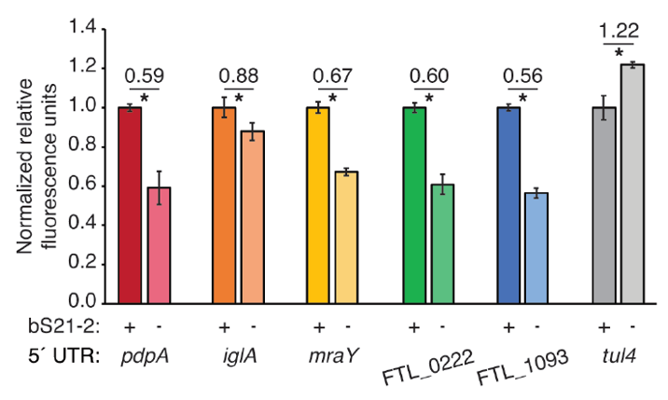
Figure 1. 5´ UTRs are sufficient to lead to bS21-2-mediated changes in translation. Relative fluorescence for indicated GFP translational fusion reporters in cells with (+; WT) or without (−; ΔrpsU2) bS21-2. The tul4 5´ UTR serves as a control. Lines above bars indicate comparisons, values above line indicate ratio of reporter activity in cells lacking bS21-2 to wild-type cells. Error bars represent 1 SD. *P < 0.05 by t-test. Figure and legend are from Trautmann et al., 2023.

After determining that the 5´ UTR is sufficient to allow bS21-2-mediated changes in translation, the Ramsey lab further investigated which elements of 5´ UTR sequences lead to regulation. In most bacterial 5´ UTRs, a particular sequence called the Shine-Dalgarno (SD) pairs with the anti-Shine-Dalgarno (aSD) sequence in the 16S rRNA of the 30S ribosomal subunit. This pairing is not strictly necessary for translation initiation but increases its efficiency. Structures of E. coli ribosomes reveal that bS21 likely directly contacts the aSD sequence (Kaledhonkar et al., 2019), implicating the SD-aSD pairing as a potential candidate for regulation by bS21-2 in F. tularensis. Upon testing translation efficiency of mRNAs with different SD sequences, the Ramsey lab found that 5´ UTRs with ideal SDs lost responsiveness to bS21-2 (Figure 2A, Trautmann et al., 2023), suggesting that bS21-2 interacts with the 5ˊ UTR in certain ways, but that the presence of a perfect SD can override these effects so that they are not as significant. In other genes, however, imperfect SD sequences do not automatically lead to regulation, so the search for other regulatory elements continued.
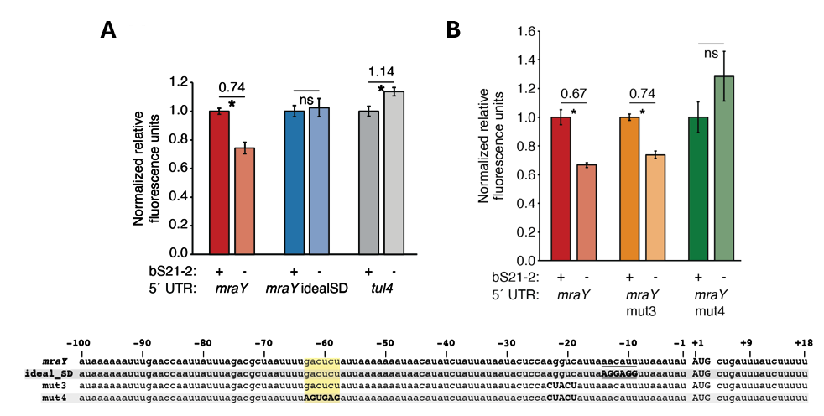
Figure 2. bS21-2-mediated translation of mraY depends on a weak Shine-Dalgarno and a specific six nucleotide sequence. Charts show relative fluorescence for indicated gfp translation fusion reporters in cells with (+; WT) or without (−; ΔrpsU2) bS21-2. (A) Introduction of an ideal SD in the mraY leader leads to loss of bS21-2 responsiveness. (B) The nucleotides between −58 and −63 in the mraY 5´ UTR, GACUCU, are essential for responsiveness to bS21-2. (A–B) Lines above bars indicate comparisons, values above line indicate ratio of reporter activity in cells lacking bS21-2 to wild-type cells. Error bars represent 1 SD. *P < 0.05 by t-test. ns = not significant. Experiments were repeated at least twice in biological triplicate, and data from a representative experiment are shown. Figure and legend are from Trautmann et al., 2023.

To find elements necessary for regulation by bS21-2, the Ramsey lab investigated the 5´ UTR of mraY. Hannah Trautmann tested the contribution of two motifs (AAAAUAAA and UUAUUUA) that are enriched in the 5´ UTR of genes regulated by bS21-2 as well as the predicted secondary structure of 5´ UTRs, but these did not contribute to regulation by bS21-2. Through further testing and modification of the mraY 5´ UTR, she identified a 6-nucleotide motif in the mraY 5´ UTR GACUCU (Figure 2B, Trautmann et al., 2023) that is necessary for regulation by bS21-2.
These studies have allowed significant progress in understanding how bS21-2 controls translation of mRNAs with specific 5’ UTRs, but we would like to go further and address several other questions. In particular, we would like to determine if these results can be recapitulated in vitro. Once a working in vitro system has been established, we can also test whether the GACUCU motif is sufficient for regulation by bS21-2 and whether there are other sequence motifs that confer regulation. By developing an in vitro assay that allows us to examine translation efficiency, we can build upon previous experimental data and develop a more comprehensive model of regulation by bS21-2.
The goal of my thesis project is to develop an in vitro translation assay for F. tularensis. In developing this assay, I will use the PURExpress® Δ Ribosome Kit from New England Biolabs which contains all the factors necessary for transcription and translation except ribosomes and permits the user to translate any protein as a reporter. When the kit components are combined with a DNA template and purified ribosomes, transcription and translation of a DNA-encoded reporter will occur, resulting in a signal that can be measured to assess translation efficiency. To use this kit for our studies, we must clone a plasmid template and purify active ribosomes from F. tularensis.
Preliminary work towards developing an in vitro translation assay performed by Hannah Trautmann used F. tularensis ribosomes and the tul4 5’ UTR – GFP reporter. While the reaction with manufacturer-provided E. coli ribosomes yielded signal in the assay, demonstrating that the reaction was properly set up, the ribosomes purified from F. tularensis did not translate detectable amounts of product (Figure 3). These results suggested to us that we should try to find a more sensitive reporter and that we should ensure that the ribosomes we are purifying are sufficiently active.
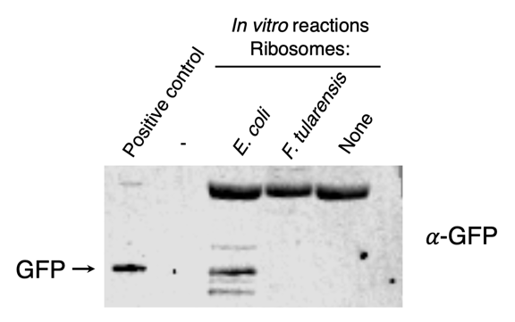
Figure 3. Ribosomes purified from F. tularensis exhibited poor activity in initial in vitro assays. In vitro translation assays were performed using a DNA template specifying an mRNA with the tul4 5’ UTR fused to the GFP gene (pKR107). Reactions contained either control E. coli ribosomes provided in the kit, ribosomes purified from F. tularensis LVS, or no ribosomes, as indicated at the top of the image. No fluorescence was detected from the reaction containing F. tularensis ribosomes, so samples were analyzed by immunoblot using an antibody to GFP. The positive control lane contains cell lysate from F. tularensis expressing GFP.

My thesis project is part of a larger effort to identify ways in which bS21 controls translation of mRNAs with specific 5’ UTRs. The purpose of this thesis was to develop an in vitro assay for F. tularensis which could assess translation efficiency of various genes, test for sequence motifs that confer regulation by bS21, and assist in developing a more comprehensive model of regulation by bS21. For my thesis, I cloned a plasmid template to use in the in vitro assay that was sensitive and easy to modify. I also purified reproducibly active ribosomes from E. coli and F. tularensis. I then used the plasmid template and purified ribosomes with the PURExpress Δ Ribosome Kit to measure translation efficiency of specific 5’ UTRs. I found that in vitro translation efficiency was dependent on bacterial species, 5’ UTR, method of lysis, and the amount of ribosomes loaded in the assay. In addition, I found that E. coli ribosomes are sensitive to kasugamycin, an aminoglycoside that inhibits translation and binds near bS21, demonstrating that the in vitro assay can be used to test for translation inhibition by specific antibiotics.

CHAPTER 2

METHODOLOGY

Bacterial strains and growth conditions
Francisella tularensis subsp. holarctica LVS cells were cultured at 37°C in supplemented Mueller-Hinton broth or brain heart infusion broth as indicated, shaking aerobically, or on plates with cysteine heart agar supplemented with 1% hemoglobin (CHAH). Mueller-Hinton broth was supplemented with 1 mg/mL glucose, 0.25 mg/mL iron pyrophosphate, and 2% Isovitalex (sMHB). Brain heart infusion broth was supplemented with 1 mg/mL cysteine, 0.01 mg/mL β-NAD, 0.01 mg/mL heme-histidine, and 5 mg/mL glucose (sBHIc). Escherichia coli strain MRE600 (Kurylo et al., 2016) was used for ribosome purifications, and E. coli strain XL1 Blue was used for plasmid cloning and propagation. E. coli cells were grown at 37°C, shaking aerobically in LB liquid media or on LB agar. E. coli cells harboring replicating plasmids were selected for on carbenicillin medium at 100 μg/mL.
Plasmid construction
The plasmids constructed for this study were derived from the DHFR control plasmid provided in the NEB PURExpress transcription/translation system kit. The DHFR plasmid, which has a high copy number pUC origin and encodes ampicillin resistance, also encodes the bacteriophage T7 RNA polymerase promoter driving expression of the E. coli dihydrofolate reductase (DHFR) gene. The plasmid also contains a ribosome binding site (RBS) which increases ribosome binding efficiency during translation and a multiple cloning site (MCS) downstream of the DHFR gene with multiple restriction enzyme cut sites for easy modification. With these elements in place, the DHFR gene can easily be exchanged with a gene of interest, replicated at a high rate in selective media, and transcribed and/or translated in the in vitro system.
The intermediate plasmid pKR81 is derived from the control DHFR plasmid, modified to include DNA specifying the T7 promoter driving expression of an F. tularensis control gene, tul4. The modified DNA was generated by synthesis (IDT). This fragment encodes the T7 promoter directly followed by 536 bp of DNA from F. tularensis, which includes the tul4 transcription start site (36 bp upstream of the translation start site; Zaide et al., 2011) and extends 50 bp past the tul4 stop codon, and encodes BmtI digestion sites on both ends. pKR81 was constructed by digesting the control DHFR plasmid with BmtI to remove the T7 promoter and DHFR gene and cloning in the digested synthesized DNA fragment.
The pKR144 plasmid was derived from pKR81 with the addition of a second, divergently positioned T7 promoter driving expression of the 5′ untranslated region (5′ UTR) of the F. tularensis gene pdpA followed by the coding sequence for the small luciferase gene NanoLuc (NLuc; Hall et al., 2012). The pdpA 5′ UTR includes the transcription start site (24 bp upstream of the translation start site) and the first six codons (Ramsey et al., 2015). This additional DNA was generated as a fragment by synthesis (IDT), which also included DNA specifying a SalI site on the 5′ end and a PvuII site on the 3′ end. pKR144 was cloned by digesting pKR81 with SalI and PvuII, which removed 11 bp, and ligating in the digested synthesized DNA fragment.
The pKR204 and pKR205 plasmids were ultimately derived from pKR144. To generate pKR204, pKR144 was modified such that between the pdpA 5′ UTR and NLuc, DNA specifying a NotI site and one extra bp was added, encoding an in-frame alanine linker. The sequence following the other T7 promoter was also modified. After the tul4 5′ UTR and the first six tul4 codons, DNA was added that specifies a NotI site and one extra bp, encoding an in-frame alanine linker, followed by the coding sequence for the fluorescent protein LanYFP. The pKR205 plasmid only differs from pKR204 in that, after the NotI site following the tul4 5′ UTR, it encodes the fluorescent protein iLov.
The pKR214 plasmid, ultimately derived from pKR204, only encodes a single T7 promoter driving expression of the tul4 5′ UTR followed by NLuc. The tul4 5′ UTR includes the tul4 transcription start site and the first six codons of tul4 and is followed by DNA specifying a NotI site and one extra bp, encoding an in-frame alanine linker. The tul4 5′ UTR – NLuc fusion was generated by ligating together PCR products generated with NotI sites encoded in primers. The second T7 promoter and reporter encoded on pKR144 was removed by digestion with SalI and XhoI and ligation of the compatible ends.
Plasmids were validated by Sanger sequencing at URI’s INBRE Molecular Informatics Core.
70S ribosome purification
Half a liter of either E. coli MRE600 or F. tularensis LVS cells were grown to mid-log phase (OD₆₀₀ 0.6-0.8 or 0.5, respectively). Cells were chilled on ice for 20 min, pelleted by centrifugation at 15,316 xg for 5 min at 4°C, washed with buffer H¹⁰M¹⁰A⁵⁰ (10 mM HEPES KOH pH 7.6, 10 mM MgCl₂, and 50 mM NH₄Cl), pelleted by centrifugation at 14,635 xg for 15 min at 4°C, and stored at -80°C. Cells were resuspended in 15 mL of H¹⁰M¹⁰A⁵⁰ with 20 U DNase I and either lysed by passing through a French press once at 800 lb/in² or by including BugBuster® Protein Extraction Reagent (MilliporeSigma) in the resuspension buffer and incubating at 37°C for 1 h. Cell debris were removed by centrifugation at 146,000 xg for 15 min at 4°C. Supernatant was layered on top of H¹⁰M¹⁰A⁵⁰⁰ + 20% sucrose (10 mM HEPES KOH pH 7.6, 10 mM MgCl₂, 500 mM NH₄Cl, 20% sucrose) and ribosomes were pelleted by ultracentrifugation in a 50.2 Ti rotor for 4 h at 146,000 xg at 4°C. The pellet was washed twice with H¹⁰M¹⁰A⁵⁰ and gently resuspended in H¹⁰M¹⁰A⁵⁰. This suspension was then layered onto another sucrose cushion (H¹⁰M¹⁰A⁵⁰ with 40% sucrose) and centrifuged for 14 h at 146,000 xg at 4°C. Purified ribosomes were gently resuspended in 100 μL of either H¹⁰M¹⁰A⁵⁰ or low magnesium buffer (H¹⁰M^{0.3}A⁵⁰) at 4°C overnight. Several initial A260 readings were taken, averaged, and used to calculate ribosome concentration. For samples in low magnesium buffer, sufficient 1 M MgCl₂ was added to bring the magnesium to a concentration of 10 mM, and the samples were incubated on ice for at least two hours. Finally, ribosome samples were diluted in H¹⁰M¹⁰A⁵⁰ buffer to 2.67 pmol/μL, aliquoted in 16 μL volumes, and stored at -80°C.
Sucrose gradient sedimentation
A light solution of H¹⁰M¹⁰A⁵⁰ buffer + 10% sucrose was layered on top of a heavy solution of H¹⁰M¹⁰A⁵⁰ buffer + 50% sucrose in open polyclear gradient tubes (Seton), and the gradients were made using a Gradient Station (BioComp). Tubes with gradients were refrigerated for 45 min, balanced, and 200 μL of sample was layered on top. The tubes were centrifuged in a Beckman-Coulter SW40 Ti rotor for 40,000 rpm for 4 hours at 4°C. The nucleic acid content throughout the gradients were assessed using a Triax flow cell set to 260 nm. Thirty fractions were collected per gradient using a Gilson Fraction Collector (FC-203B) and stored at -80°C.
In vitro translation
Ribosomes, Solution A and Factor Mix from the PureExpress ∆ Ribosome Kit (NEB) were thawed on ice. Templates were phenol-chloroform purified plasmid DNA. Reactions were assembled using a master mix; individual reactions contained 10 μL Solution A, 3 μL Factor Mix, 250 ng template, and 40 pmol ribosomes in a total volume of 30 μL. To measure inhibition of translation by antibiotics, reactions were prepared in a total volume of 29 μL, and 1 μL of antibiotic was added to reach the indicated final concentration. Thiostrepton was diluted in DMSO and kasugamycin was diluted in water. Reactions were mixed gently and incubated at 37°C for 2 hours. The reactions were stopped by placing the tubes on ice, and samples were used for a Nano-Glo® Luciferase Assay or frozen at –20°C for later use.
Nano-Glo® Luciferase Assay
In vitro translation reactions, Nano-Glo® Luciferase Assay Buffer, and Nano-Glo® Luciferase Assay Substrate (Promega) were thawed on ice. Assay substrate was diluted 1:50 with Assay Buffer and mixed with an equal volume of individual translation reactions. Reactions were incubated at room temperature for 3 minutes and luminescence was measured in a white 96-well plate.
Growth curves
F. tularensis LVS cells were grown on CHAH plates at 37°C overnight. Cells were resuspended in sMHB media and used to inoculate triplicate cultures of either sMHB media or sBHIc media (OD₆₀₀ 0.08). Cultures were grown aerobically at 37°C.
RNA extraction and analysis
RNA was extracted either following the RNA-Snap protocol (Stead et al., 2012) or using the Direct-zol RNA Miniprep kit (Zymo Research) according to the manufacturer’s protocol. RNA samples were stored at –80°C.
RNA samples were analyzed by agarose gel electrophoresis. A total of 2.5 μg each of the Ambion® Millennium™ Markers-Formamide RNA ladder and RNA samples were treated with NorthernMax™️‐Gly Sample Loading Dye according to the manufacturer’s protocol and separated on a 1% agarose gel prepared with NorthernMax™️ Gly Gel Prep/Running Buffer.

CHAPTER 3

FINDINGS

Evaluating translation in vitro using ribosomes from F. tularensis

The primary goal of this research project was to develop an in vitro assay for translation using F. tularensis Live Vaccine Strain (LVS) ribosomes. To achieve this goal, I have been working with the commercially available NEB PURExpress ∆ Ribosome in vitro translation kit. This kit contains all the factors necessary for transcription and translation with user-provided ribosomes.
Reporter development for in vitro translation
My first task was to develop a reporter template for in vitro transcription and translation that produced a high level of signal and was easy to modify. A former lab member had tested a template encoding the commonly used fluorescent reporter, superfolder green fluorescent protein (sfGFP), but it did not yield detectable signal when translated by F. tularensis LVS ribosomes (Ch 1, Fig 3). With this in mind, I began to consider other fluorescent and luminescent reporters, evaluating their size, brightness, and emission spectra.
I tested two fluorescent reporters, LanYFP and iLov, to determine if they were brighter than sfGFP and thus might provide a strong enough fluorescent signal to be detectable after translation by F. tularensis ribosomes. Specifically, I cloned the genes encoding each fluorescent reporter into a plasmid used as a template for in vitro translation (pKR144) to make a plasmid encoding LanYFP (pKR204) and another encoding iLov (pKR205). I compared the fluorescence produced by each reporter plasmid when maintained in E. coli cells and I included F. tularensis LVS cells with a plasmid encoding the sfGFP reporter (plasmid pKR146, Trautmann et al. 2023) for reference (Figure 1A). In this experiment, I found that LanYFP and iLov produced similar strong, measurable signals (Figure 1A). Since the filters we had in the spectrophotometer were more closely aligned with the excitation and emission wavelengths for LanYFP, I decided to continue testing LanYFP.
In order to assess the signal strength from LanYFP compared to a luminescent reporter, I generated a plasmid template which encoded both LanYFP and the small luciferase nLuc (pKR204). I used this template in an in vitro translation reaction with ribosomes purified from either E. coli or F. tularensis LVS and compared the signal strength (Figure 1B). I found that the signal from nLuc was almost an order of magnitude higher than the signal for LanYFP when translated by LVS ribosomes and even higher when translated by E. coli ribosomes. Thus, I chose to use nLuc for the remaining experiments because of its high signal strength in comparison to the other reporters. 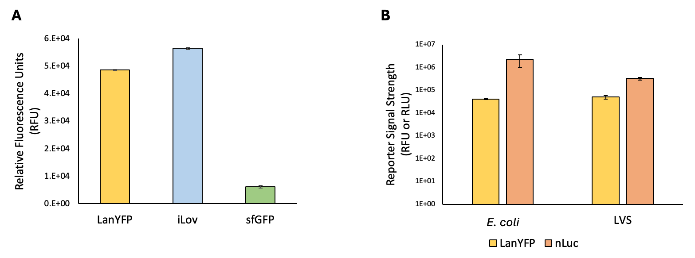
Figure 1. Comparison of reporters demonstrates that nLuc has the highest signal strength of reporters tested. (A) Comparison of signal from fluorescent reporters detected in cells. Chart shows relative fluorescence for indicated translation fusion reporters LanYFP (pKR204), iLov (pKR205), and sfGFP (pKR146). This experiment was performed in technical triplicate. (B) Comparison of LanYFP fluorescence and nLuc luminescence. Reporter signal strength is displayed in relative fluorescence units (RFU) or relative luminescence units (RLU) for the translation fusion reporter (pKR204) produced from in vitro assays using E. coli or LVS ribosomes respectively (note log scale). In vitro translation assays were performed using the pKR204 reporter template, which specifies a pdpA 5′ UTR – nLuc reporter fusion and a tul4 5′ UTR – LanYFP reporter fusion. This experiment was performed in biological duplicate. Error bars represent 1 SD.

Having identified a reporter with high signal strength, I cloned a plasmid template for in vitro translation that would allow the 5′ untranslated region to be easily altered. Specifically, I modified the plasmid with both nLuc and LanYFP (pKR204) so that it only encodes the 5′ untranslated region (UTR) of tul4, a control gene with strong translation in LVS, followed by nLuc (pKR214, Figure 2). The 5′ UTR of tul4 can be easily removed and then exchanged with another 5′ UTR after digestion with NotI and XmaI restriction enzymes. The reporter is sensitive, because nLuc consistently displayed the highest signal of all the reporters we tested, and it is easy to modify, because the two enzyme digestion sites (NotI and XmaI) allow for easy replacement of the UTR–promoter region with a DNA fragment encoding a different UTR.
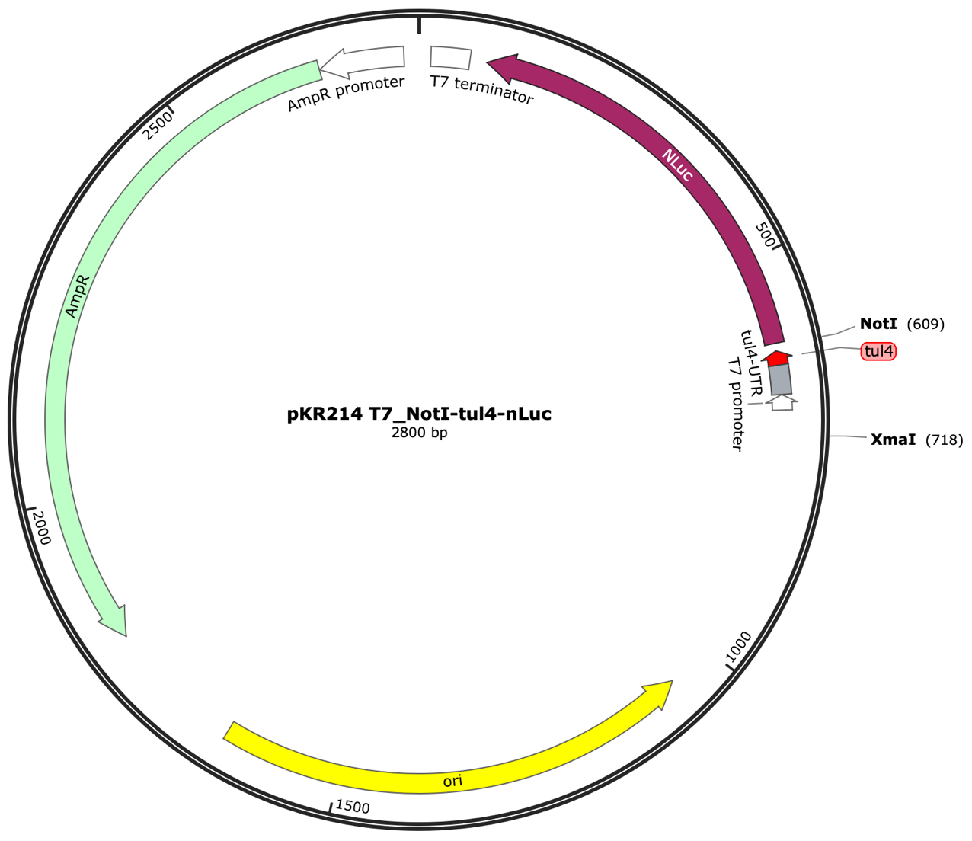
Figure 2. A sensitive and easily modifiable reporter plasmid for testing translation of 5′ UTRs. Diagram of the nLuc reporter plasmid, pKR214 PT7-tul4 5′ UTR-nLuc, encoding nLuc with the 5′ UTR of tul4. The T7 promoter and 5′ UTR are flanked by NotI and XmaI restriction enzyme cut sites, allowing for easy modification.

Purification of active ribosomes from E. coli
The second goal of my research was to purify active ribosomes from E. coli and F. tularensis LVS using a sucrose cushion purification method. I began by validating this method with E. coli MRE600, a strain which lacks RNase I and is commonly used for ribosome purifications (Kurylo et al. 2016). In this project, E. coli served as a positive control for ribosome isolation and activity. I harvested ribosomes from E. coli cells grown in LB medium and was able to achieve a yield of 1.5-5 nmol of ribosomes from 1 L of culture at a concentration of 10-30 pmol/µL. This was substantially higher than the minimum of 40 pmol ribosomes (at a concentration of at least 2.7 pmol/µL) used in the in vitro translation kit. Next, I demonstrated that the E. coli ribosomes were active using the in vitro assay and replicated these results using ribosomes from multiple purification attempts (Figure 3). The E. coli MRE600 ribosomes I purified, when used in in vitro assays, had similar activity to kit-provided E. coli ribosomes and resulted in reasonably similar reporter signal (within a log-fold difference) across purifications. This demonstrated that our sucrose cushion purification protocol yielded reproducibly active E. coli ribosomes.
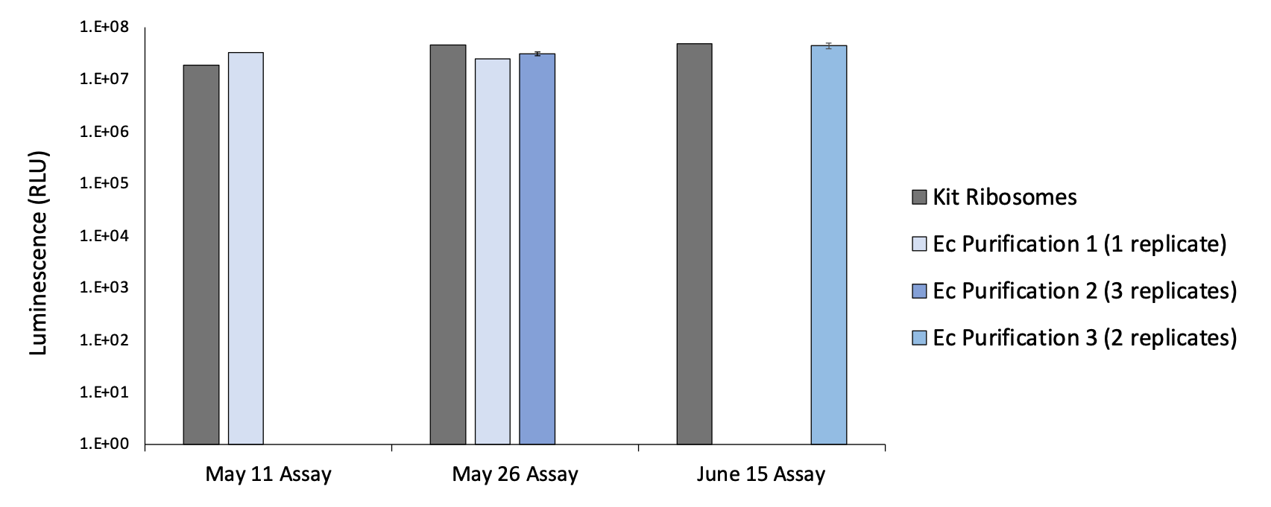
Figure 3. Relative luminescence produced by nLuc translated by purified E. coli ribosomes shows reproducible ribosome activity. Results of in vitro translation assays using the pdpA 5´ UTR-nLuc reporter (pKR144) showing translation efficiency of multiple E. coli (Ec) ribosome purifications tested on different days. Ribosomes were purified using the sucrose cushion method. Kit ribosomes are also from E. coli and were supplied with the NEB assay kit.

Kasugamycin can inhibit translation in vitro
Having validated that we can purify active E. coli ribosomes, we wanted to see if this in vitro translation assay could be used to assess inhibition of translation by a ribosome-targeting antibiotic. We chose to test two antibiotics, thiostrepton and kasugamycin. Thiostrepton is a thiopeptide antibiotic that binds to the large subunit of the ribosome and inhibits translation by interfering with the L11 ribosomal protein (Bailly 2022). Kasugamycin is an aminoglycoside of interest to us because it binds near a protein studied in the Ramsey lab, bS21, on the ribosome. To assess inhibition, I added the indicated antibiotic to the in vitro translation reaction and measured reporter activity (Figure 4). I found that, in this experiment, kasugamycin inhibits translation of E. coli ribosomes at a concentration of 1 mM. Thiostrepton also inhibited translation at a concentration of 1 mM. Thus, we conclude that we can measure translation inhibition by antibiotics in our in vitro assay.
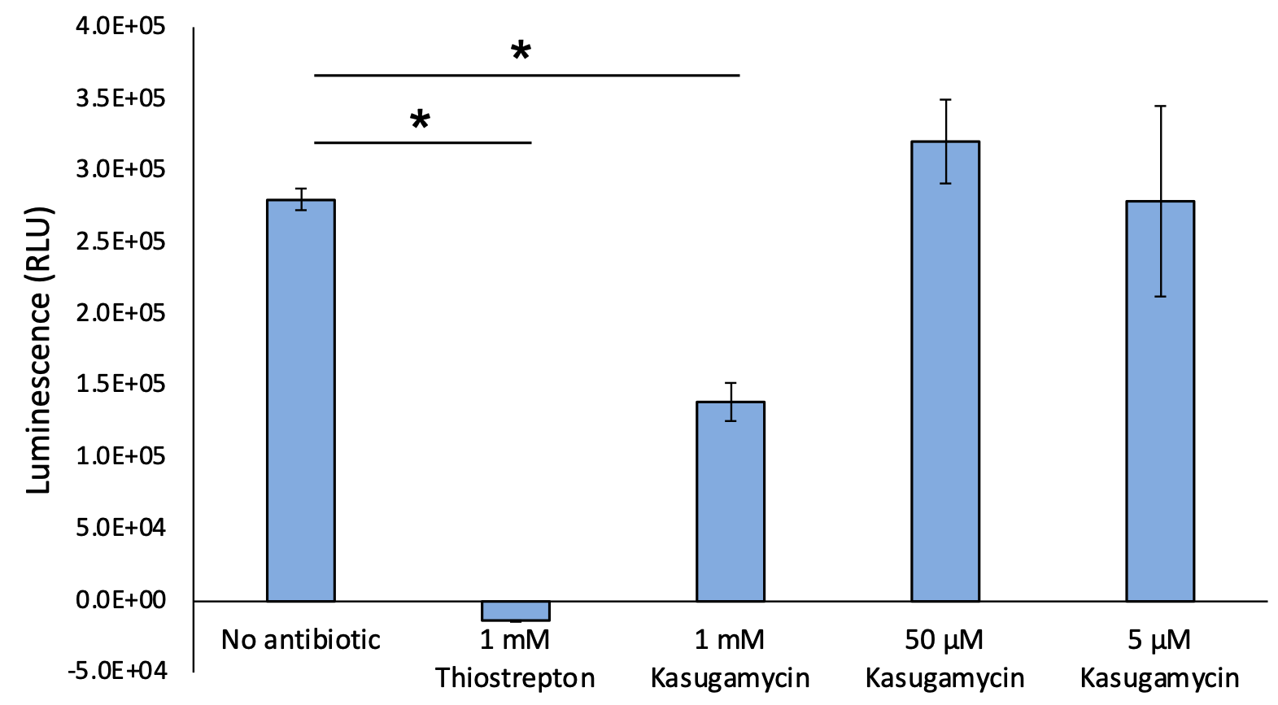
Figure 4. In vitro translation can be inhibited by ribosome-targeting drugs. A concentration of 1 mM kasugamycin or thiostrepton limits nLuc activity, indicating translation inhibition. Reporter signal strength is displayed in relative luminescence units (RLU). Samples with 1 mM thiostrepton were negative because signal was below that of background. This experiment was performed twice, and the results are representative. This experiment was performed in technical triplicate. Error bars represent 1 SD. Lines above bars indicate comparisons. *P < 0.05 by t-test.

Purification of active ribosomes from F. tularensis
After validating that ribosomes isolated using the sucrose cushion method yielded active E. coli ribosomes, I purified ribosomes from F. tularensis LVS cells. Initial purification attempts were successful but yield and concentration were low (~0.9 pmol/uL), so subsequent efforts focused on increasing yield. I doubled the volume of bacterial cells (to one liter for each sample), and I tested an alternate growth medium, supplemented brain heart infusion with cysteine (sBHIc) instead of supplemented Mueller Hinton Broth (sMHB). Specifically, I wanted to see if F. tularensis LVS would reach mid-log phase at a higher OD600 in sBHIc than in sMHB, which would be advantageous because more cells should yield more ribosomes. F. tularensis LVS cultures were started in sMHB and sBHIc media at an OD600 of ~0.08 and grown in a shaking incubator at 37°C while optical density was monitored (Figure 5).
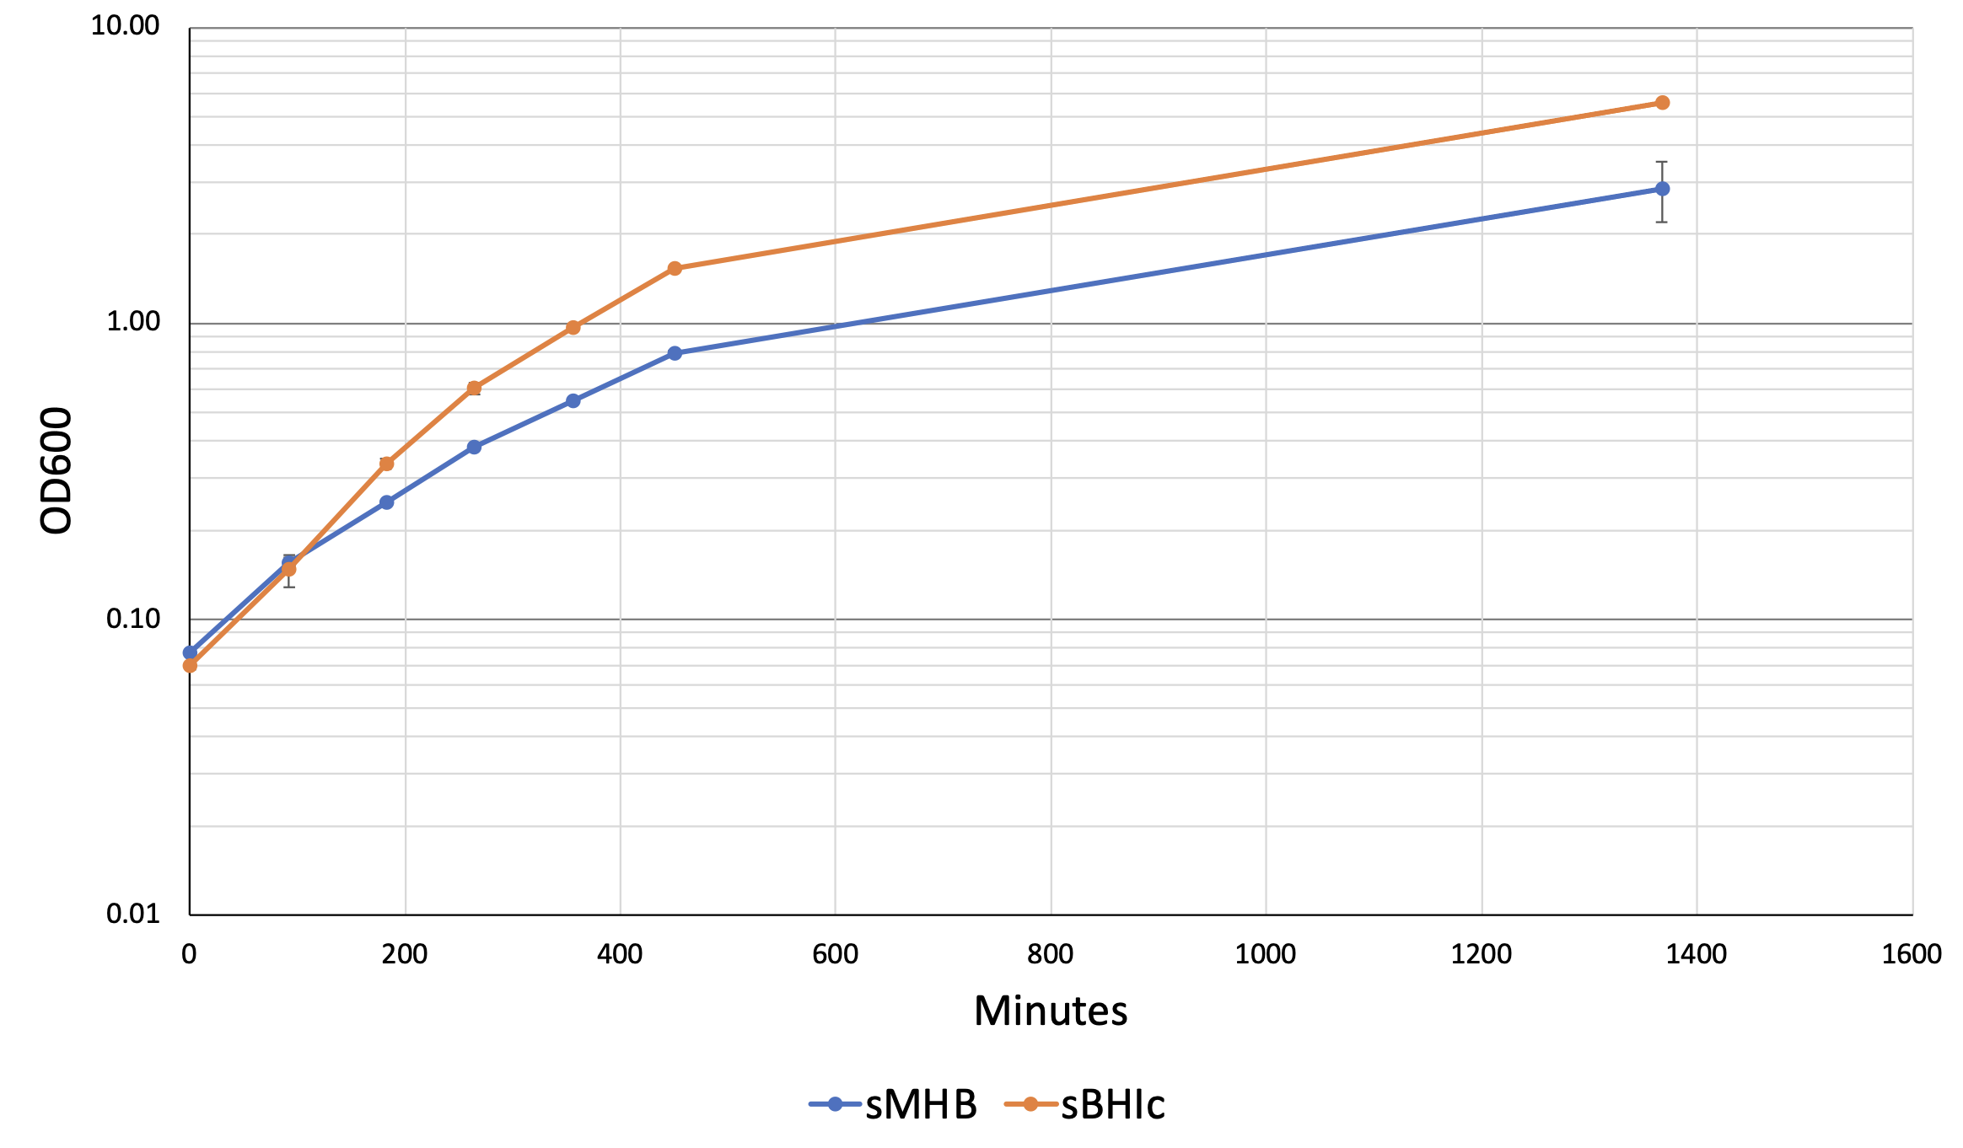
Figure 5. F. tularensis LVS grows faster and to a higher density in sBHIc medium than in sMHB medium. Each point represents the average of two technical replicates. This was also repeated with LVS harboring an empty vector and is representative of both experiments. Error bars represent 1 SD.

I found that F. tularensis LVS grew faster and maintained mid-log growth at higher cell densities in sBHIc medium than in sMHB medium. Because harvesting mid-log F. tularensis LVS cells at a higher density (OD600 of ~0.5 in sBHIc compared to ~0.3 in sMHB) recovers more cell mass, I proceeded to grow F. tularensis LVS in sBHIc medium for all further purifications. Doubling the volume of cultured cells and switching to sBHIc medium led to a sizable increase in yield (~1.9 nmol ribosomes at ~16 pmol/uL), allowing me to obtain enough F. tularensis LVS ribosomes for in vitro assays.
Next, I wanted to assess the consistency and reproducibility of E. coli and F. tularensis LVS ribosome activity. I took several steps to reduce variability and enhance consistency across assays, namely resuspending ribosome pellets overnight to ensure homogeneity, averaging several measures of concentration to increase accuracy, storing single-use aliquots to reduce freeze/thaw cycles, and using an assay master mix to reduce pipetting error. I tested reproducibility by comparing nLuc luminescence signal from in vitro assays using different ribosome purifications and multiple technical replicates (Figure 6). While I observed reproducible translation with E. coli ribosomes, there was a significant degree of variability in translation by F. tularensis ribosomes, including variability between technical replicates.
Figure 6. Assessment of translation by ribosomes from E. coli and F. tularensis shows variability in signal for F. tularensis ribosomes. Results of in vitro translation assays using the tul4 5´ UTR-nLuc reporter (pKR214) and indicated ribosomes. Letters indicate biological replicate purifications of ribosomes, each circle represents a technical replicate.
E. coli
F. tularensis
Given the difference in reproducibility between ribosomes isolated from E. coli and F. tularensis LVS, I also analyzed ribosome samples on sucrose gradients. My goal was to see if their gradient profiles would help us understand the observed variability of F. tularensis LVS ribosome activity in in vitro assays. Purified E. coli ribosomes exhibit a prominent peak corresponding to 70S ribosomes but also reveal a small peak at lower density that likely represents 50S subunits, along with higher density peaks that likely correspond to polysomes (Figure 7). When analyzing F. tularensis ribosomes, I similarly found a distinct 70S ribosome peak. However, I also observed a lower-density shoulder on the 70S peak and a single higher-density peak that may represent aggregated 70S ribosomes or 100S ribosome dimers. Ribosomes form 100S dimers when two 70S ribosomes interact with hibernation factors and undergo conformational changes; this is usually accompanied by downregulation of translation (Prossliner et al., 2018). This analysis suggests that in our F. tularensis ribosome purifications, we have active 70S ribosomes along with either 70S aggregates or 100S ribosomes. Thus, in each sample there may be a subset of ribosomes that are inactive, potentially leading to the observed variability.
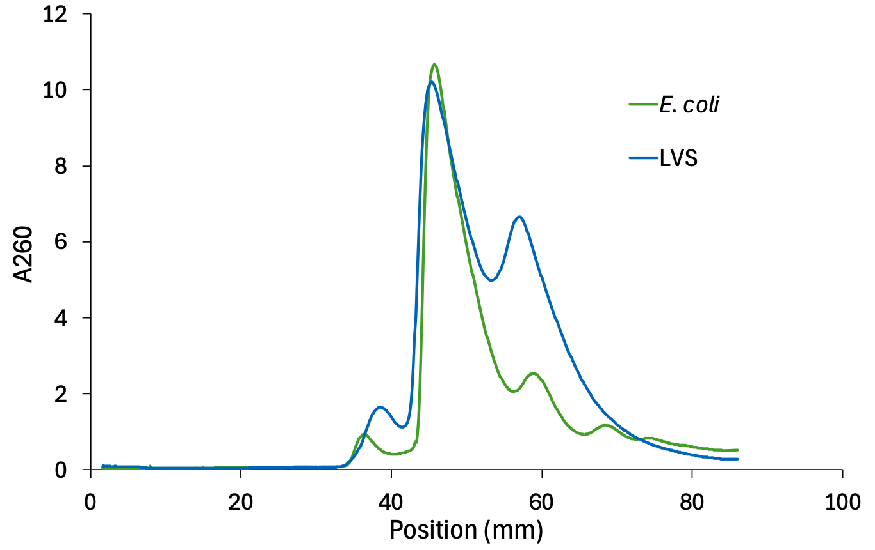
Figure 7. Sucrose gradient sedimentation profiles reveal differences in composition between E. coli and F. tularensis LVS ribosomes. Sucrose gradient profiles of ribosomes isolated from either E. coli (green, 570 pmol) or F. tularensis LVS (blue, 587 pmol). Ribosomes were purified using the sucrose cushion method after cells were lysed with BugBuster, and a total of 570-590 pmols were used in these gradients. Data from representative experiments are shown.

Lower F. tularensis ribosome concentration leads to sharper 70S peaks
Having analyzed multiple ribosome samples using sucrose gradients, I noticed that sucrose gradients run with lower concentrations of F. tularensis LVS ribosomes tended to have sharper peaks corresponding to 70S particles. I chose to test how total amounts of ribosomes impacted the gradient profiles. Specifically, I analyzed sucrose gradients loaded with 200, 800, or 1400 pmol of F. tularensis LVS ribosomes (Figure 8). I found that loading fewer ribosomes leads to sharper 70S peaks and less of a higher-density shoulder. This suggests to us that when there is a lower concentration of F. tularensis LVS ribosomes in a sample, there may be less aggregation or clumping.
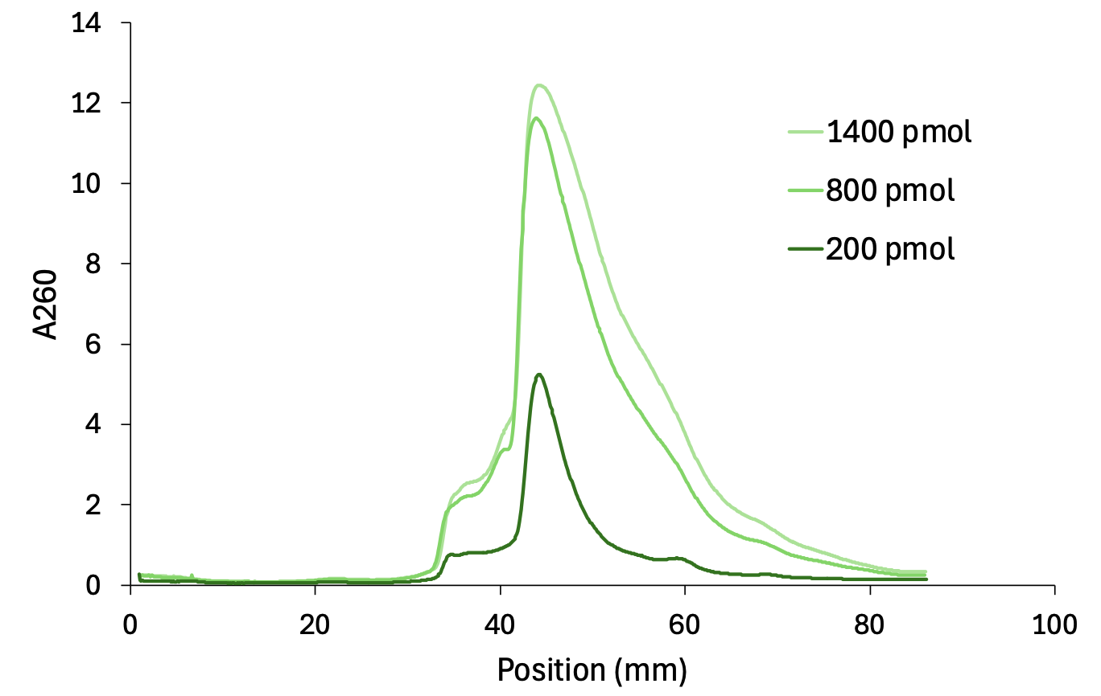
Figure 8. Loading fewer F. tularensis ribosomes onto sucrose gradients results in less aggregation. Profiles of sucrose gradients loaded with indicated amounts of F. tularensis LVS ribosomes from the same sample. Ribosomes were purified using the sucrose cushion method after cells were lysed by French press.

Ribosome concentration affects translation efficiency

Since we observed that higher concentrations of F. tularensis ribosomes can lead to aggregation, I hypothesized that changing the concentration of ribosomes in the in vitro translation assay might impact translation activity. Thus, I performed an experiment to measure reporter signal (luminescence) per ribosome at different ribosome concentrations, with the highest amount being the kit-recommended minimum of 40 pmol. I also used several different ribosome samples, specifically the kit-provided E. coli ribosomes or F. tularensis LVS ribosomes from cells lysed either by French press or the commercially available detergent BugBuster (Figure 9). For all three ribosome samples, I found that lower amounts of ribosomes exhibited higher luminescence per pmol of ribosomes, with the highest per-ribosome signal from reactions containing 2.5 pmol or fewer ribosomes. This effect is most dramatic for the E. coli ribosomes, and the signal per ribosome at lower concentrations is significantly higher for F. tularensis LVS ribosomes purified from cells lysed by French press than by BugBuster. Together, these experiments suggest that higher concentrations of ribosomes may lead to aggregation and variability, while lower ribosome concentrations may produce consistent and reproducible signals in vitro.
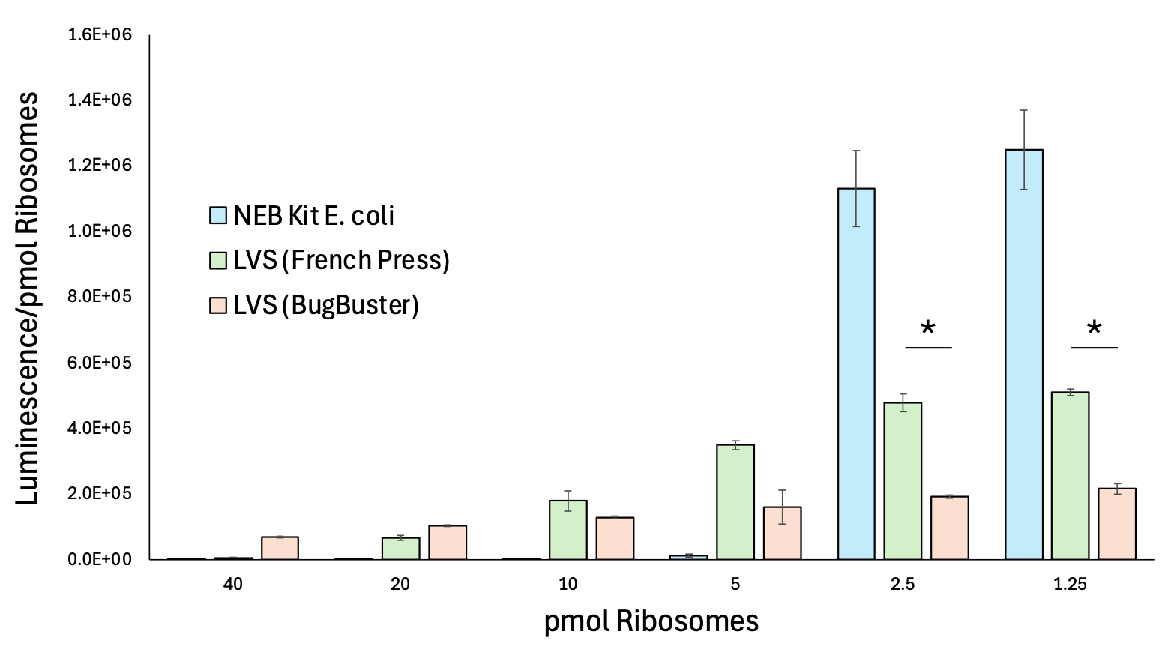
Figure 9. Lower ribosome concentrations in the in vitro translation assay leads to higher signal per ribosome. Chart depicts relative efficiency of in vitro translation assay using pKR214 as a template and indicated amount and type of ribosomes. Experiment was performed in technical triplicate. Error bars represent 1 SD. Lines above bars indicate statistical comparisons. *P < 0.05 by t-test.

F. tularensis ribosomes isolated from cells lysed by French press, not BugBuster, are more active
When assessing how F. tularensis ribosome concentration impacts translation, I found that using about 2 pmol of LVS ribosomes yields the highest signal to ribosome ratio. But I also found that the method by which cells are lysed prior to ribosome purification appears to affect translation efficiency. This led me to test if using 2 pmol ribosomes in each reaction would give a measurable and consistent signal and if there would be a consistent difference between ribosomes purified from cells lysed by French press or with BugBuster. I performed in vitro translation assays using 2 pmol ribosomes, testing three independently isolated ribosome samples for each purification condition in technical duplicate (Figure 10). I found that technical replicates yielded very similar results. The ribosomes isolated from cells lysed by French press were most similar to each other. Finally, the signal from ribosomes isolated from cells lysed by French press was significantly higher on average than that of ribosomes isolated after lysis by BugBuster. We can conclude that using 2 pmol LVS ribosomes in the in vitro translation reaction yields measurable and consistent results across most purifications and that ribosomes purified from French press-lysed cells are more active at low concentrations than those purified from BugBuster-lysed cells.
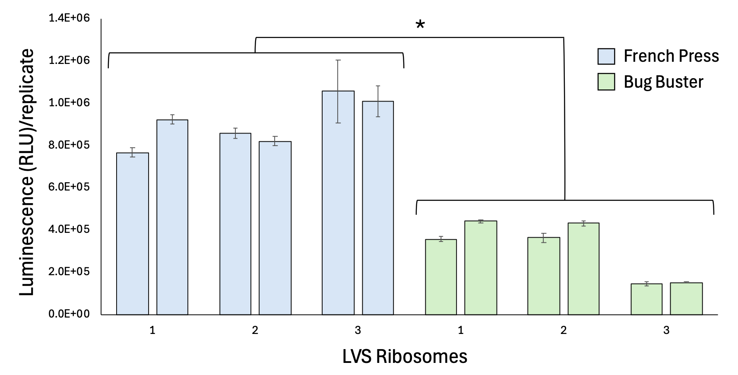
Figure 10. F. tularensis LVS ribosomes purified from French press-lysed cells are more active than those purified from BugBuster-lysed cells. Chart shows the results from in vitro assays using pKR214 as a template and 2 pmol LVS ribosomes from different purifications. Each number represents a different ribosome purification, with bars above each number representing technical replicates. Error bars represent 1 SD. Brackets above bars indicate statistical comparison among groups by t-test. Asterisk indicates comparison between two sets of ribosomes; *, P < 0.05 by t-test.

Lysis method affects processing of ribosomal RNA
To further understand the differences between ribosomes isolated from cells lysed by French press or BugBuster, I extracted RNA from several 70S ribosome samples and analyzed the rRNA by agarose gel electrophoresis. In particular, I compared 70S ribosomes purified from cells lysed by French press to those purified from cells lysed using BugBuster, as well as total RNA purified using a formamide-based extraction method (RNA-Snap) and total RNA isolated after cell lysis with BugBuster (Figure 11). I found that in all the samples using BugBuster for lysis, there was no band corresponding to the 23S rRNA but rather several smaller bands beneath the band for 16S rRNA, indicating that the 23S rRNA was being processed or fragmented during some stage of the purification after lysis with BugBuster. This was in contrast to analysis of ribosomes isolated from cells lysed by French press, which have a prominent 23S rRNA band. This discovery led me to discontinue my use of BugBuster chemical lysis as a method for lysing cells prior to purifying ribosomes, but it did yield some useful information. Specifically, I found that active ribosomes can be purified from cells after lysis with BugBuster detergent, but rRNA fragmentation or processing occurs, possibly the result of RNase activity within the proprietary chemical mixture.
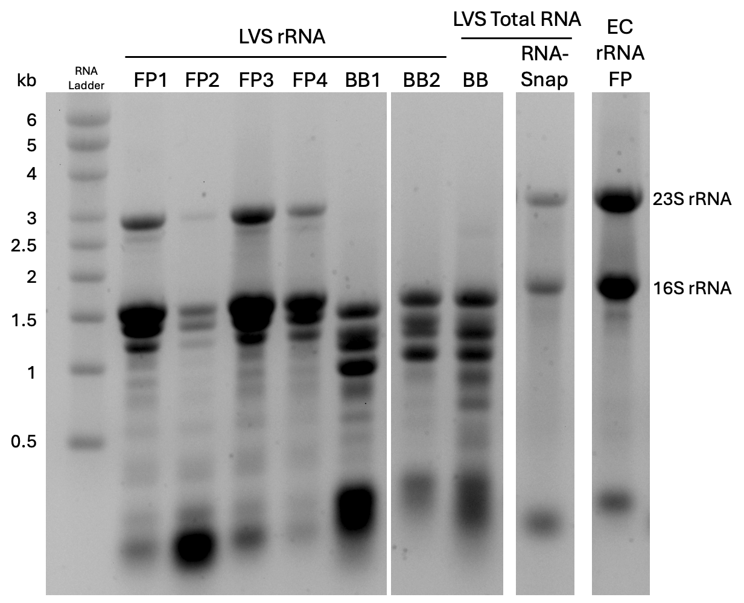
Figure 11. F. tularensis LVS ribosomes purified from BugBuster-lysed cells have fragmented 23S rRNA. Agarose gel electrophoresis of indicated RNA (total RNA extracted from cells or rRNA extracted from 70S ribosomes) denatured by glyoxal treatment. FP indicates a French press was used for cell lysis. BB indicates BugBuster was used for cell lysis. Note that gel image was cropped and re-ordered for clarity. LVS: F. tularensis LVS; EC: E. coli.

Reproducible in vitro translation by F. tularensis LVS ribosomes
A major goal of my work was to develop a reproducible assay to measure translation by F. tularensis ribosomes. Having optimized purification and in vitro assay conditions, I compared the luminescence data from several assays performed on different days using these optimized conditions (2-2.5 pmol ribosomes from French press-lysed F. tularensis LVS; Figure 12). The luminescence values appear to be reproducible across different purifications, biological replicates, and technical replicates when the assay includes about 2 pmol F. tularensis LVS ribosomes. The signal (~1x10⁶ RLU/replicate) is also adequate compared to previous reactions with 40 pmol F. tularensis LVS ribosomes (~1.3-2.5x10⁶ RLU/replicate, Figure 6). Specifically, we are obtaining about one-third of the signal for one-twentieth of the amount of ribosomes. This indicates that 2 pmol ribosomes may be an ideal amount of ribosomes to use for an in vitro assay while maintaining reproducibility and producing an adequate signal.
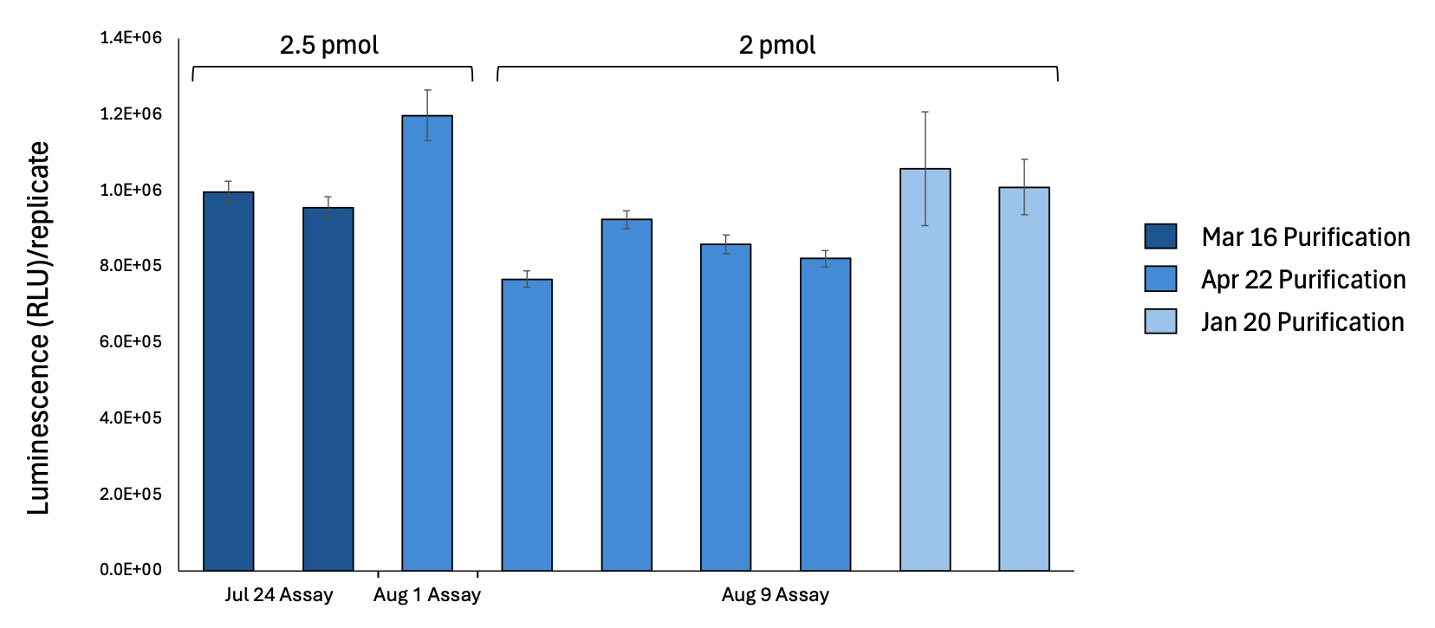
Figure 12. Comparison of luminescence data for several assays shows reproducible translation signal with 2 or 2.5 pmol F. tularensis LVS ribosomes. Chart shows the results from in vitro assays using pKR214 as a template and indicated amount of LVS ribosomes from different purifications. F. tularensis LVS ribosomes were purified from French press-lysed cells using the sucrose cushion method. Experiments were performed in technical triplicate. Error bars represent 1 SD.

CHAPTER 4

CONCLUSIONS
Summary
This research project is part of a larger effort to identify ways in which the ribosomal protein, bS21, regulates translation of mRNAs with specific leader sequences in Francisella tularensis. Previous studies using reporter assays in bacterial cells (in vivo) made significant progress towards identifying leader sequences that confer regulation by bS21, but we would like to determine if these results can be recapitulated using purified ribosomes (in vitro). Once a working in vitro system has been established, we can build upon experimental data from in vivo studies and develop a more comprehensive model of regulation by bS21. The primary goal of this research project was to develop an in vitro translation assay using F. tularensis ribosomes with the NEB PURExpress in vitro translation kit. To achieve this goal, I developed a sensitive and easily modifiable reporter construct, purified active ribosomes from E. coli and F. tularensis LVS, and optimized the reproducibility of the in vitro assay.
Using standard cloning techniques, I generated a reporter construct for the in vitro translation assay that is sensitive and easy to modify. I also purified E. coli MRE600 ribosomes using the sucrose cushion method and determined that they were translationally active in the in vitro assay. Then, I replicated these results using ribosomes from multiple purification attempts, validating that we can reproducibly isolate active ribosomes. In addition, I demonstrated that E. coli ribosomes are inhibited by kasugamycin and thiostrepton, indicating that we can use the assay to measure translation inhibition by antibiotics. I found that F. tularensis ribosomes appear to aggregate or clump more readily than E. coli ribosomes, but that when there are fewer ribosomes in a sample, there is less aggregation. This aggregation appears to impact translational activity, as I found that luminescence per picomole (pmol) of ribosomes increases as ribosome concentration decreases. After further testing, I concluded that using 2 pmol of F. tularensis LVS ribosomes in the in vitro assay yields a measurable and consistent signal across multiple ribosome purifications. This optimized in vitro assay that I developed can be used in future research to easily measure translation efficiency of mRNAs with different leader sequences andwill contribute to a better understanding of how bS21 homologs regulate translation in F. tularensis.
Successful development of a reporter plasmid for in vitro translation
I generated a plasmid template for in vitro translation reactions which uses the T7 promoter to drive expression of nLuc with the 5’ untranslated region (UTR) of tul4 (pKR214). This reporter construct allows for increased sensitivity compared to fluorescent reporters, as the luminescent signal resulting from nLuc activity was consistently higher than the signal from other tested reporters. It is easy to modify, because the UTR and promoter region are flanked by DNA encoding two enzyme digestion sites (NotI and XmaI). This allows for the removal of this region and its replacement with a DNA fragment containing specific modifications to the leader sequence, providing us with a reporter construct that can easily measure the translation efficiency of various UTRs. In the future, we can modify this plasmid to test UTRs from virulence genes that are regulated by bS21-2 to determine if this regulation is direct, and to test how specific sequence motifs impact regulation.
Reproducible purification of active ribosomes from E. coli
I found that E. coli MRE600 ribosomes purified using the sucrose cushion protocol were as active as kit-provided ribosomes in in vitro translation reactions and were within a log-fold difference in signal strength across purifications and in vitro assays. These tests validated that we can reproducibly isolate active ribosomes using our sucrose cushion-based ribosome isolation protocol.
In vitro assay measures translation inhibition by antibiotics
Using the in vitro system, I discovered that kasugamycin and thiostrepton significantly inhibit translation with E. coli ribosomes at a concentration of 1mM. This finding indicates that we can measure translation inhibition by antibiotics in our in vitro assay. In the future, this assay will allow us to test the ability of other antibiotics to inhibit translation or to validate potential antibiotic compounds.
Optimization of growth conditions for F. tularensis results in greater ribosome yield
I optimized F. tularensis LVS growth conditions to increase cell and ribosome yield, which allows us to purify a larger quantity of F. tularensis ribosomes for in vitro assays and to conduct more assays with the same samples.
Ribosome aggregation observed in sucrose gradients
I analyzed sucrose gradient profiles from various ribosome samples and determined that in our F. tularensis ribosome purifications, we have active 70S ribosomes along with either 70S aggregates or 100S ribosomes, suggesting that in each sample there may be a subset of ribosomes that are inactive. This was unexpected, because similar amounts of E. coli ribosomes did not show evidence of aggregation or clumping in sucrose gradients. This discovery opens the door to the possibility that aggregation may occur with purified ribosomes from other bacterial species. Future studies would benefit from this realization when purifying ribosomes from species other than E. coli and could check for aggregation by running purified ribosomes on sucrose gradients.
I observed a correlation between the ribosome concentration in a sample and the amount of aggregation in the gradient profile. Specifically, when there were fewer ribosomes in a sample, there was less aggregation. Future research could test modifications to the ribosome purification protocol and experiment with different buffer compositions, to limit F. tularensis ribosome aggregation and produce homogenous ribosome samples.
Use of BugBuster as a lysis agent leads to rRNA fragmentation or processing
I found that the 23S rRNA purified from cells lysed using the proprietary detergent BugBuster was either fragmented or processed. Our goal is to study translation in unprocessed ribosomes, ruling out the use of BugBuster to chemically lyse cells when purifying ribosomes. The French press uses high pressure to physically shear open cells and is commonly used as a method of cell lysis for purification of active ribosomes (Mehta et al. 2012). In the future, we will continue to use the French press to lyse cells, and we could investigate other forms of chemical lysis, such as the commercially available lysis buffer, B-PER (Thermo Scientific; Mehta et al. 2012).
Reproducible in vitro translation by F. tularensis LVS ribosomes
I observed that signal per pmol of ribosomes increased as ribosome concentration decreased, with the highest per-ribosome signal coming from reactions containing 2 pmol or fewer ribosomes from E. coli or F. tularensis. Using 2 pmol of F. tularensis LVS ribosomes in vitro yielded measurable and consistent results across multiple ribosome purifications and may be an ideal amount of ribosomes to use while ensuring a strong and reproducible signal in our in vitro assay.
Future Directions
Having optimized our in vitro assay, we can now consider additional research questions. Future studies could investigate why fewer ribosomes lead to more signal in the in vitro assay. It seems that aggregation plays a role, but other factors may also be at work. Preliminary results suggest that this effect may be reporter specific. In one experiment using a sfGFP reporter, the same increase in signal per ribosome at lower concentrations was not observed. Future experiments could explore how ribosome concentration or buffer composition impacts nLuc translation or activity.
We could also investigate factors that contribute to rRNA processing in BugBuster-lysed cells by using RNA-seq to analyze ribosome samples. After extracting RNA from purified ribosomes or whole cell lysates, we can copy the rRNA to make complementary DNA (cDNA) and then sequence the cDNA using next-generation sequencing techniques. This data will help us identify where the 23S rRNA is being fragmented and may help us understand the RNA processing events taking place in these samples.
A functional in vitro translation assay will allow us to measure the translation efficiency of mRNAs and identify what leader sequences lead to preferential translation by ribosomes with bS21-2. We can test leader sequences from mraY, iglA, rpsU2, yqeY, and other genes identified as being regulated by bS21-2 in vivo (Trautmann et al. 2022) to determine if this regulation is direct. In other words, because the in vitro assay contains only the factors necessary for transcription and translation, we can determine whether bS21-2 directly regulates the translation efficiency of particular mRNAs without having to consider the possibility that its effects may be exerted indirectly. We can also test modified UTRs with ideal Shine-Dalgarno sequences or other motifs identified as contributing to regulation by bS21-2 (Trautmann et al. 2023) to see how they impact regulation. Such experiments would help us characterize more precisely the interactions between bS21-2 and the mRNA that are necessary for regulation to occur. In addition, we can use the assay to compare the translation efficiency of ribosomes with different bS21 homologs. Because the F. tularensis genome encodes three homologs of the bS21 protein, it is possible that each homolog may regulate a certain subset of mRNAs. This assay would allow us to test the translation efficiency of mRNAs with ribosomes containing specific homologs to determine the extent of this possibility.
Finally, with this assay, we can measure translation inhibition by antibiotics. In addition to testing for translation inhibition with ribosomes from a particular species, we could test ribosomes from the same species with different composition (e.g., containing ribosomal protein homologs). Such investigations would shed light on antibiotic mechanisms of action and provide insight into methods of antibiotic resistance. The assay could be further used to test compounds that may inhibit ribosomes, allowing validation of potential antibiotics and informing new approaches to antibiotic treatment.

BIBLIOGRAPHY

Bailly, Christian. 2022. “The Bacterial Thiopeptide Thiostrepton. An Update of Its Mode of Action, Pharmacological Properties and Applications.” *European Journal of Pharmacology* 914 (January):174661. https://doi.org/10.1016/j.ejphar.2021.174661.
Chang, C., and G. R. Craven. “Identification of Several Proteins Involved in the Messenger RNA Binding Site of the 30 S Ribosome by Inactivation with 2-Methoxy-5-Nitrotropone.” Journal of Molecular Biology 117, no. 2 (December 5, 1977): 401–18. https://doi.org/10.1016/0022-2836(77)90135-8.
Degabriel, Manon, Stanimira Valeva, Sandrine Boisset, and Thomas Henry. “Pathogenicity and Virulence of Francisella Tularensis.” Virulence 14, no. 1 (December 31, 2023): 2274638. https://doi.org/10.1080/21505594.2023.2274638.
DeLong, David, and Patrick J. Manning. 1994. “CHAPTER 8 - Bacterial Diseases.” In *The Biology of the Laboratory Rabbit (Second Edition)*, edited by Patrick J. Manning, Daniel H. Ringler, and Christian E. Newcomer, 129–70. American College of Laboratory Animal Medicine. San Diego: Academic Press. https://doi.org/10.1016/B978-0-12-469235-0.50014-2.
Dennis, D. T., T. V. Inglesby, D. A. Henderson, J. G. Bartlett, M. S. Ascher, E. Eitzen, A. D. Fine, et al. “Tularemia as a Biological Weapon: Medical and Public Health Management.” JAMA 285, no. 21 (June 6, 2001): 2763–73. https://doi.org/10.1001/jama.285.21.2763.
Gauthier, David T. 2015. “Bacterial Zoonoses of Fishes: A Review and Appraisal of Evidence for Linkages between Fish and Human Infections.” *The Veterinary Journal* 203 (1): 27–35. https://doi.org/10.1016/j.tvjl.2014.10.028.
Kaledhonkar, Sandip, Ziao Fu, Kelvin Caban, Wen Li, Bo Chen, Ming Sun, Ruben L. Gonzalez, and Joachim Frank. “Late Steps in Bacterial Translation Initiation Visualized Using Time-Resolved Cryo-EM.” Nature 570, no. 7761 (June 2019): 400–404. https://doi.org/10.1038/s41586-019-1249-5.
Kingry, Luke C., and Jeannine M. Petersen. 2014. “Comparative Review of Francisella Tularensis and Francisella Novicida.” *Frontiers in Cellular and Infection Microbiology* 4 (March):35. https://doi.org/10.3389/fcimb.2014.00035.
Mehta, Preeti, Perry Woo, Krithika Venkataraman, and A. Wali Karzai. 2012. “Ribosome Purification Approaches for Studying Interactions of Regulatory Proteins and RNAs with the Ribosome.” *Methods in Molecular Biology (Clifton, N.J.)* 905:273–89. https://doi.org/10.1007/978-1-61779-949-5_18.
Oyston, Petra C. F., Anders Sjostedt, and Richard W. Titball. “Tularaemia: Bioterrorism Defence Renews Interest in Francisella Tularensis.” Nature Reviews. Microbiology 2, no. 12 (December 2004): 967–78. https://doi.org/10.1038/nrmicro1045.
Prossliner, Thomas, Kristoffer Skovbo Winther, Michael Askvad Sørensen, and Kenn Gerdes. “Ribosome Hibernation.” Annual Review of Genetics 52 (November 23, 2018): 321–48. https://doi.org/10.1146/annurev-genet-120215-035130.
Ramsey, K. M. et al. Ubiquitous promoter-localization of essential virulence regulators in Francisella tularensis. Plos Pathog 11, e1004793 (2015).
Sjöstedt, Anders. “Tularemia: History, Epidemiology, Pathogen Physiology, and Clinical Manifestations.” Annals of the New York Academy of Sciences 1105 (June 2007): 1–29. https://doi.org/10.1196/annals.1409.009.
Stead, M. B. et al. RNA snap TM: a rapid, quantitative and inexpensive, method for isolating total RNA from bacteria. Nucleic Acids Res 40, e156–e156 (2012).
Trautmann, Hannah S., and Kathryn M. Ramsey. “A Ribosomal Protein Homolog Governs Gene Expression and Virulence in a Bacterial Pathogen.” Journal of Bacteriology 204, no. 10 (September 19, 2022): e00268-22. https://doi.org/10.1128/jb.00268-22.
Trautmann, Hannah S., Sierra S. Schmidt, Steven T. Gregory, and Kathryn M. Ramsey. “Ribosome Heterogeneity Results in Leader Sequence-Mediated Regulation of Protein Synthesis in Francisella Tularensis.” Journal of Bacteriology 205, no. 9 (September 26, 2023): e0014023. https://doi.org/10.1128/jb.00140-23.
Travis, B. A. et al. Structural Basis for Virulence Activation of Francisella tularensis. Mol Cell 81, 139-152.e10 (2021).
Van Duin, Jan, and Robert Wijnands. “The Function of Ribosomal Protein S21 in Protein Synthesis.” European Journal of Biochemistry 118, no. 3 (1981): 615–19. https://doi.org/10.1111/j.1432-1033.1981.tb05563.x.
Watson, Zoe L, Fred R Ward, Raphaël Méheust, Omer Ad, Alanna Schepartz, Jillian F Banfield, and Jamie HD Cate. “Structure of the Bacterial Ribosome at 2 Å Resolution.” Edited by Sjors HW Scheres, Cynthia Wolberger, Sjors HW Scheres, Bruno Klaholz, and Israel S Fernández. eLife 9 (September 14, 2020): e60482. https://doi.org/10.7554/eLife.60482.
Zaide, G. *et al.* Identification and characterization of novel and potent transcription promoters of Francisella tularensis. *Applied and environmental microbiology* 77, 1608–1618 (2011).

