EVALUATING FRANCISELLA TULARENSIS
TRANSLATION IN VIVO
BY
BENJAMIN MOORE

A THESIS SUBMITTED IN PARTIAL FULFILLMENT OF THE
REQUIREMENTS FOR THE DEGREE OF
MASTER OF SCIENCE
IN
BIOLOGICAL AND ENVIRONMENTAL SCIENCES

UNIVERSITY OF RHODE ISLAND
2024
MASTER OF SCIENCE THESIS

OF

BENJAMIN MOORE

APPROVED:

Thesis Committee:

Major Professor Kathryn Ramsey

Steven Gregory

David Rowley

Brenton DeBoef
DEAN OF THE GRADUATE SCHOOL

UNIVERSITY OF RHODE ISLAND
2024

ABSTRACT
The abstract must contain a definite statement of the problem involved in the thesis, a description of the methods used in the development of the thesis, and a summary of the results of the findings reported in the thesis.
Francisella tularensis is a Gram-negative, facultative, intracellular bacterium which causes the disease tularemia. Previous research has demonstrated that F. tularensis ribosomes are heterogeneous and that a specific ribosomal protein, bS21-2, regulates translation. To study the regulation of translation by ribosomes in Francisella tularensis, I will use an in vitro system. I aim to develop a reporter construct for use in an in vitro translation assay that is sensitive and easy to modify and to reproducibly purify active ribosomes from F. tularensis for use in this assay.
(These) previous studies have allowed significant progress in understanding how bS21-2 controls translation of mRNAs with specific 5’ UTRs, but we would like to go further and address several other questions. In particular, we would like to determine if these results can be recapitulated in vitro. Once a working in vitro system has been established, we can also test whether the GACUCU motif is sufficient for regulation by bS21-2 and whether there are other sequence motifs that confer regulation. By developing an in vitro assay that allows us to examine translation efficiency, we can build upon previous experimental data and develop a more comprehensive model of regulation by bS21-2.
The goal of my thesis project is to develop an in vitro translation assay for F. tularensis. In developing this assay, I will use the PURExpress® Δ Ribosome Kit from New England Biolabs which contains all the factors necessary for transcription and translation except ribosomes and permits the user to translate any protein as a reporter. When the kit components are combined with a DNA template and purified ribosomes, transcription and translation of a DNA-encoded reporter will occur, resulting in a signal that can be measured to assess translation efficiency. To use this kit for our studies, we must clone a plasmid template and purify active ribosomes from F. tularensis.
Findings Summary:
Demonstrated that nLuc was the most sensitive reporter tested
Successful creation of a reporter construct that is sensitive and easy to modify
Successful and reproducible purification of active ribosomes
Demonstrated inhibition of translation by Kasugamycin using in vitro assay
Demonstrated that LVS grows better in BHI media than in MHB
Demonstrated that heat-activation did not increase ribosome activity
Demonstrated that ribosome concentration affects translation efficiency
Lower ribosome concentrations have higher luminescence/pmol
Demonstrated that UTR affects translation efficiency
tul4 UTR translated more efficiently by LVS than by EC
Demonstrated that growth media affects translation efficiency
tul4 UTR translated more efficiently by LVS from MHB than from BHI
Demonstrated that LanYFP fluorescence and nLuc luminescence did not correlate when used in a dual-reporter system and driven by different UTRs
Demonstrated that dialysis of ribosomes into low Mg buffer separates subunits
Dialysis of dissociated ribosomes in high Mg buffer reassociates subunits
Incubation of dissociated ribosomes in high Mg buffer reassociates subunits
Incubation for two hours in high Mg buffer is sufficient
Steps can be taken to increase consistency of ribosome concentration measurements
Bug Buster chemical lysis can be used to purify active ribosomes
Different lysis methods have different sucrose gradient profiles
Deleting relA and spot does not affect LVS sucrose gradient profile
Loading smaller amounts of ribosomes onto sucrose gradients leads to sharper 70S peaks
Lower ribosome concentrations have higher luminescence/pmol
Using 2 pmol of LVS ribosomes in vitro works well for luminescence and gives fairly consistent and reproducible results
Demonstrated that lysis method affects translation efficiency

ACKNOWLEDGMENTS
University of Rhode Island; Dr. Kathryn Ramsey (Hannah Trautmann, Sierra Schmidt, Kira Bernabe, Alexandra Farah, Johanyx Rodriguez, Christina Surace, George Madave, Sara Negash, Aisling Macaraeg, Oli Horyn); Dr. Steven Gregory; Janet Atoyan.

TABLE OF CONTENTS

LIST OF TABLES viii
LIST OF FIGURES x
CHAPTER 1 1
INTRODUCTION & REVIEW OF LITERATURE 1
CHAPTER 2 11
METHODOLOGY 11
CHAPTER 3 11
FINDINGS 19
CHAPTER 4 26
CONCLUSION 26
BIBLIOGRAPHY 28

LIST OF TABLES

TABLE PAGE

Table 1. The caption of the table is to be typed here. 1

Table 2. The caption of the table is to be typed here and if it is long caption it can be continued to the second line 11

Table 3. 22

Table 4. 31

Table 5. 34

TABLE PAGE

Continue your List of Tables here if you need more than one page. If you do not need more than one page, place your cursor on the previous page after the last typed word and press delete until you see the List of Figures page directly below. Make sure the List of Figures page below has a 2” margin before continuing.

This template is best used for directly typing in your content. However, you can paste text into the document, but use caution as pasting can produce varying results.

LIST OF FIGURES

FIGURE PAGE

Figure 1. The caption of the figure is to be typed here. 1

Figure 2. The caption of the table is to be typed here and if it is long caption it can be continued to the second line. 13

Figure 3. 19

Figure 4. 21

Figure 5. 34

Figure Page

Continue your List of Figures here if you need more than one page. If you do not need more than one page, place your cursor on the previous page after the last typed word and press delete until you see the Chapter 1 page directly below. Make sure the Chapter 1 page below has a 2” margin before continuing.

This template is best used for directly typing in your content. However, you can paste text into the document, but use caution as pasting can produce varying results.

CHAPTER 1

INTRODUCTION & REVIEW OF LITERATURE

Francisella tularensis is a Gram-negative, facultative, intracellular bacterium. F. tularensis causes the disease tularemia, which can be transmitted by rabbits, small rodents, or arthropods (Sjöstedt, 2007). This disease manifests at the onset with flu-like symptoms and can develop into several forms, of which the ulceroglandular form is the most common and the pneumonic form can be fatal (Degabriel et al., 2023). Because a relatively small exposure to the bacterium can cause an infection and it can be easily dispersed through the air, it has been classified as a potential bioweapon (Oyston et al., 2004). The Ramsey lab uses F. tularensis subspecies holarctica, specifically the live vaccine strain (LVS), as a model organism, because it is not infectious to humans but retains its virulence in animal models. The Ramsey lab studies post-transcriptional regulation of virulence genes in F. tularensis, specifically how changes in ribosome composition impact virulence gene expression.
Key virulence genes in F. tularensis are located within the Francisella Pathogenicity Island (FPI), a region of the genome that codes for the type 6 secretion system (T6SS). The T6SS is a protein complex necessary for bacterial intracellular survival and growth within host cells. This cluster of genes is tightly regulated at the level of transcription. Specifically, transcription increases during the stringent stress response when the alarmone (p)ppGpp binds to transcription factors MglA and SspA associated with RNA polymerase and recruits another transcription factor, PigR. This increases transcription from promoters that contain short motifs called PigR response elements (PREs), including those found on the FPI (Cuthbert et al., 2017; Degabriel et al., 2023). Recent work has demonstrated that the expression of FPI virulence genes is further controlled by regulating the translation of the mRNA into proteins by a specific ribosomal protein, bS21-2 (Trautmann & Ramsey, 2022).
Most bacteria encode one bS21 homolog or none at all. In the ribosome, bS21 is located in the small subunit near the anti-Shine Dalgarno sequence and the channel where mRNA exits the ribosome. Its location suggests that bS21 may interact directly with the 5’ untranslated region (5’ UTR) of mRNA molecules during the initiation phase of translation. Several studies have implicated bS21 in translation initiation by E. coli ribosomes (van Duin & Wijnands, 1981; Chang & Craven, 1977).
F. tularensis is unusual in that it has three homologs of bS21. The Ramsey lab found that F. tularensis ribosomes can incorporate any one of the three bS21 homologs and that the second homolog, bS21-2, is the most abundant when cells are grown in the laboratory (Trautmann & Ramsey, 2022). Additionally, in the absence of bS21-2, the abundance of certain proteins, including T6SS proteins, decreased, yet mRNA abundance remained the same (Trautmann & Ramsey, 2022). This suggests that, when bS21-2 is absent, ribosomes cannot translate these genes as efficiently. We also found that the ability of cells to replicate within macrophage decreased when bS21-2 was absent (Trautmann & Ramsey, 2022). These data lead to the development of a model in which bS21-2 allows for more efficient translation of virulence genes.
In support of a model in which bS21-2 controls translation initiation, it was found that the presence of bS21-2 can affect the translation of mRNAs with specific 5' UTR sequences and that altering the 5' UTR sequences can lead to a loss of this regulatory effect (Trautmann et al., 2023). In particular, the Ramsey lab studied these effects in vivo using a reporter assay to examine how the presence of bS21-2 alters translation of particular mRNAs in F. tularensis. These reporters consisted of a control promoter, the promoter for the gene tul4 (tul4 is not regulated by bS21-2 (Trautmann & Ramsey, 2022)), driving the transcription of an mRNA containing the 5´ UTR of a control gene or gene of interest fused to a green fluorescent protein (GFP) coding sequence. GFP production was used as a measure of translation efficiency for each mRNA. The 5' UTRs tested in this reporter assay were selected based on a proteomics analysis in which the absence of bS21-2 led to a downregulation in protein production from the selected genes (Trautmann & Ramsey, 2022). These genes included the FPI genes pdpA and iglA. When bS21-2 was absent, reporter output decreased for the selected genes but did not decrease for tul4 (Figure 1; Trautmann & Ramsey, 2022). Since changes in reporter output correlate with the amount of protein in cells with and without bS21-2, these data indicate that the 5´ UTR is sufficient to influence translation by bS21-2 in vivo. Additionally, because 5´ UTRs are generally important for initiation, these results strongly suggest that bS21-2 regulates translation during initiation.
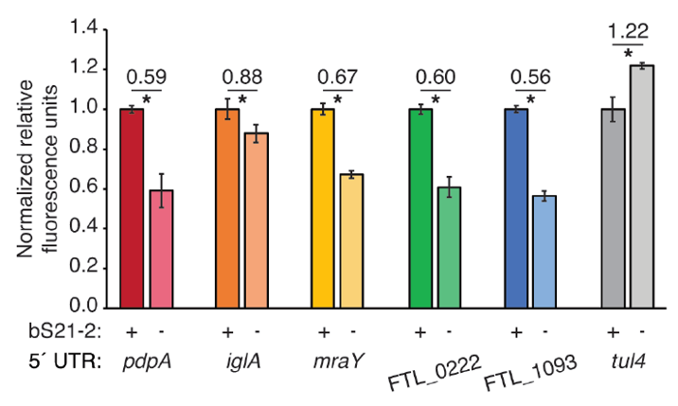
Figure 1. 5´ UTRs are sufficient to lead to bS21-2-mediated changes in translation. Relative fluorescence for indicated GFP translational fusion reporters in cells with (+; WT) or without (−; ΔrpsU2) bS21-2. The tul4 5´ UTR serves as a control. Lines above bars indicate comparisons, values above line indicate ratio of reporter activity in cells lacking bS21-2 to wild-type cells. Error bars represent 1 SD? *P < 0.05 by t-test. Figure and legend are from Trautmann et al., 2023.

After determining that the 5´ UTR is sufficient to allow bS21-2-mediated changes in translation, the Ramsey lab further investigated 5´ UTR sequences to identify specific elements that lead to regulation. In most bacterial 5´ UTRs, a particular sequence called the Shine-Dalgarno (SD) pairs with the anti-Shine-Dalgarno (aSD) sequence in the 16S rRNA of the 30S ribosomal subunit. This pairing is not strictly necessary for translation initiation but increases its efficiency. Structures of E. coli ribosomes reveal that bS21 likely directly contacts the aSD sequence (Kaledhonkar et al., 2019), implicating the SD-aSD pairing as a potential candidate for regulation by bS21-2 in F. tularensis. Upon testing translation efficiency of mRNAs with different SD sequences, the Ramsey lab found that 5´ UTRs with ideal SDs lost responsiveness to bS21-2 (Figure 2A, Trautmann et al., 2023), suggesting that bS21-2 interacts with the 5ˊ UTR in certain ways, but that the presence of a perfect SD can override these effects so that they are not as significant. In other genes, however, imperfect SD sequences do not automatically lead to regulation, so the search for other regulatory elements continues.
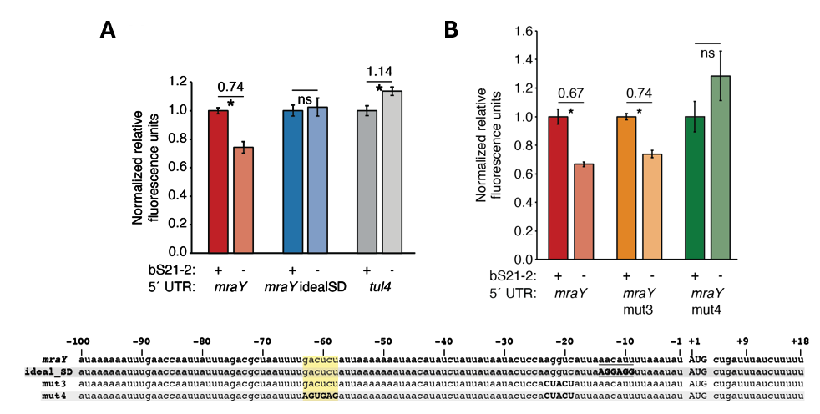
Figure 2. bS21-2-mediated translation of mraY depends on a weak Shine-Dalgarno and a specific six nucleotide sequence. Charts show relative fluorescence for indicated gfp translation fusion reporters in cells with (+; WT) or without (−; ΔrpsU2) bS21-2. (A) Introduction of an ideal SD in the mraY leader leads to loss of bS21-2 responsiveness. (B) The nucleotides between −58 and −63 in the mraY 5´ UTR, GACUCU, are essential for responsiveness to bS21-2. (A–B) Lines above bars indicate comparisons, values above line indicate ratio of reporter activity in cells lacking bS21-2 to wild-type cells. Error bars represent 1 SD. *P < 0.05 by t-test. ns = not significant. Experiments were repeated at least twice in biological triplicate, and data from a representative experiment are shown. Figure and legend are from Trautmann et al., 2023.
To find elements necessary for regulation by bS21-2, the Ramsey lab investigated the 5´ UTR of mraY. Hannah Trautmann tested the contribution of two motifs (AAAAUAAA and UUAUUUA) that are enriched in the 5´ UTR of genes regulated by bS21-2 as well as the predicted secondary structure of 5´ UTRs, but these did not contribute to regulation by bS21-2. Through further testing and modification of the mraY 5´ UTR, she identified a 6-nucleotide motif in the mraY 5´ UTR GACUCU (Figure 2B, Trautmann et al., 2023) that is necessary for regulation by bS21-2.
These studies have allowed significant progress in understanding how bS21-2 controls translation of mRNAs with specific 5’ UTRs, but we would like to go further and address several other questions. In particular, we would like to determine if these results can be recapitulated in vitro. Once a working in vitro system has been established, we can also test whether the GACUCU motif is sufficient for regulation by bS21-2 and whether there are other sequence motifs that confer regulation. By developing an in vitro assay that allows us to examine translation efficiency, we can build upon previous experimental data and develop a more comprehensive model of regulation by bS21-2.
The goal of my thesis project is to develop an in vitro translation assay for F. tularensis. In developing this assay, I will use the PURExpress® Δ Ribosome Kit from New England Biolabs which contains all the factors necessary for transcription and translation except ribosomes and permits the user to translate any protein as a reporter. When the kit components are combined with a DNA template and purified ribosomes, transcription and translation of a DNA-encoded reporter will occur, resulting in a signal that can be measured to assess translation efficiency. To use this kit for our studies, we must clone a plasmid template and purify active ribosomes from F. tularensis.
[Talk about development of methods for purifying ribosomes and measuring in vitro translation and why you picked these specific methods. Methods will include French press lysis followed by sucrose cushion ultracentrifugation, then dialysis, then sucrose gradient sedimentation, followed by the in vitro assay, addition of substrate, and luminescence reading. You may have to discuss nLuc as well as briefly discussing GFP, iLov, and LanYFP (signal ranges, fluorescence color and intensity, excitation and emission wavelengths, etc.).]
Reporter | Fluorescent or Luminescent? | Excitation and Emission Wavelengths | Color | Brightness
sfGFP | Fluorescent | 488/510 | Green | 54.15
iLov | Fluorescent | 447/497 | Cyan
LanYFP | Fluorescent | 513/524 | Yellow | 142.5
nLuc | Luminescent
https://www.fpbase.org
https://www.promega.com/resources/technologies/nanoluc-luciferase-enzyme/

Preliminary work towards developing an in vitro translation assay performed by Hannah Trautmann used F. tularensis ribosomes and the tul4 5’ UTR – GFP reporter. While the reaction with E. coli ribosomes (provided by the kit) yielded signal in the assay, showing the reaction was properly set up, the ribosomes purified from F. tularensis did not translate detectable amounts of product (Figure 3). These results suggested to us that we should try to find a more sensitive reporter and that we should ensure that the ribosomes we are purifying are sufficiently active.
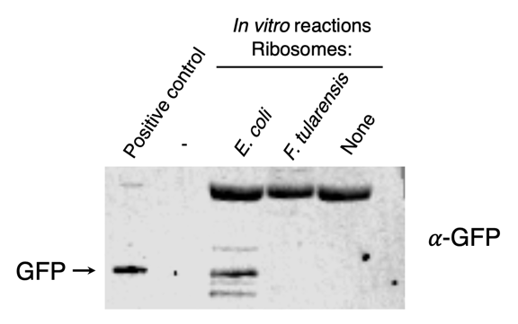
Figure 3. Ribosomes purified from F. tularensis exhibited poor activity in initial in vitro assays. In vitro translation assays were performed using a DNA template specifying an mRNA with the tul4 5’ UTR fused to the GFP gene (pKR107). Reactions contained either control ribosome from the kit (from E. coli), ribosomes purified from F. tularensis LVS, or no ribosomes (as indicated at the top of the image). No fluorescence was detected from the reaction containing F. tularensis ribosomes, so samples were analyzed by immunoblot using an antibody to GFP. The positive control lane contains cell lysate from F. tularensis expressing GFP.

My thesis project is part of a larger effort to identify ways in which bS21 controls translation of mRNAs with specific 5’ UTRs. The purpose of this thesis was to develop an in vitro assay for F. tularensis which could assess translation efficiency of various genes, test for sequence motifs that confer regulation by bS21, and assist in developing a more comprehensive model of regulation by bS21. For my thesis, I cloned a plasmid template to use in the in vitro assay that was sensitive and easy to modify. I also purified reproducibly active ribosomes from E. coli and F. tularensis. I then used the plasmid template and purified ribosomes with the PURExpress Δ Ribosome Kit to measure translation efficiency of specific 5’ UTRs. I found that translation efficiency was dependent on growth media, bacterial species, 5’ UTR, method of lysis, and the amount of ribosomes loaded in the assay. In addition, I found that E. coli ribosomes are sensitive to kasugamycin, an aminoglycoside that inhibits translation and binds near bS21, demonstrating that the in vitro assay can be used to test for translation inhibition by specific antibiotics.
In the conclusion, you should summarize the key findings you have taken from the literature and emphasize their significance to your topic, along with your overarching conclusions and avenues for future research. Be sure to clearly restate your topic and scope, so it’s clear to your reader why the literature you review is relevant to your research. (Scribbr)
Flow of thought: topic sentence pivotal study critical evaluation of study new theory with different perspective synthesis of related findings knowledge gap, opportunities, your research

Continue here.

CHAPTER 2

METHODOLOGY

Bacterial strains and growth conditions
The strain of Francisella tularensis used in these experiments was F. tularensis subsp. holarctica live vaccine strain (LVS), which is not infectious to humans, but retains its virulence in animal models (REF). Bacteria were cultured in supplemented brain heart infusion broth with cysteine (sBHIc). sBHIc was made using (per 500 mL): 18.5 g brain-heart infusion (BHI) medium (BD Diagnostics 237500) supplemented with 0.5 g L- cysteine hydrochloride, 5 mL 1 mg/mL β-NAD, 5 mL 1 mg/mL heme-histidine, and 12.5 mL 20% glucose or on plates with cysteine-heart agar supplemented with 1% hemoglobin at 37°C. The MRE600 (REF) strain of E. coli used for ribosome purifications was cultured in standard LB liquid media or on plates with LB agar at 37°C. Strains with incorporated plasmids were selected for on kanamycin medium at 5 μg/mL for LVS or at 50 μg/mL for E. coli.
Table 1. Plasmids used in this study.
Plasmid | Description
DHFR | Ampicillin resistant (AmpR), E. coli cloning vector
pKR144 | DHFR with ecDHFR gene replaced by pdpA 5’ UTR-nLuc fusion, tul4 gene, and T7 promoter/terminator pairs.
pKR214 | DHFR with ecDHFR gene replaced by tul4 5’ UTR-nLuc fusion and T7 promoter/terminator pair.

PCR primers were designed using SnapGene (GSL Biotech LLC) and ordered from ThermoFisher. Primers were used to amplify DNA fragments to be cloned into the intended plasmid, and the resulting DNA fragments were purified by washing and eluting through a spin column (QIAquick Purification Kit). The plasmid backbone and PCR fragments were digested using restriction endonucleases and subjected to gel electrophoresis. Desired products were excised and purified using the QIAquick Gel Extraction Kit. Ligations were conducted with T4 DNA ligase and the products were transformed into XL1-Blue chemically competent E. coli cells. Resulting colonies were used to grow cultures, and the plasmid DNA was isolated using a QIAprep Spin Miniprep Kit and sequenced via Sanger sequencing at URI’s INBRE CORE Facility.
To generate the nLuc coding sequence, the amino acid sequence for nLuc was codon optimized for E. coli K12. This codon-optimized sequence was inserted into SnapGene and modified with a TAA stop codon, restriction enzyme recognition sequences for SalI (5’ end) and PvuII (3’ end), the T7 promoter sequence, and the pdpA 5’ UTR sequence with six base pairs between its 3’ end and the nLuc sequence. To generate the plasmid in which the pdpA 5’ UTR is upstream of the nLuc coding sequence, this nLuc fragment was amplified and digested with SalI/PvuII. Concurrently, pKR81 (unpublished), containing the plasmid backbone, was also digested with SalI/PvuII, and the two fragments were ligated together forming the nLuc reporter plasmid, pKR144 T7-pdpA 5’ UTR-nLuc.
To create a plasmid in which the tul4 5’ UTR is upstream of the nLuc coding sequence, several steps were taken. On pKR144, the region between cut sites HpaI and NcoI was replaced with two PCR products. The first PCR product was pKR144 digested with HpaI/NotI, resulting in a fragment containing nLuc fused to the pdpA UTR and the tul4 UTR. The second PCR product was amplified from another plasmid, pKR137, and contained the coding sequence for the reporter LanYFP flanked by NotI/NcoI cut sites. The resulting plasmid, pKR189, was further modified to contain an additional NotI cut site between the nLuc coding sequence and the pdpA 5’ UTR. The resulting plasmid, pKR204, was digested with NotI, and the region between the two NotI cut sites was replacing with a fragment in a flipped orientation, so that pdpA was fused to LanYFP and tul4 was fused to nLuc. The resulting plasmid, pKR208, was further modified to form the final plasmid, pKR214, by cutting out the fragment between the SalI and XhoI cut sites, deleting the pdpA UTR-LanYFP fusion and leaving only tul4 fused to nLuc.
The DNA including putative promoter regions (approximately 250 bp for rpsU1 and approximately 400 bp for rpsU3), up to the start codon of either cspC or rpsU3, is followed by DNA specifying a triple alanine linker in frame with the green fluorescent protein gene (gfp). These constructs were created on a multi-copy plasmid and transformed into wild-type F. tularensis LVS cells. Thus, we expect that fluorescence will report the relative abundances of either bS21-1 or bS21-3.
70S ribosome purification
For E. coli, MRE600 cells were grown in 500 mL LB medium to mid-log phase (OD600 = 0.6-0.8), and for F. tularensis, wild-type LVS cells were grown in 500 mL sBHIc media to mid-log phase (OD600 = 0.5). Cells were chilled on ice for 20 min, centrifuged at 15,316 xg for 5 min at 4°C, then washed once with buffer H¹⁰M¹⁰A⁵⁰ (10 mM HEPES KOH pH 7.6, 10 mM MgCl₂, and 50 mM NH₄Cl) (REF), and centrifuged at 14,635 xg for 15 min at 4°C, and the resulting pellets were stored at - 80°C. For ribosome purification, cell pellets were resuspended in 15 mL of H¹⁰M¹⁰A⁵⁰ with 20 U DNase I. Cells were either lysed by passing through a French press once at 800 lb/in² or by using BugBuster® Protein Extraction Reagent and incubating at 37°C for 1 h. Cell debris were removed by centrifugation at 146,000 xg for 15 min at 4°C. Supernatant was layered on top of H¹⁰M¹⁰A⁵⁰⁰ + 20% sucrose (10 mM HEPES KOH pH 7.6, 10 mM MgCl₂, 500 mM NH₄Cl, 20% sucrose) and ribosomes were pelleted by ultracentrifugation in a 50.2 Ti rotor for 4 h at 146,000 xg at 4°C (REF?). The pellet was washed twice with H¹⁰M¹⁰A⁵⁰ and gently resuspended in H¹⁰M¹⁰A⁵⁰. This suspension was then layered onto another sucrose cushion (H¹⁰M¹⁰A⁵⁰ with 40% sucrose) and centrifuged for 14 h at 146,000 xg at 4°C to further purify the ribosomes. Purified ribosomes were gently resuspended in 100 μL of H¹⁰M¹⁰A⁵⁰ overnight. Several initial A260 readings were taken, averaged, and used to calculate ribosome concentration. Ribosome samples were then diluted in H¹⁰M¹⁰A⁵⁰ buffer to 2.67 pmol/μL, aliquoted in 16 μL volumes, and stored at -80°C (Thompson and Gregory, 2003).
Sucrose gradient sedimentation
A light solution of H10M10A50 buffer + 10% sucrose was layered on top of a heavy solution of H10M10A50 buffer + 50% sucrose in polycarbonate gradient tubes, and the gradients were mixed in a BioComp Instruments 153 Gradient Station (BioComp). After refrigeration for 45 min the gradients were balanced, and 200 μL of sample was layered on top. The tubes were centrifuged in a Beckman-Coulter SW40 Ti rotor for 40,000 rpm for 4 h at 4°C and gradient fractions were collected using a Triax flow cell set to 260 nm. Thirty fractions were collected per run and stored at -80°C.
In vitro assays
PureExpress ∆ Ribosome Kit Protocol
Solution A and Factor Mix from the PureExpress ∆ Ribosome Kit (NEB) were thawed on ice (REF?). Ribosomes from sucrose cushion purifications were diluted, if necessary, to 2.67 pmol/μL in H¹⁰M¹⁰A⁵⁰ buffer. Plasmid DNA was purified by phenol-chloroform extraction, and then diluted in 0.1x Buffer EB (Qiagen) to a concentration of 125 ng/μL. A master mix was made containing 10 μL Solution A, 3 μL Factor Mix, and 2 μL template DNA for each reaction, and then 15 μL master mix was added to each reaction along with 15 μL of ribosomes. After mixing gently and spinning briefly in a microfuge, the reactions were incubated at 37°C for 2 h in a thermocycler. The reactions were stopped by placing the tubes on ice, and samples were used for a Nano-Glo® Luciferase Assay or frozen at –20°C for later use.
Nano-Glo® Luciferase Assay
Nano-Glo® Luciferase Assay Buffer and Nano-Glo® Luciferase Assay Substrate (Promega) were thawed on ice (REF?). An appropriate volume of reconstituted reagent was prepared by combining one volume of substrate with 50 volumes of buffer. In vitro assay reactions were thawed on ice. Then, 30 μL of reconstituted reagent was added to the reactions, and the reactions were pipetted into a white 96-well plate. After a 3 min incubation period, the plate was read on the appropriate settings.
Growth curves
LVS cells were patched onto CHAH plates and incubated at 37°C overnight. The following day, cells were scraped up from the LVS plate and resuspended in supplemented MHB (sMHB) medium (REF). This cell suspension was used to inoculate three culture tubes with 9 mL sMHB media and three culture tubes with 9 mL supplemented BHI-cysteine (sBHIc) medium (REF) to an OD600 of 0.08. The culture tubes were incubated at 37C shaking, and the OD600 was measured after 0, 92, 182, 264, 356, and 450 minutes and after 23 hours. Absorbance readings were charted on a graph and generation times were calculated using the formula G = (t2-t1)/3.3*log(OD2/OD1).
Kasugamycin inhibition assay
PureExpress ∆ Ribosome Kit Protocol
Solution A and Factor Mix from the PureExpress ∆ Ribosome Kit (NEB) were thawed on ice. Sucrose cushion-purified E. coli ribosomes were diluted to 3.08 pmol/uL (40 pmol/14 μL) in H¹⁰M¹⁰A⁵⁰ buffer. Plasmid DNA (pKR214) was purified by phenol-chloroform extraction, and then diluted in 0.1x Buffer EB (Qiagen) to a concentration of 125 ng/μL. Thiostrepton was diluted to 10 mg/mL in DMSO. A master mix was made containing 10 μL Solution A, 3 μL Factor Mix, 2 μL template DNA, and 14 μL ribosomes for each reaction. The treatment was added to each reaction by pipetting 1 μL from stocks of Kasugamycin diluted in nuclease-free water to desired concentrations (REF), and 1 μL H¹⁰M¹⁰A⁵⁰ buffer was added to the no antibiotic control. After mixing gently and spinning briefly in a microfuge, the reactions were incubated at 37°C for 2 h in a thermocycler. The reactions were stopped by placing the tubes on ice, and the samples were frozen at –20°C for later use.
Nano-Glo® Luciferase Assay
Nano-Glo® Luciferase Assay Buffer and Nano-Glo® Luciferase Assay Substrate (Promega) were thawed on ice. An appropriate volume of reconstituted reagent was prepared by combining one volume of substrate with 50 volumes of buffer. In vitro assay reactions were thawed on ice. Then, 30 μL of reconstituted reagent was added to the reactions, and the reactions were pipetted into a white 96-well plate. After a 3 min incubation period, the plate was read on the appropriate settings.
Tight-coupled ribosomes
To prepare tight-coupled ribosomes, ribosome samples were injected into a cassette (product ID?) and suspended in 500 mL of low magnesium buffer (H¹⁰M^{0.3}A⁵⁰) overnight at 4C while stirring. The buffer was refreshed the next morning, and then the sample was either dialyzed in high magnesium buffer (H¹⁰M¹⁰A⁵⁰) overnight or the sample was extracted from the cassette, 1 M MgCl₂ was added to bring the magnesium to a concentration of 10 mM, and the sample was incubated on ice for at least two hours (Dunham, 2022).
RNA extraction
100 μL volumes from selected sucrose gradient fractions were transferred to RNase-free tubes. Under a fume hood, 300 μL TRI Reagent (Zymo Research) and 400 μL 100% ethanol were added to the sample which was then passed over a Direct-zol™️ column (Zymo Research), 400 μL at a time, and centrifuged for 30 sec at max speed (15,060 rpm). The spin column was placed in a new collection tube and washed twice with 400 μL Direct-zol™️ RNA PreWash Buffer (Zymo Research) then incubated with 700 μL Direct-zol™️ Wash Buffer (Zymo Research) for 3 min and centrifuged for 2 min at max speed. 700 μL Wash Buffer was added again, the 3 min incubation and 2 min spin were repeated, and the column was spun in a new collection tube for an additional 3 min. Finally, the column was placed in a clean 1.5 mL tube, incubated with 40 μL RNase-free water for 2 min, and spun for 1 min. RNA samples were stored at –80°C for later use.
RNA gel
RNA samples and Ambion® Millennium™ Markers-Formamide RNA ladder were normalized to ~250 ng/μL in nuclease-free water to a volume of 10 μL. Then, 10 μL NorthernMax™️‐Gly Sample Loading Dye was added, and samples were incubated for 30 min at 50°C. The tubes were spun briefly and placed on ice. An agarose gel was prepared by melting 1 g agarose in 90 mL diH₂O and 10 mL NorthernMax™️ 10X Gly Gel Prep/Running Buffer, and running buffer was made by mixing 540 mL diH₂O and 60 mL NorthernMax™️ 10X Gly Gel Prep/Running Buffer. After samples were loaded, the gel was run for 60 min at 113 V and imaged using a Bio-Rad GelDoc Imaging System.

CHAPTER 3

FINDINGS

Specific Aim #1: Develop a reporter construct for use in an in vitro translation assay that is sensitive and easy to modify.
To address my first aim, I have assessed multiple reporters to see which provides the highest signal. These reporters include the fluorescent proteins GFP, LanYFP, and iLov, and the luciferase protein nLuc. To do this, I cloned the genes encoding these reporters into an existing plasmid that allowed for transcription by the in vitro translation kit. After measuring translation efficiency using these reporter constructs, I chose nLuc because of its broad dynamic range and high signal strength in comparison to the other reporters (Figure 4).
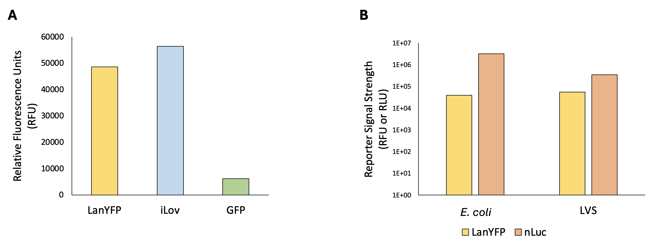
Figure 4. Comparison of reporters demonstrates that nLuc is the most sensitive reporter tested. (A) Comparison of signal from fluorescent reporters detected in cells. Chart shows relative fluorescence for indicated translation fusion reporters (LanYFP, iLov, and GFP). (B) Comparison of LanYFP fluorescence and nLuc luminescence. Reporter signal strength is displayed in relative fluorescence units or relative luminescence units for indicated translation fusion reporters (LanYFP and nLuc) produced from in vitro assays using E. coli or LVS ribosomes respectively (note log scale). In vitro translation assays were performed using the pKR204 reporter template, which specifies a pdpA 5’ UTR – nLuc reporter fusion and a tul4 5’ UTR – LanYFP reporter fusion.
To easily switch out UTR sequences in front of the nLuc coding sequence using standard cloning techniques, I modified an existing plasmid containing nLuc fused to the 5’ UTR for pdpA. This has provided us with a reporter construct that is sensitive and easy to modify for use in our in vitro translation assay.
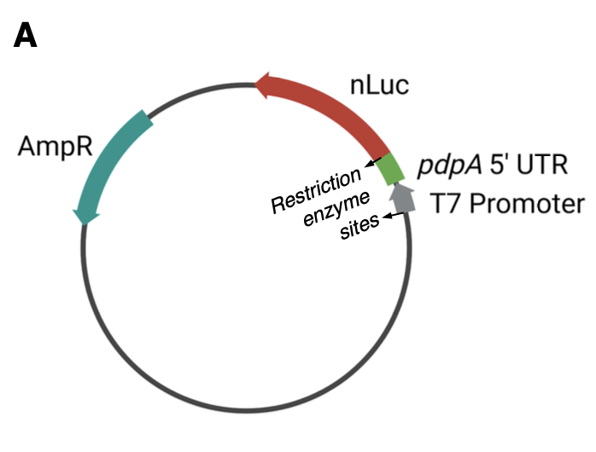
Figure X. Plasmid construct of the nLuc reporter plasmid, pKR144 PT7-pdpA 5’ UTR-nLuc. A single-reporter plasmid containing nLuc fused to the 5’ UTR of a gene of interest, flanked by NotI restriction enzyme cut sites, is easy to modify. An easily modifiable reporter construct that exhibits a broad dynamic range and high signal strength for testing translation of 5’ UTRs.

Specific Aim #2: Reproducibly purify active ribosomes from E. coli and F. tularensis.
To isolate active ribosomes, I have been using the sucrose cushion purification method. I first harvested ribosomes from E. coli cells grown in LB medium and was able to achieve a yield of 1.5-5 nmol from 1 L of culture (about 1.75g of cells) with a concentration of 10-30 pmol/µL, which is substantially higher than the 2.7 pmol/µL concentration required for the in vitro translation kit. Next, I demonstrated that the E. coli ribosomes were active using the in vitro assay and replicated these results using ribosomes from multiple purification attempts, showing that purification of E. coli ribosomes using the sucrose cushion method is reproducible (Figure 5). [Positive control for ribosome isolation / activity.]
Figure 5. Relative luminescence values for nLuc after translation by purified E. coli ribosomes. Results of in vitro translation assays using the pdpA 5´ UTR-nLuc reporter (pKR144) showing signal strength for multiple E. coli (Ec) ribosome purifications tested on different days. Ribosomes were purified using the sucrose cushion method. Kit ribosomes are also from E. coli and were supplied with the NEB assay kit.
After validating the sucrose cushion method using E. coli ribosomes, I purified ribosomes harvested from F. tularensis LVS cells grown in brain-heart infusion (BHI) media. [Add info about testing MHB vs BHI media. LVS grows better in BHI media than in MHB.]
Figure X. LVS grows better in BHI media than in MHB. LVS grows faster and reaches mid-log phase at a higher OD in BHI media than in MHB media.
I tested reproducibility by measuring nLuc luminescence signal from the same sample of sucrose cushion purified ribosomes on different days and signals from different sucrose cushion purifications on the same day (Figure 6). I observed reproducible translation with E. coli ribosomes, but a significant degree of variability in translation using F. tularensis ribosomes, including replicate to replicate variability.
Figure 6. Assessing translation by ribosomes from E. coli and F. tularensis. Results of an in vitro translation assay of the tul4 5´ UTR-nLuc reporter (pKR214) by indicated ribosomes. Letters indicate biological replicate purifications of ribosomes, each circle represents a technical replicate.
E. coli
F. tularensis
Given the variability in translation by ribosomes isolated from F. tularensis, I took several approaches. First, I made changes to the in vitro assay protocol to standardize experiments, including resuspending ribosome pellets overnight to ensure homogeneity, averaging several concentration reads to increase accuracy, storing single-use aliquots to reduce freeze/thaw cycles, and using a master mix in the assay to reduce pipetting error. I also analyzed ribosome samples on sucrose gradients, revealing that purified E. coli ribosomes exhibit prominent 70S peaks along with additional peaks that we suspect correspond to polysomes (Figure 7). When analyzing F. tularensis ribosomes, we found distinct 70S peaks as well as peaks that might correspond to 50S subunits and 100S ribosome dimers. These 100S dimers form when two 70S ribosomes interact with hibernation factors and undergo conformational changes and are usually accompanied by downregulation of translation (Prossliner et al., 2018). Since it appears that we are isolating both 70S and 100S ribosome particles together, we expect that there is a subset of purified ribosomes within each sample that are inactive, potentially leading to the observed variability. My current experiments focus on isolating homogenous 70S ribosomes to further ensure consistency between in vitro assays. This will provide us with active ribosomes from F. tularensis for use in our in vitro translation assay.
Figure 7. Sucrose gradient sedimentation profiles of purified ribosomes from indicated species. Sucrose gradient profiles of either E. coli (green) or F. tularensis LVS (blue) ribosomes. Ribosomes were purified using the sucrose cushion method.
Ongoing experiments are focused on producing homogenous, reproducibly active 70S ribosomes from F. tularensis. There seems to be a correlation between the amount of ribosomes present in a sample and how much aggregation is observed, so I will seek to determine the optimal amount of ribosomes to use in an assay that will reduce aggregation and subsequent variability. I will also see if 70S fractions can be recovered from sucrose gradients and remain as 70S ribosomes. If this is the case, we may be able to run samples on gradients after lysis and purify ribosomes directly from the 70S fractions. I will test these methods of reducing ribosome aggregation and then use these ribosomes in in vitro assays to identify a preparation method that leads to the most reproducible activity from different ribosome samples. Reproducible activity will be assessed by comparing nLuc luminescence signal from technical replicates of purified ribosomes, signals from biological replicates of ribosomes purified on the same day, as well as ribosomes purified on different days. The homogeneity of ribosome preparations will be tested by evaluating peaks on sucrose gradient sedimentation profiles. Finally, success will be determined by achieving a low degree of variability between preparations as well as low replicate to replicate variability in the in vitro assay.
Kasugamycin can inhibit translation in vitro
Figure X. Kasugamycin can inhibit translation in vitro. Kasugamycin inhibits translation in a dose of 1mM.
Bug Buster chemical lysis can be used to purify active ribosomes.
Purified E. coli and LVS ribosome samples have different ribosome profiles.
Figure X. Bug Buster lysed and purified ribosomes are measurably active in vitro. Bug Buster lysed and purified ribosomes are measurably active in vitro.
Figure X. Sucrose gradient profiles of purified E. coli and LVS ribosomes. Purified LVS ribosomes have broader 70S peaks, a 50S shoulder, and a distinct 100S peak when compared to E. coli ribosomes.
Different lysis methods have different sucrose gradient profiles.

Dialysis of ribosomes into low Mg buffer separates subunits and incubation of dissociated ribosomes in high Mg buffer reassociates subunits.
Figure X. Sucrose gradient profiles of LVS ribosomes from French Press and Bug Buster-lysed cells. The lysis method affects the appearance of the sucrose gradient profile.
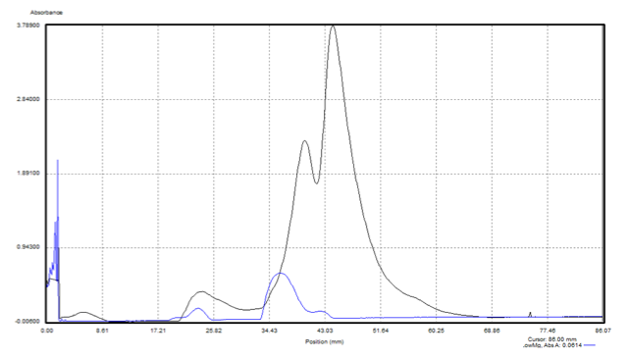
Figure X. Sucrose gradient profiles of LVS ribosomes after dialysis into low and high Mg. Successful dissociation into 30S and 50S subunits. Incubation for two hours in high Mg buffer is sufficient to reassociate 70S ribosomes.
Lower pmol ribosomes leads to sharper 70S peaks.

Figure X. Sucrose gradient profiles of LVS ribosomes with varying amounts of ribosomes loaded (200 pmol, 800 pmol, and 1400 pmol). Loading fewer ribosomes onto sucrose gradients leads to sharper 70S peaks.
Ribosome concentration affects translation efficiency (Lower pmol -> more translation).
Figure X. Serial dilution followed by in vitro luminescence assays. Lower ribosome concentrations have higher luminescence/pmol.
Using 2 pmol of LVS ribosomes in vitro works well for luminescence and gives consistent and reproducible results
Figure X. In vitro assays with 2 pmol LVS ribosomes from different purifications. Using 2 pmol of LVS ribosomes in vitro gives measurable and consistent results for luminescence across most purifications.
Lysis method affects translation efficiency.
Figure X. In vitro assays with LVS ribosomes purified from French Press or Bug Buster lysis. LVS ribosomes purified from French Press lysed cells are more active than those purified from Bug Buster lysed cells, depending on pmol ribosomes used.
Lysis method affects processing of ribosomal RNA [Talk about rRNA and rRNA processing and about the bands you would expect to see.]
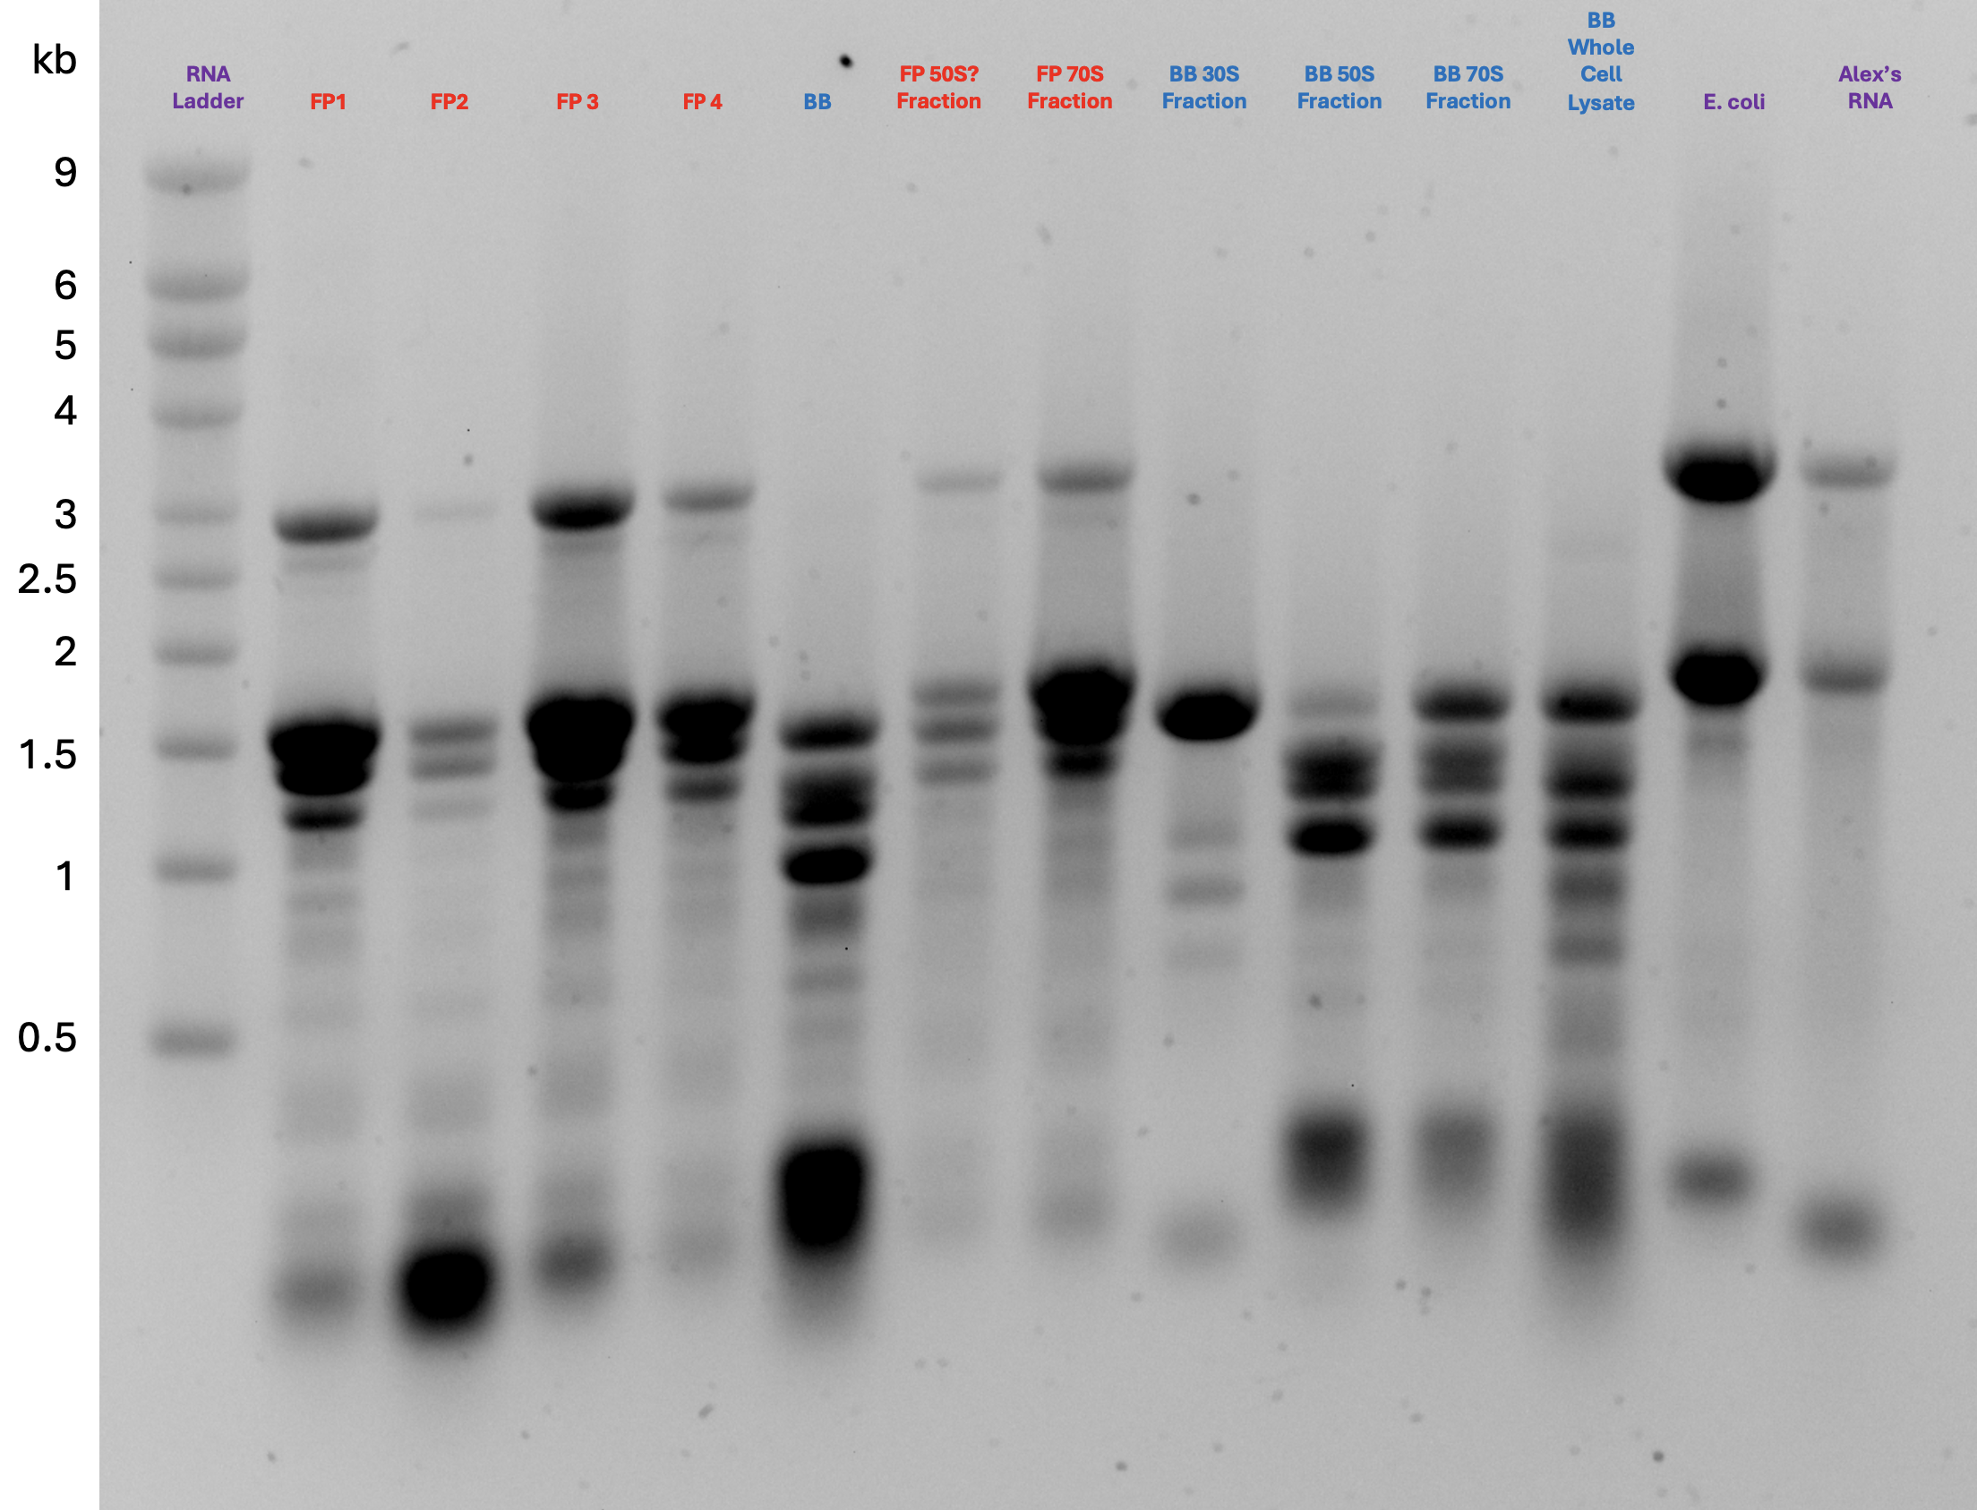
Figure X. RNA extracted from ribosomes purified from French Press or Bug Buster lysed cells and run on an RNA gel. LVS ribosomes purified from Bug Buster lysed cells display more RNA processing than those purified from French Press lysed cells.

CHAPTER 4

CONCLUSION

I modified an existing plasmid containing nLuc fused to the 5’ UTR for pdpA. This has provided us with a reporter construct that is sensitive and easy to modify for use in our in vitro translation assay. I demonstrated that the E. coli ribosomes were active using the in vitro assay and replicated these results using ribosomes from multiple purification attempts, showing that purification of E. coli ribosomes using the sucrose cushion method is reproducible. I found that translation efficiency is affected by growth media, strain, 5’ UTR, lysis method, and concentration of ribosomes in the assay.
Ongoing experiments are focused on producing homogenous, reproducibly active 70S ribosomes from F. tularensis. There seems to be a correlation between the amount of ribosomes present in a sample and how much aggregation is observed, so I will seek to determine the optimal amount of ribosomes to use in an assay that will reduce aggregation and subsequent variability. I will also see if 70S fractions can be recovered from sucrose gradients and remain as 70S ribosomes. If this is the case, we may be able to run samples on gradients after lysis and purify ribosomes directly from the 70S fractions. I will test these methods of reducing ribosome aggregation and then use these ribosomes in in vitro assays to identify a preparation method that leads to the most reproducible activity from different ribosome samples. Reproducible activity will be assessed by comparing nLuc luminescence signal from technical replicates of purified ribosomes, signals from biological replicates of ribosomes purified on the same day, as well as ribosomes purified on different days. The homogeneity of ribosome preparations will be tested by evaluating peaks on sucrose gradient sedimentation profiles. Finally, success will be determined by achieving a low degree of variability between preparations as well as low replicate to replicate variability in the in vitro assay.
My current experiments focus on isolating homogenous 70S ribosomes to further ensure consistency between in vitro assays. I found that loading smaller amounts of ribosomes onto sucrose gradients leads to sharper 70S peaks and that lower ribosome concentrations have higher luminescence/pmol Finally, I concluded that using 2 pmol of LVS ribosomes works well for luminescence in vitro and gives consistent and reproducible results. These findings can be applied to future in vitro assays that seek to measure the effects of bS21 homologs on translation of specific 5’ UTRs and contribute to an understanding of how bS21 homologs regulate translation in F. tularensis and modify the proteome to respond to different requirements or conditions.

BIBLIOGRAPHY

These pages are where you type in the references of your thesis. Every thesis must contain a bibliography which lists all the sources used or consulted in writing the entire thesis and is placed at the very end of the work. The complete citations are arranged alphabetically by last name of the author. Individual citations are not numbered. No abbreviations in titles of published works will be accepted. The full title of a book, journal, website, proceedings, or any other published work must be italicized or underlined. Citations must follow standards set by the Style Manual that the candidate is using. The bibliography for URI theses is not broken into categories. If the department wants a journal style List of References, it is done in addition to the Bibliography. Internet URLs must have date accessed.

Chang, C., and G. R. Craven. “Identification of Several Proteins Involved in the Messenger RNA Binding Site of the 30 S Ribosome by Inactivation with 2-Methoxy-5-Nitrotropone.” Journal of Molecular Biology 117, no. 2 (December 5, 1977): 401–18. https://doi.org/10.1016/0022-2836(77)90135-8.
Degabriel, Manon, Stanimira Valeva, Sandrine Boisset, and Thomas Henry. “Pathogenicity and Virulence of Francisella Tularensis.” Virulence 14, no. 1 (December 31, 2023): 2274638. https://doi.org/10.1080/21505594.2023.2274638.
Dennis, D. T., T. V. Inglesby, D. A. Henderson, J. G. Bartlett, M. S. Ascher, E. Eitzen, A. D. Fine, et al. “Tularemia as a Biological Weapon: Medical and Public Health Management.” JAMA 285, no. 21 (June 6, 2001): 2763–73. https://doi.org/10.1001/jama.285.21.2763.
Kaledhonkar, Sandip, Ziao Fu, Kelvin Caban, Wen Li, Bo Chen, Ming Sun, Ruben L. Gonzalez, and Joachim Frank. “Late Steps in Bacterial Translation Initiation Visualized Using Time-Resolved Cryo-EM.” Nature 570, no. 7761 (June 2019): 400–404. https://doi.org/10.1038/s41586-019-1249-5.
Oyston, Petra C. F., Anders Sjostedt, and Richard W. Titball. “Tularaemia: Bioterrorism Defence Renews Interest in Francisella Tularensis.” Nature Reviews. Microbiology 2, no. 12 (December 2004): 967–78. https://doi.org/10.1038/nrmicro1045.
Prossliner, Thomas, Kristoffer Skovbo Winther, Michael Askvad Sørensen, and Kenn Gerdes. “Ribosome Hibernation.” Annual Review of Genetics 52 (November 23, 2018): 321–48. https://doi.org/10.1146/annurev-genet-120215-035130.
Sjöstedt, Anders. “Tularemia: History, Epidemiology, Pathogen Physiology, and Clinical Manifestations.” Annals of the New York Academy of Sciences 1105 (June 2007): 1–29. https://doi.org/10.1196/annals.1409.009.
Trautmann, Hannah S., and Kathryn M. Ramsey. “A Ribosomal Protein Homolog Governs Gene Expression and Virulence in a Bacterial Pathogen.” Journal of Bacteriology 204, no. 10 (September 19, 2022): e00268-22. https://doi.org/10.1128/jb.00268-22.
Trautmann, Hannah S., Sierra S. Schmidt, Steven T. Gregory, and Kathryn M. Ramsey. “Ribosome Heterogeneity Results in Leader Sequence-Mediated Regulation of Protein Synthesis in Francisella Tularensis.” Journal of Bacteriology 205, no. 9 (September 26, 2023): e0014023. https://doi.org/10.1128/jb.00140-23.
Van Duin, Jan, and Robert Wijnands. “The Function of Ribosomal Protein S21 in Protein Synthesis.” European Journal of Biochemistry 118, no. 3 (1981): 615–19. https://doi.org/10.1111/j.1432-1033.1981.tb05563.x.
Watson, Zoe L, Fred R Ward, Raphaël Méheust, Omer Ad, Alanna Schepartz, Jillian F Banfield, and Jamie HD Cate. “Structure of the Bacterial Ribosome at 2 Å Resolution.” Edited by Sjors HW Scheres, Cynthia Wolberger, Sjors HW Scheres, Bruno Klaholz, and Israel S Fernández. eLife 9 (September 14, 2020): e60482. https://doi.org/10.7554/eLife.60482.

Begin typing or pasting the rest of references here. This template is best used for directly typing in your content. However, you can paste text into the document, but use caution as pasting can produce varying results

