Measuring LVS Growth Curves in MHB and BHI Media

- 700 uL supplemented MHB (sMHB) was added to a sterile microfuge tube aseptically.
- Loopfuls of cells were scraped up from the LVS plate patched out yesterday and added to the microfuge tube.
- The cells were resuspended to homogeneity using a pipette.
- A cuvette was prepared to check OD 600 by adding 900 uL sMHB, and 100 uL resuspended cells was added to the cuvette.
- The OD 600 was measured. The OD 600 of resuspended cells was calculated by multiplying the observed OD 600 by ten, and both the observed and calculated ODs were recorded:
  - LVS: 0.517 observed OD, 5.17 calculated OD
- The volume of resuspended cells necessary to obtain a final OD 600 of 0.08 in 9 mL was calculated.
  - LVS: (0.08 OD 600 )*(9,000ul)/(5.17 OD 600 ) = 139.3 uL
- I realized that this desired volume of resuspended cells was larger than what I had available to inoculate six tubes, so I scraped up more cells into this tube and added 200 uL more MHB.
- The cells were resuspended to homogeneity using a pipette.
- A cuvette was prepared to check OD 600 by adding 900 uL sMHB, and 100 uL resuspended cells was added to the cuvette.
- The OD 600 was measured. The OD 600 of resuspended cells was calculated by multiplying the observed OD 600 by ten, and both the observed and calculated ODs were recorded:
  - LVS: 0.627 observed OD, 6.27 calculated OD
- The volume of resuspended cells necessary to obtain a final OD 600 of 0.08 in 9 mL was calculated.
  - LVS: (0.08 OD 600 )*(9,000ul)/(6.27 OD 600 ) = 114.8 uL
- 9 mL of supplemented MHB media was added to three culture tubes, and 9 mL of supplemented BHI media was added to three other culture tubes.
- The volume of resuspended cells (114.8 uL) necessary to obtain a final OD 600 of 0.08 from step 11 was used to inoculate each of the six culture tubes. I did not have enough volume to inoculate the third BHI tube, so I only used two BHI cultures for the experiment.
- The culture tubes were vortexed, and 1 mL was removed from each to measure the OD:

Table 17. Initial OD600 values of LVS cultures in MHB and BHI media.
Sample ID | OD600
MHB 1 | 0.077
MHB 2 | 0.079
MHB 3 | 0.076
BHI 1 | 0.071
BHI 2 | 0.068

- The culture tubes were incubated at 37°C shaking, starting incubation at 10:53 AM.
- The culture tubes were removed and the ODs were checked at 12:25 PM by adding 0.5 mL from each culture tube to a cuvette along with 0.5 mL of fresh media (MHB or BHI) and reading in the spectrophotometer. The measured OD600 values were multiplied by two to obtain the calculated OD600 values.

Table 18. OD600 values of LVS cultures in MHB and BHI media after 92 minutes.
Sample ID | Measured OD600 | Calculated OD600
MHB 1 | 0.08 | 0.16
MHB 2 | 0.074 | 0.148
MHB 3 | 0.078 | 0.156
BHI 1 | 0.08 | 0.16
BHI 2 | 0.067 | 0.134

- The culture tubes were removed and the ODs were checked at 1:55 PM by adding 0.5 mL from each culture tube to a cuvette along with 0.5 mL of fresh media (MHB or BHI) and reading in the spectrophotometer. The measured OD600 values were multiplied by two to obtain the calculated OD600 values.

Table 19. OD600 values of LVS cultures in MHB and BHI media after 182 minutes.
Sample ID | Measured OD600 | Calculated OD600
MHB 1 | 0.123 | 0.246
MHB 2 | 0.125 | 0.25
MHB 3 | 0.123 | 0.246
BHI 1 | 0.172 | 0.344
BHI 2 | 0.163 | 0.326

- The culture tubes were removed and the ODs were checked at 3:17 PM by adding 0.5 mL from each culture tube to a cuvette along with 0.5 mL of fresh media (MHB or BHI) and reading in the spectrophotometer. The measured OD600 values were multiplied by two to obtain the calculated OD600 values.

Table 20. OD600 values of LVS cultures in MHB and BHI media after 264 minutes.
Sample ID | Measured OD600 | Calculated OD600
MHB 1 | 0.19 | 0.38
MHB 2 | 0.188 | 0.376
MHB 3 | 0.195 | 0.39
BHI 1 | 0.311 | 0.622
BHI 2 | 0.291 | 0.582

- Here, the third MHB culture tube was removed to use for a GFP assay, but the first two MHB tubes were placed back in the incubator for further measurements.
- The culture tubes were removed and the ODs were checked at 4:49 PM by adding 0.25 mL from each culture tube to a cuvette along with 0.75 mL of fresh media (MHB or BHI) and reading in the spectrophotometer. The measured OD600 values were multiplied by four to obtain the calculated OD600 values.

Table 21. OD600 values of LVS cultures in MHB and BHI media after 356 minutes.
Sample ID | Measured OD600 | Calculated OD600
MHB 1 | 0.136 | 0.544
MHB 2 | 0.137 | 0.548
BHI 1 | 0.246 | 0.984
BHI 2 | 0.24 | 0.96

- The culture tubes were removed and the ODs were checked at 6:23 PM by adding 0.2 mL from each culture tube to a cuvette along with 0.8 mL of fresh media (MHB or BHI) and reading in the spectrophotometer. The measured OD600 values were multiplied by five to obtain the calculated OD600 values.

Table 22. OD600 values of LVS cultures in MHB and BHI media after 450 minutes.
Sample ID | Measured OD600 | Calculated OD600
MHB 1 | 0.156 | 0.78
MHB 2 | 0.161 | 0.805
BHI 1 | 0.306 | 1.53
BHI 2 | 0.309 | 1.545

Measuring LVS Growth Curves in MHB and BHI Media (continued)
- The culture tubes were removed and the ODs were checked at 9:40 AM by adding 0.1 mL from each culture tube to a cuvette along with 0.9 mL of fresh media (MHB or BHI) and reading in the spectrophotometer. The measured OD600 values were multiplied by ten to obtain the calculated OD600 values.

Table 25. OD600 values of LVS cultures in MHB and BHI media after 23 hours.
Sample ID | Measured OD600 | Calculated OD600
MHB 1 | 0.239 | 2.39
MHB 2 | 0.334 | 3.34
BHI 1 | 0.56 | 5.6
BHI 2 | 0.558 | 5.58

The OD values and time points were used to plot a growth curve and estimate doubling time. The two points connecting the steepest portions of each curve were used to calculate doubling time.
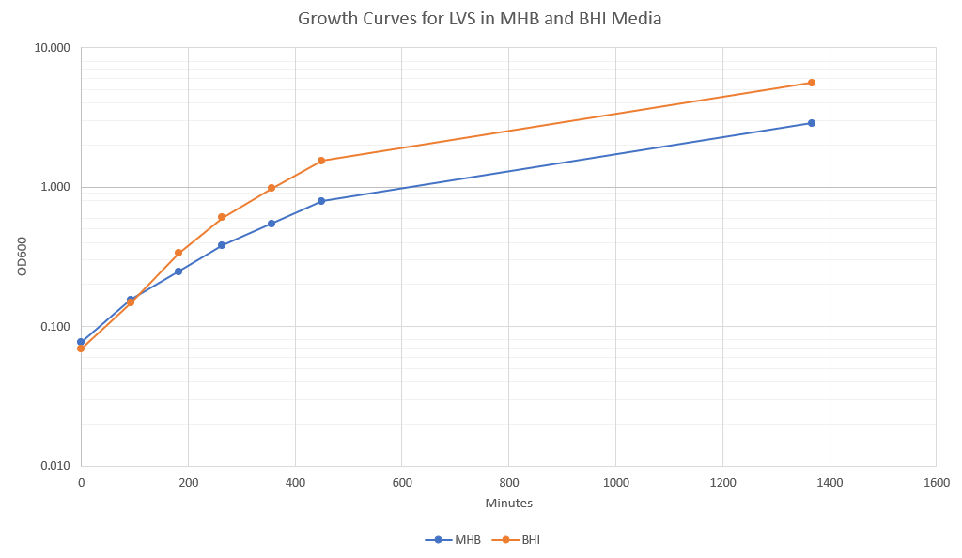

Figure 26. Growth curves for LVS in MHB and BHI Media over 1367 minutes.

The following formula was used to calculate doubling time: G = (0.301)(t2-t1)/(logOD2-logOD1).

Table 26. Doubling time calculations for LVS grown in MHB and BHI media.

 | MHB | BHI
t1 | 0 | 92
t2 | 92 | 182
OD1 | 0.077 | 0.147
OD2 | 0.155 | 0.335
Doubling Time | 91.13978186 | 75.72803908

