Info on Nano Luciferase

NanoLuc® (Nluc) luciferase is a small enzyme (19.1kDa) engineered for optimal performance as a luminescent reporter. The enzyme is about 150-fold brighter than either firefly (Photinus pyralis) or Renilla reniformis luciferase (Figure 1), using a novel coelenterazine analog (furimazine; Figure 2) to produce high intensity, glow-type
luminescence. The luminescent reaction is ATP-independent and designed to suppress background luminescence for maximal assay sensitivity.

Unfused Nluc offers maximal light output and sensitivity. Luminescence is linearly proportional to the amount of NanoLuc® protein over a 1,000,000-fold concentration range
(Figure 1), with a signal half-life of ~120 minutes.

NanoLuc® luciferase possesses a number of physical properties that make it an excellent reporter protein: small, monomeric enzyme (171 amino acids; 513bp); high thermal stability (Tm = 60°C); active over a broad pH range
(pH 6–8); no post-translational modifications or disulfide bonds; uniform distribution in cells and an emission
spectrum well suited for bioluminescence resonance energy transfer (BRET; λmax = 460nm). The enhanced thermal
stability of NanoLuc® luciferase makes the enzyme less susceptible to small molecule inhibitors that can emerge from
diverse compound libraries.

Nano-Glo® Luciferase Assay System(a–c) provides a simple, single-addition reagent that generates a glow-type signal in the presence of NanoLuc® luciferase. The reagent is prepared by mixing Nano-Glo® Luciferase Assay Substrate and Nano-Glo® Luciferase Assay Buffer and contains an integral lysis buffer to use directly on cells expressing NanoLuc® luciferase or culture medium when the luciferase is secreted.

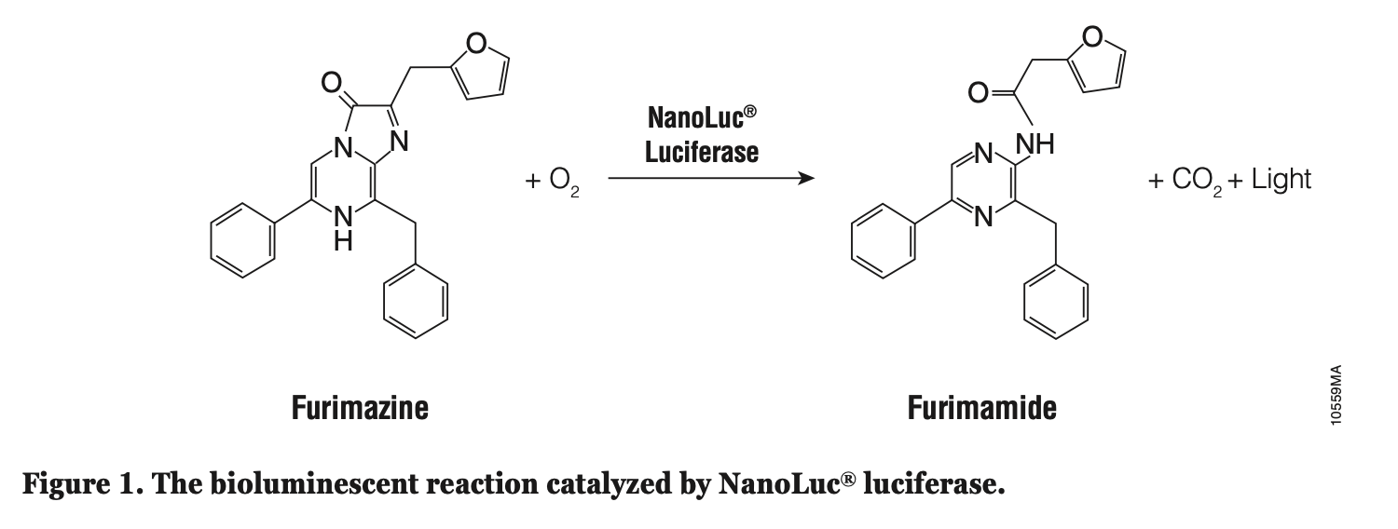

When sensitivity is needed, maximal brightness will be provided by unfused NanoLuc® (Nluc) luciferase, which can
accumulate in cells due to the long intracellular half-life of the protein (>6 hours). The bright signal from Nluc and the
low autoluminescence of the Nano-Glo® Luciferase Assay Reagent provide maximum sensitivity where expression
levels are low, such as in cell lines that are difficult to transfect.

NanoLuc® luciferase is able to maintain a glow-type luminescent signal over a broad concentration range, providing a
signal half-life of approximately 120 minutes. However, the signal half-life can decrease significantly at extremely high
concentrations of enzyme, likely due to rapid depletion of substrate (Figure 6). Samples in this range will not maintain
the same relative levels of light output compared to samples at lower NanoLuc® concentrations in the minutes to hours
after adding the Nano-Glo® Luciferase Assay Reagent. If you suspect that you may have an extremely high
concentration of NanoLuc® luciferase in your samples, monitor the rate of signal decay starting 3–10 minutes after
adding the Nano-Glo® Luciferase Assay Reagent. If the signal half-life is reduced, the initial RLU value at
3–10 minutes can be used in future work to approximate an upper limit of luminescence that will decay with a half-life
of approximately 120 minutes under your experimental conditions (luminometer, plate type, etc.). This value is
typically near or can often exceed the linear dynamic range of the luminometer used for detection (Section 5.C). If you
have samples that exceed the linear dynamic range of the instrument, modify the experimental conditions to lower the
final concentration of NanoLuc® protein in the cell lysate (Section 5.B).

