THESIS PROPOSAL
BENJAMIN MOORE
A. Title of the study: Evaluating contribution of Francisella tularensis bS21 homologs to in vitro translation
C. JUSTIFICATION FOR THE STUDY
Francisella tularensis is a Gram-negative, facultative intracellular bacterium. F. tularensis causes the disease tularemia, which can be transmitted by rabbits, small rodents, or arthropods (Sjöstedt, 2007). This disease manifests at the onset with flu-like symptoms and can develop into several forms, of which the ulceroglandular form is the most common and the pneumonic form can be fatal (Degabriel et al., 2023). Because a relatively small exposure to the bacterium can cause an infection and it can be easily dispersed through the air, it has been classified as a potential bioweapon (Oyston et al., 2004). The Ramsey lab uses F. tularensis subspecies holarctica, specifically the live vaccine strain (LVS), as a model organism because it is not infectious to humans but retains its virulence in animal models. The Ramsey lab is interested in studying post-transcriptional regulation of virulence genes in F. tularensis, specifically how changes in ribosome composition impact virulence gene expression.
Key virulence genes in F. tularensis are located within the Francisella Pathogenicity Island (FPI), a region of the genome which codes for the type 6 secretion system (T6SS). The T6SS is a protein complex necessary for bacterial intracellular survival and growth within host cells. This cluster of genes is tightly regulated at the level of transcription. Specifically, transcription increases during the stringent stress response when the alarmone (p)ppGpp binds to transcription factors MglA and SspA associated with RNA polymerase and recruits another transcription factor, PigR. This increases transcription from promoters that contain short motifs called PigR response elements (PREs), including those found on the FPI (Degabriel et al., 2023). Recent work has demonstrated that expression of FPI virulence genes is further controlled by regulating translation of the mRNA into proteins by a specific ribosomal protein, bS21-2 (Trautmann & Ramsey, 2022).
Most bacteria encode one bS21 homolog or none at all. In the ribosome, bS21 is located in the small subunit near the anti-Shine Dalgarno sequence and near the channel where mRNA exits the ribosome. Its location suggests that bS21 may interact directly with the 5’ UTR of mRNA molecules during the initiation phase of translation. In fact, several studies have implicated it in translation initiation in E. coli ribosomes (van Duin & Wijnands, 1981; Chang & Craven, 1977).
F. tularensis is unusual in that it has three homologs of bS21. Bacteria are usually very thrifty and don’t keep genes that they don’t need, so there must be some significance to the fact that F. tularensis maintains three different homologs of the gene for the bS21 protein. The Ramsey lab found that F. tularensis ribosomes can incorporate any one of the three bS21 homologs and that the second homolog, bS21-2, is the most abundant when cells are grown in the laboratory (Trautmann & Ramsey, 2022). Additionally, in the absence of bS21-2, the abundance of certain proteins, including T6SS proteins, decreased yet mRNA abundance remained the same (Trautmann & Ramsey, 2022). This suggests that when bS21-2 is absent, ribosomes are not able to translate these genes as efficiently. We also found that the ability of cells to replicate within macrophage decreased when bS21-2 was absent (Trautmann & Ramsey, 2022). These data lead to the development of a model in which bS21-2 allows for more efficient translation of virulence genes.
In support of a model in which bS21-2 controls translation initiation, it was found that the presence of bS21-2 can affect the translation of mRNAs with specific 5' UTR sequences and that altering the 5' UTR sequences can lead to a loss of this regulatory effect (Trautmann et al., 2023). In particular, the Ramsey lab studied these effects using an in vivo system, using a reporter assay to examine how the presence of bS21-2 altered translation of particular mRNAs in F. tularensis cells. These reporters consisted of a control promoter, tul4, driving expression of an mRNA containing the 5´ UTR of a control gene or gene of interest fused to GFP. Translation efficiency for each mRNA was measured by how much of the reporter protein was produced. The 5' UTRs tested in this reporter assay were selected from a proteomics analysis in which the absence of bS21-2 led to a downregulation in protein production of the selected genes (Trautmann & Ramsey, 2022). These genes included the FPI genes pdpA and iglA. When bS21-2 was absent, reporter output decreased for the selected genes but did not decrease for tul4 (Figure 1; Trautmann & Ramsey, 2022). Since changes in reporter output correlate with the amount of protein in cells with and without bS21-2, these data indicate that the 5´ UTR is sufficient to influence translation in vivo. Additionally, because 5´ UTRs are generally important for initiation, these results strongly suggest that bS21-2 is regulating translation during initiation.
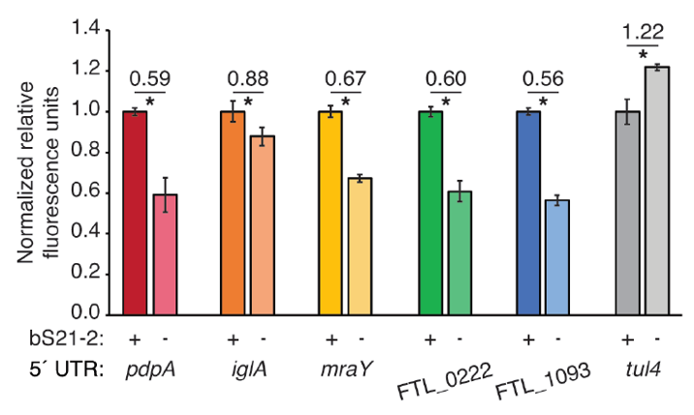
Figure 1 5´ UTRs are sufficient to lead to bS21-2-mediated changes in translation. Relative fluorescence for indicated GFP translational fusion reporters in cells with (+; WT) or without (−; ΔrpsU2) bS21-2. The tul4 5´ UTR serves as a control. Figure and legend are from Trautmann et al., 2023.

After determining that the 5´ UTR is sufficient to allow bS21-2-mediated changes in translation, the Ramsey lab further investigated 5´ UTR sequences to identify specific elements which lead to regulation. In most bacterial 5´ UTRs, a particular sequence called the Shine-Dalgarno (SD) pairs with an anti-Shine-Dalgarno (aSD) sequence in the 16S rRNA of the 30S ribosomal subunit. This pairing is not strictly necessary for translation initiation but increases the efficiency of translation initiation. Structures of E. coli ribosomes reveal that bS21 likely directly contacts the aSD sequence (Kaledhonkar et al., 2019), implicating the SD-aSD pairing as a potential candidate for regulation by bS21-2 in F. tularensis. Upon testing translation efficiency of mRNAs with different SD sequences, the Ramsey lab found that 5´ UTRs with ideal SDs lost responsiveness to bS21-2 (Figure 2A, Trautmann et al., 2023), suggesting that bS21-2 interacts with the 5ˊ UTR in certain ways, but that the presence of a perfect SD can override these effects so that they are not as noticeable. In other genes, however, imperfect SD sequences do not automatically lead to regulation, so the search for other regulatory elements continued.
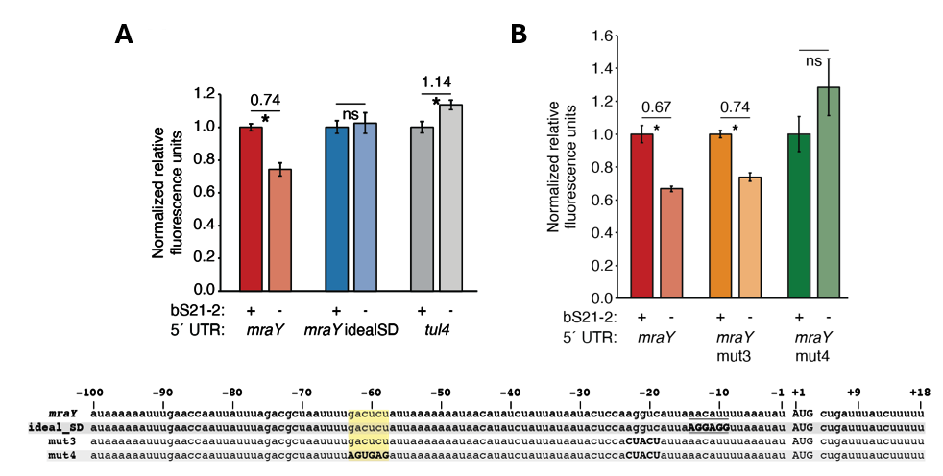
Figure 2. bS21-2-mediated translation of mraY depends on a weak Shine-Dalgarno and a specific six nucleotide sequence. Charts show relative fluorescence for indicated gfp translation fusion reporters in cells with (+; WT) or without (−; ΔrpsU2) bS21-2. (A) Introduction of an ideal SD in the mraY leader leads to loss of bS21-2 responsiveness. (B) The nucleotides between −58 and −63 in the mraY 5´ UTR, GACUCU, are essential for responsiveness to bS21-2. (A–B) Lines above bars indicate comparisons, values above line indicate ratio of reporter activity in cells lacking bS21-2 to wild-type cells. Error bars represent 1 SD. *P < 0.05 by t-test. ns = not significant. Experiments were repeated at least twice in biological triplicate, and data from a representative experiment are shown. Figure and legend are from Trautmann et al., 2023.
To find elements necessary for regulation by bS21-2, the Ramsey lab investigated the 5´ UTR of mraY. We tested the contribution of two motifs (AAAAUAAA and UUAUUUA) that are enriched in the 5´ UTR of genes regulated by bS21-2 as well as the predicted secondary structure of 5´ UTRs, but these did not contribute to regulation by bS21-2. Through further testing and modification of the mraY 5´ UTR, we identified a 6-nucleotide motif in the mraY 5´ UTR GACUCU (Fig. 2) that is necessary for regulation by bS21-2.
These studies have allowed us to make significant progress in understanding how bS21-2 controls translation of mRNAs with specific 5’ UTRs, but we would like to go further and address several other questions. In particular, we would like to determine if these results can be recapitulated in vitro. If we can develop an in vitro translation assay that allows us examine translation efficiency, we could quickly and easily address multiple other questions. These questions include: Can we recapitulate regulation of translation by bS21-2 in vitro? Is the GACUCU motif sufficient for regulation by bS21-2? Are there other sequence motifs that confer regulation? By

developing an in vitro assay to test translation efficiency, we could expand upon our previous discoveries and go further in answering our questions.
The goal of my thesis project is to develop an in vitro translation assay for F. tularensis. In developing this assay, I will use the PURExpress® Δ Ribosome Kit from New England Biolabs. This is a translation assay kit from New England Biolabs that contains all the factors necessary for transcription and translation except ribosomes and permits the user to translate any protein as a reporter. When you combine the kit components with a DNA template and purified ribosomes, transcription and translation of a DNA-encoded reporter will occur, resulting in a signal that can be measured to assess translation efficiency. To use this kit for our studies, we will need to clone a plasmid template and purify active ribosomes from F. tularensis.

Preliminary work towards developing an in vitro translation assay performed by a previous graduate student used F. tularensis ribosomes and the tul4 5’ UTR-GFP reporter. While the reaction with E. coli ribosomes (provided by the kit) yielded signal in the assay, showing the reaction was properly set up, the ribosomes purified from F. tularensis did not translate detectable amounts of product (Fig. 3). These results suggested to us that we should try to find a more sensitive reporter and that we should ensure that the ribosomes we are purifying are active.
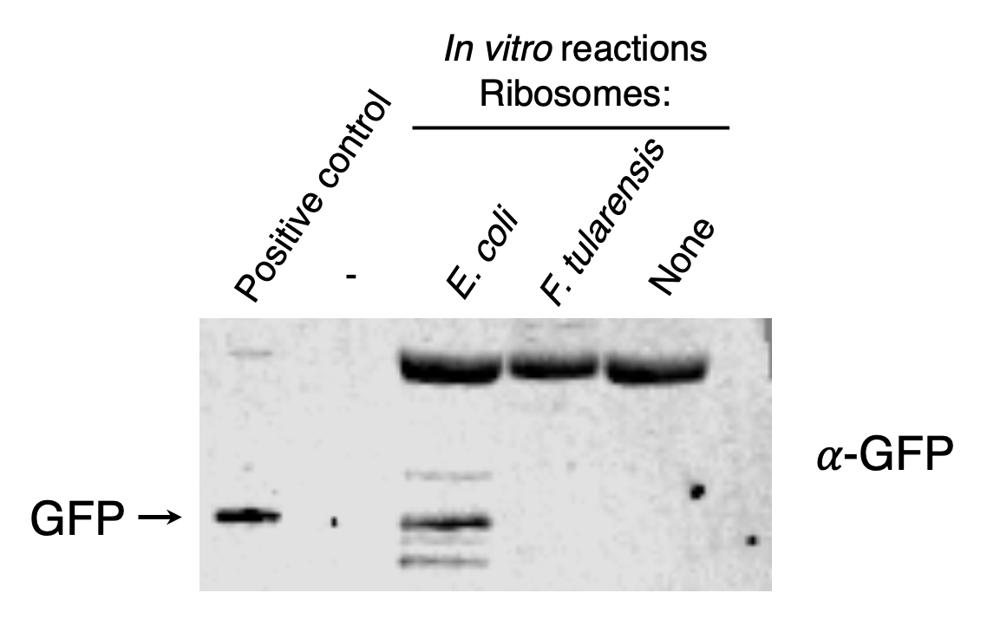
Figure 3. Ribosomes purified from F. tularensis exhibited poor activity in early in vitro assays. In vitro translation assays were performed using a DNA template specifying an mRNA with the tul4 5’ UTR fused to the GFP gene (pKR107). Reactions contained either control ribosome from the kit (purified from E. coli) or F. tularensis LVS. No fluorescence was detected from the reaction containing F. tularensis ribosomes, so samples were analyzed by immunoblot using an antibody to GFP. The positive control lane contains cell lysate from F. tularensis expressing GFP.
Specific Aim #1: Develop a reporter construct for use in an in vitro translation assay that is sensitive and easy to modify.
To address this aim, I have assessed multiple reporters to see which provides the highest signal. These reporters include the fluorescent proteins GFP, LanYFP, and iLov, and the luciferase protein nLuc. To do this, I cloned these reporters into an existing plasmid that allowed for transcription by the in vitro translation kit. I chose nLuc because of its broad dynamic range and sensitivity in comparison to the other reporters (Fig. 4). I modified an existing plasmid containing nLuc fused to the 5’ UTR for pdpA so that I could easily switch out UTR sequences in front of the nLuc coding sequence using standard cloning techniques. This has provided us with a reporter construct that is sensitive and easy to modify for use in our in vitro translation assay.
B
A
Figure title. A. Chart title. Description of chart. B. Chart title. Description of chart (note log scale).

Specific Aim #2: Reproducible purification of active ribosomes from E. coli and F. tularensis.
-Validate purification protocol with E. coli (sucrose cushion)
-Use protocol with LVS cells
We used the sucrose cushion method to purify active ribosomes after growing E. coli cells in LB media and F. tularensis cells in BHI media. We tested reproducibility by measuring signal from the same sample on different days and signals from different purifications on the same day. We experimented with growing the cells in different kinds of media (MHB, BHI) and also ran samples on sucrose gradients to see what their ribosome profiles look like and then performed dialysis to purify tight-coupled ribosomes. We averaged multiple readings for concentration and diluted the ribosomes to their working concentration before aliquoting them in small working volumes and freezing.
Formatting requirements:
15 or fewer double-spaced pages
font size no smaller than 12 point
Literature Cited
Chang, C., & Craven, G. R. (1977). Identification of several proteins involved in the messenger RNA binding site of the 30 S ribosome by inactivation with 2-methoxy-5-nitrotropone. Journal of Molecular Biology, 117(2), 401–418. https://doi.org/10.1016/0022-2836(77)90135-8
Degabriel, Manon et al. “Pathogenicity and virulence of Francisella tularensis.” Virulence vol. 14,1 (2023): 2274638. doi:10.1080/21505594.2023.2274638
Dennis D, Inglesby T, Henderson D, et al. Tularemia as a biological weapon. Journal of the American Medical Association. 2001; 285: 2763-2773.
Kaledhonkar, S., Fu, Z., Caban, K., Li, W., Chen, B., Sun, M., Gonzalez, R. L., Jr, & Frank, J. (2019). Late steps in bacterial translation initiation visualized using time-resolved cryo-EM. Nature, 570(7761), 400–404. https://doi.org/10.1038/s41586-019-1249-5
Oyston CFP, Sjöstedt A, Titball RW. Tulareamia: bioterrorism defense renews interest in Francisella tularensis. Nature Reviews Microbiology. 2004; 2:967-978.
Sjöstedt A. Tularemia: history, epidemiology, pathogen physiology, and clinical manifestations. Annals of the New York Academy of Sciences. 2007; 1105:1–29.
Trautmann, H., & Ramsey, K. (2022). A Ribosomal Protein Homolog Governs Gene Expression and Virulence in a Bacterial Pathogen. Journal of Bacteriology, 204(10), e00268-22. https://doi.org/10.1128/jb.00268-22
Trautmann, H. S., Schmidt, S. S., Gregory, S. T., & Ramsey, K. M. (2023). Ribosome heterogeneity results in leader sequence-mediated regulation of protein synthesis in Francisella tularensis. Journal of bacteriology, 205(9), e0014023. https://doi.org/10.1128/jb.00140-23
Van Duin, J., & Robert, W. (1981). The Function of Ribosomal Protein S21 in Protein Synthesis. European Journal of Biochemistry, 118(3), 615–619. https://doi.org/10.1111/j.1432-1033.1981.tb05563.x
Watson, Z. L., Ward, F. R., Méheust, R., Ad, O., Schepartz, A., Banfield, J. F., & Cate, J. H. (2020). Structure of the bacterial ribosome at 2 Å resolution. ELife, 9, e60482. https://doi.org/10.7554/eLife.60482

