THESIS PROPOSAL
BENJAMIN MOORE
A. Title of the study: Evaluating contribution of Francisella tularensis bS21 homologs to in vitro translation
C. JUSTIFICATION FOR THE STUDY
Francisella tularensis is a Gram-negative, facultative intracellular bacterium. F. tularensis causes the disease tularemia, which can be transmitted by rabbits, small rodents, or arthropods (Sjöstedt, 2007). This disease manifests at the onset with flu-like symptoms and can develop into several forms, of which the ulceroglandular form is the most common and the pneumonic form can be fatal (Degabriel et al., 2023). Because a relatively small exposure to the bacterium can cause an infection and it can be easily dispersed through the air, it has been classified as a potential bioweapon (Oyston et al., 2004). The Ramsey lab uses F. tularensis subspecies holarctica, specifically the live vaccine strain (LVS), as a model organism because it is not infectious to humans but retains its virulence in animal models. The Ramsey lab is interested in studying post-transcriptional regulation of virulence genes in F. tularensis, specifically how changes in ribosome composition impact virulence gene expression.
Key virulence genes in F. tularensis are located within the Francisella Pathogenicity Island (FPI), a region of the genome which codes for the type 6 secretion system (T6SS). The T6SS is a protein complex necessary for bacterial intracellular survival and growth within host cells. This cluster of genes is tightly regulated at the level of transcription. Specifically, transcription increases during the stringent stress response when the alarmone (p)ppGpp binds to transcription factors MglA and SspA associated with RNA polymerase and recruit s another transcription factor, PigR. This increases transcription from promoters that contain short motifs called PigR response elements (PREs), including those found on the FPI (Degabriel et al., 2023). Recent work has demonstrated that expression of FPI virulence genes is further controlled by regulating translation of the mRNA into proteins by a specific ribosomal protein, bS21-2 (Trautmann & Ramsey, 2022).
Most bacteria encode one bS21 homolog or none at all. In the ribosome, bS21 is located in the small subunit near the anti-Shine Dalgarno sequence and near the channel where mRNA exits the ribosome. Its location suggests that bS21 may interact directly with the 5’ UTR of mRNA molecules during the initiation phase of translation. In fact, several studies have implicated it in translation initiation in E. coli ribosomes (van Duin & Wijnands, 1981; Chang & Craven, 1977).
F. tularensis is unusual in that it has three homologs of bS21. Bacteria are usually very thrifty and don’t keep genes that they don’t need, so there must be some significance to the fact that F. tularensis maintains three different homologs of the gene for the bS21 protein. The Ramsey lab found that F. tularensis ribosomes can incorporate any one of the three bS21 homologs and that the second homolog, bS21-2, is the most abundant when cells are grown in the laboratory (Trautmann & Ramsey, 2022). Additionally, in the absence of bS21-2, the abundance of certain proteins, including T6SS proteins, decreased yet mRNA abundance remained the same (Trautmann & Ramsey, 2022). This suggests that when bS21-2 is absent, ribosomes are not able to translate these genes as efficiently. We also found that the ability of cells to replicate within macrophage decreased when bS21-2 was absent (Trautmann & Ramsey, 2022). These data lead to the development of a model in which bS21-2 allows for more efficient translation of virulence genes.
In support of a model in which bS21-2 controls translation initiation, it was found that the presence of bS21-2 can affect the translation of mRNAs with specific 5' UTR sequences and that altering the 5' UTR sequences can lead to a loss of this regulatory effect (Trautmann et al., 2023). In particular, the Ramsey lab studied these effects using an in vivo system, using a reporter assay to examine how the presence of bS21-2 altered translation of particular mRNAs in F. tularensis cells. These reporters consisted of a control promoter, tul4, driving expression of an mRNA containing the 5´ UTR of a control gene or gene of interest fused to GFP. Translation efficiency for each mRNA was measured by how much of the reporter protein was produced. The 5' UTRs tested in this reporter assay were selected from a proteomics analysis in which the absence of bS21-2 led to a downregulation in protein production of the selected genes (Trautmann & Ramsey, 2022). These genes included the FPI genes pdpA and iglA. When bS21-2 was absent, reporter output decreased for the selected genes but did not decrease for tul4 (Figure 1; Trautmann & Ramsey, 2022). Since changes in reporter output correlate with the amount of protein in cells with and without bS21-2, these data indicate that the 5´ UTR is sufficient to influence translation in vivo. Additionally, because 5´ UTRs are generally important for initiation, these results strongly suggest that bS21-2 is regulating translation during initiation.
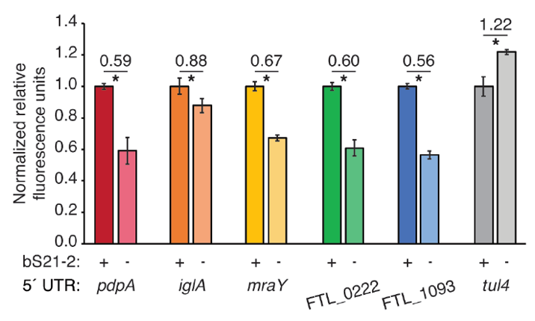
Figure 1 5´ UTRs are sufficient to lead to bS21-2-mediated changes in translation. Relative fluorescence for indicated GFP translational fusion reporters in cells with (+; WT) or without (−; ΔrpsU2) bS21-2. The tul4 5´ UTR serves as a control. Figure and legend are from Trautmann et al., 2023.

After determining that the 5´ UTR is sufficient to allow bS21-2-mediated changes in translation, the Ramsey lab further investigated 5´ UTR sequences to identify specific elements which lead to regulation. In most bacterial 5´ UTRs, a particular sequence called the Shine-Dalgarno (SD) pairs with an anti-Shine-Dalgarno (aSD) sequence in the 16S rRNA of the 30S ribosomal subunit. This pairing is not strictly necessary for translation initiation but increases the efficiency of translation initiation. Structures of E. coli ribosomes reveal that bS21 likely directly contacts the aSD sequence (Kaledhonkar et al., 2019), implicating the SD-aSD pairing as a potential candidate for regulation by bS21-2 in F. tularensis. Upon testing translation efficiency of mRNAs with different SD sequences, the Ramsey lab found that 5´ UTRs with ideal SDs lost responsiveness to bS21-2 (Figure 2A, Trautmann et al., 2023), suggesting that bS21-2 interacts with the 5ˊ UTR in certain ways, but that the presence of a perfect SD can override these effects so that they are not as noticeable. In other genes, however, imperfect SD sequences do not automatically lead to regulation, so the search for other regulatory elements continued.
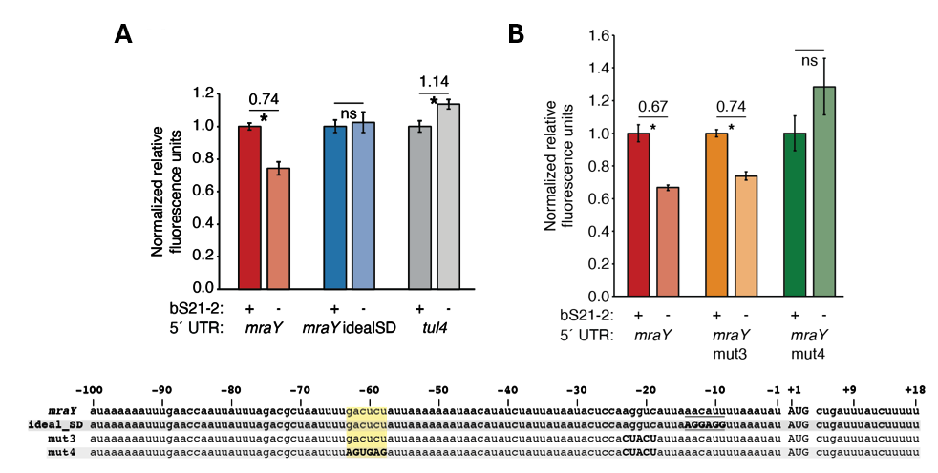
Figure 2. bS21-2-mediated translation of mraY depends on a weak Shine-Dalgarno and a specific six nucleotide sequence. Charts show relative fluorescence for indicated gfp translation fusion reporters in cells with (+; WT) or without (−; ΔrpsU2) bS21-2. (A) Introduction of an ideal SD in the mraY leader leads to loss of bS21-2 responsiveness. (B) The nucleotides between −58 and −63 in the mraY 5´ UTR, GACUCU, are essential for responsiveness to bS21-2. (A–B) Lines above bars indicate comparisons, values above line indicate ratio of reporter activity in cells lacking bS21-2 to wild-type cells. Error bars represent 1 SD. *P < 0.05 by t-test. ns = not significant. Experiments were repeated at least twice in biological triplicate, and data from a representative experiment are shown. Figure and legend are from Trautmann et al., 2023.
To find elements necessary for regulation by bS21-2, the Ramsey lab investigated the 5´ UTR of mraY. We tested the contribution of two motifs (AAAAUAAA and UUAUUUA) that are enriched in the 5´ UTR of genes regulated by bS21-2 as well as the predicted secondary structure of 5´ UTRs, but these did not contribute to regulation by bS21-2. Through further testing and modification of the mraY 5´ UTR, we identified a 6-nucleotide motif in the mraY 5´ UTR GACUCU (Fig. 2) that is necessary for regulation by bS21-2.
Taking these steps has allowed us to make significant progress in understanding how bS21-2 interacts with 5’ UTRs, but we would like to go further and address several other questions:
- Is the GACUCU motif sufficient for regulation by bS21-2?
- How does bS21-2 regulate genes lacking this motif?
- Does an ideal SD sequence always abolish regulation by bS21-2?
- Are there other sequence motifs that confer regulation?
- Can we recapitulate these results in vitro?
- Can we design a reporter construct that is sensitive and easy to use?
- Can we test for translation efficiency using an in vitro assay?
- Will changing the SD sequence to an ideal sequence in other 5’ UTRs also abolish regulation?
One way to address these questions is to develop an in vitro assay to test translation efficiency. This will allow us to expand upon our previous discoveries and go further in answering our questions.
The PURExpress® Δ Ribosome Kit is a translation assay kit from New England Biolabs that contains transcription and translation factors. This kit is reproducible, commercially available, and permits the user to translate any protein as a reporter. When you combine the kit components with a DNA template and purified ribosomes, transcription and translation of the DNA-encoded reporter will occur, resulting in a signal that can be measured to assess translation efficiency. To use this kit for our studies, we will need to clone a plasmid template and purify active ribosomes from F. tularensis.
Specific Aim #1: Develop a reporter construct for use in an in vitro translation assay that is sensitive and easy to modify.
Early results using F. tularensis ribosomes and the tul4 5’ UTR-GFP reporter didn’t give good signal. The Western Blots that were conducted using ribosome samples from in vitro assays did not indicate the presence of GFP (Fig. 3).
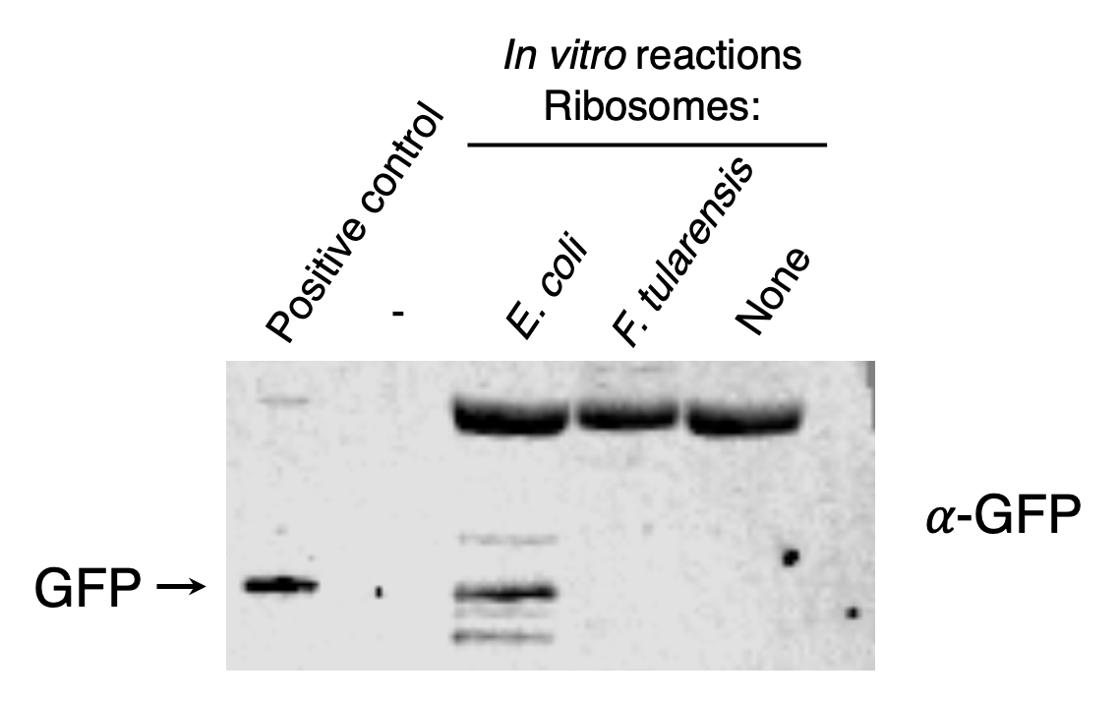
Figure 3. Ribosomes purified from F. tularensis exhibited poor activity in early in vitro assays. In vitro translation assays were performed using a DNA template specifying an mRNA with the tul4 5’ UTR fused to the GFP gene (pKR107). Reactions contained either control ribosomes from the kit (purified from E. coli) or F. tularensis LVS. No fluorescence was detected from the reaction containing F. tularensis ribosomes, so samples were analyzed by immunoblot using an antibody to GFP. The positive control lane contains cell lysate from F. tularensis expressing GFP.
I assessed multiple reporters to see which would provide the highest signal. These reporters include the fluorescent proteins GFP, LanYFP, and iLov, and the luminescent protein nLuc. I decided to choose nLuc because of its linear range (Fig. 4).
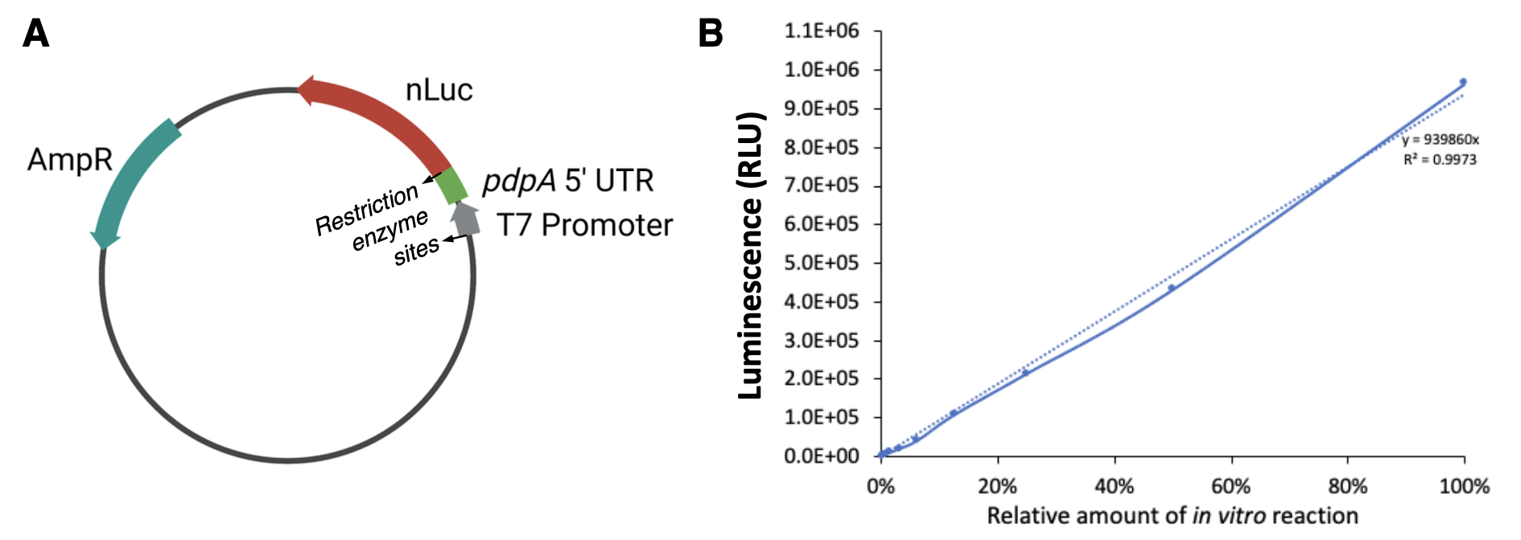
Figure 4. Generating and validating NanoLuc reporters for in vitro translation assays. A. Schematic of pKR212, a plasmid containing DNA specifying an mRNA with the pdpA 5ʹ UTR fused to the gene for the NanoLuc luciferase (nLuc). Inclusion of DNA specifying restriction enzyme sites flanking the 5ʹ UTR allows for easy exchange of leader sequences using standard cloning techniques. B. Standard curve demonstrating sensitivity and linear range of in vitro translation assays using NEB-provided ribosomes, the pKR208 reporter template, which specifies a tul4 5ʹ UTR – NanoLuc reporter fusion, and the Promega Nano-GloTM Luciferase Assay System.
I modified the existing reporter plasmid template so that I could easily switch out UTR sequences in front of the nLuc coding sequence.
Specific Aim #2: Reproducible purification of active ribosomes from E. coli and F. tularensis.
We used the sucrose cushion method to purify active ribosomes after growing E. coli cells in LB media and F. tularensis cells in BHI media. We tested reproducibility by measuring signal from the same sample on different days and signals from different purifications on the same day. We experimented with growing the cells in different kinds of media (MHB, BHI) and ran samples on sucrose gradients to see what their ribosome profiles look like and then performed dialysis to purify tight-coupled ribosomes. We averaged multiple readings for concentration and diluted the ribosomes to their working concentration before aliquoting them in small working volumes and freezing.
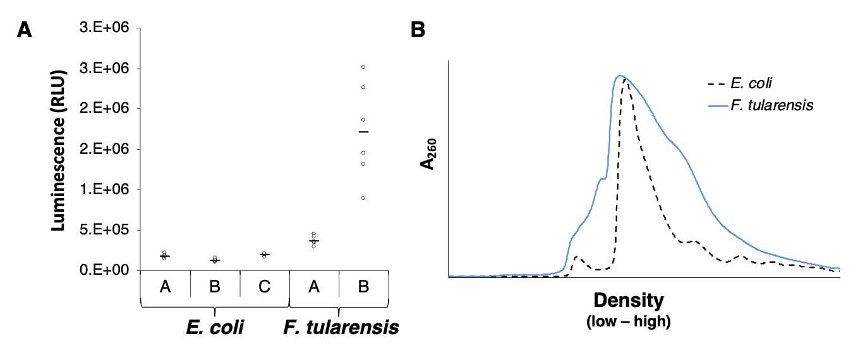
Figure 5. Comparison of ribosomes purified from E. coli and F. tularensis LVS. All ribosomes were purified using a sucrose cushion. A. Chart comparing activity of E. coli and F. tularensis ribosomes in in vitro translation assay. Letters on x-axis represent independent ribosome purifications, circles represent technical replicates, horizontal lines represent averages of technical replicates. Assays used the pKR214 reporter template, which specifies a tul4 5ʹ UTR – NanoLuc reporter fusion. B. Sucrose gradient sedimentation profiles of purified ribosomes from indicated species.
4.0 Methodology and Procedures
4.1 Bacterial Strains and Growth Conditions
The strain of Francisella tularensis used in these experiments is the live vaccine strain (LVS), which is not infectious to humans, but retains its virulence in animal models. The bacteria is cultured in brain-heart infusion (BHI) media supplemented with L-cysteine hydrochloride, β-NAD, heme-histidine, and 20% glucose or on plates with cysteine heart agar supplemented with 1% hemoglobin at 37°C. The MRE600 strain of E. coli is used for ribosome purifications cultured in LB liquid media or on plates with LB agar at 37°C. Strains with incorporated plasmids are selected for on kanamycin (kan) media at 5 µg/mL for LVS or at 50 µg/mL for E. coli.
4.2 Plasmid Design and Construction
PCR primers were designed using SnapGene (GSL Biotech LLC) and ordered from ThermoFisher. Primers were used to amplify DNA fragments to be cloned into the intended plasmid, and the resulting DNA fragments were purified by washing and eluting through a spin column (QIAquick Purification Kit). The base plasmid and PCR fragments were digested using restriction endonucleases and run on a gel. Desired products were excised and purified using the QIAquick Gel Extraction Kit. Ligations were conducted with T4 DNA ligase and the products were transformed into competent E. coli using heat shock. Resulting colonies were used to grow cultures, and the plasmid DNA was isolated using a QIAprep Spin Miniprep Kit and sequenced via Sanger sequencing at URI’s INBRE CORE Facility.
4.3 70S ribosome purification
Wild-type F. tularensis cells were grown in 500 mL sBHIc to mid-log phase (OD600 = 0.5). Cells were chilled on ice for 20 min, centrifuged at 15,316 xg for 5 min at 4°C, then washed once with buffer H10M10A50 (10 mM HEPES KOH pH 7.6, 10 mM MgCl2, and 50 mM NH4Cl), and centrifuged at 14,635 xg for 15 min at 4°C, and the resulting pellets were stored at -80°C. For ribosome purification, cell pellets were resuspended in 15 mL of H10M10A50 with 20 U DNase I. Cells were lysed by passing through a French press once at 800 lb/in2 and cell debris were removed by centrifugation at 146,000 xg for 15 min at 4°C. Supernatant was layered on top of H10M10A500 1 20% sucrose (10 mM HEPES KOH pH 7.6, 10 mM MgCl2, 500 mM NH4Cl, 20% sucrose). Ribosomes were pelleted by ultracentrifugation in a 70 Ti rotor for 4 h at 146,000 xg at 4°C. The pellet was washed twice with H10M10A50 and gently resuspended in H10M10A50. This suspension was then layered onto another sucrose cushion (H10M10A50 with 40% sucrose) and centrifuged for 14 h at 146,000 xg at 4°C to further purify the ribosomes. Purified 70S ribosomes were gently resuspended in ~100uL of H10M10A50 and stored at -80°C.
4.4 Sucrose gradient density centrifugation and fractionation
4.5 In vitro assays
PureExpress Delta Ribosome Kit Protocol
Solution A and Factor Mix from the PureExpress Delta Ribosome Kit were thawed on ice. Ribosomes from sucrose cushion purification were diluted to 2.666 pmol/uL in H10M10A50 buffer. Plasmid DNA was purified by phenol-chloroform extraction, and then diluted in 0.1xEB to a concentration of 125 ng/uL. A master mix was created with Solution A, Factor Mix, and template DNA and then ribosomes were added. After mixing gently and spinning briefly in microfuge, the reactions were incubated at 37C for 2 hours in a thermocycler. The reactions were then stopped by placing the tubes on ice. The samples were used for analysis or purification or frozen at –20°C for later use.
Nano-Glo® Luciferase Assay
Nano-Glo® Luciferase Assay Buffer and Nano-Glo® Luciferase Assay Substrate were thawed on ice and mixed by pipetting. An appropriate volume of reconstituted reagent was prepared by combining one volume of substrate with 50 volumes of buffer and mixed by pipetting. In vitro assay reactions were thawed on ice. 30 uL H10M10A50 buffer was added to a “buffer and substrate” well in a white 96-well plate, and 60 uL H10M10A50 buffer was added to a “buffer only” well. 30 uL in vitro reaction volumes were added to appropriate wells. 30 uL was added to substrate reaction wells and to the “buffer and substrate” well. After a 3-minute incubation period, the plate was read on the appropriate settings.

Formatting requirements:
15 or fewer double-spaced pages
font size no smaller than 12 point
Literature Cited
Chang, C., & Craven, G. R. (1977). Identification of several proteins involved in the messenger RNA binding site of the 30 S ribosome by inactivation with 2-methoxy-5-nitrotropone. Journal of Molecular Biology, 117(2), 401–418. https://doi.org/10.1016/0022-2836(77)90135-8
Degabriel, Manon et al. “Pathogenicity and virulence of Francisella tularensis.” Virulence vol. 14,1 (2023): 2274638. doi:10.1080/21505594.2023.2274638
Dennis D, Inglesby T, Henderson D, et al. Tularemia as a biological weapon. Journal of the American Medical Association. 2001; 285: 2763-2773.
Kaledhonkar, S., Fu, Z., Caban, K., Li, W., Chen, B., Sun, M., Gonzalez, R. L., Jr, & Frank, J. (2019). Late steps in bacterial translation initiation visualized using time-resolved cryo-EM. Nature, 570(7761), 400–404. https://doi.org/10.1038/s41586-019-1249-5
Oyston CFP, Sjöstedt A, Titball RW. Tulareamia: bioterrorism defense renews interest in Francisella tularensis. Nature Reviews Microbiology. 2004; 2:967-978.
Sjöstedt A. Tularemia: history, epidemiology, pathogen physiology, and clinical manifestations. Annals of the New York Academy of Sciences. 2007; 1105:1–29.
Trautmann, H., & Ramsey, K. (2022). A Ribosomal Protein Homolog Governs Gene Expression and Virulence in a Bacterial Pathogen. Journal of Bacteriology, 204(10), e00268-22. https://doi.org/10.1128/jb.00268-22
Trautmann, H. S., Schmidt, S. S., Gregory, S. T., & Ramsey, K. M. (2023). Ribosome heterogeneity results in leader sequence-mediated regulation of protein synthesis in Francisella tularensis. Journal of bacteriology, 205(9), e0014023. https://doi.org/10.1128/jb.00140-23
Van Duin, J., & Robert, W. (1981). The Function of Ribosomal Protein S21 in Protein Synthesis. European Journal of Biochemistry, 118(3), 615–619. https://doi.org/10.1111/j.1432-1033.1981.tb05563.x
Watson, Z. L., Ward, F. R., Méheust, R., Ad, O., Schepartz, A., Banfield, J. F., & Cate, J. H. (2020). Structure of the bacterial ribosome at 2 Å resolution. ELife, 9, e60482. https://doi.org/10.7554/eLife.60482

