THESIS PROPOSAL
BENJAMIN MOORE
A. Title of the study: Evaluating contribution of Francisella tularensis bS21 homologs to in vitro translation
C. JUSTIFICATION FOR THE STUDY
3.1 Background on Francisella tularensis and its pathogenicity
Francisella tularensis is a Gram-negative, facultative intracellular bacterium. F. tularensis causes the disease tularemia, which can be transmitted by rabbits, small rodents, or arthropods (Sjöstedt, 2007). This disease manifests at the onset with flu-like symptoms and can develop into several forms, of which the ulceroglandular form is the most common and the pneumonic form can be fatal (Degabriel et al., 2023). Because a relatively small exposure to the bacterium can cause an infection and it can be easily dispersed through the air, it has been classified as a potential bioweapon (Oyston et al., 2004). The Ramsey lab uses F. tularensis subspecies holarctica, specifically the live vaccine strain (LVS), as a model organism because it is not infectious to humans but retains its virulence in animal models. The Ramsey lab is interested in studying post-transcriptional regulation of virulence genes in F. tularensis, specifically how changes in ribosome composition impact virulence gene expression.
3.2 Significance of gene regulation and how ribosomes appear to control virulence gene expression
Key virulence genes in F. tularensis are located within the Francisella Pathogenicity Island (FPI), a region of the genome which codes for the type 6 secretion system (T6SS). The T6SS is a protein complex necessary for bacterial intracellular survival and growth within host cells. This cluster of genes is tightly regulated at the level of transcription. Specifically, transcription increases during the stringent stress response when the alarmone (p)ppGpp binds to transcription factors MglA and SspA associated with RNA polymerase and recruits another transcription factor, PigR. This increases transcription from promoters that contain short motifs called PigR response elements (PREs), including those found on the FPI (Degabriel et al., 2023). Recent work has demonstrated that expression of FPI virulence genes is further controlled by regulating translation of the mRNA into proteins by a specific ribosomal protein, bS21-2 (Trautmann & Ramsey, 2022).
3.3 What we know about bS21
Most bacteria encode one bS21 homolog or none at all. In the ribosome, bS21 is located in the small subunit near the anti-Shine Dalgarno sequence and near the channel where mRNA exits the ribosome. Its location suggests that bS21 may interact directly with the 5’ UTR of mRNA molecules during the initiation phase of translation. In fact, several studies have implicated it in translation initiation in E. coli ribosomes (van Duin & Wijnands, 1981; Chang & Craven, 1977).
3.4 Ribosome heterogeneity in F. tularensis and what we know about the impacts of bS21-2 on cell physiology
F. tularensis is unique in that it has three homologs of bS21. Bacteria are usually very thrifty and don’t keep genes that they don’t need, so there must be some significance to the fact that F. tularensis maintains three different homologs of the gene for the bS21 protein. The Ramsey lab found that F. tularensis ribosomes can incorporate any one of the three bS21 homologs and that the second homolog, bS21-2, is the most abundant when cells are grown in the laboratory (Trautmann & Ramsey, 2022). Additionally, in the absence of bS21-2, the abundance of certain proteins, including T6SS proteins, decreased yet mRNA abundance remained the same (Trautmann & Ramsey, 2022). This suggests that when bS21-2 is absent, ribosomes are not able to translate these genes as efficiently. We also found that the ability of cells to replicate within macrophage decreased when bS21-2 was absent (Trautmann & Ramsey, 2022). These data lead to the development of a model in which bS21-2 allows for more efficient translation of virulence genes.
3.5 Ramsey Lab Research on 5’ UTR Sequences
In support of a model in which bS21-2 controls translation initiation, it was found that the presence of bS21-2 can affect the translation of mRNAs with specific 5' UTR sequences and that altering the 5' UTR sequences can lead to a loss of this regulatory effect (Trautmann et al., 2023). In particular, the Ramsey lab studied these effects using an in vivo system, using a reporter assay to examine how the presence of bS21-2 altered translation of particular mRNAs in F. tularensis cells. These reporters consisted of a control promoter, tul4, driving expression of an mRNA containing the 5´ UTR of a control gene or gene of interest fused to GFP. Translation efficiency for each mRNA was measured by how much of the reporter protein was produced. The 5' UTRs tested in this reporter assay were selected from a proteomics analysis in which the absence of bS21-2 led to a downregulation in protein production of the selected genes (Trautmann & Ramsey, 2022). These genes included the FPI genes pdpA and iglA. When bS21-2 was absent, reporter output decreased for the selected genes but did not decrease for tul4 (Figure 1; Trautmann & Ramsey, 2022). Since changes in reporter output correlate with the amount of protein in cells with and without bS21-2, these data indicate that the 5´ UTR is sufficient to influence translation in vivo. Additionally, because 5´ UTRs are generally important for initiation, these results strongly suggest that bS21-2 is regulating translation during initiation.
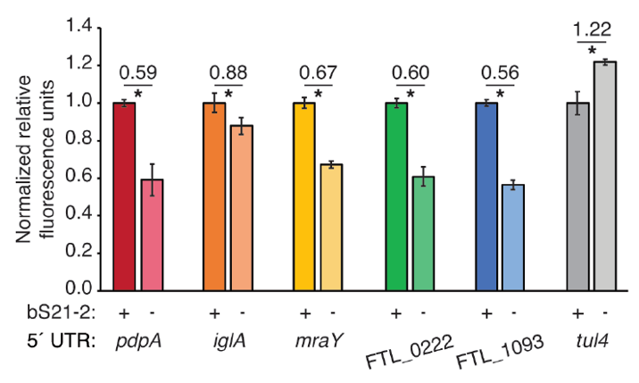
FIG 1 5´ UTRs are sufficient to lead to bS21-2-mediated changes in translation. Relative fluorescence for indicated GFP translational fusion reporters in cells with (+; WT) or without (−; ΔrpsU2) bS21-2. The tul4 5´ UTR serves as a control.
After determining that the 5´ UTR is sufficient to allow bS21-2-mediated changes in translation, the Ramsey lab further investigated 5´ UTR sequences to identify specific elements which lead to regulation. In most bacterial 5´ UTRs, a particular motif called the Shine-Dalgarno (SD) pairs with an anti-Shine-Dalgarno (aSD) sequence in the 16S rRNA of the 30S ribosomal subunit. This pairing is not strictly necessary for translation initiation but increases the efficiency of translation initiation. Structures of E. coli ribosomes reveal that bS21 likely directly contacts the aSD sequence (Kaledhonkar et al., 2019), implicating the SD-aSD pairing as a potential candidate for regulation by bS21-2 in F. tularensis. Upon testing translation efficiency of mRNAs with different SD sequences, the Ramsey lab found that 5´ UTRs with ideal SDs lost responsiveness to bS21-2 (Figure 2A, Trautmann et al., 2023), suggesting that bS21-2 interacts with the 5ˊ UTR in certain ways, but that the presence of a perfect SD can override these effects so that they are not as noticeable. In other genes, however, imperfect SD sequences do not automatically lead to regulation, so the search for other regulatory elements continued.
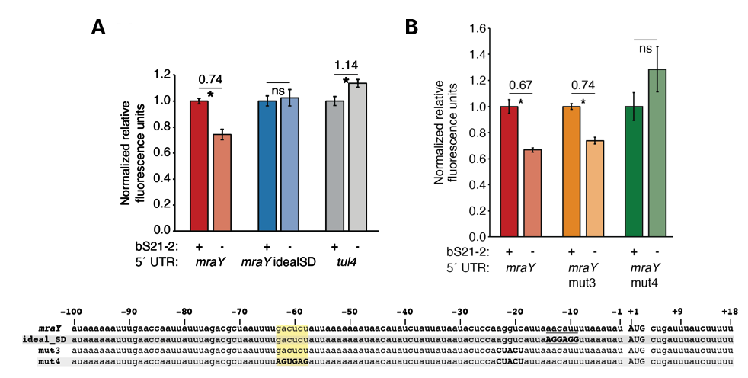
FIG 2 bS21-2-mediated translation of mraY depends on a weak Shine-Dalgarno and a specific six nucleotide sequence. Charts show relative fluorescence for indicated gfp translation fusion reporters in cells with (+; WT) or without (−; ΔrpsU2) bS21-2. (A) Introduction of an ideal SD in the mraY leader leads to loss of bS21-2 responsiveness. (B) The nucleotides between −58 and −63 in the mraY 5´ UTR, GACUCU, are essential for responsiveness to bS21-2. (A–B) Lines above bars indicate comparisons, values above line indicate ratio of reporter activity in cells lacking bS21-2 to wild-type cells. Error bars represent 1 SD. *P < 0.05 by t-test. ns = not significant. Experiments were repeated at least twice in biological triplicate, and data from a representative experiment are shown.
To find elements necessary for regulation by bS21-2, the Ramsey lab investigated the 5´ UTR of mraY. We tested two motifs (AAAAUAAA and UUAUUUA) that appeared on a search as being enriched in genes regulated by bS21-2 as well as modifications to secondary structure, but these did not contribute to regulation. Through further testing and modification of the mraY 5´ UTR , we narrowed our search for regulatory elements down to a 6-nucleotide motif GACUCU (Fig. 2) that was necessary to confer regulation by bS21-2.
- Roadmap:
-Description of how great this is, but how much is left to be figured out
Specific Aim #1: Developing a robust in vitro assay to examine bS21-mediated regulation of F. tularensis translation (with a brief description of how).
Specific Aim #2: Examining how ribosomes with altered bS21 content influence translation (with a brief description of how).
Formatting requirements:
15 or fewer double-spaced pages
font size no smaller than 12 point
Literature Cited
Chang, C., & Craven, G. R. (1977). Identification of several proteins involved in the messenger RNA binding site of the 30 S ribosome by inactivation with 2-methoxy-5-nitrotropone. Journal of Molecular Biology, 117(2), 401–418. https://doi.org/10.1016/0022-2836(77)90135-8
Degabriel, Manon et al. “Pathogenicity and virulence of Francisella tularensis.” Virulence vol. 14,1 (2023): 2274638. doi:10.1080/21505594.2023.2274638
Dennis D, Inglesby T, Henderson D, et al. Tularemia as a biological weapon. Journal of the American Medical Association. 2001; 285: 2763-2773.
Kaledhonkar, S., Fu, Z., Caban, K., Li, W., Chen, B., Sun, M., Gonzalez, R. L., Jr, & Frank, J. (2019). Late steps in bacterial translation initiation visualized using time-resolved cryo-EM. Nature, 570(7761), 400–404. https://doi.org/10.1038/s41586-019-1249-5
Oyston CFP, Sjöstedt A, Titball RW. Tulareamia: bioterrorism defense renews interest in Francisella tularensis. Nature Reviews Microbiology. 2004; 2:967-978.
Sjöstedt A. Tularemia: history, epidemiology, pathogen physiology, and clinical manifestations. Annals of the New York Academy of Sciences. 2007; 1105:1–29.
Trautmann, H., & Ramsey, K. (2022). A Ribosomal Protein Homolog Governs Gene Expression and Virulence in a Bacterial Pathogen. Journal of Bacteriology, 204(10), e00268-22. https://doi.org/10.1128/jb.00268-22
Trautmann, H. S., Schmidt, S. S., Gregory, S. T., & Ramsey, K. M. (2023). Ribosome heterogeneity results in leader sequence-mediated regulation of protein synthesis in Francisella tularensis. Journal of bacteriology, 205(9), e0014023. https://doi.org/10.1128/jb.00140-23
Van Duin, J., & Robert, W. (1981). The Function of Ribosomal Protein S21 in Protein Synthesis. European Journal of Biochemistry, 118(3), 615–619. https://doi.org/10.1111/j.1432-1033.1981.tb05563.x
Watson, Z. L., Ward, F. R., Méheust, R., Ad, O., Schepartz, A., Banfield, J. F., & Cate, J. H. (2020). Structure of the bacterial ribosome at 2 Å resolution. ELife, 9, e60482. https://doi.org/10.7554/eLife.60482

