Evaluating Francisella tularensis translation in vitro

Benjamin Moore
Advisor: Kathryn M. Ramsey
Thesis Proposal
17 July, 2024
A. STATEMENT OF THE PROBLEM
Francisella tularensis is a Gram-negative, facultative, intracellular bacterium which causes the disease tularemia. Previous research has elucidated… To study regulation of translation by ribosomes in Francisella tularensis, we will use an in vitro system. We aim to develop a reporter construct for use in an in vitro translation assay that is sensitive and easy to modify and to reproducibly purify active ribosomes from F. tularensis for use in this assay.
B. JUSTIFICATION FOR THE STUDY
Francisella tularensis is a Gram-negative, facultative, intracellular bacterium. F. tularensis causes the disease tularemia, which can be transmitted by rabbits, small rodents, or arthropods (Sjöstedt, 2007). This disease manifests at the onset with flu-like symptoms and can develop into several forms, of which the ulceroglandular form is the most common and the pneumonic form can be fatal (Degabriel et al., 2023). Because a relatively small exposure to the bacterium can cause an infection and it can be easily dispersed through the air, it has been classified as a potential bioweapon (Oyston et al., 2004). The Ramsey lab uses F. tularensis subspecies holarctica, specifically the live vaccine strain (LVS), as a model organism, because it is not infectious to humans but retains its virulence in animal models. The Ramsey lab is studies post-transcriptional regulation of virulence genes in F. tularensis, specifically how changes in ribosome composition impact virulence gene expression.
Key virulence genes in F. tularensis are located within the Francisella Pathogenicity Island (FPI), a region of the genome which codes for the type 6 secretion system (T6SS). The T6SS is a protein complex necessary for bacterial intracellular survival and growth within host cells. This cluster of genes is tightly regulated at the level of transcription. Specifically, transcription increases during the stringent stress response when the alarmone (p)ppGpp binds to transcription factors MglA and SspA associated with RNA polymerase and recruits another transcription factor, PigR. This increases transcription from promoters that contain short motifs called PigR response elements (PREs), including those found on the FPI (Degabriel et al., 2023). Recent work has demonstrated that expression of FPI virulence genes is further controlled by regulating translation of the mRNA into proteins by a specific ribosomal protein, bS21-2 (Trautmann & Ramsey, 2022).
Most bacteria encode one bS21 homolog or none at all. In the ribosome, bS21 is located in the small subunit near the anti-Shine Dalgarno sequence and the channel where mRNA exits the ribosome. Its location suggests that bS21 may interact directly with the 5’ untranslated region (5’ UTR) of mRNA molecules during the initiation phase of translation. In fact, several studies have implicated bS21 in translation initiation in E. coli ribosomes (van Duin & Wijnands, 1981; Chang & Craven, 1977).
F. tularensis is unusual in that it has three homologs of bS21. The Ramsey lab found that F. tularensis ribosomes can incorporate any one of the three bS21 homologs and that the second homolog, bS21-2, is the most abundant when cells are grown in the laboratory (Trautmann & Ramsey, 2022). Additionally, in the absence of bS21-2, the abundance of certain proteins, including T6SS proteins, decreased, yet mRNA abundance remained the same (Trautmann & Ramsey, 2022). This suggests that, when bS21-2 is absent, ribosomes are not able to translate these genes as efficiently. We also found that the ability of cells to replicate within macrophage decreased when bS21-2 was absent (Trautmann & Ramsey, 2022). These data lead to the development of a model in which bS21-2 allows for more efficient translation of virulence genes.
In support of a model in which bS21-2 controls translation initiation, it was found that the presence of bS21-2 can affect the translation of mRNAs with specific 5' UTR sequences and that altering the 5' UTR sequences can lead to a loss of this regulatory effect (Trautmann et al., 2023). In particular, the Ramsey lab studied these effects using an in vivo system, using a reporter assay to examine how the presence of bS21-2 altered translation of particular mRNAs in F. tularensis cells. These reporters consisted of a control promoter, tul4, driving expression of an mRNA containing the 5´ UTR of a control gene or gene of interest fused to green fluorescent protein (GFP). Translation efficiency for each mRNA was measured by how much of the reporter protein was produced. The 5' UTRs tested in this reporter assay were selected from a proteomics analysis in which the absence of bS21-2 led to a downregulation in protein production of the selected genes (Trautmann & Ramsey, 2022). These genes included the FPI genes pdpA and iglA. When bS21-2 was absent, reporter output decreased for the selected genes but did not decrease for tul4 (Figure 1; Trautmann & Ramsey, 2022). Since changes in reporter output correlate with the amount of protein in cells with and without bS21-2, these data indicate that the 5´ UTR is sufficient to influence translation in vivo. Additionally, because 5´ UTRs are generally important for initiation, these results strongly suggest that bS21-2 is regulating translation during initiation.
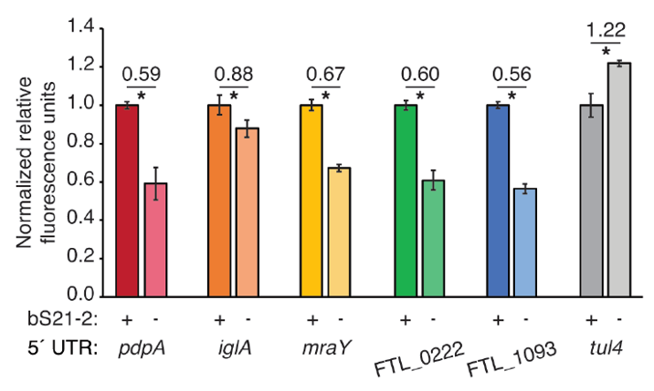
Figure 1. 5´ UTRs are sufficient to lead to bS21-2-mediated changes in translation. Relative fluorescence for indicated GFP translational fusion reporters in cells with (+; WT) or without (−; ΔrpsU2) bS21-2. The tul4 5´ UTR serves as a control. Figure and legend are from Trautmann et al., 2023.
After determining that the 5´ UTR is sufficient to allow bS21-2-mediated changes in translation, the Ramsey lab further investigated 5´ UTR sequences to identify specific elements which lead to regulation. In most bacterial 5´ UTRs, a particular sequence called the Shine-Dalgarno (SD) pairs with an anti-Shine-Dalgarno (aSD) sequence in the 16S rRNA of the 30S ribosomal subunit. This pairing is not strictly necessary for translation initiation but increases its efficiency. Structures of E. coli ribosomes reveal that bS21 likely directly contacts the aSD sequence (Kaledhonkar et al., 2019), implicating the SD-aSD pairing as a potential candidate for regulation by bS21-2 in F. tularensis. Upon testing translation efficiency of mRNAs with different SD sequences, the Ramsey lab found that 5´ UTRs with ideal SDs lost responsiveness to bS21-2 (Figure 2A, Trautmann et al., 2023), suggesting that bS21-2 interacts with the 5ˊ UTR in certain ways, but that the presence of a perfect SD can override these effects so that they are not as significant. In other genes, however, imperfect SD sequences do not automatically lead to regulation, so the search for other regulatory elements continues.
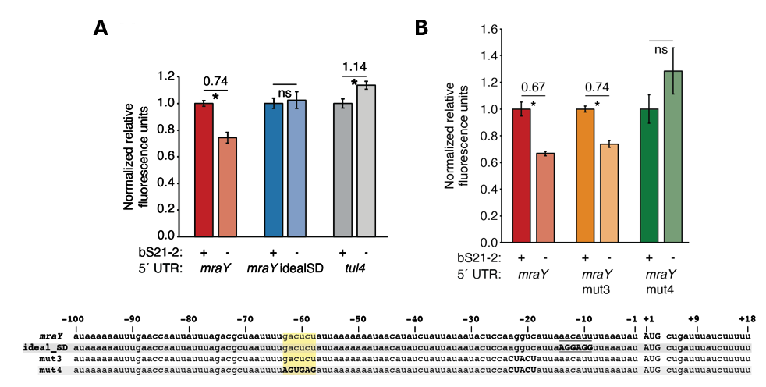
Figure 2. bS21-2-mediated translation of mraY depends on a weak Shine-Dalgarno and a specific six nucleotide sequence. Charts show relative fluorescence for indicated gfp translation fusion reporters in cells with (+; WT) or without (−; ΔrpsU2) bS21-2. (A) Introduction of an ideal SD in the mraY leader leads to loss of bS21-2 responsiveness. (B) The nucleotides between −58 and −63 in the mraY 5´ UTR, GACUCU, are essential for responsiveness to bS21-2. (A–B) Lines above bars indicate comparisons, values above line indicate ratio of reporter activity in cells lacking bS21-2 to wild-type cells. Error bars represent 1 SD. *P < 0.05 by t-test. ns = not significant. Experiments were repeated at least twice in biological triplicate, and data from a representative experiment are shown. Figure and legend are from Trautmann et al., 2023.
To find elements necessary for regulation by bS21-2, the Ramsey lab investigated the 5´ UTR of mraY. We tested the contribution of two motifs (AAAAUAAA and UUAUUUA) that are enriched in the 5´ UTR of genes regulated by bS21-2 as well as the predicted secondary structure of 5´ UTRs, but these did not contribute to regulation by bS21-2. Through further testing and modification of the mraY 5´ UTR, we identified a 6-nucleotide motif in the mraY 5´ UTR GACUCU (Figure 2B, Trautmann et al., 2023) that is necessary for regulation by bS21-2.
These studies have allowed us to make significant progress in understanding how bS21-2 controls translation of mRNAs with specific 5’ UTRs, but we would like to go further and address several other questions. In particular, we would like to determine if these results can be recapitulated in vitro. Once a working in vitro system has been established, we can also test whether the GACUCU motif is sufficient for regulation by bS21-2 and whether there are other sequence motifs that confer regulation. By developing an in vitro assay that allows us to examine translation efficiency, we can build upon previous experimental data and develop a more comprehensive model of regulation by bS21-2.
The goal of my thesis project is to develop an in vitro translation assay for F. tularensis. In developing this assay, I will use the PURExpress® Δ Ribosome Kit from New England Biolabs which contains all the factors necessary for transcription and translation except ribosomes and permits the user to translate any protein as a reporter. When the kit components are combined with a DNA template and purified ribosomes, transcription and translation of a DNA-encoded reporter will occur, resulting in a signal that can be measured to assess translation efficiency. To use this kit for our studies, we will need to clone a plasmid template and purify active ribosomes from F. tularensis.
Preliminary work towards developing an in vitro translation assay performed by a previous graduate student used F. tularensis ribosomes and the tul4 5’ UTR – GFP reporter. While the reaction with E. coli ribosomes (provided by the kit) yielded signal in the assay, showing the reaction was properly set up, the ribosomes purified from F. tularensis did not translate detectable amounts of product (Figure 3). These results suggested to us that we should try to find a more sensitive reporter and that we should ensure that the ribosomes we are purifying are sufficiently active.
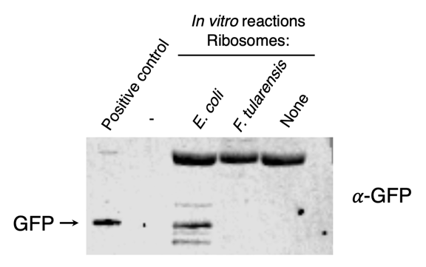
Figure 3. Ribosomes purified from F. tularensis exhibited poor activity in initial in vitro assays. In vitro translation assays were performed using a DNA template specifying an mRNA with the tul4 5’ UTR fused to the GFP gene (pKR107). Reactions contained either control ribosome from the kit (from E. coli), ribosomes purified from F. tularensis LVS, or no ribosomes (as indicated at the top of the image). No fluorescence was detected from the reaction containing F. tularensis ribosomes, so samples were analyzed by immunoblot using an antibody to GFP. The positive control lane contains cell lysate from F. tularensis expressing GFP.
C. AIMS
Specific Aim #1: Develop a reporter construct for use in an in vitro translation assay that is sensitive and easy to modify.
To address my first aim, I have assessed multiple reporters to see which provides the highest signal. These reporters include the fluorescent proteins GFP, LanYFP, and iLov, and the luciferase protein nLuc. To do this, I cloned the genes encoding these reporters into an existing plasmid that allowed for transcription by the in vitro translation kit. After measuring translation efficiency using these reporter constructs, I chose nLuc because of its broad dynamic range and high signal strength in comparison to the other reporters (Figure 4).
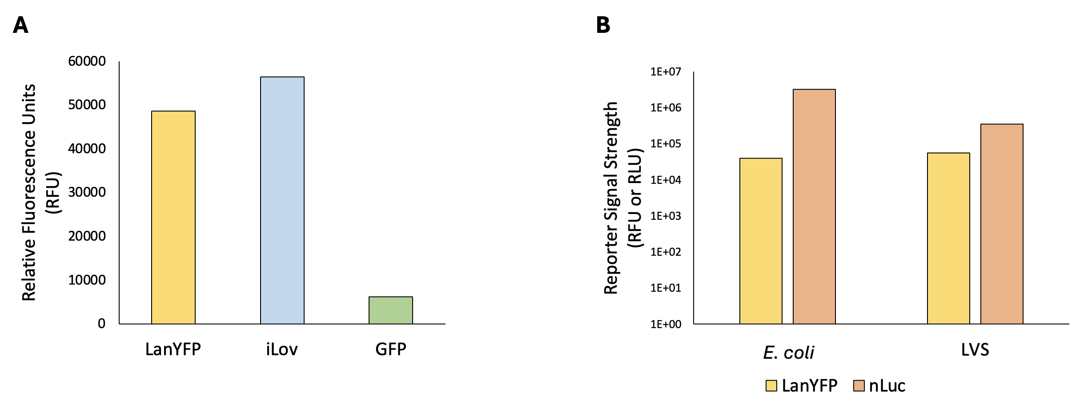
Figure 4. Comparison of reporters demonstrates that nLuc is the most sensitive reporter tested. (A) Comparison of signal from fluorescent reporters detected in cells. Chart shows relative fluorescence for indicated translation fusion reporters (LanYFP, iLov, and GFP). (B) Comparison of LanYFP fluorescence and nLuc luminescence. Reporter signal strength is displayed in relative fluorescence units or relative luminescence units for indicated translation fusion reporters (LanYFP and nLuc) produced from in vitro assays using E. coli or LVS ribosomes respectively (note log scale). In vitro translation assays were performed using the pKR204 reporter template, which specifies a pdpA 5’ UTR – nLuc reporter fusion and a tul4 5’ UTR – LanYFP reporter fusion.
To easily switch out UTR sequences in front of the nLuc coding sequence using standard cloning techniques, I modified an existing plasmid containing nLuc fused to the 5’ UTR for pdpA. This has provided us with a reporter construct that is sensitive and easy to modify for use in our in vitro translation assay.
Specific Aim #2: Reproducibly purify active ribosomes from E. coli and F. tularensis.
To isolate active ribosomes, I have been using the sucrose cushion purification method. I first harvested ribosomes from E. coli cells grown in LB media and was able to achieve a yield of 1.5-5 nmol or a concentration of 10-30 pmol/µL, which was substantially higher than the 2.7 pmol/µL concentration required for the in vitro translation kit. Next, I demonstrated that the E. coli ribosomes were active using the in vitro assay and replicated these results using ribosomes from multiple purification attempts, showing that purification of E. coli ribosomes using the sucrose cushion method is reproducible (Figure 5).
Figure 5. Relative luminescence values for nLuc after translation by purified E. coli ribosomes. nLuc reporter (T7 promoter fused to nLuc and pdpA 5’ UTR) signal strength for multiple ribosome purifications tested on multiple days shows robust and consistent luminescence signal, demonstrating activity and reproducibility of E. coli ribosomes purified using the sucrose cushion method.
After validating the sucrose cushion method using E. coli ribosomes, I purified ribosomes harvested from F. tularensis LVS cells grown in brain-heart infusion (BHI) media. I tested reproducibility by measuring nLuc luminescence signal from the same sample of sucrose cushion purified ribosomes on different days and signals from different sucrose cushion purifications on the same day. I also ran purified ribosome samples on sucrose gradients to assess subunit composition and tested the effects of dialysis to purify 70S ribosomes free of mRNA and translation factors.
Attempts to standardize experiments were helpful in reducing variability, and while sucrose gradients showed that there marked 70S peaks in LVS ribosome samples, there were also 100S peaks that were not present in E. coli ribosome samples (Figure 6). We hypothesize that 70S ribosome subunits are aggregating and forming 100S dimers, complexes of two 70S ribosomes that may have accumulated hibernation factors and undergone conformational changes. These complexes are usually accompanied by downregulation of translation (Matzov et al., 2017). Since we are isolating both 70S and 100S ribosome particles together, there is a subset of purified ribosomes within each sample that are inactive. My current experiments focus on isolating homogenous 70S ribosomes to further ensure consistency between in vitro assays. This will provide us with active ribosomes from F. tularensis for use in our in vitro translation assay.
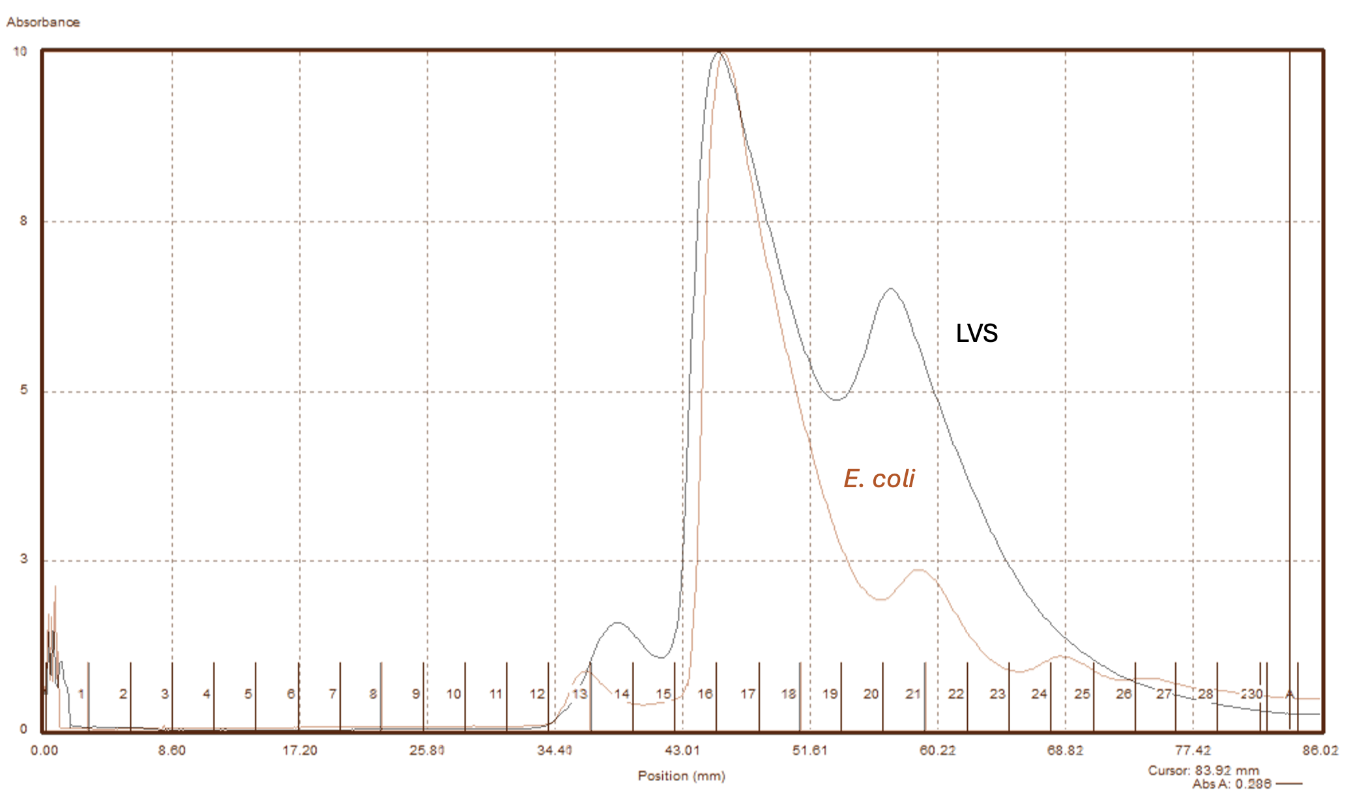
Figure 6. Sucrose gradient sedimentation profiles of purified ribosomes from indicated species. F. tularensis gradient exhibits a 70S peak along with a strong 100S peak that is less pronounced in the E. coli gradient.
D. METHODOLOGY AND PROCEDURES
Bacterial strains and growth conditions.
The strain of Francisella tularensis used in these experiments is Francisella tularensis subsp. holarctica live vaccine strain (LVS), which is not infectious to humans, but retains its virulence in animal models. Bacteria are cultured in brain-heart infusion (BHI) media supplemented with L-cysteine hydrochloride, β-NAD, heme-histidine, and 20% glucose (sBHIc) or on plates with cysteine-heart agar supplemented with 1% hemoglobin at 37°C. The MRE600 strain of E. coli used for ribosome purifications is cultured in LB liquid media or on plates with LB agar at 37°C. Strains with incorporated plasmids are selected for on kanamycin media at 5 µg/mL for LVS or at 50 µg/mL for E. coli.
Plasmid design and construction.
PCR primers were designed using SnapGene (GSL Biotech LLC) and ordered from ThermoFisher. Primers were used to amplify DNA fragments to be cloned into the intended plasmid, and the resulting DNA fragments were purified by washing and eluting through a spin column (QIAquick Purification Kit). The plasmid backbone and PCR fragments were digested using restriction endonucleases and run on a gel. Desired products were excised and purified using the QIAquick Gel Extraction Kit. Ligations were conducted with T4 DNA ligase and the products were transformed into competent E. coli cells using heat shock. Resulting colonies were used to grow cultures, and the plasmid DNA was isolated using a QIAprep Spin Miniprep Kit and sequenced via Sanger sequencing at URI’s INBRE CORE Facility.
70S ribosome purification.
For E. coli, MRE600 cells were grown in 500 mL LB media to mid-log phase (OD600 = 0.6-0.8), and for F. tularensis, wild-type LVS cells were grown in 500 mL sBHIc media to mid-log phase (OD600 = 0.5). Cells were chilled on ice for 20 min, centrifuged at 15,316 xg for 5 min at 4°C, then washed once with buffer H¹⁰M¹⁰A⁵⁰ (10 mM HEPES KOH pH 7.6, 10 mM MgCl₂, and 50 mM NH₄Cl), and centrifuged at 14,635 xg for 15 min at 4°C, and the resulting pellets were stored at -80°C. For ribosome purification, cell pellets were resuspended in 15 mL of H¹⁰M¹⁰A⁵⁰ with 20 U DNase I. Cells were either lysed by passing through a French press once at 800 lb/in² or by using 10x Bug Buster detergent and incubating at 37°C for 1 h. Cell debris were removed by centrifugation at 146,000 xg for 15 min at 4°C. Supernatant was layered on top of H¹⁰M¹⁰A⁵⁰⁰ + 20% sucrose (10 mM HEPES KOH pH 7.6, 10 mM MgCl₂, 500 mM NH₄Cl, 20% sucrose) and ribosomes were pelleted by ultracentrifugation in a 50.2 Ti rotor for 4 h at 146,000 xg at 4°C. The pellet was washed twice with H¹⁰M¹⁰A⁵⁰ and gently resuspended in H¹⁰M¹⁰A⁵⁰. This suspension was then layered onto another sucrose cushion (H¹⁰M¹⁰A⁵⁰ with 40% sucrose) and centrifuged for 14 h at 146,000 xg at 4°C to further purify the ribosomes. Purified ribosomes were gently resuspended in ~100 µL of H¹⁰M¹⁰A⁵⁰ and stored at -80°C.
Sucrose gradient sedimentation.
A light solution of H¹⁰M¹⁰A⁵⁰ buffer + 10% sucrose was layered on top of a heavy solution of H¹⁰M¹⁰A⁵⁰ buffer + 50% sucrose in polycarbonate gradient tubes, and the gradients were mixed in a BioComp Instruments 153 Gradient Station (BioComp). After refrigeration for 45 min the gradients were balanced, and 200 µL of sample was layered on top. The tubes were centrifuged in a Beckman-Coulter SW40 Ti rotor for 40,000 rpm for 4 h at 4°C and gradient fractions were collected using a Triax flow cell set to 260 nm. Thirty fractions were collected per run and stored at -80°C.
In vitro assays.
PureExpress ∆ Ribosome Kit Protocol
Solution A and Factor Mix from the PureExpress ∆ Ribosome Kit were thawed on ice. Ribosomes from sucrose cushion purification were diluted to 2.67 pmol/µL in H¹⁰M¹⁰A⁵⁰ buffer. Plasmid DNA was purified by phenol-chloroform extraction, and then diluted in 0.1xEB to a concentration of 125 ng/µL. Each reaction contained 10 µL Solution A, 3 µL Factor Mix, and 2 µL template DNA and 15 µL ribosomes. After mixing gently and spinning briefly in a microfuge, the reactions were incubated at 37°C for 2 h in a thermocycler. The reactions were stopped by placing the tubes on ice, and the samples were used for analysis or frozen at –20°C for later use.
Nano-Glo® Luciferase Assay
Nano-Glo® Luciferase Assay Buffer and Nano-Glo® Luciferase Assay Substrate were thawed on ice and mixed by pipetting. An appropriate volume of reconstituted reagent was prepared by combining one volume of substrate with 50 volumes of buffer and mixed by pipetting. In vitro assay reactions were thawed on ice. Next, 30 µL H¹⁰M¹⁰A⁵⁰ buffer was added to a “buffer and substrate” well in a white 96-well plate, and 60 µL H¹⁰M¹⁰A⁵⁰ buffer was added to a “buffer only” well. Then, 30 µL reaction volumes were added to appropriate wells. Finally, 30 µL of reconstituted reagent was added to the substrate reaction wells and to the “buffer and substrate” well. After a 3 min incubation period, the plate was read on the appropriate settings.
- RESOURCES REQUIRED
Resources required for the completion of this project will come from the laboratory of Dr. Kathryn Ramsey. Sequencing services will be provided by the URI Genomic Sequencing Center.
Literature Cited
Chang, C., & Craven, G. R. (1977). Identification of several proteins involved in the messenger RNA binding site of the 30 S ribosome by inactivation with 2-methoxy-5-nitrotropone. Journal of Molecular Biology, 117(2), 401–418. https://doi.org/10.1016/0022-2836(77)90135-8
Degabriel, Manon et al. “Pathogenicity and virulence of Francisella tularensis.” Virulence vol. 14,1 (2023): 2274638. doi:10.1080/21505594.2023.2274638
Dennis D, Inglesby T, Henderson D, et al. Tularemia as a biological weapon. Journal of the American Medical Association. 2001; 285: 2763-2773.
Kaledhonkar, S., Fu, Z., Caban, K., Li, W., Chen, B., Sun, M., Gonzalez, R. L., Jr, & Frank, J. (2019). Late steps in bacterial translation initiation visualized using time-resolved cryo-EM. Nature, 570(7761), 400–404. https://doi.org/10.1038/s41586-019-1249-5
Matzov, D., Aibara, S., Basu, A. et al. The cryo-EM structure of hibernating 100S ribosome dimer from pathogenic Staphylococcus aureus . Nat Commun 8, 723 (2017). https://doi.org/10.1038/s41467-017-00753-8
Oyston CFP, Sjöstedt A, Titball RW. Tulareamia: bioterrorism defense renews interest in Francisella tularensis. Nature Reviews Microbiology. 2004; 2:967-978.
Sjöstedt A. Tularemia: history, epidemiology, pathogen physiology, and clinical manifestations. Annals of the New York Academy of Sciences. 2007; 1105:1–29.
Trautmann, H., & Ramsey, K. (2022). A Ribosomal Protein Homolog Governs Gene Expression and Virulence in a Bacterial Pathogen. Journal of Bacteriology, 204(10), e00268-22. https://doi.org/10.1128/jb.00268-22
Trautmann, H. S., Schmidt, S. S., Gregory, S. T., & Ramsey, K. M. (2023). Ribosome heterogeneity results in leader sequence-mediated regulation of protein synthesis in Francisella tularensis. Journal of bacteriology, 205(9), e0014023. https://doi.org/10.1128/jb.00140-23
Van Duin, J., & Robert, W. (1981). The Function of Ribosomal Protein S21 in Protein Synthesis. European Journal of Biochemistry, 118(3), 615–619. https://doi.org/10.1111/j.1432-1033.1981.tb05563.x
Watson, Z. L., Ward, F. R., Méheust, R., Ad, O., Schepartz, A., Banfield, J. F., & Cate, J. H. (2020). Structure of the bacterial ribosome at 2 Å resolution. ELife, 9, e60482. https://doi.org/10.7554/eLife.60482

