THESIS PROPOSAL
BENJAMIN MOORE
TITLE: Evaluating contribution of Francisella tularensis bS21 homologs to in vitro translation
STATEMENT OF THE PROBLEM
- Introduce Francisella tularensis and bS21.
- Introduce regulation of translation by interaction of bS21 with 5’ UTRs.
- Francisella tularensis has three homologs of this ribosomal protein which appears to have regulatory effects on other proteins.
- Previous work was performed in vivo, and we don’t know if these effects can be recapitulated in vitro.
- Understanding the role of bS21 in translation would help us better understand pathogenicity, ribosomes, gene regulation, and antibiotics.
OVERALL GOAL
Investigate how ribosomes containing different homologs of bS21 influence translation of various genes using an in vitro assay, building on Hannah’s work.
AIMS
Specific Aim #1: . Developing a robust in vitro assay to examine bS21-mediated regulation of F. tularensis translation (with a brief description of how).
Specific Aim #2: Examining how ribosomes with altered bS21 content influence translation (with a brief description of how).
JUSTIFICATION FOR THE STUDY
Keep to about the length Jamie had in her proposal- so only about 5 pages double spaced! And you should include figures.
- Background on Francisella tularensis and its pathogenicity.
- Significance of gene regulation and how this takes place in the ribosome.
- What we know about bS21 and the three homologs found in Francisella.
- Regulation of 5’ UTRs.
- How is this happening? Introduce Hannah’s research on 5’ UTR sequences.
- Discuss Hannah’s in vivo work (assay, genes studied, plasmids, methods for ribosome purifications, and challenges addressed).
- Explain data for pdpA and mraY.
- Introduce in vitro assay and potential for understanding regulation of translation in a highly controlled manner.
- Expand on broader implications for pathogenicity, ribosomes, gene regulation, and antibiotics.
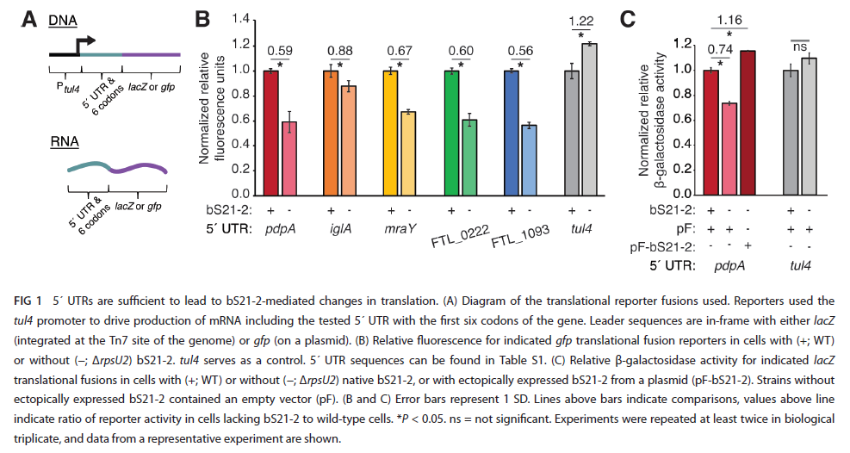
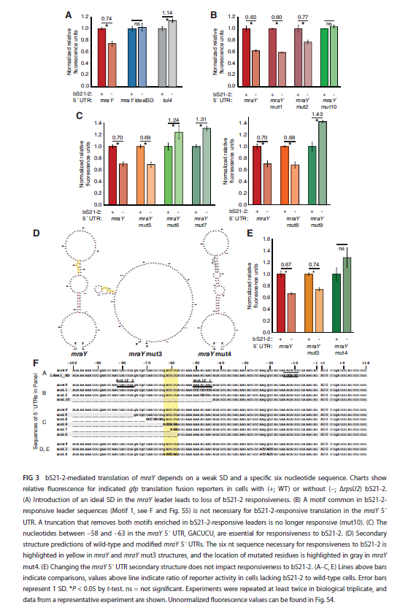
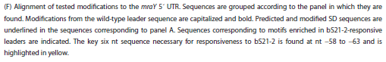
METHODOLOGY AND PROCEDURES
- Bacterial growth conditions
- Plasmid design and construction
- Ribosome purifications
- In vitro assay
- …
- …
RESOURCES REQUIRED
Resources required for the completion of this project will come from the laboratory of Dr. Kathryn Ramsey. Sequencing services will be provided by the URI Genomic Sequencing Center.

