THESIS PROPOSAL
BENJAMIN MOORE
TITLE: Evaluating contribution of Francisella tularensis bS21 homologs to in vitro translation
STATEMENT OF THE PROBLEM
- Introduce Francisella tularensis and bS21.
- Introduce regulation of translation by interaction of bS21 with 5’ UTRs.
- Francisella tularensis has three homologs of this ribosomal protein which appears to have regulatory effects on other proteins.
- Previous work was performed in vivo, and we don’t know if these effects can be recapitulated in vitro.
- Understanding the role of bS21 in translation would help us better understand pathogenicity, ribosomes, gene regulation, and antibiotics.
OVERALL GOAL
Investigate how ribosomes containing different homologs of bS21 influence translation of various genes using an in vitro assay, building on Hannah’s work.
AIMS
Specific Aim #1: Developing a robust in vitro assay to examine bS21-mediated regulation of F. tularensis translation (with a brief description of how).
Specific Aim #2: Examining how ribosomes with altered bS21 content influence translation (with a brief description of how).
JUSTIFICATION FOR THE STUDY
Keep to about the length Jamie had in her proposal- so only about 5 pages double spaced! And you should include figures.
- Background on Francisella tularensis and its pathogenicity. Francisella is a bacterium that is found in freshwater and is hosted by a number of species of small animals and insects. It is highly pathogenic, with only ten cells constituting an infectious dose, and has been developed as a bioweapon. We study the mechanisms of gene regulation in Francisella that take place during translation, specifically regulation by a ribosomal protein, bS21.
- Significance of gene regulation and how this takes place in the ribosome. The transfer of information from DNA to RNA to protein can be regulated at many points along this pathway. The point that we focus on is the regulation of translation by ribosomal protein, bS21.
- What we know about bS21 and the three homologs found in Francisella. bS21 is present in many or most bacteria and plays roles in gene regulation, virulence, and the stress response. It is also encoded by phage. The unique thing about Francisella is that it codes for three different homologs of bS21. Most bacteria only encode for one homolog. Since bacteria are thrifty, and only keep genetic information that will be useful to the cell, there must be a reason why Francisella encodes for three different homologs of this protein. Hannah found that the second homolog, bS21-2, is the most abundant in the cell. She also found that it played key roles in the regulation of virulence genes found in the Francisella Pathogenicity Island.
- Regulation of 5’ UTRs. bS21-2 plays a role, specifically, in the regulation of 5’ UTRs of these genes, because it is located next to the channel where mRNA exits the ribosome.
- How is this happening? Introduce Hannah’s research on 5’ UTR sequences. Hannah discovered that when bS21-2 was absent, translation levels of some of these key genes decreased.
- Discuss Hannah’s in vivo work (assay, genes studied, plasmids, methods for ribosome purifications, and challenges addressed). lacZ and GFP in vivo assays, studied pdpA/mraY/tul4/various FTL genes, pF plasmids, sucrose cushion and sucrose gradient.
- Explain data for pdpA and mraY. She found by mutating various parts of the 5’ UTR sequence in mraY that there was a specific six-nucleotide sequence that conferred regulation by bS21-2.
- Introduce in vitro assay and potential for understanding regulation of translation in a highly controlled manner. The in vitro assay allows us to recapitulate what Hannah was studying in her in vivo assay in a test tube where we control for only the elements that are necessary for transcription and translation of a certain plasmid DNA template along with purified ribosomes.
- Expand on broader implications for pathogenicity, ribosomes, gene regulation, and antibiotics. By learning more about these processes, we can expand our knowledge of pathogenicity, gene regulation, and antibiotics.
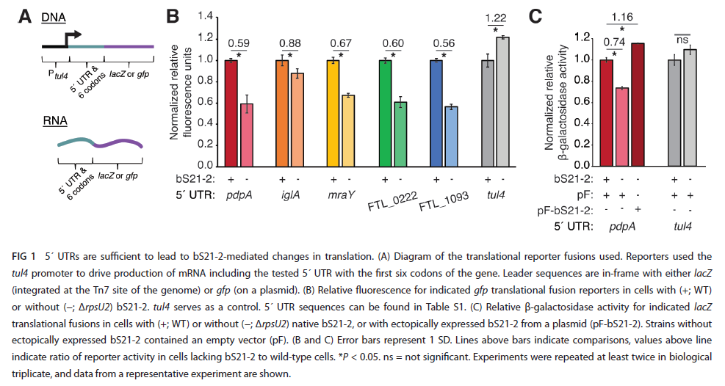
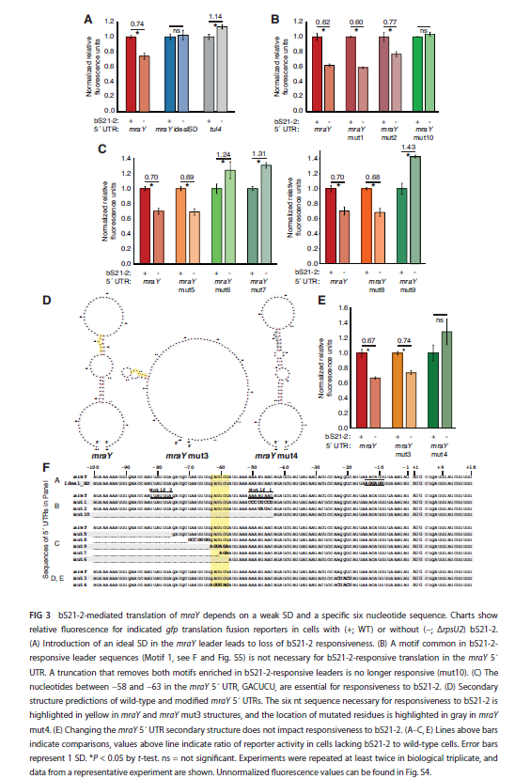
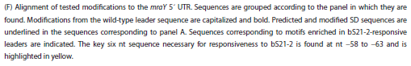
METHODOLOGY AND PROCEDURES
- Bacterial growth conditions
- Plasmid design and construction
- Ribosome purifications
- In vitro assay
- …
- …
RESOURCES REQUIRED
Resources required for the completion of this project will come from the laboratory of Dr. Kathryn Ramsey. Sequencing services will be provided by the URI Genomic Sequencing Center.

