Table of Contents
PureExpress Delta Ribosome Kit Protocol 2
Nano-Glo® Luciferase Assay Protocol 4
Figure. Plate map for in vitro assay. 4
Table. Samples used in in vitro assay. 4
Figure. Wells marked for assay in 96-well plate. 5
Figures. In vitro assay readings at gain settings of 135, 150, 100, and 135. 7
Figure. Relative luminescence values of dilution samples 1-10 for the first plate reading (Gain 135). 7
Overnight Cultures 7
Pelleting LVS Cells for Ribosome Purification 8
Hemoglobin 2% Solution 9
Notes on Kasugamycin Test with in vitro Assay 9
Calculations for in vitro assay with Kasugamycin 10
PureExpress Delta Ribosome Kit Protocol 11
Cloning Project for pKR187 12
Supplemented Brain Heart Infusion Broth with Cysteine (sBHIc) 12
Receiving Primers Protocol for KROL622 & KROL623 12
Bibliography 13

Friday, September 1, 2023

To Do:
- Nanodrop phenol-chloroform extracted plasmids
- Run in vitro assay for luminescence standard curve
- Aliquot 0.1x EB
- Make CHAH plates
Results and Data:
Took Nanodrop readings for phenol-chloroform extracted plasmids.
Sample ID | ng/µl | A260 (Abs)
PCE_pKR204 | 294.1 | 5.883
PCE_pKR205 | 413.8 | 8.276
PCE_pKR206 | 566.5 | 11.33
PCE_pKR207 | 433.3 | 8.666
PCE_pKR208 | 1104.9 | 22.098
PCE_pKR208 | 1127.8 | 22.556

I discarded the following extra 100 uM primer stocks from the -20C freezer: KROL350 (10/09/20), KROL628 (03/25/23), KROL672 (06/17/23), and KROL673 (06/17/23).
I made CHAH and CHAH-Kan plates.
Next week, I will transfer the phenol-chloroform extraction waste from the 50 mL conical to a glass bottle, label it accordingly, and use this glass bottle in the future for extractions.

PureExpress Delta Ribosome Kit Protocol
- Set up PCR reaction tubes.
Tube | DNA | Ribosomes
1 | Phenol:chloroform purified pKR208 | PURExpress
2 | Phenol:chloroform purified pKR208 | PURExpress
3 | Phenol:chloroform purified pKR208 | Nuclease-free water
- Thaw all components on ice. Pulse-spin in microfuge to collect solutions to bottom of tubes. If Solution A has precipitates, mix well prior to assembling reaction. Do not vortex Solution B.
  - Solution A
  - Phenol-chloroform purified pKR208
  - Kit ribosomes
- Dilute DNA in 0.1xEB to a concentration of 125 ng/uL.
Sample | Concentration (C1) | Desired Conc. (C2) | Desired Volume (V2) | Sample Volume (V1) | Buffer Volume
Phenol:chloroform purified pKR208 | 1127.8 ng/uL | 125 ng/uL | 20 uL | 2.22 uL | 17.78 uL
- Add components in the following order:
Solution A 10 uL
Factor Mix 3 uL
Ribosomes 4.5 uL
Template DNA 2 uL (250 ng template DNA per 25 μl reaction)
Water 10.5 uL

Total 30 uL
- Mix gently and pulse-spin in microfuge to collect mixture at the bottom of the tube
- Incubate at 37C for 2-4 hours in thermocycler (incubator is preferred to water bath). I incubated for 2 hours, 15 minutes in the thermocycler.
- Stop the reaction by placing tubes on ice.
- Freeze at -20C.
Monday, September 4, 2023

To Do:
- Patch out plate of LVS
Results and Data:
I patched out a plate of KRLVS 120 from freezer aliquots onto CHAH and put it in the 37C incubator.
Tuesday, September 5, 2023

To Do:
- Run in vitro assay for luminescence standard curve
- Aliquot 0.1x EB
- Make 2 L MHB and supplement
- Inoculate overnight LVS cultures in MHB
Results and Data:

Nano-Glo® Luciferase Assay Protocol
- Prepare plate map and list samples and controls
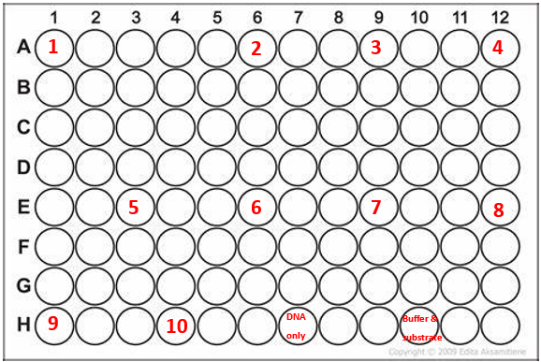

Figure. Plate map for in vitro assay.

Table. Samples used in in vitro assay.
Sample ID | Well | Dilution Factor | Notes
1 | A1 | 1.000
2 | A6 | 0.500
3 | A9 | 0.250
4 | A12 | 0.125
5 | E3 | 0.063
6 | E6 | 0.031
7 | E9 | 0.016
8 | E12 | 0.008
9 | H1 | 0.004
10 | H4 | 0.002
DNA only | H7 |  | DNA only control
Buffer and substrate | H10 |  | Buffer and substrate control
- Thaw Nano-Glo® Luciferase Assay Buffer and Nano-Glo® Luciferase Assay Substrate on ice – mix by pipetting
- Prepare appropriate volume of reconstituted reagent by combining one volume of substrate with 50 volumes of buffer – mix by pipetting
  - Example: for 250 uL of reagent mix 250 uL of buffer with 5 uL of substrate (I mixed 200 uL buffer with 4 uL substrate.)
- I thawed the in vitro assay reactions on ice.
- I marked the wells in the plate that will be used for the assay (see below).
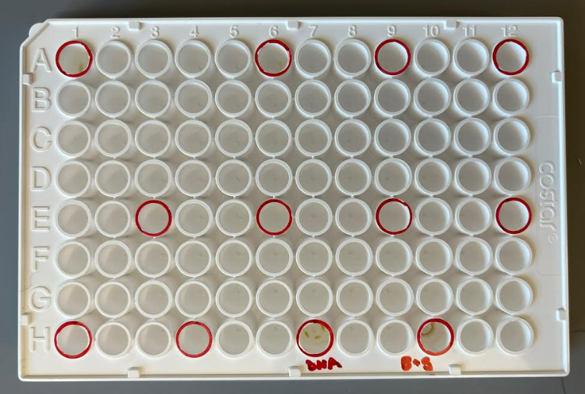

Figure. Wells marked for assay in 96-well plate.
- I brought the 96-well plate, an aliquot of H10M10A50 buffer, the reconstituted reagent, and the reactions 1-3 on ice as well as a 200 uL pipettor and tips (should have also brought the flash drive) to the Matthew Ramsey lab.
- I turned on the plate reader and waited for it to initialize.
- Matthew helped me set up a protocol for the experiment which we entitled, “KMR23_luminescence.” This protocol turns off temperature control, starts with 5 seconds of orbital shaking, and reads luminescence without a filter (using the “Hole” setting) with a gain of 135. We set the integration time to 1 second, and Matthew said that 1-2 seconds is best for this setting.
- I created a new experiment based on this protocol entitled, “230905_BM_luminescence” (originally entitled “230509_BM_luminescence” by mistake).
- Added 60 uL buffer to wells 2-10 and 30 uL buffer to “buffer and substrate” well.
- Added 30 uL reaction volumes from reactions 1-3 to wells 1 and 2 and “DNA only” well.
- Added 30 uL substrate to wells 1 and 2 and to the wells for “DNA only” and for “buffer and substrate.”
- Set timer for 3 minutes
  - Pipetted 60 uL from well 2 to well 3, then 60 uL from well 3 to well 4, and so on. Removed 60 uL from well 10 after final transfer.
- Read the plate on the appropriate settings. (I read the plate at the following gain settings: 135, 150, 100, and 135 again. It took approximately 2 minutes, 15 seconds to read the plate and an additional minute to change the settings, so if the first read was at time 0, then the second read was at approximately time 3:15, the third at time 6:30, and the last at time 9:45.)
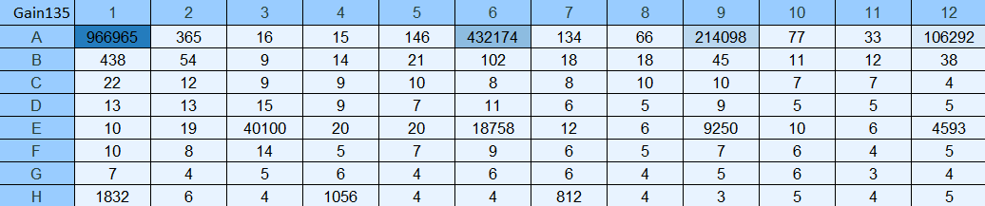
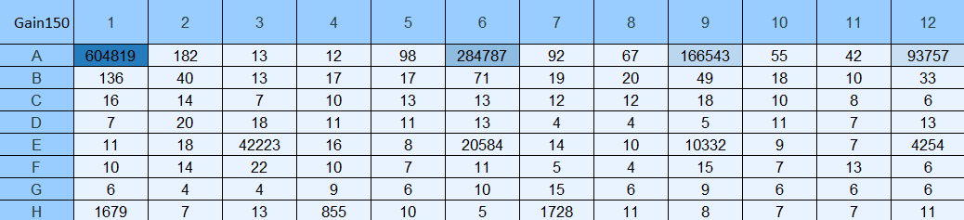
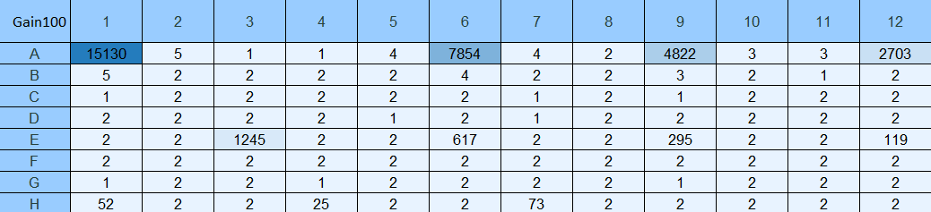
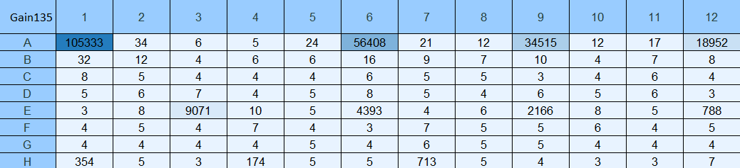

Figures. In vitro assay readings at gain settings of 135, 150, 100, and 135.
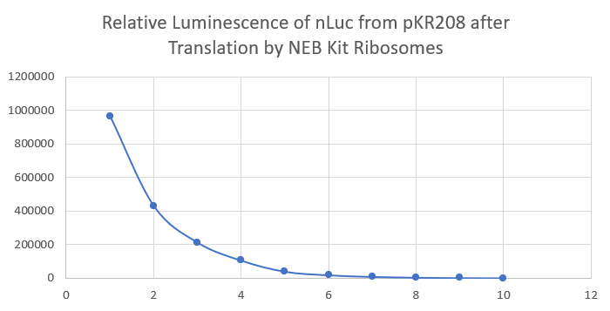

Figure. Relative luminescence values of dilution samples 1-10 for the first plate reading (Gain 135).
I aliquoted 0.1xEB from the 50 mL conical to 12x1.5 mL microcentrifuge tubes.
I made 2 L of MHB.
Wednesday, September 6, 2023

To Do:
- Supplement MHB
- Inoculate overnight LVS cultures in MHB
- Make hemoglobin
- Wash dishes and label with purple tape
- Coordinate with Steve for French press
- Update luminescence charts
Results and Data:
The ultracentrifuge tubes we use are Product #355618. The Dutta lab has a 50.2 Ti rotor.

I supplemented 4x500 mL MHB with 10 mL IsoVitalex, 5 mL 2.5% iron pyrophosphate, and 5 mL 10% glucose. When I got to flasks 1c and 1d, I wasn’t sure which one I had supplemented with IsoVitalex. I thought I had supplemented 1d, so I supplemented 1c, but I may have supplemented 1c twice and 1d not at all.

Overnight Cultures
- Labeled a sterile microfuge tube and added 1 mL supplemented MHB (sMHB) aseptically.
- Scraped up loopfuls of cells from the plate and added to microfuge tube.
- Resuspended cells to homogeneity using a pipette.
- Prepared cuvettes to check OD 600 by labeling one per sample and adding 900 uL sMHB.
- Added 100 uL resuspended cells to appropriate cuvettes.
- Checked OD 600. Calculated OD 600 of resuspended cells (10x observed OD 600), and recorded both observed and calculated OD:
  - LVS pF: 1.311 observed OD, 13.11 calculated OD
- Calculated volume of resuspended cells necessary to obtain a final OD 600 of 0.003 in 500 mL.
  - LVS pF: (0.003 OD 600 )*(500,000ul)/(13.11 OD 600 ) = 114.4 uL
- To appropriately labeled 500 mL flasks from prep of supplemented MHB above, added volume of resuspended cells calculated to obtain final OD 600 of 0.003.
- Incubated flasks at 37°C shaking overnight, starting incubation at 6:22 PM.

Thursday, September 7, 2023

To Do:
- Pellet LVS cultures
- Make hemoglobin
- Make iron pyrophosphate
- Make sucrose cushion buffers
- Coordinate with Steve for French press
- Update luminescence charts
- Run in vitro assay with Kasugamycin
Results and Data:

Pelleting LVS Cells for Ribosome Purification
- Checked OD600 of flasks at 9:30 AM and found them to be the following:
Sample | OD600
1a | 0.243
1b | 0.281
1c | 0.222
1d | 0.245

- This seems to be the perfect time to capture the cultures at just the right OD. There is a range from 0.22 to 0.28 with two of them being almost exactly between 0.2 and 0.3. I calculated the time between starting incubation and reading ODs to be 15 hours and 8 minutes. This means that I could start the cultures at 6 PM and take them out at 9 AM or start them at 5:30 PM and take them out at 8:30 AM.
- *Take a 1 mL sample for whole cell proteins. Add equal amounts OD of 1x SLB (i.e. 0.3 OD, add 0.3 mL 1x SLB). Store sample at -20C.* (I forgot to do this step.)
- I poured the cultures into 250 mL bottles and put the bottles in the -20C freezer at 9:40 AM. At 9:50 AM, I transferred the bottles to a bin with ice.
- I harvested the cells by centrifuging with ThermoScientific Multifuge X Pro Series centrifuge (F14-6x250 LE rotor) at 4C for 5 mins at 11,300xg. I spun four bottles at a time, starting the first spin at 10:08 AM and the second spin at 10:18 AM.
- Resuspended the cell pellet in 30 ml H10M10A50 and pelleted the cells in a 50 mL screw-cap tube with ThermoScientific Multifuge X Pro Series centrifuge (F13-14x50cy rotor) at 4C for 15 mins at 7,720xg, starting the spin at 11:08 AM.
- Took the mass of the cell pellet and found it to be 1.84g. This is just over the mass of the last E. coli pellet (1.70g) which was made from 1 L of culture and less than the mass of the last LVS pellet (2.07g) which was grown to an OD of ~0.33 from 1.5 L of culture, so the mass of LVS grown to an OD of 0.2-0.3 might be about half that of MRE600 grown to an OD of 0.6-0.8, and additionally, LVS grown to a higher OD will have a greater cell density.
- Froze the cell pellet at -80C.

Hemoglobin 2% Solution
Add 6g freeze-dried hemoglobin to a 500 mL flask along with a large stir bar.
Add 300mL of ddiH₂O (type I).
Place the flask on a stir plate and stir for a few minutes to dissolve the hemoglobin.
Add aluminum foil and autoclave tape to the top of the flask.
Autoclave on a 20-minute liquid cycle with water in the bin.
Cool down (ideally to ~55C – can be in water bath set to 56C) and store in 4C fridge.

I made 2.5% Iron pyrophosphate (1.25g iron pyrophosphate in 50mL of ddiH₂O (type 1), dissolved overnight, fresh solution every 2 weeks (filter-sterilized).

Notes on Kasugamycin Test with in vitro Assay
Question: Can Kasugamycin inhibit translation in vitro?
Read paper on this topic.
Toeprinting assay (incubate ribosomes w/mRNA – stalled initiation, primer with reverse transcriptase, stalls, Ksg inhibits ribosome activity in this assay)
Use kit ribosomes, your ribosomes, and three different concentrations of Ksg (1mM, 50uM, and 5uM), and see if you get a dose-dependent inhibition of translation.
Add drug to in vitro assay along with Solution A, Factor Mix, ribosomes, and template DNA. This will ensure that the drug interacts with the ribosomes before translation begins.
Research questions:
- How does bS21 affect the ribosome structure?
- How does the antibiotic affect the ribosome structure?
- How does the antibiotic affect the ribosome when different homologs of bS21 are bound?
Kasugamycin binds near bS21.

Calculations for in vitro assay with Kasugamycin
The molar mass for Kasugamycin (Ksg) is 379.366 g/mol.
To find molarity of our Ksg stock, which is at a concentration of 50 mg/mL, I use the following conversions:

1 mol | 1 g | 50 mg | 1000 mL
379.366 g | 1000 mg | 1 mL | 1 L

and get a value of 0.132 M or 132 mM.

The three concentrations of Ksg that I want to use in the assay are 1 mM, 50 uM (0.05 mM), and 5 uM (0.005 mM). If I want to add 1 uL of Ksg stock to each 30 uL in vitro assay reaction, then I need to make three different Ksg stocks with appropriate concentrations. If I use the equation C1V1=C2V2, and I set V1 as 1 uL, then I can find the appropriate concentrations for each stock, which would be C1. C2 would be one of the three desired concentrations (1 mM, 0.05 mM, and 0.005 mM) and V2 would be the reaction volume (30 uL).

C1V1=C2V2  C1(1 uL) = (1 mM)(30 uL)  C1 = (1 mM)(30 uL)/(1 uL)  C1 = 30 mM | C1V1=C2V2  C1(1 uL) = (0.05 mM)(30 uL)  C1 = (0.05 mM)(30 uL)/(1 uL)  C1 = 1.5 mM | C1V1=C2V2  C1(1 uL) = (0.005 mM)(30 uL)  C1 = (0.005 mM)(30 uL)/(1 uL)  C1 = 0.15 mM

To prepare the three diluted stocks, I will start from the 132 mM Ksg stock and dilute with water. If I use C1V1=C2V2 again, substituting either 5 uL or 1 uL for V1, which will be the volume I take from the original stock, I can find the final volume I will need to prepare for the diluted stocks, which will be V2. C1 will be 132 mM, and C2 will be one of the three desired concentrations (30 mM, 1.5 mM, and 0.15 mM).

C1V1=C2V2  (132 mM)(5 uL) = (30 mM)V2  V2 = (132 mM)(5 uL)/(30 mM)  V2 = 22 uL  22 uL – 5 uL Ksg = 17 uL water | C1V1=C2V2  (132 mM)(5 uL) = (1.5 mM)V2  V2 = (132 mM)(5 uL)/(1.5 mM)  V2 = 440 uL  440 uL – 5 uL Ksg = 435 uL water | C1V1=C2V2  (132 mM)(1 uL) = (0.15 mM)V2  V2 = (132 mM)(1 uL)/(0.15 mM)  V2 = 880 uL  880 uL – 1 uL Ksg = 879 uL water

Stock 1 will be 5 uL Ksg + 17 uL water.
Stock 2 will be 5 uL Ksg + 435 uL water.
Stock 3 will be 1 uL Ksg + 879 uL water.

Monday, September 11, 2023

To Do:
- Make sucrose cushion buffers
- Coordinate with Steve for French press
- Run in vitro assay with Kasugamycin
Results and Data:
Helped Jake Grecco set up his lab notebook and bench space, and we talked about scheduling and projects. We set up Google Drive and a Notion page and discussed media prep and cloning.

I made stocks 1, 2, and 3 of Kasugamycin from previous entry (9/7/23).

PureExpress Delta Ribosome Kit Protocol
- Set up PCR reaction tubes.
Tube | DNA | Ribosomes | Purpose
1 | Phenol:chloroform purified pKR208 | PURExpress | 1mM Ksg
2 | Phenol:chloroform purified pKR208 | PURExpress | 50uM Ksg
3 | Phenol:chloroform purified pKR208 | PURExpress | 5uM Ksg
4 | Phenol:chloroform purified pKR208 | PURExpress | no abx
5 | Phenol:chloroform purified pKR208 | Nuclease-free water | control
- Thaw all components on ice. Pulse-spin in microfuge to collect solutions to bottom of tubes. If Solution A has precipitates, mix well prior to assembling reaction. Do not vortex Solution B.
  - Solution A
  - Factor Mix
  - Phenol-chloroform purified pKR208
  - Kit ribosomes
- Dilute DNA in 0.1xEB to a concentration of 125 ng/uL.
Sample | Concentration (C1) | Desired Conc. (C2) | Desired Volume (V2) | Sample Volume (V1) | Buffer Volume
Phenol:chloroform purified pKR208 | 1127.8 ng/uL | 125 ng/uL | 20 uL | 2.22 uL | 17.78 uL
- Add components in the following order:
Solution A 10 uL
Factor Mix 3 uL
Ribosomes 4.5 uL
Template DNA 2 uL (250 ng template DNA per 25 μl reaction)
Kasugamycin 1 uL
Water 9.5 uL

Total 30 uL
- Mix gently and pulse-spin in microfuge to collect mixture at the bottom of the tube
- Incubate at 37C for 2-4 hours in thermocycler (incubator is preferred to water bath) (incubated for 2 hours, 10 minutes)
- Stop the reaction by placing tubes on ice.
- Freeze at -20C.

Cloning Project for pKR187
Went over cloning project for pKR187. We have 100 uM primer stocks in the fridge for KROL622 and KROL 623, so we will need to reconstitute these and make 10 uM stock primers. Then, we can start the PCR reaction.
Notes from the plasmid database: “Overlap extension products from pKR152: P1- KROL622 and KROL326; P2- KROL623 and KROL550; Overlap PCR- KROL326 and KROL550, KpnI/NotI digested.”
Tuesday, September 12, 2023

To Do:
- Make BHI media
- Reconstitute KROL622 and KROL623 and make working stocks
- Make sucrose cushion buffers
- Coordinate with Steve for French press
- Run in vitro assay with Kasugamycin
Results and Data:

Supplemented Brain Heart Infusion Broth with Cysteine (sBHIc)
For 500 mL:
- Combine in a 1 L bottle:
  - 18.5 g BHI
  - .5 g L-cysteine hydrochloride
  - If preparing sBHIc with 5% KCl, add 25 g KCl (and be sure to label the bottle!)
- Add 480 mL type I ddiH₂0, shake to mix
- Autoclave 30’, let cool
- Store media in the dark for up to 1 month prior to adding supplements

Receiving Primers Protocol for KROL622 & KROL623
By: Hannah Trautmann
- Spin primers at maximum speed in tabletop centrifuge for 3 minutes so desiccated primers go to the bottom of the tube.
- Add 0.1x EB to a final concentration of 100 uM. Calculate this by multiplying the reported nm by 10 and adding that volume in ul (i.e. 12.7 nmoles = add 127 uL of 0.1xEB).
- Put on 42°C heat block for 5 minutes to help primers dissolve
- Vortex and brief spin.
- Label tubes with KROL numbers on the top and put in the appropriate 100 uM stock box in the -20°C freezer.
- If a PCR primer, make a 10 uM stock by diluting 20 uL of the 100 uM stock into 180 uL of 0.1xEB. Label with purple sticker and put in appropriate freezer box.
- Put Certificate of Analysis sheet in “Oligos Spec Sheet” binder and shipping sheet in Invoices box.

Nano-Glo® Luciferase Assay Protocol
- Prepare plate map and list samples and controls
 | 1 | 2 | 3 | 4 | 5 | 6 | 7 | 8 | 9 | 10 | 11 | 12
A | 1. 1 mM Ksg |  |  |  |  | 2. 50 uM Ksg |  |  |  |  | 3. 5 uM Ksg
B
C
D
E | 4. No abx |  |  |  |  | 5. Water + substrate |  |  |  |  | 6. 5 uM Ksg?
F
G
H |  |  |  | H10M10A50 Buffer + substrate |  |  |  |  | H10M10A50 Buffer
- Thaw reactions on ice
- Thaw Nano-Glo® Luciferase Assay Buffer and Nano-Glo® Luciferase Assay Substrate on ice – mix by pipetting
- Prepare appropriate volume of reconstituted reagent by combining one volume of substrate with 50 volumes of buffer – mix by pipetting
  - For 280 uL of reagent mix 280 uL of buffer with 5.6 uL of substrate
- Bring 96-well plate, an aliquot of H10M10A50 buffer, the reconstituted reagent, a small waste beaker, and the reactions on ice as well as a 200 uL pipettor and tips to the plate reader
- Add reactions to designated wells
- Turn on the plate reader and wait for it to initialize
- Select appropriate protocol
- Add equal volume of assay substrate to reaction volume (30 uL) – mix by pipetting
- Set timer for 3 minutes
- Read the plate on the appropriate settings
Note: Ensure luminescence values remain within the linear range of 10^3 and 10^8
- Read again after 5 minutes and after 10 minutes
- Read again with filter set to 460/40
- Export data as Excel file and save to flash drive
For some reason, the brightest signal came from the well with 1 mM Kasugamycin (A1 - the highest concentration – 1 mM Ksg) and the faintest signal (among the reaction wells) came from the well with no Kasugamycin (E1 - the lowest concentration – 0 mM Ksg). This is the opposite of what I would expect, since Kasugamycin should inhibit translation. I also saw that overall signal decreased over time. The approximate times for the plate reads were 00:45 after starting the first read (the first read was interrupted initially by a message that the gain was too high, so I turned it down from 135 to 100), 05:10, and 10:08.
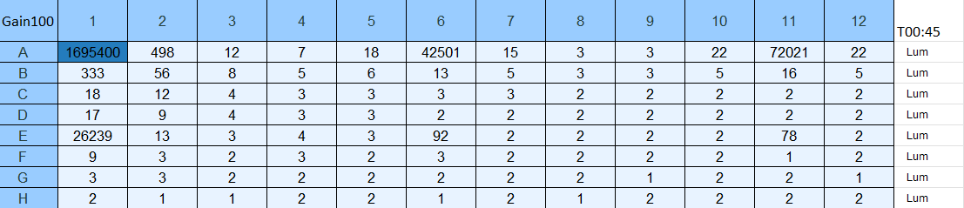
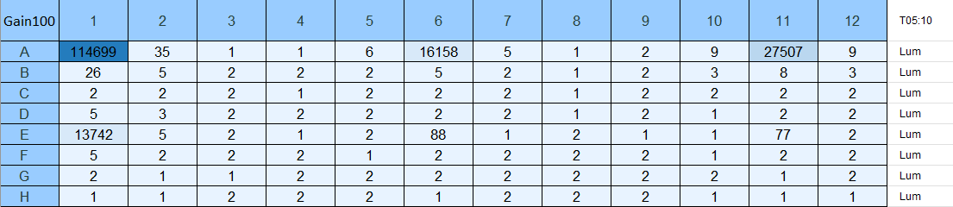
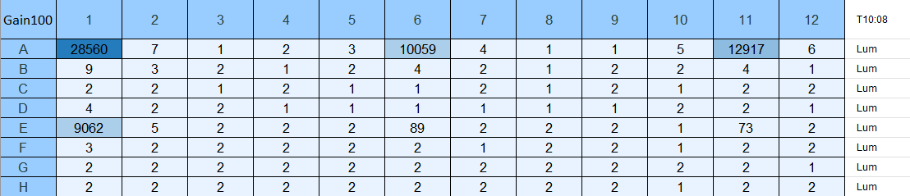

Figures. In vitro assay readings with gain setting of 100 at approx. T=0, 5, and 10 min.

I tried reading the plate with the filter set to 460 nm +/-40 nm, because the emission wavelength of nLuc is 460 nm. I wanted to see there was any contribution to total luminescence by anything else in the reaction wells, and if capturing only the light emitted from nLuc would result in a more reasonable distribution of luminescence values for the different concentrations of Kasugamycin, but this was not the case. I will have to run this assay again. This final read was conducted approximately 14:25 after beginning reads for the assay.

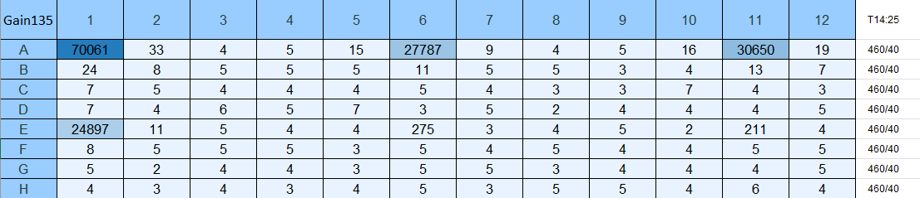

Figure. In vitro assay reading with gain setting of 135 with filter set to 460/40.

Figure. Chart of relative luminescence values for first plate read.

Here, it is shown that the luminescence values generally increased for higher concentrations of Kasugamycin. The exception is that between reaction wells 2 and 3, the luminescence values decreased for higher values of Kasugamycin.

Wednesday, September 13, 2023

To Do:
- Supplement BHI media
- Set up test PCR
- Make sucrose cushion buffers
Results and Data:

PCR (20 uL Reaction)
- Set up table below to specify which primers and source DNA will be used. Be sure to include at least 1 positive and 1 negative control for each PCR experiment.
Reaction Number | Plasmid/Region | Source DNA | Primers | Length (bps)
1 | pKR152 | same | KROL622,  KROL326 | 212
2 | pKR152 | same | KROL623,  KROL550 | 103
3 | + control | LVS gDNA | KROL15, KROL16 | 441
4 | - control | - | KROL622,  KROL326 | -
5 | - control | - | KROL623,  KROL550 | -

- Use PCR_worksheet.xlsx to make establish the specifics of what will be added.
- For reaction 1, the concentrated stock of pKR205 was used.
- For reactions 1-3, the pipette was set to 4 uL instead of 0.4 uL when adding plasmid/gDNA/water.
- For reaction number 4, the 100 ng/uL stock of pKR205 was used and the proper volume of plasmid was used (0.4 uL).
Master Mix
- 74.4 uL diH2O
- 24 uL buffer
- 9.6 uL dNTPs
- 2.4 uL Primestar Polymerase
Individual Reactions Volumes
- 0.6 uL forward primer
- 0.6 uL reverse primer
- 0.4 uL template
- 18.4 uL MM
- Acquire and label PCR tubes.
- Get a container of ice to keep the components on.
- Acquire the following components and put them on ice. If any of the solutions are frozen, be sure to vortex the microfuge tube in order to dissolve it (tubes with frozen components may not be homogenized). Centrifuge the microfuge tubes to get any solution out of the microfuge tube cover. DO NOT vortex the enzyme itself or any solution with enzyme because vortexing will expose it to oxygen and degrade it.
  - Molecular grade H2O in 1.5 mL microfuge tube
  - KOD/primestar buffer
  - dNTPs
  - oligo F (10uM)
  - oligo R (10uM)
  - template (eg. LVS gDNA, plasmid, colony, etc.)
  - KOD/primestar enzyme: kept in the freezer until it is used as it is expensive and should be added last
- Prepare a master-mix in a 1.5 mL microfuge tube by adding the following according to the worksheet and using micropipettes:
  - Add ddiH2O
  - Add dNTPs
  - Add KOD buffer
  - Add KOD enzyme
- Mix the master-mix solution by pipetting up and down. Do not vortex to mix.
- Add appropriate volume of master mix to each PCR tube.
- Add appropriate volume of each experiment specific primer (forward and reverse) to PCR tubes.
- Add appropriate volume of template (or ddiH2O to negative controls) to PCR tubes.
- Close PCR tubes until the caps are tight.
- Pulse spin gently in picofuge microcentrifuge.
- Place the PCR Tubes in the thermocycler on STN 1 – the following settings should be in place:
  - Heat at 94 degrees for 2 minutes
  - 94 degrees C for 20 seconds
  - 50 degrees C for 30 seconds
  - 68 degrees C for 1 minute/kb (adjust based on expected size of product - 30s in this case)
  - Go back to step 2
  - Repeat 32x
  - 68 degrees C for 5 minutes
  - 12 degrees C for infinity

H¹⁰M¹⁰A⁵⁰
10 mM Hepes KOH pH7.6 6 ml 1M Hepes KOH pH 7.6
10 mM MgCl₂ 6 ml 1M MgCl₂
50 mM NH₄Cl 6 ml 5M NH₄Cl
H₂O to 600 mL
600 ml
H¹⁰M¹⁰A⁵⁰⁰ + 20 % sucrose
10 mM Hepes KOH pH7.6 1 ml 1M Hepes KOH pH 7.6 300 uL 1 M HEPES
10 mM MgCl₂ 1 ml 1M MgCl₂ 300 uL 1M MgCl₂
500 mM NH₄Cl 10 ml 5M NH₄Cl 3 ml 5M NH₄Cl
Sucrose 20 g 6 g
H₂O to 100 ml H₂O to 30 ml
100 ml 30 ml
H¹⁰M¹⁰A⁵⁰ + 40 % sucrose
10 mM Hepes KOH pH7.6 2 ml 1M Hepes KOH pH 7.6 400 uL 1M HEPES
10 mM MgCl₂ 2 ml 1M MgCl₂ 400 uL 1M MgCl₂
50 mM NH₄Cl 2 ml 5M NH₄Cl 400 uL 5M NH₄Cl
Sucrose 80 g 16 g
H₂O to 200 ml H₂O to 40 ml
200 ml 40 ml

PCR Gel
- Melt 1% agarose gel at 300C and let cool in water bath to 50-55C.
- Put the gel cast into the gel rig sideways.
- Add 50 mL of 1% agarose gel into a flask with 5 uL SYBR safe solution, swirl the flask to mix, and then pour into the gel rig.
- Insert a comb to mold wells in the gel.
- Let sit until the 1% agarose – 1x SYBR safe solution has cooled and solidified into a gel.
- Carefully remove the comb.
- Pour 100 ml of 1x TAE buffer solution into the gel tank (add just enough to submerge the gel itself slightly).
- Add 4 uL 6x loading dye to 20 uL PCR solutions.
- Load 10 µL of 2x log ladder into the first well.
- Load 15 µL of the PCR-dye mixture into the wells sequentially.
- Insert the electrodes and run the gel at 113 volts for 30 minutes.
- Look at the gel with the GelDoc and image in Image Lab.

Bibliography
Ramsey, K. M. and Dove, S. L. (2016) ‘A response regulator promotes Francisella tularensis intramacrophage growth by repressing an anti-virulence factor’, Molecular Microbiology. doi: 10.1111/mmi.13418.

