Table of Contents
March 2024 3
Friday, March 1, 2024 3
Ribosome Purification Day Three 3
Table. Nanodrop A260 readings for ribosome dilutions. 3
Table. Sample data for purified ribosomes. 3
Monday, March 4, 2024 4
Tuesday, March 5, 2024 4
Thursday, March 7, 2024 5
In Vitro Assay 3/7/24 5
PureExpress Delta Ribosome Kit Protocol 5
Friday, March 8, 2024 7
Table. Primers and DNA loaded for the PCR. 7
Figure. Johanyx’s PCR samples run on a gel. 8
Tuesday, March 12, 2024 8
Nano-Glo® Luciferase Assay Protocol 8
Figure. Kasugamycin Inhibition Assay Measuring nLuc Luminescence with Translation of pKR214 (T7-tul4-nLuc) by E. coli Ribosomes 9
Figure. Deviation calculations for 240229 inhibition assay. 10
Figure. Deviation calculations for 240312 inhibition assay. 10
Wednesday, March 13, 2024 10
Calculations for in vitro assay with Kasugamycin 10
Calculations for in vitro assay with Thiostrepton 11
In Vitro Assay 3/13/24 12
PureExpress Delta Ribosome Kit Protocol 12
Thursday, March 14, 2024 13
Ribosome Purification Day One 13
Friday, March 15, 2024 14
Ribosome Purification Day Two 15
Saturday, March 16, 2024 15
Ribosome Purification Day Three 15
Table. A260 readings for ribosome samples. 15
Table. Average A260 readings of ribosome samples. 15
Table. Volume calculations for ribosome samples. 16
Table. Sample data for purified ribosomes. 16
Monday, March 18, 2024 16
Nano-Glo® Luciferase Assay Protocol 16
Figure. Kasugamycin Inhibition Assay Measuring nLuc Luminescence with Translation of pKR214 (T7-tul4-nLuc) by E. coli Ribosomes 18
Tuesday, March 19, 2024 18
Meeting with Kathryn 19
Making Aliquots of LVS ΔrpsU1 ΔrpsU3 Ribosomes 20
Colony PCR Testing for Deletion of FTL0508 20
Table. Reactions for Colony PCR 20
PCR Protocol (updated 7/1/19) 21
Wednesday, March 20, 2024 22
Figure. Rough estimate of growth over time for LVS in sBHIc. 23
Thursday, March 21, 2024 24
Friday, March 22, 2024 24
PureExpress Delta Ribosome Kit Protocol 24
Nano-Glo® Luciferase Assay Protocol 25
Figure. nLuc Luminescence with Translation of pKR214 (T7-tul4-nLuc) by LVS Ribosomes. 27
Monday, March 25, 2024 27
Buffers for Purification of Tight-Coupled Ribosomes 27
Meeting with Steve 28
Tuesday, March 26, 2024 28
Receiving Primers Protocol 29
Colony PCR Testing for Mutations in FTL0544 (PPK) 29
Table. Reactions for Colony PCR 29
PCR Protocol (updated 7/1/19) 30
Signal for Luminescence from Kit Ribosomes 32
Wednesday, March 27, 2024 32
Thursday, March 28, 2024 32
Bibliography 33

March 2024

Friday, March 1, 2024
To Do:
- Make CHAH plates
- Measure ribosome concentrations and freeze aliquots
Results and Data:
I made aliquots of nuclease-free water to store in my drawer, and I removed Johanyx’s PCR samples from the thermocycler and put them in her cloning box in the -20C.

Ribosome Purification Day Three
- Pellet any remaining debris in the microfuge at max speed for 5 mins.
- Save the supernatant without aspirating the pellet.
- Take multiple concentration readings from the supernatant by diluting 2 uL in 198 uL of water (1:100 dilution) twice for each sample and then measuring the concentration of each dilution three times on the Nanodrop.
- Multiply the average A260 reading for each sample (six measurements) by the dilution factor (100), then divide by 14.5 to give you the concentration in micrograms per microliter. Take that number and divide by 2.7 to get the concentration in pmol per microliter. If the concentration is still too high to read, make a greater dilution and multiply by the appropriate dilution factor.
- I did not dilute these samples, because we will be sending one in for structure analysis and using the other to prepare tight-coupled ribosomes using a protocol from Christine Dunham.
- Spin the tubes briefly in benchtop microcentrifuge, and freeze at -80 °C.

Table. Nanodrop A260 readings for ribosome dilutions.
Sample ID | ng/µl | A260 (Abs)
1a1 | 189.4 | 4.736
1a2 | 189.7 | 4.741
1a3 | 191.5 | 4.788
1b1 | 185.2 | 4.63
1b2 | 186.9 | 4.672
1b3 | 186.4 | 4.661
2a1 | 183 | 4.576
2a2 | 182.2 | 4.556
2a3 | 184.4 | 4.61
2b1 | 186 | 4.649
2b2 | 190.4 | 4.759
2b3 | 187.2 | 4.68

Table. Sample data for purified ribosomes.
Sample ID | Diluted? | Dilution Ratio | Date Measured | A260 | ug/uL | pmol/uL | OD600 | Media | Pellet Weight (g)
LVS_D1D3_1 | Y | 1:100 | 3/1/2024 | 4.705 | 32.446 | 12.017 | 0.510, 0.539 | BHI | 2.25
LVS_D1D3_2 | Y | 1:100 | 3/1/2024 | 4.638 | 31.989 | 11.848 | 0.463, 0.483 | BHI | 1.89
I removed one of the three samples of KRLVS294 (#3 of 3) from my personal cell stocks in the -80C that were made on 1/29/24 and transferred it to the Strains Box 10 as KRLVS294.2 and updated the strains list accordingly. We would need to sequence the DNA or run a diagnostic digest to ensure that this has the pKR217 plasmid, but the colony sizes are similar to those of other LVS ΔrpsU1 ΔrpsU2 strains that we electroporated with plasmids from the cloning library (see last figure of plate with LVS ΔrpsU1ΔrpsU2 pF-E2-27_3 from 2/6/24.

Monday, March 4, 2024
To Do:
- Make CHAH and CHAH-Kan plates
- Send out ribosome sample
Results and Data:
I made CHAH and CHAH-Kan plates today.

I sent out the ribosome sample to Duke University. I prepared the shipment and dropped it off at the shipping and receiving area in the loading dock at 3 PM, and FedEx just came and picked up the package. Tippawan was not in, so I corresponded with Cindy Sorlien and spoke with someone at the Chemistry stockroom. I was able to get 5.5 pounds of dry ice in a styrofoam box, although the stockroom employee did not know how much it cost. I prepared a shipping label addressed to Dr. Rajiv Singh for priority overnight shipping (just a few dollars more than standard shipping). I transferred the sample to a cryovial and put it in a plastic bag along with a piece of paper with information about the sample.

LVS ΔrpsU1 ΔrpsU3 Ribosomes
150 uL Volume
31.989 mg/uL
11.848 pmol/uL

Resuspended in H10M10A50 buffer:
10 mM HEPES KOH pH 7.6
10 mM MgCl2
50 mM NH4Cl

Tracking no.: 775404915023

I helped Johanyx run a gel for her test PCR, but unfortunately we did not see any bands for any of the samples. We reran the PCR using fresh buffer, dNTPs, and polymerase, and we will run the samples on a gel tomorrow.

Johanyx looked at her plates for testing sucrose selectivity. I patched out twelve colonies from the 10⁻⁷ CHAH+10% sucrose plate onto CHAH and CHAH-Kan.

Tuesday, March 5, 2024
To Do:
- Redo Ksg assay
- Run test PCR gel with Johanyx
Results and Data:
Johanyx ran the PCR samples from yesterday on a gel but still did not have bands, so she ran another PCR using 1 uL of template instead of 0.4 uL.

Thursday, March 7, 2024
To Do:
- Redo Ksg inhibition assay
- Help George put a slide together for LM
- Help Johanyx set up another test PCR and make dilutions for colony PCR
Results and Data:
Yesterday, Alex ran a gel for Johanyx and there were still no bands, so we will probably test the primers next. I believe that KROL15 and KROL16 would work because they amplify off LVS gDNA. If that works, it would tell us something is wrong with the primer stocks. Today, I’m going to redo the Ksg assay using the DMSO stocks from the freezer, help George, work on my presentation, and help Johanyx with running another PCR and doing a colony PCR with her transformants. We can make the PCR dilutions, but we should probably wait to run the PCR reaction until we know if something is wrong with the primers.

In Vitro Assay 3/7/24

PureExpress Delta Ribosome Kit Protocol
- Set up PCR reaction tubes.
Tube | Purpose
1 | No abx
2 | 50uM Thiostrepton
3 | DMSO
4 | 5mM Ksg
5 | 1mM Ksg
6 | 50uM Ksg
7 | 5uM Ksg
8 | control
- Thaw all components on ice. Pulse-spin in microfuge to collect solutions to bottom of tubes. If Solution A has precipitates, mix well prior to assembling reaction. Do not vortex Solution B.
  - Solution A
  - Factor Mix
  - Ribosomes (EC singleton - 8/16/23)
  - Kasugamycin
  - Phenol-chloroform purified pKR214
- Measure ribosome concentration.
- Dilute ribosomes to 3.077 pmol/uL in H10M10A50 buffer, enough for a final volume of 13 uL per reaction and 40 pmol per reaction.
 | Concentration (C1) | Desired Concentration (C2) | Desired Volume (V2) | Sample Volume (V1) | Buffer Volume
8/16 E. coli | 5.582 pmol/uL | 3.077 pmol/uL | 108.8 uL | 60 uL | 48.8 uL
- Dilute DNA in 0.1xEB to a concentration of 125 ng/uL.
Sample | Concentration (C1) | Desired Conc. (C2) | Desired Volume (V2) | Sample Volume (V1) | Buffer Volume
Phenol:chloroform purified pKR214 | 899.4 ng/uL | 125 ng/uL | 20 uL | 2.78 uL | 17.22
- Prepare stocks of Kasugamycin, Thiostrepton, and DMSO
  - Thiostrepton was 10 mg/mL in DMSO
- Create a Master Mix by adding Solution A, Factor Mix, and the plasmid template to a tube and mix by pipetting. To calculate working volumes, multiply required volumes by 1.2 to account for pipetting error. If you are running an inhibition assay, you can include ribosomes in the Master mix. I included enough ribosomes for 7 reactions, because the eighth reaction is a no ribosome control. I will combine Solution A, Factor Mix, and the plasmid first, aliquot the negative control, and then add the ribosomes and make the remaining aliquots. To calculate working volumes for Solution A, Factor Mix, and the plasmid, I multiplied the total volume for seven reactions times 1.2 and then I added the volume for an eighth reaction. This way, once I remove 15 uL for the eighth reaction, the proportions for the components in the Master Mix will match the proportion of the ribosomes I add.
Master Mix Components | Volume Each (uL) | Total Volume (uL) | Total x1.2
Solution A | 10 | 70+10 | 84+10=94
Factor Mix | 3 | 21+3 | 25.2+3=28.2
E. coli ribosomes | 13 | 91 | 109.2
Phenol-chloroform purified pKR214 | 2 | 14+2 | 16.8+2=18.8
- Add Master Mix to each tube.
- Add water to respective tubes.
- Add treatment to respective tubes.
Tube | Solution A | Factor Mix | Ribosomes | DNA (125 ng/uL) | Treatment | Water
1 | 10 uL | 3 uL | 13 uL 8/16 E. coli | 2 uL Phenol:chloroform purified pKR214 | - | 1 uL
2 | 10 uL | 3 uL | 13 uL 8/16 E. coli | 2 uL Phenol:chloroform purified pKR214 | 0.25 uL Thiostrepton | -
3 | 10 uL | 3 uL | 13 uL 8/16 E. coli | 2 uL Phenol:chloroform purified pKR214 | 0.25 uL DMSO | -
4 | 10 uL | 3 uL | 13 uL 8/16 E. coli | 2 uL Phenol:chloroform purified pKR214 | 1.14 uL 132 mM Ksg stock | -
5 | 10 uL | 3 uL | 13 uL 8/16 E. coli | 2 uL Phenol:chloroform purified pKR214 | 1 uL 30 mM Ksg stock | -
6 | 10 uL | 3 uL | 13 uL 8/16 E. coli | 2 uL Phenol:chloroform purified pKR214 | 1 uL 1.5 mM Ksg stock | -
7 | 10 uL | 3 uL | 13 uL 8/16 E. coli | 2 uL Phenol:chloroform purified pKR214 | 1 uL 0.15 mM Ksg stock | 15 uL
8 | 10 uL | 3 uL | - | 2 uL Phenol:chloroform purified pKR214 | -
- Reaction 7 had slightly less Master Mix – I was down to the last of it and there were some bubbles that were aspirated.
- The ribosomes and Master Mix (without the treatments) were added to the PCR tubes and sat for about an hour and a half before the treatments were added.
- Mix gently and pulse-spin in microfuge to collect mixture at the bottom of the tube
- Incubate at 37C for 2 hours in thermocycler
- Stop the reaction by placing tubes on ice.
- Freeze at -20C.

Friday, March 8, 2024
To Do:
- Finish Ksg inhibition assay
- Make dilutions for colony PCR
- Run gel for Johanyx’s PCR
Results and Data:
I ran a gel for Johanyx’s PCR and it came back with no bands. The primers can be faintly seen at the bottom.

Table. Primers and DNA loaded for the PCR.
Lane | 1 | 2 | 3 | 4
DNA | LVS gDNA | none | LVS gDNA | None
Primers | KROL15, 16 | KROL15, 16 | KROL661, 662 | KROL661, 662

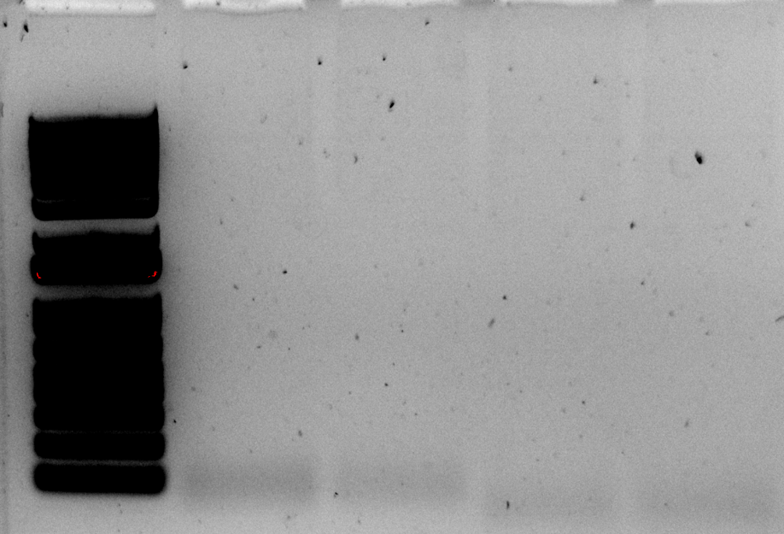

Figure. Johanyx’s PCR samples run on a gel.

Tuesday, March 12, 2024
To Do:
- Finish Ksg inhibition assay
Results and Data:

Nano-Glo® Luciferase Assay Protocol
- Prepare plate map and list samples and controls
 | 1 | 2 | 3 | 4 | 5 | 6 | 7 | 8 | 9 | 10 | 11 | 12
A | 1a |  | 1b |  | 1c |  | 5a |  | 5b |  | 5c
B
C | 2a |  | 2b |  | 2c |  | 6a |  | 6b |  | 6c
D
E | 3a |  | 3b |  | 3c |  | 7a |  | 7b |  | 7c
F
G | 4a |  | 4b |  | 4c |  | 8a |  | 8b |  | 8c
H
- Thaw reactions on ice
- Thaw Nano-Glo® Luciferase Assay Buffer and Nano-Glo® Luciferase Assay Substrate on ice – mix by pipetting
- Prepare appropriate volume of reconstituted reagent by combining one volume of substrate with 50 volumes of buffer – mix by pipetting
# Reactions = A | A x 1.2 = B | B x 50 uL Buffer | B x 1 uL Substrate
8 | 9.6 | 480 | 9.6
- Add the mixed NanoGlo reagent to PCR tubes in 40 uL volumes corresponding to the number of reactions in the assay
- Bring white 96-well plate, the reconstituted reagent, a waste container, the flash drive, a razor blade, and the reactions on ice as well as a 200 uL multichannel pipettor and tips to the plate reader
- Turn on the plate reader and wait for it to initialize
- Select appropriate protocol
- Add equal volume of assay substrate to reaction volume (30 uL) using the multichannel pipettor and mix by pipetting
- Set timer for 3 minutes (The reaction ran for about another 40 seconds.)
- As the 3 minute incubation is taking place, pipette 18 uL/well three times for each reaction to set up a technical triplicate, changing your tips in between each time you pipette. (The last aliquots for reactions 3 and 7 had bubbles so may not have been full volumes.)
- Read the plate on the appropriate settings
Note: Ensure luminescence values remain within the linear range of 10^3 and 10^8
- Export data as Excel file and save to flash drive
- Save reactions in -20C for future Western blots
The overall signal for the reactions was lower than last time the inhibition assay was performed. This could be because the ribosomes were from a different purification. Could it have been affected by the fact that the ribosomes sat with the Master Mix on ice for about an hour and a half before the treatments were added and the reactions were incubated? Also, the reactions treated with Kasugamycin had a higher signal than the reaction with no antibiotic, the reaction with 1 mM Ksg had the highest signal as opposed to having the lowest signal of the Ksg treatments and being about half the signal of the no antibiotic reaction in the previous assay, and the reactions treated with Ksg did not seem to follow a trend with their signal corresponding to their Ksg concentration. These results are troubling. I am not sure how much of this may be due to the fact that the reactions sat out on ice for a little over an hour before the treatments were added and the incubation step began. Could there have been pipetting error? I will repeat this inhibition assay a third time, and the results will likely resemble either the first time or this second time, but right now we can’t be conclusive because both assays we ran so far look different.

Figure. Kasugamycin Inhibition Assay Measuring nLuc Luminescence with Translation of pKR214 (T7-tul4-nLuc) by E. coli Ribosomes

I also looked at deviation in pipetting the technical triplicates for both inhibition assays by subtracting the luminescence values for each well from the average of the three wells in the triplicate and dividing by the average (see figures below). Overall, the middle reads seemed to have the lowest deviation, and the last two reactions in the Feb 29 assay had the highest deviation. Next time, I will try using the multi-dispense function.

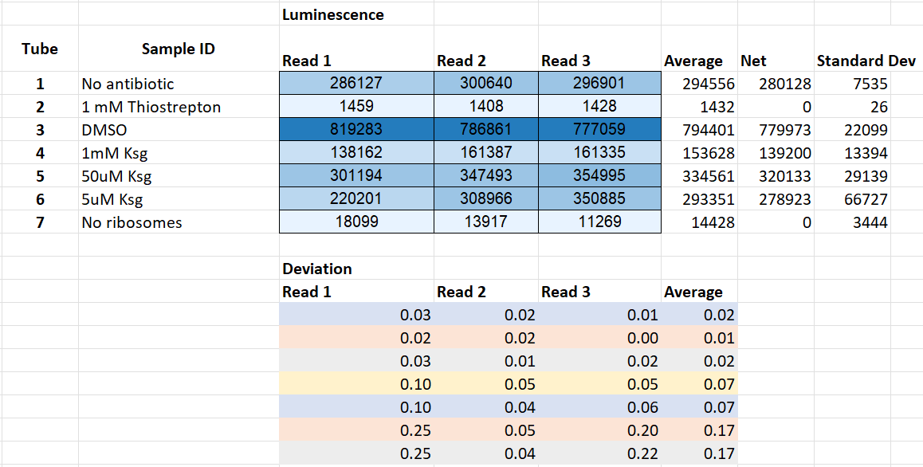

Figure. Deviation calculations for 240229 inhibition assay.

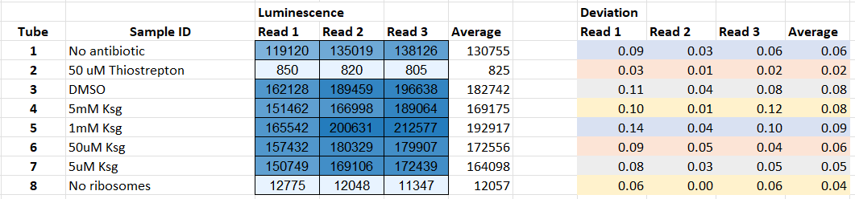

Figure. Deviation calculations for 240312 inhibition assay.

I made a 1 mL aliquot of 10 mg/mL Thiostrepton from the Gregory lab and stored it in the fridge.

Wednesday, March 13, 2024
To Do:
- Begin third Ksg inhibition assay
- Prepare for LVS ribosome purification
- Prepare for splitting protocol
- Attend George’s exhibition
Results and Data:

Calculations for in vitro assay with Kasugamycin
The molar mass for Kasugamycin (Ksg) is 379.366 g/mol.
To find molarity of our Ksg stock, which is at a concentration of 50 mg/mL, I use the following conversions:

1 mol | 1 g | 50 mg | 1000 mL
379.366 g | 1000 mg | 1 mL | 1 L

and get a value of 0.132 M or 132 mM.

The three concentrations of Ksg that I want to use in the assay are 1 mM, 50 uM (0.05 mM), and 5 uM (0.005 mM). If I want to add 1 uL of Ksg stock to each 30 uL in vitro assay reaction, then I need to make three different Ksg stocks with appropriate concentrations. If I use the equation C1V1=C2V2, and I set V1 as 1 uL, then I can find the appropriate concentrations for each stock, which would be C1. C2 would be one of the three desired concentrations (1 mM, 0.05 mM, and 0.005 mM) and V2 would be the reaction volume (30 uL).

C1V1=C2V2  C1(1 uL) = (1 mM)(30 uL)  C1 = (1 mM)(30 uL)/(1 uL)  C1 = 30 mM | C1V1=C2V2  C1(1 uL) = (0.05 mM)(30 uL)  C1 = (0.05 mM)(30 uL)/(1 uL)  C1 = 1.5 mM | C1V1=C2V2  C1(1 uL) = (0.005 mM)(30 uL)  C1 = (0.005 mM)(30 uL)/(1 uL)  C1 = 0.15 mM

To prepare the three diluted stocks, I will start from the 132 mM Ksg stock and dilute with water. If I use C1V1=C2V2 again, substituting either 5 uL or 1 uL for V1, which will be the volume I take from the original stock, I can find the final volume I will need to prepare for the diluted stocks, which will be V2. C1 will be 132 mM, and C2 will be one of the three desired concentrations (30 mM, 1.5 mM, and 0.15 mM).

C1V1=C2V2  (132 mM)(5 uL) = (30 mM)V2  V2 = (132 mM)(5 uL)/(30 mM)  V2 = 22 uL  22 uL – 5 uL Ksg = 17 uL water | C1V1=C2V2  (132 mM)(5 uL) = (1.5 mM)V2  V2 = (132 mM)(5 uL)/(1.5 mM)  V2 = 440 uL  440 uL – 5 uL Ksg = 435 uL water | C1V1=C2V2  (132 mM)(1 uL) = (0.15 mM)V2  V2 = (132 mM)(1 uL)/(0.15 mM)  V2 = 880 uL  880 uL – 1 uL Ksg = 879 uL water

Stock 1 will be 5 uL Ksg + 17 uL water.
Stock 2 will be 5 uL Ksg + 435 uL water.
Stock 3 will be 1 uL Ksg + 879 uL water.

Calculations for in vitro assay with Thiostrepton
The molar mass for Thiostrepton is 1664.83 g/mol.
To find molarity of our stock (borrowed from the Gregory lab), which is at a concentration of 10 mg/mL, I use the following conversions:

1 mol | 1 g | 10 mg | 1000 mL
1664.83 g | 1000 mg | 1 mL | 1 L

and get a value of 0.006 M or 6 mM.

Adding 1 uL of Thiostrepton would result in a 200 uM concentration.

In Vitro Assay 3/13/24

PureExpress Delta Ribosome Kit Protocol
- Set up PCR reaction tubes.
Tube | Purpose
1 | No abx
2 | 200uM Thiostrepton
3 | 4.4mM Ksg
4 | 1mM Ksg
5 | 50uM Ksg
6 | control
- Thaw all components on ice. Pulse-spin in microfuge to collect solutions to bottom of tubes. If Solution A has precipitates, mix well prior to assembling reaction. Do not vortex Solution B.
  - Solution A
  - Factor Mix
  - Ribosomes (EC singleton - 6/7/23)
  - Kasugamycin
  - Thiostrepton
  - Phenol-chloroform purified pKR214
- Dilute ribosomes to 3.077 pmol/uL in H10M10A50 buffer, enough for a final volume of 14 uL per reaction and 40 pmol per reaction.
 | Concentration (C1) | Desired Concentration (C2) | Desired Volume (V2) | Sample Volume (V1) | Buffer Volume
6/7 E. coli | 9.219 pmol/uL | 2.857 pmol/uL | 193.6 | 60 uL | 133.6 uL
- Dilute DNA in 0.1xEB to a concentration of 125 ng/uL.
Sample | Concentration (C1) | Desired Conc. (C2) | Desired Volume (V2) | Sample Volume (V1) | Buffer Volume
Phenol:chloroform purified pKR214 | 899.4 ng/uL | 125 ng/uL | 20 uL | 2.78 uL | 17.22
- Prepare stocks of Kasugamycin, Thiostrepton, and DMSO
  - Thiostrepton was 10 mg/mL in DMSO
- Create a Master Mix by adding Solution A, Factor Mix, and the plasmid template to a tube and mix by pipetting. To calculate working volumes, multiply required volumes by 1.2 to account for pipetting error. If you are running an inhibition assay, you can include ribosomes in the Master mix. In this case, combine Solution A, Factor Mix, and the plasmid first, aliquot the negative control, and then add the ribosomes and make the remaining aliquots.
Master Mix Components | Volume Each (uL) | Reactions | Total Volume (uL) | Total x1.2
Solution A | 10 | 6 | 60+10 | 72+10=82
Factor Mix | 3 | 6 | 18+3 | 21.6+3=24.6
E. coli ribosomes | 14 | 5 | 70 | 93.6
Phenol-chloroform purified pKR214 | 2 | 6 | 12+2 | 14.4+2=16.4
- Add Master Mix to each tube.
- Add water to respective tubes.
- Add treatment to respective tubes.
Tube | Solution A | Factor Mix | Ribosomes | DNA (125 ng/uL) | Treatment | H10M10A50 Buffer
1 | 10 uL | 3 uL | 14 uL 6/7 E. coli | 2 uL Phenol:chloroform purified pKR214 | - | 1 uL
2 | 10 uL | 3 uL | 14 uL 6/7 E. coli | 2 uL Phenol:chloroform purified pKR214 | 1 uL Thiostrepton
3 | 10 uL | 3 uL | 14 uL 6/7 E. coli | 2 uL Phenol:chloroform purified pKR214 | 1 uL 132 mM Ksg stock
4 | 10 uL | 3 uL | 14 uL 6/7 E. coli | 2 uL Phenol:chloroform purified pKR214 | 1 uL 30 mM Ksg stock
5 | 10 uL | 3 uL | 14 uL 6/7 E. coli | 2 uL Phenol:chloroform purified pKR214 | 1 uL 1.5 mM Ksg stock
6 | 10 uL | 3 uL | - | 2 uL Phenol:chloroform purified pKR214 | - | 15 uL
- Mix gently and pulse-spin in microfuge to collect mixture at the bottom of the tube
- Incubate at 37C for 2 hours in thermocycler
- Stop the reaction by placing tubes on ice.
- Freeze at -20C.

Thursday, March 14, 2024
To Do:
- Begin LVS ribosome purification
- Make 40% sucrose buffer
Results and Data:

Ribosome Purification Day One
- Thaw the cell pellets (from 2/12/24) and resuspend it in 2.5 ml H10M10A50 per gram of cells (recommended: add buffer to increase volume for French Press, so it is at least 13 mL per sample).
  - 13 mL were used
- Chill the centrifuge rotor.
- Add 20 ul of 1 U/ul DNase.
- Pass once through the French Press set on high with max pressure set to 1280. Collect the lysate in 50 mL conical tubes then transfer to 30 ml Oakridge tubes (red caps).
  - We turned up the French press to 1400
  - The first sample only went up to about 250 on the first pass, so we ran another pass.
  - The second sample only went up to about 300, so we ran it twice as well.
  - For the third sample, I tightened the pressure valve a little bit more, and for the first pass it went up to about 500 and for the second pass it went up to about 1000. The color of the lysate for this sample was noticeably darker than the other two (see image). In the future, we might have to ensure that the pressure valve is tightened enough. Colby and Kathy will also look at the manual and see if there are any things that need to be replaced (o-rings, etc.).
- Ensure caps and tube rims are dry and balance the Oakridge tubes to within 0.002 g using H10M10A50 buffer.
- Pellet the cell debris in a 70 Ti rotor at 30,000 rpm, 15 minutes, 4 °C. Check the O-rings and add SPINKOTE lubricant if necessary.
- Layer the S30 supernatant avoiding the pellet over a 10 ml sucrose cushion, H10M10A500 + 20% sucrose being sure not to let the two layers mix.
  - The pellet for the third sample looked darker than the others (see image) and less of it had dissolved back into the solution when the supernatant was being removed. This might mean that more lysis leads to easier extraction of the supernatant without extra cellular debris present.
- Ensure caps and tube rims are dry and balance the Oakridge tubes to within 0.002 g using H10M10A50 buffer.
- Centrifuge in a 70 Ti rotor at 40,000 rpm, 4 hours, 4 °C.
- Rinse the ribosome pellet with 10 mL H10M10A50 twice, without disturbing the pellet, and resuspend it in 1.0 ml of H10M10A50. This may take a while. Do not pipet or vortex.
- Microfuge the suspension for 5 minutes at max speed and keep the supernatant.
- Layer 1 ml of ribosomes onto 15 ml H10M10A50 + 40% sucrose.
- Ensure caps and tube rims are dry and balance the Oakridge tubes to within 0.002 g using H10M10A50 buffer.
- Centrifuge in a 70 Ti rotor at 30,000 rpm, 14 hours, 4 °C.
I made more H10M10A50 + 40 % sucrose buffer and more 1M MgCl2.

H¹⁰M¹⁰A⁵⁰ + 40 % sucrose
10 mM Hepes KOH pH7.6 2 ml 1M Hepes KOH pH 7.6 400 uL 1M HEPES
10 mM MgCl₂ 2 ml 1M MgCl₂ 400 uL 1M MgCl₂
50 mM NH₄Cl 2 ml 5M NH₄Cl 400 uL 5M NH₄Cl
Sucrose 80 g 16 g
H₂O to 200 ml H₂O to 40 ml
200 ml 40 ml

1M MgCl₂ 203.3 g/mol = 20.33 g/ 100 ml

Friday, March 15, 2024
To Do:
- Continue LVS ribosome purification
Results and Data:

Ribosome Purification Day Two
- Rinse the pellet with 10 mL H10M10A50 twice, without disturbing the pellet.
- Dissolve the ribosome pellet in 250 ul or less (minimal volume, start with 100 uL) of H10M10A50, allowing it to resuspend overnight.

Saturday, March 16, 2024
To Do:
- Finish LVS ribosome purification
Results and Data:

Ribosome Purification Day Three
- Pellet any remaining debris in the microfuge at max speed for 5 mins.
- Save the supernatant without aspirating the pellet.
- Take multiple concentration readings from the supernatant by diluting 2 uL in 198 uL of water (1:100 dilution) twice for each sample and then measuring the concentration of each dilution three times on the Nanodrop.

Table. A260 readings for ribosome samples.
Sample ID | ng/µl | A260 (Abs)
1a1 | 30.8 | 0.771
1a2 | 30.8 | 0.771
1a3 | 30.3 | 0.758
1b1 | 29.6 | 0.739
1b2 | 30.8 | 0.770
1b3 | 31 | 0.775
2a1 | 68.8 | 1.721
2a2 | 69.6 | 1.739
2a3 | 69.1 | 1.726
2b1 | 70 | 1.750
2b2 | 68.8 | 1.720
2b3 | 70.5 | 1.763
3a1 | 62.4 | 1.560
3a2 | 62.7 | 1.567
3a3 | 65.3 | 1.631
3b1 | 65.6 | 1.640
3b2 | 62.4 | 1.561
3b3 | 63.7 | 1.592

Table. Average A260 readings of ribosome samples.
Sample ID | Average A260 Reading
1 | 0.764
2 | 1.737
3 | 1.592

- Multiply the average A260 reading for each sample (six measurements) by the dilution factor (100), then divide by 14.5 to give you the concentration in micrograms per microliter. Take that number and divide by 2.7 to get the concentration in pmol per microliter. If the concentration is still too high to read, make a greater dilution and multiply by the appropriate dilution factor.
- Use the calculated concentration to dilute the sample to a concentration of 2.666 pmol/uL, then aliquot the stock in 16 uL volumes into PCR strip tubes. The concentrations for the first two samples was good (above 4 pmol/uL), but the first sample had a lower concentration than the desired working concentration of 2.666 pmol/uL. I need to be more careful during the wash steps to ensure that I am not washing off a significant amount of ribosomes. Sometimes a little orange film remains, but if I resuspend the samples and then spin them at max speed for 5 minutes, there is a small orange pellet that I can discard, so it might be better to be more conservative when washing the ribosome pellets rather than trying to get off all the orange film.

Table. Volume calculations for ribosome samples.
Sample | C1 | V1 | C2 | V2 | Buffer
LVS_1 | 1.951 | 120 | 2.666 | 87.84 | -32.16
LVS_2 | 4.436 | 120 | 2.666 | 199.65 | 79.65
LVS_3 | 4.066 | 120 | 2.666 | 183.02 | 63.02
- Spin the tubes briefly in benchtop microcentrifuge, and freeze at -80 °C.

Table. Sample data for purified ribosomes.
Sample ID | Diluted? | Dilution Ratio | Date Measured | A260 | ug/uL | pmol/uL | OD600 | Media | Pellet Weight (g) | Volume (uL) Purified | Total Yield (pmol) | Total Yield (nmol)
LVS_1 | Y | 1:100 | 3/16/2024 | 0.764 | 5.269 | 1.951 | 0.535, 0.454 | BHI | 1.71 | 120 | 234.176 | 0.234
LVS_2 | Y | 1:100 | 3/16/2024 | 1.737 | 11.976 | 4.436 | 0.507, 0.580 | BHI | 1.98 | 120 | 532.261 | 0.532
LVS_3 | Y | 1:100 | 3/16/2024 | 1.592 | 10.978 | 4.066 | 0.522, 0.540 | BHI | 1.82 | 120 | 487.918 | 0.488

Monday, March 18, 2024
To Do:
- Read Ksg inhibition assay
- Make hemoglobin and CHAH plates
- Look for equipment for splitting protocol
Results and Data:
I made CHAH and CHAH-Kan plates.

I tried using multi-dispense function with water starting at 60 uL. It seemed to work alright, so I tried using the multi-dispense function for the assay.

Nano-Glo® Luciferase Assay Protocol
- Prepare plate map and list samples and controls
 | 1 | 2 | 3 | 4 | 5 | 6 | 7 | 8 | 9 | 10 | 11 | 12
A | 1a |  | 1b |  | 1c |  | 5a |  | 5b |  | 5c
B
C | 2a |  | 2b |  | 2c |  | 6a |  | 6b |  | 6c
D
E | 3a |  | 3b |  | 3c
F
G | 4a |  | 4b |  | 4c
H
- Thaw reactions on ice
- Thaw Nano-Glo® Luciferase Assay Buffer and Nano-Glo® Luciferase Assay Substrate on ice – mix by pipetting
- Prepare appropriate volume of reconstituted reagent by combining one volume of substrate with 50 volumes of buffer – mix by pipetting
# Reactions (R) | Buffer = R x 50 uL x 1.2 | Substrate = R x 1 uL x 1.2
6 | 360 | 7.2
- Add the mixed NanoGlo reagent to PCR tubes in 40 uL volumes corresponding to the number of reactions in the assay
- Bring white 96-well plate, the reconstituted reagent, a waste container, the flash drive, a razor blade, and the reactions on ice as well as a 200 uL multichannel pipettor and tips to the plate reader
- Turn on the plate reader and wait for it to initialize
- Select appropriate protocol
- Add equal volume of assay substrate to reaction volume (30 uL) using the multichannel pipettor and mix by pipetting
- Set timer for 3 minutes
- As the 3 minute incubation is taking place, pipette 18 uL/well three times for each reaction to set up a technical triplicate, changing your tips in between each time you pipette (This time, I used the multi-dispense function, but it wasn’t the most effective, because the total volume required to dispense (54 uL) was too close to the total volume present in the reactions (60 uL), so the pipette drew up some bubbles. Next time, I will pipette singly or use the multi-dispense function with the pipette set to a smaller volume (15-16 uL).)
- Read the plate on the appropriate settings (Note: Ensure luminescence values remain within the linear range of 10^3 and 10^8.)
- Export data as Excel file and save to flash drive
- Save reactions in -20C for future Western blots

Figure. Kasugamycin Inhibition Assay Measuring nLuc Luminescence with Translation of pKR214 (T7-tul4-nLuc) by E. coli Ribosomes
The variability for this assay was greater than I would have liked, due to the inaccuracy of the multi-dispense function operating close to the reaction volume. Translation was clearly inhibited by Thiostrepton (lower concentration used than for previous assays, so not complete inhibition). Concentrations of 4.4 mM and 1 mM Ksg exhibited a clear inhibitory effect. Overall, this assay was closer to the first assay (Feb 29) than the second (March 12), so it validated the inhibitory effect of 1 mM and higher concentrations of Ksg and showed that some inaccuracies must have been introduced in the second assay (perhaps by the fact that the ribosomes sat with the Master Mix on ice for about an hour and a half before the treatments were added and the reactions were incubated).

Tuesday, March 19, 2024
To Do:
- Look for equipment for splitting protocol
- Review protocol for tight-coupled ribosomes
- Run colony PCR (Johanyx)
- Make more patches from 10^16 plates (Johanyx)
Results and Data:
Recap: Yesterday, I ran a third Kasugamycin assay and tried using the multi-dispense function on the pipettor. The assay worked well and confirmed the results from the first Ksg assay, but there was more variability in the assay due to error introduced by the multi-dispense function operating close to the limits of the reaction volume. Next time, I will have to pipette singly or use a smaller volume per well (15-16 uL). For now, we have verified that Kasugamycin inhibits translation in concentrations of 1mM and higher and that the in vitro assay is an effective way of measuring this inhibition. In the future, we may run more refined experiments. I need to make sure that I am concentrating intently when pipetting to ensure precision and accuracy. Today, I will be working with George and Johanyx. I will also be preparing to run the experiment for purifying tight-coupled ribosomes. I can review the protocol and then talk to Kathryn about it during our meeting today. With George, we have received the primers to check for mutations in PPK, so we will reconstitute them and then set up a colony PCR to check for mutations in our diluted samples. These ten samples were taken from colonies on the plates streaked on 2/2/24 and imaged and picked/diluted on 2/6/24. I will also be helping Johanyx make more patches (12 total) from her 10^-6 plates onto CHAH and CHAH-Kan and running her colony PCR with samples picked from the patches that were made yesterday (be sure to pick from CHAH plates). Pick, heat, dilute, run PCR. I also want to work on my thesis proposal today. Maybe I can try writing in my notebook and devote it to that purpose or writing on my iPad. I will need to pick and send a review article as well. I can do this during a working lunch. George is not coming in today, so I moved his experiments to Thursday.

I found the cassettes and syringes that will be needed for the dialysis steps in the protocol for purifying tight-coupled ribosomes. The cassettes we have are too large for the ribosome sample I will be working with, so Kathryn is ordering smaller cassettes, and they will arrive next Wednesday. I reviewed the protocol for purifying tight-coupled ribosomes and discussed it with Kathryn.

Meeting with Kathryn
- Kasugamycin inhibition assays
- Try pipetting 15-16 uL next time using multi-dispense function
- Results can go in thesis
- Analyze data with statistics (t-test)
- Look at 231120_SS_Thesis_final.pdf and ScatterPlotTemplate_1 for guidance
- Make Excel template for chart so data can be easily formatted in the future
  - Scientific notation on y-axis
  - Data points displayed
  - Fold change compared to WT
  - Significance (asterisks)
- Ribosome purifications
- Run 2 aliquots from samples 2 and 3 purified on 3/16/24
- Complete lysis matters more than number of passes
- Be careful with washes and don’t be concerned about getting every bit of the orange film off of the pellet
- Pay attention to anything that could lower yield
- In the future, try lysing two samples with Bug Buster and two samples with the French press and compare the yield
  - You will need to make H10M10A50 with Bug Buster at a concentration of 1x
  - Add DNAse 1 and incubate at 37C for 30 minutes
- Pelleting LVS cells
  - Check data with samples grown in BHI overnight that were overgrown
  - Could try inoculating at 0.01 or 0.005 OD
  - Document what OD you started them at and when they were ready
  - You can put the glass flasks on ice
  - You can put 15 mL of buffer on each pellet to help with resuspension and use the 5 mL serological pipette to resuspend
- Purifying tight-coupled ribosomes
- Talk to Kira about scheduling sucrose gradient
- Cassettes arrive next Wednesday
- Plan overnight dialysis for low Mg, then high Mg, then gradient
- Look for an alternate cold room to use for overnight dialysis

Making Aliquots of LVS ΔrpsU1 ΔrpsU3 Ribosomes
I made two 10 uL aliquots of the LVS ΔrpsU1 ΔrpsU3 ribosomes that I purified on 3/1/24. One of these I will use for future in vitro assays, and one of them I will run on the sucrose gradient.

Colony PCR Testing for Deletion of FTL0508
I helped Johanyx run a colony PCR on samples that had been patched on CHAH-Kan from CHAH+10% sucrose. The purpose of the colony PCR was to check for deletion of FTL_0508 (UDP-N-acetylmuramate) using the primers KROL681 and KROL682. The product will be 3549 if WT, 2212 if ∆FTL_0508.

We conducted colony PCR on all patches from two CHAH plates. Both CHAH plates had twelve patches from colonies that had grown on CHAH+10% sucrose when testing for sucrose selectivity. The patches were scraped up with a sterile wooden stick and used to inoculate PCR tubes with 50 uL of nuclease-free water. The PCR tubes were numbered according to the table below. The tubes were spun briefly in the picofuge, and the samples were heated at 95C for 10 minutes in the thermocycler to lyse the cells. Then, the samples were diluted 1:10 by pipetting 10 uL from the heated samples to new PCR tubes with 90 uL of nuclease-free water. These samples were also briefly spun in the picofuge. Controls included LVS gDNA, LVS from colonies on a negative control transformation plate from 2/6, and the pKR200 plasmid diluted 1:10.

Table. Reactions for Colony PCR
Reaction Number | Plasmid/Region | Source DNA | Primers | Length (bps)
1 | Checking deletion of FTL_0508 | 1.1 | KROL681&682 | 3549 or 2212
2 | Checking deletion of FTL_0508 | 1.2 | KROL681&682 | 3549 or 2212
3 | Checking deletion of FTL_0508 | 1.3 | KROL681&682 | 3549 or 2212
4 | Checking deletion of FTL_0508 | 1.4 | KROL681&682 | 3549 or 2212
5 | Checking deletion of FTL_0508 | 1.5 | KROL681&682 | 3549 or 2212
6 | Checking deletion of FTL_0508 | 1.6 | KROL681&682 | 3549 or 2212
7 | Checking deletion of FTL_0508 | 1.7 | KROL681&682 | 3549 or 2212
8 | Checking deletion of FTL_0508 | 1.8 | KROL681&682 | 3549 or 2212
9 | Checking deletion of FTL_0508 | 1.9 | KROL681&682 | 3549 or 2212
10 | Checking deletion of FTL_0508 | 1.10 | KROL681&682 | 3549 or 2212
11 | Checking deletion of FTL_0508 | 1.11 | KROL681&682 | 3549 or 2212
12 | Checking deletion of FTL_0508 | 1.12 | KROL681&682 | 3549 or 2212
13 | Checking deletion of FTL_0508 | 2.1 | KROL681&682 | 3549 or 2212
14 | Checking deletion of FTL_0508 | 2.2 | KROL681&682 | 3549 or 2212
15 | Checking deletion of FTL_0508 | 2.3 | KROL681&682 | 3549 or 2212
16 | Checking deletion of FTL_0508 | 2.4 | KROL681&682 | 3549 or 2212
17 | Checking deletion of FTL_0508 | 2.5 | KROL681&682 | 3549 or 2212
18 | Checking deletion of FTL_0508 | 2.6 | KROL681&682 | 3549 or 2212
19 | Checking deletion of FTL_0508 | 2.7 | KROL681&682 | 3549 or 2212
20 | Checking deletion of FTL_0508 | 2.8 | KROL681&682 | 3549 or 2212
21 | Checking deletion of FTL_0508 | 2.9 | KROL681&682 | 3549 or 2212
22 | Checking deletion of FTL_0508 | 2.10 | KROL681&682 | 3549 or 2212
23 | Checking deletion of FTL_0508 | 2.11 | KROL681&682 | 3549 or 2212
24 | Checking deletion of FTL_0508 | 2.12 | KROL681&682 | 3549 or 2212
25 | Control | LVS colony (from plate from 2/6) | KROL681&682 | 3549
26 | Control | LVS gDNA | KROL681&682 | 3549
27 | Control | pKR200 plasmid (diluted 1:10) | KROL681&682 | 2212?

PCR Protocol (updated 7/1/19)
- Acquire and label PCR tubes. Be sure to include at least 1 positive and 1 negative control for each PCR experiment.
- Get a container of ice to keep the components on
- Acquire the following components and put them on ice, labeling tubes if necessary:
  - Molecular grade H2O in 1.5 mL microfuge tube
  - KOD/primestar buffer
  - dNTPs
  - oligo F (10uM)
  - oligo R (10uM)
  - template (eg. LVS gDNA, plasmid, colony, etc.)
  - Note: KOD/primestar enzyme should be kept in the freezer until it is used as it is expensive and should be added last
- Centrifuge the microfuge tubes to get any solution out of the microfuge tube cover
- If any of the solutions are frozen, be sure to vortex the microfuge tube in order to dissolve it (tubes with frozen components may not be homogenized)
  - DO NOT vortex the enzyme itself or any solution with enzyme because vortexing will expose it to oxygen and degrade it
- Use PCR_worksheet.xlsx to make establish the specifics of what will be added
  - The file is located in the Protocols folder
  - Also setup table below to specify which primers and source DNA will be used
- Add appropriate volume (based on PCR worksheet) of each experiment specific primer (forward and reverse) to PCR tubes
- Prepare a master-mix in a 1.5 mL microfuge tube by adding the following according to the worksheet and using micropipettes:
  - Add ddi H2O
  - Add dNTPs
  - Add KOD buffer
  - Add oligo F (10uM)
  - Add oligo R (10uM)
  - Add KOD enzyme
- Mix the master-mix solution by pipetting up and down
  - Do not vortex to mix
- Add appropriate volume of master-mix to each PCR tube (19.6 uL)
- Close PCR Tubes until the caps are tight
- Place the PCR Tubes in the thermocycler on STN 1 – the following settings should be in place:
  - Heat at 94 degrees for 2 minutes,
  - 94 degrees C for 20 seconds
  - 50 degrees C for 30 seconds
  - 68 degrees C for 1 minute/kb (3.6 minutes for the 3.5 kb expected product for WT LVS)
  - Go back to step 2
  - Repeat 32x
  - 68 degrees C for 5 minutes
  - 12 degrees C for infinity

Total reaction volume | 20
Total number of reactions | 27
 |  |  |  | Factor
Component | Stock concentration | Final concentration | 1 rxn volume | 28
ddiH2O |  |  | 12.4 | 347.2
PrimeSTAR GXL Buffer | 5x | 1x | 4.0 | 112
dNTPs | 2.5 mM | 0.2 mM | 1.6 | 44.8
oligo F | 10 uM | 0.3 uM | 0.6 | 16.8
oligo R | 10 uM | 0.3 uM | 0.6 | 16.8
template | 100 ng/ul | 2 ng/ul | 0.4
PrimeSTAR GXL DNA Polymerase | 1.25 U/ul | 0.025 U/ul | 0.4 | 11.2
 |  | Total volume | 20 | 548.8

Wednesday, March 20, 2024
To Do:
- Run colony PCR gel (Johanyx)
- Work on thesis proposal (notebook or iPad)
- Pick and send research paper
- Find alternate cold room
- Look up data for BHI samples grown overnight
- Make buffers for splitting protocol
- Prep for IVA with LVS
Results and Data:
Kathryn came in and began running the gel for Johanyx’s colony PCR. We will see how the gel turns out and decide whether we need to run more PCR reactions from the patches Johanyx made from the 10^16 dilution plates. The gels did not show consistent banding patterns for the samples, so Kathryn wants to make sure that Johanyx pipettes 1 uL of template per reaction instead of 0.4 uL. She also wants Johanyx to save the PCR tubes with the dilutions instead of throwing them away. I should talk about these points with her tomorrow.

On Tues, Oct 24, 2023, to appropriately labeled 500 mL flasks from prep of supplemented BHI, added volume of resuspended cells calculated to obtain final OD 600 of 0.005. Incubated flasks at 37°C shaking overnight, starting incubation at 5:20 PM.

On Wed, Oct 25, 2023, checked OD600 of flasks at 9:10 AM and found them to be the following:
Sample | 1a | 1b | 2a | 2b | 3a | 3c
OD600 | 0.992 | 0.878 | 0.797 | 0.763 | 0.760 | 0.836

Based on this data and the very rough graph with data from various incubations put together to get a rough estimate of growth over time (below), I calculate that if I inoculate the cultures at an OD600 of 0.005 at 7 PM, I should check them to see if they are at an OD600 of 0.5 at 8 AM the following morning (12-14 hours).

Figure. Rough estimate of growth over time for LVS in sBHIc.

Summary: Kathryn ran another PCR using samples taken from the patches on the 10^-6 plates. I made lists of the buffers needed for the splitting protocol, which I can make tomorrow. I figured out a tentative time window (12-14 hours) for growing LVS cultures in BHI overnight starting at OD 0.005. I could try this out with 500mL-1L culture and see how it goes. I picked a paper for journal club that I will have to read tomorrow. I am looking for a cold room to use. Marina said that the one on the third floor is holding temp. I will have to verify this or check in about the cold room on the first floor. Tomorrow, I will be working with George to reconstitute primers and run a colony PCR. I can help Johanyx run a gel. I can also run an IVA using the LVS samples that were recently purified, using the multichannel to pipette 16 uL per well with the multi-dispense function. I need to keep working on my thesis proposal.

Thursday, March 21, 2024
To Do:
- Check with Prada lab about cold room
- Work on thesis proposal (notebook or iPad)
- Read research paper for journal club
Results and Data:

Friday, March 22, 2024
To Do:
- Pick up invoice for HA peptide
- Make buffers for splitting protocol
- Run IVA with LVS
Results and Data:

PureExpress Delta Ribosome Kit Protocol
- Set up PCR reaction tubes.
Tube | Sample ID | Moles (pmol)
1 | 3/16 LVS 2a | 40
2 | 3/16 LVS 2b | 40
3 | 3/16 LVS 3a | 40
4 | 3/16 LVS 3b | 40
5 | Negative Control | -
- Thaw all components on ice. Pulse-spin in microfuge to collect solutions to bottom of tubes. If Solution A has precipitates, mix well prior to assembling reaction.
  - Solution A
  - Factor Mix
  - Ribosomes
  - Phenol-chloroform purified plasmid template
- Dilute DNA in 0.1xEB to a concentration of 125 ng/uL.
Sample | Concentration (C1) | Desired Conc. (C2) | Desired Volume (V2) | Sample Volume (V1) | Buffer Volume
Phenol:chloroform purified pKR214 | 899.4 ng/uL | 125 ng/uL | 20 uL | 2.78 uL | 17.22
- Create a Master Mix by adding Solution A, Factor Mix, and the plasmid template to a tube and mix by pipetting. To calculate working volumes, multiply required volumes by 1.2 to account for pipetting error. If you are running an inhibition assay, you can include ribosomes in the Master mix. In this case, combine Solution A, Factor Mix, and the plasmid first, aliquot the negative control, and then add the ribosomes and make the remaining aliquots.
Components | Volume Each (uL) | Reactions Needed | Total Volume (uL) | Total x1.2
Solution A | 10 | 5 | 50 | 60
Factor Mix | 3 | 5 | 15 | 18
Ribosomes | 15 | - | - | -
Phenol-chloroform purified plasmid template | 2 | 5 | 10 | 12
- Add 15 uL Master Mix to each tube
- Add 15 uL ribosomes to respective tubes
Tube | Solution A | Factor Mix | Ribosomes | DNA (125 ng/uL) | Buffer
1 | 10 uL | 3 uL | 15 uL 3/16 LVS | 2 uL Phenol:chloroform purified pKR214
2 | 10 uL | 3 uL | 15 uL 3/16 LVS | 2 uL Phenol:chloroform purified pKR214
3 | 10 uL | 3 uL | 15 uL 3/16 LVS | 2 uL Phenol:chloroform purified pKR214
4 | 10 uL | 3 uL | 15 uL 3/16 LVS | 2 uL Phenol:chloroform purified pKR214
5 | 10 uL | 3 uL | - | 2 uL Phenol:chloroform purified pKR214 | 15 uL H10M10A50
- Mix gently and pulse-spin in microfuge to collect mixture at the bottom of the tube
- Incubate at 37C for 2 hours in thermocycler (lid set to 105C, incubation was for 2.5 hours)
- Stop the reaction by placing tubes on ice
- Freeze at -20C

Nano-Glo® Luciferase Assay Protocol
- Prepare plate map and list samples and controls
 | 1 | 2 | 3 | 4 | 5 | 6 | 7 | 8 | 9 | 10 | 11 | 12
A | 2a1 |  | 2a2 |  | 2a3 |  | neg |  | neg |  | neg
B
C | 2b1 |  | 2b2 |  | 2b3
D
E | 3a1 |  | 3a2 |  | 3a3
F
G | 3b1 |  | 3b2 |  | 3b3
H
- Thaw reactions on ice
- Thaw Nano-Glo® Luciferase Assay Buffer and Nano-Glo® Luciferase Assay Substrate on ice – mix by pipetting
- Prepare appropriate volume of reconstituted reagent by combining one volume of substrate with 50 volumes of buffer – mix by pipetting
# Reactions (R) | Buffer = R x 50 uL x 1.2 | Substrate = R x 1 uL x 1.2
5 | 300 | 6
- Add the mixed NanoGlo reagent to PCR tubes in 40 uL volumes corresponding to the number of reactions in the assay
- Bring white 96-well plate, the reconstituted reagent, a waste container, the flash drive, a razor blade, and the reactions on ice as well as a 200 uL multichannel pipettor and tips to the plate reader
- Turn on the plate reader and wait for it to initialize
- Select appropriate protocol
- Add equal volume of assay substrate to reaction volume (30 uL) using the multichannel pipettor and mix by pipetting
- Set timer for 3 minutes
- As the 3 minute incubation is taking place, pipette 16 uL/well three times for each reaction to set up a technical triplicate, using the multi-dispense function
- Read the plate on the appropriate settings (Note: Ensure luminescence values remain within the linear range of 10^3 and 10^8)
- Export data as Excel file and save to flash drive
- Save reactions in -20C for future Western blots

Figure. nLuc Luminescence with Translation of pKR214 (T7-tul4-nLuc) by LVS Ribosomes.
Samples LVS 2a and 2b were similar, but 3a and 3b were significantly different from each other.

Monday, March 25, 2024
To Do:
- Make buffers for splitting protocol
- Make square CHAH plates (Johanyx)
- Work on thesis proposal
Results and Data:

Buffers for Purification of Tight-Coupled Ribosomes

H¹⁰M¹⁰A⁵⁰ (High Mg Buffer)
10 mM Hepes KOH pH7.6 10 ml 1M Hepes KOH pH 7.6
10 mM MgCl₂ 10 ml 1M MgCl₂
50 mM NH₄Cl 10 ml 5M NH₄Cl
H₂O to 1000 mL
1000 ml

H¹⁰M^{0.3}A⁵⁰ (Low Mg Buffer)
10 mM Hepes KOH pH7.6 10 ml 1M Hepes KOH pH 7.6
0.3 mM MgCl₂ 0.3 ml 1M MgCl₂
50 mM NH₄Cl 10 ml 5M NH₄Cl
H₂O to 1000 mL
1000 ml

H¹⁰M¹⁰A⁵⁰ + 10% sucrose
10 mM Hepes KOH pH7.6 1.5 ml 1M Hepes KOH pH 7.6
10 mM MgCl₂ 1.5 ml 1M MgCl₂
50 mM NH₄Cl 1.5 ml 5M NH₄Cl
Sucrose 15 g
H₂O to 150 ml
150 ml

H¹⁰M¹⁰A⁵⁰ + 40% sucrose
10 mM Hepes KOH pH7.6 1.5 ml 1M Hepes KOH pH 7.6
10 mM MgCl₂ 1.5 ml 1M MgCl₂
50 mM NH₄Cl 1.5 ml 5M NH₄Cl
Sucrose 60 g
H₂O to 150 ml
150 ml

H¹⁰M¹⁰A⁵⁰ + 50% sucrose
10 mM Hepes KOH pH7.6 5 ml 1M Hepes KOH pH 7.6
10 mM MgCl₂ 5 ml 1M MgCl₂
50 mM NH₄Cl 5 ml 5M NH₄Cl
Sucrose 250 g
H₂O to 500 ml
500 ml

Meeting with Steve
I met with Dr. Gregory to discuss ways we could optimize the in vitro assay. He said that one thing we could check is whether the ribosomes are fully resuspended at the end of the ribosome purifications. I can take the A260 readings of random aliquots and read them multiple times to see if there is variability and if the ribosomes are fully dissolved. I can also try warming the aliquots at 37C for different amounts of time to see how long it takes for the A260 reading to become consistent. Finally, I can look at the raw data values for the kit ribosomes to see how much variability they demonstrated between assays.

Tuesday, March 26, 2024
To Do:
- Reconstitute primers (George)
- Run colony PCR (George)
- Make single-use aliquots and glycerol stocks (Johanyx)
- Work on suggestions from Steve for checking consistency of ribosome samples
- Check on stir plate and reserve for the weekend
- Coordinate sucrose gradient with Kira
- Make 1 L BHI and more supplements if needed
Results and Data:
Recap: Today, I will be helping George and Johanyx with their projects. I will also continue planning for the splitting protocol (sending Kathryn any questions I have, checking on the stir plate and reserving it for the weekend, coordinating the sucrose gradient with Kira), working on Steve’s suggestions for checking consistency of ribosome samples, working on my thesis proposal, and making 1 L of BHI media (along with more B-NAD and Heme-His if needed).

I helped George run a colony PCR to check for mutations in FTL_0544 (PPK) using the primers KROL683 and KROL684.

Receiving Primers Protocol
By: Hannah Trautmann
- Spin primers (KROL683&684) at maximum speed in tabletop centrifuge for 3 minutes so dessicated primers go to the bottom of the tube.
- Add 0.1x EB to a final concentration of 100 uM. Calculate this by multiplying the reported nm by 10 and adding that volume in ul (i.e. 12.7 nmoles = add 127 uL of 0.1xEB).
- Put on 42°C heat block for 5 minutes to help primers dissolve
- Vortex and brief spin.
- Label tubes with KROL numbers on the top and put in the appropriate 100 uM stock box in the -20°C freezer.
- Optional: Make dilution for intended purpose of primer.
  - If a PCR primer, make a 10 uM stock by diluting 20 uL of the 100 uM stock into 180 uL of 0.1xEB. Label with purple sticker and put in appropriate freezer box.
  - If a sequencing primer, make a 2.5 uM stock by diluting 5 uL of the 100 uM stock into 195 uL of 0.1x EB. Label with blue sticker and put in appropriate freezer box.
- Put Certificate of Analysis sheet in “Oligos Spec Sheet” binder and shipping sheet in Invoices box.

Colony PCR Testing for Mutations in FTL0544 (PPK)
We conducted colony PCR on samples that had been diluted previously by Kathryn (2/6/24). She picked a colony from each plate, mixed them in water, heated them at 95C to lyse the cells, and diluted them 1:10 in water. She then stored them in PCR strip tubes in George’s -20C box and numbered the samples (and plates) 1-10. Controls will include LVS gDNA with the same primers, LVS gDNA with KROL15&16, and lysate 1 (LVS pF) with KROL15&16.

We will add 2 uL of the diluted samples to the reactions in George’s colony PCR. Because George doesn’t have a lot of experience with PCR, we will scale the reaction up to 60 uL, and before the PCR purification, we will run 5 uL on a gel to ensure there is a product. Because there will be a small volume of product, the bands might be faint. In this case, we can do two exposures, one for the ladder and one for the bands.

Table. Reactions for Colony PCR
Reaction Number | Plasmid/Region | Strain Source | Genotype | Primers | Length (bps)
1 | Checking mutations in FTL_0544 | KRLVS120 | LVS pF | KROL683&684 | 1060
2 | Checking mutations in FTL_0544 | KRLVS196 | LVS ∆rpsU1 ∆rpsU2 pF | KROL683&684 | 1060
3 | Checking mutations in FTL_0544 | E2-24 | LVS ∆rpsU1 ∆rpsU2 pF-E2-24 | KROL683&684 | 1060
4 | Checking mutations in FTL_0544 | KRLVS292 | LVS ∆rpsU1 ∆rpsU2 pF-E2-24 | KROL683&684 | 1060
5 | Checking mutations in FTL_0544 | E2-26 | LVS ∆rpsU1 ∆rpsU2 pF-E2-26 | KROL683&684 | 1060
6 | Checking mutations in FTL_0544 | KRLVS293 | LVS ∆rpsU1 ∆rpsU2 pF-E2-26 | KROL683&684 | 1060
7 | Checking mutations in FTL_0544 | E2-27 | LVS ∆rpsU1 ∆rpsU2 pF-E2-27 | KROL683&684 | 1060
8 | Checking mutations in FTL_0544 | KRLVS294.3 | LVS ∆rpsU1 ∆rpsU2 pF-E2-27 | KROL683&684 | 1060
9 | Checking mutations in FTL_0544 | KRLVS294.1 | LVS ∆rpsU1 ∆rpsU2 pF-E2-27 | KROL683&684 | 1060
10 | Checking mutations in FTL_0544 | KRLVS294.2 | LVS ∆rpsU1 ∆rpsU2 pF-E2-27 | KROL683&684 | 1060
11 | Control | LVS gDNA | LVS | KROL683&684 | 1060
12 | Control | KRLVS120 | LVS pF | KROL15&16 | 464
13 | Control | LVS gDNA | LVS | KROL15&16 | 464

PCR Protocol (updated 7/1/19)
- Acquire and label PCR tubes. Be sure to include at least 1 positive and 1 negative control for each PCR experiment.
- Get a container of ice to keep the components on
- Acquire the following components and put them on ice, labeling tubes if necessary:
  - Molecular grade H2O in 1.5 mL microfuge tube
  - KOD/primestar buffer
  - dNTPs
  - oligo F (10uM)
  - oligo R (10uM)
  - template (eg. LVS gDNA, plasmid, colony, etc.)
  - Note: KOD/primestar enzyme should be kept in the freezer until it is used as it is expensive and should be added last
- Centrifuge the microfuge tubes to get any solution out of the microfuge tube cover
- If any of the solutions are frozen, be sure to vortex the microfuge tube in order to dissolve it (tubes with frozen components may not be homogenized)
  - DO NOT vortex the enzyme itself or any solution with enzyme because vortexing will expose it to oxygen and degrade it
- Use PCR_worksheet.xlsx to make establish the specifics of what will be added
  - The file is located in the Protocols folder
  - Also setup table below to specify which primers and source DNA will be used
- Add appropriate volume (based on PCR worksheet) of each experiment specific primer (forward and reverse) to PCR tubes
- Prepare a master-mix in a 1.5 mL microfuge tube by adding the following according to the worksheet and using micropipettes:
  - Add ddi H2O
  - Add dNTPs
  - Add KOD buffer
  - Add oligo F (10uM)
  - Add oligo R (10uM)
  - Add KOD enzyme
- Mix the master-mix solution by pipetting up and down
  - Do not vortex to mix
- Add appropriate volume of master-mix to each PCR tube (19 uL)
- Close PCR Tubes until the caps are tight
- Place the PCR Tubes in the thermocycler on STN 1 – the following settings should be in place:
  - Heat at 94 degrees for 2 minutes,
  - 94 degrees C for 20 seconds
  - 50 degrees C for 30 seconds
  - 68 degrees C for 1 minute/kb (1 minute, 12 sec for the 1.1 kb expected product)
  - Go back to step 2
  - Repeat 32x
  - 68 degrees C for 5 minutes
  - 12 degrees C for infinity

Total reaction volume | 60
Total number of reactions | 11
 |  |  |  | Factor
Component | Stock concentration | Final concentration | 1 rxn volume | 12
ddiH2O |  |  | 37.2 | 446.4
PrimeSTAR GXL Buffer | 5x | 1x | 12.0 | 144
dNTPs | 2.5 mM | 0.2 mM | 4.8 | 57.6
oligo F | 10 uM | 0.3 uM | 1.8 | 21.6
oligo R | 10 uM | 0.3 uM | 1.8 | 21.6
template | 100 ng/ul | 2 ng/ul | 1.2
PrimeSTAR GXL DNA Polymerase | 1.25 U/ul | 0.025 U/ul | 1.2 | 14.4
 |  | Total volume | 60 | 705.6

Total reaction volume | 60
Total number of reactions | 2
 |  |  |  | Factor
Component | Stock concentration | Final concentration | 1 rxn volume | 3
ddiH2O |  |  | 37.2 | 111.6
PrimeSTAR GXL Buffer | 5x | 1x | 12.0 | 36
dNTPs | 2.5 mM | 0.2 mM | 4.8 | 14.4
oligo F | 10 uM | 0.3 uM | 1.8 | 5.4
oligo R | 10 uM | 0.3 uM | 1.8 | 5.4
template | 100 ng/ul | 2 ng/ul | 1.2
PrimeSTAR GXL DNA Polymerase | 1.25 U/ul | 0.025 U/ul | 1.2 | 3.6
 |  | Total volume | 60 | 176.4

Signal for Luminescence from Kit Ribosomes
Here is a table of luminescence values and details from the individual assays when kit ribosomes were used. There doesn't seem to be a consistent relationship between the variables present and the luminescence readings.
Date of Assay | Reaction Incubation Period | Reagent Incubation Period | Volume of Kit Ribosomes Used | Luminescence Reading
May 11, 2023 | 4 hours | 12.5 minutes | 4.01 uL | 19,000,000
May 26, 2023 | 4 hours | 9 minutes | 4.28 uL | 46,201,684
June 15, 2023 | 4 hours | Longer than 3 minutes? (plate was spun) | 4.01 uL | 48,637,440

Wednesday, March 27, 2024
To Do:
- Coordinate sucrose gradient with Kira
- Make 1.5 L BHI
- Reserve rotor from Janet
Results and Data:

Making BHIc Media
For 500 mL:
- Combine in a 1 L bottle:
  - 18.5 g BHI
  - .5 g L-cysteine hydrochloride
  - If preparing sBHIc with 5% KCl, add 25 g KCl (and be sure to label the bottle!)
- Add 480 mL type I ddiH₂0, shake to mix
- Autoclave 30’, let cool
- Store media in the dark for up to 1 month prior to adding supplements

Thursday, March 28, 2024
To Do:
- Supplement 1 L BHI
- Run colony PCR gel (George)
Results and Data:

Supplementing BHIc Media
If aliquots of supplements are already made, thaw at room temperature (keeping heme-histidine away from light)
Aseptically add:
- 5 mL 1 mg/mL β-NAD
- 5 mL 1 mg/mL heme-histidine
- 12.5 mL 20% glucose
Use media within 2 weeks.

Colony PCR Gel
- Melted 1% agarose gel and let cool.
- Put gel casts into the gel rigs sideways.
- Added 1% agarose gel and SYBR safe solution and mixed with the combs (about 1 uL SYBR safe to 10 mL gel)
- Inserted combs to mold wells in the gel.
- Let sit until the 1% agarose – 1x SYBR safe solution had cooled and solidified into a gel.
- Carefully removed the comb.
- Poured 1x TAE buffer solution into the gel tank (add just enough to slightly submerge the gel itself).
- Added 1 uL 6x loading dye to 5 uL of the PCR reactions.
- Loaded 10 µL of 2x log ladder into the first well.
- Loaded 5 µL of the PCR-dye mixture into the wells in sequential order.
- Inserted the electrodes and ran the gels at 120 & 113 volts for about 35 minutes.
- Imaged on the GelDoc.

Table. Colony PCR Samples and Controls
Reaction Number | Plasmid/Region | Strain Source | Genotype | Primers | Length (bps)
1 | Checking mutations in FTL_0544 | KRLVS120 | LVS pF | KROL683&684 | 1060
2 | Checking mutations in FTL_0544 | KRLVS196 | LVS ∆rpsU1 ∆rpsU2 pF | KROL683&684 | 1060
3 | Checking mutations in FTL_0544 | E2-24 | LVS ∆rpsU1 ∆rpsU2 pF-E2-24 | KROL683&684 | 1060
4 | Checking mutations in FTL_0544 | KRLVS292 | LVS ∆rpsU1 ∆rpsU2 pF-E2-24 | KROL683&684 | 1060
5 | Checking mutations in FTL_0544 | E2-26 | LVS ∆rpsU1 ∆rpsU2 pF-E2-26 | KROL683&684 | 1060
6 | Checking mutations in FTL_0544 | KRLVS293 | LVS ∆rpsU1 ∆rpsU2 pF-E2-26 | KROL683&684 | 1060
7 | Checking mutations in FTL_0544 | E2-27 | LVS ∆rpsU1 ∆rpsU2 pF-E2-27 | KROL683&684 | 1060
8 | Checking mutations in FTL_0544 | KRLVS294.3 | LVS ∆rpsU1 ∆rpsU2 pF-E2-27 | KROL683&684 | 1060
9 | Checking mutations in FTL_0544 | KRLVS294.1 | LVS ∆rpsU1 ∆rpsU2 pF-E2-27 | KROL683&684 | 1060
10 | Checking mutations in FTL_0544 | KRLVS294.2 | LVS ∆rpsU1 ∆rpsU2 pF-E2-27 | KROL683&684 | 1060
11 | Control | LVS gDNA | LVS | KROL683&684 | 1060
12 | Control | KRLVS120 | LVS pF | KROL15&16 | 464
13 | Control | LVS gDNA | LVS | KROL15&16 | 464

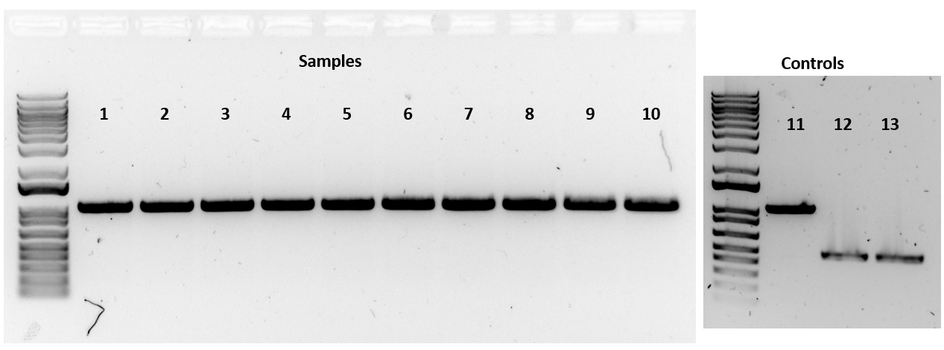

Figure. Banding Patterns for Colony PCR Samples and Controls

The banding patterns were exactly as expected. Each of the ten lysates had a band around 1060 bp. Next time, George and I will review these results and prepare the samples for sequencing.

Friday, March 29, 2024
To Do:
- Work on suggestions from Steve for checking consistency of ribosome samples
- Supplement 0.5 L BHI and make more supplements
- Work on BBM abstract
- Make CHAH plates
Results and Data:
1 mg/mL β-NAD
- Dissolve 100 mg β -NAD in 100 mL type I ddiH₂0
- Filter-sterilize and prepare 5 mL aliquots in 15 or 50 mL conical tubes
- Store at -20°C

1 mg/mL heme-histidine
- To about 90 mL type I ddiH₂0, add:
  - 100 mg L-histidine
  - 100 mg Hemin–HCL
  - 1 ml 1 N NaOH
- Microwave briefly to dissolve
- Adjust volume to 100 mL by adding type 1 ddiH₂0
- Filter-sterilize and prepare 5 mL aliquots in 15 or 50 mL conical tubes
- Store at -20°C away from light

Monday, April 1, 2024
To Do:
- Work on suggestions from Steve for checking consistency of ribosome samples
- Work on BBM abstract
- Patch plate for Kathryn
- Run Kathryn’s samples on a gel
Results and Data:

Checking Consistency of Ribosome Samples
I can take the A260 readings of random aliquots and read them multiple times to see if there is variability and if the ribosomes are fully dissolved. I can also try warming the aliquots at 37C for different amounts of time to see how long it takes for the A260 reading to become consistent.

Sample ID | A260 (Abs) | ug/uL | pmol/uL | Variance
1a | 1.681 | 11.59 | 4.29 | 0.01
1b | 1.353 | 9.33 | 3.46 | 0.21
1c | 2.876 | 19.83 | 7.35 | 0.69
1d | 1.421 | 9.80 | 3.63 | 0.17
1e | 1.576 | 10.87 | 4.03 | 0.07
1f | 1.254 | 8.65 | 3.20 | 0.26
1g | 1.747 | 12.05 | 4.46 | 0.03
Average | 1.70 | 11.73 | 4.35
2a | 1.317 | 9.08 | 3.36 | 0.15
2b | 1.536 | 10.59 | 3.92 | 0.01
2c | 1.532 | 10.57 | 3.91 | 0.02
2d | 1.451 | 10.01 | 3.71 | 0.07
2e | 2.144 | 14.79 | 5.48 | 0.38
2f | 1.368 | 9.43 | 3.49 | 0.12
Average | 1.56 | 10.74 | 3.98
3a | 1.396 | 9.63 | 3.57 | 0.02
3b | 1.565 | 10.79 | 4.00 | 0.10
3c | 1.425 | 9.83 | 3.64 | 0.00
3d | 1.355 | 9.34 | 3.46 | 0.05
3e | 1.366 | 9.42 | 3.49 | 0.04
3f | 1.432 | 9.88 | 3.66 | 0.00
Average | 1.42 | 9.81 | 3.64

Supplementing BHIc Media
If aliquots of supplements are already made, thaw at room temperature (keeping heme-histidine away from light)
Aseptically add:
- 5 mL 1 mg/mL β-NAD
- 5 mL 1 mg/mL heme-histidine
- 12.5 mL 20% glucose
Use media within 2 weeks.
I supplemented 0.5L of BHIc in a 1L bottle and stored it in the fridge.
I patched a CHAH plate with LVS from a single-use aliquot for Kathryn and stored it in the incubator.
I removed Kathryn’s ten PCR reactions from the thermocycler and ran them on a gel. I poured 100 mL of 1% agarose and mixed it with 11uL SYBRSafe, and I added 3 uL of 6x orange dye to the PCR reactions and vortexed to mix. When the gel had set, I loaded 10 uL of ladder in the first well and 15 uL of the PCR reactions in the subsequent wells. I ran the gel at 113 V for about 45 minutes and imaged using the Gel Doc. The tenth reaction had no band (negative control) and I accidentally cropped it out of the image (below). Reactions 1-7 and 9 had bands around 3.5 kb where Kathryn expected them to be.
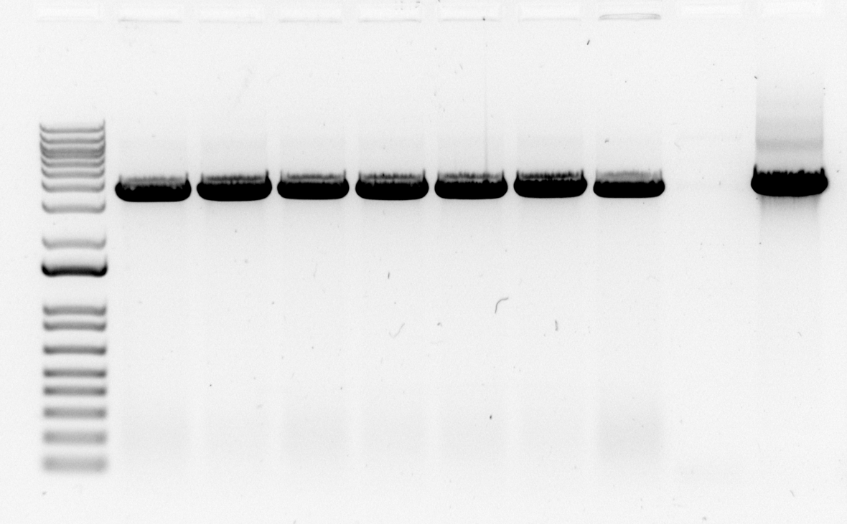

Figure. Gel image with samples from Kathryn’s PCR.

Tuesday, April 2, 2024
To Do:
- Work on plans for splitting protocol
- Low Mg dialysis
Results and Data:
Recap: Yesterday I patched cells for Kathryn and ran her samples on a gel. I also tested the concentration of several LVS aliquots. This morning, I worked on my thesis proposal, and today I need to work on my BBM abstract. I also need to prepare for the low Mg dialysis tonight.

I ran the initial dialysis step for the tight-coupled ribosome purification by dialyzing the sample of LVS ΔrpsU1 ΔrpsU3 ribosomes into low magnesium buffer (H¹⁰M^{0.3}A⁵⁰).

Meeting with Kathryn
Progress
- Plasmids
- Single-reporter assay
- E. coli and LVS isolation and reproducibility
- Ksg inhibits translation in vitro
- Isolation of LVS bS21-2 ribosomes for structure analysis (2 ways)
Next Steps
- Isolate bS21-1, 2, and 3 ribosomes
  - Check Ksg inhibition
  - Check relative pdpA translation
  - Send for mass spectrometry
- Have thesis written by the beginning of August
  - Topic: Developing an in vitro translation assay for Francisella ribosomes
- Begin job search
  - Have QR code to LinkedIn profile
  - Prepare to network with industry contacts at BBM

Wednesday, April 3, 2024
To Do:
- Change low Mg buffer
- High Mg dialysis
Results and Data:
I refreshed the low Mg buffer early in the day and changed the buffer out for high Mg buffer before leaving (around 5 PM).

Thursday, April 4, 2024
To Do:
- Sucrose gradient and fractionation
Results and Data:

Making a Sucrose Gradient
- Have prepared a light solution (i.e. 10% sucrose) and a heavy solution (50% sucrose) that has been autoclaved and filter-sterilized (Solutions were filter-sterilized but not autoclaved.). Sucrose solutions should be in the same buffer as your sample (this was true for all the samples except for sample 2 – in this case the sample was in low magnesium buffer H¹⁰M^{0.3}A⁵⁰ and the sucrose solutions were in high magnesium buffer H¹⁰M¹⁰A⁵⁰). Also prepare about 205 uL of your sample, diluted to 0.6 ug/ul (All samples were diluted to a volume of 100 uL, and the concentrations were not measured.).
- Put a tube in the marker block and draw a line at the top ledge.
- With a 30mL syringe, push into light solution and pump the air bubbles out. Draw out light solution (about 8 mL per gradient) and plunge needle to the very bottom of the tube. Lift the needle as solution pours out, be careful to keep the tip of the needle just under the surface of the solution. Stop at just above the line.
- With a 10mL syringe, push into heavy solution and pump the air bubbles out. Draw out heavy solution, then wipe the needle and push a drop out, dabbing onto a kimwipe (making sure there’s no air). Holding the tube with thumb and middle finger, use forefinger as a guide as you plunge needle to bottom of tube, resting the needle along the wall, and push out gently just enough to form a pool. Keep pushing out solution as you draw up the needle, keeping the tip about 1 cm below the interface of the layers until there is about 2-3mm of space at the top. Make sure needle is resting against the wall of the tube as you quickly draw it out. There should be a visible line between the layers.
- Use light solution to adjust the top layers, making sure all samples are at the same level
- Cap the tubes, making sure the hole is the last part to seal. Some liquid should be visible inside the cap, if there is visible air or you can’t see liquid in cap add some more light solution.
- Turn on gradient station in back, select “GMST”
- Use the up and down keys on the gradient station and the level to level the plate. When level press “done”.
- Put tubes in tube holder (no need to balance); Go to exit -> gradient -> recent-> confirm rotor -> use (confirm 10:50) -> run (recent should be the 10-50% sucrose gradient because that’s the one we have been using. If you need to find a different one go to recent and scroll through)
- Put back in tube rack and refrigerate for 45 minutes. Now is a good time to cool down the ultracentrifuge. (The gradients were refrigerated for 1 hour.)
- Take off caps, remove 40uL of top layer and weigh the samples. Using light solution, adjust as necessary until there is no more than .002 difference in weight.
  - Sample 1 was at 16.897 g and adjusted to 16.900 g, then paired with sample 3.
  - Sample 2 was at 16.977 g and paired with sample 6.
  - Sample 3 was at 16.900 g and paired with sample 1.
  - Sample 4 was at 17.039 g and adjusted to 17.046 g, then paired with sample 5.
  - Sample 5 was at 17.046 g and paired with sample 4.
  - Sample 6 was at 16.931 g and adjusted to 16.977 g, then paired with sample 2.
- Use sample layering device to add 200uL of sample to the top (put tube in tube holder, use both hands for the device, press edge of syringe against farther tube wall and gently push the sample onto the top layer). (I used a P200 pipette to layer 100uL of sample on top of the sucrose gradient.)
- Put samples on ice and bring to INBRE to spin on ultracentrifuge with rotor SW40 Ti. 40,000 rpm for 4 hours at 4C, using 5 for acceleration and deceleration. (Used min for accel and decel.).
- After spin, continue with fractionation protocol.

Fractionating
- Before launching the Triax software, turn fractionator on via button on side, then set fractionator to “scan”
- Choose the username, click “single UV OD scan”. Channel A Wavelength should be 260 nm
- On the bottom of the screen fill out Gradients necessary info (i.e. sample volume, gradient type, speed, etc)
- Under the rotor settings (SW40Ti) select “number of fractions” as the mode to fractionate by
- On the LED Power screen, make sure Channel A is reading between 800,000 and 900,000. Push water through the cell if it needs to be adjusted
- Go to scan set up, make sure everything is filled out correctly
- Go to graph. Pump water through the cell again to calibrate. Y axis should be close to 0, with at least two zeros following the decimal point (e.g. 0.002)
- Purge air through the system, then load the first sample. Cap the sample with the flow cell cap by turning and pushing down and put sample in the flow cell, using bottom lock. Slide it on the fractionator then rotate 90ºC to fix it in place (window should face front)
- Load microcentrifuge tubes in rack in the middle two rows, then put the rack on the fractionator. The 29 should face the back. The dispenser will make a U moving back then left then forwards, so load tubes accordingly.
- On software, hit “start scan”. When all of the tubes are filled, hit “end” to move the tubing to the back. Flush with water for 10 seconds then air for 10 seconds. Repeat for a total of 3 washes. Rinse screw-on cap with DI water.
- Save run as csv when prompted and graph via file -> save graph image.
- Repeat Step 9 for the remaining samples.
- When all of the samples are complete, push water through the flow cell, then flush 5 times with water, 3 times with 70% isopropyl alcohol, and 5 times with air only using the dry syringe. Switch metal lever down to assist with air flushes.
- Flush the line your sample goes through with DI water.
- Save fractions at -20C if interested in proteins, -80C if interested in RNA.

Table. Sucrose Gradient Sample Information
Sample | Strain | Purpose | Date Purified
1 | LVS D1D3 | Pre-Dialysis | 3/1/24
2 | LVS D1D3 | Low Magnesium | 3/1/24
3 | LVS D1D3 | Post-Dialysis | 3/1/24
4 | LVS (BHI) | Control | 1/20/24
5 | EC | Control | 2/10/24
6 | LVS (MHB) | Control | 9/16/23
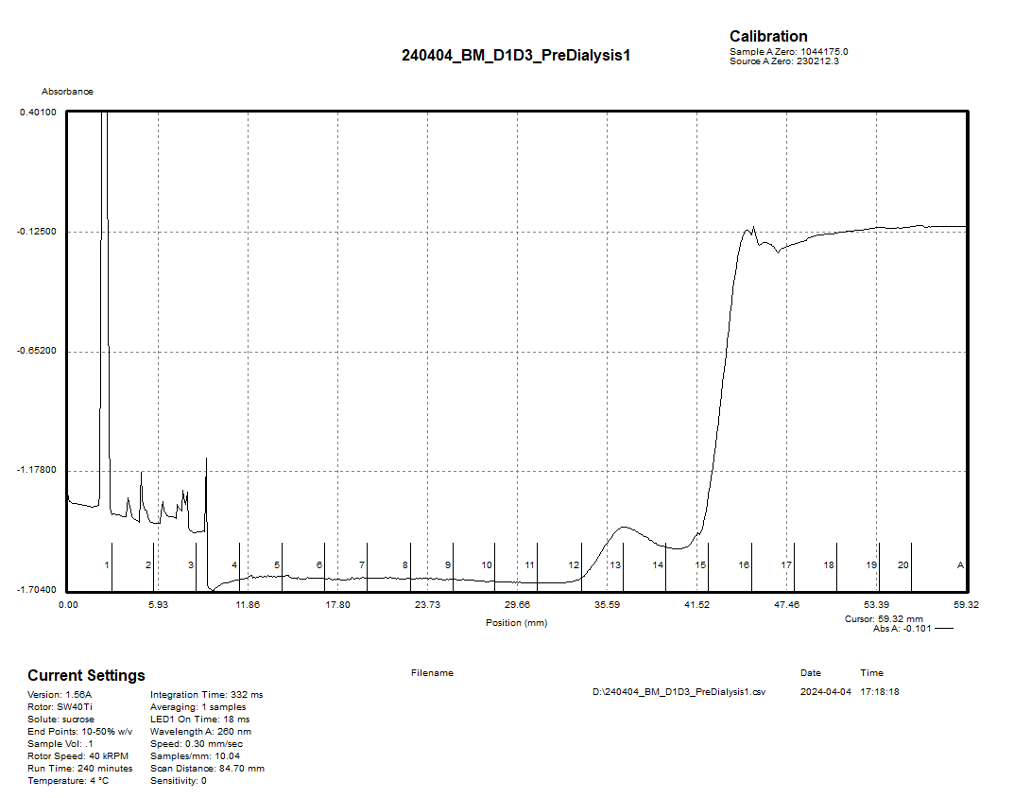

Figure. Graph showing fractions for first half of gradient one (pre-dialysis sample).
The small peak here around fractions 13-14 may be 30S or 50S subunits. Unfortunately, the arm of the fractionator knocked into the flow cell during this run, because the fractionator and flow cell were too close together. We moved them further apart, but the run was interrupted around fraction 17. I ran the rest of the gradient later and obtained the results below.
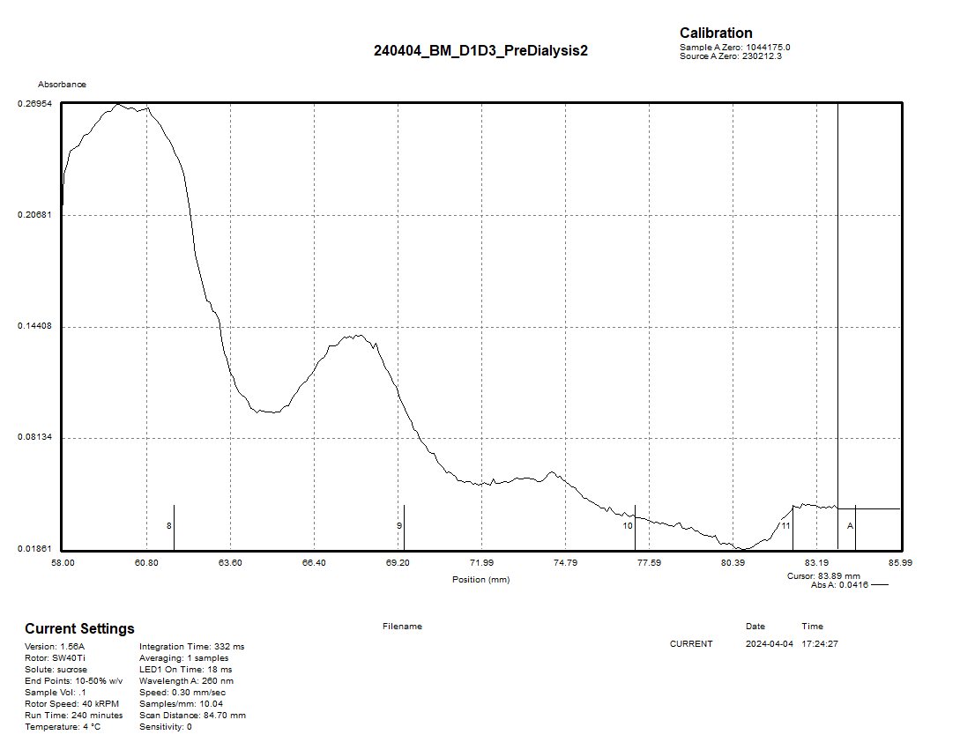

Figure. Graph showing fractions for second half of gradient one (pre-dialysis sample).
The remaining part of the gradient did not produce a clean graph, and it is difficult to identify the peaks. The first peak may be the 70S subunits and the second peak may be polysomes.

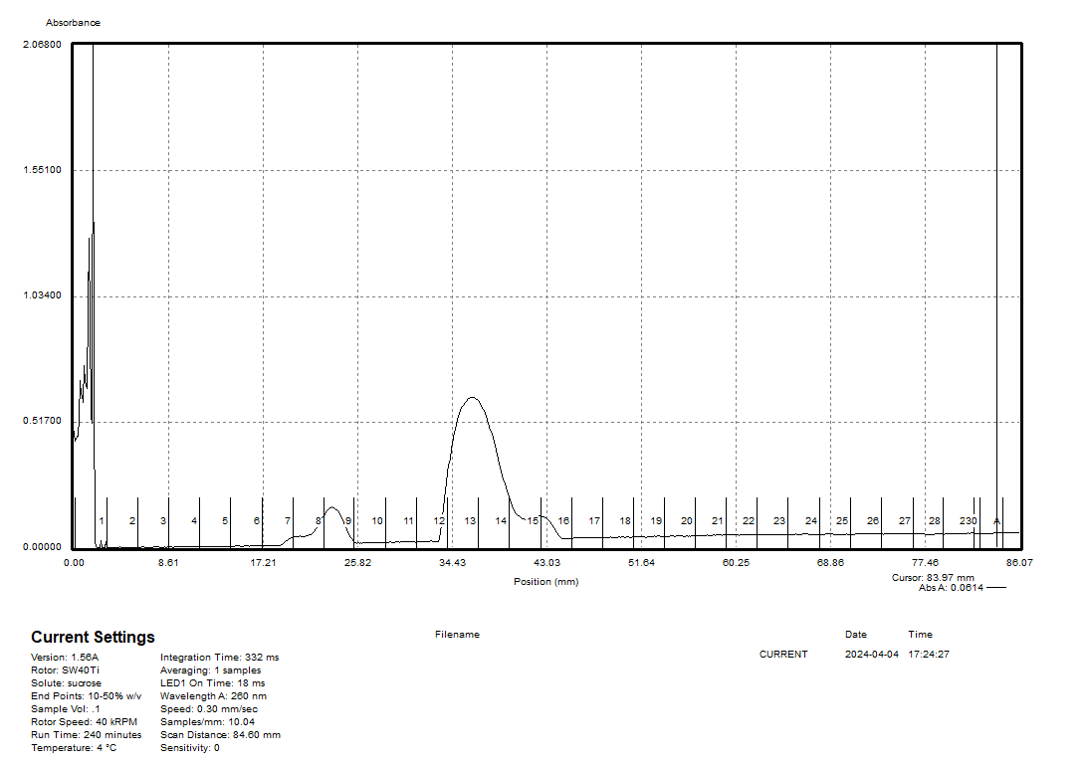

Figure. Graph showing fractions for gradient two (low magnesium sample).
This graph appears to have a 30S peak around fractions 8-9, a 50S peak around fractions 13-14, and a small 70S peak around fractions 15-16. It seems clear that most of the ribosomes have dissociated into 30S and 50S subunits.

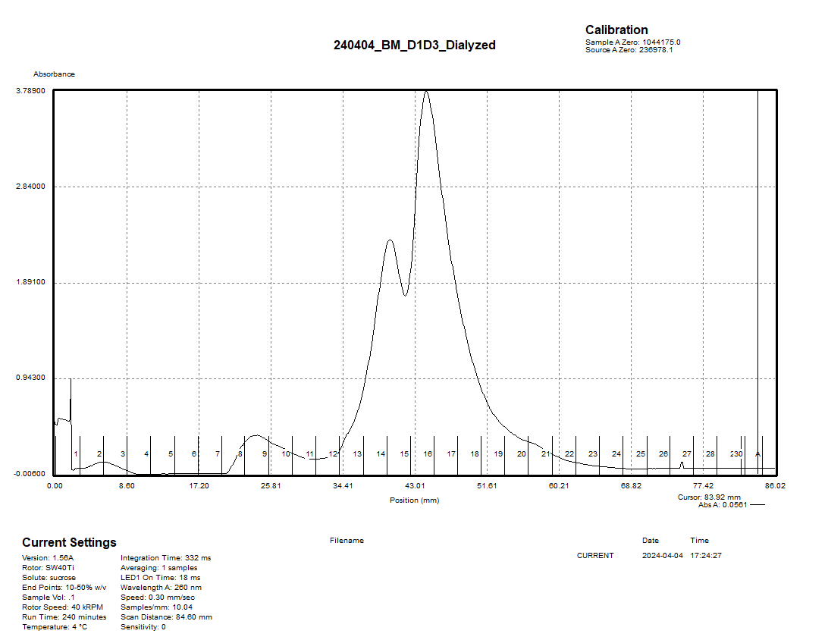

Figure. Graph showing fractions for gradient three (post-dialysis sample).
This was a nice graph clearly showing 30S peak at fraction 8-10, a 50S peak at fractions 14-15, and a 70S peak at fractions 16-18 with no distinct polysomes. It looks like the dialysis worked very well to separate loose-coupled ribosomes, dissociate extra RNA and proteins, and then assemble tight-coupled ribosomes, although there is not a clear comparison between this sample and the pre-dialysis sample. In the future, we may proceed with dialysis without running on a sucrose gradient and see if the dialysis steps are sufficient to produce ribosome samples that give a clear, reproducible signal.

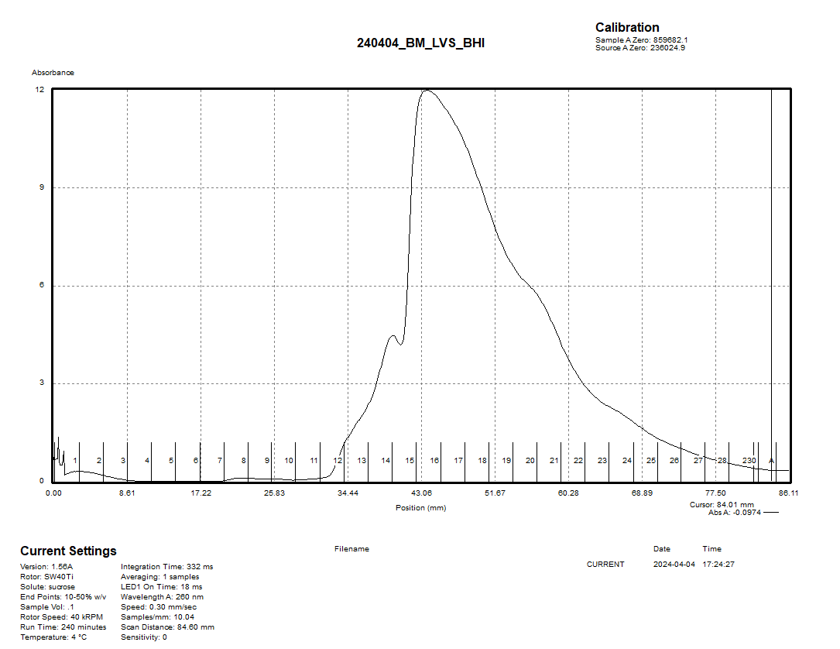

Figure. Graph showing fractions for gradient four (LVS from BHI).
This graph appears to have a 50S peak around fractions 13-15 and a 70S peak around fractions 16-18 with a long tail sloping off gradually which may indicate polysomes or associated translation factors. It seems that most ribosomes present are assembled and actively translating, which is a good sign, but the peak is rather messy indicating the presence of associated RNA and proteins. Running a dialysis to purify tight-coupled ribosomes would probably clean this up quite a bit.
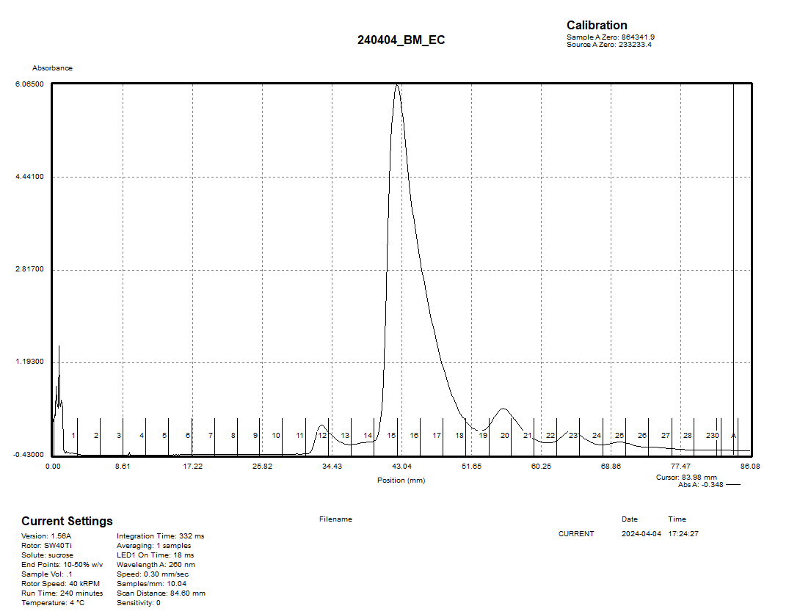

Figure. Graph showing fractions for gradient five (E. coli sample).
This graph shows a peak around fractions 12-13 which may be 30S or 50S subunits, a large 70S peak around fractions 15-18, and smaller peaks above these which may indicate polysomes. It would be interesting to purify tight-coupled E. coli ribosomes and compare them with these.

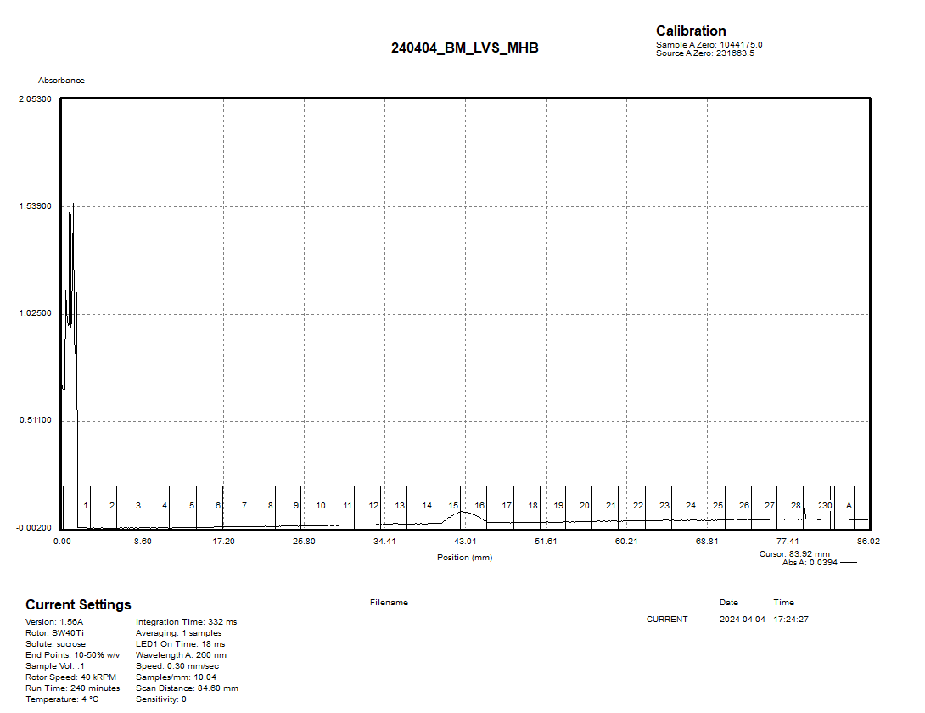

Figure. Graph showing fractions for gradient six (LVS from MHB sample).
It doesn’t look like there were enough ribosomes in this sample to get a distinct signal, but there might be a 70S peak at fractions 15-16.

Friday, April 5, 2024
To Do:
- Make CHAH-Kan plates
Results and Data:
I made CHAH-Kan plates.

Monday, April 8, 2024
To Do:
- Overnight spin for 70S fractions from sucrose gradient
- Work on thesis proposal
- Update lab notebook
- Patch LVS on CHAH for growth of overnight cultures
- Make CHAH plates
Results and Data:
I made small bottles of 20% bleach.

Pelleting 70S Fractions from Sucrose Gradient
I selected fraction samples 16-18 from the dialyzed ribosomes purified on the sucrose gradient and thawed them on ice. I then layered them over 15 mL of H10M10A50 + 40% sucrose in ultracentrifuge tubes. I balanced the tubes to within 0.002 g and spun them in the 50.2 Ti rotor at 30,000 rpm for 23 hours at 4C.

I patched out an LVS single-use aliquot onto CHAH to use for a test of overnight LVS incubation to see how long it takes to grow LVS to an OD of 0.5 from a starting OD of 0.005. I also decided to make more CHAH plates.

Tuesday, April 9, 2024
To Do:
- Prep colony PCR samples for sequencing (George)
- Resuspend tight-coupled ribosome pellets overnight in 50 uL of H10M10A50 buffer
Results and Data:
Today, I worked with George on preparing his PCR samples for sequencing. We reviewed the gel images from the PCR test and talked about the theory behind the sequencing reaction. Then, we decided to use primers KROL683&684 for the sequencing reactions as well. We started filling out the sequencing submission template, then we ran a PCR cleanup and obtained the concentrations of the purified PCR samples with the Nanodrop. We used these concentrations to complete the submission worksheet and calculate the volumes of DNA and water to add to the reactions. Next time, we will make 2.5 uM primer stocks for the primers KROL683&684 and setup the reactions. George will be off next week, so we will review the results when he comes back in the following week.

Table. Nanodrop concentrations of PCR purified FTL_0544 fragments.
Sample ID | ng/uL
1 | 95.1
2 | 70.2
3 | 80.9
4 | 84.2
5 | 91.4
6 | 72.1
7 | 80.7
8 | 93
9 | 86.4
10 | 115.4

Resuspending Tight-Coupled Ribosome Pellets
I washed the pellets twice briefly with 10 mL H10M10A50 buffer, then I added 50 uL buffer to resuspend and put them on the orbital shaker overnight. The pellet for fraction 16 dislodged along with an orange film when I added the 50 uL buffer, and it is possible that the pellets became smaller after the washes. 50 uL was enough volume to resuspend the pellets.

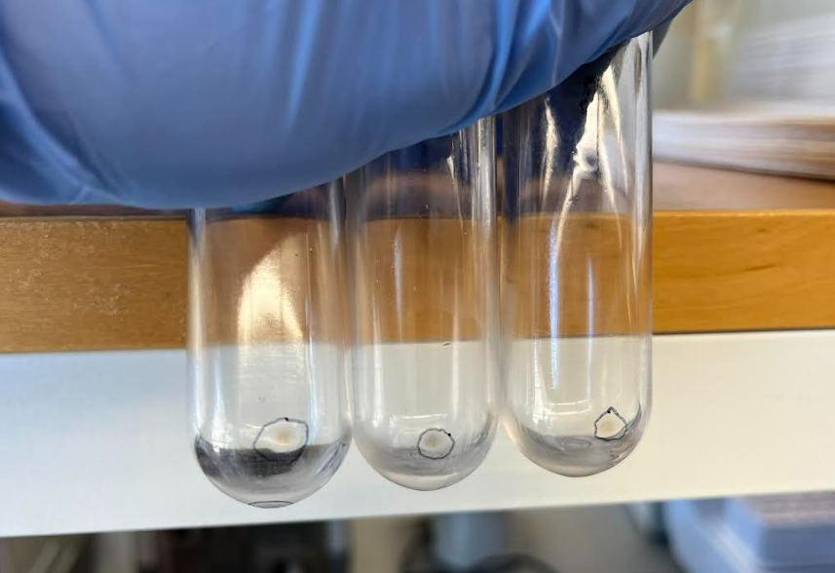

Figure. 70S pellets after 23-hour spin.

Wednesday, April 10, 2024
To Do:
- Measure concentration of tight-coupled ribosomes
- Aliquot and freeze tight-coupled ribosomes
- Suspend LVS cells and warm BHI media
- Inoculate overnight cultures
- Remeasure concentrations for LVS ribosome samples
Results and Data:

Ribosome Purification Day Three
- Pellet any remaining debris in the microfuge at max speed for 5 mins.
- Save the supernatant without aspirating the pellet.
- Take the average A260 reading for each sample (undiluted), then divide by 14.5 to give you the concentration in micrograms per microliter. Take that number and divide by 2.7 to get the concentration in pmol per microliter. If the concentration is still too high to read, make a greater dilution and multiply by the appropriate dilution factor.
- Spin the tubes briefly in benchtop microcentrifuge, and freeze at -80 °C.

Table. Absorbance values for purified 70S ribosome samples.
Sample ID | A260 (Abs)
16a | 2.86
16b | 2.764
17a | 1.673
17b | 1.625
18a | 1.349
18b | 1.338
Combined_a | 1.756
Combined_b | 1.797
Combined_c | 1.805

Table. Sample data for LVS ΔrpsU1 ΔrpsU3 70S ribosomes after fractionation.
A260 | ug/uL | pmol/uL
1.786 | 0.123 | 0.046

Meeting with Kathryn
For the next IVA, I should run the pre and post splitting samples, regular LVS, and E. coli. The concentration of ribosomes in the reactions may be lower than 40 pmol. In the future, I will want to consider running sucrose gradients for purifications and sending LVS samples in for mass spec analysis. My thesis proposal should be done by May 1 or week before (last day of classes is Apr 29).

Inoculating LVS Cultures
- Scrape up one plate per sample of Francisella into a 1.5 mL tube of sBHIc.
- Measure OD of cell suspension.
  - Measurement 1: 50 uL suspension into 950 uL BHI
    - 1.432 OD x 20 = 28.64 OD
  - Measurement 2: 20 uL suspension into 980 uL BHI
    - 0.617 OD x 50 = 30.85 OD
  - Average Measurement: (28.64 + 30.85)/2 = 29.745
- Inoculate 500 ml of sBHIc in 1 liter baffled flasks with correct volume of culture.
- Started flask 1a at 0.001 and flask 1b at 0.0005 at 5 PM.

C1V1=C2V2  (29.745)V1 = (0.001)(500,000)  V1 = 16.81 uL | C1V1=C2V2  (29.745)V1 = (0.0005)(500,000)  V1 = 8.40 uL

Meeting with Kathryn and Steve
Rerun fractions from the 70S portion of LVS on the gradient.
Run a sample on a gradient, then add MNase and run again.
Dialyze into a higher concentration of magnesium.
Compare LVS gradients after FP, FP with Brij, and BB.

Thursday, April 11, 2024
To Do:
- Pellet LVS cells
- Prepare colony PCR samples for sequencing (George)
- Remeasure concentrations for LVS ribosome samples
Results and Data:

Sequencing Colony PCR Samples (George)
I made 2.5 uM primer stocks for KROL683&684 by adding 50 uL of the 10 uM stocks to 150 uL of 0.1xEB. I also diluted the template stocks 1:10 by adding 2 uL of each template stock to 18 uL of 0.1xEB. I set up the reactions as shown in the worksheet below and submitted them for sequencing.
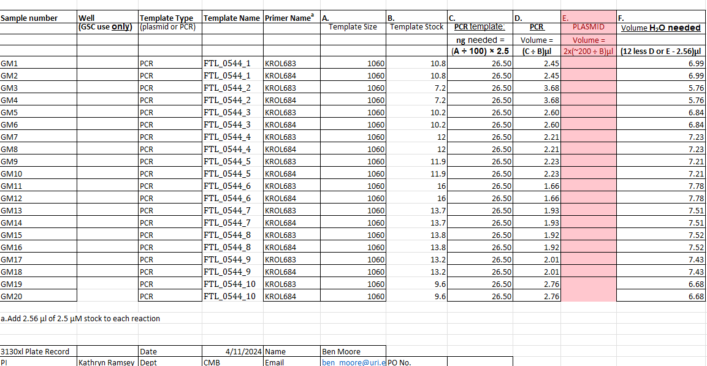

Figure. Sequencing submission sheet for colony PCR samples.

Cell Pelleting
- Incubate with shake at 37 °C to an OD600 of 0.5.

Table. OD600 measurements for Flasks 1a and 1b at various time points.
Time | OD600 for Flask 1a | OD600 for Flask 1b
9:39 AM | 0.126 | 0.031
11:38 AM | 0.296 | 0.101
12:49 PM | 0.474 | 0.153
2:09 PM | - | 0.271
3:46 PM | - | 0.498
- I noticed that flask 1a looked more foamy throughout the incubation than flask 1b.
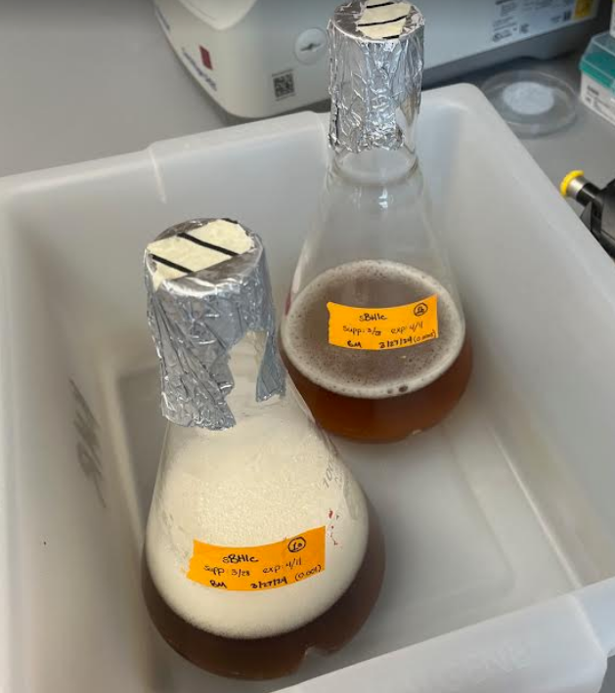

Figure. Comparison of foaminess for flasks 1a and 1b.
- Take a 1 mL sample for whole cell proteins. Add equal amounts OD of 1x SLB (i.e. 0.5 OD, add 0.5 mL 1x SLB). Store sample at -20C.
- Chill the cultures on ice for 20 minutes while chilling F14-6x250 LE rotor to 4˚C. (Can put glass flasks on ice. For flask 1b, I swirled the flask in a bin with ice slurry using the orbital shaker.)
- Transfer cultures to 250 mL bottles and balance them to within 1 g.
- Harvest the cells by centrifuging with lab centrifuge (ThermoScientific Multifuge X Pro Series) at 4˚C for 5 mins at max speed (15,316xg).
- Resuspend the cell pellet in 30 ml H10M10A50 while chilling F13-14x50cy rotor to 4˚C. (Can put 15 mL onto each pellet for faster resuspension, and can use 5 mL serological pipette to resuspend.)
- Transfer resuspension into 50 mL screw-cap tubes and balance them to within 1g.
- Pellet the cells with lab centrifuge (ThermoScientific Multifuge X Pro Series) at 4˚C for 15 mins at max speed (14,635xg).
- Decant the supernatant and find mass of cell pellet (2.18 g)
- Freeze the cell pellet at -80C.
The first time I looked at the data, it seemed that 12-14 hours was a good estimate for overnight growth, starting at 0.005 and ending at 0.5. This time, I started the cultures at lower ODs (0.001 and 0.0005), so I might expect the incubation to take longer. I was also using supplements in the media that were made a while ago (2-3 years ago?), so I’m wondering if this would affect incubation time, even if the supplements had been stored in the freezer and thawed a few times. This time, the flask inoculated at 0.001 took about 19 hours and 45 minutes to reach an OD of 0.5 and the flask inoculated at 0.0005 took about 22 hours and 45 minutes. I think that I can safely inoculate cultures to an OD of 0.001 at 4-5 PM and come in to check them at 9 AM the following day without having them overgrow, unless having fresher supplements would make them grow faster. Next time, I should start them at 0.001 at 5 PM, just to be safe.

Friday, April 12, 2024
To Do:
- Remeasure concentrations for LVS ribosome samples
- Make CHAH plates
- Review George’s sequencing results
Results and Data:
I threw away two ultracentrifuge tubes that had cracks in them. One of them I noticed a crack in after the last ultra spin, and the other had been sitting around for a while, because I was holding on to it in case we might need it for something. I kept the caps for the ultra tubes.

I made more CHAH and CHAH-Kan plates.

Concentrations of LVS Ribosome Samples

 | 1a | 1b | 2a | 2b | 3a | 3b
Average A260 Values | 0.70 | 0.71 | 0.83 | 0.83 | 0.84 | 0.82

Sample A260 Averages | 1a | 1b | 1c | 1d | 1e | 1f | Average
 | 0.8575 | 0.707 | 0.708 | 0.711 | 0.6525 | 0.768 | 0.734
 | 0.783
 | 0.8165
Average | 0.819
Deviation | 0.12 | 0.04 | 0.04 | 0.03 | 0.11 | 0.05

Notes from Journal Club
Western blots were used previously to detect tul4, which is a lipoprotein which localizes to the membrane and has a localization signal peptide which is cleaved off during processing. We can detect full-length and cleaved tul4 on the Western blot. We should try using Brij during the next ribosome purification. We should also try comparing cell lysis using the French press to lysis using the Bug Buster detergent. Next time, we can test Bug Buster lysis, standard French press lysis, and French press lysis using Brij.

Monday, April 15, 2024
To Do:
- Review George’s sequencing results
- Finish next section of thesis proposal
- Patch three plates of CHAH with LVS
Results and Data:
George’s sequencing samples did not have mutations in PPK.

I patched three plates of CHAH with LVS in preparation for a ribosome purification in triplicate this week.

Tuesday, April 16, 2024
To Do:
- Send LVS D1D3 sample to Duke University
- Make 3.5 L supplemented BHI media
- Inoculate 3 L BHI media at starting OD of 0.001
- Write letter of recommendation for George
Results and Data:

Inoculating LVS Cultures
- Warm flasks of sBHIc media in the shaking incubator.
- Scrape up one plate per sample of Francisella into a 1.5 mL tube of sBHIc.
- Measure OD of cell suspension by adding 20 uL of the suspension into 980 uL sBHIc, then taking the OD600 measurement and multiplying by 50.
  - Sample 1: 25.5
  - Sample 2: 27.4
  - Sample 3: 29.95
- Inoculate 500 ml of sBHIc in 1 liter baffled flasks with correct volume of culture to an OD600 of 0.001.
C1V1=C2V2  (25.5)V1 = (0.001)(500,000)  V1 = 19.61 uL | C1V1=C2V2  (27.4)V1 = (0.001)(500,000)  V1 = 18.25 uL | C1V1=C2V2  (29.95)V1 = (0.001)(500,000)  V1 = 16.69 uL
- Began incubation at 5:10 PM.

Sending Ribosome Sample to Duke University
I sent out a sample of tight-coupled LVS ribosomes. These are the same as the last ribosomes we sent, except we also ran them through a splitting protocol where we dialyzed them into low magnesium and then back into high magnesium. We then ran the dialyzed ribosomes on a sucrose gradient, selected the 70S fractions, and purified them using a sucrose cushion. The sample yield is relatively low, but we hope Rajiv and Maria will have enough for their experiments.

LVS ΔrpsU1 ΔrpsU3 Tight-Coupled 70S Ribosomes

190 uL Volume
0.123 mg/uL
0.046 pmol/uL
Resuspended in H10M10A50 buffer:

10 mM HEPES KOH pH 7.6
10 mM MgCl2
50 mM NH4Cl

Tracking no.: 775976107622

Making BHIc Media
For 500 mL:
- Combine in a 1 L bottle:
  - 18.5 g BHI
  - .5 g L-cysteine hydrochloride
  - If preparing sBHIc with 5% KCl, add 25 g KCl (and be sure to label the bottle!)
- Add 480 mL type I ddiH₂0, shake to mix
- Autoclave 30’, let cool
- Store media in the dark for up to 1 month prior to adding supplements

Supplementing BHIc Media
If aliquots of supplements are already made, thaw at room temperature (keeping heme-histidine away from light)
Aseptically add:
- 5 mL 1 mg/mL β-NAD
- 5 mL 1 mg/mL heme-histidine
- 12.5 mL 20% glucose
Use media within 2 weeks.

Wednesday, April 17, 2024
To Do:
- Review George’s sequencing results
- Plan next IVA and sending sample to Duke University
- Finish next section of thesis proposal
Results and Data:

Pelleting LVS Cultures
- Incubate with shake at 37 °C to an OD600 of 0.5.
- I checked the ODs of the cultures at 9:20 AM:
Flask | OD600
1a | 0.155
1b | 0.151
2a | 0.162
2b | 0.133
3a | 0.159
3b | 0.190

- I checked the cultures again at 12:05 PM, and they were ready:
Flask | OD600
1a | 0.492
1b | 0.500
2a | 0.528
2b | 0.454
3a | 0.510
3b | 0.613

- This means that with fresh media it will take about 19 hours for a 500 mL culture of LVS at 0.001 OD600 to reach an OD600 of 0.5.
- Take a 1 mL sample for whole cell proteins. Add equal amounts OD of 1x SLB (i.e. 0.5 OD, add 0.5 mL 1x SLB). Store sample at -20C.
- Chill the cultures by placing the flasks in an ice water bath for 20 minutes and gently swirling.
- Chill F14-6x250 LE rotor to 4˚C.
- Transfer cultures to 250 mL bottles and balance them to within 1 g.
- Harvest the cells by centrifuging with lab centrifuge (ThermoScientific Multifuge X Pro Series) at 4˚C for 5 mins at max speed (15,316xg).
- Resuspend the cell pellet in 30 ml H10M10A50 while chilling F13-14x50cy rotor to 4˚C. (Can put 15 mL onto each pellet for faster resuspension, and can use 5 mL serological pipette to resuspend.)
- Transfer resuspension into 50 mL screw-cap tubes and balance them to within 1g.
- Pellet the cells with lab centrifuge (ThermoScientific Multifuge X Pro Series) at 4˚C for 15 mins at max speed (14,635xg).
- Decant the supernatant and find mass of cell pellet.
Sample | Mass (g)
1 | 2.29
2 | 2.20
3 | 2.66
- Freeze the cell pellet at -80C.

Thursday, April 18, 2024
To Do:
- Begin ribosome purification
Results and Data:

Ribosome Purification Day One
- Thaw the cell pellets and resuspend in 2.5 ml H10M10A50 per gram of cells (recommended: add buffer to increase volume for French Press, so it is at least 13 mL per sample). I added 13 mL per sample.
- Chill the centrifuge rotor.
- Add 20 ul of 1 U/ul DNase.
- Pass once through the French Press set on high with max pressure set to 1280, ensuring that pressure valve is tightened enough. Collect the lysate in 50 mL conical tubes then transfer to 30 ml Oakridge tubes (red caps).
  - Steve ran the first sample through, starting on medium, then switching to high when the pressure went up to about 1200 psi, then slowly released the pressure valve. The cell lysate squirted out faster than he expected, so he had to tighten the valve and slowly release the pressure again. I ran the sample through a second time, trying Steve’s method.
  - I ran the second sample through the way I normally do, on high, with the pressure valve finger-tight. The lysate came out slowly, but the pressure only went up to a few hundred psi. I ran the sample through three more times, and tried Steve’s method on the last two passes.
  - The lysate for sample 2 looked more opaque (less lysed) than for sample 1 (Figure below).
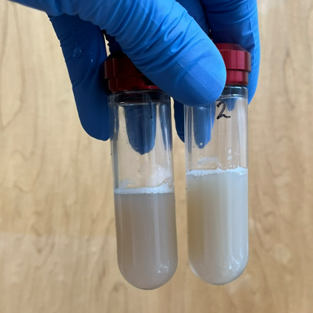

Figure. Lysate for samples 1 and 2.
- Ensure caps and tube rims are dry and balance the Oakridge tubes to within 0.002 g using H10M10A50 buffer.
- Pellet the cell debris in a 70 Ti rotor at 30,000 rpm, 15 minutes, 4 °C. Check the O-rings and add SPINKOTE lubricant if necessary.
- The pellet for sample 1 looked more clearly lysed than the pellet for sample 2. The pellet for sample 2 still had white material (unlysed cells?). Sample 3 also had white material in the pellet. (Figures below)
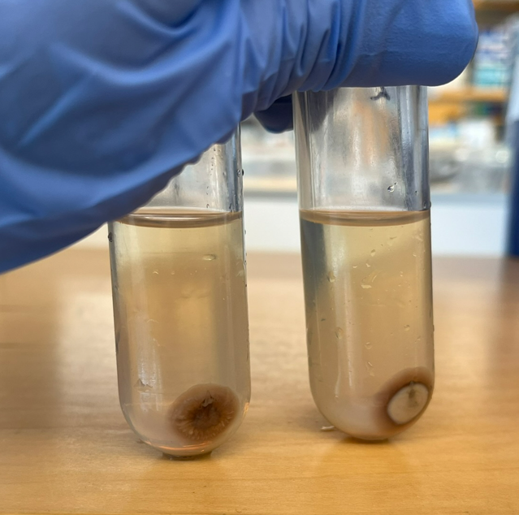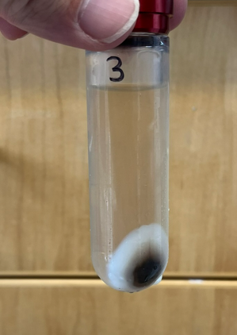

Figures. Pellets for samples 1-3 after 15-min spin.
- Transfer the S30 supernatant avoiding the pellet, to a 15 ml conical tube and add Brij 58 to 0.5 % (1/10 vol of 5 % stock; optional). Incubate on ice for 30 minutes or more. (This was done for sample 2. Sample 1 was also transferred to a 15 mL conical tube without Brij, and both samples were placed on ice at 11:10 AM. They were not removed from ice directly after 30 minutes, because there was some delay as sample 3 was being prepared.)
- Prepared Buffer A + PI + BB (I should have simply added Bug Buster to 1x concentration to H10M10A50 buffer.)

Reagents
Buffer A + PI +BB
Final composition | Stock solutions | For 25 mL
25 mM KHEPES pH 7.9 | 1 M KHEPES | 625 uL
10 mM MgCl₂ | 1 M MgCl₂ | 250 uL
10 mM NH₄Cl | 1 M NH₄Cl | 250 uL
0.5 mM DTT | 0.5 M DTT | 25 uL
1X Bug Buster | 10X Bug Buster | 2.5 mL
10% glycerol | 75% glycerol | 3.3 mL
Water |  | 18 mL
 | + 2 tablets protease inhibitor
Protease inhibitor tablets: Complete Mini EDTA-free Protease Inhibitor Cocktail Tablets, Sigma cat # 11836170001
- Resuspended sample 3 in 20 mL Buffer A + PI + BB.
- Added 20 uL DNase I (Lucigen/Epiceter), mixed by pipetting.
- Incubated sample 3 at 37°C for 30’.
- Collect the lysate in 50 mL conical tubes then transfer to 30 ml Oakridge tubes (red caps).
- Ensure caps and tube rims are dry and balance the Oakridge tubes to within 0.002 g using H10M10A50 buffer.
- Pellet the cell debris in a 70 Ti rotor at 30,000 rpm, 15 minutes, 4 °C. Check the O-rings and add SPINKOTE lubricant if necessary.
- Layered the S30 for samples 1-3 over a 10 ml sucrose cushion, H10M10A500 + 20% sucrose being sure not to let the two layers mix.
- Ensure caps and tube rims are dry and balance the Oakridge tubes to within 0.002 g using H10M10A50 buffer.
- Centrifuge in a 70 Ti rotor at 40,000 rpm, 4 hours, 4 °C. (This spin was started at 2 PM.)
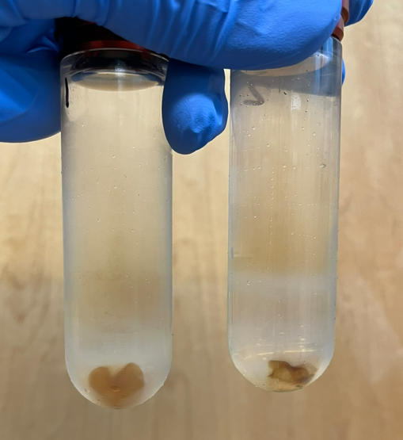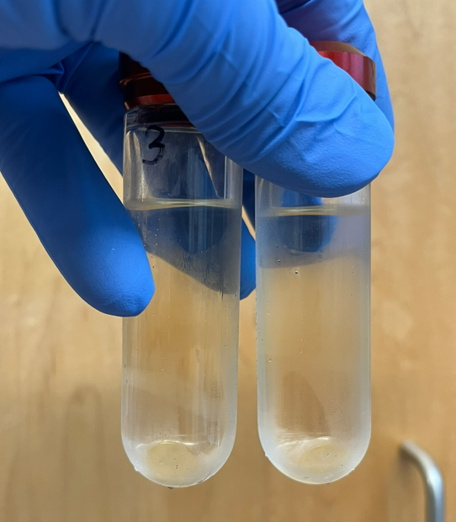

Figures. Ribosome pellets for samples 1-3 after 4-hour spin.
- Rinse the ribosome pellet with 10 mL H10M10A50 twice, without disturbing the pellet, and resuspend it in 1.0 ml of H10M10A50. This may take a while. Do not pipet or vortex. (I need to be more careful during the wash steps to ensure that I am not washing off a significant amount of ribosomes. Sometimes a little orange film remains, but if I resuspend the samples and then spin them at max speed for 5 minutes, there is a small orange pellet that I can discard, so it might be better to be more conservative when washing the ribosome pellets rather than trying to get off all the orange film.)
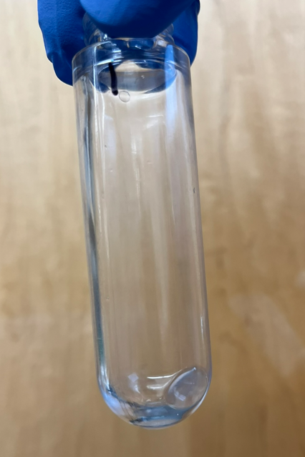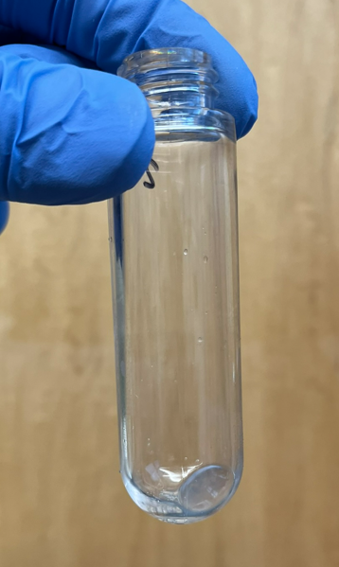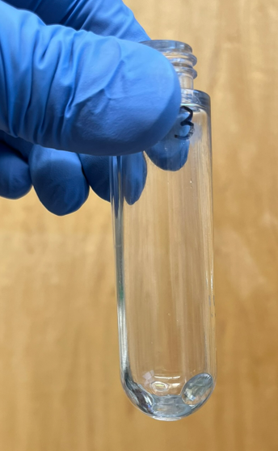

Figures. Ribosome pellets for samples 1-3 after washes.
- Microfuge the suspension for 5 minutes at max speed and keep the supernatant.
- Layer 1 ml of ribosomes onto 15 ml H10M10A50 + 40% sucrose.
- Ensure caps and tube rims are dry and balance the Oakridge tubes to within 0.002 g using H10M10A50 buffer.
- Centrifuge in a 70 Ti rotor at 30,000 rpm, 14 hours, 4°C.

Friday, April 19, 2024
To Do:
- Continue ribosome purification
Results and Data:

Ribosome Purification Day Two
- Microfuge the suspension for 5 minutes at max speed and keep the supernatant.
- Layer 1 ml of ribosomes onto 15 ml H10M10A50 + 40% sucrose. I combined tubes 3 and 4 from the Bug Buster lysis, layering a total of 2 mL of ribosomes. Because of this, I also added about 1 mL more of H10M10A50 buffer to samples 1 and 2.
- Ensure caps and tube rims are dry and balance the Oakridge tubes to within 0.002 g using H10M10A50 buffer.
- Centrifuge in a 70 Ti rotor at 30,000 rpm, 14 hours, 4 °C.
I made CHAH and CHAH-Kan plates.

Saturday, April 20, 2024
To Do:
- Continue ribosome purification
Results and Data:

Ribosome Purification Day Three
- Rinse the pellet with 10 mL H10M10A50 twice, without disturbing the pellet. (I did this each time while counting to 15.)
- Dissolve the ribosome pellet in 250 ul or less (minimal volume, start with 100 uL) of H10M10A50, allowing it to resuspend overnight.

Sunday, April 21, 2024
To Do:
- Continue ribosome purification
Results and Data:
I replaced the ice the samples were placed on and let them resuspend overnight into Monday.

Monday, April 22, 2024
To Do:
- Aliquot and freeze ribosome samples
Results and Data:

Ribosome Purification Day Four
- Pellet any remaining debris in the microfuge at max speed for 5 mins.
- Save the supernatant without aspirating the pellet.
- Take multiple concentration readings from the supernatant by diluting 2 uL in 198 uL of water (1:100 dilution) twice for each sample (add 200 uL water, take out 2 uL water, then add 2 uL ribosomes) and then measuring the concentration of each dilution three times on the Nanodrop.
- Multiply the average A260 reading for each sample (six measurements) by the dilution factor (100), then divide by 14.5 to give you the concentration in micrograms per microliter. Take that number and divide by 2.7 to get the concentration in pmol per microliter. If the concentration is still too high to read, make a greater dilution and multiply by the appropriate dilution factor.
- Use the calculated concentration to dilute the sample to a concentration of 2.666 pmol/uL, then aliquot the stock in 16 uL volumes into PCR strip tubes.
- Spin the tubes briefly in benchtop microcentrifuge, and freeze at -80 °C.

Table. Average A260 values for LVS ribosome samples.
Sample ID | ng/µl | A260 (Abs)
1a1 | 528.3 | 13.207
1a2 | 515.8 | 12.895
1a3 | 514.7 | 12.868
1b1 | 477.3 | 11.933
1b2 | 480.1 | 12.003
1b3 | 480.9 | 12.022
2a1 | 652.2 | 16.305
2a2 | 611 | 15.275
2a3 | 598 | 14.951
2b1 | 637.3 | 15.932
2b2 | 621.7 | 15.542
2b3 | 620.7 | 15.518
3a1 | 391.6 | 9.789
3a2 | 390.8 | 9.77
3a3 | 388 | 9.7
3b1 | 429.4 | 10.736
3b2 | 422.6 | 10.565
3b3 | 429.3 | 10.731

Table. Average A260 values for LVS ribosome samples.
 | Average A260
1a | 13.0
1b | 12.0
2a | 15.5
2b | 15.7
3a | 9.8
3b | 10.7

Table. Sample data for LVS ribosomes.
Sample ID | Diluted? | Dilution Ratio | Date Measured | A260 | ug/uL | pmol/uL | OD600 | Media | Pellet Weight (g) | Volume (uL) Purified | Total Yield (pmol) | Total Yield (nmol)
LVS_1 | Y | 1:100 | 4/22/24 | 12.488 | 86.124 | 31.898 | 0.492, 0.500 | BHI | 2.29 | 120 | 3827.739 | 3.828
LVS_2 | Y | 1:100 | 4/22/24 | 15.587 | 107.498 | 39.814 | 0.528, 0.454 | BHI | 2.2 | 120 | 4777.676 | 4.778
LVS_3 | Y | 1:100 | 4/22/24 | 10.215 | 70.449 | 26.092 | 0.510, 0.613 | BHI | 2.66 | 120 | 3131.086 | 3.131

Tuesday, April 23, 2024
To Do:
- Look at sequencing results (George)
- Prepare samples for whole genome sequencing (George)
- Prepare for sucrose gradients
Results and Data:
George and I looked at the sequencing results for the PPK gene and discussed the fact that there were no obvious mutations. We patched out cloning library strains E2-24, E2-26, and E2-27, and KRLVS294.1 onto CHAH-Kan, and on Thursday we will perform gDNA extraction and send the DNA out for whole-genome sequencing.

Meeting with Kathryn
For the sucrose gradients, load 1200 pmol of sample with buffer added to 150 uL.
Underneath the 70S peak, select alternating fractions, rerunning one on the gradient to see if it runs as a single peak or displays the same overall pattern and running the other on a gel to see what ribosomal RNAs it is composed of. In 30S fractions you expect to see 16S and 5S, and in 50S fractions you expect to see 23S. I should have added 1x Bug Buster directly to 13 mL of H10M10A50 for the last ribosome purification, so that the lysis would have been comparable to the other samples and so the entire supernatant could be layered on a 10 mL sucrose cushion. I can try this next time if we decide to move ahead with the Bug Buster.

Wednesday, April 24, 2024
To Do:
- Update lab notebook
- Prepare for sucrose gradients
Results and Data:

Table. Calculations for preparation of samples.
# | ID | Sample Conc. (pmol/uL) | uL Sample | uL Buffer | pmol
1 | LVS_1 | 31.898 | 38 | 112 | 1200
2 | LVS_2 | 39.814 | 30 | 120 | 1200
3 | LVS_3 | 26.092 | 46 | 104 | 1200
4 | EC_1 | 3.760 | 150 | 0 | 564
5 |  |  |  |  | 1200
6 |  |  |  |  | 1200

A fan on the -80C freezer failed, so we moved everything to the Matthew Ramsey and Dutta freezers.

Thursday, April 25, 2024
To Do:
- Run sucrose gradients
Results and Data:
Recap: Today I am going to run sucrose gradients for the three LVS samples I recently purified. I also need to make sure my lab notebook is updated and plan for the reruns of certain samples from the gradient. George will shadow me and Kira as we work on the gradients. We also have lab meeting, so I will prepare slides for that. Otherwise, I can help Christina and Johanyx.

For the sucrose gradients, load 1200 pmol of sample with buffer added to 150 uL.
Underneath the 70S peak, select alternating fractions, rerunning one on the gradient to see if it runs as a single peak or displays the same overall pattern and running the other on a gel to see what ribosomal RNAs it is composed of. In 30S fractions you expect to see 16S and 5S, and in 50S fractions you expect to see 23S.

Making a Sucrose Gradient
- Have prepared a light solution (i.e. 10% sucrose) and a heavy solution (50% sucrose) that has been autoclaved and filter-sterilized (Solutions were filter-sterilized but not autoclaved.). Sucrose solutions should be in the same buffer as your sample. Also prepare about 205 uL of your sample, diluted to 0.6 ug/ul (My samples were diluted to a volume of 150 uL).
# | ID | Sample Conc. (pmol/uL) | uL Sample | uL Buffer | pmol
1 | LVS_1 | 31.898 | 38 | 112 | 1200
2 | LVS_2 | 39.814 | 30 | 120 | 1200
3 | LVS_3 | 26.092 | 46 | 104 | 1200
4 | EC_1 | 3.760 | 150 | 0 | 564
5 | KB +
6 | KB -

- Put a tube in the marker block and draw a line at the top ledge.
- With a 30mL syringe, push into light solution and pump the air bubbles out. Draw out light solution (about 8 mL per gradient) and plunge needle to the very bottom of the tube. Lift the needle as solution pours out, be careful to keep the tip of the needle just under the surface of the solution. Stop at just above the line.
- With a 10mL syringe, push into heavy solution and pump the air bubbles out. Draw out heavy solution, then wipe the needle and push a drop out, dabbing onto a kimwipe (making sure there’s no air). Holding the tube with thumb and middle finger, use forefinger as a guide as you plunge needle to bottom of tube, resting the needle along the wall, and push out gently just enough to form a pool. Keep pushing out solution as you draw up the needle, keeping the tip about 1 cm below the interface of the layers until there is about 2-3mm of space at the top. Make sure needle is resting against the wall of the tube as you quickly draw it out. There should be a visible line between the layers.
- Use light solution to adjust the top layers, making sure all samples are at the same level
- Cap the tubes, making sure the hole is the last part to seal. Some liquid should be visible inside the cap, if there is visible air or you can’t see liquid in cap add some more light solution.
- Turn on gradient station in back, select “GMST”
- Use the up and down keys on the gradient station and the level to level the plate. When level press “done”.
- Put tubes in tube holder (no need to balance); Go to exit -> gradient -> recent-> confirm rotor -> use (confirm 10:50) -> run (recent should be the 10-50% sucrose gradient because that’s the one we have been using. If you need to find a different one go to recent and scroll through)
- Put back in tube rack and refrigerate for 45 minutes. Now is a good time to cool down the ultracentrifuge.
- Take off caps, remove 40uL of top layer and weigh the samples. Using light solution, adjust as necessary until there is no more than .002 difference in weight.
  - Sample 1 was at 16.897 g and adjusted to 16.900 g, then paired with sample 3.
  - Sample 2 was at 16.977 g and paired with sample 6.
  - Sample 3 was at 16.900 g and paired with sample 1.
  - Sample 4 was at 17.039 g and adjusted to 17.046 g, then paired with sample 5.
  - Sample 5 was at 17.046 g and paired with sample 4.
  - Sample 6 was at 16.931 g and adjusted to 16.977 g, then paired with sample 2.
- Use sample layering device to add 200uL of sample to the top (put tube in tube holder, use both hands for the device, press edge of syringe against farther tube wall and gently push the sample onto the top layer). (I used a P200 pipette to layer 150 uL of sample on top of sucrose gradient.)
- Put samples on ice and bring to INBRE to spin on ultracentrifuge with rotor SW40 Ti. 40,000 rpm for 4 hours at 4C, using 5 for acceleration and deceleration. (Used CBLS centrifuge and min setting for accel and decel.).
- After spin, continue with fractionation protocol.

Fractionating
- Before launching the Triax software, turn fractionator on via button on side, then set fractionator to “scan.” (You must turn on the fractionator and the flow cell.)
- Choose the username, click “single UV OD scan”. Channel A Wavelength should be 260 nm
- On the bottom of the screen fill out Gradients necessary info (i.e. sample volume, gradient type, speed, etc)
- Under the rotor settings (SW40Ti) select “number of fractions” as the mode to fractionate by
- On the LED Power screen, make sure Channel A is reading between 800,000 and 900,000. Push water through the cell if it needs to be adjusted
- Go to scan set up, make sure everything is filled out correctly
- Go to graph. Pump water through the cell again to calibrate. Y axis should be close to 0, with at least two zeros following the decimal point (e.g. 0.002)
- Purge air through the system, then load the first sample. Cap the sample with the flow cell cap by turning and pushing down and put sample in the flow cell, using bottom lock. Slide it on the fractionator then rotate 90ºC to fix it in place (window should face front)
- Load microcentrifuge tubes in rack in the middle two rows, then put the rack on the fractionator. The 29 should face the back. The dispenser will make a U moving back then left then forwards, so load tubes accordingly.
- On software, hit “start scan”. When all of the tubes are filled, hit “end” to move the tubing to the back. Flush with water for 10 seconds then air for 10 seconds. Repeat for a total of 3 washes. Rinse screw-on cap with DI water.
- Save run as csv when prompted and graph via file -> save graph image.
- Repeat Step 9 for the remaining samples.
- When all of the samples are complete, push water through the flow cell, then flush 5 times with water, 3 times with 70% isopropyl alcohol, and 5 times with air only using the dry syringe. Switch metal lever down to assist with air flushes.
- Flush the line your sample goes through with DI water.
- Save fractions at -20C if interested in proteins, -80C if interested in RNA.

Table. Sucrose Gradient Sample Information
Sample | Strain | Purpose | Date Purified
1 | LVS | French Press | 4/22/24
2 | LVS | French Press with Brij | 4/22/24
3 | LVS | Bug Buster | 4/22/24
4 | EC | Control | 2/10/24
5 | Kira’s + sample | Control | ?
6 | Kira’s - sample | Control | ?

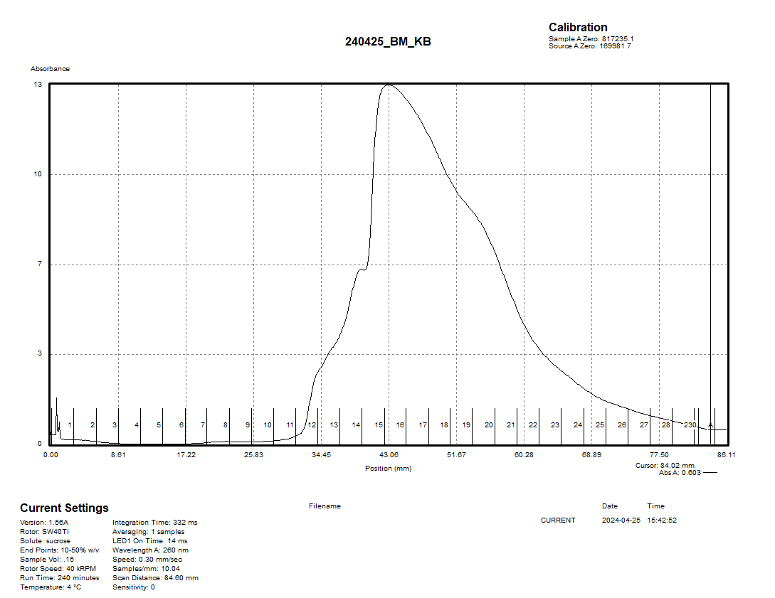

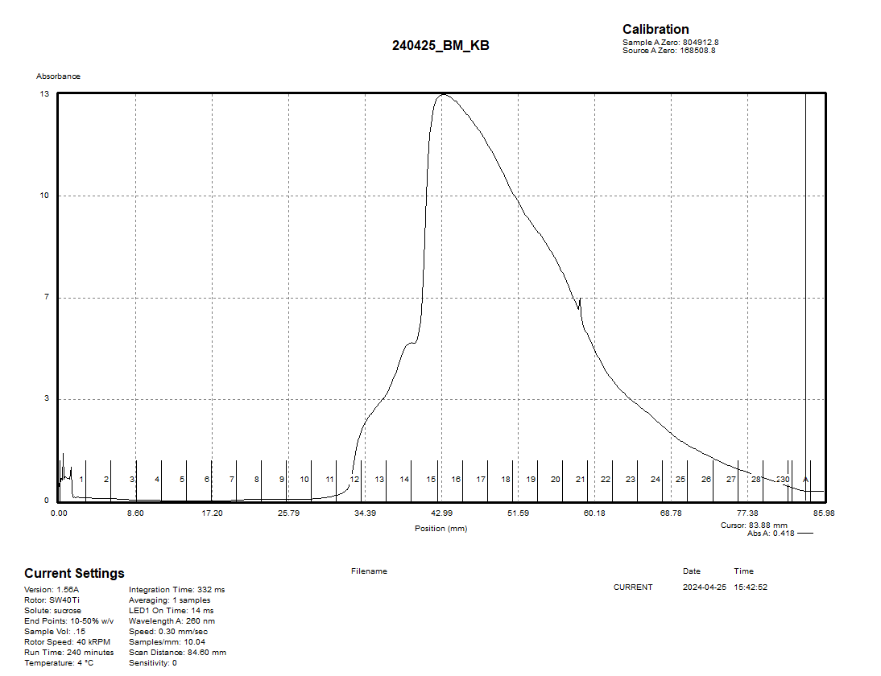

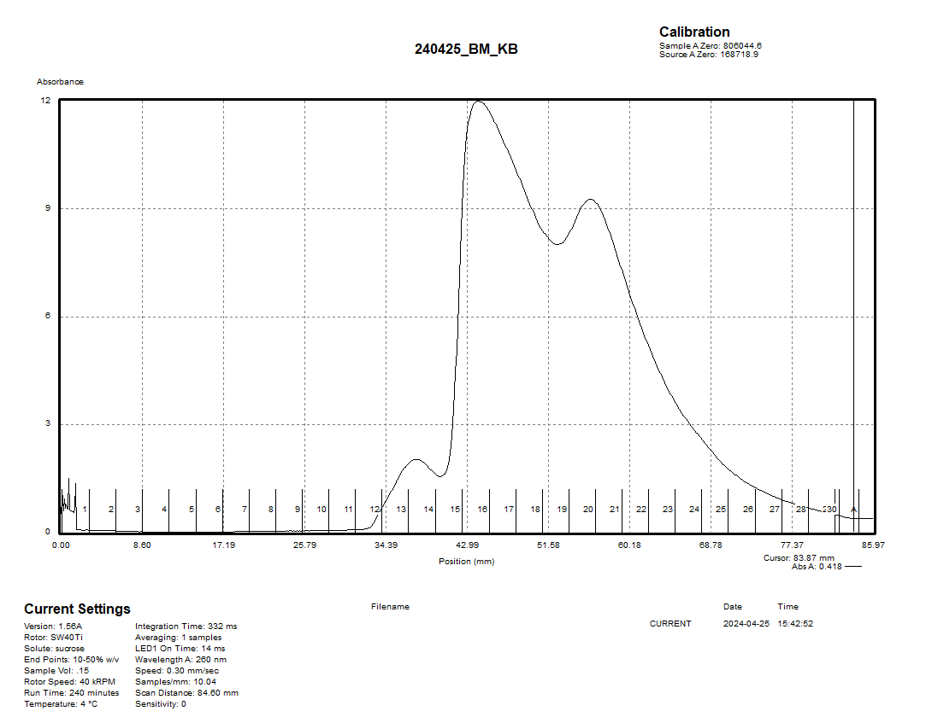

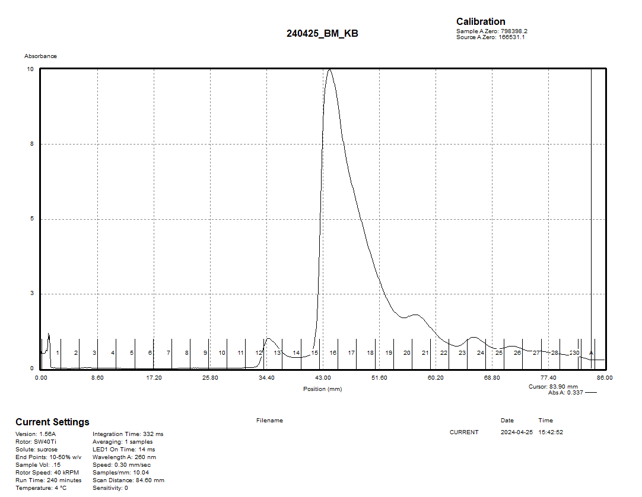

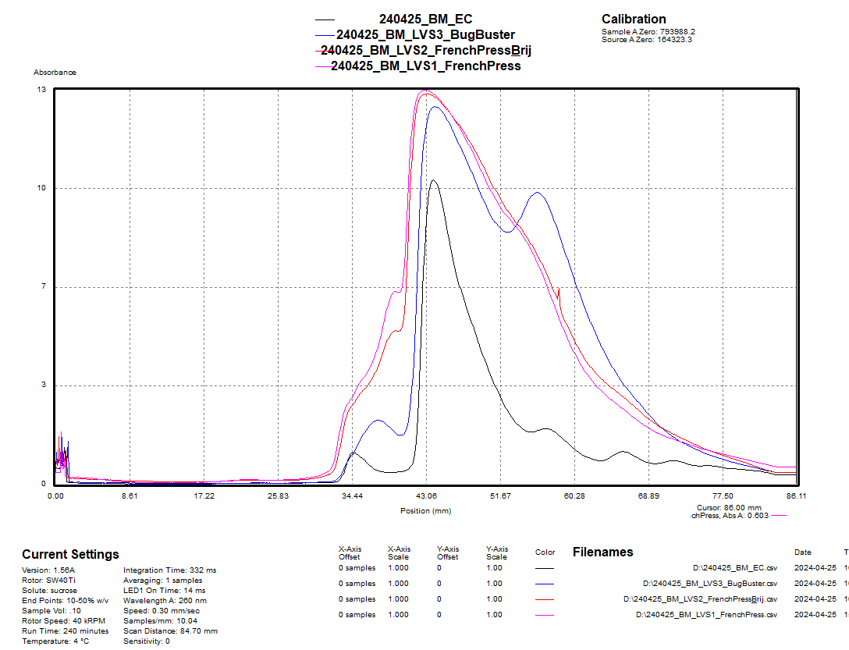
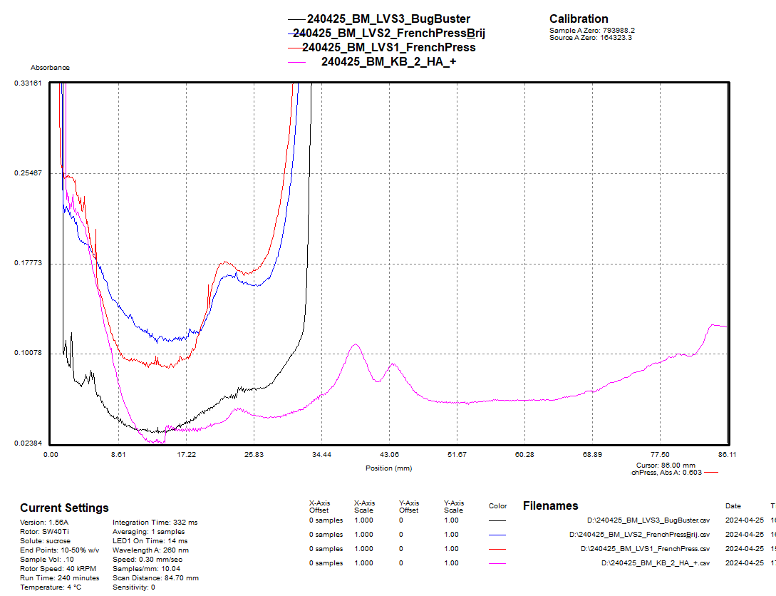

Friday, April 26, 2024
To Do:
- Plan for next round of sucrose gradients
Results and Data:
Recap: Today, I should talk to Kathryn about the results of the sucrose gradients and see which fractions she wants me to rerun. I can plan for the next round of gradients and run them next week (Tuesday?). I will have joint lab meeting and seminar today, and I will need to read the paper in preparation for journal club. I can work on my thesis proposal or on career development.

R: Plan ahead for next round of gradients.
P: Thesis proposal.
S: Make buffers, plan for gDNA extraction.

Bibliography
Ramsey, K. M. and Dove, S. L. (2016) ‘A response regulator promotes Francisella tularensis intramacrophage growth by repressing an anti-virulence factor’, Molecular Microbiology. doi: 10.1111/mmi.13418.

