Table of Contents
May 2024 2
Wednesday, May 1, 2024 2
Making a Sucrose Gradient 2
Fractionating 4
Table. Sucrose Gradient Sample Information 4
Reagents 4
Thursday, May 2, 2024 5
Table. DNA concentrations for George’s samples after 1:20 dilution. 5
Buffers for Purification of Tight-Coupled Ribosomes 5
Friday, May 3, 2024 6
Buffers for Purification of Tight-Coupled Ribosomes 6
Monday, May 6, 2024 7
Making a Sucrose Gradient 7
Table. Calculations for bringing samples to desired Mg molarity and volume of 200 uL. 7
Fractionating 8
Table. Sucrose Gradient Sample Information 9
Figure. Sucrose gradient for LVS French Press pre-dialysis sample. 10
Figure. Sucrose gradient for LVS French Press 0.3mM Mg sample. 10
Figure. Sucrose gradient for LVS French Press 3mM Mg sample. 10
Figure. Sucrose gradient for LVS French Press 6mM Mg sample. 11
Figure. Sucrose gradient for LVS French Press 10mM Mg sample. 11
Figure. Sucrose gradient for LVS French Press 12mM Mg sample. 12
Tuesday, May 7, 2024 12
Making a Sucrose Gradient 12
Table. Calculations for bringing samples to desired Mg molarity and volume of 200 uL. 12
Fractionating 13
Table. Sucrose Gradient Sample Information 14
Wednesday, May 8, 2024 14
Thursday, May 9, 2024 14
Meeting with Kathryn 15
Figure. Comparison of pre-dialysis French press sample from 5/6/24 and initial sucrose gradient from 4/25/24. 16
Figure. Comparison of pre-dialysis Bug Buster sample from 5/6/24 and initial sucrose gradient from 4/25/24 17
Friday, May 10, 2024 17
Inoculating LVS Cultures 17
Saturday, May 11, 2024 18
Monday, May 13, 2024 18
Tuesday, May 14, 2024 18
Wednesday, May 15, 2024 18
Thursday, May 16, 2024 18
Friday, May 17, 2024 18
Bibliography 19

May 2024

Wednesday, May 1, 2024
To Do:
- Refresh Low Mg2+ buffer for French Press sample
- Rerun sucrose gradients for French Press and Bug Buster fractions
- Extract French Press sample from cassette and add MgCl2
- Make more Low Mg2+ buffer
- Make buffers (H¹⁰M^{0.3}A⁵⁰, H¹⁰M¹⁰A⁵⁰, and 10% and 50% sucrose buffers)
- Make more salt solutions
- Dialyze Bug Buster sample in low Mg2+
Results and Data:
I refreshed the Low Mg2+ buffer for the French Press sample and placed it back in the cold room at 11:20 AM. I took it out of the cold room at 10 PM, extracted the sample from the cassette, transferred it to a 1.5 mL tube, and stored it in the -20C.

FP: 16, 18, 20
BB: 16, 18, 20

Making a Sucrose Gradient
- Have prepared a light solution (i.e. 10% sucrose) and a heavy solution (50% sucrose) that has been autoclaved and filter-sterilized (Solutions were filter-sterilized but not autoclaved.). Sucrose solutions should be in the same buffer as your sample. Also prepare about 205 uL of your sample, diluted to 0.6 ug/ul (My samples were diluted to a volume of 150 uL).
# | ID | Sample Conc. (pmol/uL) | uL Sample | uL Buffer | pmol
1 | LVS_1 | 31.898 | 38 | 112 | 1200
2 | LVS_2 | 39.814 | 30 | 120 | 1200
3 | LVS_3 | 26.092 | 46 | 104 | 1200
4 | EC_1 | 3.760 | 150 | 0 | 564
5 | KB +
6 | KB -

- Put a tube in the marker block and draw a line at the top ledge.
- With a 30mL syringe, push into light solution and pump the air bubbles out. Draw out light solution (about 8 mL per gradient) and plunge needle to the very bottom of the tube. Lift the needle as solution pours out, be careful to keep the tip of the needle just under the surface of the solution. Stop at just above the line.
- With a 10mL syringe, push into heavy solution and pump the air bubbles out. Draw out heavy solution, then wipe the needle and push a drop out, dabbing onto a kimwipe (making sure there’s no air). Holding the tube with thumb and middle finger, use forefinger as a guide as you plunge needle to bottom of tube, resting the needle along the wall, and push out gently just enough to form a pool. Keep pushing out solution as you draw up the needle, keeping the tip about 1 cm below the interface of the layers until there is about 2-3mm of space at the top. Make sure needle is resting against the wall of the tube as you quickly draw it out. There should be a visible line between the layers.
- Use light solution to adjust the top layers, making sure all samples are at the same level
- Cap the tubes, making sure the hole is the last part to seal. Some liquid should be visible inside the cap, if there is visible air or you can’t see liquid in cap add some more light solution.
- Turn on gradient station in back, select “GMST”
- Use the up and down keys on the gradient station and the level to level the plate. When level press “done”.
- Put tubes in tube holder (no need to balance); Go to exit -> gradient -> recent-> confirm rotor -> use (confirm 10:50) -> run (recent should be the 10-50% sucrose gradient because that’s the one we have been using. If you need to find a different one go to recent and scroll through)
- Put back in tube rack and refrigerate for 45 minutes. Now is a good time to cool down the ultracentrifuge.
- Take off caps, remove 40uL of top layer and weigh the samples. Using light solution, adjust as necessary until there is no more than .002 difference in weight.
  - Sample 1 was at 16.897 g and adjusted to 16.900 g, then paired with sample 3.
  - Sample 2 was at 16.977 g and paired with sample 6.
  - Sample 3 was at 16.900 g and paired with sample 1.
  - Sample 4 was at 17.039 g and adjusted to 17.046 g, then paired with sample 5.
  - Sample 5 was at 17.046 g and paired with sample 4.
  - Sample 6 was at 16.931 g and adjusted to 16.977 g, then paired with sample 2.
- Use sample layering device to add 200uL of sample to the top (put tube in tube holder, use both hands for the device, press edge of syringe against farther tube wall and gently push the sample onto the top layer). (I used a P200 pipette to layer 150 uL of sample on top of sucrose gradient.)
- Put samples on ice and bring to INBRE to spin on ultracentrifuge with rotor SW40 Ti. 40,000 rpm for 4 hours at 4C, using 5 for acceleration and deceleration. (Used CBLS centrifuge and min setting for accel and decel.).
- After spin, continue with fractionation protocol.

Fractionating
- Before launching the Triax software, turn fractionator on via button on side, then set fractionator to “scan.” (You must turn on the fractionator and the flow cell.)
- Choose the username, click “single UV OD scan”. Channel A Wavelength should be 260 nm
- On the bottom of the screen fill out Gradients necessary info (i.e. sample volume, gradient type, speed, etc)
- Under the rotor settings (SW40Ti) select “number of fractions” as the mode to fractionate by
- On the LED Power screen, make sure Channel A is reading between 800,000 and 900,000. Push water through the cell if it needs to be adjusted
- Go to scan set up, make sure everything is filled out correctly
- Go to graph. Pump water through the cell again to calibrate. Y axis should be close to 0, with at least two zeros following the decimal point (e.g. 0.002)
- Purge air through the system, then load the first sample. Cap the sample with the flow cell cap by turning and pushing down and put sample in the flow cell, using bottom lock. Slide it on the fractionator then rotate 90ºC to fix it in place (window should face front)
- Load microcentrifuge tubes in rack in the middle two rows, then put the rack on the fractionator. The 29 should face the back. The dispenser will make a U moving back then left then forwards, so load tubes accordingly.
- On software, hit “start scan”. When all of the tubes are filled, hit “end” to move the tubing to the back. Flush with water for 10 seconds then air for 10 seconds. Repeat for a total of 3 washes. Rinse screw-on cap with DI water.
- Save run as csv when prompted and graph via file -> save graph image.
- Repeat Step 9 for the remaining samples.
- When all of the samples are complete, push water through the flow cell, then flush 5 times with water, 3 times with 70% isopropyl alcohol, and 5 times with air only using the dry syringe. Switch metal lever down to assist with air flushes.
- Flush the line your sample goes through with DI water.
- Save fractions at -20C if interested in proteins, -80C if interested in RNA. (Fractions were stored at -20C).

Table. Sucrose Gradient Sample Information
Sample | Strain | Purpose | Date Purified
1 | LVS | French Press | 4/22/24
2 | LVS | French Press with Brij | 4/22/24
3 | LVS | Bug Buster | 4/22/24
4 | EC | Control | 2/10/24
5 | Kira’s + sample | Control | ?
6 | Kira’s - sample | Control | ?

Reagents
I made some KHEPES buffer and brought the pH to 7.6. I also tried to make some 5M NH4Cl using ammonium chloride from an old container, but the crystals did not dissolve.

1M Hepes pH 7.6 238.3 g/mol = 23.83 g/ 100 ml = 35.75 g/150 mL = 47.66 g/ 200 ml
pH with 2.14 g KOH/ 100 ml = 4.28 g/ 200 ml

5M NH₄Cl 53.489 g/mol = 8.02 g/ 30 mL for 5M = 13.37 g/50 mL for 5M
32.08/120 mL for 5 M

Thursday, May 2, 2024
To Do:
- Make more Low Mg2+ buffer
- Make buffers (H¹⁰M¹⁰A⁵⁰, and 10% and 50% sucrose buffers)
- Make more salt solutions
Results and Data:
I made some 5M NH4Cl. The solution I tried to make yesterday was still not dissolved, so I may have added too much NH4Cl or maybe it was because I used part of an old container of ammonium chloride.

George and I worked on preparing his samples for sequencing. From SeqCoast Genomics: “If providing gDNA, we request a concentration of >10ng/ul in a volume of at least 30ul. We prefer that sample concentrations be quantified by Qubit or other fluorometry-based techniques, as Nanodrop methods tend to overestimate quantity. Use water or dilute TE for elution.”

We added 2 uL of each sample to 38 uL of 0.1xEB in PCR strip tubes to make 1:20 dilutions and then remeasured them on the NanoDrop to get the following concentrations:

Table. DNA concentrations for George’s samples after 1:20 dilution.
Sample # | Sample ID | User name | Date and Time | Nucleic Acid | Unit
1 | E2-24 | Science | 5/2/2024 11:24:00 AM | 236.4 | ng/µl
2 | E2-26 | Science | 5/2/2024 11:25:15 AM | 77.5 | ng/µl
2 | E2-26 | Science | 5/2/2024 11:26:16 AM | 86.9 | ng/µl
3 | E2-27 | Science | 5/2/2024 11:27:38 AM | 149.7 | ng/µl
4 | KRLVS294.1 | Science | 5/2/2024 11:28:50 AM | 111.2 | ng/µl

Buffers for Purification of Tight-Coupled Ribosomes
H¹⁰M^{0.3}A⁵⁰ (Low Mg Buffer)
10 mM Hepes KOH pH7.6 10 ml 1M Hepes KOH pH 7.6
0.3 mM MgCl₂ 0.3 ml 1M MgCl₂
50 mM NH₄Cl 10 ml 5M NH₄Cl
H₂O to 1000 mL
1000 ml

H¹⁰M^{0.3}A⁵⁰ + 10% sucrose
10 mM Hepes KOH pH7.6 0.5 ml 1M Hepes KOH pH 7.6
10 mM MgCl₂ 15 ul 1M MgCl₂
50 mM NH₄Cl 0.5 ml 5M NH₄Cl
Sucrose 5 g
H₂O to 50 ml
50 ml

H¹⁰M³A⁵⁰ + 10% sucrose
10 mM Hepes KOH pH7.6 0.5 ml 1M Hepes KOH pH 7.6
10 mM MgCl₂ 150 ul 1M MgCl₂
50 mM NH₄Cl 0.5 ml 5M NH₄Cl
Sucrose 5 g
H₂O to 50 ml
50 ml

H¹⁰M⁶A⁵⁰ + 10% sucrose
10 mM Hepes KOH pH7.6 0.5 ml 1M Hepes KOH pH 7.6
10 mM MgCl₂ 300 ul 1M MgCl₂
50 mM NH₄Cl 0.5 ml 5M NH₄Cl
Sucrose 5 g
H₂O to 50 ml
50 ml

H¹⁰M¹²A⁵⁰ + 10% sucrose
10 mM Hepes KOH pH7.6 0.5 ml 1M Hepes KOH pH 7.6
10 mM MgCl₂ 600 ul 1M MgCl₂
50 mM NH₄Cl 0.5 ml 5M NH₄Cl
Sucrose 5 g
H₂O to 50 ml
50 ml

Friday, May 3, 2024
To Do:
- Make 50% sucrose buffers
- Make CHAH and CHAH-Kan plates
Results and Data:
Recap: Today, I was going to run sucrose gradients for the French Press samples that were dialyzed, but I didn’t have enough time, so I made the 50% sucrose buffers and CHAH plates instead. I could also work on some writing. Early next week, I will do the remaining sucrose gradients and dialysis steps.

Buffers for Purification of Tight-Coupled Ribosomes
H¹⁰M^{0.3}A⁵⁰ + 50% sucrose
10 mM Hepes KOH pH7.6 0.5 ml 1M Hepes KOH pH 7.6
10 mM MgCl₂ 15 ul 1M MgCl₂
50 mM NH₄Cl 0.5 ml 5M NH₄Cl
Sucrose 25 g
H₂O to 50 ml
50 ml

H¹⁰M³A⁵⁰ + 50% sucrose
10 mM Hepes KOH pH7.6 0.5 ml 1M Hepes KOH pH 7.6
10 mM MgCl₂ 150 ul 1M MgCl₂
50 mM NH₄Cl 0.5 ml 5M NH₄Cl
Sucrose 25 g
H₂O to 50 ml
50 ml

H¹⁰M⁶A⁵⁰ + 50% sucrose
10 mM Hepes KOH pH7.6 0.5 ml 1M Hepes KOH pH 7.6
10 mM MgCl₂ 300 ul 1M MgCl₂
50 mM NH₄Cl 0.5 ml 5M NH₄Cl
Sucrose 25 g
H₂O to 50 ml
50 ml

H¹⁰M¹²A⁵⁰ + 50% sucrose
10 mM Hepes KOH pH7.6 0.5 ml 1M Hepes KOH pH 7.6
10 mM MgCl₂ 600 ul 1M MgCl₂
50 mM NH₄Cl 0.5 ml 5M NH₄Cl
Sucrose 25 g
H₂O to 50 ml
50 ml

Monday, May 6, 2024
To Do:
- Add MgCl2 to dialyzed French Press sample
- Run dialyzed French Press sample on sucrose gradients
- Dialyze Bug Buster sample in low Mg2+
Results and Data:
Recap: Today I am adding MgCl2 to my dialyzed ribosome samples from the French press purification. I am then running them on sucrose gradients. I am also dialyzing my Bug Buster sample overnight.

Making a Sucrose Gradient
- Have prepared a light solution (i.e. 10% sucrose) and a heavy solution (50% sucrose) that has been autoclaved and filter-sterilized (Solutions were filter-sterilized but not autoclaved.). Sucrose solutions should be in the same buffer as your sample. Also prepare about 205 uL of your sample, diluted to 0.6 ug/ul (My samples were diluted to a volume of 200 uL).

Table. Calculations for bringing samples to desired Mg molarity and volume of 200 uL.
Sample # | Starting Volume (uL) | Desired Volume (uL) | Starting uL MgCl2 | Desired M MgCl2 | Desired uL MgCl2 | Volume MgCl2 to add (uL) | Volume Buffer to add (uL)
1 | 20 | 200 | 2 | 10 | 2 | 0 | 180
2 | 20 | 200 | 0.06 | 0.3 | 0.06 | 0 | 180
3 | 20 | 200 | 0.06 | 3 | 0.6 | 0.54 | 179.5
4 | 20 | 200 | 0.06 | 6 | 1.2 | 1.14 | 178.9
5 | 20 | 200 | 0.06 | 10 | 2 | 1.94 | 178.1
6 | 20 | 200 | 0.06 | 12 | 2.4 | 2.34 | 177.7

- Put a tube in the marker block and draw a line at the top ledge.
- With a 30mL syringe, push into light solution and pump the air bubbles out. Draw out light solution (about 8 mL per gradient) and plunge needle to the very bottom of the tube. Lift the needle as solution pours out, be careful to keep the tip of the needle just under the surface of the solution. Stop at just above the line.
- With a 10mL syringe, push into heavy solution and pump the air bubbles out. Draw out heavy solution, then wipe the needle and push a drop out, dabbing onto a kimwipe (making sure there’s no air). Holding the tube with thumb and middle finger, use forefinger as a guide as you plunge needle to bottom of tube, resting the needle along the wall, and push out gently just enough to form a pool. Keep pushing out solution as you draw up the needle, keeping the tip about 1 cm below the interface of the layers until there is about 2-3mm of space at the top. Make sure needle is resting against the wall of the tube as you quickly draw it out. There should be a visible line between the layers.
- Use light solution to adjust the top layers, making sure all samples are at the same level
- Cap the tubes, making sure the hole is the last part to seal. Some liquid should be visible inside the cap, if there is visible air or you can’t see liquid in cap add some more light solution.
- Turn on gradient station in back, select “GMST”
- Use the up and down keys on the gradient station and the level to level the plate. When level press “done”.
- Put tubes in tube holder (no need to balance); Go to exit -> gradient -> recent-> confirm rotor -> use (confirm 10:50) -> run (recent should be the 10-50% sucrose gradient because that’s the one we have been using. If you need to find a different one go to recent and scroll through)
- Put back in tube rack and refrigerate for 45 minutes (about 55 minutes). Now is a good time to cool down the ultracentrifuge.
- Take off caps, remove 40uL of top layer and weigh the samples. Using light solution, adjust as necessary until there is no more than .002 difference in weight.
- Use sample layering device to add 200uL of sample to the top (put tube in tube holder, use both hands for the device, press edge of syringe against farther tube wall and gently push the sample onto the top layer). (I used a P200 pipette to layer 190 uL of sample on top of sucrose gradient.)
- Put samples on ice and bring to INBRE to spin on ultracentrifuge with rotor SW40 Ti. 40,000 rpm for 4 hours at 4C, using 5 for acceleration and deceleration. (Used CBLS centrifuge and min setting for accel and decel.).
- After spin, continue with fractionation protocol.

Fractionating
- Before launching the Triax software, turn fractionator on via button on side, then set fractionator to “scan.” (You must turn on the fractionator and the flow cell.)
- Choose the username, click “single UV OD scan”. Channel A Wavelength should be 260 nm
- On the bottom of the screen fill out Gradients necessary info (i.e. sample volume, gradient type, speed, etc)
- Under the rotor settings (SW40Ti) select “number of fractions” as the mode to fractionate by
- On the LED Power screen, make sure Channel A is reading between 800,000 and 900,000. Push water through the cell if it needs to be adjusted
- Go to scan set up, make sure everything is filled out correctly
- Go to graph. Pump water through the cell again to calibrate. Y axis should be close to 0, with at least two zeros following the decimal point (e.g. 0.002)
- Purge air through the system, then load the first sample. Cap the sample with the flow cell cap by turning and pushing down and put sample in the flow cell, using bottom lock. Slide it on the fractionator then rotate 90ºC to fix it in place (window should face front)
- Load microcentrifuge tubes in rack in the middle two rows, then put the rack on the fractionator. The 29 should face the back. The dispenser will make a U moving back then left then forwards, so load tubes accordingly.
- On software, hit “start scan”. When all of the tubes are filled, hit “end” to move the tubing to the back. Flush with water for 10 seconds then air for 10 seconds. Repeat for a total of 3 washes. Rinse screw-on cap with DI water.
- Save run as csv when prompted and graph via file -> save graph image.
- Repeat Step 9 for the remaining samples. (The tube for sample 6 tipped over as it was being loaded into the flow cell. Some of the sample was lost and the resulting graph did not read well.)
- When all of the samples are complete, push water through the flow cell, then flush 5 times with water, 3 times with 70% isopropyl alcohol, and 5 times with air only using the dry syringe. Switch metal lever down to assist with air flushes.
- Flush the line your sample goes through with DI water.
- Save fractions at -20C if interested in proteins, -80C if interested in RNA. (Fractions were stored at -20C).

Table. Sucrose Gradient Sample Information
Sample | Strain | Purification Method | Date Purified | Stage | Mg2+ Conc.
1 | LVS | French Press | 4/22/24 | Pre-dialysis | 10 mM
2 | LVS | French Press | 4/22/24 | Low Mg2+ | 0.3 mM
3 | LVS | French Press | 4/22/24 | Post-dialysis | 3 mM
4 | LVS | French Press | 4/22/24 | Post-dialysis | 6 mM
5 | LVS | French Press | 4/22/24 | Post-dialysis | 10 mM
6 | LVS | French Press | 4/22/24 | Post-dialysis | 12 mM
I checked the volume of the Bug Buster ribosome sample (#3) from 4/22/24 and found it to be about 65 uL, so I estimated that I will need about 10 uL for each sample (see table from 4/26/24). I set aside 10 uL for the pre-dialysis sample. I added the rest of the sample to a cassette and floated it in 500 mL of the Low Mg buffer in a 1L beaker and put it on a stir plate in the cold room in the Matthew Ramsey lab at 5:40 PM.

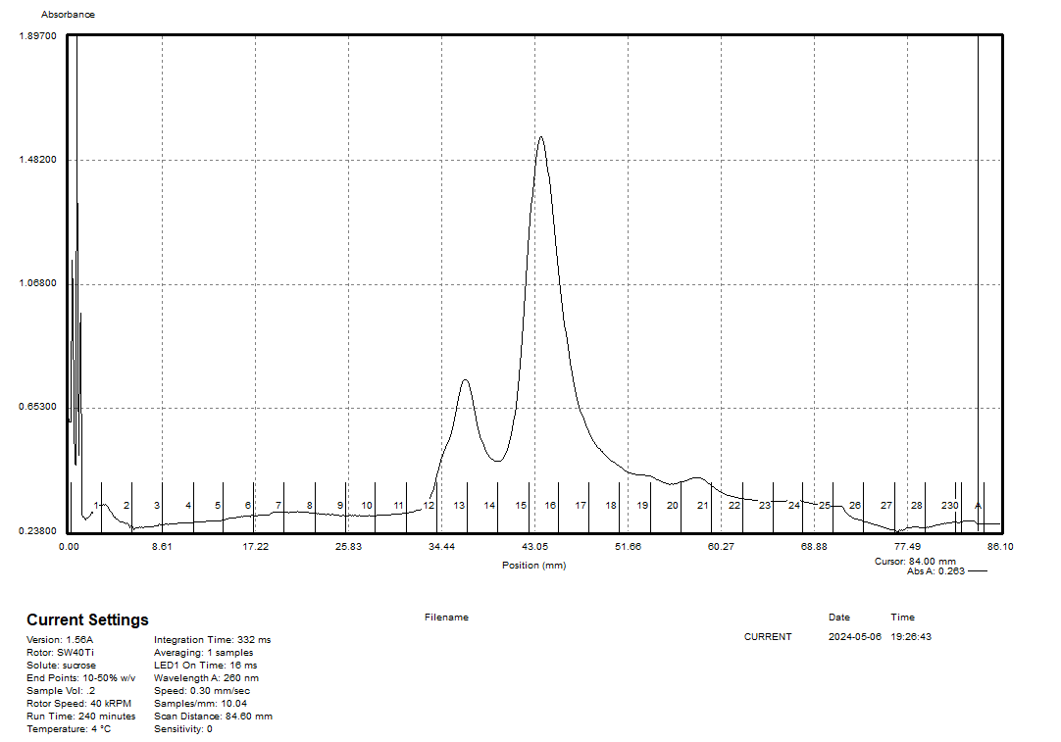

50S and 70S are present.

Figure. Sucrose gradient for LVS French Press pre-dialysis sample.
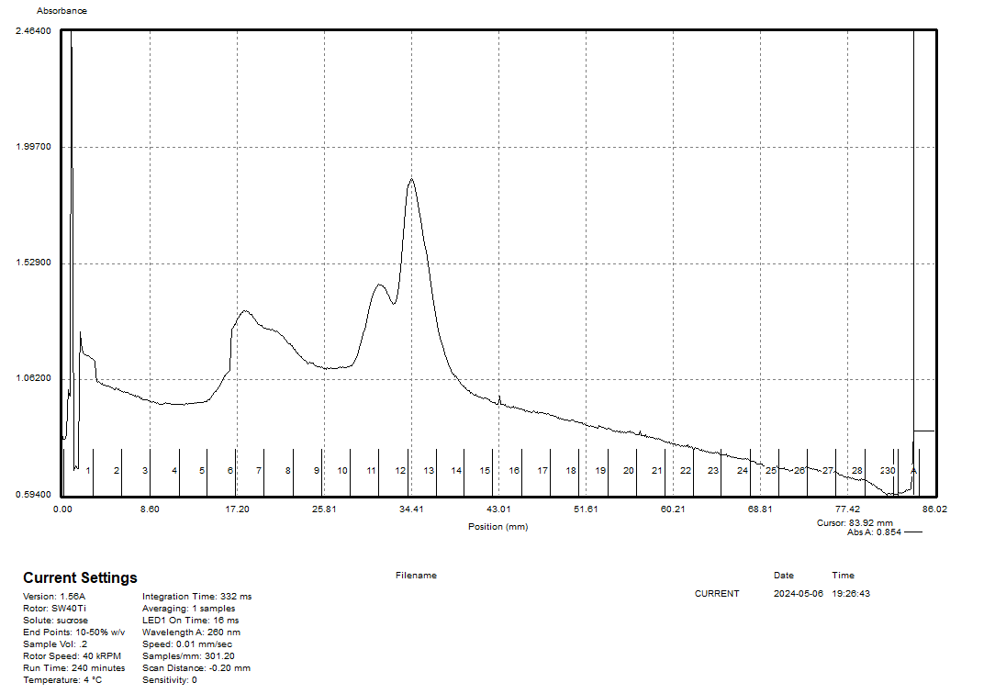

Figure. Sucrose gradient for LVS French Press 0.3mM Mg sample.

30S and strange 50S are present.

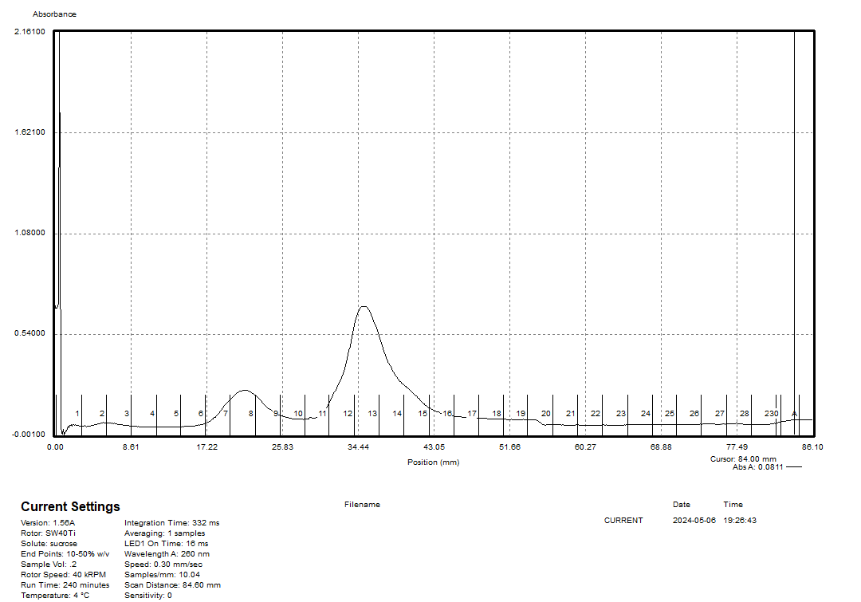

Figure. Sucrose gradient for LVS French Press 3mM Mg sample.

30S and 50S are present.

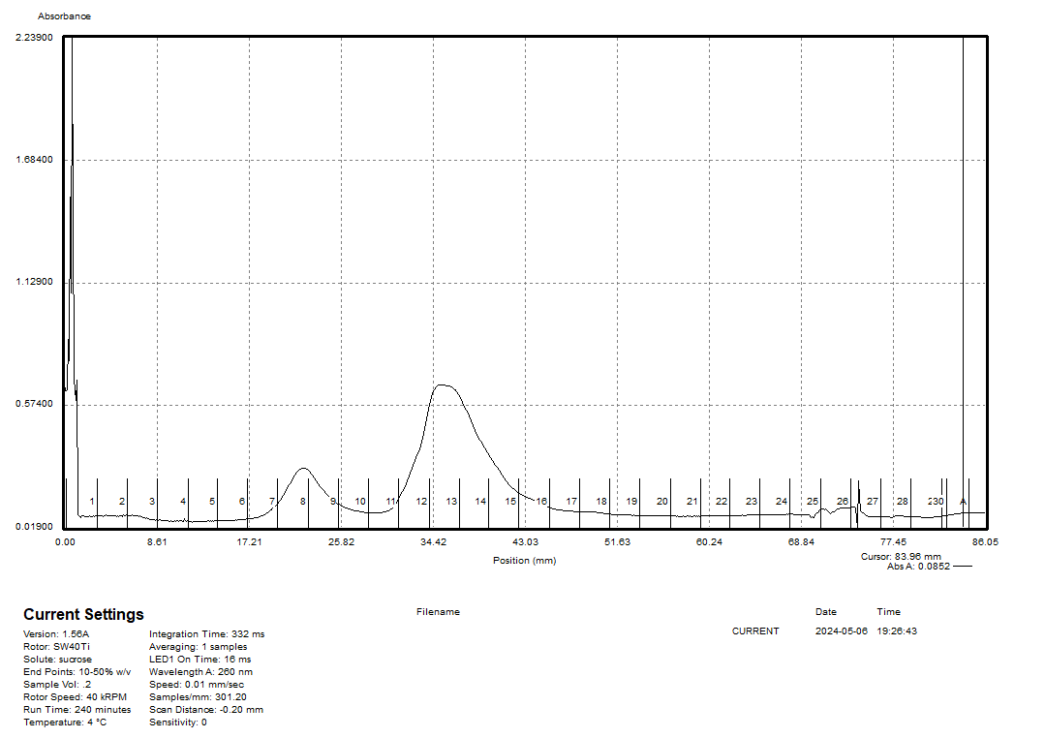

Figure. Sucrose gradient for LVS French Press 6mM Mg sample.

30S and 50S are present.

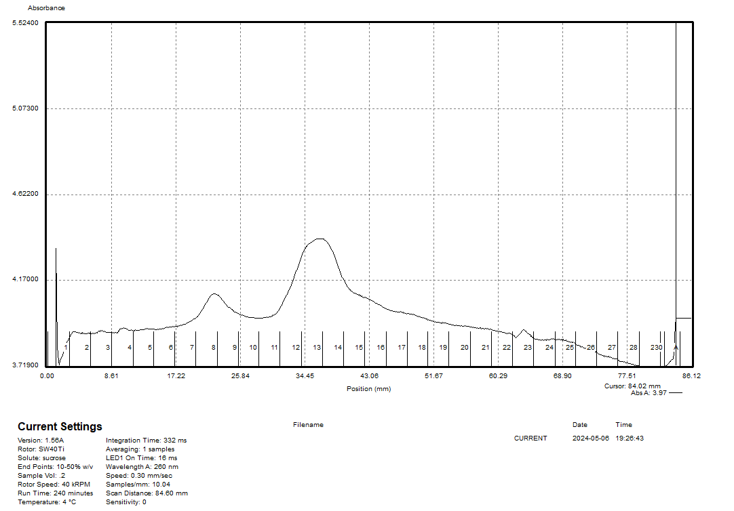

Figure. Sucrose gradient for LVS French Press 10mM Mg sample.

30S and 50S are present.
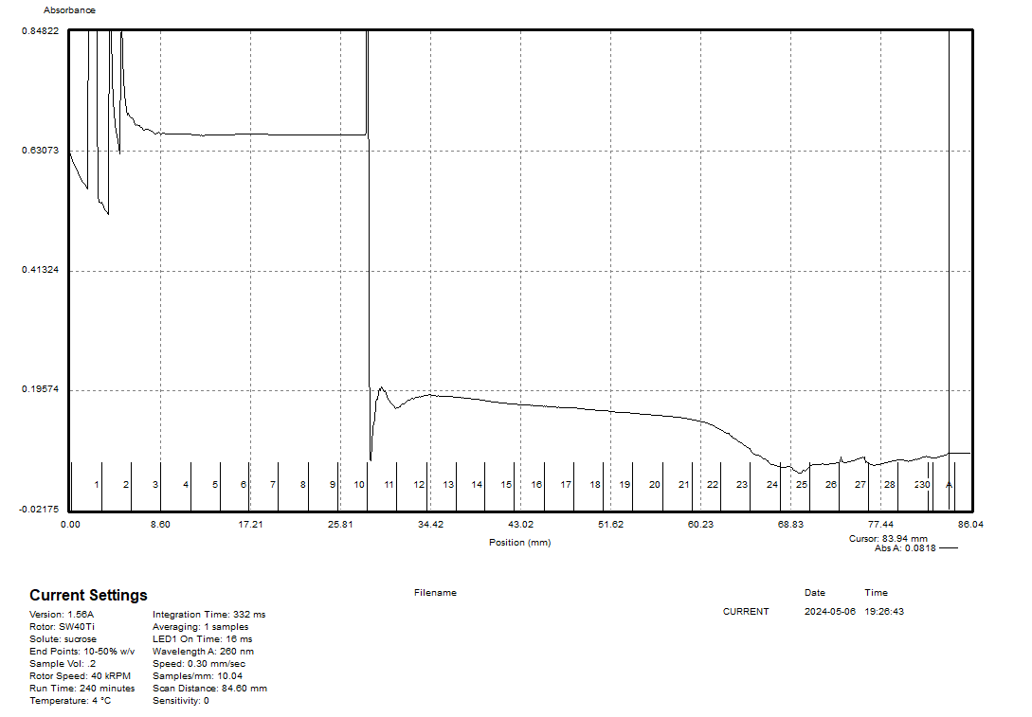

Figure. Sucrose gradient for LVS French Press 12mM Mg sample.

This sample didn’t work out very well, because the tube was knocked over as it was being put into the gradient machine, and some of the sample spilled out.

Tuesday, May 7, 2024
To Do:
- Extract Bug Buster sample from cassette and add MgCl2
- Run dialyzed Bug Buster sample on sucrose gradients
- Send George’s samples out for whole genome sequencing
Results and Data:
I made more H10M10A50 + 10% sucrose buffer.

Making a Sucrose Gradient
- Have prepared a light solution (i.e. 10% sucrose) and a heavy solution (50% sucrose) that has been autoclaved and filter-sterilized (Solutions were filter-sterilized but not autoclaved.). Sucrose solutions should be in the same buffer as your sample. Also prepare about 205 uL of your sample, diluted to 0.6 ug/ul (My samples were diluted to a volume of 200 uL).

Table. Calculations for bringing samples to desired Mg molarity and volume of 200 uL.
Sample # | Starting Volume (uL) | Desired Volume (uL) | Starting uL MgCl2 | Desired M MgCl2 | Desired uL MgCl2 | Volume MgCl2 to add (uL) | Volume Buffer to add (uL)
1 | 10 | 200 | 1 | 10 | 1 | 0 | 190
2 | 20 | 200 | 0.06 | 0.3 | 0.06 | 0 | 180
3 | 20 | 200 | 0.06 | 3 | 0.6 | 0.54 | 179.5
4 | 20 | 200 | 0.06 | 6 | 1.2 | 1.14 | 178.9
5 | 20 | 200 | 0.06 | 10 | 2 | 1.94 | 178.1
6 | 20 | 200 | 0.06 | 12 | 2.4 | 2.34 | 177.7

- Put a tube in the marker block and draw a line at the top ledge.
- With a 30mL syringe, push into light solution and pump the air bubbles out. Draw out light solution (about 8 mL per gradient) and plunge needle to the very bottom of the tube. Lift the needle as solution pours out, be careful to keep the tip of the needle just under the surface of the solution. Stop at just above the line.
- With a 10mL syringe, push into heavy solution and pump the air bubbles out. Draw out heavy solution, then wipe the needle and push a drop out, dabbing onto a kimwipe (making sure there’s no air). Holding the tube with thumb and middle finger, use forefinger as a guide as you plunge needle to bottom of tube, resting the needle along the wall, and push out gently just enough to form a pool. Keep pushing out solution as you draw up the needle, keeping the tip about 1 cm below the interface of the layers until there is about 2-3mm of space at the top. Make sure needle is resting against the wall of the tube as you quickly draw it out. There should be a visible line between the layers.
- Use light solution to adjust the top layers, making sure all samples are at the same level
- Cap the tubes, making sure the hole is the last part to seal. Some liquid should be visible inside the cap, if there is visible air or you can’t see liquid in cap add some more light solution.
- Turn on gradient station in back, select “GMST”
- Use the up and down keys on the gradient station and the level to level the plate. When level press “done”.
- Put tubes in tube holder (no need to balance); Go to exit -> gradient -> recent-> confirm rotor -> use (confirm 10:50) -> run (recent should be the 10-50% sucrose gradient because that’s the one we have been using. If you need to find a different one go to recent and scroll through)
- Put back in tube rack and refrigerate for 45 minutes. Now is a good time to cool down the ultracentrifuge.
- Take off caps, remove 40uL of top layer and weigh the samples (I did not remove the top 40 uL). Using light solution, adjust as necessary until there is no more than .002 difference in weight.
- Use sample layering device to add 200uL of sample to the top (put tube in tube holder, use both hands for the device, press edge of syringe against farther tube wall and gently push the sample onto the top layer). (I used a P200 pipette to layer 190 uL of sample on top of sucrose gradient.)
- Put samples on ice and bring to INBRE to spin on ultracentrifuge with rotor SW40 Ti. 40,000 rpm for 4 hours at 4C, using 5 for acceleration and deceleration. (Used CBLS centrifuge and min setting for accel and decel.).
- After spin, continue with fractionation protocol.

Fractionating
- Before launching the Triax software, turn fractionator on via button on side, then set fractionator to “scan.” (You must turn on the fractionator and the flow cell.)
- Choose the username, click “single UV OD scan”. Channel A Wavelength should be 260 nm
- On the bottom of the screen fill out Gradients necessary info (i.e. sample volume, gradient type, speed, etc)
- Under the rotor settings (SW40Ti) select “number of fractions” as the mode to fractionate by
- On the LED Power screen, make sure Channel A is reading between 800,000 and 900,000. Push water through the cell if it needs to be adjusted
- Go to scan set up, make sure everything is filled out correctly
- Go to graph. Pump water through the cell again to calibrate. Y axis should be close to 0, with at least two zeros following the decimal point (e.g. 0.002)
- Purge air through the system, then load the first sample. Cap the sample with the flow cell cap by turning and pushing down and put sample in the flow cell, using bottom lock. Slide it on the fractionator then rotate 90ºC to fix it in place (window should face front)
- Load microcentrifuge tubes in rack in the middle two rows, then put the rack on the fractionator. The 29 should face the back. The dispenser will make a U moving back then left then forwards, so load tubes accordingly.
- On software, hit “start scan”. When all of the tubes are filled, hit “end” to move the tubing to the back. Flush with water for 10 seconds then air for 10 seconds. Repeat for a total of 3 washes. Rinse screw-on cap with DI water.
- Save run as csv when prompted and graph via file -> save graph image.
- Repeat Step 9 for the remaining samples. (The tube for sample 6 tipped over as it was being loaded into the flow cell. Some of the sample was lost and the resulting graph did not read well.)
- When all of the samples are complete, push water through the flow cell, then flush 5 times with water, 3 times with 70% isopropyl alcohol, and 5 times with air only using the dry syringe. Switch metal lever down to assist with air flushes.
- Flush the line your sample goes through with DI water.
- Save fractions at -20C if interested in proteins, -80C if interested in RNA. (Fractions were stored at -20C).

Table. Sucrose Gradient Sample Information
Sample | Strain | Purification Method | Date Purified | Stage | Mg2+ Conc.
1 | LVS | Bug Buster | 4/22/24 | Pre-dialysis | 10 mM
2 | LVS | Bug Buster | 4/22/24 | Low Mg2+ | 0.3 mM
3 | LVS | Bug Buster | 4/22/24 | Post-dialysis | 3 mM
4 | LVS | Bug Buster | 4/22/24 | Post-dialysis | 6 mM
5 | LVS | Bug Buster | 4/22/24 | Post-dialysis | 10 mM
6 | LVS | Bug Buster | 4/22/24 | Post-dialysis | 12 mM

Wednesday, May 8, 2024
To Do:
- Process data from sucrose gradients
- Update lab notebook
Results and Data:
I updated the chemical inventory with correct locations for chemicals and printed updated Hazcom signs. I processed the data for the sucrose gradients and sent Kathryn a PowerPoint file with comparisons of the graphs.

Thursday, May 9, 2024
To Do:
- Make 2.5 L of sBHIc
- Patch 2 plates of LVS on CHAH
- Work on thesis proposal
Results and Data:
Today I made and supplemented 2.5 L of sBHIc. I also patched out two plates of LVS on CHAH.

For 500 mL:
- Combine in a 1 L bottle:
  - 18.5 g BHI
  - .5 g L-cysteine hydrochloride
  - If preparing sBHIc with 5% KCl, add 25 g KCl (and be sure to label the bottle!)
- Add 480 mL type I ddiH₂0, shake to mix
- Autoclave 30’, let cool
- Store media in the dark for up to 1 month prior to adding supplements
Supplementing media prior to use:
- If aliquots of supplements are already made, thaw at room temperature (keeping heme-histidine away from light)
- Aseptically add:
  - 5 mL 1 mg/mL β-NAD
  - 5 mL 1 mg/mL heme-histidine
  - 12.5 mL 20% glucose
- Use media within 2 weeks

Meeting with Kathryn
Kathryn and I looked at the sucrose gradient graphs from the dialysis of the French press and Bug Buster samples. The pre-dialysis French press sample curve from 5/6/24 does not look the same as the curve for the initial sucrose gradient that I had run those ribosomes on from 4/25/24. Kathryn would like me to purify LVS ribosomes in duplicate using the Bug Buster method with Brij and to resuspend the final pellets in low Mg buffer (0.3 mM Mg²⁺). Then, I should add 1M MgCl2 to 10 uL to reach a concentration of 10 mM Mg²⁺ and incubate on ice overnight. The following morning, I should add 1M MgCl2 to another 10 uL of purified ribosomes to reach a concentration of 10 mM Mg²⁺ and incubate for two hours while I set up sucrose gradients. Then, I can run the ribosomes that were incubated overnight in high Mg along with the ribosomes that were incubated in high Mg for 2 hours and see if 2 hours is long enough to get a good yield of 70S ribosomes or if an overnight incubation is necessary.

I will make and supplement BHI media today and patch LVS so that I can pellet cells tomorrow. If it will take 7 hours for them to grow and I inoculate them at 9 AM, they will be ready at 4 PM, so I should try to get to lab even earlier, like 8 AM. Next week, starting Monday, I can perform the Bug buster lysis and ultra spins, then the overnight resuspension and overnight incubations, followed by the sucrose gradients. This will help us determine the best method for purifying uniform 70S ribosomes.

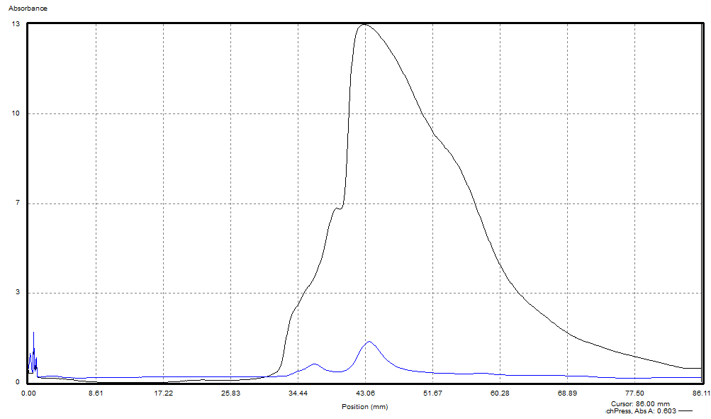

Figure. Comparison of pre-dialysis French press sample from 5/6/24 and initial sucrose gradient from 4/25/24.

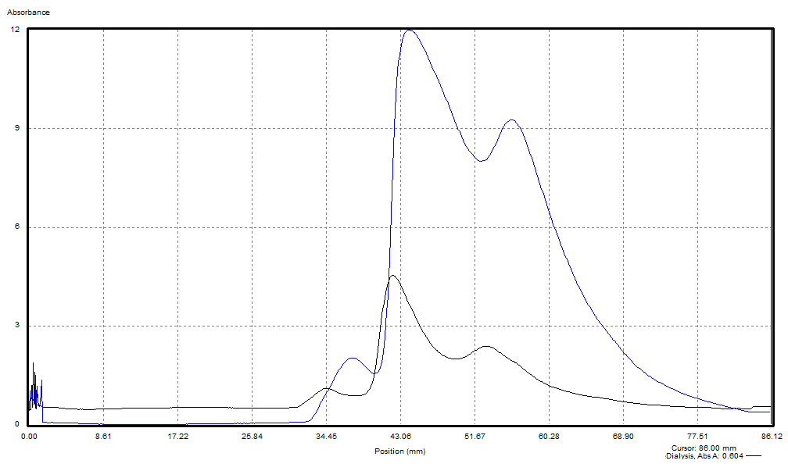

Figure. Comparison of pre-dialysis Bug Buster sample from 5/6/24 and initial sucrose gradient from 4/25/24

Friday, May 10, 2024
To Do:
- Inoculate 2L BHI media with LVS
Results and Data:

Inoculating LVS Cultures
- Warm flasks of sBHIc media in the shaking incubator.
- Scrape up one plate per sample of Francisella into a 1.5 mL tube of sBHIc.
- Measure OD of cell suspension by adding 20 uL of the suspension into 980 uL sBHIc, then taking the OD600 measurement and multiplying by 50.
  - Sample 1: 0.652 x 50 = 32.6
  - Sample 2: 0.546 x 50 = 27.3
- Inoculate 500 ml of sBHIc in 1 liter baffled flasks with correct volume of culture to an OD600 of 0.001.
C1V1=C2V2  (32.6)V1 = (0.001)(500,000)  V1 = 15.34 uL | C1V1=C2V2  (27.3)V1 = (0.001)(500,000)  V1 = 18.32 uL
- Began incubation at 5:10 PM.

Saturday, May 11, 2024
To Do:
- Pellet LVS cells
Results and Data:
Recap:

Pelleting LVS Cultures
- Get two buckets of ice.
- Incubate with shake at 37 °C to an OD600 of 0.5.
- I checked the ODs of the cultures at 12:04 PM, and they were ready:
Flask | OD600
1a | 0.560
1b | 0.553
2a | 0.519
2b | 0.525
- Take a 1 mL sample for whole cell proteins. Add equal amounts OD of 1x SLB (i.e. 0.5 OD, add 0.5 mL 1x SLB). Store sample at -20C.
- Chill the cultures by placing the flasks in an ice water bath for 20 minutes and gently swirling. (30 minutes in ice-water bath.)
- Chill F14-6x250 LE rotor to 4˚C.
- Transfer cultures to 250 mL bottles and balance them to within 1 g.
- Harvest the cells by centrifuging with lab centrifuge (ThermoScientific Multifuge X Pro Series) at 4˚C for 5 mins at max speed (15,316xg).
- Resuspend the cell pellet in 30 ml H10M10A50 while chilling F13-14x50cy rotor to 4˚C. (Can put 15 mL onto each pellet for faster resuspension, and can use 5 mL serological pipette to resuspend.)
- Transfer resuspension into 50 mL screw-cap tubes and balance them to within 1g.
- Pellet the cells with lab centrifuge (ThermoScientific Multifuge X Pro Series) at 4˚C for 15 mins at max speed (14,635xg).
- Decant the supernatant and find mass of cell pellet.
Sample | Mass (g)
1 | 2.62
2 | 2.47
- Freeze the cell pellet at -80C.

Monday, May 13, 2024
To Do:
- Resuspend cells pellets and lyse with Bug Buster
- 15-min ultracentrifuge spin
- 4-hour ultracentrifuge spin
- 14-hour ultracentrifuge spin
Results and Data:

Ribosome Purification Day One
- Thaw the cell pellets and resuspend in 2.5 ml H10M10A50 per gram of cells (recommended: add buffer to increase volume for French Press, so it is at least 13 mL per sample).
- Chill the centrifuge rotor.
- Add Bug Buster to 1x concentration to H10M10A50 buffer. (I added 1.5 mL Bug Buster and 13.5 mL H10M10A50 buffer.)
- Add 20 ul of 1 U/ul DNase.
- Incubate at 37°C for 30’. (I incubated for 35’.)
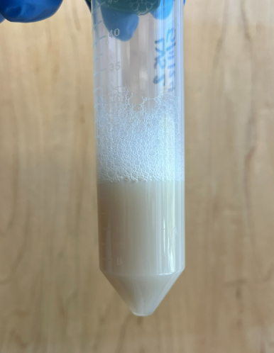

Figure. Cell lysate after 30 minute incubation with Bug Buster.
- Ensure caps and tube rims are dry and balance the Oakridge tubes to within 0.002 g using H10M10A50 buffer.
- Pellet the cell debris in a 70 Ti rotor at 30,000 rpm, 15 minutes, 4 °C. Check the O-rings and add SPINKOTE lubricant if necessary.
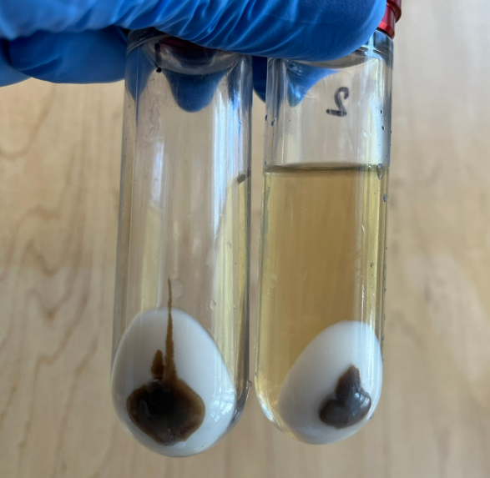

Figure. Pellet and supernatant for samples 1 and 2 after 15-min spin. (Supernatant had already been removed from sample 1.)
- The pellets contained a lot of white cellular matter, indicating that the cells were not fully lysed.
- Transfer the S30 supernatant avoiding the pellet, to a 15 ml conical tube and add Brij 58 to 0.5 % (1/10 vol of 5 % stock). (I added 1.7 mL of 5% Brij 58 to about 15 mL of supernatant.) Incubate on ice for 30 minutes or more.
- Layer the S30 over a 10 ml sucrose cushion, H10M10A500 + 20% sucrose being sure not to let the two layers mix.
- Ensure caps and tube rims are dry and balance the Oakridge tubes to within 0.002 g using H10M10A50 buffer. (It took a while to balance the tubes because they were filled close to the top. Next time, I should resuspend the pellets in a smaller volume of buffer.)
- Centrifuge in a 70 Ti rotor at 40,000 rpm, 4 hours, 4 °C.
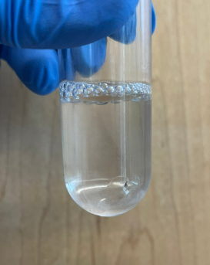

Figure. Ribosome pellet after 4-hour spin.
- Rinse the ribosome pellet with 10 mL H10M10A50 twice, without disturbing the pellet, and resuspend it in 1.0 ml of H10M10A50. This may take a while. Do not pipet or vortex.
- Microfuge the suspension for 5 minutes at max speed and keep the supernatant.
- Layer 1 ml of ribosomes onto 15 ml H10M10A50 + 40% sucrose.
- Ensure caps and tube rims are dry and balance the Oakridge tubes to within 0.002 g using H10M10A50 buffer.
- Centrifuge in a 70 Ti rotor at 30,000 rpm, 14 hours, 4 °C.

Tuesday, May 14, 2024
To Do:
- Resuspend ribosomes overnight in low Mg
Results and Data:

Ribosome Purification Day Two
- Rinse the pellet with 10 mL H10M10A50 twice, without disturbing the pellet.
  - I need to be more careful during the wash steps to ensure that I am not washing off a significant amount of ribosomes. Sometimes a little orange film remains, but if I resuspend the samples and then spin them at max speed for 5 minutes, there is a small orange pellet that I can discard, so it might be better to be more conservative when washing the ribosome pellets rather than trying to get off all the orange film.
- Dissolve the ribosome pellet in 250 ul or less (minimal volume, start with 100 uL) of H10M0.3A50, allowing it to resuspend overnight.
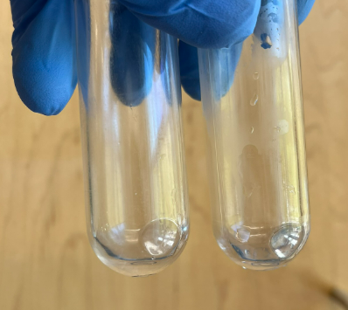

Figure. Ribosome pellets after 14-hour spin.
I made CHAH and CHAH-Kan plates.

Wednesday, May 15, 2024
To Do:
- Recover ribosomes and measure concentration
- Incubate 20 uL ribosomes overnight in high Mg
Results and Data:
I took out the ribosomes and measured their concentration, then I set aside two 20 uL aliquots from sample 1 to test with incubation in high magnesium for two lengths of time (overnight and two hours).

Ribosome Purification Day Three
- Pellet any remaining debris in the microfuge at max speed for 5 mins.
- Save the supernatant without aspirating the pellet.
- Take multiple concentration readings from the supernatant by diluting 2 uL in 198 uL of water (1:100 dilution) twice for each sample (add 200 uL water, take out 2 uL water, then add 2 uL ribosomes) and then measuring the concentration of each dilution three times on the Nanodrop.
- Multiply the average A260 reading for each sample (six measurements) by the dilution factor (100), then divide by 14.5 to give you the concentration in micrograms per microliter. Take that number and divide by 2.7 to get the concentration in pmol per microliter. If the concentration is still too high to read, make a greater dilution and multiply by the appropriate dilution factor.
- Spin the tubes briefly in benchtop microcentrifuge, and freeze at -80 °C.

Table. A260 readings for 1:100 diluted ribosome samples.
Sample ID | A260 (Abs)
1a1 | 6.739
1a2 | 6.74
1a3 | 6.826
1b1 | 6.896
1b2 | 6.891
1b3 | 6.899
2a1 | 5.521
2a2 | 5.517
2a3 | 5.523
2b1 | 5.812
2b2 | 5.827
2b3 | 5.812
1 | 6.832
2 | 5.669

Table. Ribosome sample data for purified ribosomes.
Sample ID | Diluted? | Dilution Ratio | Date Measured | A260 | ug/uL | pmol/uL | OD600 | Media | Pellet Weight (g) | Volume (uL) Purified | Total Yield (pmol) | Total Yield (nmol)
LVS_1 | Y | 1:100 | 5/15/2024 | 6.832 | 47.116 | 17.450 | 0.56, 0.553 | BHI | 2.62 | 120 | 2094.049 | 2.094
LVS_2 | Y | 1:100 | 5/15/2024 | 5.669 | 39.094 | 14.479 | 0.519, 0.525 | BHI | 2.47 | 120 | 1737.522 | 1.738

To the 20 uL aliquot that I wanted to incubate in high magnesium overnight, I added 1.94 uL MgCl2 and 178 uL H10M0.3A50 and mixed by pipetting. Then, I put the sample in a bucket of ice in the fridge.

Table. Calculations for bringing samples to desired Mg molarity and volume of 200 uL.
Starting Volume (uL) | Desired Volume (uL) | Starting uL MgCl2 | Desired M MgCl2 | Desired uL MgCl2 | Volume MgCl2 to add (uL) | Volume Buffer to add (uL)
20 | 200 | 0.06 | 10 | 2 | 1.94 | 178.1

Thursday, May 16, 2024
To Do:
- Incubate 20 uL ribosomes in high Mg for 2 hours
- Set up sucrose gradients
- Collect fractions for ribosomes incubated overnight and for 2 hours
Results and Data:

Making a Sucrose Gradient
- Have prepared a light solution (i.e. 10% sucrose) and a heavy solution (50% sucrose) that has been autoclaved and filter-sterilized (Solutions were filter-sterilized but not autoclaved.). Sucrose solutions should be in the same buffer as your sample. Also prepare about 205 uL of your sample, diluted to 0.6 ug/ul (My samples were diluted to a volume of 200 uL).

Table. Calculations for bringing samples to desired Mg molarity and volume of 200 uL.
Sample # | Starting Volume (uL) | Desired Volume (uL) | Starting uL MgCl2 | Desired M MgCl2 | Desired uL MgCl2 | Volume MgCl2 to add (uL) | Volume Buffer to add (uL, H10M0.3A50)
1 | 20 | 200 | 0.06 | 0.3 | 0.06 | 0 | 180
2 | 20 | 200 | 0.06 | 10 | 2 | 1.94 | 178.1
3 | 20 | 200 | 0.06 | 10 | 2 | 1.94 | 178.1
4 | 20 | 200 | 2 | 10 | 20 | 0 | 180 (H10M10A50)

- Put a tube in the marker block and draw a line at the top ledge.
- With a 30mL syringe, push into light solution and pump the air bubbles out. Draw out light solution (about 8 mL per gradient) and plunge needle to the very bottom of the tube. Lift the needle as solution pours out, be careful to keep the tip of the needle just under the surface of the solution. Stop at just above the line.
- With a 10mL syringe, push into heavy solution and pump the air bubbles out. Draw out heavy solution, then wipe the needle and push a drop out, dabbing onto a kimwipe (making sure there’s no air). Holding the tube with thumb and middle finger, use forefinger as a guide as you plunge needle to bottom of tube, resting the needle along the wall, and push out gently just enough to form a pool. Keep pushing out solution as you draw up the needle, keeping the tip about 1 cm below the interface of the layers until there is about 2-3mm of space at the top. Make sure needle is resting against the wall of the tube as you quickly draw it out. There should be a visible line between the layers.
- Use light solution to adjust the top layers, making sure all samples are at the same level
- Cap the tubes, making sure the hole is the last part to seal. Some liquid should be visible inside the cap, if there is visible air or you can’t see liquid in cap add some more light solution.
- Turn on gradient station in back, select “GMST”
- Use the up and down keys on the gradient station and the level to level the plate. When level press “done”.
- Put tubes in tube holder (no need to balance); Go to exit -> gradient -> recent-> confirm rotor -> use (confirm 10:50) -> run (recent should be the 10-50% sucrose gradient because that’s the one we have been using. If you need to find a different one go to recent and scroll through)
- Put back in tube rack and refrigerate for 45 minutes. Now is a good time to cool down the ultracentrifuge. (Tubes were refrigerated for 1.5 hours.)
- Take off caps, remove 40uL of top layer and weigh the samples. Using light solution, adjust as necessary until there is no more than .002 difference in weight.
- Use sample layering device to add 200uL of sample to the top (put tube in tube holder, use both hands for the device, press edge of syringe against farther tube wall and gently push the sample onto the top layer). (I used a P200 pipette to layer 180 uL of sample on top of sucrose gradient.)
- Put samples on ice and bring to INBRE to spin on ultracentrifuge with rotor SW40 Ti. 40,000 rpm for 4 hours at 4C, using 5 for acceleration and deceleration. (Used CBLS centrifuge and max setting for accel and decel.).
- After spin, continue with fractionation protocol.

Fractionating
- Before launching the Triax software, turn fractionator on via button on side, then set fractionator to “scan.” (You must turn on the fractionator and the flow cell.)
- Choose the username, click “single UV OD scan”. Channel A Wavelength should be 260 nm
- On the bottom of the screen fill out Gradients necessary info (i.e. sample volume, gradient type, speed, etc)
- Under the rotor settings (SW40Ti) select “number of fractions” as the mode to fractionate by
- On the LED Power screen, make sure Channel A is reading between 800,000 and 900,000. Push water through the cell if it needs to be adjusted
- Go to scan set up, make sure everything is filled out correctly
- Go to graph. Pump water through the cell again to calibrate. Y axis should be close to 0, with at least two zeros following the decimal point (e.g. 0.002)
- Purge air through the system, then load the first sample. Cap the sample with the flow cell cap by turning and pushing down and put sample in the flow cell, using bottom lock. Slide it on the fractionator then rotate 90ºC to fix it in place (window should face front)
- Load microcentrifuge tubes in rack in the middle two rows, then put the rack on the fractionator. The 29 should face the back. The dispenser will make a U moving back then left then forwards, so load tubes accordingly.
- On software, hit “start scan”. When all of the tubes are filled, hit “end” to move the tubing to the back. Flush with water for 10 seconds then air for 10 seconds. Repeat for a total of 3 washes. Rinse screw-on cap with DI water.
- Save run as csv when prompted and graph via file -> save graph image.
- Repeat Step 9 for the remaining samples.
- When all of the samples are complete, push water through the flow cell, then flush 5 times with water, 3 times with 70% isopropyl alcohol, and 5 times with air only using the dry syringe. Switch metal lever down to assist with air flushes.
- Flush the line your sample goes through with DI water.
- Save fractions at -20C if interested in proteins, -80C if interested in RNA. (Fractions were stored at -20C).

Table. Sucrose Gradient Sample Information
Sample | Strain | Purification Method | Date Purified | Stage | Mg2+ Conc.
1 | LVS | Bug Buster | 5/15/24 | Low Mg2+ | 0.3 mM
2 | LVS | Bug Buster | 5/15/24 | Post-dialysis (2-hour incubation) | 10 mM
3 | LVS | Bug Buster | 5/15/24 | Post-dialysis (overnight incubation) | 10 mM
4 | LVS | French Press | 4/22/24 | Pre-dialysis | 10 mM

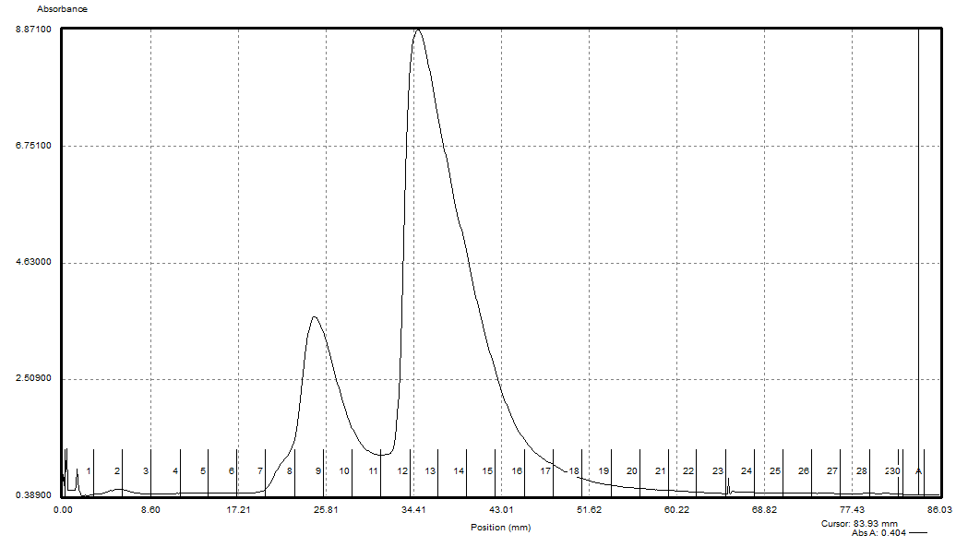

Figure. Sucrose gradient of LVS ribosomes after lysis with Bug Buster and resuspension in low (0.3mM) Mg.
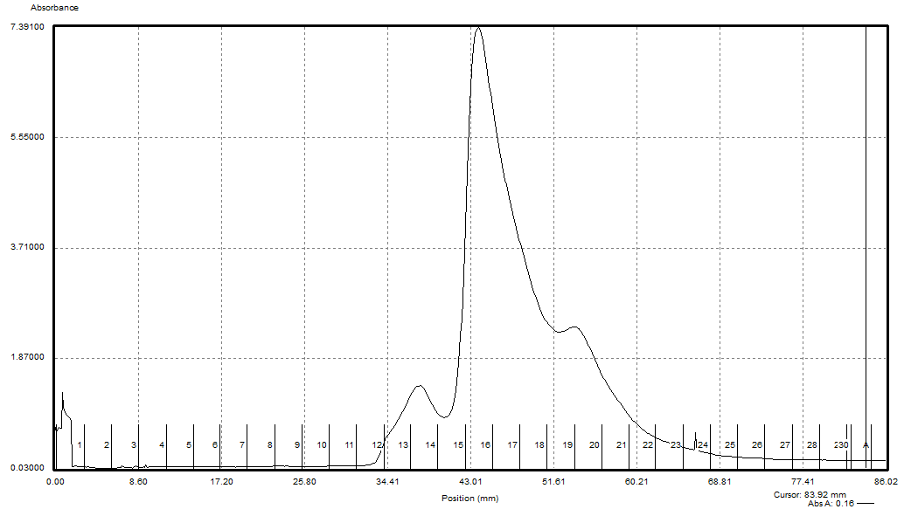

Figure. Sucrose gradient of LVS ribosomes after lysis with Bug Buster, resuspension in low (0.3mM) Mg, and incubation in high (10mM) Mg for 2 hours.

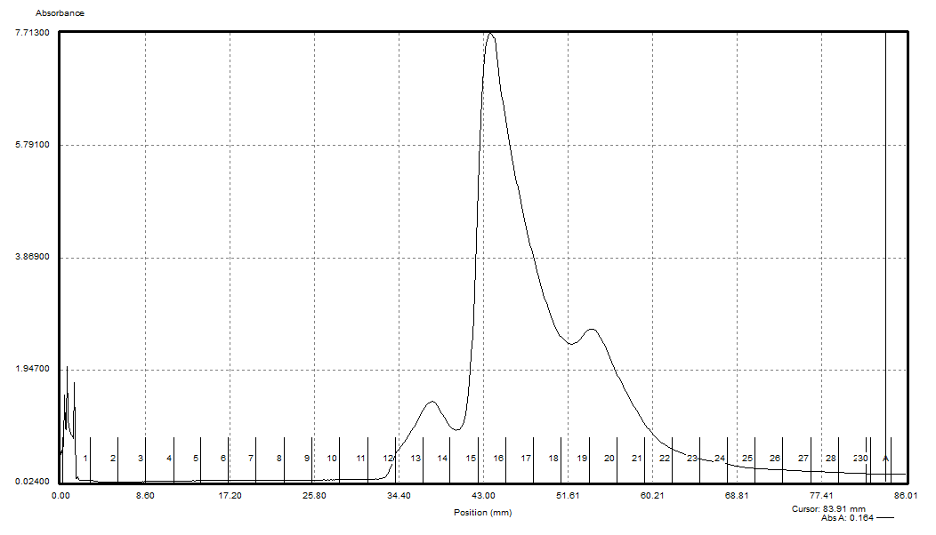

Figure. Sucrose gradient of LVS ribosomes after lysis with Bug Buster, resuspension in low (0.3mM) Mg, and incubation in high (10mM) Mg overnight.

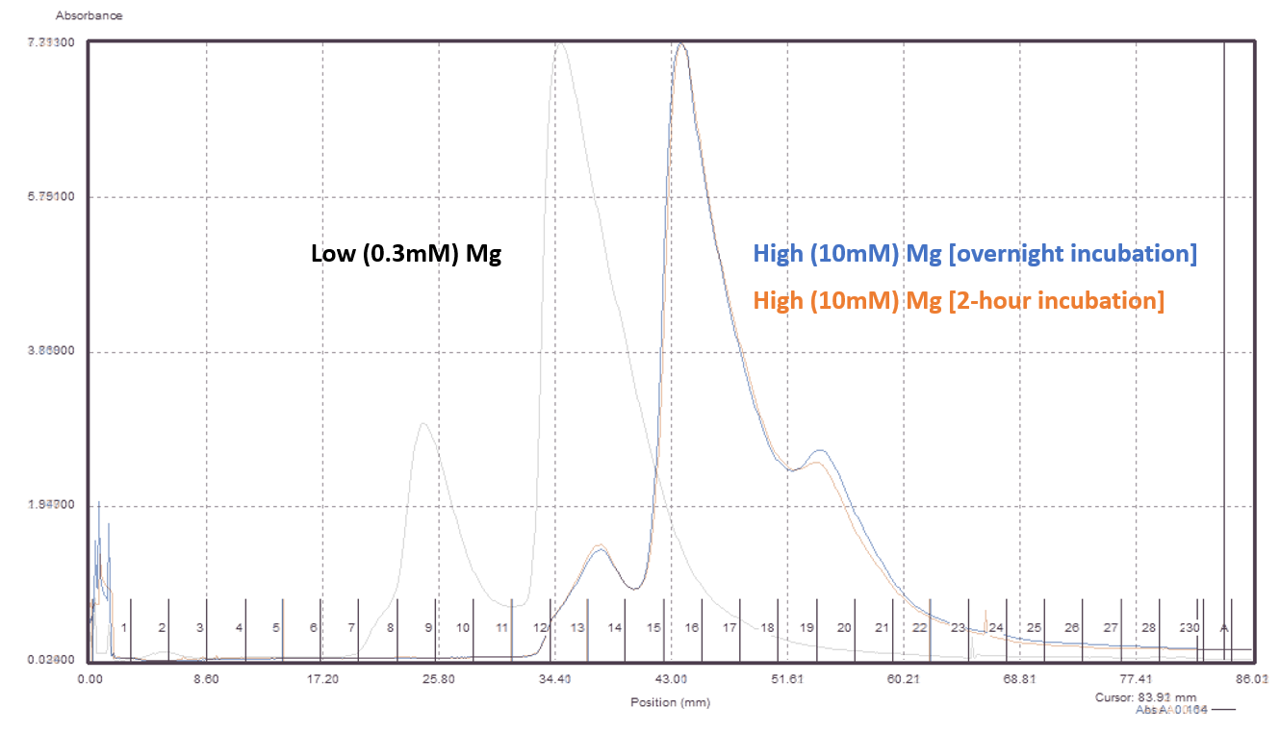

Figure. Comparison of sucrose gradients.
The takeaway from these graphs is that whether you incubate for 2 hours or overnight doesn't matter - the curves are very similar. Interestingly, they both have a shoulder where 100S? ribosomes would be. Maybe they dimerize once they reassemble into 70S?

Friday, May 17, 2024
To Do:
- Run gradients with fractions from ON Mg incubation
- Help move freezer drawers
- Take pictures of plates
- Make hemoglobin
- Work on thesis proposal
Results and Data:

Streaking for Isolation
I took pictures of the plates that George and I used on Tuesday to practice streaking for isolation.
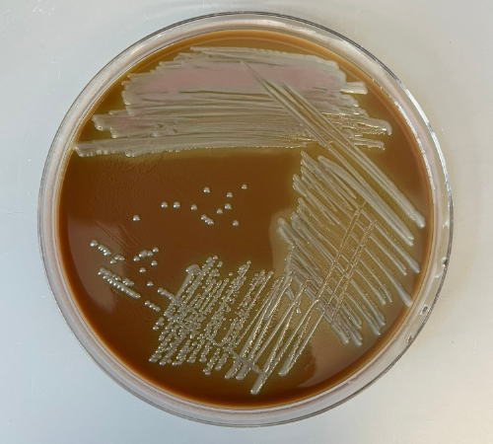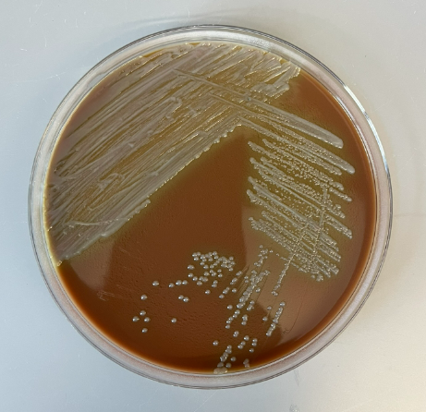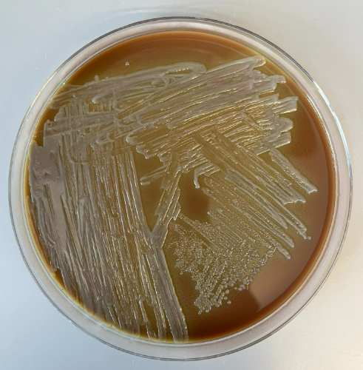

Figures. Practice plates for streaking for isolation.

Making a Sucrose Gradient
- Have prepared a light solution (i.e. 10% sucrose) and a heavy solution (50% sucrose) that has been autoclaved and filter-sterilized (Solutions were filter-sterilized but not autoclaved.). Sucrose solutions should be in the same buffer as your sample. Also prepare about 205 uL of your sample, diluted to 0.6 ug/ul (Sample 4 was diluted to a volume of 200 uL).

Table. Calculations for bringing sample four to desired Mg molarity and volume of 200 uL.
Starting Volume (uL) | Desired Volume (uL) | Starting uL MgCl2 | Desired M MgCl2 | Desired uL MgCl2 | Volume MgCl2 to add (uL) | Volume Buffer to add (uL)
20 | 200 | 0.06 | 10 | 2 | 1.94 | 178.1

- Put a tube in the marker block and draw a line at the top ledge.
- With a 30mL syringe, push into light solution and pump the air bubbles out. Draw out light solution (about 8 mL per gradient) and plunge needle to the very bottom of the tube. Lift the needle as solution pours out, be careful to keep the tip of the needle just under the surface of the solution. Stop at just above the line.
- With a 10mL syringe, push into heavy solution and pump the air bubbles out. Draw out heavy solution, then wipe the needle and push a drop out, dabbing onto a kimwipe (making sure there’s no air). Holding the tube with thumb and middle finger, use forefinger as a guide as you plunge needle to bottom of tube, resting the needle along the wall, and push out gently just enough to form a pool. Keep pushing out solution as you draw up the needle, keeping the tip about 1 cm below the interface of the layers until there is about 2-3mm of space at the top. Make sure needle is resting against the wall of the tube as you quickly draw it out. There should be a visible line between the layers.
- Use light solution to adjust the top layers, making sure all samples are at the same level
- Cap the tubes, making sure the hole is the last part to seal. Some liquid should be visible inside the cap, if there is visible air or you can’t see liquid in cap add some more light solution.
- Turn on gradient station in back, select “GMST”
- Use the up and down keys on the gradient station and the level to level the plate. When level press “done”.
- Put tubes in tube holder (no need to balance); Go to exit -> gradient -> recent-> confirm rotor -> use (confirm 10:50) -> run (recent should be the 10-50% sucrose gradient because that’s the one we have been using. If you need to find a different one go to recent and scroll through)
- Put back in tube rack and refrigerate for 45 minutes. Now is a good time to cool down the ultracentrifuge.
- Take off caps, remove 40uL of top layer and weigh the samples. Using light solution, adjust as necessary until there is no more than .002 difference in weight.
- Use sample layering device to add 200uL of sample to the top (put tube in tube holder, use both hands for the device, press edge of syringe against farther tube wall and gently push the sample onto the top layer). (I used a P200 pipette to layer 190 uL of sample on top of sucrose gradient.)
- Put samples on ice and bring to INBRE to spin on ultracentrifuge with rotor SW40 Ti. 40,000 rpm for 4 hours at 4C, using 5 for acceleration and deceleration. (Used CBLS centrifuge and max setting for accel and decel.).
- After spin, continue with fractionation protocol.

Fractionating
- Before launching the Triax software, turn fractionator on via button on side, then set fractionator to “scan.” (You must turn on the fractionator and the flow cell.)
- Choose the username, click “single UV OD scan”. Channel A Wavelength should be 260 nm
- On the bottom of the screen fill out Gradients necessary info (i.e. sample volume, gradient type, speed, etc)
- Under the rotor settings (SW40Ti) select “number of fractions” as the mode to fractionate by
- On the LED Power screen, make sure Channel A is reading between 800,000 and 900,000. Push water through the cell if it needs to be adjusted
- Go to scan set up, make sure everything is filled out correctly
- Go to graph. Pump water through the cell again to calibrate. Y axis should be close to 0, with at least two zeros following the decimal point (e.g. 0.002)
- Purge air through the system, then load the first sample. Cap the sample with the flow cell cap by turning and pushing down and put sample in the flow cell, using bottom lock. Slide it on the fractionator then rotate 90ºC to fix it in place (window should face front)
- Load microcentrifuge tubes in rack in the middle two rows, then put the rack on the fractionator. The 29 should face the back. The dispenser will make a U moving back then left then forwards, so load tubes accordingly.
- On software, hit “start scan”. When all of the tubes are filled, hit “end” to move the tubing to the back. Flush with water for 10 seconds then air for 10 seconds. Repeat for a total of 3 washes. Rinse screw-on cap with DI water.
- Save run as csv when prompted and graph via file -> save graph image.
- Repeat Step 9 for the remaining samples.
- When all of the samples are complete, push water through the flow cell, then flush 5 times with water, 3 times with 70% isopropyl alcohol, and 5 times with air only using the dry syringe. Switch metal lever down to assist with air flushes.
- Flush the line your sample goes through with DI water.
- Save fractions at -20C if interested in proteins, -80C if interested in RNA. (Fractions were stored at -20C).

Table. Sucrose Gradient Sample Information
Sample | Strain | Purification Method | Date Purified | Stage | Fraction | Mg2+ Conc.
1 | LVS | Bug Buster | 5/15/24 | Post-dialysis (overnight incubation) | 14 | 10 mM
2 | LVS | Bug Buster | 5/15/24 | Post-dialysis (overnight incubation) | 16 | 10 mM
3 | LVS | Bug Buster | 5/15/24 | Post-dialysis (overnight incubation) | 20 | 10 mM
4 | LVS | Bug Buster | 5/15/24 | Post-dialysis (2-hour incubation) | - | 10 mM

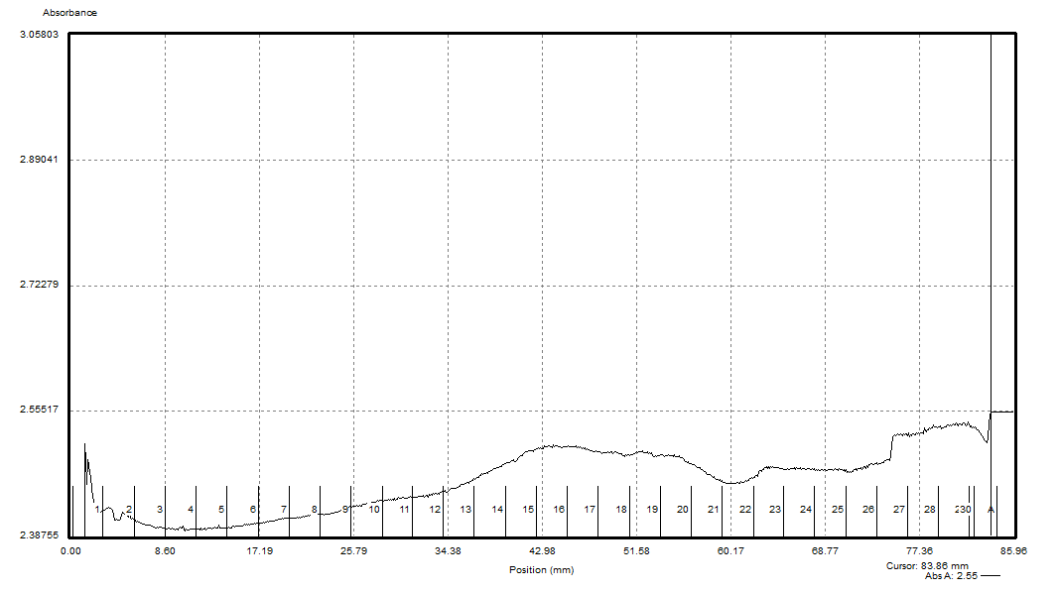

Figure. Sucrose gradient graph for fraction 14 from sample incubated in high magnesium overnight.

Fraction 14 turned out a little weird and the curves for fractions 14, 16, and 20 weren't completely smooth. I think part of this may be the low concentration of the samples - I ran about 200 uL of each fraction out of about 400 uL that was present (and the fractions were more dilute than the original sample to begin with).
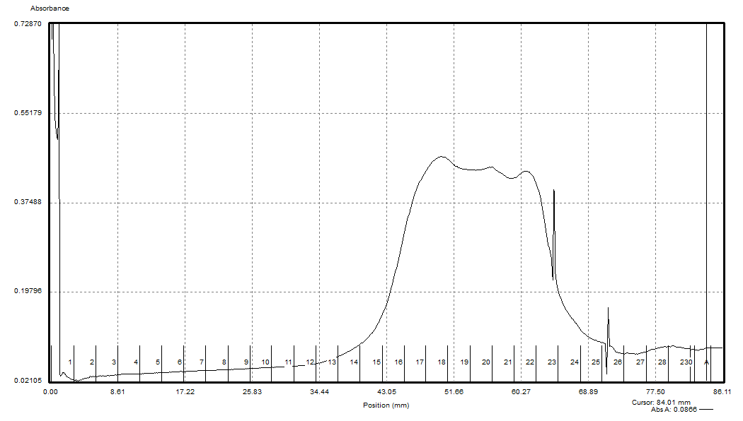

Figure. Sucrose gradient graph for fraction 16 from sample incubated in high magnesium overnight.

Here, it seems like the 70S ribosomes didn’t stay as 70S, but began to aggregate (see comparison figures below).

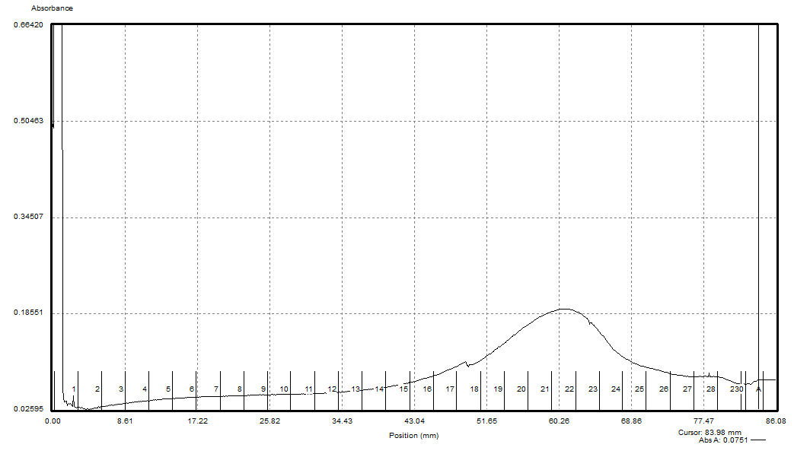

Figure. Sucrose gradient graph for fraction 20 from sample incubated in high magnesium overnight.

Here it seems like the 100S ribosomes stayed as 100S ribosomes.

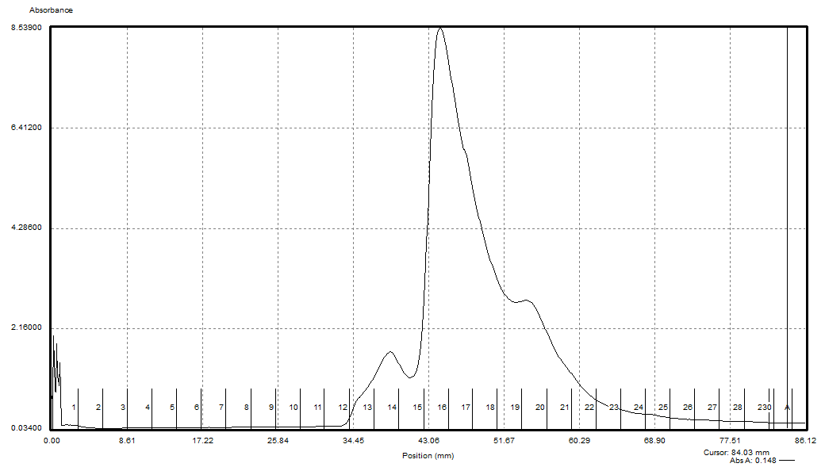

Figure. Sucrose gradient graph for sample incubated in high magnesium for two hours.

The sample from this 2-hour incubation looks very similar to the samples from the overnight and 2-hour incubations that were run on 5/16 (see comparison figures below).
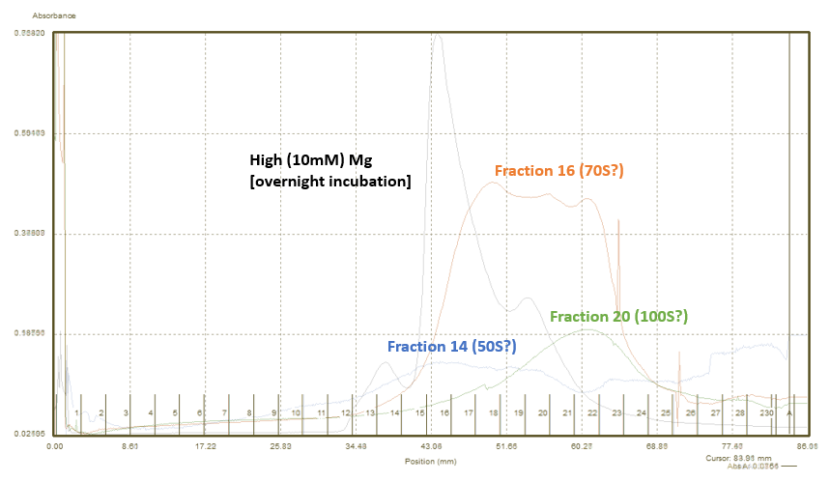

Figure. Comparison of sucrose gradient fractions with original graph (overlay, not to scale).

It seems like the fractions all shifted to the right a little bit (further aggregation?), but these curves are also not shown to scale (see comparison to scale below).

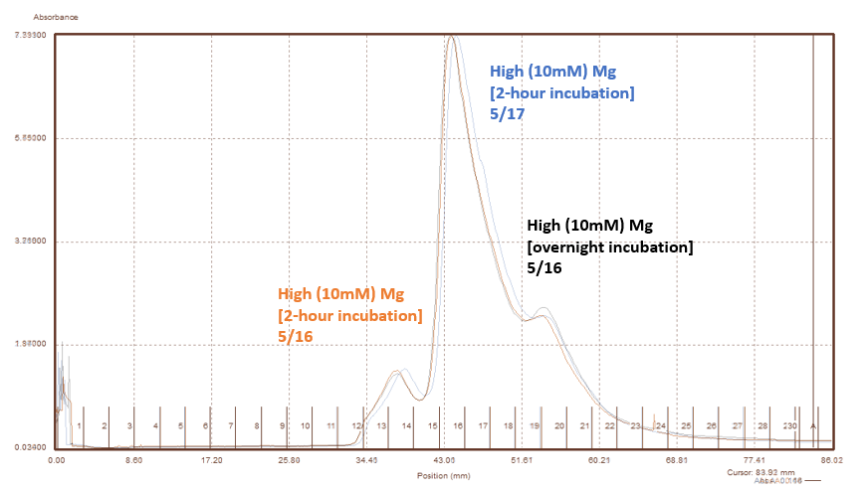

Figure. Comparison of overnight incubation run on 5/16 with 2-hour incubations run on 5/16 and 5/17 (overlay, not to scale).

These curves are very similar, so these results reinforce the hypothesis that a 2-hour incubation in high magnesium is sufficient to reconstitute 70S ribosomes.
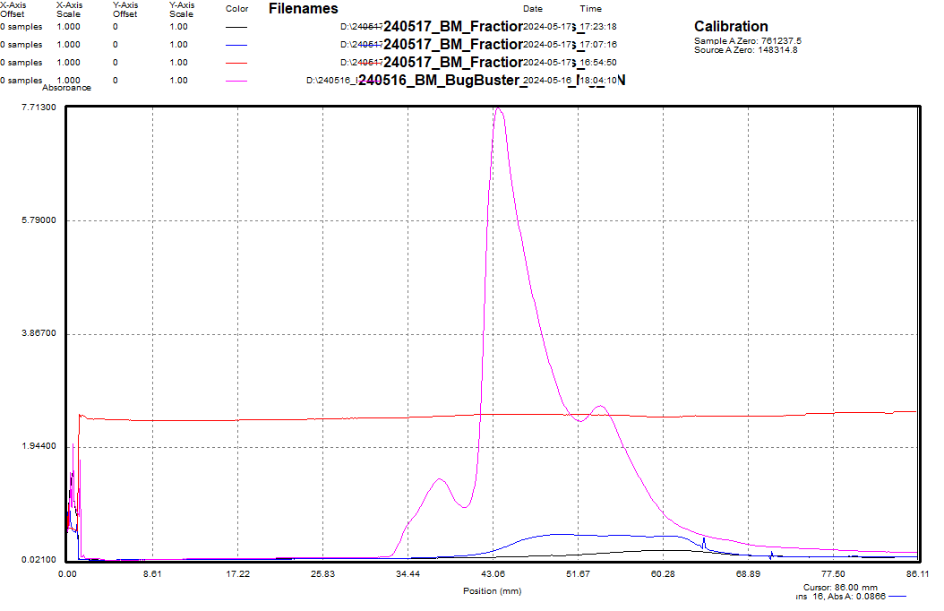

Figure. Comparison of sucrose gradient fractions with original graph (to scale).

From the scale figure here, you can see that the signal is very low, and I’m not sure why the graph for fraction 14 is higher than the others.
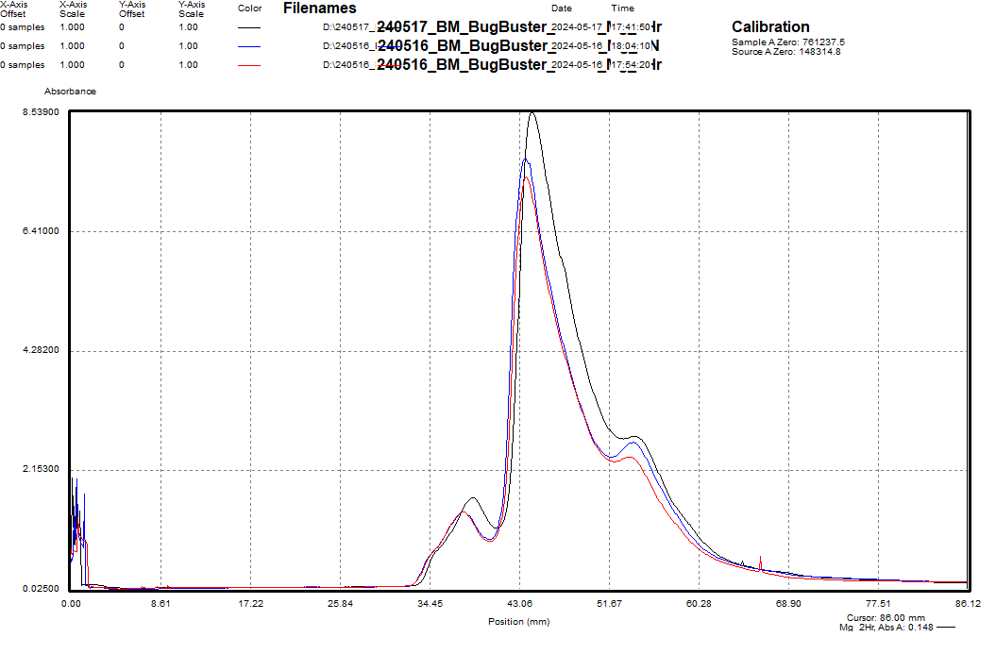

Figure. Comparison of overnight incubation run on 5/16 with 2-hour incubations run on 5/16 and 5/17 (to scale).

Even set to scale, the graphs are very similar, showing that a 2-hour incubation in high magnesium should be sufficient, and overnight incubation is unnecessary.

I made four flasks of 2% hemoglobin.

2% Hemoglobin
- Add 6g freeze-dried hemoglobin to 300mL of ddiH₂O (type I).
- Autoclave on 20’ liquid cycle with water in the bin.
- Cool down (ideally to ~55C) and store in fridge.

I helped Kira move six freezer racks from the Matthew Ramsey lab -80C to our -80C.

Monday, May 20, 2024
To Do:
- Run gradient samples on a gel
Results and Data:
Recap: Today I should work on my thesis proposal and update Kathryn on my latest results so that we can decide how to move forward. I received a specimen from AddGene. I moved fractions to the -80C. I need to figure which fractions I need to keep. I talked to Kathryn about the results, and she recommends running the remainder of fractions 14, 16, and 20 on an RNA gel to see what rRNA they are made of. I can run Alex’s old RNA as a control. I should use plenty of SYBRsafe, and I may have to overexpose the gel. I can either do an RNA extraction from an aqueous solution, or I can try a method Steve suggested of simply adding the samples to water and running them without an extraction.

Steve said that I could add enough water (ddH2O) to dilute the magnesium in the samples to a low concentration, at which point the ribosomes will dissociate. I was concerned that we didn’t have enough sample, because the sucrose gradient fractions were already very dilute.

After talking to Kathryn further, she suggested that I incubate 10 uL of each sample with 1 uL of 0.5M EDTA pH8.0, and then add sample loading buffer and run them on a gel. The EDTA should chelate the magnesium ions and allow the rRNA to dissociate. I incubated the samples with EDTA on ice while preparing the agarose gel, so for about 1 hour.

Steve emailed back, also recommending that I include EDTA in the gel loading buffer, and suggesting that I could heat the samples for a few minutes before loading. At this point, I had already loaded the samples, so I went ahead without heating them.

RNA Gel
- Melt 1% agarose gel at 300C and let cool in water bath to 50-55C.
- Put gel cast into the gel rig sideways.
- Added 50 mL of 1% agarose gel into gel rig along with 5 uL SYBR safe solution and mixed with comb.
- Inserted a comb to mold wells in the gel.
- Let sit until the 1% agarose – 1x SYBR safe solution had cooled and solidified into a gel.
- Carefully removed the comb.
- Poured 100 ml of 1x TAE buffer solution into the gel tank (add just enough to slightly submerge the gel itself).
- Added 4.67 uL 4x loading dye to 11 uL RNA solutions (10 uL sample + 1 uL 0.5M EDTA pH8.0).
- Loaded 10 µL of 2x log ladder into the first well.
- Loaded 14 µL of the RNA-dye mixture into the wells in sequential order.
- Inserted the electrodes and ran the gel at 113 volts for 45 minutes.
Lane | Sample ID | Expected rRNA | Visible rRNA
1 | Fraction 14 (50S?) | 23S | None
2 | Fraction 16 (70S?) | 23S, 16S, 5S | 16S
3 | Fraction 20 (100S?) | 23S, 16S, 5S | 16S
4 | Alex’s RNA sample | 23S, 16S, 5S | 23S, 16S, 5S

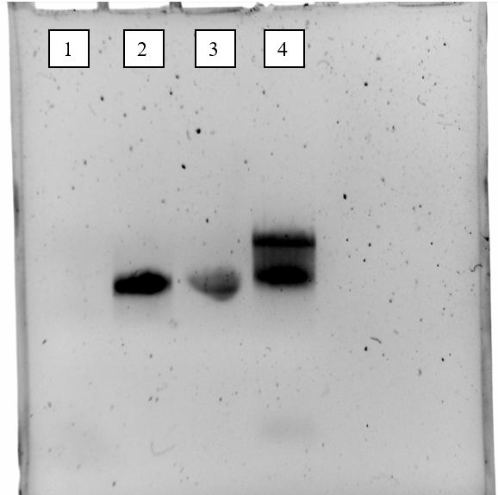

Figure. RNA gel with fractions 14, 16, 20, and a control.

It seems that all three bands are visible on Alex’s sample (lane 4), but only the band for 16S rRNA is visible for fractions 16 and 20 (lanes 2 and 3). The band for fraction 16 is darker which may be because of the higher concentration of rRNA in the sample as shown on the graph. Could dimerization of 70S ribosomes in the 100S sample (fraction 20) have affected the banding at all? Was adding the EDTA sufficient to dissociate the magnesium and cause the ribosomes to fall apart? Should I also try the heating step?
I worked on the scatter plot for the Kasugamycin inhibition assay (see below). I need to keep working on this figure and create a template for it, so I can include it in my thesis.
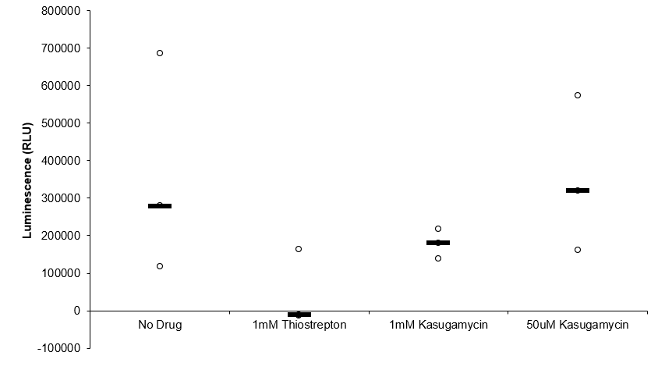

Figure. Scatter plot for Kasugamycin inhibition assay.

Tuesday, May 21, 2024
Results and Data:
I went to the RI Life Sciences Hub in Providence this morning and made some good connections that I should follow up with. Kathryn sent me an RNA extraction protocol, and I will run that tomorrow. I can continue working on my thesis proposal today.

Wednesday, May 22, 2024
To Do:
- RNA extraction and gel
- Sucrose gradient to test for identity of fractions 9 and 13 from low Mg sample
Results and Data:
Today I am going to work on the RNA extraction and gel, work on my thesis proposal, start applying for jobs, and potentially meet with Kathryn.

RNA isolation from sucrose gradient fractions
- Transfer 100 uL of fraction from sucrose gradient to RNase-free tube
Perform steps in chemical fume hood, wear lab coat, gloves, and goggles. Use only RNase-free reagents and consumables.
- Add 300 uL TRI-Reagent (stored at 4°C)
- Add 400 uL 100% ethanol (from RNA only stock)
- Pass sample over Directzol column, 600 uL per spin, 30 sec per spin at max speed, discarding flow-through in phenol and methanol waste
- Place spin column in new collection tube
- Wash twice with 400 uL RNA PreWash buffer, discarding flow-through in phenol and methanol waste
- Add 700 ul of Wash buffer, let sit on column for 3 min
- Spin max speed for 2 min, discard flow-through in phenol and methanol waste
Can move from chemical fume hood to bench here if desired.
- Add 700 ul Wash buffer again, discard flow-through in regular waste
- Spin max speed for 2 min, discard flow-through in regular waste
- Place column in new collection tube
- Spin max speed for 3 min
- Place column in clean 1.5 mL tube
- Add 40 uL RNase-free water, let sit on column 2 min
- Spin max speed 1 min
- Measure RNA concentration with Nanodrop.
- Store RNA at -80°C.
To analyze, combine 10 uL with 2 uL blue loading dye (RNA box) and run on agarose gel (make new 1% agarose and use new buffer).

Table. RNA concentrations for extracted RNA samples.
Sample ID | Ng/uL
ON_HighMg_14 | 46.2
ON_HighMg_16 | 440.1
ON_HighMg_20 | 115.1
LowMg_9 | 4.2
LowMg_9 | 6.7
LowMg_13 | 3.3

Running RNA Gel
Written by: Sierra Schmidt
- Make 10 uL aliquots with normalized concentrations, using water to dilute. Then add 2 uL purple loading dye for a final concentration of 1-1.5x purple loading dye and run on gel.
  - Note: RNA concentration should end with each sample being pipet-able. Typically ran final concentration of ~300 ng/uL
- Rinse comb and gel rig with DI water, then spray with ethanol
- Make fresh 1% agarose gel by adding 1.2 g to 120 mL fresh 1xTAE (or 0.6 g in 60mL 1xTAE for small gel rig) and stir with heat until completely dissolved, then place in 56°C water bath until cool enough to touch.
- Set up gel rig to cast gel, with ladder.
- Add 12 uL of Sbyr Safe dye to rig, pour gel, use ladder to mix, then replace ladder and allow to set.
- Add new 1xTAE, turn gel, and remove ladder.
- Load 12 uL of each sample.
- Ran until separated at 113V, at least ~15 minutes.
- Look for distinctive bands (23s, 16s, tRNA+5s), rather than smears.

Making Agarose Gel
- Add 1 g agarose powder to 100 mL 1x TAE buffer in 250 mL.
- Add stirbar to container.
- Heat to dissolve the agarose while stirring (don’t let it overboil, should look like clear liquid, no solids).
- Once the sugar has dissolved, make a 1x concentration of SYBR safe in the 1% agarose solution.
- To make, add 10µL of 10,000x SYBR safe dye to the 1% agarose solution
- Let the 1% agarose solution cool to approximately 50-55°C.
- Apply autoclave tape to the edges of the gel cast (ensure the tape is tightly bound).
- Pour 1% agarose - 1x SYBR safe solution into the cast and insert a comb to mold wells in the gel.
- Let sit until the 1% agarose – 1x SYBR safe solution has cooled and solidified into a gel.
- Carefully remove the comb.
- Pour the 100 ml of 1x TAE buffer solution into the gel tank (add just enough to slightly submerge the gel itself).

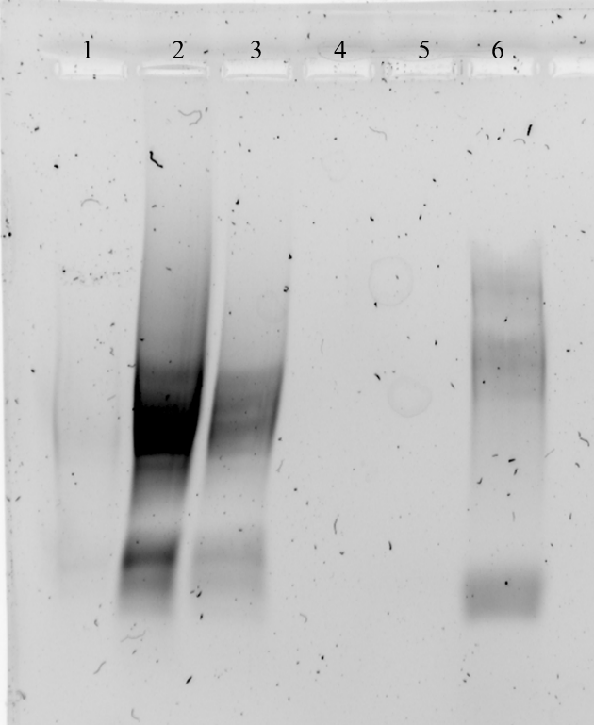

Figure. RNA gel with samples from RNA extraction and a control from Alex.

Table. Sample information for RNA gel.
Lane | 1 | 2 | 3 | 4 | 5 | 6
Sample | LVS High Mg | LVS High Mg | LVS High Mg | LVS Low Mg | LVS Low Mg | Alex control
Fraction | 14 | 16 | 20 | 9 | 13 | -
Concentration | 46.2 ng/µl | 440.1 ng/µl | 115.1 ng/µl | 5.45 ng/µl | 3.3 ng/µl | ?
Expected Composition | 50S | 70S | 100S | 30S | 50S | 70S
Expected RNAs | 23S, 5S | 23S, 16S, 5S | 23S, 16S, 5S | 16S | 23S, 5S | 23S, 16S, 5S
Observed RNAs | 16S?, 5S? | 16S?, 5S? | 16S?, 5S? | none | none | 23S, 16S, 5S

I'm not exactly sure how to interpret the bands for samples 1-3, but I gave it a shot. I think I chose the wrong set of fractions for samples 4 & 5. They could have been labeled better and I may have mixed them up with fractions from a different day after they were moved from one freezer to another. Also, the concentration of RNA in the samples was close to zero and a fresh set of gradients I ran with these fractions came back with no peaks (see below). I may try again with samples from the other set I may have gotten them confused with.

These gradients were run to test whether the fractions 9 and 13 I selected from the Low Mg sample above were the right ones. The boxes I had stored the fractions in were not labeled individually, but stacked with another box of fractions in which I had placed a sheet of paper with a date and info about the samples. When the boxes were moved from the -20C to the -80C and back again during the freezer repair, the boxes may have been disorganized, and so I may have chose the fractions from 5/17 instead of the ones from 5/16. I realized later that I could have simply tested the concentrations of the fractions on the Nanodrop rather than running sucrose gradients.

Making a Sucrose Gradient
- Have prepared a light solution (i.e. 10% sucrose) and a heavy solution (50% sucrose) that has been autoclaved and filter-sterilized (Solutions were filter-sterilized but not autoclaved.). Sucrose solutions should be in the same buffer as your sample. Also prepare about 205 uL of your sample, diluted to 0.6 ug/ul.
- Put a tube in the marker block and draw a line at the top ledge.
- With a 30mL syringe, push into light solution and pump the air bubbles out. Draw out light solution (about 8 mL per gradient) and plunge needle to the very bottom of the tube. Lift the needle as solution pours out, be careful to keep the tip of the needle just under the surface of the solution. Stop at just above the line.
- With a 10mL syringe, push into heavy solution and pump the air bubbles out. Draw out heavy solution, then wipe the needle and push a drop out, dabbing onto a kimwipe (making sure there’s no air). Holding the tube with thumb and middle finger, use forefinger as a guide as you plunge needle to bottom of tube, resting the needle along the wall, and push out gently just enough to form a pool. Keep pushing out solution as you draw up the needle, keeping the tip about 1 cm below the interface of the layers until there is about 2-3mm of space at the top. Make sure needle is resting against the wall of the tube as you quickly draw it out. There should be a visible line between the layers.
- Use light solution to adjust the top layers, making sure all samples are at the same level
- Cap the tubes, making sure the hole is the last part to seal. Some liquid should be visible inside the cap, if there is visible air or you can’t see liquid in cap add some more light solution.
- Turn on gradient station in back, select “GMST”
- Use the up and down keys on the gradient station and the level to level the plate. When level press “done”.
- Put tubes in tube holder (no need to balance); Go to exit -> gradient -> recent-> confirm rotor -> use (confirm 10:50) -> run (recent should be the 10-50% sucrose gradient because that’s the one we have been using. If you need to find a different one go to recent and scroll through)
- Put back in tube rack and refrigerate for 45 minutes. Now is a good time to cool down the ultracentrifuge.
- Take off caps, remove 40uL of top layer and weigh the samples. Using light solution, adjust as necessary until there is no more than .002 difference in weight.
- Use sample layering device to add 200uL of sample to the top (put tube in tube holder, use both hands for the device, press edge of syringe against farther tube wall and gently push the sample onto the top layer). (I used a P200 pipette to layer 200 uL of sample on top of sucrose gradient.)
- Put samples on ice and bring to INBRE to spin on ultracentrifuge with rotor SW40 Ti. 40,000 rpm for 4 hours at 4C, using 5 for acceleration and deceleration. (Used CBLS centrifuge and min setting for accel and decel.).
- After spin, continue with fractionation protocol.

Fractionating
- Before launching the Triax software, turn fractionator on via button on side, then set fractionator to “scan.” (You must turn on the fractionator and the flow cell.)
- Choose the username, click “single UV OD scan”. Channel A Wavelength should be 260 nm
- On the bottom of the screen fill out Gradients necessary info (i.e. sample volume, gradient type, speed, etc)
- Under the rotor settings (SW40Ti) select “number of fractions” as the mode to fractionate by
- On the LED Power screen, make sure Channel A is reading between 800,000 and 900,000. Push water through the cell if it needs to be adjusted
- Go to scan set up, make sure everything is filled out correctly
- Go to graph. Pump water through the cell again to calibrate. Y axis should be close to 0, with at least two zeros following the decimal point (e.g. 0.002)
- Purge air through the system, then load the first sample. Cap the sample with the flow cell cap by turning and pushing down and put sample in the flow cell, using bottom lock. Slide it on the fractionator then rotate 90ºC to fix it in place (window should face front)
- Load microcentrifuge tubes in rack in the middle two rows, then put the rack on the fractionator. The 29 should face the back. The dispenser will make a U moving back then left then forwards, so load tubes accordingly.
- On software, hit “start scan”. When all of the tubes are filled, hit “end” to move the tubing to the back. Flush with water for 10 seconds then air for 10 seconds. Repeat for a total of 3 washes. Rinse screw-on cap with DI water.
- Save run as csv when prompted and graph via file -> save graph image.
- Repeat Step 9 for the remaining samples.
- When all of the samples are complete, push water through the flow cell, then flush 5 times with water, 3 times with 70% isopropyl alcohol, and 5 times with air only using the dry syringe. Switch metal lever down to assist with air flushes.
- Flush the line your sample goes through with DI water.
- Save fractions at -20C if interested in proteins, -80C if interested in RNA. (I did not keep the fractions, because I was simply testing to see if I had the selected the right fractions for the RNA extraction above).

Table. Sucrose Gradient Sample Information
Sample | Strain | Purification Method | Date Purified | Stage | Fraction | Mg2+ Conc.
1 | LVS | Bug Buster | 5/15/24 | Dialyzed in Low Mg | 9 | 0.3 mM
2 | LVS | Bug Buster | 5/15/24 | Dialyzed in Low Mg | 13 | 0.3 mM

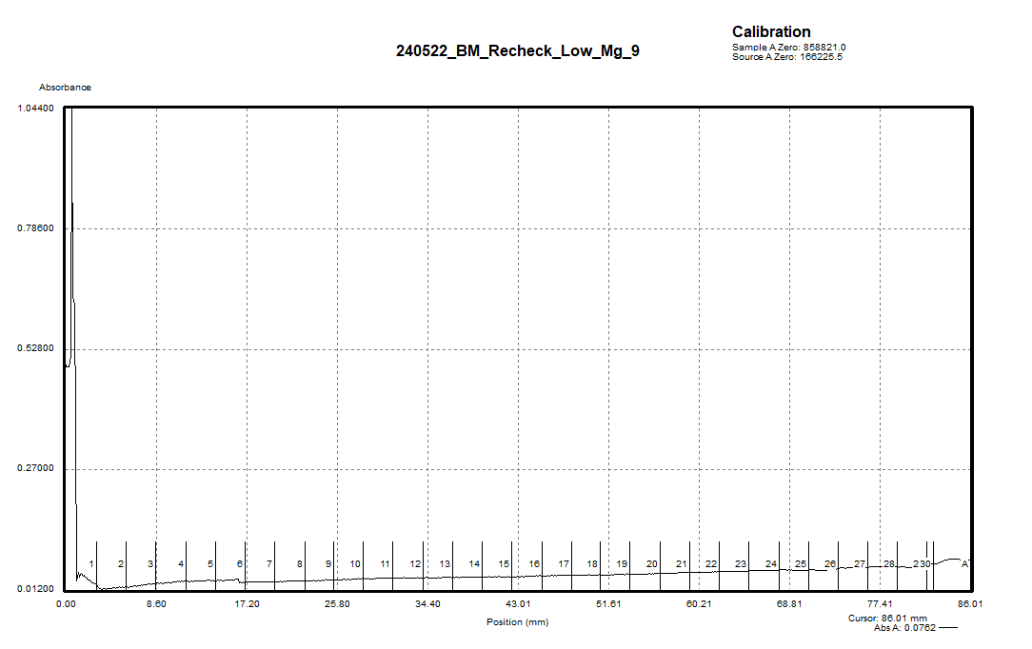

Figure. Sucrose gradient to verify ID of fraction 9 from Low Mg sample (5/16?).

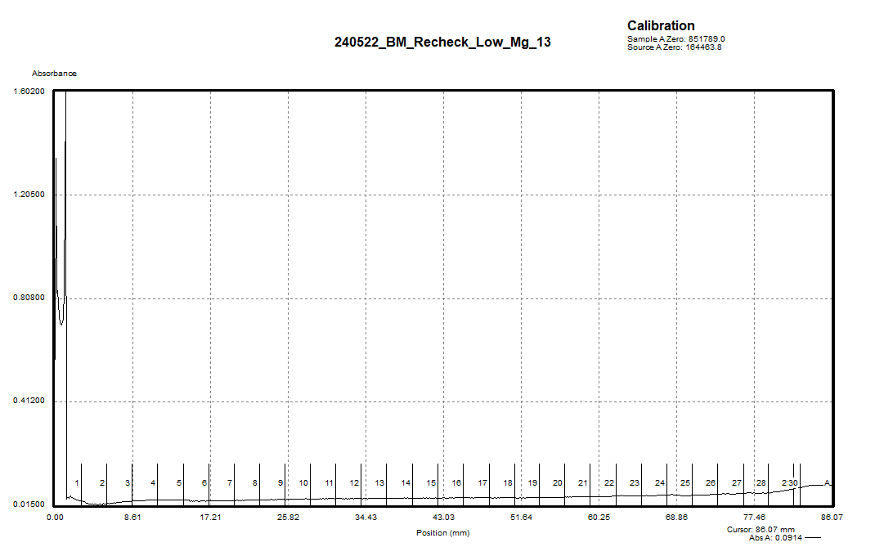

Figure. Sucrose gradient to verify ID of fraction 13 from Low Mg sample (5/16?).

The gradients for fractions 9 and 13 didn’t show any peaks and the RNA concentration was very low from the RNA extraction, so I may have selected the wrong samples. I will have to test RNA concentrations of samples 9 and 13 from the other box to see if those are the correct ones.

Thursday, May 23, 2024
To Do:
- Test concentrations of sucrose gradient fractions from orange and pink boxes
Results and Data:
The -80C freezer was displaying a mains power failure alert, so Johanyx and I moved racks 7A, 7E, 8A, 9A, 10A, and 5E back into the -80C in Matthew Ramsey’s lab, and we moved racks 4A, 11A, and the plastic bags with fraction tubes into the -20C.

I tested the concentrations of the gradients fractions 9 and 13 from the two boxes (orange and pink) in the freezer which contained samples from 5/16 and 5/17. Looking back at the graphs from both days, it is evident that whichever set of fractions has a higher concentration is the set from 5/16. I diluted 2 uL of each fraction into 98 uL of nuclease-free water (1:50 dilution) before measuring.

Table. RNA concentrations for fractions 9 and 13 in orange and pink boxes.
Sample ID | Ng/ul | A260 (Abs)
9_orange | -0.6 | -0.014
13_orange | -0.4 | -0.01
9_pink | 97.9 | 2.446
13_pink | 309.4 | 7.735
9_orange | 0.2 | 0.005
13_orange | 0.8 | 0.02
9_pink | 98.9 | 2.472
13_pink | 293.2 | 7.33

It looks like fractions 9 and 13 from the pink box had higher concentrations than those from the orange box, and are the fractions collected from the Low Mg sample on 5/16. Yesterday, I RNA extracted the samples from the orange box, which were the wrong ones, so tomorrow I will plan to RNA extract the samples from the pink box. I threw away the samples from 5/17, including those from the orange box, because I shouldn’t need them anymore, and I consolidated the samples from 5/16, including those from the pink box, into a plastic bag in the -20C.

Conclusions: Today, I helped move racks back into the Matthew Ramsey lab and the -20C from the -80C. I send results from my RNA extraction and gel to Kathryn and measured fractions 9 and 13 on the Nanodrop. I also helped Johanyx.

Friday, May 24, 2024
To Do:
- RNA extract fractions 9 and 13 from 5/16
- Run an RNA gel with RNA extracted samples
Results and Data:

RNA isolation from sucrose gradient fractions
- Transfer 100 uL of fraction from sucrose gradient to RNase-free tube
Perform steps in chemical fume hood, wear lab coat, gloves, and goggles. Use only RNase-free reagents and consumables.
- Add 300 uL TRI-Reagent (stored at 4°C)
- Add 400 uL 100% ethanol (from RNA only stock)
- Pass sample over Directzol column, 600 uL per spin, 30 sec per spin at max speed, discarding flow-through in phenol and methanol waste
- Place spin column in new collection tube
- Wash twice with 400 uL RNA PreWash buffer, discarding flow-through in phenol and methanol waste
- Add 700 ul of Wash buffer, let sit on column for 3 min
- Spin max speed for 2 min, discard flow-through in phenol and methanol waste
Can move from chemical fume hood to bench here if desired.
- Add 700 ul Wash buffer again, discard flow-through in regular waste
- Spin max speed for 2 min, discard flow-through in regular waste
- Place column in new collection tube
- Spin max speed for 3 min
- Place column in clean 1.5 mL tube
- Add 40 uL RNase-free water, let sit on column 2 min
- Spin max speed 1 min
- Measure RNA concentration with Nanodrop.
- Store RNA at -80°C.
To analyze, combine 10 uL with 2 uL blue loading dye (RNA box) and run on agarose gel (make new 1% agarose and use new buffer).

Table. RNA concentrations for extracted RNA samples.
Sample ID | Ng/ul | A260 (Abs)
LowMg_9 | 170.6 | 4.266
LowMg_13 | 533.9 | 13.347

Running RNA Gel
Written by: Sierra Schmidt
- Make 10 uL aliquots with normalized concentrations, using water to dilute. Then add 2 uL purple loading dye for a final concentration of 1-1.5x purple loading dye and run on gel.
  - Note: RNA concentration should end with each sample being pipet-able. Typically ran final concentration of ~300 ng/uL
- Rinse comb and gel rig with DI water, then spray with ethanol
- Make fresh 1% agarose gel by adding 1.2 g to 120 mL fresh 1xTAE (or 0.6 g in 60mL 1xTAE for small gel rig) and stir with heat until completely dissolved, then place in 56°C water bath until cool enough to touch.
- Set up gel rig to cast gel, with ladder.
- Add 12 uL of Sbyr Safe dye to rig, pour gel, use ladder to mix, then replace ladder and allow to set.
- Add new 1xTAE, turn gel, and remove ladder.
- Load 12 uL of each sample.
- Ran until separated at 113V, at least ~15 minutes.
- Look for distinctive bands (23s, 16s, tRNA+5s), rather than smears.

Making Agarose Gel
- Add 1 g agarose powder to 100 mL 1x TAE buffer in 250 mL.
- Add stirbar to container.
- Heat to dissolve the agarose while stirring (don’t let it overboil, should look like clear liquid, no solids).
- Once the sugar has dissolved, make a 1x concentration of SYBR safe in the 1% agarose solution.
- To make, add 10µL of 10,000x SYBR safe dye to the 1% agarose solution
- Let the 1% agarose solution cool to approximately 50-55°C.
- Apply autoclave tape to the edges of the gel cast (ensure the tape is tightly bound).
- Pour 1% agarose - 1x SYBR safe solution into the cast and insert a comb to mold wells in the gel.
- Let sit until the 1% agarose – 1x SYBR safe solution has cooled and solidified into a gel.
- Carefully remove the comb.
- Pour the 100 ml of 1x TAE buffer solution into the gel tank (add just enough to slightly submerge the gel itself).

I normalized the RNA samples to the concentration of the least concentrated sample (sample 1) which was 46.2 ng/uL by adding nuclease free water to a certain volume of sample to reach a total volume of 10 uL, then I added 2 uL of purple loading dye and pipetted 12 uL into the wells of the gel.

Table. Normalization of samples to concentration of sample 14.
Sample | Sample ID | Ng/uL | Volume sample (uL) | Volume H2O (uL)
1 | LVS High Mg Fraction 14 | 46.2 | 10 | 0
2 | LVS High Mg Fraction 16 | 440.1 | 1.05 | 8.95
3 | LVS High Mg Fraction 20 | 115.1 | 4.01 | 5.99
4 | LVS Low Mg Fraction 9 | 170.6 | 2.71 | 7.29
5 | LVS Low Mg Fraction 13 | 533.9 | 0.87 | 9.13
6 | Neg control (from Alex) | ? | 5 | 5

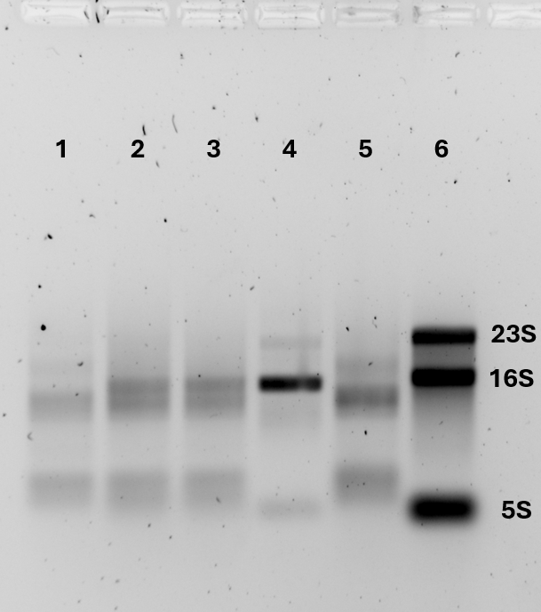

Figure. RNA gel with samples from RNA extraction and a control from Alex.

Table. Sample information for RNA gel.
Lane | 1 | 2 | 3 | 4 | 5 | 6
Sample | LVS High Mg | LVS High Mg | LVS High Mg | LVS Low Mg | LVS Low Mg | Alex control
Fraction | 14 | 16 | 20 | 9 | 13 | -
Concentration | 46.2 ng/µl | 46.2 ng/µl | 46.2 ng/µl | 46.2 ng/µl | 46.2 ng/µl | ?
Expected Composition | 50S | 70S | 100S | 30S | 50S | 70S
Expected RNAs | 23S, 5S | 23S, 16S, 5S | 23S, 16S, 5S | 16S | 23S, 5S | 23S, 16S, 5S
Observed RNAs | 16S?, 5S? | 16S?, 5S? | 16S?, 5S? | 23S, 16S, 5S? | none | 23S, 16S, 5S

Tuesday, May 28, 2024
To Do:
- Meet with Kathryn
- Interpret results for RNA gel
- Make hemoglobin
- Make CHAH and CHAH-Kan plates
Results and Data:
I made four flasks of 2% hemoglobin as well as CHAH and CHAH-Kan plates.

2% Hemoglobin
- Add 6g freeze-dried hemoglobin to 300mL of ddiH₂O (type I).
- Autoclave on 20’ liquid cycle with water in the bin.
- Cool down (ideally to ~55C) and store in fridge.

Meeting with Kathryn
Kathryn said that I should try purifying RNA using a new kit that she ordered from ThermoFisher. The kit might arrive tomorrow, so I could plan the purification for tomorrow. I will need to take precautions when handling the gel (wear separate gloves and put plastic wrap on GelDoc before placing gel down) because it contains ethidium bromide.

We are wondering if the ribosomes could be aggregating at higher concentrations, so Kathryn wants me to find out the number of moles of ribosomes that were loaded for each gradient and see if this is consistent with more moles leading to more aggregation. She would also like me to see which fractions have a number of moles that is similar to the number of moles used in the in vitro assay, to see whether there is a correlation. After that, I will look at the peaks and estimate the volume/moles beneath them? I will try to answer the question, “What is the ideal number of moles that corresponds to a good 70S ribosome profile? We can also try changing the salt concentration and seeing if that has an effect on aggregation.

Kathryn is designing plasmids with His tags on hibernation factors to be able to deplete the hibernation factors and see if aggregation is minimized and/or if hibernation factors are essential. We can look further at growth conditions to see if we can minimize production of hibernation factors. We know in E. coli, that ppGpp (an alarmone and stress factor which activates different regulons) is required for production of hibernation factors, but we don’t know if this is required in F. tularensis. Kathryn has a strain of LVS lacking relA and spot, which are required for ppGpp production, called JCLVS57.3 (ΔrelA ΔspoT). This strain grows very slowly, but Kathryn patched it out on xx/xx/xx. I should make personal glycerol stocks of this strain, and I should grow cultures with this strain and with regular LVS and purify ribosomes from both using the Bug Buster lysis method. I should grow this strain overnight, starting at a higher OD and harvesting later the next day.

Wednesday, May 29, 2024
To Do:

Results and Data:

Thursday, May 30, 2024
To Do:

Results and Data:

Friday, May 31, 2024
To Do:

Results and Data:

Bibliography
Ramsey, K. M. and Dove, S. L. (2016) ‘A response regulator promotes Francisella tularensis intramacrophage growth by repressing an anti-virulence factor’, Molecular Microbiology. doi: 10.1111/mmi.13418.

